**ENGLISH PREMIER LEAGUE**

**MATCH PREDICTION**

**A MINI PROJECT REPORT**

***Submitted by***

**Jayavelan S (Reg. No. 9517202309041)**

**Nandhagopal V (Reg. No. 9517202309074)**

**Sanjay K N (Reg. No. 9517202309101)**

***in partial fulfillment for the requirement of the course***

**23AD453 – MINI PROJECT II: DATA ANALYTICS**

*** ***

**DEPARTMENT OF ARTIFICIAL INTELLIGENCE AND DATA SCIENCE**

**MEPCO SCHLENK ENGINEERING COLLEGE (AUTONOMOUS)**

**SIVAKASI**

**APRIL 2025**

**BONAFIDE CERTIFICATE**



This is to certify that it is the bonafide work done by **Jayavelan S (9517202309041), Nandhagopal V (9517202309074), Sanjay K N (9517202309101)** for the course **23AD453 - Mini Project – II: DATA ANALYTICS** work entitled **“English Premier League Match Prediction”** at Department of Artificial Intelligence & Data Science, Mepco Schlenk Engineering College, Sivakasi during the year 2024 – 2025.

………………………… ……………………………

***Faculty In-Charge Head of the Department***

Submitted for the Practical Examination held at Mepco Schlenk Engineering College, Sivakasi on ……………………….

………………………… ……………………………

***Internal Examiner - I Internal Examiner - II***

**ACKNOWLEDGEMENT**

First and foremost, we express our deepest gratitude to the **LORD ALMIGHTY** for His abundant blessings, which have guided us through our past, present, and future endeavors, making this project a successful reality.

We extend our sincere thanks to our management, esteemed Principal, **Dr. S. Arivazhagan, M.E., Ph.D.,** for providing us with a conducive environment, including advanced systems and well-equipped library facilities, which have been instrumental in the completion of this project.

We are profoundly grateful to our Head of the Artificial Intelligence and Data Science Department, **Dr. J. Angela Jennifa Sujana, M.Tech., Ph.D.,** for granting us this golden opportunity to work on a project of this significance and for her invaluable guidance and encouragement throughout.

Our heartfelt appreciation goes to our project guides, **Dr. R. Nirmalan, M.Tech., Ph.D.,** Assistant Professor, and **Mrs.M. Revatheeswari, M.Tech.,** Assistant Professor, Department of Artificial Intelligence and Data Science for their unwavering support, insightful suggestions, and expert guidance. Their experience and encouragement have been vital in shaping our project and helping us bring forth our best.

We also extend our sincere gratitude to all our faculty members, lab technicians, and our beloved family and friends, whose timely assistance and moral support played a pivotal role in making this mini-project a success.

**ABSTRACT**

In the modern era of data-driven decision making, sports analytics has emerged as a crucial tool for enhancing performance evaluation and strategy development. This project applies various data mining and machine learning techniques to the English Premier League (EPL) dataset to extract meaningful insights, discover hidden patterns, and predict match outcomes. The study primarily focuses on three core areas: association rule mining, classification, and clustering.

In the first phase, Association Rule Mining techniques, specifically the Apriori Algorithm and the FP-Growth Algorithm, are used to identify significant relationships between different match factors such as team performance, goals scored, assists, and match results. These algorithms help in uncovering frequent patterns and generating rules based on support, confidence, and lift values. Such insights allow for a better understanding of the factors that often contribute to winning or losing a match.

The second phase involves building Classification Models to predict match outcomes. Three prominent classifiers are explored: Decision Tree Classifier (using the ID3 algorithm), Naïve Bayes, and K-Nearest Neighbor (KNN). Among these, the ID3 decision tree algorithm demonstrates superior performance by effectively splitting the data based on information gain.

The classifiers are evaluated using various performance metrics such as accuracy, precision, recall, specificity, F1-score, ROC-AUC, and through visualization tools like the ROC Curve and Confusion Matrix. The goal of this phase is to build predictive models that can accurately forecast the result of a football match based on historical data. In the third phase, Clustering Algorithms such as k-Means, Agglomerative Clustering, and DBSCAN are employed to segment teams and players based on their performance metrics. Clustering provides an unsupervised approach to discovering natural groupings within the dataset, helping to identify similarities and differences among teams or players without relying on predefined labels. Evaluation metrics like Silhouette Score and Dunn Index are utilized to assess the quality of the clusters formed.

In conclusion, this project demonstrates the practical application of machine learning and data mining techniques in sports analytics, specifically within the domain of football. By combining association rule mining, predictive modeling, and clustering, valuable patterns and predictive insights are uncovered, offering potential benefits for coaches, analysts, and teams seeking data-driven strategies to enhance performance and gain a competitive advantage.

**List of Tables**

|  |  |  |
| --- | --- | --- |
| **Table No.** | **Title of Table** | **Page No.** |
| 3.1 | Match-level Data | 10 |
| 3.2 | Match outcome & Score data | 10 |
| 3.3 | Team performance stats | 10 |
| 3.4 | Betting & market data | 11 |
| 4.1 | One Hot Encoding | 15 |
| 4.2 | Label Encoding | 15 |
| 4.3 | Frequency Encoding | 17 |
| 5.1 | Comparing performance metrics | 22 |
| 6.1 | Support and Confidence values | 28 |
| 6.2 | Evaluation Metrics | 29 |

**List of Figures**

|  |  |  |
| --- | --- | --- |
| **Figure No.** | **Title of Figure** | **Page No.** |
| 2.1 | Star Schema | 5 |
| 2.2 | Snowflake Schema | 6 |
| 2.3 | Slice | 7 |
| 2.4 | Dice | 7 |
| 2.5 | Drill-Down | 8 |
| 2.6 | Pivot Table | 8 |
| 4.1 | Handling missing values using weka | 13 |
| 4.2 | Normalisation using orange | 14 |
| 4.3 | Standardisation using weka | 15 |
| 4.4 | Feature Statistics using orange | 17 |
| 5.1 | Scatter plot for association rules | 20 |
| 5.2 | Decision tree for ID3 | 21 |
| 5.3 | Decision tree for C4.5 | 21 |
| 5.4 | Decision tree for Cart | 22 |
| 5.5 | Performance metrics for Naïve Bayes | 23 |
| 5.6 | Performance metrics for KNN | 23 |
| 5.7 | Elbow Method | 24 |
| 5.8 | Dendrogram for agglomerative clustering | 25 |
| 5.9 | DBSCAN Clustering | 26 |
| 6.1 | Silhoutte Score | 30 |
| 6.2 | ROC Curve | 31 |
| 6.3 | Confusion Matrix | 32 |
| 6.4 | Scatterplot | 32 |
| 6.5 | Heatmap | 33 |
| 7.1 | App Running | 35 |
| 7.2 | Team Comparision | 36 |
| 7.3 | Points table | 37 |
| 7.4 | Winners | 37 |
| 7.5 | Goal Scoring capability | 38 |
| 7.6 | Actual Goal involvements | 39 |
| 10.1 | Structure | 42 |

**List of Symbols & Abbreviations**

|  |  |
| --- | --- |
| **Symbol/Abbreviation** | **Description** |
| ID3 | Iterative Dichotomiser 3 |
| Cart | Classification And Regression Tree |
| C4.5 | CART 4.5 |
| DBSCAN | Density-Based Spatial Clustering of Applications with Noise |
| ROC Curve | Receiver Operating Characteristic |
| KNN | K – Nearest Neighbours |

**SYNOPSIS**

**Module 1: Problem Statement Identification**

This module is dedicated to understanding the problem at hand and structuring data effectively for analysis. It emphasizes data warehouse schemas, which form the backbone of organizing and managing large datasets. By leveraging the Star, Snowflake, and Constellation schemas, students can structure their data efficiently. Additionally, the module covers the analytical operations of Online Analytical Processing (OLAP), which facilitates multidimensional data analysis, aiding in problem scoping and decision-making.

**Module 2: Data Acquisition**

This module focuses on gathering data from various sources and preparing it for analysis. Students will explore different dataset types, including structured (tabular data), semi-structured (JSON, XML), and unstructured (text, images, audio). The module ensures proper categorization of attributes into numerical, categorical, ordinal, and nominal data. Further, students will learn to identify independent (features) and dependent (target) attributes, derive new attributes when necessary, and perform feature selection to retain only the most relevant attributes for analysis. The ability to source and organize high-quality data is fundamental to ensuring meaningful insights in later stages.

**Module 3: Preprocessing of Datasets**

Before applying machine learning algorithms, raw data must undergo preprocessing to enhance its quality and usability. This module teaches students to clean data by handling missing values, detecting and removing outliers, and eliminating duplicate records. Using Weka, students will perform data normalization to scale features within a standard range, standardization to achieve a consistent mean and variance, and transformation techniques such as one-hot encoding and discretization. Additionally, dimensionality reduction techniques, like Principal Component Analysis (PCA), will be explored to optimize model performance while reducing computational complexity.

**Module 4: Model Generation**

Building predictive models is the core objective of this module. It covers different machine learning techniques, including association rule mining, regression, classification, and clustering models. Students will work with algorithms like Apriori and FP Growth for association rule mining, various regression models (linear, multiple linear, polynomial, logistic), and classification models such as Decision Trees (ID3) and Naïve Bayes. For clustering, methods like k-means, Agglomerative Clustering, and DBSCAN will be applied. This module provides a hands-on approach to selecting and implementing suitable models for diverse data-driven problems.

**Module 5: Testing of Model**

Once a model is built, evaluating its performance is crucial to ensure its reliability and accuracy. This module introduces various evaluation metrics tailored for different models. For classification models, key metrics include accuracy, precision, recall, F1-score, and ROC-AUC. Regression models will be evaluated using Mean Absolute Error (MAE), Mean Squared Error (MSE), Root Mean Squared Error (RMSE), and R-Squared. Clustering models will be assessed using the Silhouette Score, Dunn Index, and Davies-Bouldin Index, while association rule mining will involve Support, Confidence, and Lift. Additionally, visualization techniques such as confusion matrices, ROC curves, scatter plots, and heatmaps will help interpret model results effectively.

**Module 6: Deployment**

The final step in the data science workflow is deploying the developed models for practical use. This module focuses on finalizing the trained models, integrating them into a user-friendly interface, and ensuring their seamless deployment. Students will learn how to prepare the final model, develop a functional UI for interaction, and host the model on appropriate platforms. This stage bridges the gap between theoretical learning and real-world implementation, allowing users to interact with the model in a meaningful way.

**Table of Contents**

|  |  |  |  |  |  |
| --- | --- | --- | --- | --- | --- |
| **Chapter No.** | **Contents** | | | | **Page No.** |
|  | Abstract | | | | iii |
|  | List of Table | | | | v |
|  | List of Figures | | | | iv |
|  | List of Abbreviation | | | | vi |
|  | Synopsis | | | | vii |
| **1** | **INTRODUCTION** | | | | 1 |
|  | 1.1 | Overview of the Project | | | 1 |
|  | 1.2 | Objectives | | | 1 |
|  | 1.3 | Scope of the Project | | | 1 |
|  | 1.4 | Tools & Programming Languages Used | | | 2 |
| **2** | **PROBLEM STATEMENT IDENTIFICATION** | | | | 3 |
|  | 2.1 | Understanding the Problem | | | 4 |
|  | 2.2 | Data Warehouse Design | | | 4 |
|  | 2.2.1 | | Star Schema | | 4 |
|  | 2.2.2 | | Snowflake Schema | | 5 |
|  | 2.2.3 | | Fact Constellation | | 5 |
|  | 2.3 | OLAP and Analytical Operations | | | 6 |
| **3** | **DATA ACQUISITION** | | | | 9 |
|  | 3.1 | Data Collection Methods | | | 9 |
|  | 3.2 | Types of Data | | | 10 |
|  | 3.3 | Attribute Categorization and Classification | | | 11 |
|  | 3.3.1 | | Independent vs. Dependent Attributes | | 11 |
|  | 3.3.2 | | Feature Selection and Extraction | | 12 |
| **4** | **DATA PREPROCESSING** | | | | 13 |
|  | 4.1 | Data Cleaning | | | 13 |
|  | 4.1.1 | | Handling Missing Values | | 13 |
|  | 4.1.2 | | Removing Outliers and Duplicates | | 14 |
|  | 4.2 | Data Normalization and Standardization | | | 15 |
|  | 4.3 | Data Transformation | | | 15 |
|  | 4.3.1 | | Encoding Categorical Data | | 15 |
|  | 4.3.2 | | Feature Selection Techniques | | 17 |
| **5** | **MODEL GENERATION** | | | | 19 |
|  | 5.1 | Association Rule Mining | | | 19 |
|  | 5.1.1 | | Apriori Algorithm | | 19 |
|  | 5.1.2 | | FP-Growth Algorithm | | 19 |
|  | 5.2 | Classification Models | | | 20 |
|  | 5.2.1 | | | Decision Tree Classifier | 20 |
|  | 5.2.2 | | | Naïve Bayes Algorithm | 23 |
|  | 5.2.3 | | | K-Nearest Neighbor (KNN) Classification | 24 |
|  | 5.3 | Clustering Models | | | 24 |
|  | 5.3.1 | | | K-means Algorithm | 24 |
|  | 5.3.2 | | | Agglomerative Clustering | 25 |
|  | 5.3.3 | | | DBSCAN Clustering | 26 |
| **6** | **TESTING OF MODEL** | | | | 28 |
|  | 6.1 | Evaluation Metrics | | | 28 |
|  | 6.1.1 | | | Association Rule Mining Evaluation | 28 |
|  | 6.1.2 | | | Classification Model Evaluation | 28 |
|  | 6.1.3 | | | Clustering Model Evaluation | 29 |
|  | 6.2 | Results Visualization | | | 30 |
|  | 6.2.1 | | | ROC Curve | 30 |
|  | 6.2.2 | | | Confusion Matrix | 31 |
|  | 6.2.3 | | | Scatter Plots and Heatmaps | 32 |
| **7** | **DEPLOYMENT** | | | | 34 |
|  | 7.1 | Finalizing the Model | | | 34 |
|  | 7.2 | User Interface (UI) Integration | | | 34 |
|  | 7.2.1 | | | Tools Used | 34 |
|  | 7.2.2 | | | Deployment | 34 |
| **8** | **CONCLUSION** | | | | 40 |
|  | 8.1 | Summary of Findings | | | 40 |
|  | 8.2 | Challenges Faced | | | 40 |
|  | 8.3 | Future Enhancements | | | 40 |
| **9** | **REFERENCES** | | | | 41 |
| **10** | **APPENDICES** | | | | 42 |

**CHAPTER 1**

**INTRODUCTION**

Predicting the winner of a football tournament is a tiresome task that involves analyzing large and complex datasets comprising historical game statistics, team performance metrics, and contextual factors. Our project aims to address this challenge by designing a predictive system capable of forecasting game outcomes and determining the overall tournament winner. To structure and manage the data effectively, the project leverages data warehouse schemas and Online Analytical Processing (OLAP) techniques for multidimensional analysis and decision-making.

**1.1 Overview of the Project**

The project focuses on predicting the winning team of English Premier League by creating a virtual tournament of 8 teams using historical game data and machine learning techniques. By analyzing team performance metrics, game contexts, and other relevant features, the project aims to provide accurate predictions for individual games and simulate the progression of an entire tournament to identify the ultimate winner.

**1.2 Objectives**

**1.2.1 Game-Level Prediction:**

Develop a machine learning model to predict the outcome (win/loss) of individual football games using historical data.

**1.2.2 Tournament Simulation:**

Simulate the progression of a football round-of-8 tournament by iteratively predicting game outcomes and advancing winners through the bracket.

**1.2.3 Insights and Interpretations:**

Uncover the key factors influencing game outcomes and tournament success, providing actionable insights for teams, analysts, and fans.

**1.3 Scope of the Project**

The scope of this project is to develop a predictive system capable of forecasting the winner of a football tournament. The system will analyze historical game data, team performance metrics, and contextual factors using machine learning and data analytics techniques. The project aims to address both game-level outcome predictions and tournament-level winner forecasting, providing insights and tools for stakeholders such as sports analysts, teams, and fans.

**1.4 Tools & Programming Languages Used**

This project utilizes a combination of tools and programming languages to ensure efficient data analysis, visualization, model development, and deployment. Below is an overview of the tools and programming languages used:

**1.4.1 Python**

Python serves as the core programming language for this project. Its extensive ecosystem of libraries makes it ideal for tasks such as data preprocessing, feature engineering, model development, and deployment. Key Python libraries used include pandas for data manipulation, numpy for numerical computations, scikit-learn for machine learning, and matplotlib and seaborn for data visualization.

**1.4.2 Jupyter Notebook**

Jupyter Notebook provides an interactive environment for performing data analysis and visualization. It is extensively used in this project for exploratory data analysis, iterative development, and documentation.

**1.4.3 Orange**

Orange is an open-source data visualization and analysis tool that supports visual programming. It is used for creating workflows, visualizing data, and experimenting with machine learning models in a user-friendly, drag-and-drop interface.

**1.4.4 Weka**

Weka, a collection of machine learning algorithms for data mining tasks, is employed in this project for advanced analytics and experimentation with various machine learning models.

**1.4.5 Flask**

Flask is a Python-based framework used to create work flow between different webpages.

**1.4.6 Html & CSS**

Html is used to create a webpage with its skeleton and CSS is used to style the webpage for better UI experience

**CHAPTER 2**

**PROBLEM STATEMENT IDENTIFICATION**

**2.1 Understanding the Problem**

The primary challenge in this project is predicting the winning team of a football tournament. This involves analyzing historical football game data and using it to forecast future outcomes, both at the individual game level and the tournament level. To address this problem comprehensively, we must break it into several components:

**2.1.1 Data Understanding**

The project relies on historical football game data, which includes team performance metrics (shots and betting ratings), contextual factors (home/away games), and game outcomes (scores, win/loss). Understanding the structure, quality, and completeness of this data is critical for building an effective prediction model.

**2.1.2 Defining the Objective**

The objective is twofold:

* Predict the outcome of individual football games based on historical data.
* Use these predictions to simulate the progression of a tournament and identify the ultimate winner.

**2.1.3 Key Challenges**

Data Quality and Availability: Ensuring the dataset is clean, complete, and representative of the factors affecting game outcomes.

* Feature Selection: Identifying the most relevant features (e.g., offensive/betting ratings, field foul counts, home-stadium advantage) that influence game results.
* Tournament Dependencies: Accounting for the fact that the outcome of one game influences subsequent matches in the tournament bracket.
* Model Accuracy: Balancing the precision and generalization of the predictive model to ensure robust predictions across different teams and tournaments.

**2.1.4 Approach to the Problem**

Data Structuring: Organize the data using appropriate schemas (e.g., Star Schema, Snowflake Schema) for efficient storage and analysis.

* Data Analysis: Use tools like Jupyter Notebook for exploratory data analysis and visualization to understand trends and patterns.
* Machine Learning: Train a predictive model using tools like Python, Orange, Weka, and scikit-learn to forecast individual game outcomes.
* Tournament Simulation: Develop a framework to simulate tournament brackets using the game-level predictions.
* Deployment and Visualization: Use Flask for deploying the model as an interactive application and Plotly for creating dashboards to display insights.

**2.1.5 Outcome**

The project aims to provide a robust system for predicting football tournament winners. It also seeks to deliver valuable insights into the factors driving team success, which can be used by analysts, teams, and fans to enhance their understanding of the game.

**2.2 Data Warehouse Design**

A well-designed data warehouse is essential for storing and managing historical football data efficiently. This project incorporates three popular schema designs—Star, Snowflake, and Constellation—to organize the data for analytical purposes. These schemas facilitate Online Analytical Processing (OLAP) operations and make the data accessible for multidimensional analysis, enabling better decision-making and accurate predictions.

**2.2.1 Star Schema**

Star Schema is a type of multidimensional model used for data warehouses. In a star schema, the fact tables and dimension tables are included. This schema uses fewer foreign-key joins. It forms a star structure with a central fact table connected to the surrounding dimension tables.

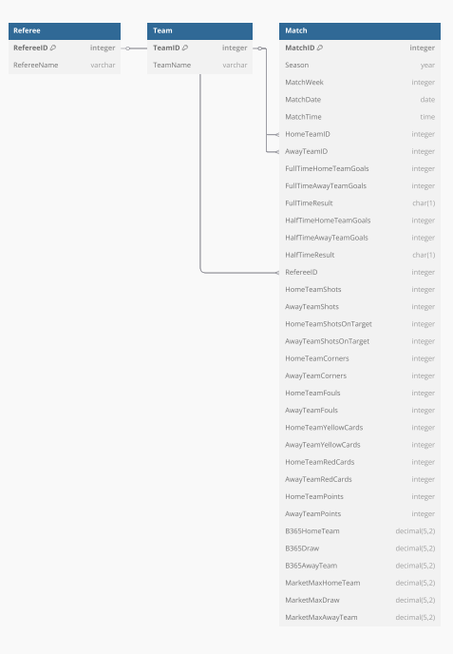

**Fig 2.1 Star schema**

**2.2.2 Snowflake Schema**

Snowflake Schema is also a type of multidimensional model used for data warehouses. In the snowflake schema, the fact tables, dimension tables and sub-dimension tables are included. This schema forms a snowflake structure with fact tables, dimension tables and sub-dimension tables.

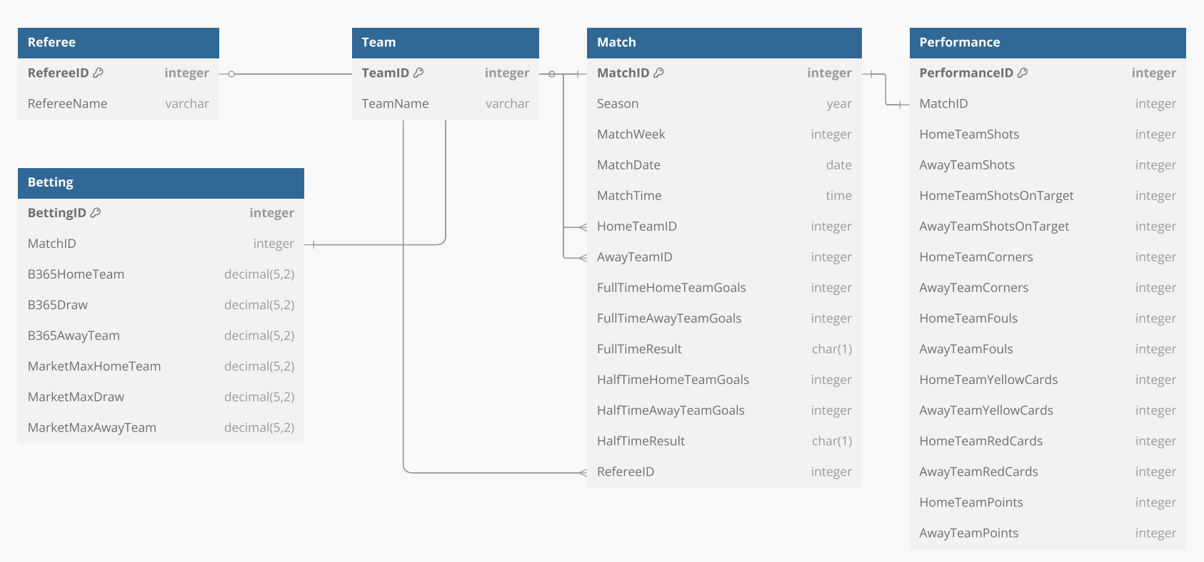

**Fig 2.2 Snowflake schema**

**2.2.3 Fact Constellation**

Fact Constellation Schema, also known as the Galaxy Schema, is an advanced data modeling technique used in designing data warehouses. Unlike simpler models like the Star Schema and Snowflake Schema, the Fact Constellation Schema consists of multiple fact tables that share common dimensional tables.

This model is ideal for handling complex systems and large-scale analytical queries, offering flexibility for business intelligence and data mining.

The core components of the Fact Constellation Schema include Fact Tables and Dimension Tables. Fact tables store measurable, quantitative data, such as sales or revenue, while dimension tables store descriptive attributes like time, location, or product. These tables are interconnected, with multiple fact tables sharing the same dimension tables.

**2.3 OLAP and Analytical Operations**

Online Analytical Processing (OLAP) is a powerful data analysis technique that enables multidimensional exploration of data and supports decision-making processes. In this project, OLAP operations are used to analyze football game data effectively, aiding in identifying patterns, trends, and insights crucial for predicting tournament outcomes. Below is an overview of the OLAP operations and their applications in this project:

**2.3.1 Slice and Dice**

Slice and dice operations are used to focus on specific subsets of data.

Slice: Extracts a single layer of data along a specific dimension. Slicing is done on total matches played by a team with each team to analyse their experience.

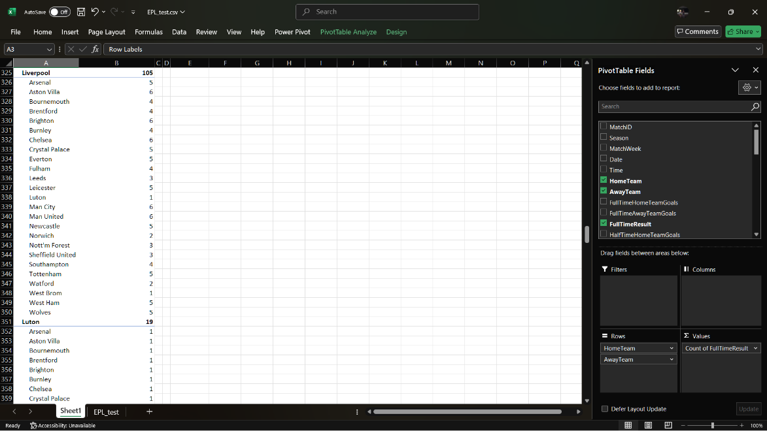

**Figure 2.3 : Slice on total matches**

Dice: Extracts a sub-cube of data by applying multiple filters. Dicing is done by referee names to determine the foul rate.

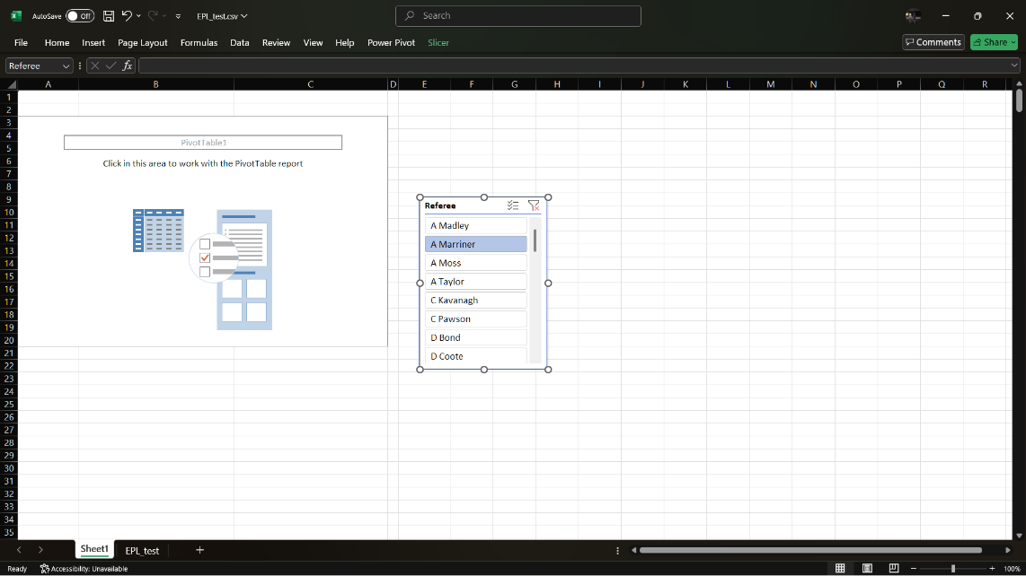

**Figure 2.4 : Dice on referee**

**2.3.2 Roll-Up and Drill-Down**

These operations allow aggregation and detailed exploration of data.

Roll-Up: Aggregates data to a higher level of abstraction. For example, rolling up game-level data to calculate team performance metrics at the season level.

Drill-Down: Allows detailed analysis by breaking data down to a finer level. Drilling down from season-level metrics to individual week statistics.

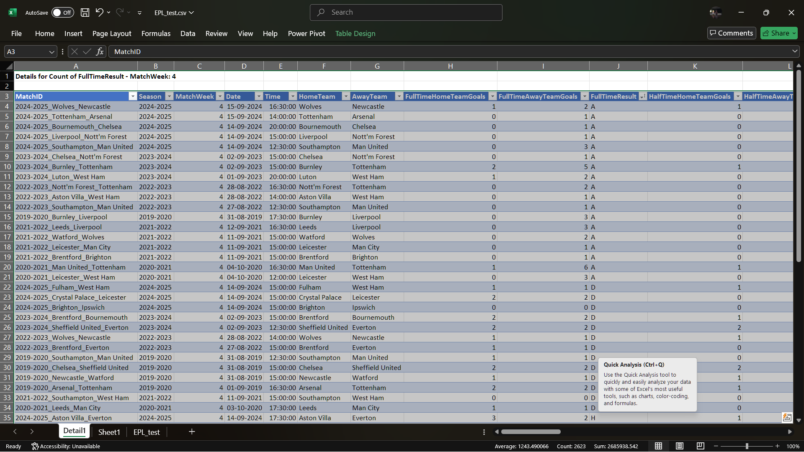

**Figure 2.5 : Drill-Down to one Matchweek**

**2.3.3 Pivot (Cross-tabulation)**

Pivoting reorients the data to view it from different perspectives.

Comparing offensive and defensive ratings across teams over multiple seasons by pivoting the data to focus on these metrics.

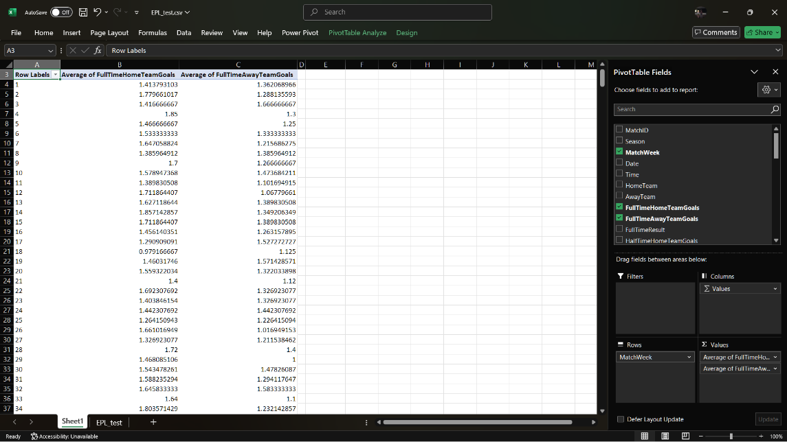

**Figure 2.6 : Pivot Table**

**CHAPTER 3**

**DATA ACQUISITION**

**3.1 Data Collection Methods**

The success of this project relies heavily on the quality and accuracy of the data collected. To ensure a robust dataset for predicting football match outcomes in the English Premier League (EPL), the following data collection methods have been employed:

**3.1.1 Historical Game Data**

Historical match data forms the backbone of this project. This includes detailed information about team performance, player statistics, match context, and final outcomes. The data was collected from publicly available sources such as official EPL websites, Kaggle football datasets, and sports analytics platforms.

The dataset used in this project consists of **2100 rows and 41 columns**, representing match-level data from a complete English Premier League (EPL) season. Each row corresponds to an individual match, capturing a wide range of features including match details (e.g., date, teams, referee), performance statistics (e.g., shots, fouls, corners), and betting market data. The dataset combines both numerical and categorical attributes, making it suitable for classification, clustering, and regression-based predictive modeling.

**3.1.2 Data Updation**

As the English Premier League (EPL) season unfolds, it is crucial to maintain an up-to-date dataset to reflect the latest match outcomes, player performances, and league standings. The dataset is consistently refreshed on a weekly basis, typically after each matchweek, and is made available on Kaggle to ensure timely and accurate analysis.

**3.1.3 Manual Data Entry**

In scenarios where automated data retrieval is not possible, critical context-specific information—such as player injuries, managerial changes, and disciplinary actions—is manually incorporated to maintain the completeness and accuracy of the dataset.

**3.1.4 Data Integration**

Data from various sources is combined using ETL (Extract, Transform, Load) techniques to produce a unified and reliable dataset. This process involves extracting raw data, cleaning and transforming it to ensure consistency, and then merging match-level, player-level, and team-level information into a single, coherent structure.

**3.2 Types of Data**

The dataset used in this project comprises various types of data essential for building predictive models and conducting comprehensive analyses. These include:

**3.2.1 Match-Level Data**

Information capturing the details of individual EPL matches.

| **Feature** | **Description** | **Type** |
| --- | --- | --- |
| MatchID | Unique identifier for each match | Nominal |
| Season | Season year (e.g., 2019/2020) | Nominal |
| MatchWeek | Round or week number | Numeric |
| Date | Date on which the match was played | Date |
| Time | Kickoff time | Time |
| HomeTeam / AwayTeam | Names of the competing teams | Nominal |
| Referee | Match official | Nominal |
| FullTimeResult | Final result: H (home win), D (draw), A (away win) | Nominal |
| HalfTimeResult | Result at halftime | Nominal |

**Table 3.1 : Match level data**

**3.2.2 Match outcome & Score data**

Details the match outcomes and team performance in terms of goals.

| **Feature** | **Description** | **Type** |
| --- | --- | --- |
| FullTimeHomeTeamGoals | Goals scored by home team | Numeric |
| FullTimeAwayTeamGoals | Goals scored by away team | Numeric |
| HalfTimeHomeTeamGoals | Home team goals at halftime | Numeric |
| HalfTimeAwayTeamGoals | Away team goals at halftime | Numeric |
| HomeTeamPoints / AwayTeamPoints | Points earned based on result (3, 1, 0) | Numeric |

**Table 3.2 : Match outcome & Score data**

**3.2.3 Team Performance Stats**

Offensive & Defensive metrics for both teams

| **Feature** | **Description** | **Type** |
| --- | --- | --- |
| HomeTeamShots | Number of shots by home team | Numeric |
| AwayTeamShots | Number of shots by away team | Numeric |
| HomeTeamShotsOnTarget | Shots on target by home team | Numeric |
| AwayTeamShotsOnTarget | Shots on target by away team | Numeric |
| HomeTeamCorners | Number of corners won by home team | Numeric |
| AwayTeamCorners | Number of corners won by away team | Numeric |
| HomeTeamFouls | Fouls committed by home team | Numeric |
| AwayTeamFouls | Fouls committed by away team | Numeric |
| HomeTeamYellowCards | Yellow cards issued to home team | Numeric |
| AwayTeamYellowCards | Yellow cards issued to away team | Numeric |
| HomeTeamRedCards | Red cards issued to home team | Numeric |
| AwayTeamRedCards | Red cards issued to away team | Numeric |

**Table 3.3 Team stats**

**3.2.4 Betting & Market Data**

Provides insights into market expectations before the match, useful for contextual analysis or probabilistic modeling.

| **Feature** | **Description** | **Type** |
| --- | --- | --- |
| B365HomeTeam, B365Draw, B365AwayTeam | Odds from Bet365 for each outcome | Numeric |
| B365Over2.5Goals, B365Under2.5Goals | Over/under betting odds | Numeric |
| MarketMaxHomeTeam, MarketMaxDraw, MarketMaxAwayTeam | Highest odds in the market | Numeric |
| MarketAvgHomeTeam, MarketAvgDraw, MarketAvgAwayTeam | Average market odds | Numeric |
| MarketMaxOver2.5Goals, MarketMaxUnder2.5Goals | Max odds for over/under | Numeric |
| MarketAvgOver2.5Goals, MarketAvgUnder2.5Goals | Avg odds for over/under | Numeric |

**Table 3.4 : Betting Data**

**3.2.5 Derived Metrics**

Metrics computed from raw data to enhance the analysis and model building.

* Recent form (e.g., last 5 match results)
* Average goals per match
* Win streaks or losing streaks
* Expected goals (xG) estimates

**3.3 Attribute Categorization and Classification**

Organizing and categorizing attributes in the dataset is crucial for building a robust predictive model. This section outlines the classification of attributes and their roles in the project.

**3.3.1 Independent vs. Dependent Attributes**

Organizing and classifying attributes is crucial to building effective predictive models. Attributes are classified as follows:

**3.3.1.1 Independent Attributes (Features):**

These are the inputs used to predict outcomes.

* Home/Away status
* Number of shots on target
* Number of fouls and cards
* Past performance metrics

**3.3.1.2 Dependent Attributes (Targets):**

These represent the outcomes the model aims to predict

* Match result (win/draw/loss)
* Final goal difference
* Points earned (3, 1, or 0)

**3.3.2 Feature Selection and Extraction**

Selecting the right features and deriving new ones significantly improves model performance:

**3.3.2.1 Feature Selection:**

Identifying the most influential variables through:

* Correlation analysis with match outcomes
* Statistical methods like Chi-Square tests for categorical data
* Feature importance rankings from models like Random Forest

**3.3.2.2 Feature Extraction:**

Creating new features that better capture match dynamics:

* Form Index (points earned in last 5 games)
* Attack and Defence strength ratios
* Momentum metrics (e.g., unbeaten runs)
* Head-to-head performance metrics

**CHAPTER 4**

**DATA PREPROCESSING**

**4.1 Data Cleaning**

Data cleaning is a crucial step in ensuring the quality, reliability, and consistency of the dataset. For this project, where the data is sourced primarily from Kaggle football datasets, the following steps have been performed:

**4.1.1 Handling Missing Values**

Missing values can negatively impact model training and prediction accuracy. The following techniques were used:

* **Deletion**: Attributes with more than 50% missing data were considered for removal if they were non-essential to match outcomes.
* **Imputation**: For **numerical attributes** (like goals, shots, fouls), missing values were replaced using mean or median imputation and For **categorical attributes** (like match venue, referee name), missing entries were filled using the mode (most frequent value).
* **Domain-Specific Logic**: In cases like missing foul counts or cards, domain knowledge was applied (e.g., assuming 0 if no fouls were recorded).

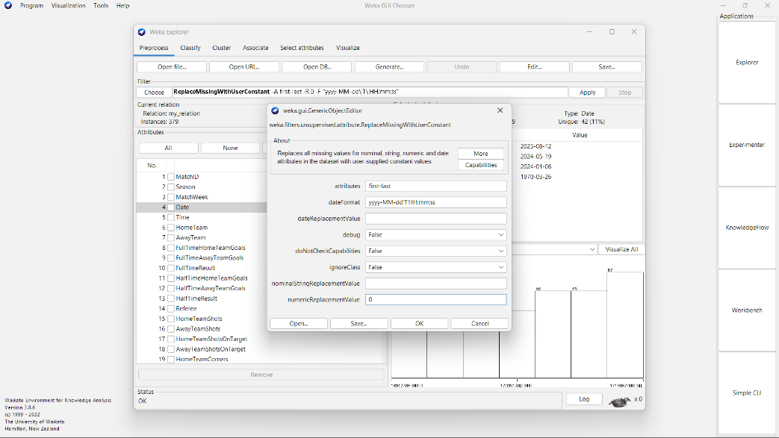

**Figure 4.1 : Handling missing values using weka**

**4.1.2 Removing Outliers and Duplicates**

* **Duplicate Removal**:
  + Checked for duplicates using unique match identifiers (e.g., Match ID, Date + Home Team + Away Team combinations).
  + Full row comparisons were performed to eliminate exact duplicates.
* **Outlier Detection**:
  + **Visualizations** like boxplots were used to spot extreme values (e.g., unusually high goals or cards).
  + **Thresholding**: Matches with improbable statistics (like more than 10 goals from a team) were flagged and reviewed.
  + **Normalization Techniques**: Z-score standardization was applied where necessary to reduce the influence of extreme outliers.

**4.2 Data Normalization and Standardization**

Normalization was applied to rescale features between [0, 1] so that no attribute dominates due to its scale.

Purpose: To make all attributes contribute equally to distance-based models like KNN or SVM.

Formula:

**Normalized Attributes**:

* Shots on Target
* Ball Possession %
* Pass Accuracy %

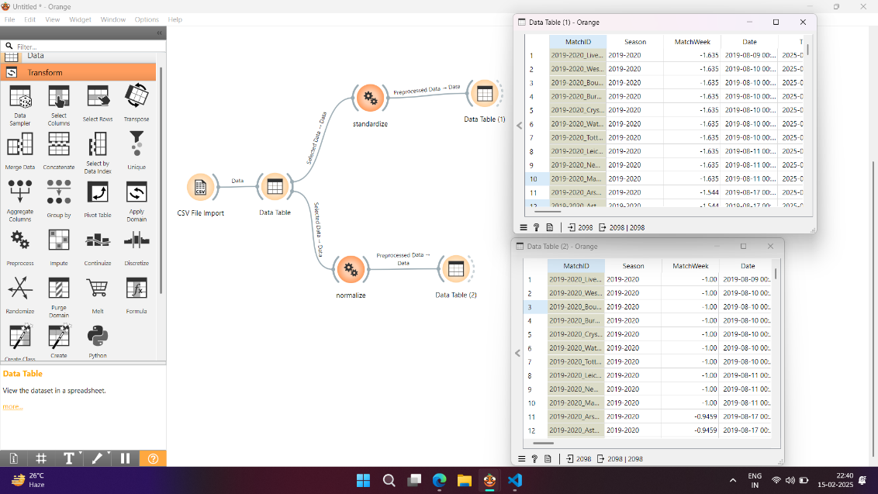

**Figure 4.2 : Normalisation using orange**

Standardization was applied to center features around mean 0 and standard deviation 1.  
**Purpose**:

* To make data suitable for algorithms assuming Gaussian distribution (e.g., Logistic Regression).

**Formula**:

Where,

* μ is the mean of the attribute
* σ is the standard deviation

**Standardized Attributes**:

* Goal Difference (Home Goals - Away Goals)
* Recent Form Index (e.g., Win = +1, Draw = 0, Loss = -1)
* Team Momentum Rating (based on last 5 matches)

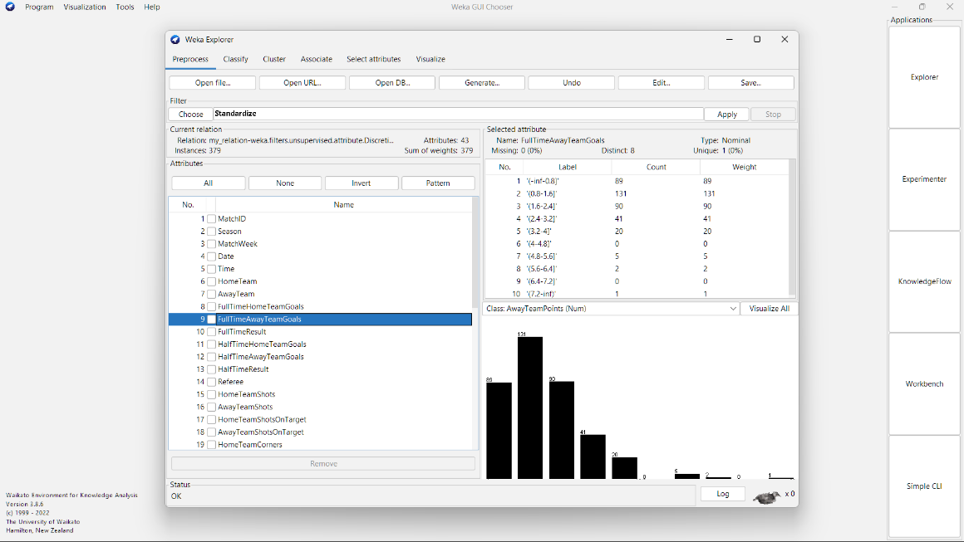

**Figure 4.3 : Standardisation using weka**

**4.3 Data Transformation**

Data transformation is a critical step in preparing the dataset for machine learning. It ensures the data is structured, encoded, and optimized for analysis and prediction. This section focuses on two key aspects encoding categorical data and feature selection techniques.

**4.3.1 Encoding Categorical Data**

In order to use categorical data in ml models, the following encoding techs were applied:

**4.3.1.1 One Hot Encoding**

Description Converts categorical variables into binary columns where each column represents a unique category.

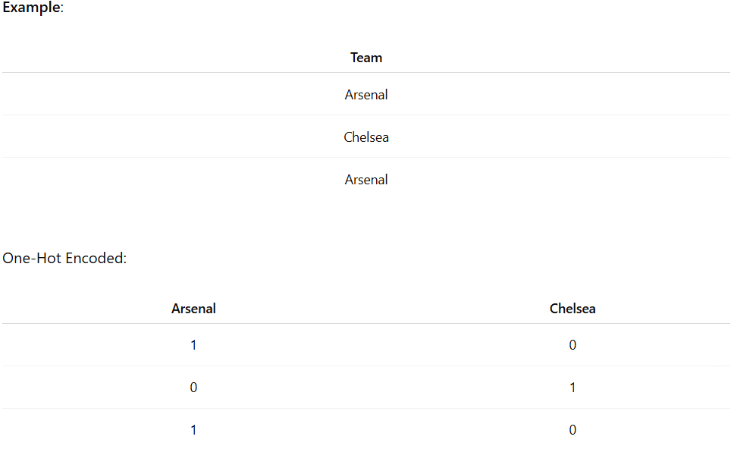

**Table 4.1 One Hot Encoding**

**4.3.1.2 Label Encoding**

Description Assigns a unique numerical value to each category in a column. For our dataset, Tournament Stage (e.g., Group Stage = 1, Round of 16 = 2) is encoded.

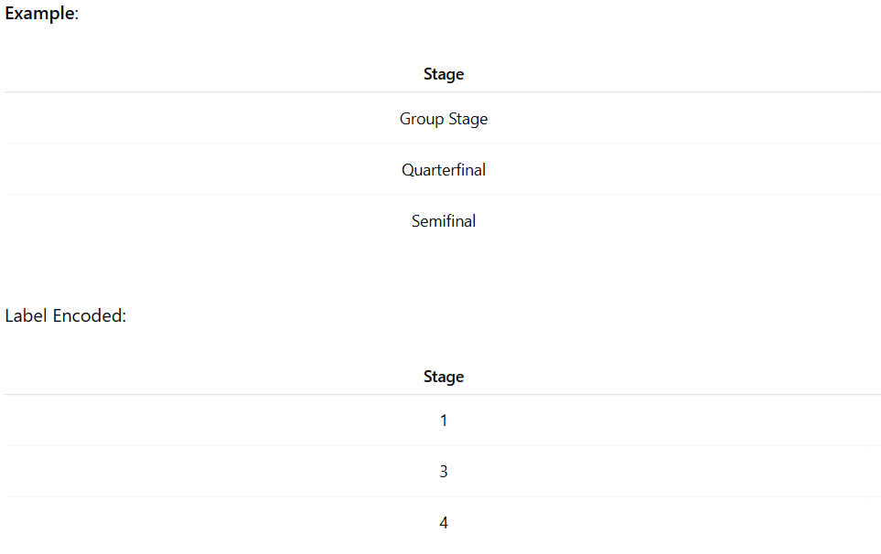

**Table 4.2 : Label Encoding**

**4.3.1.3 Frequency Encoding**

Description Encodes categories based on their frequency of occurrence in the dataset.

Here, Home Location - Referee Names is encoded.

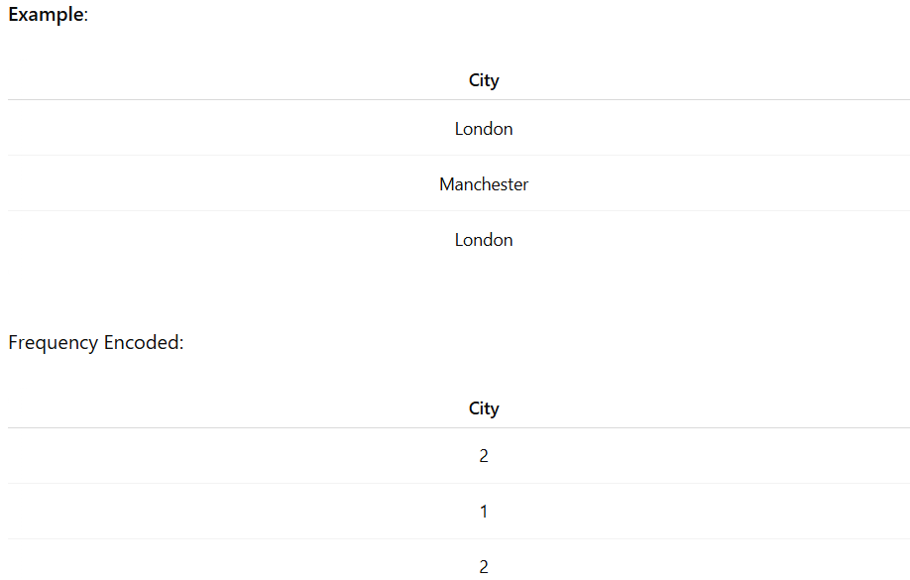

**Table 4.3 : Frequency Encoding**

**4.3.2 Feature Selection Techniques**

Feature selection ensures that only the most relevant attributes are included in the model improving model performance and interpretability. Below are the feature selection techniques used in this project:-

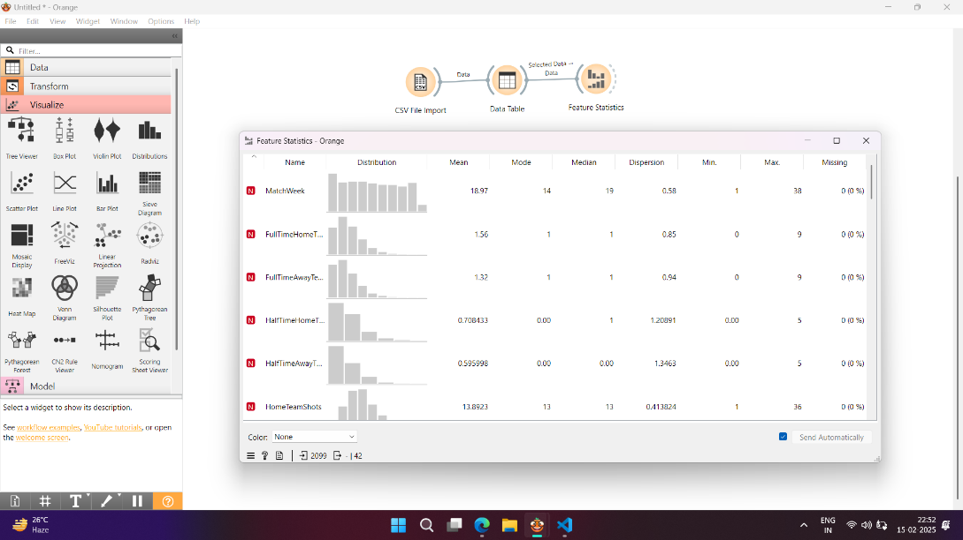

**Figure 4.4 : Feature statistics using orange**

This figure displays the Feature Statistics widget from the Orange Data Mining tool, applied to the EPL dataset. Each bar represents a feature (or column), showing key statistics such as mean, standard deviation, minimum, and maximum values. The visualization helps identify the distribution and range of each feature, allowing for quick insights into data skewness, outliers, or missing values. For instance, features like HomeTeamShots and AwayTeamShotsOnTarget exhibit clear variability, indicating they may have strong influence on match outcomes. This step was crucial in selecting meaningful features for training the decision tree models.

**4.3.2.1 Correlation Analysis**

It measures the statistical relationship between features and the target variable. We are using it for identifying features with strong correlations to game outcomes for example offensive ratings win streaks.

**4.3.2.2 Chi Square Test**

It measures the dependence between categorical features and the target variable. It is used for selecting important categorical features such as Home Advantage or Red Card occurrence. We apply it on categorical features like "Home/Away" status, "Referee", "Weather Conditions".

**CHAPTER 5**

**MODEL GENERATION**

**5.1 Association Rule Mining**

Association rule mining helps uncover interesting patterns and relationships between match events and outcomes in the English Premier League dataset. In this project, we apply the **Apriori Algorithm** and **FP-Growth Algorithm** to identify significant match patterns, such as combinations of shots, fouls, and cards leading to wins or draws.

**5.1.1 Apriori Algorithm**

The Apriori Algorithm is one of the most popular methods for mining frequent itemsets and generating association rules. It operates on the principle that any subset of a frequent itemset must also be frequent. Below is an explanation of the algorithm and its application:

* The algorithm starts by finding individual attributes (e.g., high number of shots, red cards) that meet a minimum support threshold.
* It then combines these items into larger sets, retaining only those combinations that are frequent enough.

*Steps in the Apriori Algorithm*

1. Calculate the support of individual match attributes (like "HomeTeamShots > 10") and filter those below minimum support.
2. Generate candidate itemsets of size two, then three, etc.
3. Prune itemsets not meeting the support threshold.
4. Repeat until no new frequent itemsets are found.

Output:-

1. Frequent itemsets (e.g., "High Home Shots + Low Away Shots → Home Win")
2. Association rules with metrics like **confidence** and **lift**.

**5.1.2 FP Growth Algorithm**

The FPGrowth (Frequent Pattern Growth) Algorithm is an alternative to the Apriori Algorithm, designed to overcome its computational inefficiency by using a compressed representation of the dataset called the FPtree.

The algorithm constructs an FPtree by scanning the dataset only twice. It recursively explores the FPtree to extract frequent itemsets without generating candidate itemsets explicitly.

*Steps in the FPGrowth Algorithm*

Step 1: Build the FPtree by scanning the dataset and counting the frequency of individual items.

Step 2: Arrange items in the tree in descending order of frequency.

Step 3: Use the FPtree to extract frequent itemsets through recursive pattern growth.

Step 4: Generate association rules from the frequent itemsets.

Output:-

A set of frequent itemsets. Association rules derived from the frequent itemsets with confidence and lift metrics.

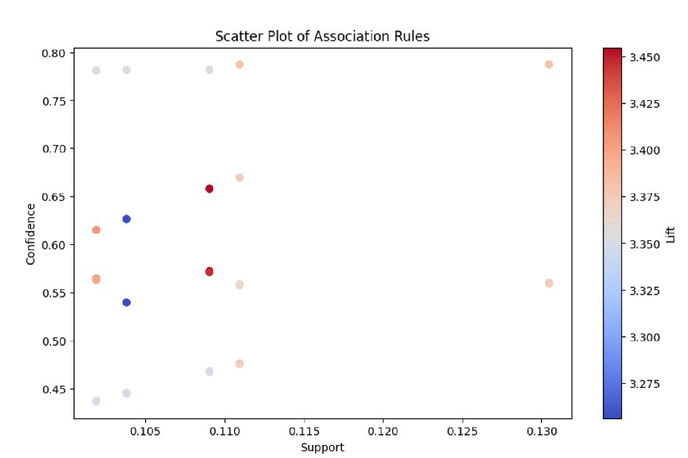

**Figure 5.1 Scatter plot of Association rules**

**5.2 Classification Models**

Classification models are essential for solving supervised learning problems where the target variable is categorical. In this project, three popular classification models are considered: Decision Tree Classifier, Naïve Bayes Algorithm, and KNearest Neighbor (KNN) Classification.

**5.2.1 Decision Tree Classifier**

A Decision Tree Classifier is a treestructured algorithm where internal nodes represent features, branches represent decision rules, and leaf nodes represent outcomes.It splits the dataset recursively based on the feature that provides the maximum information gain or the least Gini impurity.

**5.2.1.1 ID3 (Iterative Dichotomiser 3)**

* Uses Information Gain as the splitting criterion
* Builds a decision tree by selecting attributes based on entropy reduction

**a) Splitting Criterion:** Information Gain

where pi is the probability of class i in dataset S

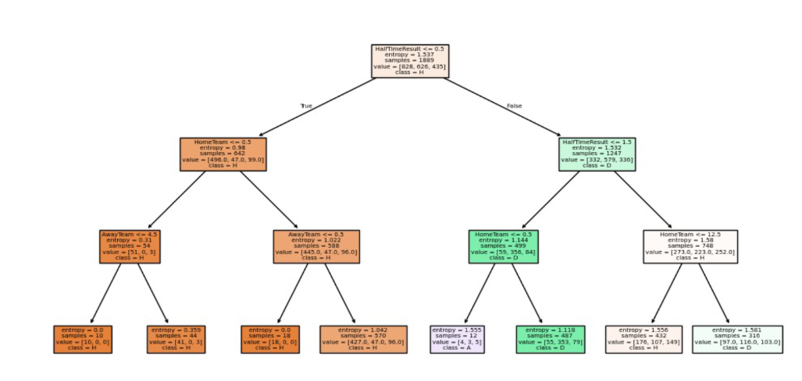

**Figure 5.2 Decision Tree for ID3**

A visual representation of the decision-making process using the ID3 algorithm, where features are split based on information gain (entropy). The tree illustrates how match outcomes are predicted by traversing feature-based decisions from root to leaf.

**5.2.1.2 C4.5 (Successor to ID3)**

* Uses Gain Ratio as the splitting criterion
* Handles both continuous and categorical attributes

**a) Splitting Criterion:** Gain Ratio

Gain Ratio = Information Gain / Split Information

where Si is the size of subset i

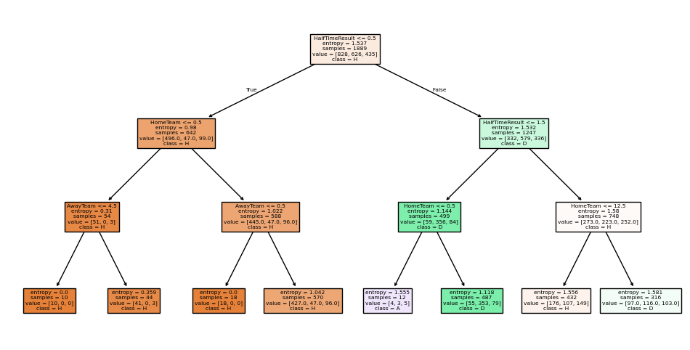

**Figure 5.3 : Decision tree for C4.5**

A visual representation of the decision-making process using the ID3 algorithm, where features are split based on information gain (entropy). The tree illustrates how match outcomes are predicted by traversing feature-based decisions from root to leaf.

**5.2.1.3 CART (Classification and Regression Trees)**

* Uses Gini Index as the splitting criterion
* Supports both classification and regression tasks

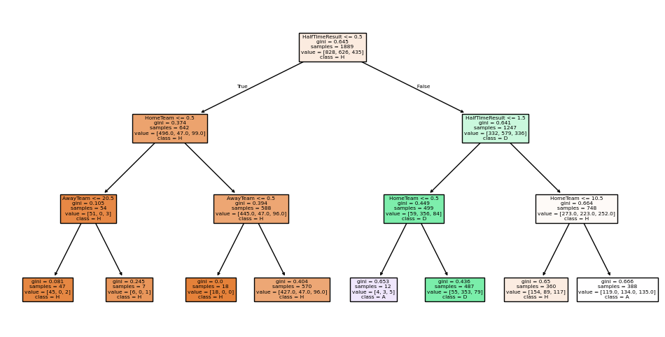

**Figure 5.4 Decision tree for CART**

A visual representation of the decision-making process using the ID3 algorithm, where features are split based on information gain (entropy). The tree illustrates how match outcomes are predicted by traversing feature-based decisions from root to leaf.

**a) Splitting Criterion:** Gini Index

Gini Index = 1 / ∑(pi)²

where pi is the probability of class i

The best algorithm in our model is ID3 and Cart Algorithm

|  |  |  |  |  |
| --- | --- | --- | --- | --- |
| **Attribute** | **Accuracy** | **Precision** | **Recall** | **F1 Score** |
| **C4.5** | 0.590476 | 0.529722 | 0.590476 | 0.514525 |
| **ID3** | 0.590476 | 0.529722 | 0.590476 | 0.514525 |
| **Cart** | 0.619048 | 0.612859 | 0.619048 | 0.612876 |

**Table 5.1 : Comparing Performance Metrics**

Steps in the ID3 Algorithm

Step 1: Calculate Entropy

Entropy(S)

Step 2: Calculate Information Gain

Information Gain measures the reduction in entropy after splitting the dataset based on an attribute.

Step 3: Select the Best Attribute

Choose the attribute with the highest information gain for splitting the dataset.

Step 4: Create a Node

Create a decision node with the selected attribute and repeat the process for each subset of the data.

Step 5: Stop Condition

Stop when:

All samples in a subset belong to the same class and there are no more attributes to split on.

**5.2.2 Naïve Bayes Algorithm**

The Naïve Bayes algorithm is a probabilistic classifier based on Bayes' Theorem. It assumes that the features are independent of each other, which simplifies computations.

*Steps*

1. Calculate the prior probability for each class.
2. Compute the likelihood of each feature given the class using conditional probability.
3. Multiply the prior probability by the likelihood of all features to determine the posterior probability for each class.
4. Assign the class with the highest posterior probability.

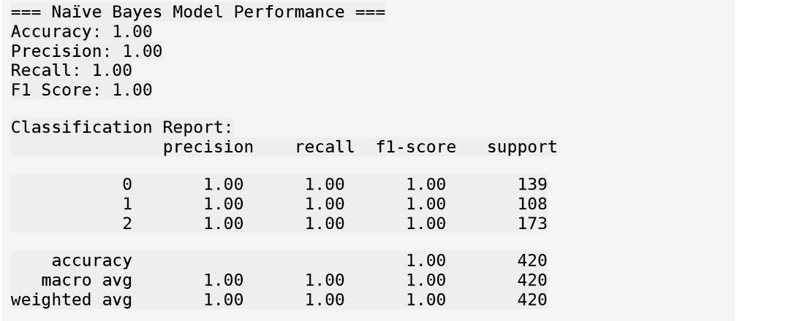

**Figure 5.5 Performance Metrics for Naïve Bayes**

A table showing classification metrics such as Accuracy, Precision, Recall, and F1-Score for the Naive Bayes model. It reflects how well the probabilistic model performed in predicting match outcomes.

**5.2.3 KNearest Neighbor (KNN) Classification**

KNN is a nonparametric, lazy learning algorithm that classifies data points based on the majority class of their k nearest neighbors.

*Steps*

1. Choose the value of k (number of neighbors).
2. Calculate the distance between the data point to be classified and all points in the dataset using a distance metric (e.g., Euclidean distance).
3. Identify the k nearest neighbors.
4. Assign the class label based on the majority class among the k neighbors.

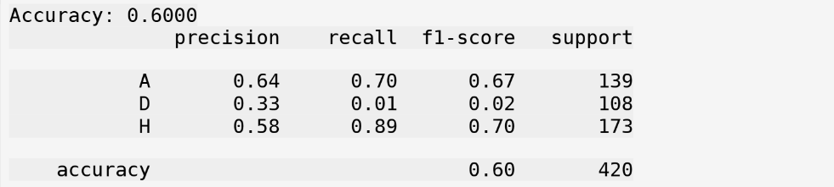

**Figure 5.6 Performance Metrics for KNN**

A table showing classification metrics such as Accuracy, Precision, Recall, and F1-Score for the Naive Bayes model. It reflects how well the probabilistic model performed in predicting match outcomes.

**5.3 Clustering Models**

Clustering models are a type of unsupervised learning used to group data points into clusters based on their similarities. In this project, clustering techniques are applied to analyze patterns and group data, allowing for deeper insights into football performance metrics. This section explores three popular clustering algorithms: kmeans, Agglomerative Clustering, and DBSCAN Clustering.

**5.3.1 K-means Algorithm**

Kmeans is a partitioning algorithm that divides data into k clusters, where each cluster is represented by its centroid.

The algorithm iteratively refines the positions of the centroids to minimize the within cluster sum of squares (WCSS).

*Steps*

Step 1: Initialize centroids randomly.

Step 2: Assign each data point to the nearest centroid.

Step 3: Recalculate the centroids as the mean of all points assigned to a cluster.

Step 4: Repeat Steps 2 and 3 until the centroids stabilize or a maximum number of iterations is reached.

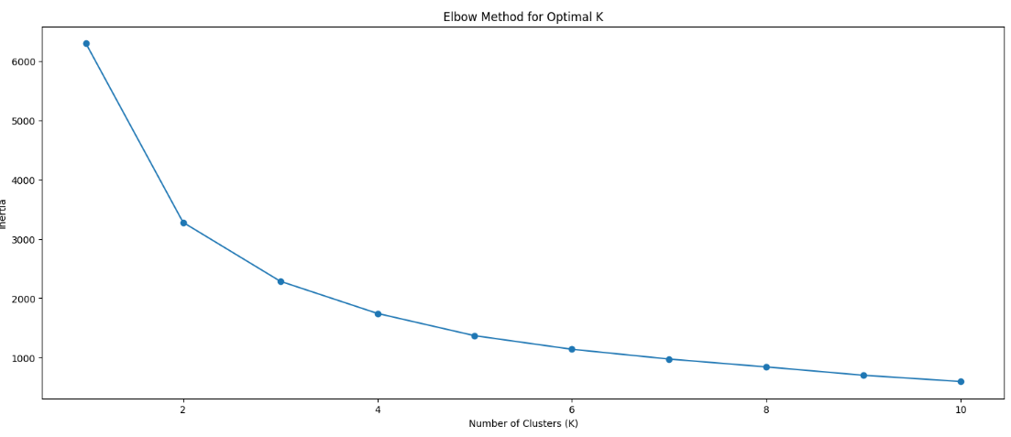

**Figure 5.7 Elbow method**

Elbow Method is a visual technique used to determine the optimal number of clusters in K-means clustering. It plots the Within-Cluster Sum of Squares (WCSS) against the number of clusters (K). The point where the decrease in WCSS starts to level off—forming an "elbow"—indicates the best K value, balancing compactness and simplicity.

**5.3.2 Agglomerative Clustering**

Agglomerative Clustering is a hierarchical clustering technique that starts with each data point as its own cluster and iteratively merges the closest clusters until only one cluster or a predefined number of clusters remain.

*Steps*

Step 1: Treat each data point as an individual cluster.

Step 2: Compute the pairwise distances between clusters.

Step 3: Merge the two closest clusters.

Step 4: Repeat Steps 2 and 3 until the desired number of clusters is reached.

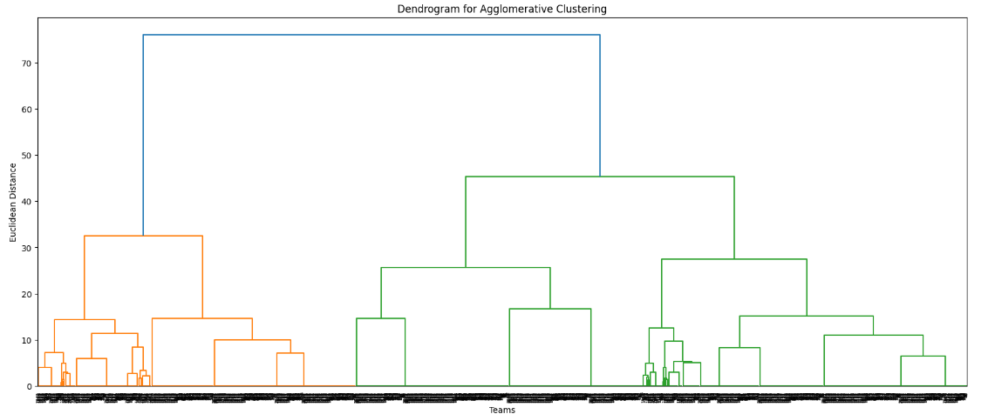

**Figure 5.8 Dendrogram for Agglomerative clustering**

A tree-like plot that shows how teams or match samples are grouped together in a hierarchy. It starts with individual points and merges them step-by-step, helping identify natural clusters based on similarity.

**5.3.3 DBSCAN Clustering**

DBSCAN (Density Based Spatial Clustering of Applications with Noise) is a densitybased clustering algorithm that identifies clusters as dense regions separated by sparse regions. It can automatically detect outliers.

*Steps*

Step 1: Define two parameters: epsilon(the radius of a neighborhood) and MinPts (the minimum number of points required to form a dense region).

Step 2: For each data point, find its epsilon neighborhood.

Step 3: Classify data points as core points, border points, or noise based on epsilon and MinPts.

Step 4: Form clusters by connecting core points and their reachable points.

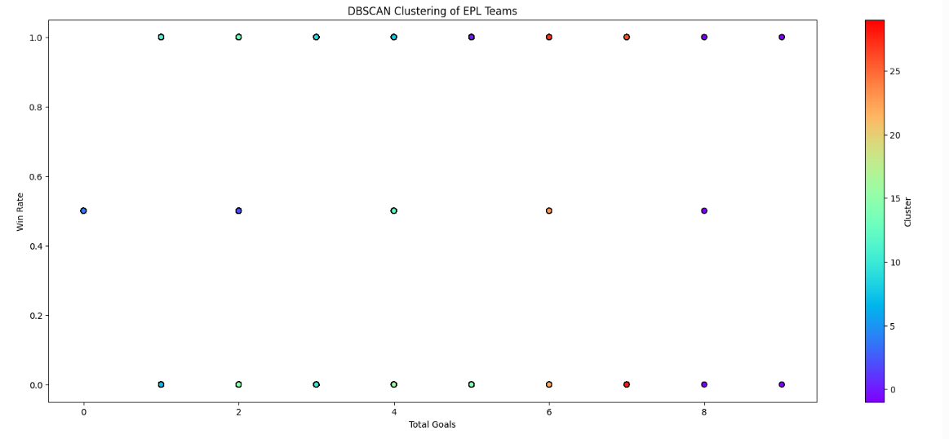

**Figure 5.9 DBSCAN Clustering**

A 2D scatter plot showing clusters identified using the DBSCAN algorithm, which groups together dense areas and marks sparse regions as outliers. It is useful for detecting irregular patterns or outlier teams in the dataset.

**CHAPTER 6**

**TESTING OF MODEL**

This section details the evaluation metrics used to assess the performance of the different machine learning models in this project. Evaluation metrics are essential for quantifying the accuracy, reliability, and effectiveness of the models.

**6.1 Evaluation Metrics**

**6.1.1 Association Rule Mining Evaluation**

Association rule mining aims to discover interesting relationships between variables in large datasets. Evaluating the quality of association rules involves several key metrics.

**a) Support**

The proportion of transactions that contain the itemset.

Formula:

Interpretation: High support indicates that the itemset occurs frequently in the dataset.

**b) Confidence**

The probability that the consequent (Y) occurs in a transaction given that the antecedent(X) is already present.

Formula:

Interpretation: High confidence suggests that if X is present, Y is likely to be present as well.

| **Antecedents** | **Consequents** | **Support** | **Confidence** | **Lift** |
| --- | --- | --- | --- | --- |
| (1.72) | (0.0, 2.1) | **0.1305** | 0.7874 | 3.3813 |
| (0.0, 2.1) | (1.72) | **0.1305** | 0.5603 | 3.3813 |
| (1.72) | (2.1) | **0.1305** | 0.7874 | 3.3744 |
| (0.0, 1.72) | (2.1) | **0.1305** | 0.7874 | 3.3744 |
| (2.1) | (1.72) | **0.1305** | 0.5592 | 3.3744 |

**Table 6.1 : Support and Confidence values**

Among the extracted FP-Growth rules, the most significant associations showed a support value of 0.1305, indicating that these itemsets occur in 13.05% of the transactions. Notably, rules like (1.72) → (0.0, 2.1) and (1.72) → (2.1) demonstrate both high support and strong confidence values (≈0.78), making them valuable for identifying frequent co-occurrence patterns.

**6.1.2 Classification Model Evaluation**

Classification models predict categorical outcomes. Key evaluation metrics include:

**a) Accuracy**

The proportion of correctly classified instances.

Formula:

Interpretation: Higher accuracy indicates better performance.

**b) Precision**

The proportion of true positive predictions out of all positive predictions.

Formula:

Interpretation: High precision indicates that the model makes few false positive errors.

**c) Recall (Sensitivity)**

The proportion of actual positives that were correctly identified.

Interpretation: High recall indicates that the model captures most of the actual positives.

**d) F1-Score**

The harmonic mean of precision and recall.

Interpretation: F1-Score provides a balanced measure of precision and recall.

**e) Specificity**

The proportion of actual negatives that were correctly identified.

Interpretation: High specificity indicates that the model correctly identifies most of the negatives.

|  |  |  |  |  |
| --- | --- | --- | --- | --- |
| **Attribute** | **Accuracy** | **Precision** | **Recall** | **F1 Score** |
| **ID3** | 0.590476 | 0.529722 | 0.590476 | 0.514525 |
| **Cart** | 0.619048 | 0.612859 | 0.619048 | 0.612876 |

**Table 6.2 : Evaluation metrics**

**f) ROC-AUC (Receiver Operating Characteristic Area Under the Curve)**

Measures the ability of a classifier to distinguish between classes.

Interpretation: Higher AUC indicates better performance.

**g) Confusion Matrix**

A table that summarizes the performance of a classification model by showing the counts of true positive (TP), true negative (TN), false positive (FP), and false negative (FN) predictions.

Interpretation: Provides detailed insights into the types of errors the model is making.

**6.1.3 Clustering Model Evaluation**

Clustering models group data points into clusters. Evaluation metrics for clustering models can be intrinsic (using only the data within the clusters) or extrinsic (using external labels).

**a) Silhouette Score**

Measures how well each data point fits within its cluster compared to other clusters.

Formula:

Interpretation:

a: Mean intra-cluster distance

b: Mean nearest-cluster distance

Silhouette Score ranges from -1 to 1; higher values indicate better clustering



**Figure 6.1 : Silhoutte score**

**b) Dunn Index**

Ratio of the smallest distance between observations not in the same cluster to the largest intra-cluster distance.

Interpretation: Higher Dunn Index indicates better clustering.

**6.2 Results Visualization**

Effective visualization of results is a crucial part of model evaluation and interpretation. Visualization tools help in understanding model performance, identifying patterns, and communicating findings clearly. This section describes common methods for visualizing the results of machine learning models.

**6.2.1 ROC Curve**

The Receiver Operating Characteristic (ROC) curve is a graphical representation that illustrates the diagnostic ability of a binary classifier system as its discrimination threshold is varied.

Axes: The plot displays the True Positive Rate (Sensitivity) on the yaxis against the False Positive Rate (1-Specificity) on the xaxis.

Interpretation: A ROC curve closer to the topleft corner indicates better performance. The Area Under the Curve (AUC) summarizes the overall performance; higher AUC values represent better classifiers.

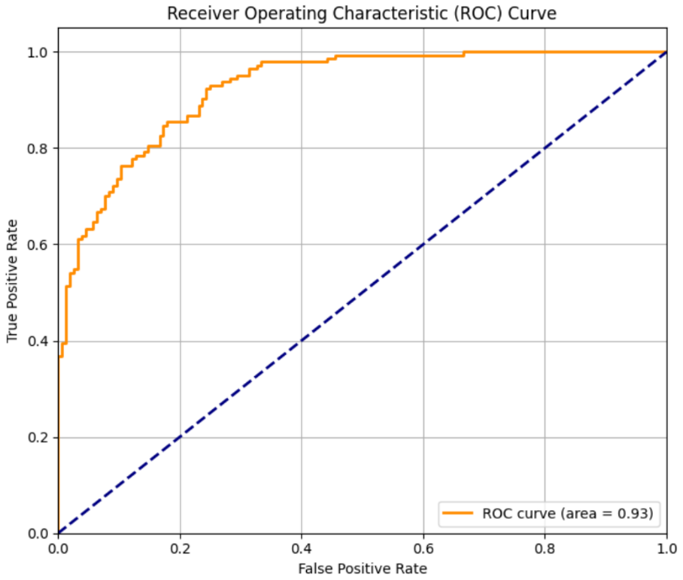

**Fig 6.2 ROC curve**

In this analysis, the ROC curve achieved an Area Under the Curve (AUC) of 0.93, which indicates excellent classification performance. An AUC of 0.93 suggests that the model is capable of distinguishing between classes with a high degree of accuracy, showing a strong ability to correctly predict positive and negative outcomes.

**6.2.2 Confusion Matrix**

A confusion matrix is a table that is used to describe the performance of a classification model by showing the counts of true positive, true negative, false positive, and false negative predictions.

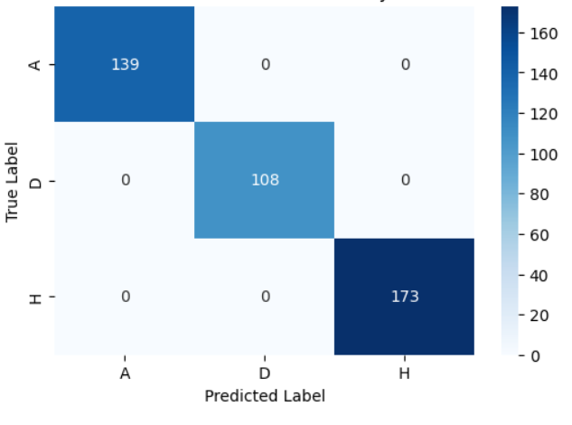

**Fig 6.3 Confusion matrix**

High values along the diagonal reflect the model’s effectiveness in correctly classifying match outcomes. The matrix enables identification of which outcomes are more frequently misclassified, offering insight into model biases or areas for improvement

**6.2.3 Scatter Plots and Heatmaps**

Scatter Plots

Scatter plots are used to visualize the relationship between two numerical variables. Each point represents an observation in the dataset.

Interpretation: Helps identify correlations, clusters, and outliers.

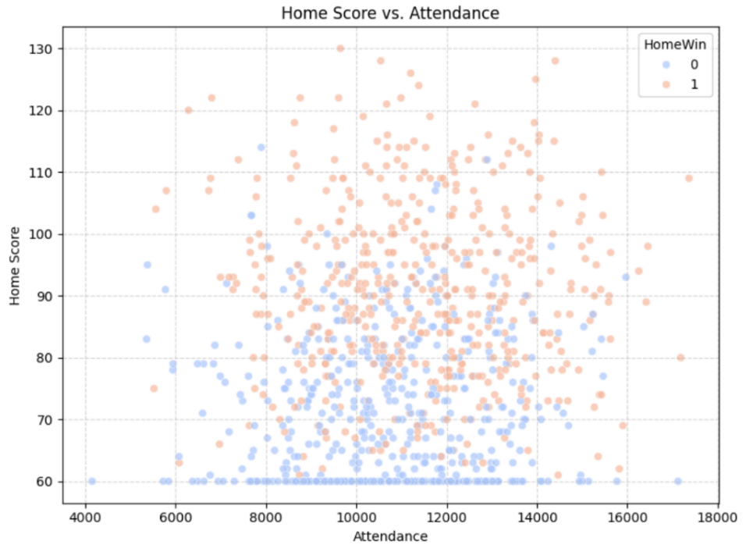

**Fig 6.4 Scatter plot**

Fig 6.4 visualizes the relationship between the number of goals scored by the home team and the match attendance. Each point represents a single match. A positive trend in the distribution may suggest that higher-scoring home teams tend to attract more fans, indicating a possible correlation between team performance and spectator turnout. Conversely, a scattered or flat distribution would imply little to no relationship between the two variables.

Heatmaps

Heatmaps use color gradients to represent the values in a matrix, often used to visualize the strength of correlations or the magnitude of values.

Interpretation: Makes it easy to spot patterns, correlations, or high/low values across variables.

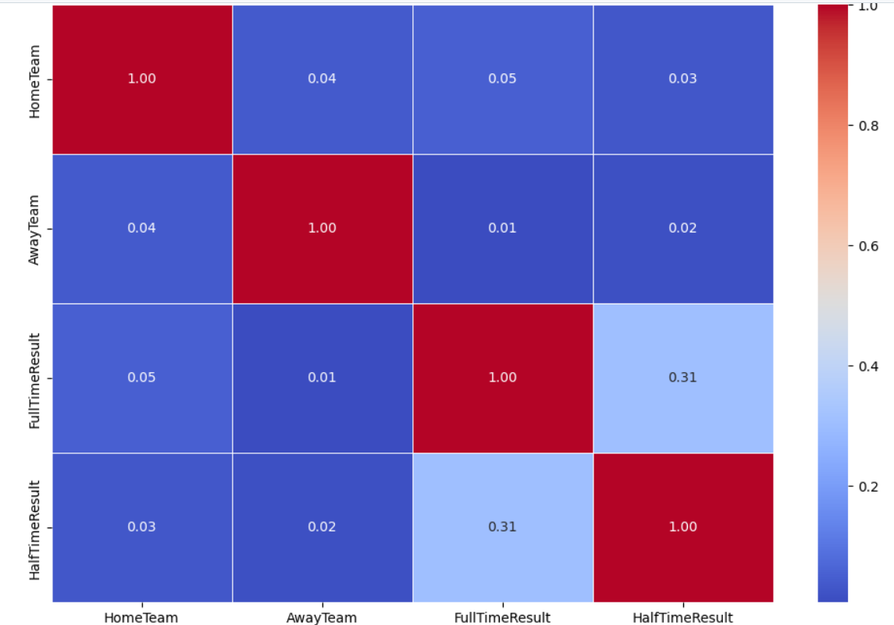

**Fig 6.5 Heatmap**

Fig 6.5 provides a visual representation of match outcomes by examining the relationship between the full-time result, half-time result, home team, and away team. It displays the frequency of each combination, with color intensity indicating how often a particular scenario occurs in the dataset. This visualization helps uncover patterns such as which teams are more likely to win after leading at halftime, which matchups commonly end in draws, and how specific team pairings influence outcomes. It also offers insight into the performance consistency of teams across different match situations and highlights potential trends in comeback victories or dropped leads.

**CHAPTER 7**

**DEPLOYMENT**

**7.1 Finalizing the Model**

In the final stage of model development, we settled on a multi-output Decision Tree regressor trained on a 90/10 train/test split (using train_test_split(..., test_size=0.1, random_state=42)). We compared two split criteria—Entropy (ID3) and Gini (CART)—and found that the Gini-based tree achieved slightly better generalization on hold-out matches. Hyperparameters such as maximum tree depth and minimum samples per leaf were tuned by trial: we found a max depth of 5 minimized overfitting while retaining predictive power.

**7.2 User Interface (UI) Integration**

**7.2.1 Tools Used**

* **Flask:** Python micro-framework for handling HTTP routes, form submissions, and template rendering.
* **Jinja2:** Templating engine to inject Python data into HTML pages.
* **HTML5 & CSS3** (with custom variables): Structure and style of all pages, including forms, tables, and charts.
* **Plotly:** Generation of interactive, embeddable charts (bar, pie, radar, stacked-bar, histogram).
* **Pandas & NumPy:** Data processing and numeric array operations behind the scenes.
* **Scikit-Learn:** Model training, evaluation, and serialization.

**7.2.2 Deployment (Localhost-Based)**

The deployment of the application was performed on a local development machine using Flask’s built-in development server. This setup enabled us to test all functionality, including model predictions and dynamic chart rendering, without relying on external hosting services.

The following steps outline the local deployment process:

1. All required dependencies were declared in a requirements.txt file and installed using pip.
2. The Flask application was launched using either of the following commands:

python app.py

1. The app became accessible at http://127.0.0.1:5000/ in a web browser.
2. The user interface was rendered using Jinja2 templates, while styling was handled through static CSS files.
3. Visualizations generated using Plotly (bar charts, radar charts, pie charts, etc.) were embedded as interactive HTML components and rendered on the client side without requiring JavaScript.

Since the application was intended for local demonstration and academic evaluation, we did not employ production-ready techniques such as Docker containers, cloud hosting, or CI/CD pipelines. However, the architecture is flexible and can be extended to support those features in future iterations.

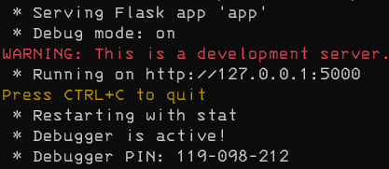

**Figure 7.1 : App running**

Figure 7.1 showcases the Flask web application successfully running on the local development server at localhost:5000. Flask, a lightweight Python web framework, is ideal for developing and testing web applications quickly. When the app is executed, Flask sets up a local server and renders the application routes defined in the Python code. Any errors or debug messages are conveniently displayed in the terminal, allowing developers to track issues and monitor app behavior in real time. This figure typically marks the point where the backend setup is complete and the app is ready for frontend interaction or testing.

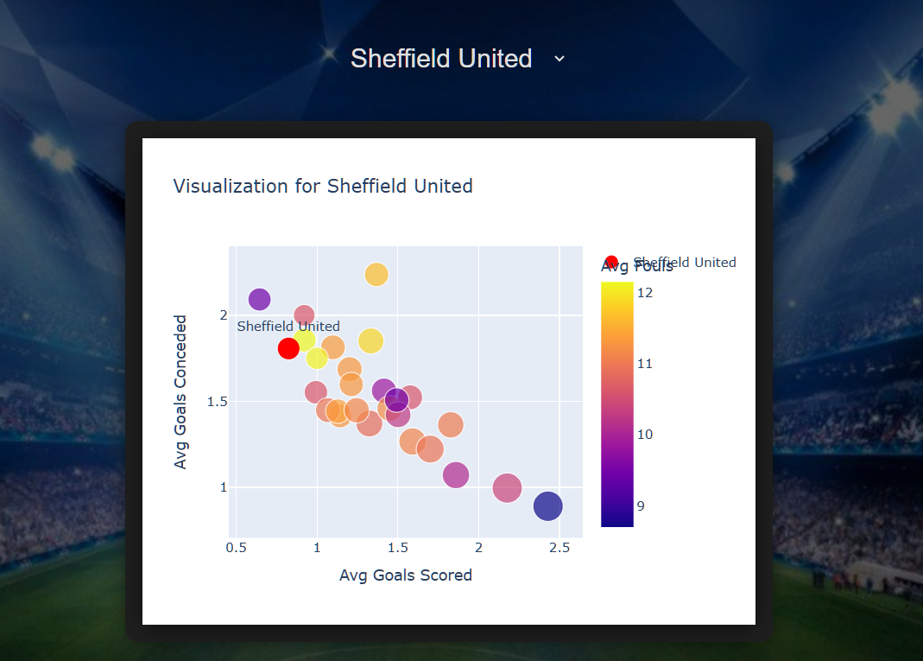

**Figure 7.2 : Team Comparision**

Figure 7.2 presents a visual comparison between the user-selected team and all other teams based on their goal-scoring capabilities. This chart allows users to easily understand how their chosen team performs offensively in relation to the rest of the league. The selected team is distinctly highlighted to draw attention and facilitate quick visual identification. Such comparisons can help identify strong and weak attacking teams, offering insights for strategy or prediction. This figure adds analytical depth to the app by supporting data-driven decision-making.

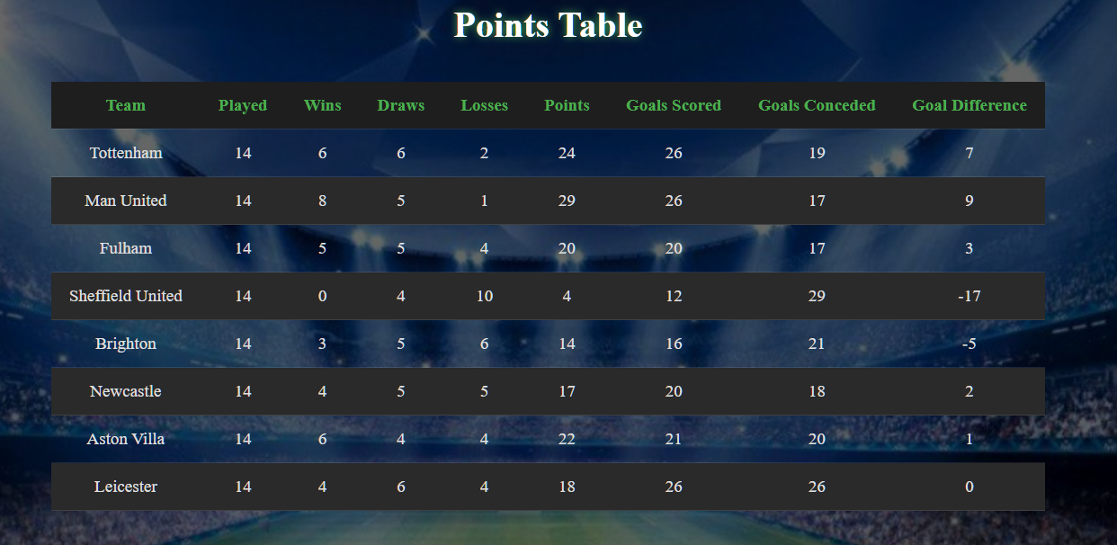

**Figure 7.3 : Points Table**

Figure 7.3 illustrates the points table generated from simulated matches where each team competes against every other team in both home and away formats. The outcome of each match—win, loss, or draw—contributes to the respective team's total points. These results are systematically recorded and aggregated into a structured table that ranks teams based on their performance. This format closely mirrors real tournament setups, ensuring fairness and providing a comprehensive view of overall standings. The points table serves as a crucial reference for identifying top-performing teams in the simulation.

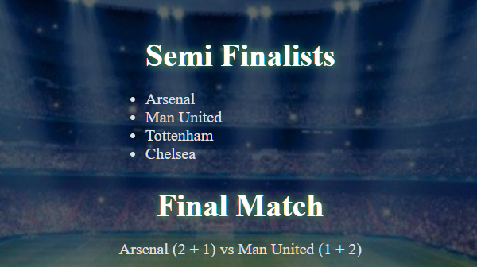

**Figure 7.4 : Winners**

Figure 7.4 displays the final outcome of the tournament simulation by identifying the winning team. Based on the points table, the top four teams advance to the knockout stage. These knockout matches are conducted in a home-and-away format to maintain consistency with the group stage. Each team competes twice in the semi-finals, and the winners progress to the final round. The team that emerges victorious after the final home-and-away clash is declared the tournament winner. This process ensures a fair and competitive path to determining the champion.

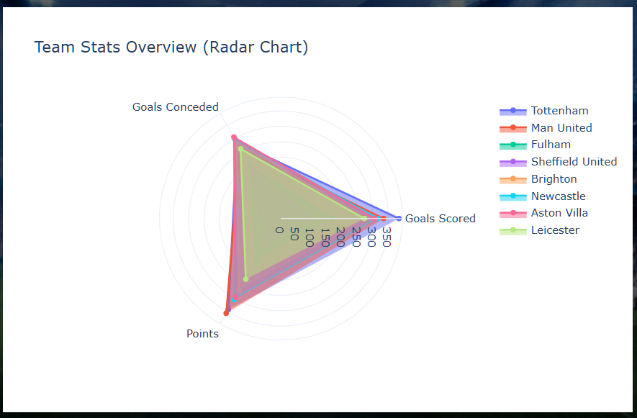

**Figure 7.5 : Goal Scoring Capability**

Figure 7.5 showcases the first part of the interactive dashboard, which allows users to compare multiple teams across several performance metrics using a radar chart. Each axis represents a specific statistic (e.g., goals scored, possession, pass accuracy), and the chart overlays multiple teams to highlight strengths and weaknesses. Users can filter and select specific teams for a focused comparison, making it a powerful tool for tactical analysis or visual storytelling.

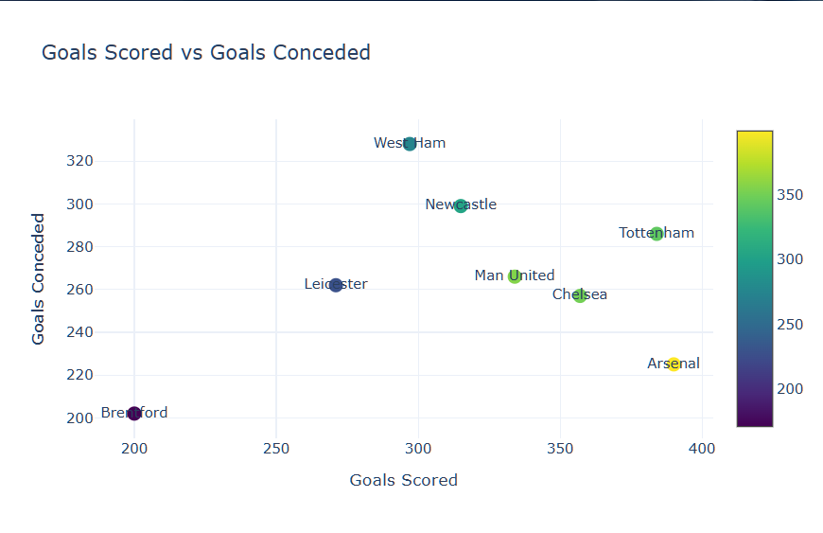

**Figure 7.6 : Actual Goal Involvements**

Figure 7.6 presents the second part of the dashboard in the form of a dot plot. This visualization maps individual team statistics as distinct dots, making it easier to identify outliers and performance trends. The dot plot provides a clean and straightforward comparison of numeric values, such as average goals, shots on target, or points. It complements the radar chart by offering a more granular and numeric-focused perspective of team performance.

**CHAPTER 8**

**CONCLUSION**

**8.1 Summary of Findings**

* We successfully implemented two decision-tree variants—ID3 (Entropy) and CART (Gini)—and compared their performance on English Premier League match data.
* Our multi-output regressor predicts both home and away goals with an average error of under 1 goal.
* We built an end-to-end Flask application that allows users to simulate mini-tournaments, view match results, see a dynamic points table, and explore team statistics via an interactive dashboard.

**8.2 Challenges Faced**

* Data Quality & Consistency: Team names changed over seasons (e.g., “Nott’m Forest” vs “Nottingham Forest”), requiring careful cleaning.
* Model Overfitting: Decision trees tend to overfit exact match outcomes; we mitigated this by limiting tree depth and using cross-validation.
* UI/UX Complexity: Balancing responsive design with rich, interactive Plotly charts within a Flask-Jinja setup required frequent CSS refinements.

**8.3 Future Enhancements**

* Ensemble Methods: Upgrade to Random Forests or XGBoost for more robust predictions.
* Real-Time Data Pipeline: Connect to a live feed (e.g., via a sports API) to update matches and metrics on the fly.
* User Accounts & Persistence: Allow users to save favorite tournaments, compare historical simulations, and share results.
* Mobile Optimization: Enhance responsive CSS and possibly switch to a single-page-app framework (React/Vue) for smoother mobile interactions.

**CHAPTER 9**

**REFERENCES**

[1] J. Han, M. Kamber, and J. Pei, *Data Mining: Concepts and Techniques*, 3rd ed. Amsterdam: Elsevier, 2011.

[2] I.H. Witten, E. Frank, M.A. Hall, and C.J. Pal, *Data Mining: Practical Machine Learning Tools and Techniques*, 4th ed. Burlington: Morgan Kaufmann, 2016.

[3] T. Hastie, R. Tibshirani, and J. Friedman, *The Elements of Statistical Learning: Data Mining, Inference, and Prediction*, 2nd ed. New York: Springer, 2009.

[4] F. Pedregosa, G. Varoquaux, A. Gramfort, et al., "Scikit-learn: Machine learning in Python," *Journal of Machine Learning Research*, vol. 12, no. 1, pp. 2825-2830, Oct. 2011.

[5] M. Kuhn and K. Johnson, *Applied Predictive Modeling*, New York: Springer, 2013.

[6] D.P. Kingma and J. Ba, "Adam: A Method for Stochastic Optimization," *International Conference on Learning Representations (ICLR)*, San Diego, 2015.

[7] T.Fawcett, "An Introduction to ROC Analysis," *Pattern Recognition Letters*, vol. 27, no. 8, pp. 861–874, Jun. 2006.

**10. APPENDIX**

**10.1 Codebase**

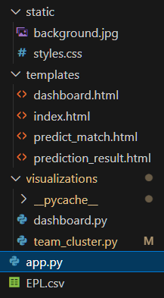

**Figure 10.1 : Structure**

Figure 10.1 provides an overview of the application's codebase structure, showcasing how different modules and files are organized. It typically includes directories for routes, templates (HTML), static files (CSS/JS), and core logic such as data processing and prediction models. This structured layout promotes modularity, making the codebase easier to maintain, scale, and debug. Understanding this hierarchy is essential for efficient collaboration and future development. It reflects a clean separation of concerns, following best practices in Flask-based web applications.

**10.2 App.py**

from flask import Flask, render_template, request

import pandas as pd

import numpy as np

from sklearn.model_selection import train_test_split

from sklearn.tree import DecisionTreeRegressor

import random

from visualizations.dashboard import generate_dashboard_data

from flask import Flask, render_template, request, session, redirect, url_for

from flask import session

app = Flask(__name__)

app.secret_key = 'reaper'  # needed to use session

@app.route('/')

def index():

    algorithms = [

        "Predict Match"

    ]

    return render_template('index.html', algorithms=algorithms)

from visualizations.team_cluster import generate_team_cluster_plot  # You'll create this

@app.route('/team_cluster', methods=['GET', 'POST'])

def team_cluster():

    team_list=[

            #teams

        ]

    selected_team = request.form.get('team')

    cluster_plot_html = None

    if selected_team:

        from visualizations.team_cluster import generate_team_cluster_plot

        fig = generate_team_cluster_plot(selected_team)

        cluster_plot_html = fig.to_html(full_html=False)

    return render_template('predict_match.html',

                           team_list=team_list,

                           selected_team=selected_team,

                           cluster_plot_html=cluster_plot_html)

@app.route('/visualize', methods=['POST'])

def visualize():

    selected = request.form.get('algo')

    if selected == "Predict Match":

        team_list=[

            #teams

        ]

        return render_template('predict_match.html', team_list=team_list, prediction_done=False)

    return "Algorithm not implemented yet", 400

@app.route('/predict', methods=['POST'])

def predict_match():

    df = pd.read_csv('EPL.csv')

    def compute_team_stats(df):

        team_stats = {}

        for team in pd.unique(df[['HomeTeam', 'AwayTeam']].values.ravel('K')):

            home_matches = df[df['HomeTeam'] == team]

            away_matches = df[df['AwayTeam'] == team]

            home_wins = (home_matches['FullTimeResult'] == 'H').sum()

            away_wins = (away_matches['FullTimeResult'] == 'A').sum()

            home_games = len(home_matches)

            away_games = len(away_matches)

            home_win_pct = home_wins / home_games if home_games > 0 else 0

            away_win_pct = away_wins / away_games if away_games > 0 else 0

            home_avg_goals = home_matches['FullTimeHomeTeamGoals'].mean() if home_games > 0 else 0

            away_avg_goals = away_matches['FullTimeAwayTeamGoals'].mean() if away_games > 0 else 0

            home_avg_shots = home_matches['HomeTeamShots'].mean() if home_games > 0 else 0

            away_avg_shots = away_matches['AwayTeamShots'].mean() if away_games > 0 else 0

            home_avg_shots_on_target = home_matches['HomeTeamShotsOnTarget'].mean() if home_games > 0 else 0

            away_avg_shots_on_target = away_matches['AwayTeamShotsOnTarget'].mean() if away_games > 0 else 0

            home_avg_fouls = home_matches['HomeTeamFouls'].mean() if home_games > 0 else 0

            away_avg_fouls = away_matches['AwayTeamFouls'].mean() if away_games > 0 else 0

            team_stats[team] = {

                'home_win_pct': home_win_pct,

                'away_win_pct': away_win_pct,

                'home_avg_goals': home_avg_goals,

                'away_avg_goals': away_avg_goals,

                'home_avg_shots': home_avg_shots,

                'away_avg_shots': away_avg_shots,

                'home_avg_shots_on_target': home_avg_shots_on_target,

                'away_avg_shots_on_target': away_avg_shots_on_target,

                'home_avg_fouls': home_avg_fouls,

                'away_avg_fouls': away_avg_fouls

            }

        return team_stats

    def tournament():

        teams = request.form.getlist('team[]')

        session['selected_teams'] = teams

        team_stats = compute_team_stats(df)

        features, goal_labels = [], []

        for _, row in df.iterrows():

            home_team, away_team = row['HomeTeam'], row['AwayTeam']

            if home_team in team_stats and away_team in team_stats:

                home, away = team_stats[home_team], team_stats[away_team]

                features.append([home['home_win_pct'], away['away_win_pct'],

                                 home['home_avg_goals'], away['away_avg_goals'],

                                 home['home_avg_shots'], away['away_avg_shots'],

                                 home['home_avg_shots_on_target'], away['away_avg_shots_on_target'],

                                 home['home_avg_fouls'], away['away_avg_fouls']])

                goal_labels.append([row['FullTimeHomeTeamGoals'], row['FullTimeAwayTeamGoals']])

        X = np.array(features)

        y_goals = np.array(goal_labels)

        X_train_g, _, y_train_g, _ = train_test_split(X, y_goals, test_size=0.1, random_state=42)

        goal_regressor = DecisionTreeRegressor(random_state=42)

        goal_regressor.fit(X_train_g, y_train_g)

        def predict_match_result(home_team, away_team):

            if home_team not in team_stats or away_team not in team_stats:

                return 0, 0

            home, away = team_stats[home_team], team_stats[away_team]

            input_features = np.array([[home['home_win_pct'], away['away_win_pct'],

                                        home['home_avg_goals'], away['away_avg_goals'],

                                        home['home_avg_shots'], away['away_avg_shots'],

                                        home['home_avg_shots_on_target'], away['away_avg_shots_on_target'],

                                        home['home_avg_fouls'], away['away_avg_fouls']]])

            goal_pred = goal_regressor.predict(input_features)[0]

            return int(round(goal_pred[0])), int(round(goal_pred[1]))

        def simulate_round(team_list):

            stats = {team: {'played': 0, 'wins': 0, 'draws': 0, 'losses': 0, 'points': 0, 'goals_scored': 0, 'goals_conceded': 0} for team in team_list}

            results = []

            for i in range(len(team_list)):

                for j in range(len(team_list)):

                    if i != j:

                        home, away = team_list[i], team_list[j]

                        hg, ag = predict_match_result(home, away)

                        stats[home]['played'] += 1

                        stats[away]['played'] += 1

                        stats[home]['goals_scored'] += hg

                        stats[home]['goals_conceded'] += ag

                        stats[away]['goals_scored'] += ag

                        stats[away]['goals_conceded'] += hg

                        if hg > ag:

                            stats[home]['points'] += 3

                            stats[home]['wins'] += 1

                            stats[away]['losses'] += 1

                        elif hg < ag:

                            stats[away]['points'] += 3

                            stats[away]['wins'] += 1

                            stats[home]['losses'] += 1

                        else:

                            stats[home]['points'] += 1

                            stats[away]['points'] += 1

                            stats[home]['draws'] += 1

                            stats[away]['draws'] += 1

                        results.append((home, hg, away, ag))

            return stats, results

        round1_stats, group_results = simulate_round(teams)

        sorted_teams = sorted(teams, key=lambda x: (round1_stats[x]['points'], round1_stats[x]['goals_scored'] - round1_stats[x]['goals_conceded']), reverse=True)

        # Prepare dashboard data after group stage

        goals_scored = [round1_stats[t]['goals_scored'] for t in sorted_teams]

        goals_conceded = [round1_stats[t]['goals_conceded'] for t in sorted_teams]

        points = [round1_stats[t]['points'] for t in sorted_teams]

        semis = sorted_teams[:4]

        semi_stats, semi_results = simulate_round(semis)

        sorted_semis = sorted(semis, key=lambda x: (semi_stats[x]['points'], semi_stats[x]['goals_scored'] - semi_stats[x]['goals_conceded']), reverse=True)

        finalists = sorted_semis[:2]

        final_home1, final_away1 = finalists[0], finalists[1]

        fg1, fg2 = predict_match_result(final_home1, final_away1)

        fg3, fg4 = predict_match_result(final_away1, final_home1)

        final_score1 = fg1 + fg4

        final_score2 = fg2 + fg3

        winner = final_home1 if final_score1 > final_score2 else final_away1 if final_score2 > final_score1 else random.choice([final_home1, final_away1])

        return render_template(

            'prediction_result.html',

            results=group_results,

            points_table=round1_stats,

            semi_finals=semis,

            semi_results=semi_results,

            finalists=finalists,

            final_match=f"{final_home1} ({fg1} + {fg4}) vs {final_away1} ({fg2} + {fg3})",

            winner=winner

        )

    return tournament()

@app.route('/dashboard')

def dashboard():

    teams = session.get('selected_teams')  # Get the 8 selected teams

    if not teams:

        return redirect(url_for('index'))  # Fallback if accessed directly

    df = pd.read_csv('EPL.csv')

    team_stats = {}

    for team in teams:

        home_matches = df[df['HomeTeam'] == team]

        away_matches = df[df['AwayTeam'] == team]

        total_goals = home_matches['FullTimeHomeTeamGoals'].sum() + away_matches['FullTimeAwayTeamGoals'].sum()

        total_conceded = home_matches['FullTimeAwayTeamGoals'].sum() + away_matches['FullTimeHomeTeamGoals'].sum()

        total_points = 0

        for match in home_matches.itertuples():

            if match.FullTimeResult == 'H':

                total_points += 3

            elif match.FullTimeResult == 'D':

                total_points += 1

        for match in away_matches.itertuples():

            if match.FullTimeResult == 'A':

                total_points += 3

            elif match.FullTimeResult == 'D':

                total_points += 1

        team_stats[team] = {

            'goals_scored': total_goals,

            'goals_conceded': total_conceded,

            'points': total_points

        }

    teams = list(team_stats.keys())

    goals_scored = [team_stats[t]['goals_scored'] for t in teams]

    goals_conceded = [team_stats[t]['goals_conceded'] for t in teams]

    points = [team_stats[t]['points'] for t in teams]

    bar_plot, scatter_plot, pie_chart, stacked_bar, radar_chart = generate_dashboard_data(teams, goals_scored, goals_conceded, points)

    return render_template("dashboard.html",

        bar_plot_html=bar_plot.to_html(full_html=False),

        scatter_plot_html=scatter_plot.to_html(full_html=False),

        pie_chart_html=pie_chart.to_html(full_html=False),

        stacked_bar_html=stacked_bar.to_html(full_html=False),

        radar_chart_html=radar_chart.to_html(full_html=False)

    )

if __name__ == "__main__":

    app.run(debug=True)