KN calculation - ContainerGroup6

Stability 24.00.04.133, build: 133
Model file: C:\Users\User\Downloads\ContainerGroup6 (4) (Highest precision, 34 sections, Trimming off, Skin thickness not applied). Long. datum: AP; Vert. datum: Baseline. Analysis tolerance - ideal(worst case): Disp.%: 0.01000(0.100); Trim%(LCG-TCG): 0.01000(0.100); Heel%(LCG-TCG): 0.01000(0.100)
Damage Case - Intact

Initial Trim = 0 m (+ve by stern)
Specific gravity = 1.025; (Density = 1.025 tonne/m^3)
VCG = 0 m; TCG = 0 m
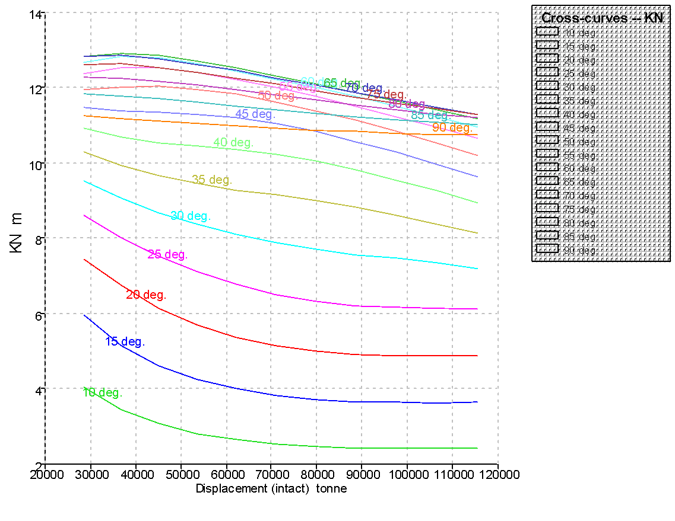

Displacement (intact)  tonne | Draft Amidships  m | Trim (+ve by stern)  m | LCG  m | TCG  m | KN  10.0 deg. Starb. | KN  15.0 deg. Starb. | KN  20.0 deg. Starb. | KN  25.0 deg. Starb. | KN  30.0 deg. Starb. | KN  35.0 deg. Starb. | KN  40.0 deg. Starb. | KN  45.0 deg. Starb. | KN  50.0 deg. Starb. | KN  55.0 deg. Starb. | KN  60.0 deg. Starb. | KN  65.0 deg. Starb. | KN  70.0 deg. Starb. | KN  75.0 deg. Starb. | KN  80.0 deg. Starb. | KN  85.0 deg. Starb. | KN  90.0 deg. Starb.
28569 | 4.000 | 0.000 | 145.020 | 0.000 | 4.055 | 5.956 | 7.451 | 8.602 | 9.525 | 10.286 | 10.926 | 11.478 | 11.954 | 12.365 | 12.680 | 12.840 | 12.820 | 12.616 | 12.294 | 11.827 | 11.250
36748 | 5.000 | 0.000 | 145.816 | 0.000 | 3.455 | 5.171 | 6.738 | 8.009 | 9.054 | 9.938 | 10.705 | 11.388 | 12.018 | 12.524 | 12.835 | 12.930 | 12.857 | 12.636 | 12.266 | 11.783 | 11.187
45093 | 6.000 | 0.000 | 146.410 | 0.000 | 3.071 | 4.623 | 6.157 | 7.523 | 8.676 | 9.671 | 10.548 | 11.346 | 12.034 | 12.517 | 12.789 | 12.870 | 12.778 | 12.532 | 12.177 | 11.700 | 11.116
53565 | 7.000 | 0.000 | 146.846 | 0.000 | 2.818 | 4.251 | 5.704 | 7.116 | 8.364 | 9.459 | 10.438 | 11.308 | 11.966 | 12.402 | 12.646 | 12.707 | 12.626 | 12.409 | 12.067 | 11.612 | 11.055
62136 | 8.000 | 0.000 | 147.122 | 0.000 | 2.650 | 4.000 | 5.379 | 6.779 | 8.102 | 9.287 | 10.354 | 11.210 | 11.821 | 12.225 | 12.446 | 12.521 | 12.453 | 12.257 | 11.940 | 11.515 | 10.997
70800 | 9.000 | 0.000 | 147.202 | 0.000 | 2.541 | 3.835 | 5.158 | 6.519 | 7.881 | 9.150 | 10.234 | 11.046 | 11.625 | 12.010 | 12.235 | 12.314 | 12.263 | 12.091 | 11.806 | 11.421 | 10.937
79564 | 10.000 | 0.000 | 147.070 | 0.000 | 2.472 | 3.729 | 5.014 | 6.338 | 7.703 | 9.013 | 10.058 | 10.833 | 11.391 | 11.774 | 12.005 | 12.099 | 12.069 | 11.924 | 11.673 | 11.323 | 10.882
88420 | 11.000 | 0.000 | 146.823 | 0.000 | 2.433 | 3.668 | 4.927 | 6.225 | 7.573 | 8.838 | 9.830 | 10.578 | 11.130 | 11.518 | 11.763 | 11.877 | 11.872 | 11.758 | 11.541 | 11.230 | 10.832
97364 | 12.000 | 0.000 | 146.541 | 0.000 | 2.416 | 3.640 | 4.885 | 6.166 | 7.464 | 8.619 | 9.561 | 10.293 | 10.846 | 11.246 | 11.509 | 11.650 | 11.677 | 11.598 | 11.419 | 11.148 | 10.790
106401 | 13.000 | 0.000 | 146.253 | 0.000 | 2.417 | 3.638 | 4.878 | 6.147 | 7.339 | 8.376 | 9.265 | 9.983 | 10.542 | 10.959 | 11.247 | 11.419 | 11.482 | 11.442 | 11.304 | 11.076 | 10.761
115533 | 14.000 | 0.000 | 145.973 | 0.000 | 2.431 | 3.657 | 4.900 | 6.120 | 7.189 | 8.124 | 8.949 | 9.653 | 10.221 | 10.658 | 10.977 | 11.184 | 11.285 | 11.287 | 11.195 | 11.012 | 10.743

Key point | Immersion angle at 28569 t  deg | Immersion angle at 36748 t  deg | Immersion angle at 45093 t  deg | Immersion angle at 53565 t  deg | Immersion angle at 62136 t  deg | Immersion angle at 70800 t  deg | Immersion angle at 79564 t  deg | Immersion angle at 88420 t  deg | Immersion angle at 97364 t  deg | Immersion angle at 106401 t  deg | Immersion angle at 115533 t  deg
Margin Line | 54.2 | 49.2 | 45.0 | 41.2 | 37.8 | 34.7 | 31.9 | 29.1 | 26.4 | 23.6 | 20.6
Deck Edge | 54.4 | 49.4 | 45.2 | 41.4 | 38.0 | 34.9 | 32.1 | 29.3 | 26.6 | 23.8 | 20.9

