ABC Inc.
Migrating Talend Data Pipelines to Apache Spark on Google Cloud
Financial Cost Assessment, Cluster Sizing Benchmarks and Migration Business Case
Prepared for: Office of the CTO, ABC Inc.
Prepared by: Google Cloud Consulting Engagement
July 16, 2026 | All amounts in Canadian dollars (CAD)
CONFIDENTIAL — FOR INTERNAL MANAGEMENT USE

Contents

1. Executive Summary
ABC Inc. currently runs its data integration workloads on an on-premise Talend platform. Jobs that join multiple large datasets are slow because Talend materializes intermediate “virtual tables” on a single processing node. This report quantifies the cost of migrating the flagship reporting pipeline — a 3-way join over a 30-million-row fact table and three 3-million-row dimension tables producing a 200,000-row analytical dataset — to Apache Spark on Google Cloud, priced for the Toronto region (northamerica-northeast2) in Canadian dollars.
Key findings:
- A single run of the pipeline on Google Cloud Serverless Spark is estimated at approximately CA$1.70 per run (about CA$2.54 on an ephemeral Dataproc cluster). Run daily, total platform cost including Cloud Storage, Secret Manager, Monitoring and networking is approximately CA$79 per month, or roughly CA$950 per year.
- The recommended capacity is modest: a 36-DCU serverless Spark profile (equivalent to one driver and eight 4-vCPU executors), completing the job in an estimated 25–35 minutes — versus multi-hour runtimes typical of single-node virtual-table joins in Talend.
- Published benchmarks show even small Spark clusters (32 vCPU) sustain 150–350 GB/hour on join-heavy ETL, scaling near-linearly: Spark holds the industry sort record of 100 TB in 23 minutes on 206 nodes, and TPC-DS suites at 10 TB scale complete in hours on large clusters.
- Because Spark on GCP is billed per second with scale-to-zero, the cloud cost concern is manageable: ABC pays only for the ~30 minutes per day the job runs. A persistent, always-on cluster of the same size would cost about CA$2,470 per month — 31× more — which is why we recommend serverless or ephemeral clusters.
- If the full raw fact table (30M rows × 100 KB ≈ 3 TB) had to be scanned uncompressed on every run rather than the stated ~100 GB working set, cost would still only be approximately CA$15–18 per run (CA$500–600 per month) — see the sensitivity analysis in Section 7.4.
Recommendation: adopt Google Cloud Serverless Spark for this pipeline, store data as compressed Parquet in Cloud Storage, and use broadcast joins for the three dimension tables. Validate this estimate with a 2-week proof of concept, and confirm final rates in the Google Cloud Pricing Calculator (cloud.google.com/products/calculator) with currency set to CAD.

2. Background and Objectives
ABC Inc.’s data pipelines are built on an on-premise Talend deployment. The infrastructure is largely amortized, so out-of-pocket processing cost is low; however, multi-dataset joins force Talend to create intermediate virtual tables, serializing work through a single JVM and extending batch windows. The CTO has asked for:
- A benchmark view of how much data different sizes of Spark clusters can process, grounded in real-world studies.
- A cost estimate, in Canadian dollars, for a single Spark job on GCP processing the ~100 GB reporting dataset described below, using Google’s published pricing (Google Cloud Pricing Calculator rates for the Toronto region).
- A recommended cluster size for the migrated pipeline and its running cost, including supporting services (Cloud Storage, Secret Manager, monitoring, networking).

2.1 Workload profile
Attribute | Value
Fact table | 30,000,000 rows (row width up to 100 KB in source system)
Dimension tables | 3 tables × 3,000,000 rows each
Join pattern | 3-way join of fact table to all three dimensions
Output | ~200,000-row curated dataset for analysis and reporting
Working data volume | ~100 GB per run (columnar/compressed working set)
Cadence assumed | Daily (30 runs per month)
Target region / currency | Toronto, northamerica-northeast2 / CAD

2.2 A note on data volume
Taken literally, 30 million rows at 100 KB each is roughly 3 TB of raw data, while the pipeline is described as a ~100 GB medium-sized workload. In practice these reconcile: pipelines rarely read every column of a wide row, and columnar formats such as Parquet with Snappy compression routinely reduce wide operational rows by 10–30×. Our primary estimate therefore uses the stated ~100 GB effective volume; Section 7.4 prices the conservative full-3 TB case so management can see the upper bound.

3. Current State: Why Talend Joins Are Slow
Talend (Open Studio / Data Integration) executes jobs as generated Java programs on one node. When several datasets are joined, components such as tMap stage lookup data in memory or in temporary “virtual tables” on disk. For ABC’s pipeline this means the 30M-row fact table and three 3M-row dimensions are staged, indexed and probed on a single machine — memory pressure spills to disk, and the join runs sequentially. Symptoms reported by ABC match this pattern: join-heavy jobs dominate the batch window while simple extract-load jobs are fine.
Apache Spark addresses precisely this bottleneck: data is partitioned across many executors, joins execute in parallel in memory, and small dimension tables are broadcast to every executor so the large table never needs to be shuffled at all. Section 8 details the comparison.

4. Target Architecture on Google Cloud
The proposed design lands source extracts in a Cloud Storage bucket as Parquet, processes them with a PySpark job on Google Cloud Serverless Spark (the managed service formerly known as Dataproc Serverless), and publishes the 200K-row curated output to BigQuery (or a curated GCS bucket) for reporting. Secret Manager holds database credentials; Cloud Monitoring and Logging provide observability; Cloud Composer or Cloud Scheduler triggers the daily run.
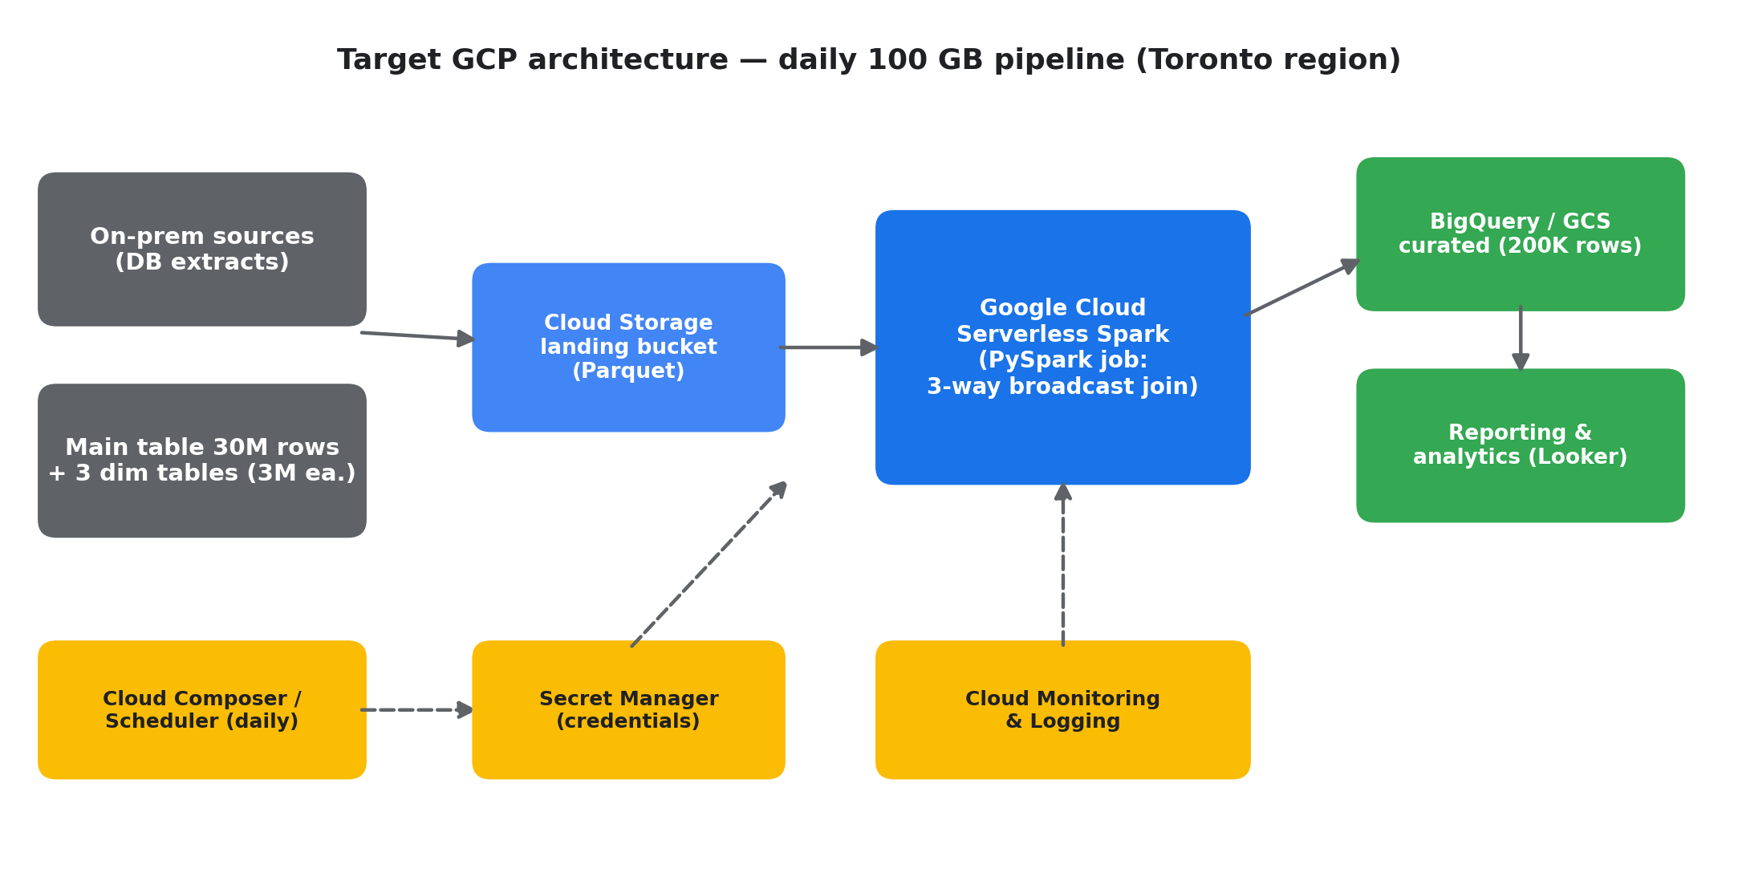
Figure 1 — Target GCP architecture for the migrated pipeline (Toronto region).
Two managed deployment models were evaluated:
- Serverless Spark (recommended): no cluster to create or manage; billed per second of Data Compute Unit (DCU) usage with scale-to-zero. Best fit for a scheduled batch job that runs under an hour per day.
- Dataproc on Compute Engine (ephemeral): a right-sized cluster created for each run and deleted afterwards. Slightly cheaper per vCPU-hour at sustained usage and allows Spot VMs, but adds ~90 seconds of provisioning and operational overhead.

5. How Much Can Spark Clusters Process? Benchmarks
The table and chart below summarize indicative processing capability for join/shuffle-heavy ETL, synthesized from public TPC-DS results, vendor benchmarks and published case studies. Actual throughput depends on file format, join selectivity and skew; these figures are planning-grade.
Cluster size | Typical configuration | Indicative ETL capability | Real-world reference point
Small — 32 vCPU | 8 × n2-standard-4 workers (128 GB RAM) | 150–350 GB/hour; 100 GB TPC-DS query suite in well under an hour | Google Dataproc TPC-DS reference runs use 4–8 n2-standard-8 workers at the 1 TB scale factor
Medium — 128 vCPU | 16 × n2-standard-8 (512 GB RAM) | 0.7–1.5 TB/hour | 1 TB TPC-DS full 99-query suites complete in low single-digit hours on clusters of this class
Large — 512 vCPU | 64 × n2-standard-8 (2 TB RAM) | 3–6 TB/hour | Databricks ran all 104 TPC-DS queries at 10 TB scale in ~5.5 hours
Extra-large — 1,000+ vCPU | Autoscaled fleets; Spot VMs | 10+ TB/hour | Spark’s Daytona GraySort record: 100 TB sorted in 23 minutes on 206 nodes (6,592 cores); LiveRamp runs ~100,000 Spark jobs/day on Dataproc clusters autoscaling to 1,000 VMs each (~256,000-core peak)

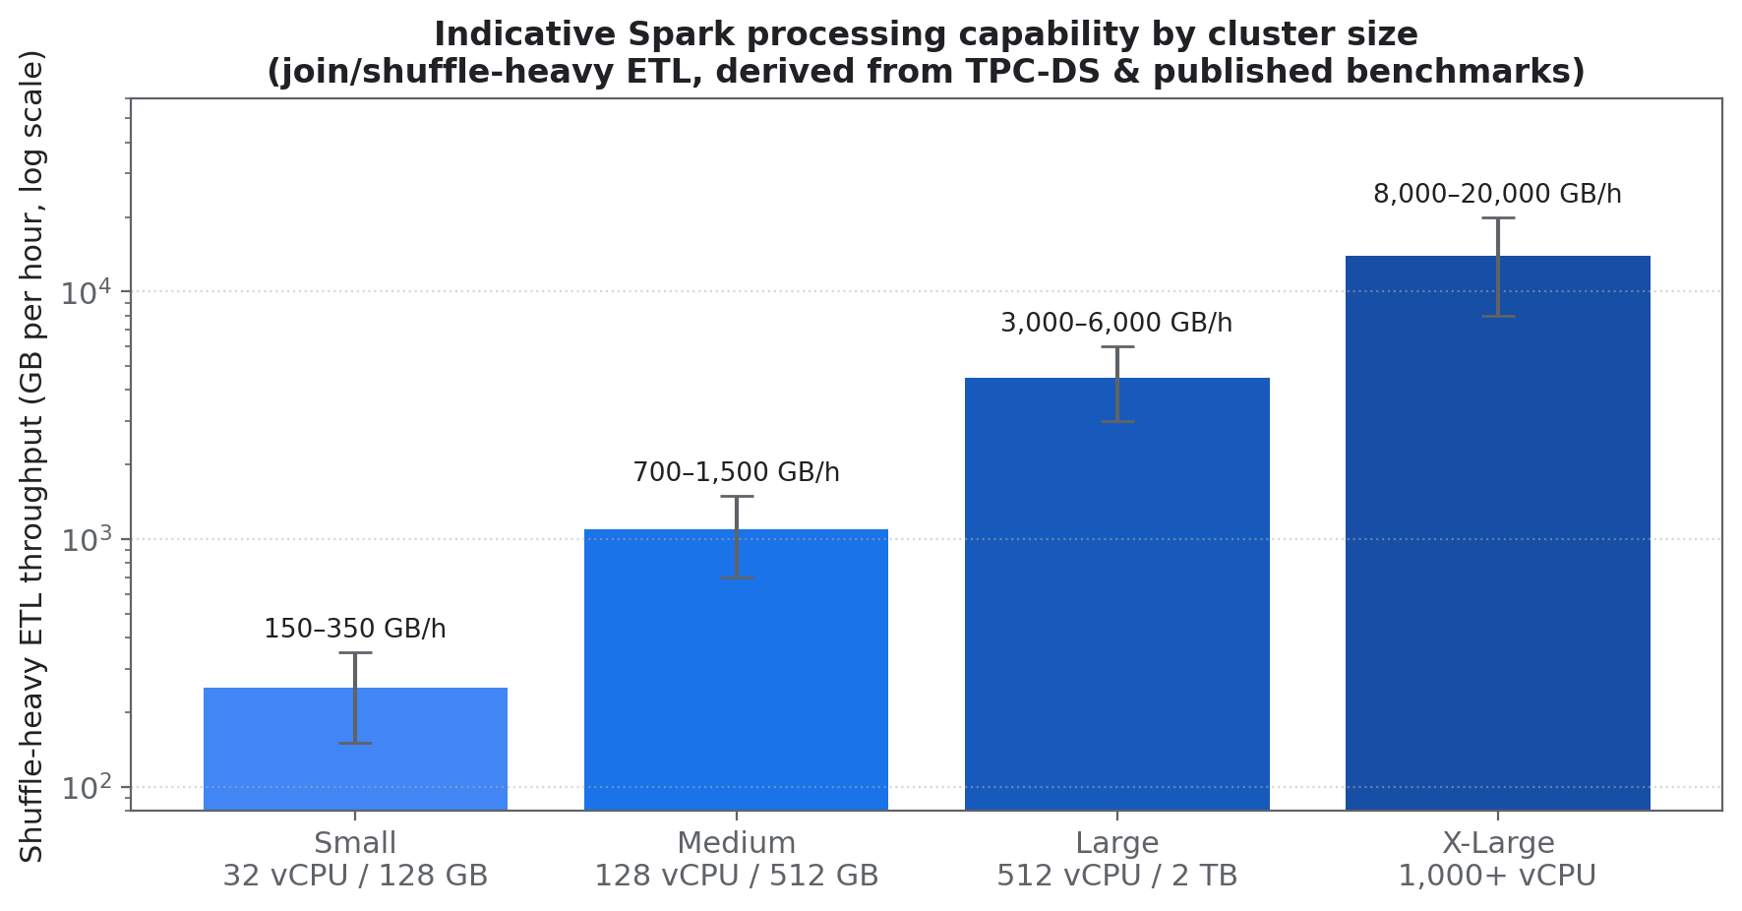
Figure 2 — Indicative shuffle-heavy ETL throughput by cluster size (log scale).
Google additionally offers the Lightning Engine execution tier, which Google benchmarks at up to 4.9× faster than open-source Spark for large ETL/SQL workloads with zero code changes — an upgrade path if ABC’s volumes grow.
Implication for ABC: the 100 GB pipeline sits comfortably at the “small cluster” end of this spectrum. Even the conservative 3 TB interpretation is a routine medium-cluster workload.

6. Recommended Cluster Sizing for ABC’s Pipeline
Sizing logic: with the three 3M-row dimension tables compressed to a few GB each, Spark will broadcast them to every executor, so the 30M-row fact table is joined without any shuffle of the large side. The dominant cost is scanning and filtering ~100 GB of Parquet. At a conservative 200–300 GB/hour for a 32-core cluster, the job completes in roughly 25–35 minutes.
Parameter | Serverless Spark (recommended) | Dataproc on Compute Engine
Compute profile | Driver 4 vCPU/16 GB + 8 executors × 4 vCPU/16 GB = 36 DCU | 1 master + 8 workers, all n2-standard-4 (36 vCPU / 144 GB)
Shuffle/scratch storage | ~800 GB standard shuffle storage | 100 GB pd-balanced per node (900 GB)
Estimated wall-clock | 25–35 minutes | 35–50 minutes (incl. ~90 s provisioning)
Spark tuning highlights | Broadcast joins for 3 dims; AQE enabled by default; Parquet + Snappy | Same, plus autoscaling policy and Spot secondary workers optional
Scale path if volume grows | Raise executor count — no infrastructure change | Autoscaling to more workers; Spot VMs cut compute up to ~64%

Either footprint is small. We recommend Serverless Spark because the job is short, scheduled and bursty — the profile where per-second, scale-to-zero billing is most economical and where ABC carries zero cluster-management burden.

7. Cost Estimate (Canadian Dollars, Toronto Region)

7.1 Methodology and rates
Rates below are Google’s published list prices as presented in the Google Cloud pricing pages / Pricing Calculator in July 2026. Google publishes calculator rates for the default region (us-central1); Toronto (northamerica-northeast2) carries a ~10% regional uplift, which we have applied. USD figures are converted at 1 USD = 1.40 CAD (Bank-of-Canada-area market rate, July 16, 2026). Google bills in USD by default (or fixed CAD SKU prices for CAD-billed accounts), so the CAD figures below should be re-confirmed in the Pricing Calculator with currency set to CAD at contract time.
Price component | Unit | USD (Toronto est.) | CAD @1.40
Serverless Spark — DCU (standard tier) | per DCU-hour | $0.066 | $0.0924
Serverless Spark — shuffle storage | per GiB-hour | $0.0000603 | $0.0000844
Dataproc management fee (cluster model) | per vCPU-hour | $0.010 | $0.0140
Compute Engine n2-standard-4 (on-demand) | per hour | $0.2137 | $0.2992
Balanced persistent disk | per GB-month | $0.110 | $0.154
Cloud Storage — Standard class | per GB-month | $0.023 | $0.0322
Secret Manager — active secret version | per version-month | $0.06 | $0.084
Secret Manager — access operations | per 10,000 ops | $0.03 | $0.042

7.2 Cost of a single pipeline run
Serverless Spark (36 DCU, 30-minute run, ~800 GiB-hour-equivalent shuffle):
Line item | Calculation | CAD
DCU compute | 36 DCU × 0.5 h × CA$0.0924 | $1.66
Shuffle storage | 800 GiB × 0.5 h × CA$0.0000844 | $0.03
Total per run — Serverless |  | $1.70

Ephemeral Dataproc cluster (1 master + 8 workers n2-standard-4, 45 minutes including provisioning):
Line item | Calculation | CAD
Compute Engine VMs | 9 VMs × 0.75 h × CA$0.2992 | $2.02
Dataproc management fee | 36 vCPU × 0.75 h × CA$0.0140 | $0.38
Persistent disks (prorated) | 900 GB × CA$0.154 ÷ 730 h × 0.75 h | $0.14
Total per run — Ephemeral cluster |  | $2.54

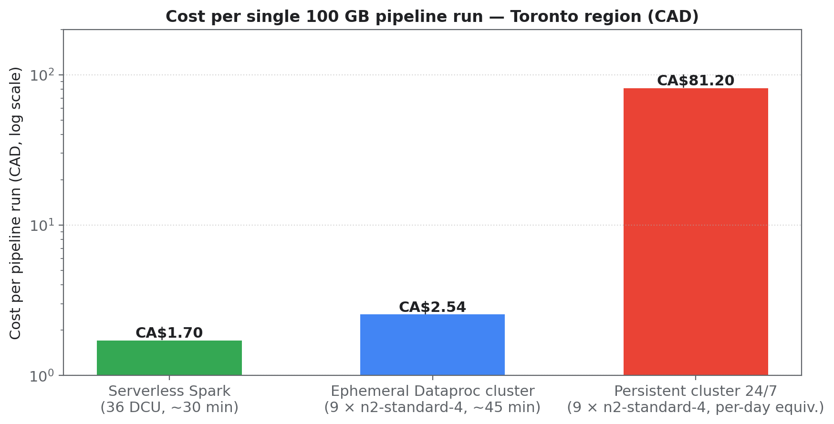
Figure 3 — Per-run cost by deployment model. A persistent 24/7 cluster (right) illustrates why ephemeral/serverless execution matters: same hardware, ~31× the effective daily cost.

7.3 Monthly and annual total cost of ownership (daily runs)
Cost component | Sizing assumption | CAD / month | CAD / year
Serverless Spark compute | 30 runs × CA$1.70 | $51.00 | $612
Cloud Storage buckets | 500 GB Standard (landing + curated + 30-day history) + PUT/GET operations | $18.90 | $227
Cloud Monitoring & Logging | Job metrics/logs beyond free allotment | $7.00 | $84
Network egress | ~10 GB/month report exports to on-prem | $1.68 | $20
Secret Manager | 6 secret versions + ~60K accesses | $0.76 | $9
TOTAL — Serverless option |  | $79.34 | $952
(Alternative) Ephemeral Dataproc clusters | 30 runs × CA$2.54 + same supporting services | $104.54 | $1,254
(Avoid) Persistent 24/7 cluster | 9 × n2-standard-4 always on + mgmt fee + disks | $2,472 | $29,664

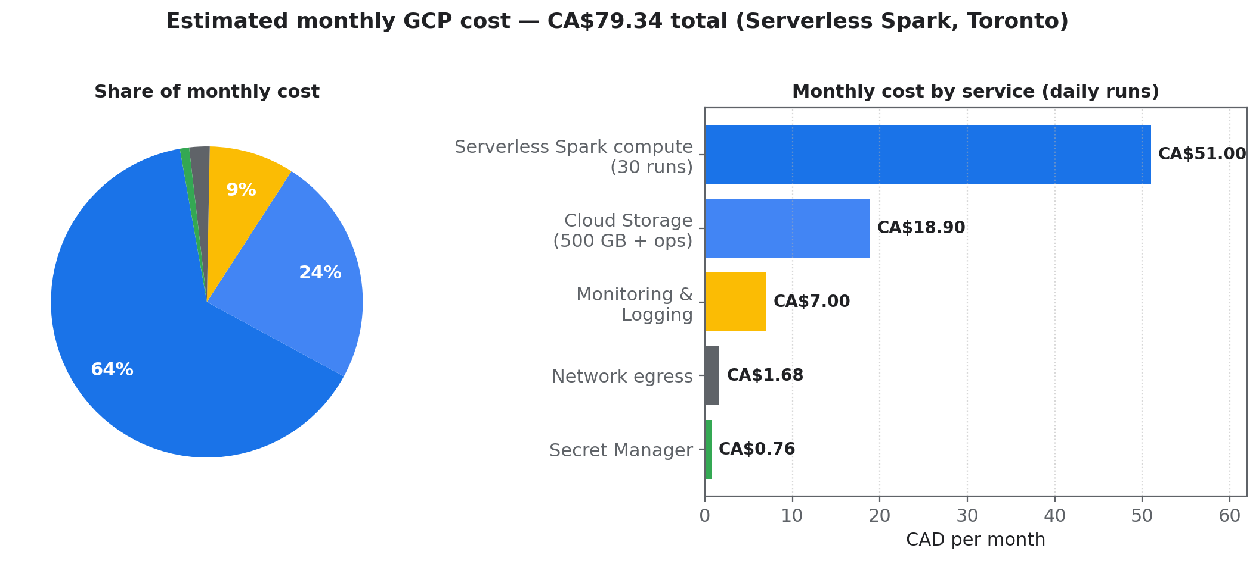
Figure 4 — Monthly cost breakdown, Serverless option, daily cadence.
One-time costs excluded from the run-rate above: pipeline re-development and testing effort, historical data transfer (negligible at these volumes — online transfer of 3 TB is free ingress; only on-prem network egress applies), and a short parallel-run period.

7.4 Sensitivity analysis
Scenario | Compute profile | Per run (CAD) | Per month (CAD)
Base case — ~100 GB working set | 36 DCU × ~0.5 h | $1.70 | $79 total
Full raw scan — ~3 TB (30M × 100 KB, uncompressed) | 96 DCU × ~1.5 h | $15–18 | $500–600 total
Weekly instead of daily cadence (base case) | 36 DCU × ~0.5 h | $1.70 | $36 total
Volume doubles (200 GB) | 48 DCU × ~0.6 h | $2.70 | $110 total

Even the most conservative interpretation of the data volume keeps this pipeline well under CA$0.6K per month — a small fraction of typical enterprise data-platform budgets, and directly comparable to the incremental power/maintenance share of the on-prem batch window it replaces.

8. Spark on GCP vs Talend On-Premise
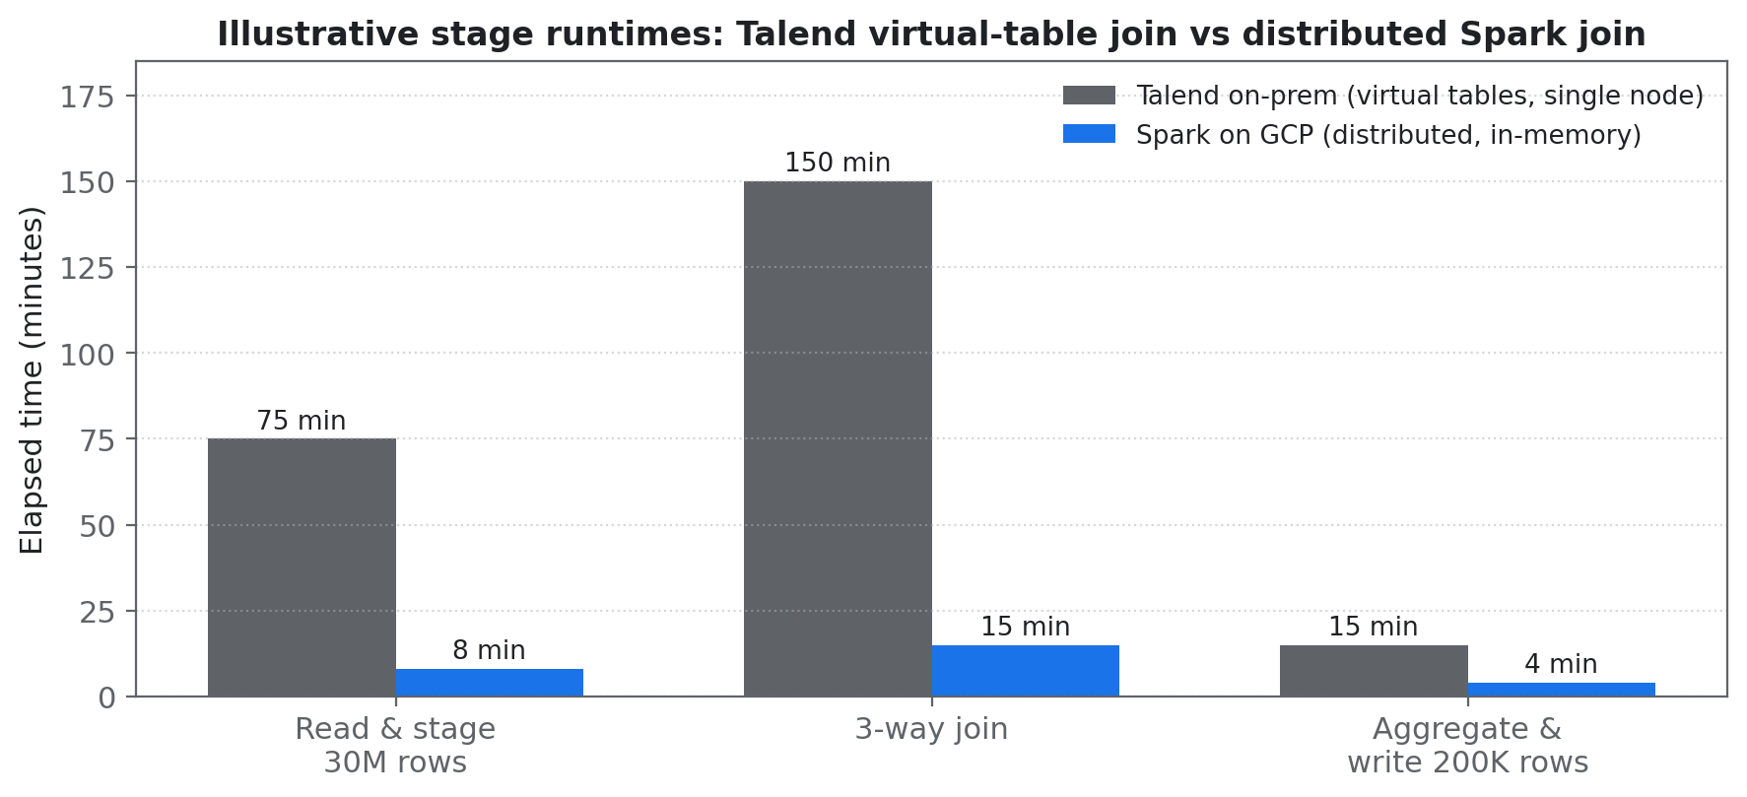
Figure 5 — Illustrative stage-level runtimes for ABC’s join pipeline (single-node Talend virtual-table join vs distributed Spark broadcast join). Actuals to be validated in the proof of concept.
Dimension | Talend on-premise | Spark on Google Cloud
Join execution | Virtual tables staged on one node; lookups spill to disk; sequential | Distributed, in-memory; small dimensions broadcast so the 30M-row table is never shuffled
Scalability | Vertical only — bigger server | Horizontal — add executors in seconds; autoscaling
Elasticity & cost model | Fixed capacity, sized for peak; idle between batches | Per-second billing, scale-to-zero; pay for ~30 min/day
Performance headroom | Limited by single JVM & local I/O | Near-linear scaling; 100 TB sort record in 23 min; optional Lightning Engine up to 4.9×
Data formats | Row-oriented staging | Columnar Parquet/ORC with predicate pushdown — reads only needed columns
Operations | Patch, upgrade, and capacity-manage servers and Talend runtime | Fully managed; no cluster to patch (serverless); built-in monitoring
Licensing | Talend subscription per user/core | Open-source Apache Spark; pay only for infrastructure consumed
Ecosystem | Separate tools for warehouse/BI hand-off | Native connectors to BigQuery, GCS, Looker; same code scales from 100 GB to 10 TB
Skills & portability | Proprietary job designs | Standard PySpark — portable across clouds and on-prem

A balanced note: Talend remains a capable ELT orchestration and data-quality tool, and ABC’s on-prem hardware is sunk cost. The economic case here is not that cloud compute is cheaper than “free” amortized servers — it is that (a) the join bottleneck disappears, shrinking the batch window from hours to minutes; (b) the cloud cost of doing so is under CA$100/month; and (c) capacity stops being a constraint on new analytical workloads.

9. Real-World Case Studies

9.1 LiveRamp — 100,000 Spark jobs a day on Dataproc
Data-connectivity company LiveRamp migrated its on-premise Hadoop/Spark estate to Google Cloud Dataproc. One team alone runs ~100,000 Spark jobs daily across 12 Dataproc clusters, each autoscaling independently to 1,000 VMs (~256,000-core peak). Per-cluster billing attribution made cost reporting straightforward — evidence that the Dataproc model scales from ABC’s single daily job to extreme volumes on the same architecture.

9.2 Talend estate re-platformed to cloud Spark
A North American enterprise (published by consultancy Wavicle) rebuilt its Talend ETL estate on cloud-native Spark (AWS EMR): 218 ETL jobs and 51 process launchers migrated in six months, with idle compute eliminated via auto-shutdown after 30 minutes of inactivity. The pattern — Talend job designs translated to Spark SQL/PySpark, with pay-per-use clusters — is directly analogous to ABC’s migration, on a different cloud.

9.3 Industry benchmarks — TPC-DS and the sort record
Databricks published a full 104-query TPC-DS run at 10 TB scale completing in ~5.5 hours, and Apache Spark set the Daytona GraySort world record by sorting 100 TB in 23 minutes on 206 machines (6,592 cores) — 3× faster than the previous MapReduce record using 10× fewer machines. Google’s own Lightning Engine benchmarks show up to 4.9× speed-up over open-source Spark on TPC-DS/TPC-H-derived workloads. These establish the ceiling: ABC’s 100 GB job uses a tiny slice of proven capability.

10. Risks, Assumptions and Next Steps

10.1 Key assumptions
- Effective processed volume ~100 GB/run (Parquet, compressed); full-3 TB case priced in Section 7.4.
- Toronto region list prices with ~10% regional uplift over us-central1; FX at 1.40 CAD/USD (July 16, 2026). Final CAD SKU prices should be confirmed in the Google Cloud Pricing Calculator / a Google sales quote.
- Daily cadence, 30 runs/month; no committed-use discounts applied (1-year CUDs would cut Compute Engine costs ~37%, Spot VMs up to ~64% for the cluster option).
- BigQuery analysis/storage costs for the 200K-row output are immaterial (<CA$1/month) and included under Cloud Storage/reporting.

10.2 Risks and mitigations
Risk | Impact | Mitigation
Data volume assumption wrong (3 TB raw scans) | Cost rises to ~CA$500–600/mo | Convert sources to partitioned Parquet; column pruning; incremental loads
Join skew or memory pressure extends runtime | Longer runs = proportionally higher cost | AQE (on by default), broadcast joins, salting hot keys; validate in PoC
FX movement (CAD/USD) | ±5–10% on CAD totals | Re-quote at contract; consider CAD-billed account
Egress to on-prem grows | Egress billed per GB | Keep reporting consumption in BigQuery/Looker; export summaries only
Skills gap (Talend → PySpark) | Migration timeline | Targeted training; start with this single pipeline as the lighthouse project

10.3 Recommended next steps
- Two-week proof of concept: migrate this pipeline to Serverless Spark, measure actual runtime, DCU consumption and output parity against Talend.
- Confirm CAD pricing via the Google Cloud Pricing Calculator and a Google/partner quote; evaluate committed-use discounts once steady-state usage is known.
- Define the landing-zone basics: project structure, GCS bucket layout, Secret Manager for credentials, budget alerts in Cloud Billing.
- On PoC success, build the migration backlog for the remaining Talend jobs, prioritizing join-heavy pipelines where Spark’s advantage is largest.

Appendix A — Sources
- Google Cloud — Managed Service for Apache Spark (Dataproc) pricing: cloud.google.com/products/managed-service-for-apache-spark/pricing
- Google Cloud Pricing Calculator: cloud.google.com/products/calculator
- Google Cloud — Cloud Storage pricing: cloud.google.com/storage/pricing
- Google Cloud — Secret Manager pricing: cloud.google.com/secret-manager/pricing
- Compute Engine n2-standard-4 regional pricing: cloudprice.net/gcp/compute/instances/n2-standard-4; economize.cloud GCP pricing catalog
- Google Cloud blog — Best practices for migrating Hadoop to GCP Dataproc (LiveRamp case): cloud.google.com/blog/products/data-analytics/best-practices-for-migrating-hadoop-to-gcp-dataproc
- Wavicle Data — Talend ETL rebuilt on AWS case study: wavicledata.com/case-studies/talend-etl-rebuilt-on-aws-cutting-costs-delivery-time
- Databricks — Benchmarking Big Data SQL Platforms (TPC-DS 10 TB): databricks.com/blog/2017/07/12/benchmarking-big-data-sql-platforms-in-the-cloud.html
- Apache Spark Daytona GraySort record: spark.apache.org (sortbenchmark.org 2014 results)
- USD/CAD market rate July 16, 2026 (~1.40): tradingeconomics.com/canada/currency

Disclaimer: figures are planning-grade estimates based on list prices and public benchmarks at the date of writing; they are not a Google quotation. Confirm binding prices with Google Cloud or an authorized partner.

