**ASSESSMENT OF MARGINAL WORKERS**

**IN TAMILNADU**

**Problem Definition:**

The problem is to address the challenges faced by marginal workers in Tamil Nadu using data science. Marginal workers are those who engage in irregular or seasonal employment, often in low-paying and precarious jobs. To apply design thinking and data science to this issue, you should start with a clear **problem statement:**

Problem Statement: "How can we improve the livelihoods and working conditions of marginal workers in Tamil Nadu through data-driven interventions that enhance their access to stable and better-paying employment opportunities?"

**Design Thinking Approach:**

**1. Empathize:**

• Begin by understanding the needs, challenges, and aspirations of marginal workers in Tamil Nadu.

•Conduct interviews, surveys, and observations to gather qualitative data on their experiences and struggles.

**2. Define:**

• Synthesize the data collected during the empathize phase to define specific problems and pain points faced by marginal workers.

•Create personas to represent different segments of marginal workers, considering factors like age, gender, education, and location.

**3. Ideate:**

•Brainstorm innovative solutions that leverage data science to address the identified problems.

•Encourage diverse perspectives and collaboration among stakeholders, including policymakers, NGOs, and the workers themselves.

**4. Prototype:**

•Develop prototypes of data-driven tools or systems that can potentially improve the situation of marginal workers.

•These prototypes could include job matching algorithms, skill development platforms, or predictive models for seasonal job availability.

**5. Test:**

• Pilot test the prototypes with a small group of marginal workers to gather feedback and refine the solutions.

•Use A/B testing to measure the effectiveness of different interventions.

**Data Science Integration:**

**1. Data Collection:**

•Collect relevant data, including demographic information, employment history, wage levels, and geographical factors, from various sources.

•Use surveys, government databases, and mobile apps to gather real-time data.

**2. Data Analysis:**

•Analyze the collected data to identify patterns, trends, and correlations related to marginal workers' employment conditions.

•Employ machine learning models for predictive analysis, such as forecasting job demand in specific sectors or locations.

**3. Visualization:**

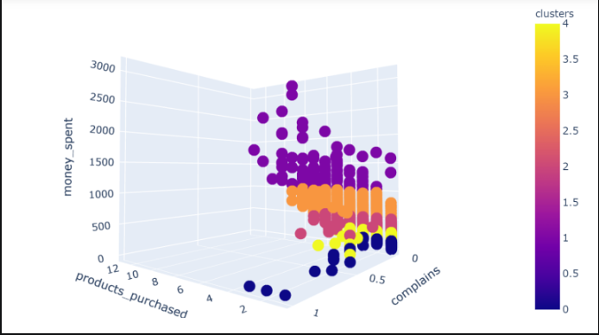

•Create data visualizations and dashboards to communicate insights effectively to stakeholders.

•Visualizations can help policymakers and organizations make informed decisions.

**4. Decision Support:**

•Use data science to provide decision support tools for policymakers to implement targeted interventions.

•Recommend policies or programs that can improve the livelihoods of marginal workers.

**5. Continuous Improvement:**

•Continuously collect and analyze data to assess the impact of interventions and make necessary adjustments.

By applying the principles of design thinking and utilizing data science, you can develop innovative and data-driven solutions to address the challenges faced by marginal workers in Tamil Nadu, ultimately improving their quality of life and economic prospects.