
ISO 9001:2015 Certified Institution, Accredited by NBA (BME, CSE, ECE, EEE, IT & MECH),
Accredited by NAAC with ‘A’ Grade with CGPA of 3.49,
#42, Avadi-Vel Tech Road, Avadi, Chennai-600062, Tamilnadu, India


DEPARTMENT OF ELECTRONICS AND COMMUNICATION ENGINEERING

231ITV61 – APP DEVELOPMENT LAB INTEGRATED
NAME :
REGISTER NO :
ROLL NO :
PROGRAMME : B.E – ELECTRONICS AND COMMUNICATION ENGINEERING
YEAR :
SEMESTER :

Department of Artificial Intelligence and Data Science

VISION
To promote Centre of excellence through effectual Teaching and Learning, imparting the contemporary knowledge centric education through innovative research in multidisciplinary fields.
MISSION
- To impart quality technical skills through practicing, knowledge updating in recent technology and produce professionals with multidisciplinary and leadership skills.
- To promote innovative thinking for design and development of software products of varying complexity with intelligence to fulfil the global standards and demands.
- To inculcate professional ethics among the graduates and to adapt the changing technologies through lifelong learning.


ISO 9001:2015 Certified Institution,
Accredited by NBA (BME, CSE, ECE, EEE, IT & MECH),
Accredited by NAAC with ‘A’ Grade with CGPA of 3.49,
#42, Avadi-Vel Tech Road, Avadi, Chennai-600062, Tamilnadu, India


CERTIFICATE

Name:
Year: Semester: Programme: B.E – ELECTRONICS AND COMMUNICATION ENGINEERING
University Register No: College Roll No:
Certified that this is the bonafide record of work done by the above student in 231ITV61- APP DEVELOPMENT during the academic year 2025-26.

Signature of Course In charge Signature of Head of the Department

Submitted for the University Practical Examination held on ………………… at VEL TECH MULTI TECH Dr. RANGARAJAN Dr. SAKUNTHALA ENGINEERING COLLEGE, #42, AVADI- VEL TECH ROAD, AVADI, CHENNAI-600062.

Signature of Examiners

Internal Examiner……………………... External Examiner……………………

Date…………….

DEPARTMENT OF ARTIFICIAL INTELLIGENCE AND DATA SCIENCE
PROGRAMME EDUCATIONAL OBJECTIVES (PEOs)

PEOs | PROGRAMME EDUCATIONAL OBJECTIVES
PEO1 | Train the graduates with the potential of strong knowledge in the respective field and to create innovative multidisciplinary solutions for challenges in the society
PEO2 | Groom the engineers to understand, analyse different nature of data and use Machine Learning techniques to develop software systems with varying complexity for data intensive applications
PEO3 | To practice professionalism among the graduates and reflect good leadership skills with ethical standards and continued professional development through lifelong learning.

PROGRAMME SPECIFIC OUTCOMES (PSOs)

PSO’s | PROGRAMME SPECIFIC OUTCOMES
PSO1 | To impart theoretical knowledge in the respective field along with recent industrial tools and techniques to solve societal problems
PSO2 | Apply the core competency obtained in the field of Machine Learning for analysis, design and development of computing systems for multi-disciplinary problems
PSO3 | Acquire knowledge in the field of intelligence, deep learning and develop software solutions for security and analytics of large volume of data.

PROGRAMME OUTCOMES (POs)
PO’s | PROGRAMME OUTCOMES
PO1 | Engineering Knowledge: Apply knowledge of mathematics, natural science, computing, engineering  fundamentals and an engineering specialization as specified in WK1 to WK4 respectively to develop to the solution of complex engineering problems.
PO2 | Problem Analysis: Identify, formulate, review research literature and analyze complex engineering problems reaching substantiated conclusions with consideration for sustainable development. (WK1 to WK4).
PO3 | Design/Development of Solutions: Design creative solutions for complex engineering problems and  design/develop systems / components/processes to meet identified needs with consideration for the public health and safety, whole-life cost, net zero carbon, culture, society and environment as required. (WK5).
PO4 | Conduct Investigations of Complex Problems: Conduct investigations of complex engineering problems  using research-based knowledge including design of experiments, modelling, analysis & interpretation of data to provide valid conclusions. (WK8).
PO5 | Engineering Tool Usage: Create, select and apply appropriate techniques, resources and modern engineering  & IT tools, including prediction and modelling recognizing their limitations to solve complex engineering problems. (WK2 and WK6).
PO6 | The Engineer and The World: Analyze and evaluate societal and environmental aspects while solving  complex engineering problems for its impact on sustainability with reference to economy, health, safety, legal framework, culture and environment. (WK1, WK5, and WK7).
PO7 | Ethics: Apply ethical principles and commit to professional ethics, human values, diversity and inclusion; adhere to national & international laws. (WK9).
PO8 | Individual and Collaborative Team work: Function effectively as an individual, and as a member or leader in diverse/multi-disciplinary teams.
PO9 | Communication: Communicate effectively and inclusively within the engineering community and society at large, such as being able to comprehend and write effective reports and design documentation, make effective presentations considering cultural, language, and learning differences.
PO10 | Project Management and Finance: Apply knowledge and understanding of engineering management principles and economic decision-making and apply these to one’s own work, as a member and leader in a  team, and to manage projects and in multidisciplinary environments.
PO11 | Life-Long Learning: Recognize the need for, and have the preparation and ability for  i) Independent and life-long learning ii) adaptability to new and emerging technologies and iii) critical thinking in the broadest context of technological change. (WK8)

Knowledge and Attitude Profiles (WK)
WK1: Understanding of natural and social sciences. | WK2: Mathematics, numerical analysis, data analysis, and computing.
WK3: Engineering fundamentals. | WK4: Specialized engineering knowledge.
WK5: Engineering design and operations, including sustainability. | WK6: Engineering practice (technology).
WK7: Role of engineering in society, sustainability, and professional responsibility. | WK8: Current research literature and critical thinking.
WK9: Ethics, professional responsibilities, and inclusive behavior.

COURSE NAME: SOFT COMPUTING CODE COURSE: 231AIV17
COURSE OBJECTIVES:
- To introduce the ideas of fuzzy sets, fuzzy logic and the use of heuristics based on human experience.
- Develop the theoretical background required to perform optimization tasks in neural network training.
- Study of genetic algorithms, differential evolution, and other evolutionary techniques.
- Familiarization with neural networks capable of learning from examples and generalizing to form inference rules
- Analyze practical case studies that showcase the implementation and intelligent functioning of soft computing-based systems.

SYLLABUS
Implementation of fuzzy control/Inference system
Programming Exercise on classification with a discrete perceptron Generation of AND NOT function using McCullochPitts neural net Implementation of XOR with back propagation algorithm Implementation of self-organizing maps for a specific application Programming exercises on maximizing a function using Genetic algorithm Implementation of two input sine function
LIST OF EXERCISES

COURSE OUTCOMES

At the end of the course, the student should be able to

Course Outcome | CO Statements
CO1 | Explore the basic structure and functioning of fuzzy logic operators and inference techniques.
CO2 | Gain a deep understanding of the concepts and structure of neural networks, including neurons, layers, and activation functions
CO3 | Learn the functionality of Genetic Algorithms in Optimization problems
CO4 | Apply soft computing techniques in real world applications
CO5 | Use hybrid techniques involving Neural networks and Fuzzy logic

CO-PO, CO-PSO MAPPING

CO | PO1 | PO2 | PO3 | PO4 | PO5 | PO6 | PO7 | PO8 | PO9 | PO10 | PO11 | PSO1 | PSO2 | PSO3
CO1 | 3 | 3 | 2 | - | 3 | - | 3 | - | - | - | 3 | - | - | -
CO2 | 3 | 3 | 2 | - | 1 | - | 1 | - | 1 | - | 2 | - | - | -
CO3 | 3 | 3 | 2 | - | 2 | - | 3 | - | - | - | 2 | - | - | -
CO4 | 3 | 3 | 2 | - | 2 | - | 3 | - | - | - | 2 | - | - | -
CO5 | 3 | 3 | 2 | - | 2 | - | - | 2 | - | - | 3 | - | - | -
Average | 3.0 | 3.0 | 2.0 | - | 2.0 | - | 2.5 | 2.0 | 1.0 | - | 2.4 | - | - | -

INDEX

EX  No | Date | Name of the Experiment | CO | Page No | Teacher Sign
1 |  | Calculator App | CO1
2 |  | To do list App | CO2
3 |  | Reciepe finder App | CO3
4 |  | Quiz App | CO3
5 |  | Movie discovery App | CO4
6 |  | Social media App | CO4
7 |  | Fitness tracker App | CO5
8 |  | Event planning App | CO5

Signature of Course In charge

EX NO:1 | CALCULATOR APPLICATION USING ANDROID STUDIO
DATE:

AIM:

To design and develop a mobile-based Calculator application using Android Studio that
performs basic arithmetic operations such as addition, subtraction, multiplication, and division
based on user input.

SOFTWARE / TOOLS REQUIRED:

- Android Studio
- Java Development Kit (JDK 17)
- Android SDK
- Android Emulator / Physical Android Device
- Operating System: Windows / Ubuntu

ALGORITHM:

Step 1: Launch Android Studio and create a new Android project using Empty Activity.
Step 2: Design the user interface of the calculator using XML layout.
Step 3: Add numeric buttons (0–9), arithmetic operators (+, −, ×, ÷), clear, and equals button.
Step 4: Create an input display to show the entered numbers and results.
Step 5: Capture user input using button click events.
Step 6: Store the first operand and selected operator.
Step 7: Perform the arithmetic operation when the equals button is pressed.
Step 8: Display the calculated result on the screen.
Step 9: Execute the application using an Android emulator and verify the output.

PROCEDURE:

Step 1: Create New Android Project

- Open Android Studio
- Select New Project → Empty Views Activity
- Project Name: CalculatorApp
- Language: Java
- Minimum SDK: API 21

Step 2: Design UI Layout

- Open activity_main.xml
- Use LinearLayout to arrange buttons
- Add EditText for display and Buttons for digits and operations

Step 3: Implement Java Logic

- Open MainActivity.java
- Define variables to store operands and operator
- Implement button click methods for digits, operators, clear, and equals
- Perform calculations dynamically based on user input

PROGRAM:
activity_main.xml
<?xml version="1.0" encoding="utf-8"?>
<LinearLayout xmlns:android="http://schemas.android.com/apk/res/android"
android:layout_width="match_parent"
android:layout_height="match_parent"
android:orientation="vertical"
android:padding="16dp"
android:background="#000000">
<!-- Display -->
<EditText
android:id="@+id/display"
android:layout_width="match_parent"
android:layout_height="wrap_content"
android:text="0"
android:textColor="#FFFFFF"
android:textSize="32sp"
android:gravity="end"
android:enabled="false"
android:background="@android:color/transparent"
android:padding="16dp" />
<!-- Row 1 -->
<LinearLayout
android:layout_width="match_parent"
android:layout_height="wrap_content">
<Button android:text="7" android:onClick="onDigit" style="@style/CalcBtn"/>
<Button android:text="8" android:onClick="onDigit" style="@style/CalcBtn"/>
<Button android:text="9" android:onClick="onDigit" style="@style/CalcBtn"/>
<Button android:text="/" android:onClick="onOperator" style="@style/CalcBtnOp"/>
</LinearLayout>
<!-- Row 2 -->
<LinearLayout
android:layout_width="match_parent"
android:layout_height="wrap_content">
<Button android:text="4" android:onClick="onDigit" style="@style/CalcBtn"/>
<Button android:text="5" android:onClick="onDigit" style="@style/CalcBtn"/>
<Button android:text="6" android:onClick="onDigit" style="@style/CalcBtn"/>
<Button android:text="*" android:onClick="onOperator" style="@style/CalcBtnOp"/>
</LinearLayout>
<!-- Row 3 -->
<LinearLayout
android:layout_width="match_parent"
android:layout_height="wrap_content">
<Button android:text="1" android:onClick="onDigit" style="@style/CalcBtn"/>
<Button android:text="2" android:onClick="onDigit" style="@style/CalcBtn"/>
<Button android:text="3" android:onClick="onDigit" style="@style/CalcBtn"/>
<Button android:text="-" android:onClick="onOperator" style="@style/CalcBtnOp"/>
</LinearLayout>
<!-- Row 4 -->
<LinearLayout
android:layout_width="match_parent"
android:layout_height="wrap_content">
<Button android:text="0" android:onClick="onDigit" style="@style/CalcBtn"/>
<Button android:text="C" android:onClick="onClear" style="@style/CalcBtnOp"/>
<Button android:text="=" android:onClick="onEqual" style="@style/CalcBtnOp"/>
<Button android:text="+" android:onClick="onOperator" style="@style/CalcBtnOp"/>
</LinearLayout>
</LinearLayout>

MainActivity.java

package com.example.calculatorapp;
import androidx.appcompat.app.AppCompatActivity;
import android.os.Bundle;
import android.view.View;
import android.widget.Button;
import android.widget.EditText;
public class MainActivity extends AppCompatActivity {
EditText display;
double first = 0;
String operator = "";
boolean isNew = true;
@Override
protected void onCreate(Bundle savedInstanceState) {
super.onCreate(savedInstanceState);
setContentView(R.layout.activity_main);
display = findViewById(R.id.display);
}
public void onDigit(View v) {
Button b = (Button) v;
if (isNew) {
display.setText(b.getText().toString());
isNew = false;
} else {
display.append(b.getText().toString());
}
}
public void onOperator(View v) {
Button b = (Button) v;
first = Double.parseDouble(display.getText().toString());
operator = b.getText().toString();
isNew = true;
}
public void onEqual(View v) {
double second = Double.parseDouble(display.getText().toString());
double result = 0;
switch (operator) {
case "+": result = first + second; break;
case "-": result = first - second; break;
case "*": result = first * second; break;
case "/": result = second != 0 ? first / second : 0; break;
}
display.setText(String.valueOf(result));
isNew = true;
}
public void onClear(View v) {
display.setText("0");
first = 0;
operator = "";
isNew = true;
}
}

styles.xml:
<resources>
<style name="CalcBtn">
<item name="android:layout_width">0dp</item>
<item name="android:layout_height">80dp</item>
<item name="android:layout_weight">1</item>
<item name="android:textSize">22sp</item>
</style>
<style name="CalcBtnOp">
<item name="android:layout_width">0dp</item>
<item name="android:layout_height">80dp</item>
<item name="android:layout_weight">1</item>
<item name="android:textSize">22sp</item>
<item name="android:backgroundTint">#FF9800</item>
</style>
</resources>

OUTPUT:

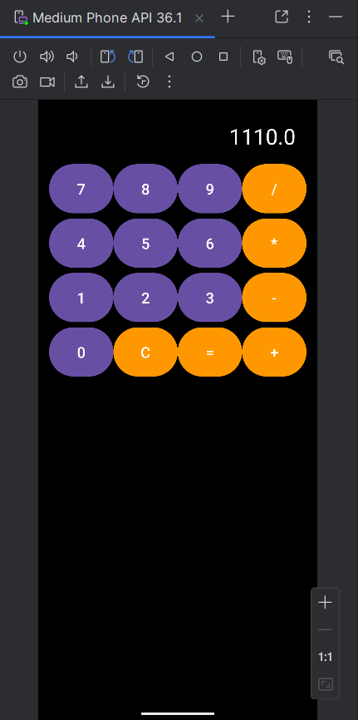

RESULT:

Thus, a Calculator application was successfully designed and developed using Android Studio,
and basic arithmetic operations were performed based on user input.

EX NO:2 | TO-DO LIST(KOTLIN) USING ANDROID STUDIO
DATE:

AIM:
To design and develop a To-Do List mobile application using Kotlin in Android Studio that
enables users to create, store, and manage their daily tasks efficiently.

ALGORITHM:
- Start the app.
- Enter task in input field.
- Click Add button.
- Store task in ArrayList.
- Display tasks in ListView.
- Stop the app.

PROGRAM:
- activity_main.xml

<LinearLayout xmlns:android="http://schemas.android.com/apk/res/android"
android:orientation="vertical"
android:padding="20dp"
android:layout_width="match_parent"
android:layout_height="match_parent">

<EditText
android:id="@+id/taskInput"
android:hint="Enter Task"
android:layout_width="match_parent"
android:layout_height="wrap_content"/>

<Button
android:text="Add Task"
android:onClick="addTask"
android:layout_width="match_parent"
android:layout_height="wrap_content"/>

<ListView
android:id="@+id/listView"
android:layout_width="match_parent"
android:layout_height="wrap_content"/>

</LinearLayout>
- MainActivity.kt

package com.example.todo

import android.os.Bundle
import android.view.View
import android.widget.*
import androidx.appcompat.app.AppCompatActivity

class MainActivity : AppCompatActivity() {

lateinit var listView: ListView
lateinit var input: EditText
lateinit var tasks: ArrayList<String>
lateinit var adapter: ArrayAdapter<String>

override fun onCreate(savedInstanceState: Bundle?) {
super.onCreate(savedInstanceState)
setContentView(R.layout.activity_main)

listView = findViewById(R.id.listView)
input = findViewById(R.id.taskInput)

tasks = ArrayList()
adapter = ArrayAdapter(this,
android.R.layout.simple_list_item_1, tasks)

listView.adapter = adapter
}

fun addTask(view: View){
tasks.add(input.text.toString())
adapter.notifyDataSetChanged()
input.text.clear()
}
}

OUTPUT:

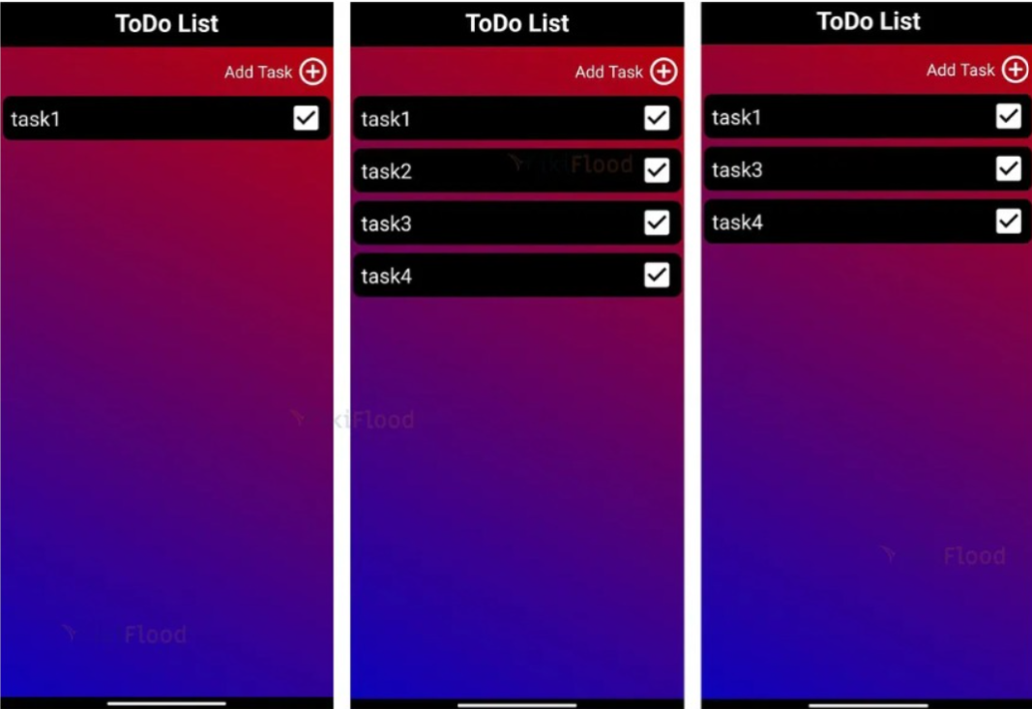

RESULT:

Ex.No:3 | RECIPE FINDER APP
DATE:

AIM:
To develop a Recipe Finder Android Application using Android Studio that allows users to browse
and view recipe details based on their selection.
ALGORITHM:
- Start the app.
- Display recipe list.
- User selects recipe.
- Show ingredients & steps.
- Stop the app.
PROGRAM:
- activity_main.xml

<LinearLayout xmlns:android="http://schemas.android.com/apk/res/android"
android:orientation="vertical"
android:padding="20dp"
android:layout_width="match_parent"
android:layout_height="match_parent">

<Spinner
android:id="@+id/spinner"
android:layout_width="match_parent"
android:layout_height="wrap_content"/>

<TextView
android:id="@+id/details"
android:textSize="18sp"
android:layout_marginTop="20dp"
android:layout_width="wrap_content"
android:layout_height="wrap_content"/>

</LinearLayout>

- MainActivity.java

package com.example.recipe;

import android.os.Bundle;
import android.widget.*;
import androidx.appcompat.app.AppCompatActivity;

public class MainActivity extends AppCompatActivity {

Spinner spinner;
TextView details;

String[] recipes = {"Dosa","Pongal","Biryani"};

@Override
protected void onCreate(Bundle b){
super.onCreate(b);
setContentView(R.layout.activity_main);

spinner = findViewById(R.id.spinner);
details = findViewById(R.id.details);

ArrayAdapter<String> ad =
new ArrayAdapter<>(this,
android.R.layout.simple_spinner_item, recipes);

spinner.setAdapter(ad);

spinner.setOnItemSelectedListener(
new AdapterView.OnItemSelectedListener() {
@Override
public void onItemSelected(
AdapterView<?> p, android.view.View v,
int i, long l) {

if(i==0)
details.setText("Dosa:\nRice + Dal");
else if(i==1)
details.setText("Pongal:\nRice + Pepper");
else
details.setText("Biryani:\nRice + Chicken");
}

public void onNothingSelected(
AdapterView<?> p){}
});
}
}

OUTPUT:
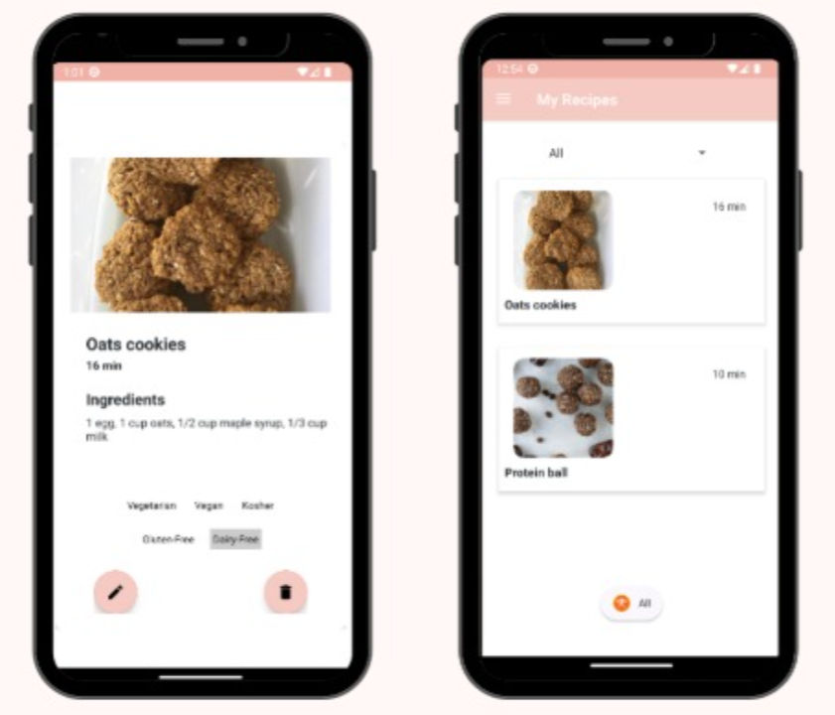

RESULT:

Ex.No:4 | QUIZ APP
DATE:

AIM:
To design and implement a Quiz Application using Android Studio that presents multiple-
choice questions to users and evaluates their responses.

ALGORITHM:
- Start the app.
- Display question & options.
- User selects answer.
- Check correctness.
- Display score.
- Stop the app.

PROGRAM:
- activity_main.xml

<LinearLayout xmlns:android="http://schemas.android.com/apk/res/android"
android:orientation="vertical"
android:padding="20dp"
android:layout_width="match_parent"
android:layout_height="match_parent">

<TextView
android:text="Capital of India?"
android:textSize="20sp"
android:layout_width="wrap_content"
android:layout_height="wrap_content"/>

<RadioGroup android:id="@+id/group">

<RadioButton android:id="@+id/op1"
android:text="Delhi"/>
<RadioButton android:id="@+id/op2"
android:text="Chennai"/>
<RadioButton android:id="@+id/op3"
android:text="Mumbai"/>
<RadioButton android:id="@+id/op4"
android:text="Kolkata"/>

</RadioGroup>

<Button
android:text="Submit"
android:onClick="checkAnswer"
android:layout_width="wrap_content"
android:layout_height="wrap_content"/>

<TextView
android:id="@+id/result"
android:textSize="18sp"
android:layout_width="wrap_content"
android:layout_height="wrap_content"/>

</LinearLayout>

- MainActivity.java

package com.example.quiz;

import android.os.Bundle;
import android.view.View;
import android.widget.*;
import androidx.appcompat.app.AppCompatActivity;

public class MainActivity extends AppCompatActivity {

RadioGroup group;
TextView result;

@Override
protected void onCreate(Bundle b){
super.onCreate(b);
setContentView(R.layout.activity_main);

group = findViewById(R.id.group);
result = findViewById(R.id.result);
}

public void checkAnswer(View v){
int id = group.getCheckedRadioButtonId();

if(id == R.id.op1)
result.setText("Correct Answer");
else
result.setText("Wrong Answer");
}
}

OUTPUT:

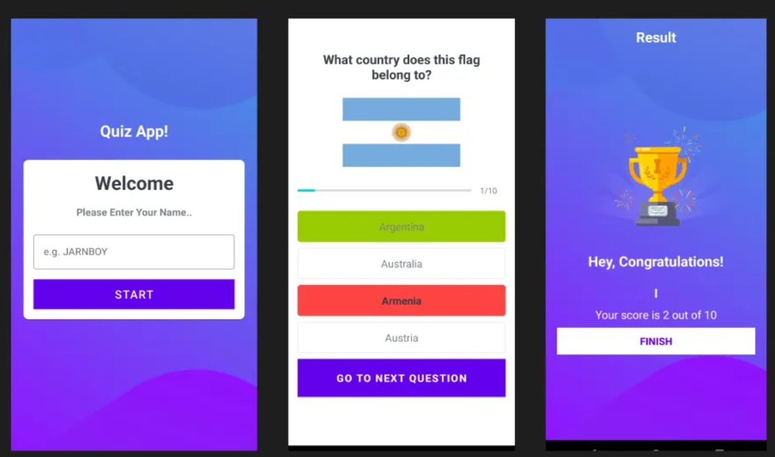

RESULT:

EX NO:5 | MOVIE DISCOVERY APP
DATE:

AIM:
To design and develop a Movie Discovery Web Application using React.js that allows users
to search and view movie titles dynamically based on user input.

SOFTWARE REQUIREMENTS
- Operating System: Windows / Linux / macOS
- Frontend Framework: React.js
- Programming Language: JavaScript (ES6)
- Runtime Environment: Node.js
- Package Manager: npm
- Code Editor: Visual Studio Code
- Web Browser: Google Chrome / Edge

ALGORITHM
- Start the application
- Create a React project using Create React App
- Design the user interface for movie search
- Accept movie name input from the user
- Store movie list data using React useState
- Filter movie list based on search input
- Display matching movie names dynamically
- Update results as user types
- Stop the application

INSTALLATION PROCESS
- Install Node.js on the system
- Verify installation using:
- node -v
- npm -v
- Create a new React project:
- npx create-react-app movie-discovery
- Navigate to the project directory:
- cd movie-discovery
- Start the React application:
- npm start
- Open the browser and access:
- http://localhost:3000

PROGRAM
App.js
import { useState } from "react";

function App() {
const [search, setSearch] = useState("");

const movies = [
"Inception",
"Interstellar",
"Avengers",
"Titanic",
"Avatar",
"Jurassic Park",
"The Dark Knight"
];

const filteredMovies = movies.filter(movie =>
movie.toLowerCase().includes(search.toLowerCase())
);

return (
<div style={{ padding: "20px" }}>
<h2>Movie Discovery App</h2>

<input
type="text"
placeholder="Search Movie"
value={search}
onChange={(e) => setSearch(e.target.value)}
/>

<ul>
{filteredMovies.map((movie, index) => (
<li key={index}>{movie}</li>
))}
</ul>
</div>
);
}

export default App;

OUTPUT:

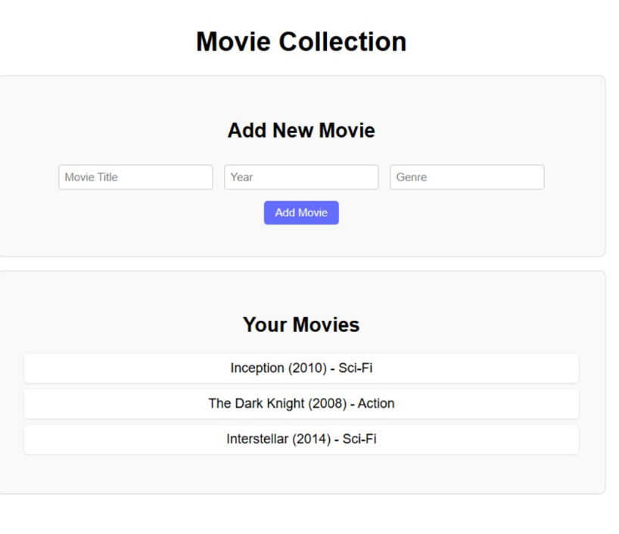

RESULT:.

EX NO:6 | SOCIAL MEDIA APP
DATE:

AIM:
To design and develop a Social Media Web Application using React.js that allows users to
create posts and view them dynamically in a feed.

SOFTWARE REQUIREMENTS:
- Operating System: Windows / Linux / macOS
- Frontend Framework: React.js
- Programming Language: JavaScript (ES6)
- Runtime Environment: Node.js
- Package Manager: npm
- Code Editor: Visual Studio Code
- Web Browser: Google Chrome / Edge

ALGORITHM:
- Start the application
- Create a React project using Create React App
- Design components for:
- Post Input Section
- Post Feed Section
- Accept post content from the user
- Store posts using React useState
- Add new posts to the feed
- Display all posts dynamically
- Update the feed whenever a new post is added
- Stop the application

INSTALLATION PROCESS:
- Install Node.js on the system
- Verify installation:
- node -v
- npm -v
- Create a new React application:
- npx create-react-app social-media-app
- Navigate to project folder:
- cd social-media-app
- Start the application:
- npm start
- Open browser and visit:
- http://localhost:3000

PROGRAM:
App.js
import { useState } from "react";

function App() {
const [post, setPost] = useState("");
const [posts, setPosts] = useState([]);

const addPost = () => {
if (post) {
setPosts([post, ...posts]);
setPost("");
}
};

return (
<div style={{ padding: "20px" }}>
<h2>Social Media App</h2>

<textarea
placeholder="What's on your mind?"
value={post}
onChange={(e) => setPost(e.target.value)}
/>

<br />

<button onClick={addPost}>Post</button>

<hr />

<h3>Feed</h3>
<ul>
{posts.map((item, index) => (
<li key={index}>{item}</li>
))}
</ul>
</div>
);
}

export default App;

OUTPUT:

RESULT:

EX NO:7 | FITNESS TRAKER
DATE:

AIM:
To design and develop a Fitness Tracker Web Application using React.js that allows users to
track their daily fitness activities such as workouts, calories burned, and exercise duration through
an interactive user interface.

SOFTWARE REQUIREMENTS
- Operating System: Windows / Linux / macOS
- Frontend: React.js
- Language: JavaScript (ES6)
- Runtime: Node.js
- Package Manager: npm
- Code Editor: Visual Studio Code
- Browser: Google Chrome / Edge

ALGORITHM
- Start the application
- Create a React project using Create React App
- Design UI components such as:
- Activity Input Form
- Activity List
- Summary Section
- Accept user input for:
- Exercise name
- Duration
- Calories burned
- Store activity data using React useState
- Display entered activities dynamically
- Calculate total calories burned
- Render updated results on the UI
- Stop the application

INSTALLATION PROCESS:

- Install Node.js from the official website
- Verify installation using command:
- node -v
- npm -v
- Create a new React application:
- npx create-react-app fitness-tracker
- Navigate to project folder:
- cd fitness-tracker
- Start the React development server:
- npm start
- Open browser and access:
- http://localhost:3000

PROGRAM
App.js
import { useState } from "react";

function App() {
const [activity, setActivity] = useState("");
const [calories, setCalories] = useState("");
const [list, setList] = useState([]);

const addActivity = () => {
if (activity && calories) {
setList([...list, { activity, calories: Number(calories) }]);
setActivity("");
setCalories("");
}
};

const totalCalories = list.reduce((sum, item) => sum + item.calories, 0);

return (
<div style={{ padding: "20px" }}>
<h2>Fitness Tracker</h2>

<input
type="text"
placeholder="Activity Name"
value={activity}
onChange={(e) => setActivity(e.target.value)}
/>

<input
type="number"
placeholder="Calories Burned"
value={calories}
onChange={(e) => setCalories(e.target.value)}
/>

<button onClick={addActivity}>Add</button>

<ul>
{list.map((item, index) => (
<li key={index}>
{item.activity} - {item.calories} calories
</li>
))}
</ul>

<h3>Total Calories Burned: {totalCalories}</h3>
</div>
);
}

export default App;

OUTPUT:

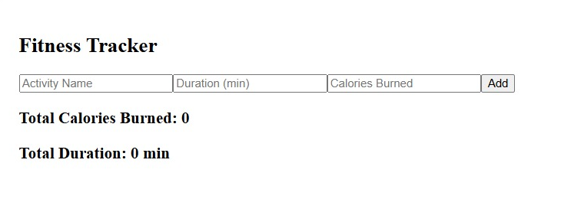

RESULT:

EX NO:8 | EVENT PLANNING APP
DATE:

AIM:
To design and develop an Event Planning Web Application using React.js that allows users
to create, view, and manage events with details such as event name, date, and location.

SOFTWARE REQUIREMENTS
- Operating System: Windows / Linux / macOS
- Frontend: React.js
- Language: JavaScript (ES6)
- Runtime Environment: Node.js
- Package Manager: npm
- Code Editor: Visual Studio Code
- Browser: Google Chrome / Edge

ALGORITHM
- Start the application
- Create a React project using Create React App
- Design UI components for:
  - Event Input Form
  - Event List Display
- Accept user inputs:
  - Event name
  - Event date
  - Event location
- Store event data using React useState
- Display added events dynamically
- Allow multiple event entries
- Render updated event list on the screen
- Stop the application

INSTALLATION PROCESS
- Install Node.js on the system
- Verify Node and npm installation:
- node -v
- npm -v
- Create a new React project:
- npx create-react-app event-planner
- Navigate to project directory:
- cd event-planner
- Start the application:
- npm start
- Open the browser and go to:
- http://localhost:3000

PROGRAM

App.js
import { useState } from "react";

function App() {
const [name, setName] = useState("");
const [date, setDate] = useState("");
const [location, setLocation] = useState("");
const [events, setEvents] = useState([]);

const addEvent = () => {
if (name && date && location) {
setEvents([...events, { name, date, location }]);
setName("");
setDate("");
setLocation("");
}
};
return (
<div style={{ padding: "20px" }}>
<h2>Event Planning App</h2>

<input
type="text"
placeholder="Event Name"
value={name}
onChange={(e) => setName(e.target.value)}
/>

<input
type="date"
value={date}
onChange={(e) => setDate(e.target.value)}
/>

<input
type="text"
placeholder="Location"
value={location}
onChange={(e) => setLocation(e.target.value)}
/>

<button onClick={addEvent}>Add Event</button>

<ul>
{events.map((event, index) => (
<li key={index}>
{event.name} | {event.date} | {event.location}
</li>
))}
</ul>
</div>
export default App;
OUTPUT:

RESULT:

