EX.NO: 2 CREATING A WEBPAGE WITH CASCADING STYLE SHEET

DATE :

AIM:

To create a webpage with the following using html to embedded the style sheet

ALGORITHM:

- Create an HTML file (index.html).
- Design the webpage using HTML tags.
- Create a CSS file (style.css).
- Link the CSS file to the HTML file.
- Apply styles using CSS.
- Save both files.
- Open the HTML file in a web browser.
- Verify the webpage output.

PROGRAM:
HTML (index.html)
<!DOCTYPE html>
<html>
<head>
<title>My Webpage</title>
<link rel="stylesheet" href="style.css">
</head>
<body>

<header>
<h1>Welcome to My Website</h1>
</header>
<nav>
<a href="#">Home</a>
<a href="#">About</a>
<a href="#">Services</a>
<a href="#">Contact</a>
</nav>
<section>
<h2>About This Page</h2>
<p>This webpage is designed using HTML and styled with CSS.</p>
</section>
<footer>
<p>&copy; 2026 My Website. All Rights Reserved.</p>
</footer>

</body>
</html>

style.css

body {
font-family: Arial, sans-serif;
background-color: #f4f4f4;
margin: 0;
padding: 0;
}

header {
background-color: #007BFF;
color: white;
text-align: center;
padding: 20px;
}

nav {
background-color: #333;
padding: 10px;
text-align: center;
}

nav a {
color: white;
text-decoration: none;
margin: 15px;
font-weight: bold;
}

nav a:hover {
color: yellow;
}

section {
padding: 20px;
background-color: white;
margin: 20px;
border-radius: 8px;
}

footer {
background-color: #007BFF;
color: white;
text-align: center;
padding: 10px;
position: fixed;
bottom: 0;
width: 100%;
}

OUTPUT:

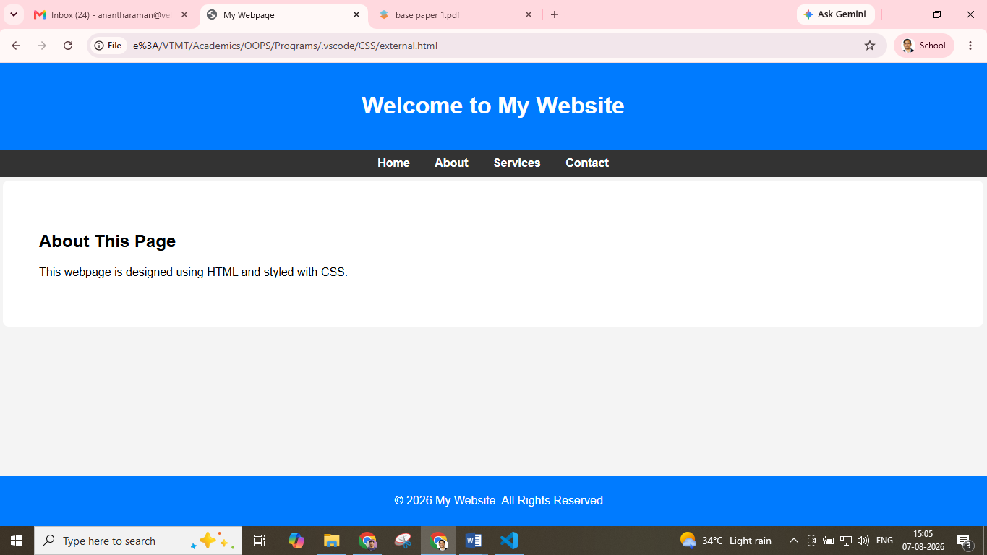

RESULT: Thus creation of an webpage using cascading style sheet has been developed successfully.

