EX.NO :3 CLIENT SIDE SCRIPTS for validating web form control using DHTML
DATE:

AIM:

To develop a program for validating web form control using DHTML.

ALGORITHM:

Step1:Start the program.
Step2: Define the title within the tag.
Step3: Give the script type within the script tag.
Step4: Validate each and every column as the box with the if condition.
Step5: If empty value are given or the block term are next then it is verified with certain condition.
Step6:If values is empty then a message is been displayed.
Step7: Form is designed with GUI tool is description.
Step8: All buttons are processed accordingly.
Step9: Stop the program.

PROGRAM:

//Webforms.html
<html>
<head>
<script type='text/javascript'> function formValidator()
{
var firstname=document.getElementById('firstname'); var lastname=document.getElementById('lastname'); var addr=document.getElementById('addr');
var zip=document.getElementById('zip'); var
Countries=document.getElementById('Countries'); var username=document.getElementById('username'); var email=document.getElementById('email');
var dd=document.getElementById('dd'); var mm=document.getElementById('mm');
var yyyy=document.getElementById('yyyy'); var
comment=document.getElementById('comment');var password=document.getElementById('password'); if(isAlphabet(firstname,"Please enter only letters for your First name"))
{
if(isAlphabet(lastname,"Please enter only letters for your Last name"))
{
if(isNumeric(dd,"Please enter a date"))
{
if(madeSelection(mm,"Please Choose"))
if(isNumeric(yyyy,"Please enter a year"))
{
if(isAlphanumeric(addr,"Enter Numbers and letters only for address"))
{
if(isNumeric(zip,"please enter a valid zip code"))
{
if(madeSelection(Countries,"Please Choose"))
{
if(lengthRestriction(username,6,8))
{
if(isAlphanumeric(password,"Enter Numbers and letters only for password"))
{
if(emailValidator(email,"Please enter a valid email address"))
{
if(notEmpty(comment,"Please fill the comment"))
{
document.write("<b><i>Thank's for submitting your details</i></b>");alert("Successful Entry!!");
return true;
}}}}}}}}}}}}
return false;
}
function notEmpty(elem,helperMsg)
{
if(elem.value.length==0)
{
alert(helperMsg)
;elem.focus(); return false;
}
return true;
}
function isNumeric(elem,helperMsg)
{
var numericExpression=/^[0-9]+$/; if(elem.value.match(numericExpression))
{
return true;
}
else
{
alert(helperMsg)
;elem.focus(); return false;
}
}
function isAlphabet(elem,helperMsg)
{
var alphaExp=/^[a-zA-Z]+$/; if(elem.value.match(alphaExp)
)
return true;
}
else
{
alert(helperMsg); elem.focus()
;return false;
}
}
function isAlphanumeric(elem,helperMsg)
{
var alphaExp=/^[0-9, a-z a-z, 0-9, A-Z A-Z, - 0-9 .
]+$/;if(elem.value.match(alphaExp))
{
return true;
}
else
{
alert(helperMsg)
;elem.focus(); return false;
}
}
function lengthRestriction(elem,min,max)
{
var unput=elem.value; if(unput.length>=min&&unput.length<=max)
{
return true;
}
else
{
alert("Please enter between "+min+" and "+max+" charactters");elem.focus();
return false;
}
}
function madeSelection(elem,helperMsg)
{
if(elem.value=="Please Choose")
{
alert(helperMsg)
;elem.focus(); return false;
}
else
{
return true;
}
}
function emailValidator(elem,helperMsg)
var emailExp=/^[0-9 a-z . a-z 0-9]+\@[a-z]+\.[a-z]{2,4}$/;if(elem.value.match(emailExp))
{
return true;
}
else
{
alert(helperMsg)
;elem.focus(); return false;
}
}
</script>
<h1><center><b><font color="#347235">Please Enter YourDetails</font></b></center></h1>
</head>
<body bgcolor="LIGHTGREEN">
<hr>
<form onsubmit='return formValidator()' height="50%">
<table height="50%" border="3pt" align="center">
<tr><td><b><font color="#347235">First Name:</font></b></td><td><inputtype='text' id='firstname'/></td></tr><br />
<tr><td><b><font color="#347235">Last Name:</font></b></td><td><inputtype='text' id='lastname'/></td></tr><br
/>
<tr><td><b><font color="347235">Date of Birth(dd/mm/yyyy):</font></b></td><td><input type='text' id='dd' />
<select id='mm'>
<option>Please Choose</option>
<option value="1">Jan</option>
<option value="2">Feb</option>
<option value="3">Mar</option>
<option value="4">Apr</option>
<option value="5">May</option>
<option value="6">Jun</option>
<option value="7">Jul</option>
<option value="8">Aug</option>
<option value="9">Sep</option>
<option value="10">Oct</option>
<option value="11">Nov</option>
<option value="12">Dec</option>
</select>
<input type='text' id='yyyy' /></td></tr><br />

<tr><td><b><font color="#347235">Address:</font></b></td><td><inputtype='text' id='addr'/></td></tr><br />
<tr><td><b><font color="#347235">Zip code:</font></b></td><td><inputtype='text' id='zip'/></td></tr><br />
<tr><td><b><font
color="#347235">Countries:</font></b></td><td><selectid='Countries'>
<option>Please Choose</option>
<option value="United Kingdom">United Kingdom</option>
<option value="Afghanistan">Afghanistan</option>
<option value="America">America</option>
<option value="India">India</option>
<option value="Tanzania">Tanzania</option>
<option value="Zimbabwe">Zimbabwe</option>
<option value="Switzerland">Switzerland</option>
</select></td></tr><br />
<tr><td><b><font color="#347235">Username(6-8 characters):</font></b></td><td><input type='text' id='username'
/></td></tr><br />
<tr><td><b><font color="#347235">Password:</font></b></td><td><inputtype='password' id='password' /></td></tr><br />
<tr><td><b><font color="#347235">Email:</font></b></td><td><inputtype='text' id='email' /></td></tr><br />

<tr><td><b><font color="#347235">Comment:</font></b></td><td><textarea id='comment'cols="20"rows="5" name="Address"></textarea></td></tr><br />
<tr><td><input type='submit' value='Check Form' /></td></tr>
</table>
</form>
</body></html>

OUTPUT:

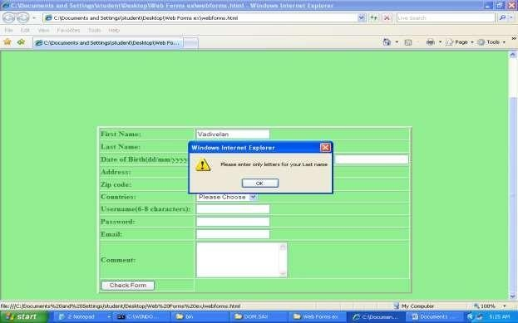

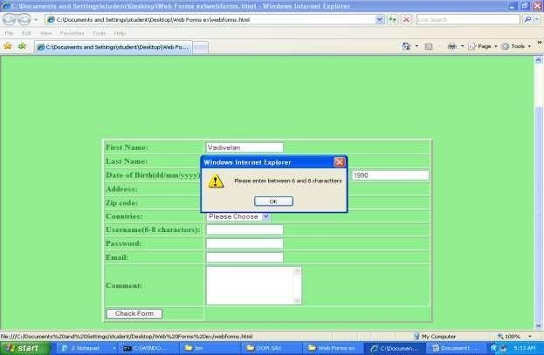

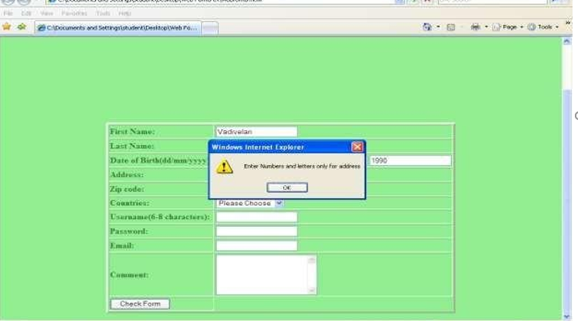
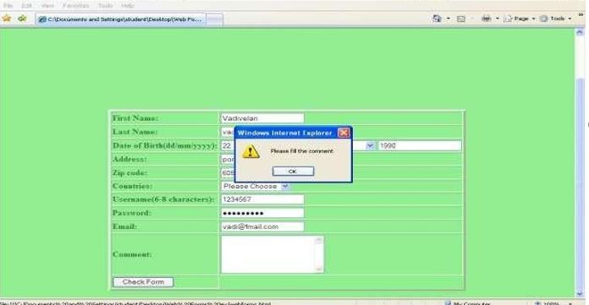

RESULT :

Thus developing client side scripts for validating web from controls using DHTML has been verified.

