Create a new project: Django_Demo1:

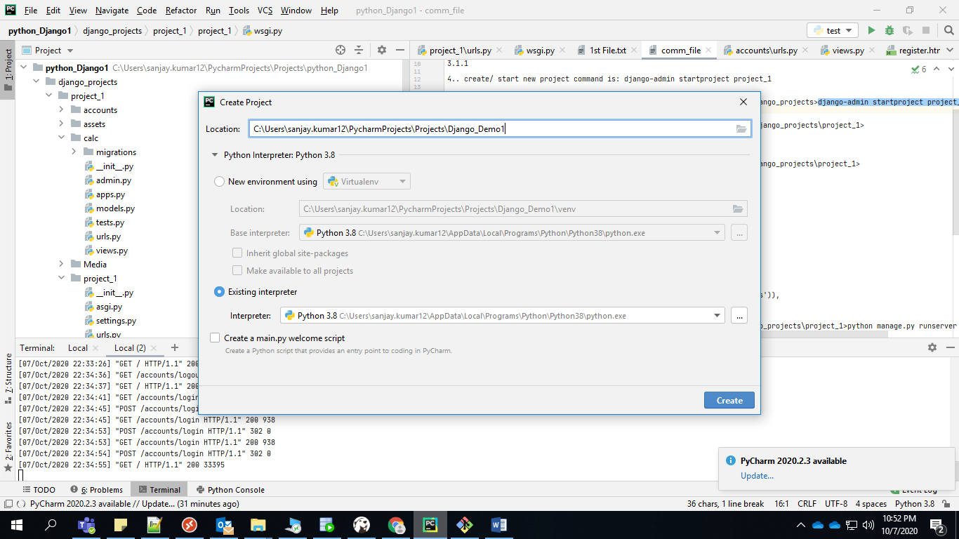

Step2: create virtual environment:

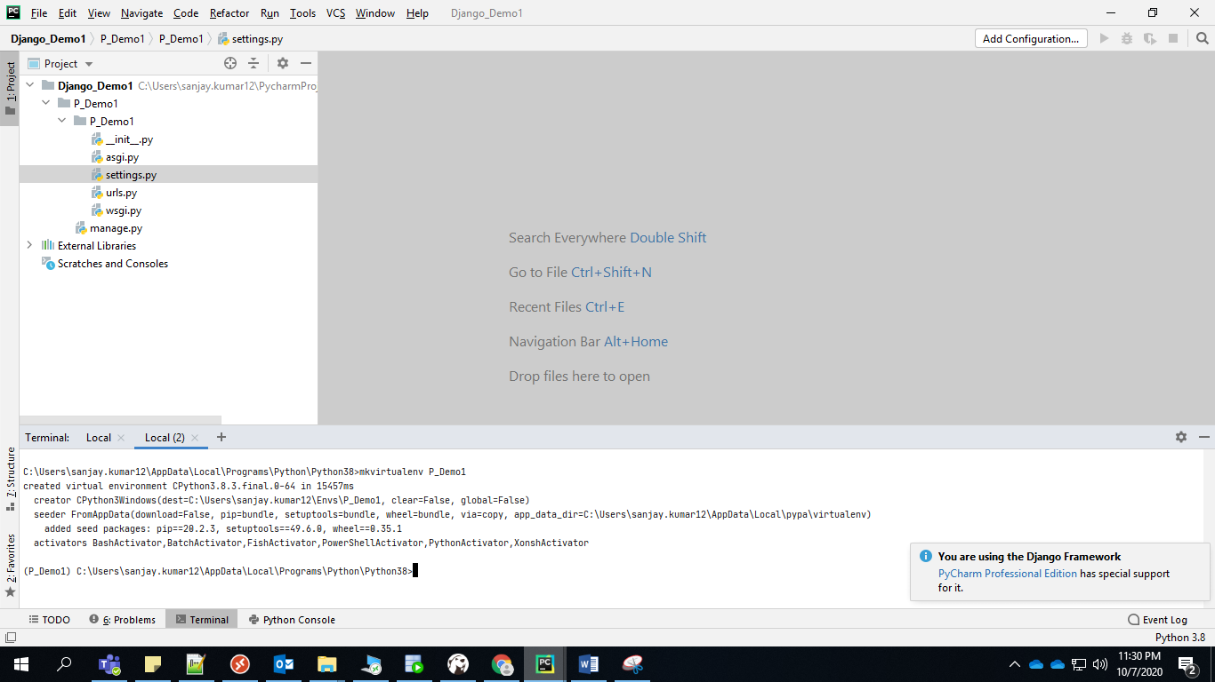

Step3: create new project and setup: workon virtual env: ( P_Demo1)

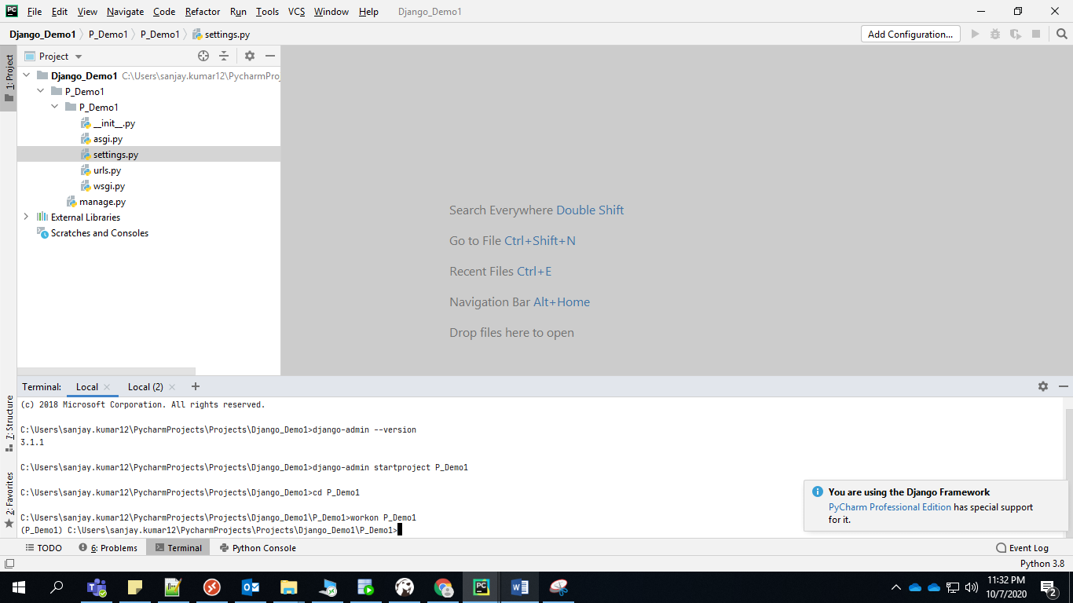

Step4: Plan project:

Project Name: PeopleSoft App:

Home Page:

Account : Create user ( Registration )

Login Page ( Authentication )