Software Requirements Specification (SRS)

Restaurant Ordering System

Prepared by : Sanjay Kumar D K
Date : 2024-11-14

1. Introduction

1.1 Purpose
The purpose of this document is to define the software requirements for the Restaurant Ordering System. This system will be used by restaurants to manage customer orders, calculate bills with taxes, handle order processing, and manage customer data. The system will be console-based and will feature functionalities like adding menu items, viewing order totals, and concurrent order processing.

1.2 Scope
The system will be designed for small to medium-sized restaurants to manage orders and customer information efficiently. The following core functionalities will be included:
- Menu management
- Order processing
- Bill calculation with taxes
- Concurrent processing of customer orders
- Exception handling for invalid or out-of-stock items
- Data persistence using file handling and database (JDBC)

1.3 Definitions, Acronyms, and Abbreviations
- MenuItem: A class representing a menu item (e.g., food or drink).
- Order: A collection of menu items placed by a customer.
- Customer: A class representing a customer making an order.
- JDBC: Java Database Connectivity for managing database operations.
- ArrayList: A resizable array implementation for storing orders.
- HashMap: A collection used for storing menu items and their details.

2. System Overview
The system will allow customers to select menu items, create orders, calculate total amounts, and display receipts with taxes. The application will handle concurrent order processing using multithreading to improve performance and responsiveness.

2.1 Features
- Menu Item Management: Ability to add, modify, or remove items from the menu.
- Order Management: Add items to orders, view totals, and calculate bills with taxes.
- Concurrency: Use multithreading to process multiple customer orders simultaneously.
- Database Integration: Use JDBC to store and retrieve customer and order information.
- Error Handling: Ensure that invalid orders, out-of-stock items, and other errors are handled gracefully.

3. Functional Requirements

3.1 Core Packages and Classes

Admin:
Includes classes like Admin,AdminActions,AdminImpl,Main.
Customer:
Includes classes like Customer,CustomerDAO,CustomerDAOImpl,CustomerOrder.
Database:
Includes classes like DBConnection,FileManager
Order:
Includes classes like Order ,OrderItem.OrderItemsDAO,OrderItemsDAOImpl,OrderManager,OrderProcessor,OrdersDAO,OrdersDAOImpl
Menu:
Includes classes like Beverage, Maincourse, MenuItem

3.2 Inheritance and Polymorphism

MenuItem Inheritance:
- Beverage: Inherits from MenuItem and overrides the getPrice() method to include any beverage-specific pricing rules.
- MainCourse: Inherits from MenuItem and overrides the getPrice() method to include any main course-specific pricing rules.

Polymorphism:
- The getPrice() method of MenuItem will be overridden by specific subclasses (Beverage, MainCourse) to calculate the price in different ways, depending on the type of item.

3.3 Data Structures
- Menu Management: The menu will be stored in a HashMap where the item_id is the key and the MenuItem object is the value.
- Order Management: Orders will be stored in an ArrayList where each entry corresponds to a customer's order.

3.4 Exception Handling
- Invalid or out-of-stock items will raise exceptions that will be caught and handled appropriately.
- Exceptions like ItemNotFoundException, InsufficientStockException, and InvalidOrderException will be thrown and handled with user-friendly messages.

3.5 File Handling
- Menu and order data will be stored in files. Menu data will be retrieved when the system starts, and orders will be saved after each transaction.

3.6 Multithreading
- The system will allow multiple customers to place orders concurrently using Java's Thread or ExecutorService to process each order in separate threads.

3.7 User Interface
The system will display a console-based menu for interacting with the user. The interface will prompt the user to:
- View available menu items
- Add items to their order
- View the current order and total
- Proceed to checkout and generate the bill

4. Non-Functional Requirements

4.1 Performance
- The system should be able to handle up to 100 concurrent orders without significant delay in processing.

4.2 Usability
- The user interface should be simple and intuitive, with clear prompts and instructions for each action.

4.3 Reliability
- The system must ensure that orders are processed accurately and bills are calculated correctly. Errors like invalid entries or insufficient stock should be gracefully handled.

4.4 Maintainability
- The code should be modular, with separate classes for menu items, orders, customers, and database management.
- Proper documentation should be provided for future updates and maintenance.

4.5 Scalability
- The system should be able to scale if needed, for instance, to accommodate more menu items or higher order volumes.

4.6 Security
- Sensitive customer data (like email and phone numbers) should be protected using encryption methods if stored in the database.

5. System Architecture

5.1 Database Design

MenuItems Table
Column | Data Type | Description
item_id | INT | Unique identifier for the item.
item_name | VARCHAR(100) | Name of the menu item.
item_type | VARCHAR(50) | Type of menu item (e.g., Beverage).
price | DECIMAL(10, 2) | Price of the item.
available_stock | INT | Number of items available in stock.

Orders Table
Column | Data Type | Description
order_id | INT | Unique identifier for the order.
customer_id | INT | References the customer who placed the order.
order_date | DATETIME | Date and time when the order was placed.
total_amount | DECIMAL(10, 2) | Total amount for the order, including taxes.
status | VARCHAR(50) | Status of the order (e.g., "Completed").

OrderItems Table
Column | Data Type | Description
order_item_id | INT | Unique identifier for each order item.
order_id | INT | References the order to which the item belongs.
item_id | INT | References the menu item ordered.
quantity | INT | Quantity of the menu item ordered.

Customers Table
Column | Data Type | Description
customer_id | INT | Unique identifier for each customer.
name | VARCHAR(100) | Name of the customer.
email | VARCHAR(100) | Email address of the customer.
phone | VARCHAR(15) | Contact number of the customer.

5.2 Multithreading Implementation
- OrderProcessor Thread: Each customer’s order will be processed in a separate thread.
- OrderQueue: A thread-safe queue will be used to manage orders that are being processed concurrently.

5.3 Database Integration (JDBC)
- Use JDBC to connect to the database, retrieve and store data related to menu items, orders, and customers.

6. External Interface Requirements

6.1 Hardware Interfaces
- No specific hardware interfaces are required as the system will run on a standard computer.

6.2 Software Interfaces
- Java 8 or higher
- JDBC for database connectivity
- Multithreading support for concurrent order processing

6.3 Communication Interfaces
- No specific communication interfaces are required; the system will interact with the user through the console.

7. Appendices

7.1 References
- Java Documentation for multithreading
- JDBC API Documentation
- MySQL or other relational database management systems

USE CASE DIAGRAM

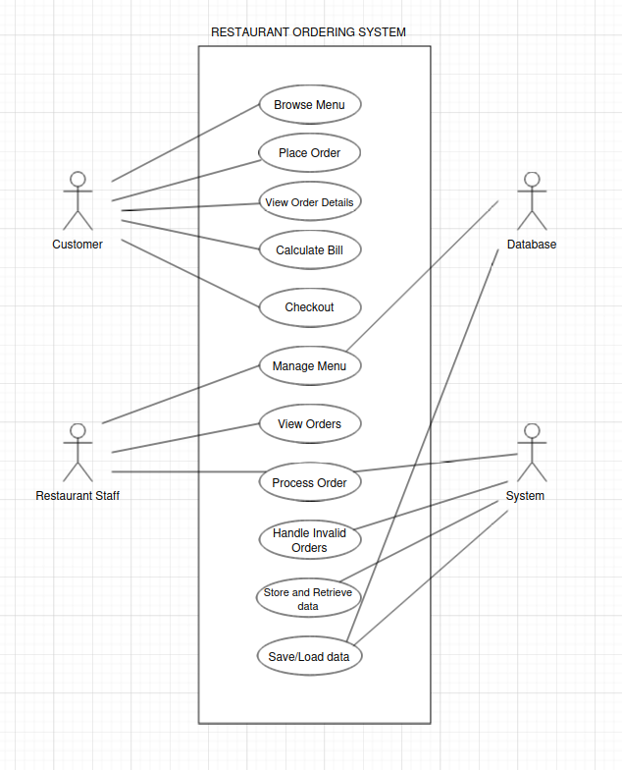

CLASS DIAGRAM

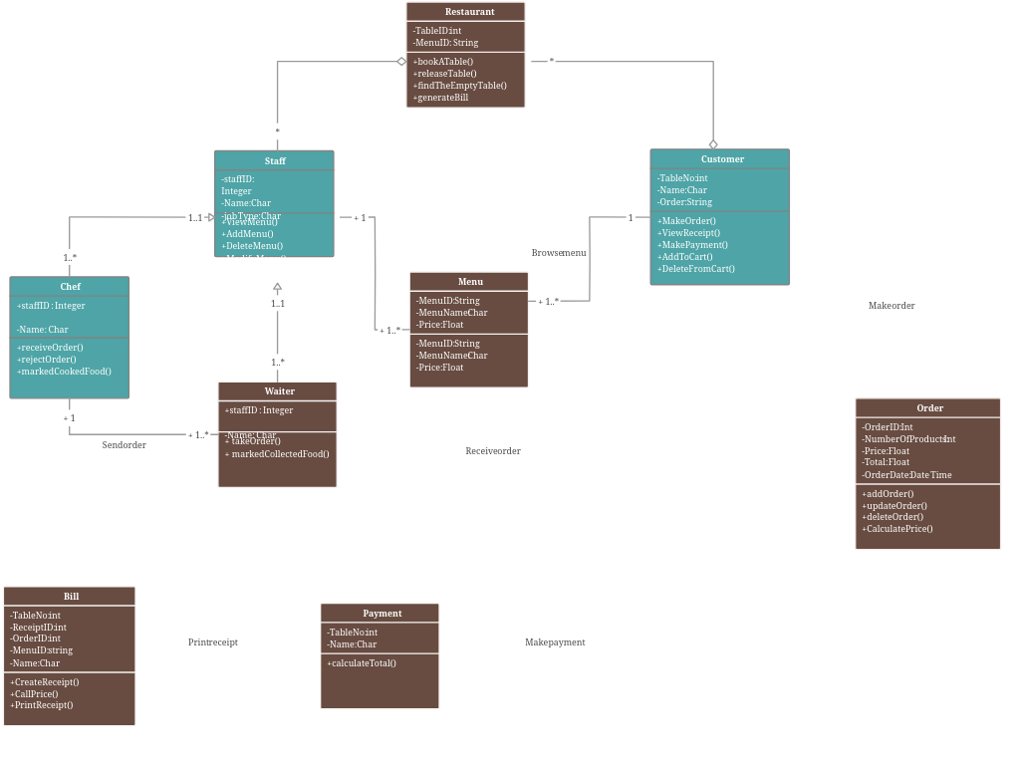

SCHEMA DIAGRAM

