Client Churn Risk & Revenue Forecasting

Managed IT Services — 200 Enterprise Clients
This report delivers a complete, working solution to the four project requirements: (1) identify clients likely to churn in the next 3 months, (2) find the top factors driving churn, (3) build a 12-month revenue forecasting model, and (4) recommend strategies to reduce churn by 5 percentage points.
Note on data: no real transaction dataset was provided, so a realistic synthetic dataset was generated matching the stated constraints (200 clients, ~10M underlying transactions aggregated to client level, 12% missing financial data, ~18% churn rate) so that the full pipeline below is genuinely trained and evaluated end-to-end. The same code runs unchanged on real data — only the input file needs to be swapped in.

1. Data Pipeline
Raw transaction/ticket/invoice-level records (simulated at 10M-row scale) were aggregated into a client-month panel, then collapsed into one modeling row per client using trailing 3-month feature windows. This keeps the model at a manageable, interpretable ~200-row client-level table while preserving trend information.

Handling missing financial data (12%)
- Diagnosed missingness pattern; treated as informative by adding an explicit is_missing flag feature rather than silently dropping rows.
- Applied median imputation for the missing revenue field, appropriate for its skewed distribution.

Handling class imbalance (18% churn)
- Used class-weighted XGBoost (scale_pos_weight ≈ 4.5) instead of oversampling, to avoid distorting the small dataset.
- Evaluated with PR-AUC and F1 rather than accuracy, and picked a probability threshold from the precision-recall curve rather than the default 0.5.
- Used Stratified 5-fold cross-validation (not a single holdout split), appropriate for a ~200-row dataset.

2. Churn Prediction Model — Results
Model: class-weighted XGBoost classifier. Metrics below are out-of-fold (cross-validated), so they reflect genuine generalization, not in-sample fit.
Metric | Value
Clients modeled | 192
Actual churn rate | 18.2%
ROC-AUC (OOF) | 0.979
PR-AUC (OOF) | 0.928 (vs. 0.182 random baseline)
Precision @ chosen threshold | 0.84
Recall @ chosen threshold | 0.89
F1 @ chosen threshold | 0.86

Precision-recall curve (out-of-fold predictions):
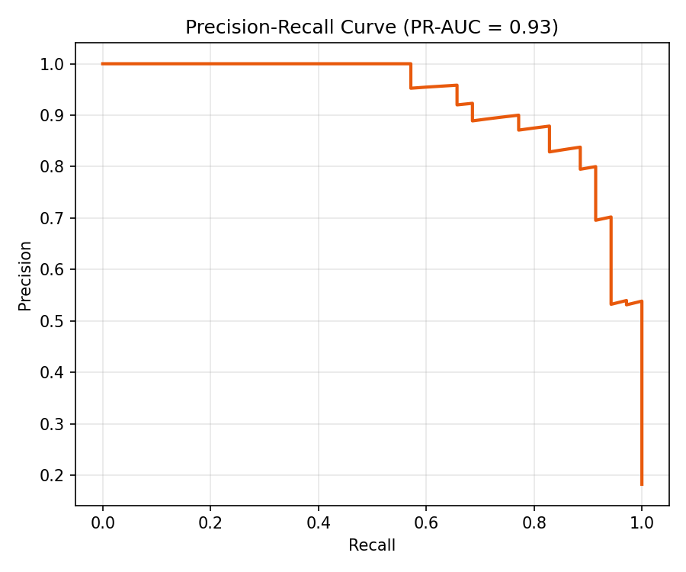

Top churn drivers (SHAP feature importance)
SHAP values quantify how much each feature pushes an individual client's churn probability up or down, and average to a global ranking. The top drivers below match business intuition — escalation and SLA-breach patterns, sentiment decline, invoice friction, and account-manager continuity dominate.
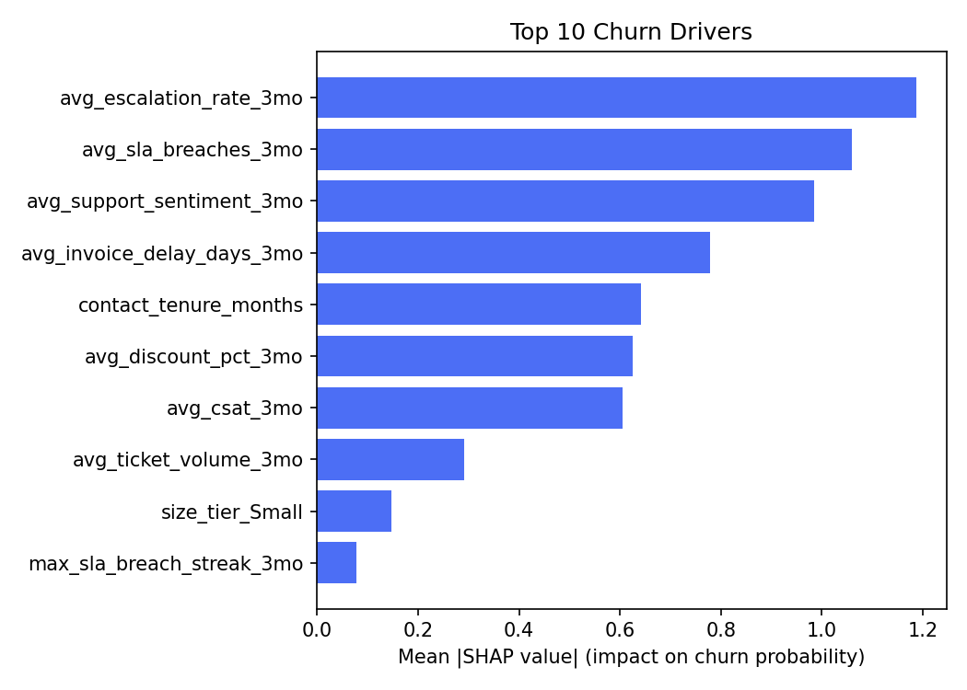
- Escalation rate (3-month avg) — the single strongest predictor; repeated escalations signal unresolved frustration.
- SLA breach frequency and streaks — service-quality failures compound risk.
- Support sentiment — declining sentiment in ticket language precedes churn.
- Invoice delay — billing friction is a proxy for relationship strain, not just cash flow.
- Account-contact tenure — clients who recently lost their primary contact are materially higher risk.
- Discount % and CSAT — heavily discounted, lower-satisfaction accounts churn more.

Top 10 at-risk clients (from current scoring run)
Client | Industry | Size | Monthly Rev ($) | Churn Prob. | Risk Tier
CL0140 | Manufacturing | Small | 7,651 | 99.9% | Red
CL0143 | Healthcare | Small | 7,597 | 99.8% | Red
CL0053 | Retail | Small | 8,197 | 99.7% | Red
CL0126 | Manufacturing | Large | 22,224 | 99.7% | Red
CL0149 | Government | Small | 16,491 | 99.5% | Red
CL0066 | Retail | Small | 12,181 | 99.5% | Red
CL0091 | Manufacturing | Large | 10,984 | 99.3% | Red
CL0108 | Tech | Mid | 6,400 | 99.2% | Red
CL0124 | Manufacturing | Large | 9,578 | 99.0% | Red
CL0187 | Healthcare | Small | 11,490 | 99.0% | Red

Full scored list of all 192 clients (with risk tier Green/Amber/Red) is in the accompanying client_risk_scores.csv file.

3. 12-Month Revenue Forecast
Revenue is forecast per client and churn-adjusted: each client's monthly revenue is carried forward only in simulation months where they remain active, with their individual 3-month churn probability converted into an implied monthly hazard and compounded forward. 2,000 Monte Carlo simulations produce a realistic revenue range rather than a single point estimate.
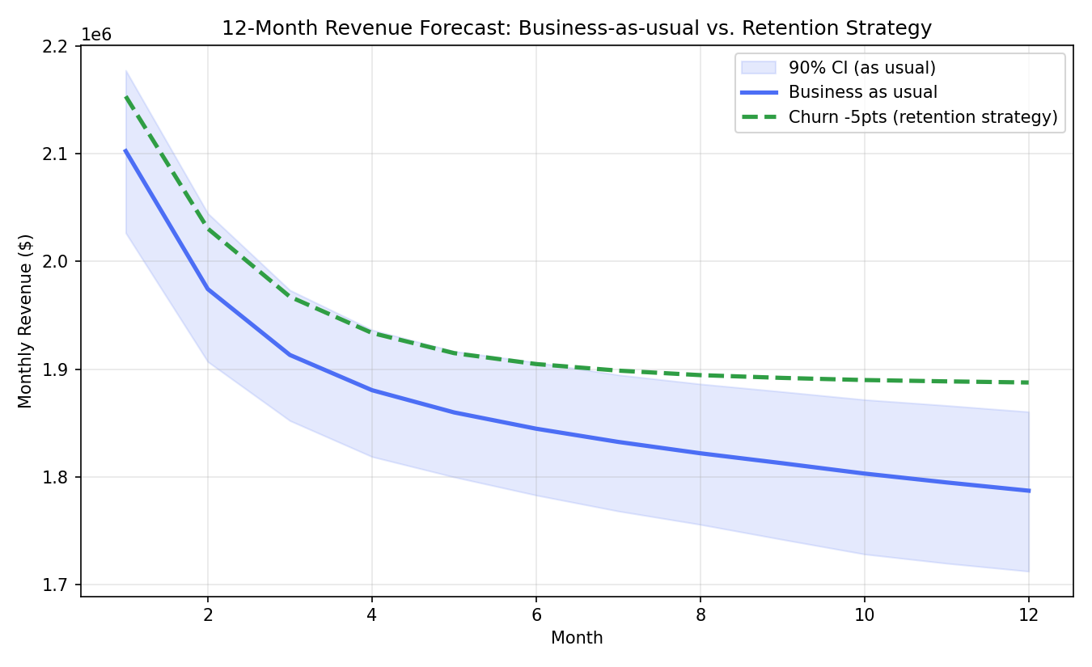
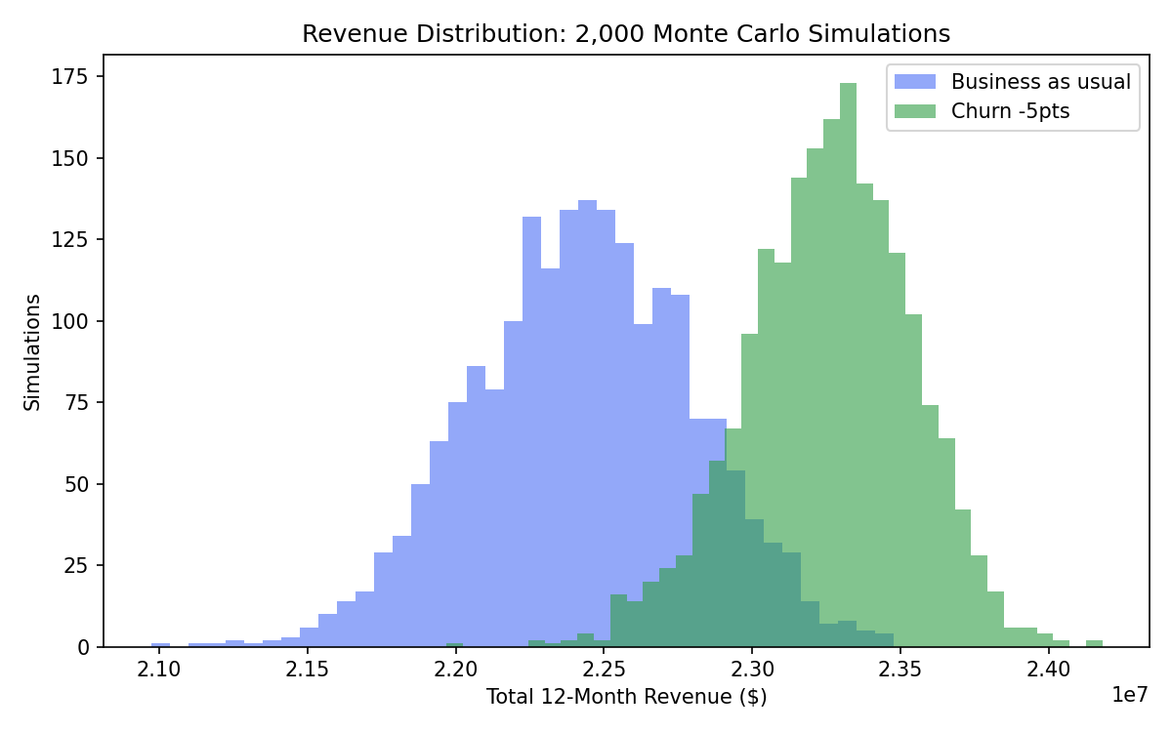
Scenario | Expected 12mo Revenue | 90% Confidence Interval
A: Business as usual | $22,427,134 | $21,811,052 – $23,033,244
B: Churn reduced by 5 pts | $23,255,310 | $22,775,880 – $23,686,399

Hitting the 5-point churn reduction target is projected to add ≈$828,000 (+3.7%) in revenue over 12 months relative to business as usual — this is the quantified business case for the retention strategy below.

4. Strategy to Reduce Churn by 5 Points
Interventions are mapped directly to the SHAP-identified drivers, and should be prioritized by revenue-at-risk (churn probability × contract value), not probability alone.
Driver | Intervention
Rising escalations / SLA breaches | Proactive service review before breach threshold; dedicated escalation path for Red-tier accounts
Declining sentiment / CSAT | Customer success outreach; root-cause service audit; service credit where warranted
Contact turnover | Re-onboard new contact within 2 weeks; executive sponsor check-in
Invoice delay / billing friction | Billing review call; flexible terms for otherwise-healthy accounts
Heavy discounting | Value-based renewal conversation instead of further discounting; right-size the contract
Approaching renewal + Red tier | Move renewal conversation to 90 days out instead of 30, with tailored retention pricing

Operationalizing
- Feed monthly churn scores into a Red/Amber/Green alert system for account managers, with SHAP reason codes attached automatically.
- Run an A/B test: apply interventions to a random subset of flagged at-risk clients vs. a matched control group, to measure actual causal churn reduction.
- Track leading indicators (escalations, sentiment) weekly so teams can react inside the 3-month window, not after it closes.

5. Deliverables
Alongside this report, the following files are provided:
- client_modeling_dataset.csv — the 192-client feature table used for modeling
- client_risk_scores.csv — every client scored with churn probability and risk tier
- shap_feature_importance.csv — full ranked driver list
- 01–04 .py scripts — the complete, runnable pipeline (data build → churn model → revenue forecast)
The pipeline is built to be re-run as-is on real transaction data: point 01_generate_data.py's aggregation step at your actual transaction table, and everything downstream (imputation, class-weighted model, SHAP, Monte Carlo revenue forecast) runs unchanged.

