
e-Yantra Robotics Competition 2022-23
Implementation Analysis: Functional RoadBot
FB_1558
Team leader name | Sanjay Varyani
College | Dharmsinh Desai University
Email | sanjayvaryani1@gmail.com
Date | 6 Jan 2023

Q1. State the scope of the theme assigned to you. [ 5 Marks ]

With the help of this theme we can work on the startup for the RoadBot which will solve the IRC (India Road Congress) problem, i.e. to pour the dump or pot holes of Indian roads on minimum time with proper maintenance of traffic signal.

This will reduce the hazardous road accident which are occurred due to potholes located in main road area.

Q2. Upload the Final Arena Image as per configuration given in the rulebook. [ 5 Marks ]

< Prepare the arena according to the steps given in Section 3: Arena, of the Rulebook. Your final arena should look like as shown in Figure 3.3.2 of Rulebook.
Take a photo from the top view of the complete arena such that the entire arena along with its components such as Deposition Containers are clearly visible in the photo.
Answer Format: The one image file should be inserted in this document as .jpg.>

Q3. Explain the components that you will be using to design the Dispensing Mechanism. Explain its working for the theme. Where will this mechanism be mounted on the robot (left, right, back, front)? Also justify your mounting strategy. [ 5 Marks ]

< Team should classify the components into various categories: mechanical systems, electronic systems etc. and mention how these units will be used in the theme. You may draw diagrams/figures to illustrate your answer.
Answer format: Bulleted form
1. Component 1
2. Component 2
3. ….etc. >

Q4. Will you be using IR proximity sensor(s) to detect the Deposition Containers? If yes, where are you going to place (left, right, back, front) Deposition Containers and what is your placement strategy? [ 5 Marks ]
< Answer in not more than 100 words
You can also draw some diagrams/figures to illustrate your answer in a better way.>

Q5. What challenges do you expect to encounter while designing the Dispensing Mechanism? How will you overcome them? [ 5 Marks ]
< Answer format:
Challenge 1:
Solution 1:
Challenge 2:
Solution 2:
….…etc. You can also draw some diagrams/figures to illustrate your answer in a better way.>

Q6. In this theme, we use the following formula as mentioned in Judging and Scoring section of Rulebook: [ 5 Marks ]

Consider the following scenario and use the above formula to calculate the total score. The given three inputs are as follows:
RCM_set = [2, 1, 9, 4, 5, 6, 7, 3, 8]
cell_map = %{ 1 => [2, 4],
2 => [1, 3],
3 => [6],
4 => [1, 5, 7],
5 => [4, 6, 8],
6 => [3, 5, 9],
7 => [4],
8 => [5, 9],
9 => [6, 8]
}
grid_image:
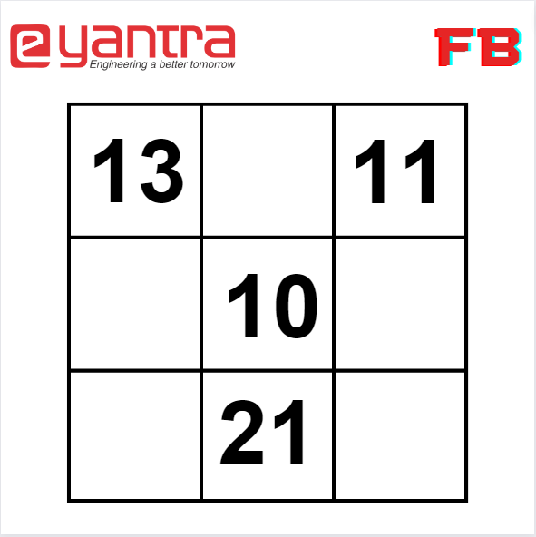
- After the image processing completion, following is the output shown in iex terminal:
  - [[“13”, "na", “11”], ["na", “10”, "na"], ["na", “21” ,"na"]]
- After finding the sum of subsets following is the output shown in iex terminal:
  - %{10 => [[3, 6, 1]], 11 =>[[7, 4]], 13 => [[8, 5]], 21 => [[2, 9]]}
- For a theme run, the robot completes the task in 60 seconds.
- Following table gives the list of valid dropping of RCMs in Deposition Container:

Location | RCMs Dropped
1 | 8, 5
3 | 7, 4
5 | 6, 1 (3 was invalid dropping)
8 | 2, 9

- During the theme run, following events occurred:
  - robot displaced the Deposition Container once
  - robot required a Reposition

(300 − 60) + (10 × 4) + (10 × 3) − (0 + 0 + 3 + 10)×5 + (100 × 2) + (100 × 3) + 0 − (50 × 3)
= 595
Q7. Draw a flowchart illustrating the algorithm you propose to use for theme implementation. [ 5 Marks ]

< The flowchart should elaborate on every possible function that you will be using for
completing all the tasks in the assigned theme. Follow the standard pictorial representation used to draw the flowchart.
Answer format: Text, Word-limit: 1000 words >

Q8. What are the major challenges that you can anticipate in addressing this theme and how do you propose to tackle them? [ 5 Marks ]

< Answer format: Bulleted form
1. Challenge 1
2. Challenge 2
3. Challenge 3, etc. >

IMPORTANT:

- The document you submit should be in YOUR OWN WORDS. To avoid any copyright violations, you must NOT copy phrases directly from manuals or web.
- The team should NOT mail or upload the document anywhere else except on the portal.
- e-Yantra holds complete discretion to disqualify a team if any foul play is suspected.

