Sentiment Analysis for marketing using AI

Problem Statement:

The problem at hand is to perform sentiment analysis on a Twitter US Airline Sentiment dataset to gain insights into public sentiment regarding various US airlines. The primary objective is to help airlines and related businesses make informed marketing decisions and improve customer satisfaction. This analysis will classify tweets into positive, negative, or neutral sentiment categories to understand the overall sentiment trends and identify areas for improvement.

Design Thinking Process:

1. Empathize:

- Understand the target audience (airline companies and related businesses) and their pain points.

- Explore the Twitter US Airline Sentiment dataset to identify key challenges and trends.

- Conduct user interviews and surveys to gather input from potential users of the sentiment analysis results.

2. Define:

- Clearly define the problem and objectives of the sentiment analysis project.

- Set measurable goals, such as improving customer satisfaction, identifying specific issues, or tracking sentiment trends.

- Create user personas to represent the needs and expectations of the target audience.

3. Ideate:

- Brainstorm potential solutions, strategies, and approaches for sentiment analysis.

- Consider various machine learning and natural language processing (NLP) techniques for sentiment classification.

- Explore data visualization methods for presenting the results effectively.

4. Prototype:

- Develop a prototype sentiment analysis model using a subset of the Twitter US Airline Sentiment dataset.

- Experiment with different NLP libraries, machine learning algorithms, and feature engineering techniques.

- Create initial data visualizations to test the presentation of insights.

5. Test:

- Evaluate the prototype model's performance through cross-validation and testing on unseen data.

- Collect feedback from potential users to refine the model and improve its accuracy.

- Iterate on the model and data visualization based on feedback.

6. Implement:

- Build a production-ready sentiment analysis model using the full Twitter US Airline Sentiment dataset.

- Deploy the model to process real-time tweets and classify their sentiment.

- Set up a system for continuous monitoring and updating of the sentiment analysis process.

Phases of Development for Sentiment Analysis:

1. Data Collection:

- Obtain the Twitter US Airline Sentiment dataset, which includes tweets related to US airlines and their associated sentiment labels (positive, negative, neutral).

2. Data Preprocessing:

- Clean the dataset by removing duplicates, handling missing data, and standardizing text (lowercasing, removing special characters, etc.).

- Tokenize and lemmatize the text to prepare it for analysis.

3. Feature Engineering:

- Extract relevant features from the text data, such as word embeddings, TF-IDF vectors, or word frequency counts.

4. Model Development:

- Train and fine-tune machine learning models for sentiment classification, such as logistic regression, random forests, or deep learning models like LSTM or BERT.

5. Model Evaluation:

- Evaluate the model's performance using metrics like accuracy, precision, recall, and F1-score.

- Use cross-validation to ensure generalization to unseen data.

6. Real-time Sentiment Analysis:

- Implement a pipeline to process real-time tweets and classify their sentiment using the trained model.

7. Data Visualization:

- Develop data visualizations (e.g., sentiment trends over time, sentiment breakdown by airline) to communicate insights effectively.

8. Continuous Improvement:

- Continuously monitor model performance and retrain as needed.

- Gather user feedback and iterate on data visualization to enhance usability.

9. Reporting and Actionable Insights:

- Share sentiment analysis results with airline companies and related businesses.

- Provide actionable insights to help them make informed marketing decisions, improve customer service, and address specific issues.

Dataset Description:

The dataset used for sentiment analysis in the context of Twitter US Airline Sentiment typically includes tweets from Twitter users that mention various US airlines. Each tweet is labeled with one of three sentiment categories: positive, negative, or neutral. The dataset often contains features like the tweet text, the airline mentioned, and the date of the tweet. It's a valuable resource for understanding public sentiment towards airline companies.

Data Preprocessing Steps:

Data preprocessing is a crucial phase in sentiment analysis to clean and prepare the data for analysis. Here are some common preprocessing steps for this type of dataset:

1. Text Cleaning:

- Lowercasing: Convert all text to lowercase to ensure uniformity.

- Removing Special Characters: Eliminate punctuation, symbols, and special characters from the text.

- Removing Numbers: Exclude numerical values unless they are relevant to sentiment analysis.

- Removing URLs: Remove URLs or links often found in tweets.

- Handling Mentions and Hashtags: Decide whether to remove, replace, or retain mentions and hashtags (e.g., @airline, #flight).

2. Tokenization:

- Tokenize the text into individual words or tokens, making it easier to process.

3. Stopword Removal:

- Remove common stopwords (e.g., "the," "and," "in") that do not carry significant sentiment information.

4. Lemmatization or Stemming:

- Reduce words to their base forms using lemmatization or stemming. This helps in capturing the root meaning of words.

5. Handling Missing Data:

- Address any missing values in the dataset, typically in features like airline, date, or tweet text.

Sentiment Analysis Techniques:

Sentiment analysis involves classifying text data into different sentiment categories (positive, negative, or neutral). Various techniques can be employed for this task:

1. Rule-Based Sentiment Analysis:

- Rule-based methods use predefined lexicons, dictionaries, and grammatical rules to determine sentiment. Words are assigned sentiment scores, and the overall sentiment of a text is calculated based on the scores of the words it contains. For example, the AFINN lexicon assigns a polarity score to words.

2. Machine Learning-Based Sentiment Analysis:

- Supervised Learning: Machine learning models, such as logistic regression, support vector machines (SVM), or deep learning models, can be trained on labeled data to classify tweets into sentiment categories. Features used for classification may include TF-IDF vectors, word embeddings, or n-grams.

- Unsupervised Learning: Techniques like topic modeling (e.g., Latent Dirichlet Allocation) and clustering (e.g., K-means) can group similar tweets together, which can then be manually labeled with sentiment categories.

3. Sentiment Analysis APIs:

- Many cloud-based natural language processing APIs, such as those provided by Google Cloud, Microsoft Azure, or Amazon Comprehend, offer sentiment analysis as a service. These APIs can quickly classify text into sentiment categories, making them convenient for developers.

4. Pretrained Language Models:

- Models like BERT, GPT-3, and RoBERTa have shown excellent performance in various NLP tasks, including sentiment analysis. These models can be fine-tuned on specific sentiment analysis datasets to achieve state-of-the-art results.

5. Ensemble Models:

- Combining the outputs of multiple sentiment analysis techniques, such as rule-based and machine learning-based models, can improve overall accuracy.

6. Aspect-Based Sentiment Analysis:

- In addition to overall sentiment classification, aspect-based sentiment analysis can identify specific aspects of the airline experience (e.g., service, food, punctuality) and assign sentiment scores to each aspect.

The choice of sentiment analysis technique depends on the specific goals of the analysis, the available data, and the desired level of accuracy and interpretability. Data preprocessing plays a critical role in ensuring the quality of input data for the sentiment analysis process.

In the development of sentiment analysis for Twitter US Airline Sentiment, several innovative techniques and approaches can be employed to enhance the accuracy and effectiveness of the analysis. Here are some innovative techniques and approaches that can be considered:

1. **Hybrid Models**: Combining different sentiment analysis techniques can lead to more accurate results. For example, you can use a rule-based model to identify specific sentiment keywords or phrases and then use a machine learning-based model to perform the overall sentiment classification. This hybrid approach can leverage the strengths of both methods.

2. **Transfer Learning**: Utilizing pretrained language models, such as BERT, GPT-3, or RoBERTa, and fine-tuning them on the Twitter US Airline Sentiment dataset can lead to state-of-the-art results. These models have the ability to capture complex contextual information, and fine-tuning allows them to adapt to the specific nuances of the airline sentiment domain.

3. **Emotion Analysis**: Beyond just classifying sentiment as positive, negative, or neutral, you can perform emotion analysis to identify the emotional tone of tweets. This can provide more nuanced insights into how customers feel about their airline experiences. Emotion categories may include happiness, anger, frustration, satisfaction, etc.

4. **Aspect-Based Sentiment Analysis**: Rather than only classifying overall sentiment, conduct aspect-based sentiment analysis to identify and categorize specific aspects of the airline experience. This can help airlines pinpoint areas that need improvement, such as customer service, in-flight entertainment, or baggage handling.

5. **Time Series Analysis**: Analyze sentiment trends over time to identify patterns, seasonality, and any recurring issues. Time series analysis can provide insights into the impact of marketing campaigns, events, or changes in airline operations on sentiment.

6. **Multimodal Analysis**: In addition to text analysis, consider incorporating image and video data from social media. Analyzing visual content along with text can offer a more comprehensive understanding of sentiment.

7. **Social Network Analysis**: Explore the social network structure of users posting tweets related to airline sentiment. Identify influencers, communities, and the spread of sentiment through the network. This information can be valuable for targeted marketing efforts.

8. **Anomaly Detection**: Use anomaly detection techniques to identify unusual spikes or drops in sentiment. These anomalies could be due to significant events, accidents, or viral social media posts that impact sentiment.

9. **Sentiment in Customer Service Interactions**: Analyze sentiment not only in public tweets but also in private customer service interactions. Sentiment in customer service chats can provide insights into individual customer experiences and help airlines address specific issues in real-time.

10. **Geospatial Analysis**: Consider geospatial analysis to understand regional variations in sentiment. Different regions may have unique preferences, cultural nuances, and experiences with airlines.

11. **A/B Testing**: Implement A/B testing to assess the impact of marketing campaigns or policy changes on sentiment. By comparing sentiment before and after specific interventions, you can measure their effectiveness.

12. **Human-in-the-Loop**: Integrate human annotators into the sentiment analysis process to handle challenging cases and continuously improve model performance. Active learning techniques can identify uncertain cases for human review.

13. **Ethical Considerations**: Implement ethical and bias mitigation techniques to ensure that sentiment analysis does not produce unfair or biased results, especially in a domain as critical as airline sentiment. Fairness, transparency, and accountability should be core principles.

These innovative techniques and approaches can help enhance the depth and accuracy of sentiment analysis for marketing in the context of the Twitter US Airline Sentiment dataset. The choice of techniques should align with the specific goals of the analysis and the available resources.

Coding part 1:

import pandas as pd

from nltk.sentiment.vader import SentimentIntensityAnalyzer

from textblob import TextBlob

# Load your custom CSV dataset

dataset = pd.read_csv('Tweets.csv')

# Define a function to determine sentiment using VADER

def get_sentiment_vader(text):

    analyzer = SentimentIntensityAnalyzer()

    sentiment_scores = analyzer.polarity_scores(text)

    compound_score = sentiment_scores['compound']

    if compound_score >= 0.05:

        return 'positive'

    elif compound_score <= -0.05:

        return 'negative'

    else:

        return 'neutral'

# Define a function to determine sentiment using TextBlob

def get_sentiment_textblob(text):

    analysis = TextBlob(text)

    polarity = analysis.sentiment.polarity

    if polarity > 0:

        return 'positive'

    elif polarity < 0:

        return 'negative'

    else:

        return 'neutral'

# Apply sentiment analysis to each row in the dataset

dataset['sentiment_vader'] = dataset['text'].apply(get_sentiment_vader)

dataset['sentiment_textblob'] = dataset['text'].apply(get_sentiment_textblob)

# Display the results

print(dataset[['text', 'sentiment_vader', 'sentiment_textblob']])

Output 1:

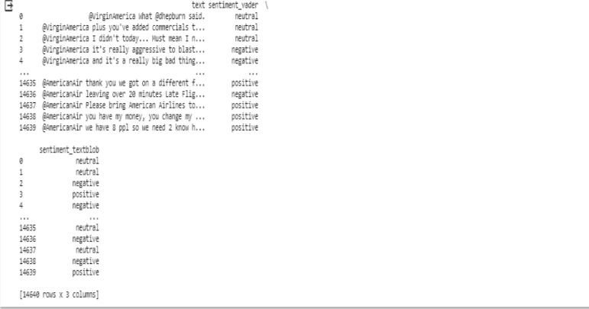

Coding part 2:

import nitk

nltk.download(‘vader_lexicon’)

!pip install vaderSentiment

import pandas as pd

from nitk.sentiment.vader

import SentimentIntensityAnalyzer

from textblob import TexBlob

#Load your custom CSV dataset

dataset = pd.read_csv(‘Tweets.csv')

#Define function to determine sentiment using VADEE

def get_sentiment_vader(text):

    analyzer = sentimentIntensityAnalyzer()

    sentiment_scores = analyzer.polarity_scores (text)

    compound_score = sentiment scores['compound']

    if compound_score.=0.05:

        return 'positive'

    elif compound_score<=-0.05:

        return 'negative'

    else:

        return 'neutral'

#Define a function to determine Sef get sentiment testolbekk analysis Textslos text polarity analysis,sestiment.polarity polarity

def get_sentiment_textblob(text):

analysis=TextBlob(text)

poplarity=analysis.sentiment.polarity

    if polarity > 0:

       return 'positive'

    elif polarity < 0:

        return 'negative'

    else:

        return 'neutral'

 #apply sentiment analysis to each row in the dataset

   dataset['sentiment_vader']=dataset['text'].apply(get_sentiment_vader)

#Insights

#calculate the distribution of sentiment labels for each method

vader_sentiment_distribution = dataset['sentiment vader'].value_counts()

textblob_sentiment_distribution = dataset['sentiment textblob'].value_counts()

#Calculate the overall sentiment distribution in the dataset

overall_sentiment_distribution = dataset[['sentiment_vader', 'sentiment textblob']].mode().iloc[0]

#Print insights

int("VADER Sentiment Distribution:")

print(vader_sentiment_distribution)

print("\nTextelob Sentiment Distributions:")

print(textblob_sentiment_distribution)

print("\noverall sentiment Distribution:")

print(overall_sentiment_distribution)

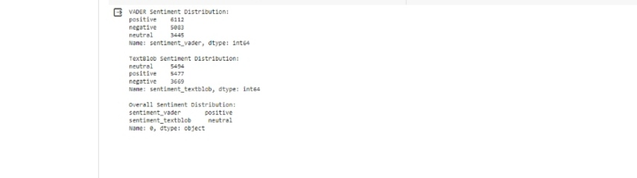Output: