

|  |
| --- |
| **CBS1008 - Operations Research - Embedded Lab** |
| **Lab Assessment II** |
| Student Name : SANJAY MUZUMDAR Student ID : 19BBS0041 |
| Lab Slot: L53 + L54 |

**1. A retail store stocks two types of shirts *A* and *B*. These are packed in attractive**

**cardboard boxes. During a week the store can sell a maximum of 400 shirts of type *A* and a maximum of 300 shirts of type *B*. The storage capacity, however, is limited to a maximum of 600 of both types combined. Type *A* shirt fetches a profit of Rs. 2/- per unit and type *B* a profit of Rs. 5/- per unit. How many of each type the store should stock per week to maximize the total profit? Formulate a mathematical model of the problem and also solve the model.**

> library(lpSolve)

Warning message:

package ‘lpSolve’ was built under R version 3.6.2

> objective.in = c(2,5)

> const.mat = matrix(c(1,1,1,0,0,1),nrow=3,byrow=TRUE)

> const.dir = c("<=","<=","<=")

> const.rhs = c(600,400,300)

> optimum = lp(direction="max",objective.in,const.mat,const.dir,const.rhs)

> optimum$solution

[1] 300 300

> optimum$objval

[1] 2100

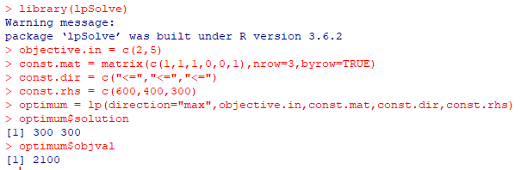

**2. A patient consults a doctor to check up his ill health. Doctor examines him and advises him that he is having deficiency of two vitamins, vitamin *A* and vitamin *D*. Doctor advises him to consume vitamin *A* and *D* regularly for a period of time so that he can regain his health. Doctor prescribes tonic *X* and tonic *Y*, which are having vitamin *A*, and *D* in certain proportion. Also advises the patient to consume at least 40 units of vitamin *A* and 50 units of vitamin daily. The cost of tonics *X* and *Y* and the proportion of vitamin *A* and *D* that present in *X* and *Y* are given in the table below. Formulate and solve the LPP to minimize the cost of tonics.**

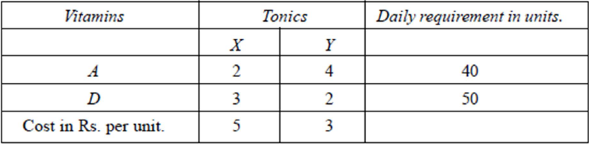

> library(lpSolve)

Warning message:

package ‘lpSolve’ was built under R version 3.6.2

> objective.in = c(5,3)

> const.mat = matrix(c(2,4,3,2),nrow=2,byrow=TRUE)

> const.dir = c(">=",">=")

> const.rhs = c(40,50)

> optimum = lp(direction="min",objective.in,const.mat,const.dir,const.rhs)

> optimum$solution

[1] 0 25

> optimum$objval

[1] 75

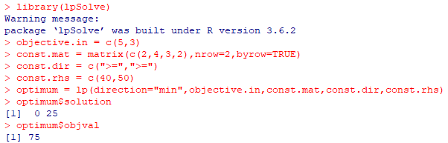

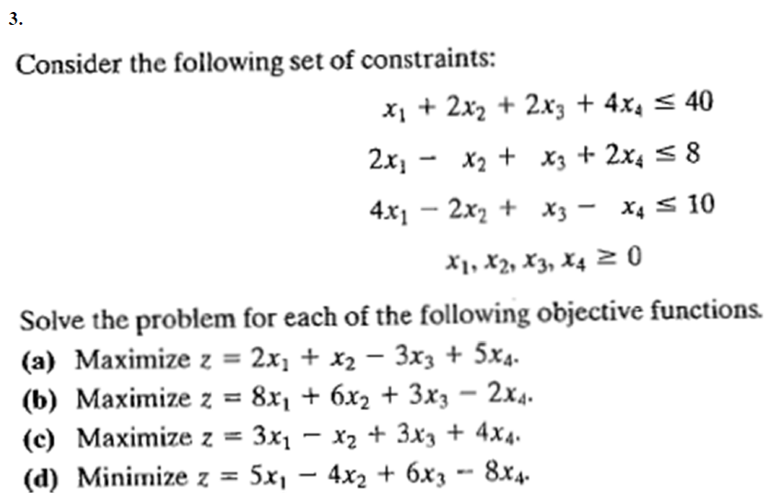

a)

> library(lpSolve)

Warning message:

package ‘lpSolve’ was built under R version 3.6.2

> objective.in = c(2,1,-3,5)

> const.mat = matrix(c(1,2,2,4,2,-1,1,2,4,-2,1,-1),nrow=3,byrow=TRUE)

> const.dir = c("<=","<=","<=")

> const.rhs = c(40,8,10)

> optimum = lp(direction="max",objective.in,const.mat,const.dir,const.rhs)

> optimum$solution

[1] 0 6 0 7

> optimum$objval

[1] 41

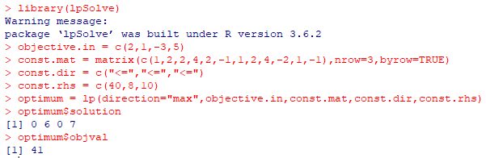

b)

> library(lpSolve)

Warning message:

package ‘lpSolve’ was built under R version 3.6.2

> objective.in = c(8,6,3,-2)

> const.mat = matrix(c(1,2,2,4,2,-1,1,2,4,-2,1,-1),nrow=3,byrow=TRUE)

> const.dir = c("<=","<=","<=")

> const.rhs = c(40,8,10)

> optimum = lp(direction="max",objective.in,const.mat,const.dir,const.rhs)

> optimum$solution

[1] 10 15 0 0

> optimum$objval

[1] 170

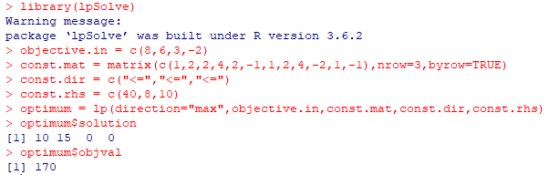

c)

> library(lpSolve)

Warning message:

package ‘lpSolve’ was built under R version 3.6.2

> objective.in = c(3,-1,3,4)

> const.mat = matrix(c(1,2,2,4,2,-1,1,2,4,-2,1,-1),nrow=3,byrow=TRUE)

> const.dir = c("<=","<=","<=")

> const.rhs = c(40,8,10)

> optimum = lp(direction="max",objective.in,const.mat,const.dir,const.rhs)

> optimum$solution

[1] 0 6 14 0

> optimum$objval

[1] 36

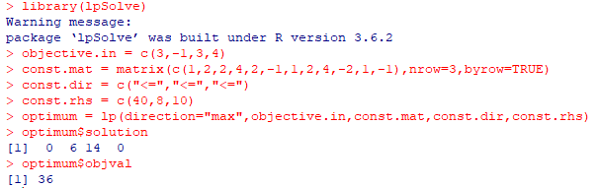

d)

> library(lpSolve)

Warning message:

package ‘lpSolve’ was built under R version 3.6.2

> objective.in = c(5,-4,6,-8)

> const.mat = matrix(c(1,2,2,4,2,-1,1,2,4,-2,1,-1),nrow=3,byrow=TRUE)

> const.dir = c("<=","<=","<=")

> const.rhs = c(40,8,10)

> optimum = lp(direction="min",objective.in,const.mat,const.dir,const.rhs)

> optimum$solution

[1] 0 6 0 7

> optimum$objval

[1] -80

