NAME: GAURAV POOSARLA

REGISTER NUMBER: 19BBS0104

SUBJECT: OPERATION RESEARCH

1. Create your own (Student Record) dataset and do the summary statistics and graphs with interpretation. Use at least 25 observations with five variables.

Solution:

**Code:**

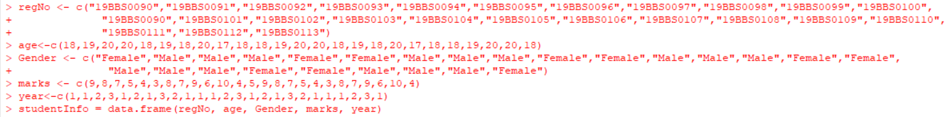**Output:**

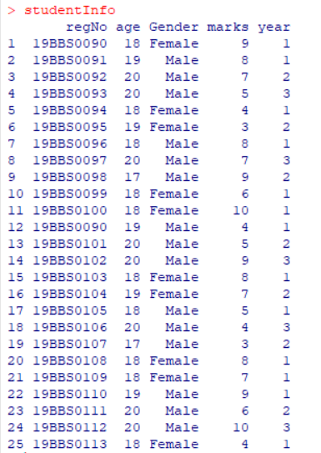

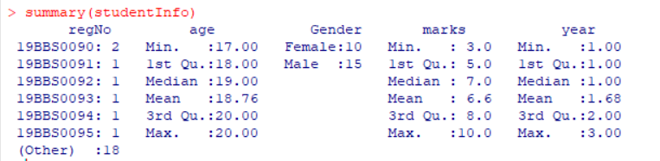

**Graphs:**

**Codes:**



**Output:**

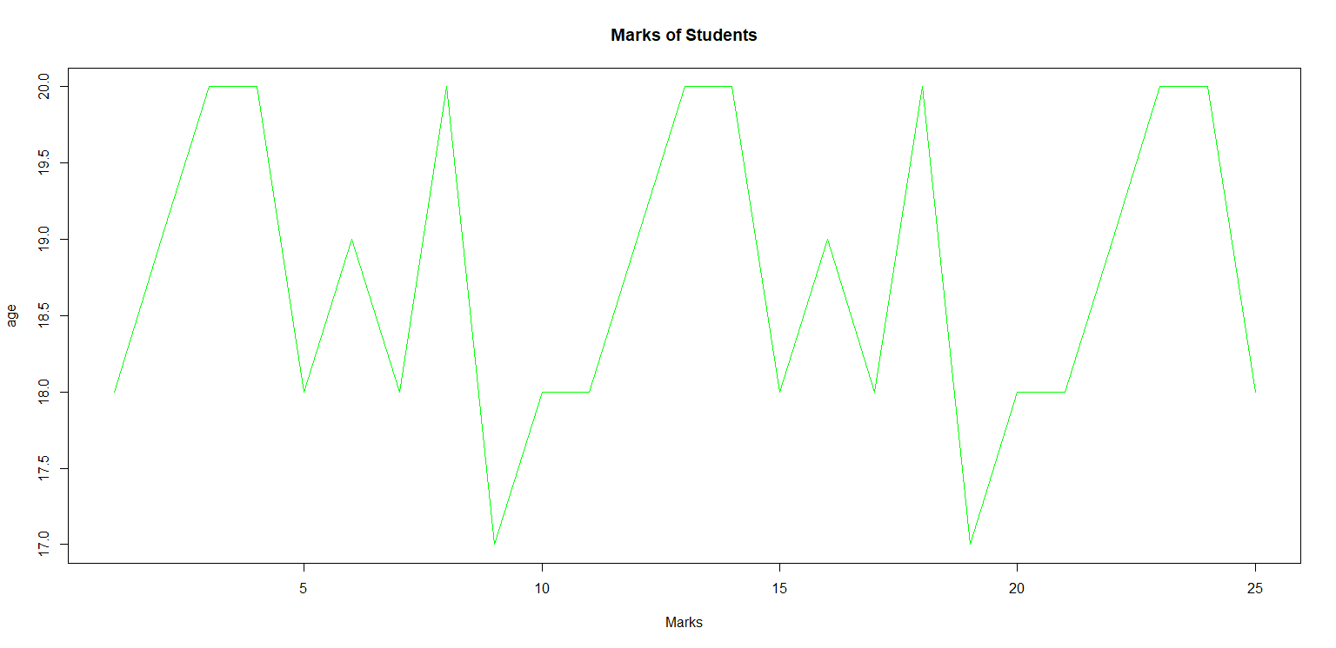

**Barplot:**

**Code:**



**Output:**

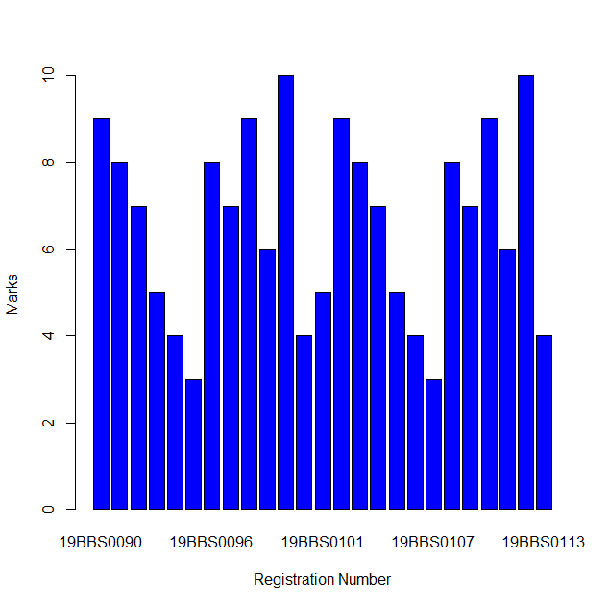

**Pie Chart:**

**Code:**



**Output:**

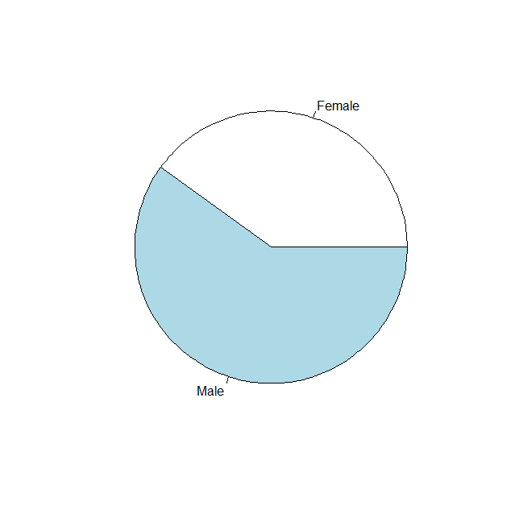

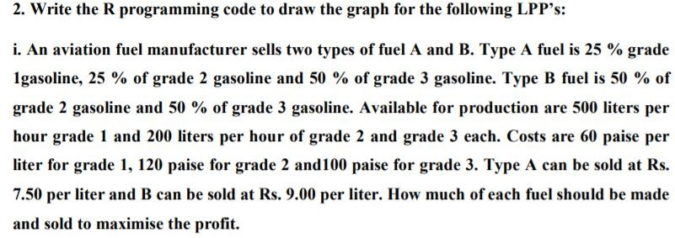

**SOLUTION:**

**GIVEN PROBLEM IN R: AFTER DOING CALCULATIONS INSERTING THE FINAL EQUATIONS.**

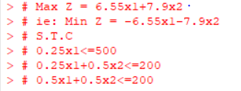

**CODE:**

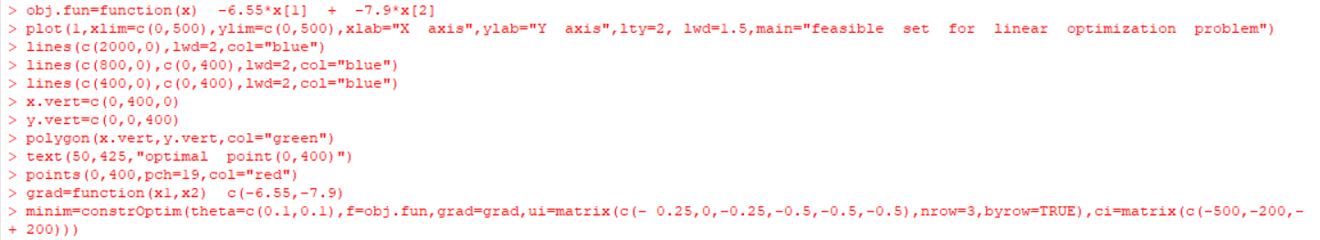

**OUTPUT:**

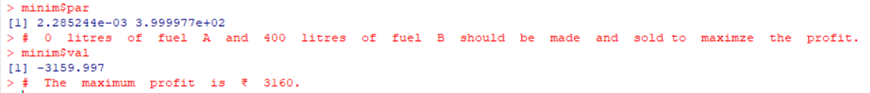

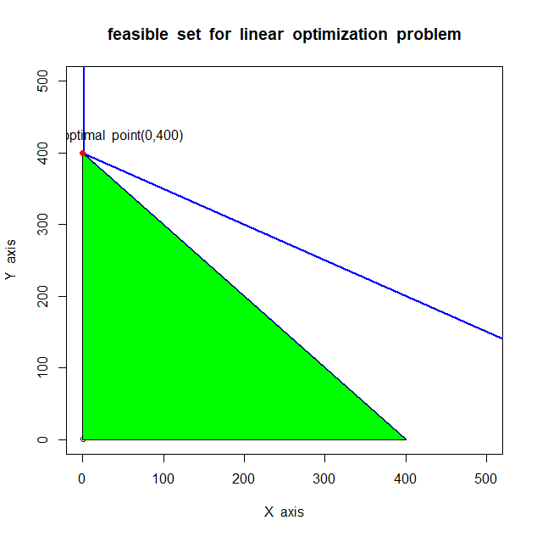

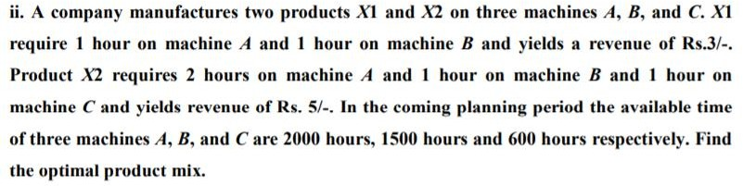

**SOLUTION: GIVEN PROBLEM IN R**

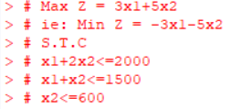

**CODE:**

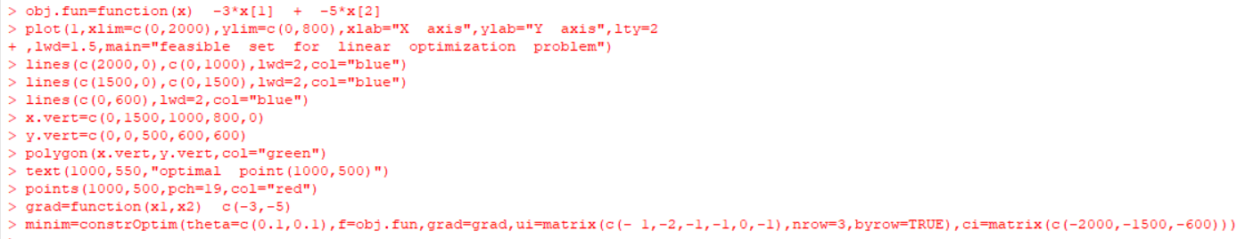

**OUTPUT:**

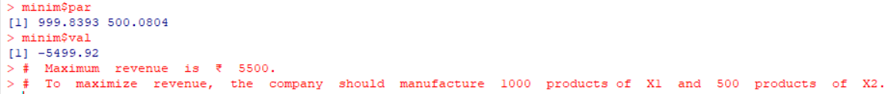

**GRAPH:**

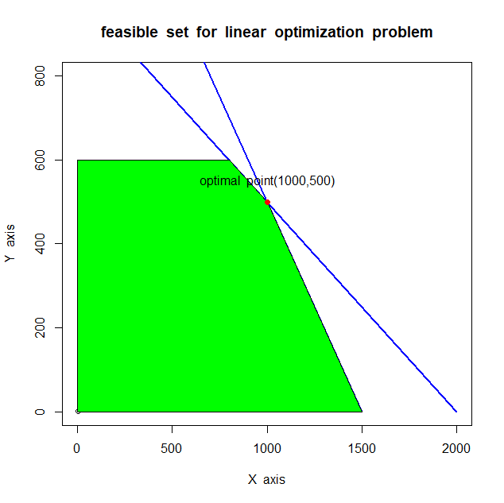

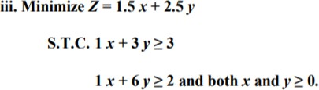

**SOLUTION:**

**GIVEN PROBLEM IN R:**

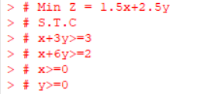

**CODE:**

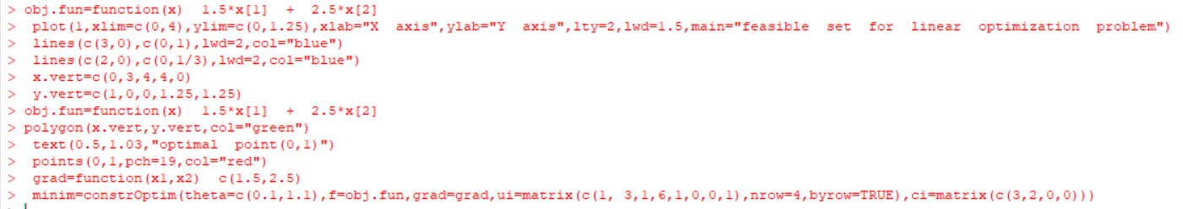

**OUTPUT:**

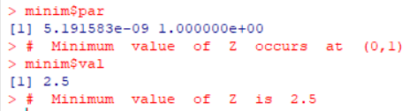

**GRAPH:**

