Engrafa Build Tool
v1.0 Deployment Guide

Revision History
Author | Revision Number | Date
TCASSEMBLER | 1.0 | 08.05.2015

Deployment Instructions 3
1. Organization of Submission 3
2. Application Setup 3
2.1. Configuration files 3
2.2. Box.com configuration 4
2.3. CrowdFlower configuration 5
2.4. Set up CrowdFlower jobs and the database 6
3. Database Setup 6
4. Deployment Instructions 7
5. Verification 7

Deployment Instructions

Organization of Submission

Path | Description
document_manager | The document manager directory.
integration_manager | The integration manager directory.
docs | Contains this file and reference documents.
maintenance | The maintenance directory.
package.json | The dependency lib.
middleware_service | The middleware service directory.
workflow_manager | The workflow manager directory.
config.js | The configuration file.
Gruntfile.js | The grunt files.
lint.bat | The lint command file.
README.md | The git readme file.

Application Setup

- Node.js 0.10.29 (http://nodejs.org/)
- MongoDB 2.6 (http://www.mongodb.org/)
- Box.com API (http://developer.box.com)
- CrowdFlower REST API (http://crowdflower.com)
- Git bash (http://git-scm.com/downloads)

This application also relies on Forever and Grunt, you may install them globally using the Node Package Manager:

npm install -g forever
npm install grunt -g
npm install grunt-cli -g

Bower is also required to install the client / UI side libraries.
npm install bower -g

If you’re using Linux or Unix, please run it under root permission, for example, add sudo prefix before command.

Configuration files

config.js
The following items represent environmental settings and you must update them before using the app. You can leave other fields with default value.
Property | Description
BOX_PUBLIC_FOLDER_ID | The box.com public folder id.
BOX_ACCESS_TOKEN | The box.com access token.
BOX_REFRESH_TOKEN | The box.com refresh token.
BOX_API_CLIENT_ID | The box.com api client id.
BOX_API_CLIENT_SECRET | The box.com api client secret.
CROWDFLOWER_API_KEY | The crowd flower api key.
INTEGRATION_MANAGER_MONGODB_URL | The integration manager mongodb url.
INTEGRATION_MANAGER_MONGODB_TEST_URL | The integration manager mongodb test url.
WORKFLOW_MANAGER_MONGODB_URL | The workflow manager mongodb url.
WORKFLOW_MANAGER_MONGODB_TEST_URL | The workflow manager mongodb test url.
TAIL_LINE | The tail command output line number. Should be empty in Windows System.
CLIENT_ID | The client id registered in Integration Manager
AUTHENTICATION_KEY | The authentication key of the client with the above CLIENT_ID

Box.com configuration

Go to http://developers.box.com/ and sign up if you haven’t already. Once you have created an account, create an app. Name it whatever you want. Provide the redirect_uri value as http://localhost:3000/callback .
Also note down the Client ID and Client secret values:
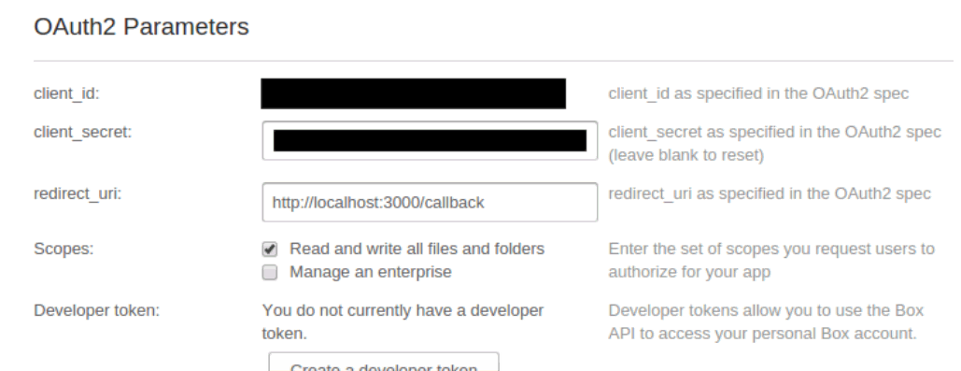

You copy the two values into the config.js file. Look for the BOX_API_CLIENT_ID and BOX_API_CLIENT_SECRET properties where you will copy the values to.

Next, go to your box.com and sign in / sign up. Once inside, create a folder named “public”. Note down the folder id (for the public folder) which you can find in the URL once you are inside the folder:
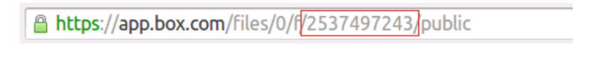

Copy this id into the config.js file. Looks for the BOX_PUBLIC_FOLDER_ID property where you will copy the value to.

Next, create a folder in Box named ClientA. Inside this folder, create two more folders named standard_input and standard_output. Your final folder structure in Box should look like this:

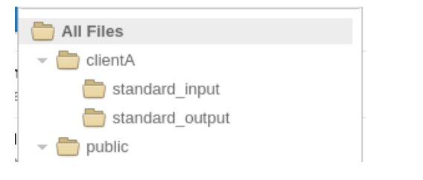

Now, just like the public folder, note down the IDs for the standard_input and standard_output folder by going into each folder and nothing down the ID in the URL.

Copy these values into workflow_manager/test_files/config.js.

In url, W1_INPUT corresponds to the standard_input folder while W2_OUTPUT corresponds to the standard_ output folder.

Now, run following command in workflow_manager directory.
$ node test_files/box-oauth/app.js

Open your favorite browser and go to http://localhost:3000
Here you will be taken to the Box.com authentication page. Grant the permissions after which you will be redirected and shown the following screen:
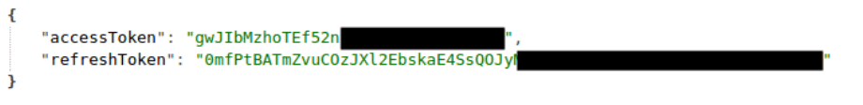

Copy the accessToken and refreshToken values to config.js file. Look for the BOX_ACCESS_TOKEN and BOX_REFRESH_TOKEN properties to which you need to copy the values to. In addition to this, you need to copy the values to the access_token and refresh_token files respectively if getting error. These files are in the ROOT/workflow_manager directory and ROOT/middleware_service directory.

If you get errors about invalid Box.com access token / refresh token, then you may need to get the BOX_ACCESS_TOKEN and BOX_REFRESH_TOKEN values again as they may have expired.

Done. Box integration is now ready.

CrowdFlower configuration

You need to create two types of users. A Customer and a Contributor.

For a customer user, go to http://info.crowdflower.com/get-started and click on “Start My Free Trial”. In case you can’t register using GMail, check out section 2.4 in the Deployment Guide (under docs folder).
You only need to create one customer user.

To create a Contributor user, go to https://tasks.crowdflower.com/sessions/new and Sign Up.
Depending on the challenge, you may have to create more than one Contributor user.

Now, log in with your customer user credentials, go to https://make.crowdflower.com/account/user and note down the API key. Copy this into config/config.js. Look for CROWDFLOWER_API_KEY property where you need to copy the value to.

Done. Your CrowdFlower integration is ready.

Set up CrowdFlower jobs and the database

The following commands are running under workflow_manager directory.
First, make sure you don’t have any previous running jobs in CrowdFlower. Run:
$ node test_files/cf_helpers/remove-all.js
Run it a couple of times to make sure that they have been completely removed. If you get no output on running the command, then you are good to proceed further.

Next, create and insert the jobs. Run:
$ node test_files/cf_helpers/create-jobs.js

To simplify, it could directly run following npm command instead of above 2 commands:
npm run prepareJobs
This will output the jobs created. Copy the output to test_files/config.js. This time, copy it to the JOBS property.

This will reset the database first and then populate the database with the values required to run the application.

In workflow_manager\config directory, copy internal-jobs.example.json to internal-jobs.json, update the job id with above shown job id.

Notes, in Windows System, please install the tool http://www.microsoft.com/en-us/download/details.aspx?id=17657
Update the TAIL_LINE in config.js based on the OS.

Database Setup
It needs to properly populate the test data. Please refer to above sections for detail.

To manually test, run following command in integration_manager directory to insert test data.
node test_files/populate.js

Deployment Instructions
The assembly depends on other modules. Here is taking Windows for example, it’s similar to setup in other OS.

In submission root directory, run following command to install dependencies.
npm install

To start all instances,
cd maintenance
npm run startInstances

To stop all instances, in maintenance directory, run following command:
npm run stopInstances

To only start the workflow manager module, in maintenance directory, run following command:
npm run startWorkflow

To only start the integration manager module, in maintenance directory, run following command:
npm run startIntegration

To only stop the workflow manager module, in maintenance directory, run following command:
npm run stopWorkflow

To only stop the integration manager module, in maintenance directory, run following command:
npm run stopIntegration

To remove all generated access token files, in maintenance directory, run following command:
npm run removeTokens

To start the workflow_manager server.js, run following command in workflow_manager directory.
node server.js

In you want to use the mock_api, in the middleware service folder, run following command in middleware_service directory.
node test_files/mock_api.js

Verification

Start / stop instances.
After run “npm run startInstances” command to start instances. Run “forever list” command to check all of them are start.
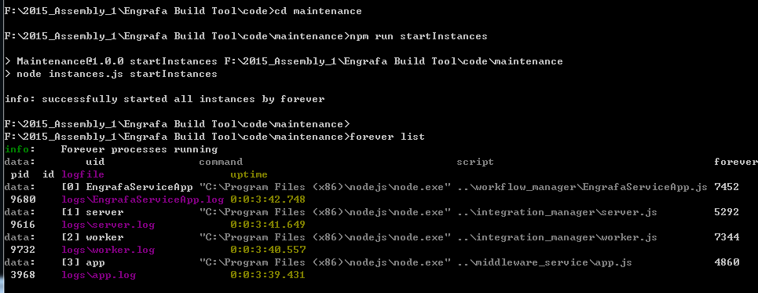

Also check the logs directory in each module to make sure the instances are running.

After run “npm run stopInstances“ command to stop instances, run “forever list” command to check all of them are stopped.
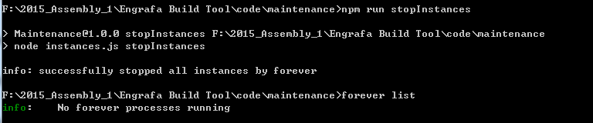

Grunt test
In integration_manager directory, run following command to populate the test data.
node test_files/populate.js
In submission root directory, run “forever stopall” to stop all instances before run test.
Run following command to run the test code.
grunt test

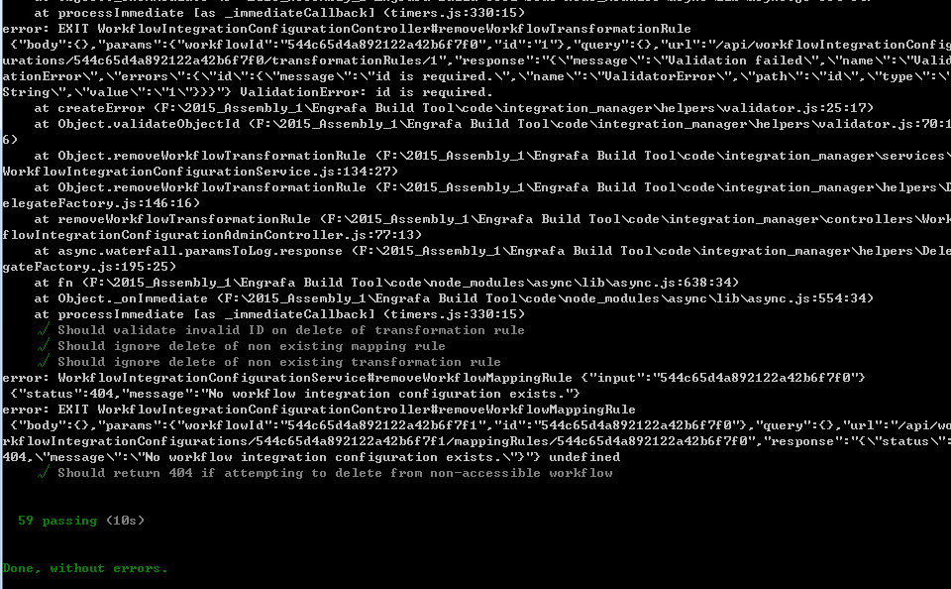

Jslint check
In windows command line window, go to submission root directory, run following command and it’ll output jslint check result.
lint.bat
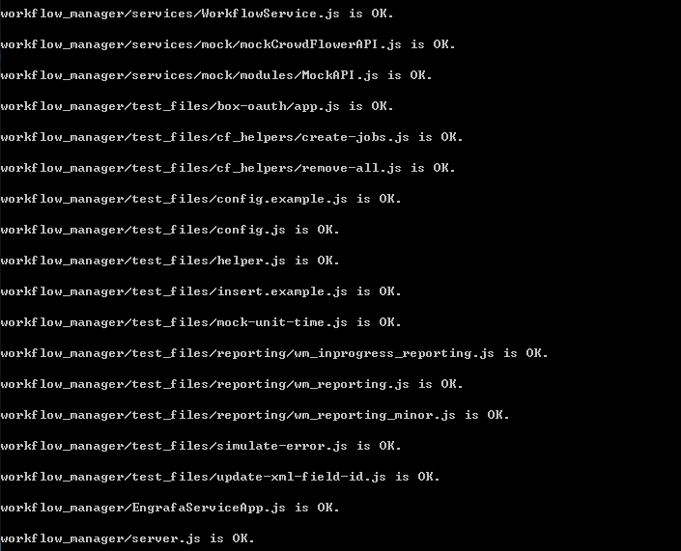

Workflow_Manager server.js
After start, open http://localhost:3500/ in browser, login with admin // password, it’ll show following page.
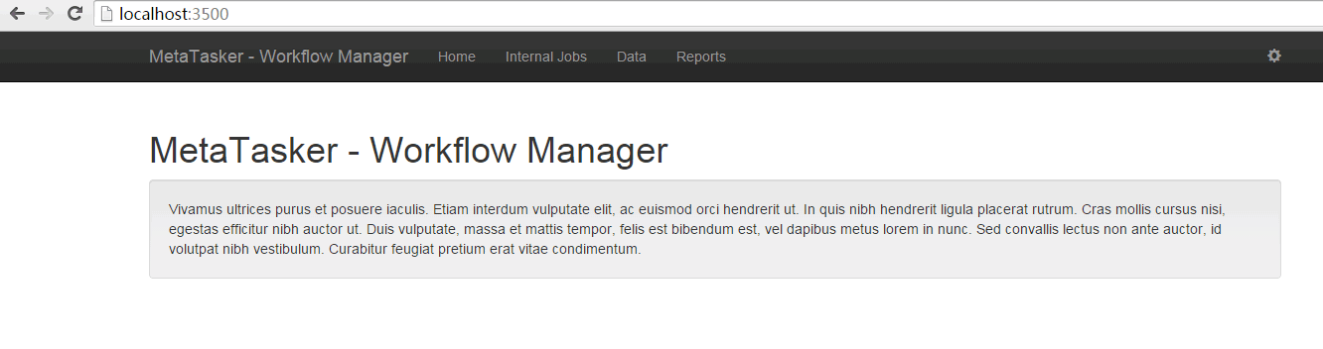

integration_manager
After start, open http://localhost:4030/login in browser, login with admin1 // admin1, it’ll show following page.
