Engrafa Document Processor Assembly v1.0
Deployment Guide

Revision History
Author | Revision Number | Date
arvind81983 | 1.0 | 10.27.2014

Deployment Instructions 3
1. Organization of Submission 3
2. Application Setup 3
2.1. Configuration file 3
3. Database Setup 3
4. Deployment Instructions 4
4.1. Create AWS Windows Server 2012 instance from provided AMI 4
4.2. Deploy files to instance 5
4.3. Install Document Processor as a windows service to run on system startup 6
4.4. Add Windows Firewall exception to 8080 7
4.5. Uncomment Trapeze code when Client provides the license 8
4.6. Create an AMI from the current ec2 instance 8
4.7. Node application 9
5. Verification 10
5.1. Process Document 10
5.2. Get lic usage logs 10
6. Resource Contact List 11

Deployment Instructions

Organization of Submission

Path | Description
docs | Contains documentation
controllers | Contains application controllers
services | Contains application services
test_files | Contains files used for manual testing
config.js | Contains configuration
server.js | Server
package.json | Contains node dependencies
Processing | Contains processed files
Cvisionlogs | Contains CVISION log files

Application Setup

- Node.js 0.10.29 (http://nodejs.org/)

Configuration file
File Document Processor/config.js

Name | Description | Sample value
CVISION_TRAPEZE_COMMAND | This represents the command used to run CVISION Trapeze, including command line options except for "-in" and "-out". | Check file (too large)
DOCUMENT_PROCESSING_DIRECTORY | This represents the directory used to temporarily hold document processing input and output files. | ./processing
SERVER_PORT | This represents the port used to serve HTTP server. | 8080
CVISION_TRAPEZE_LICENSE_USAGE_LOG | This represents the CVISION Trapeze license usage log file. | ./licUsage.log

The default values are enough for running the test steps.

Database Setup
N/A

Deployment Instructions

Create AWS Windows Server 2012 instance from provided AMI
You must have an AWS account and your Account ID must have permission to use the private AMI (“CVision Trapeze”).

Login to your AWS account and go to AMI images. Change filter to ‘Private Images’:
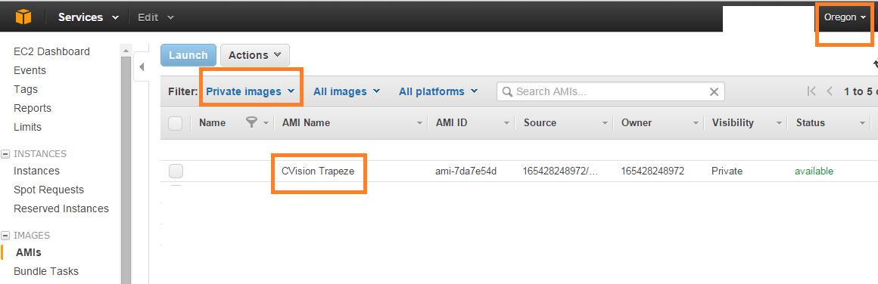

Then either click on Launch and create an instance (Note: Do not create a spot request as you cannot start/stop a spot request as per http://docs.aws.amazon.com/AWSJavaScriptSDK/latest/frames.html#!AWS/EC2.html
). NOTE: You need to keep tcp port 8080 (SERVER_PORT configured in config.js) open for incoming traffic.

Create an associate elastic IP with the instance
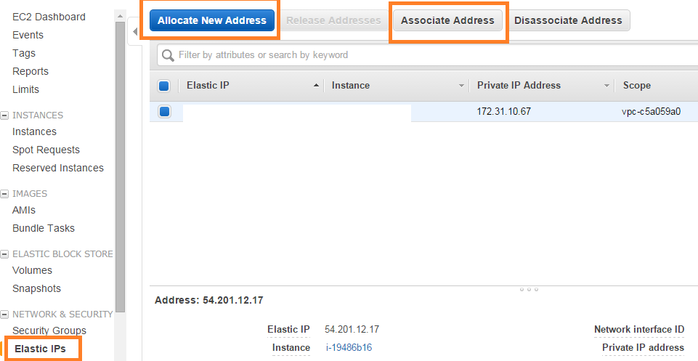

Go to EC2 Dashboard to check status of instance creation
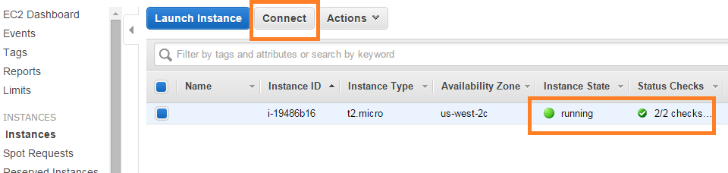

Click on download RDP from the popup
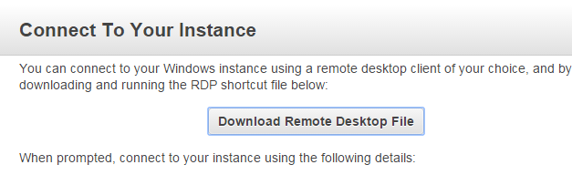

Open the downloaded <instance ip>.rdp file (Accept the warning window) and enter the password CVision2014. Accept the certificate warning and you will be logged in
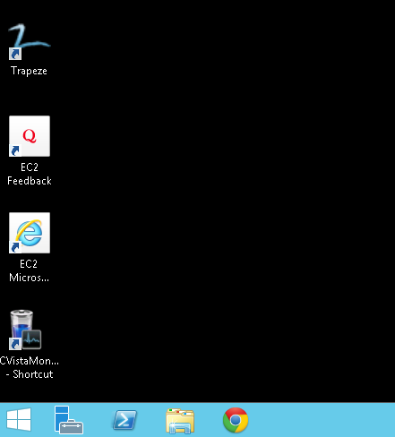

Install Node. Download Node (64-bit) msi from http://nodejs.org/download/

Deploy files to instance
Email the Document Processor files from your local machine and download it on the server (You can also map a drive or created a shared folder).
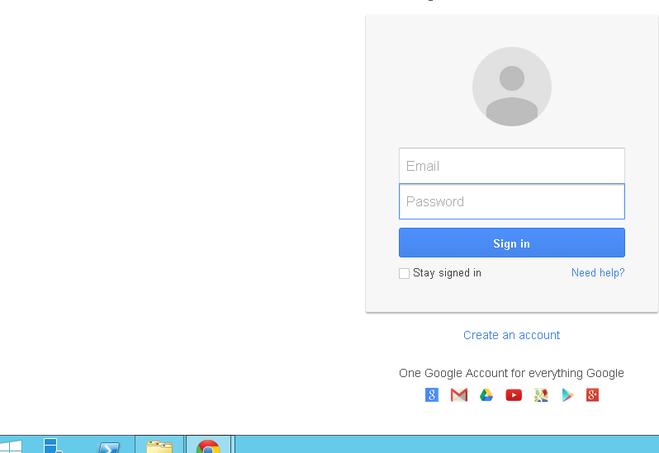

Extract the files to C:\Document Processor
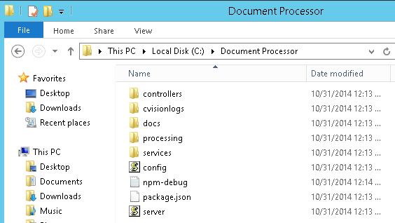

Then open the path in shell and run npm install command
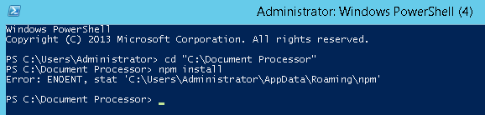

You will the error ‘ENOENT, stat ‘ C:\Users\Administrator\AppData\Roaming\npm’
This is because that folder is not there, create the folder
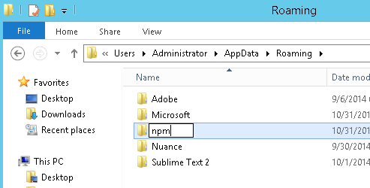

And rerun the npm install command and it should now run fine.

Install Document Processor as a windows service to run on system startup

- Download latest version of NSSM (version 2.24) from http://nssm.cc/
- Extract the downloaded zip file to a folder say C:\Users\Administrator\Downloads\nssm-2.24
- Copy the nssm.exe from C:\Users\Administrator\Downloads\nssm-2.24\win64 folder to C:\Document Processor\ folder (where Document Processor files were extracted)
- Open command prompt and point it to C:\Document Processor\ folder.
- Run the following command:
nssm install

In the popup window enter the values as shown:
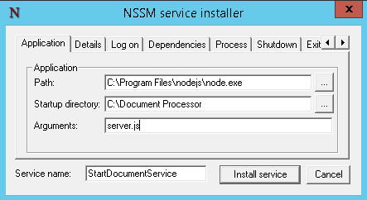

Where C:\Document Processor\server.js points to location of server.js file in extract Document Processor folder and C:\Program Files\nodejs\node.exe points to node.exe file in installed folder of node js.

- Start the service by running the command: net start StartDocumentService
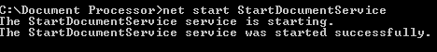

If you get any error (like NET msg 3547) then download and install NDPFixit-KB3005628-X64 (64-bit patch) from http://support2.microsoft.com/kb/3005628 and try again to install and start the service.

Add Windows Firewall exception to 8080

Open port 8080 in windows firewall

Click on Windows Start button and then Control Panel
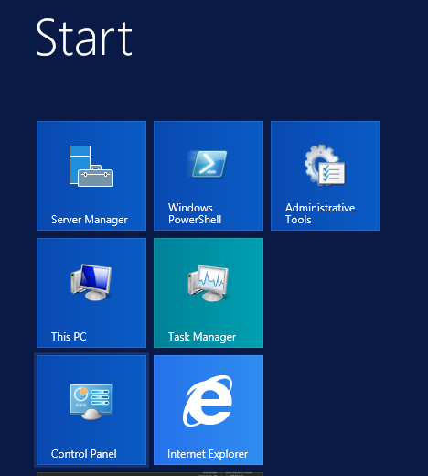

ControlPanel-->System Security-->Windows Firewall-->Advance Settings-->inboundRules-->New Rule->Port

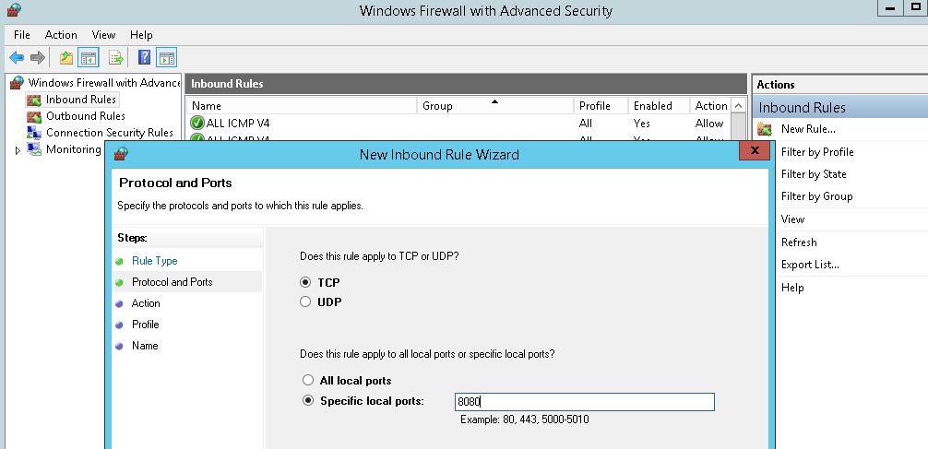
Save it with a name.

Uncomment Trapeze code when Client provides the license
Code related to running Trapeze command has been commented (Check this forum post for more details: http://apps.topcoder.com/forums/?module=Thread&threadID=836919&start=0).

If you want to enable the functionality then:
- Uncomment the lines 33-44 of the file Document Processor/services/DocumentProcessor.js.
- Uncomment lines 54-61 of file Document Processor/controllers/DocumentProcessingController.js.
- Remove the lines 63-68 of file Document Processor/controllers/DocumentProcessingController.js.

Create an AMI from the current ec2 instance

- Login to aws.amazon.com
- Select the ec2 instance used for setting up everything
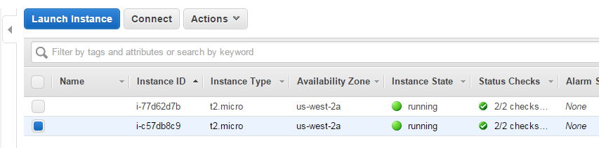
- Now select ‘Create Image’ from Actions menu
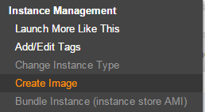
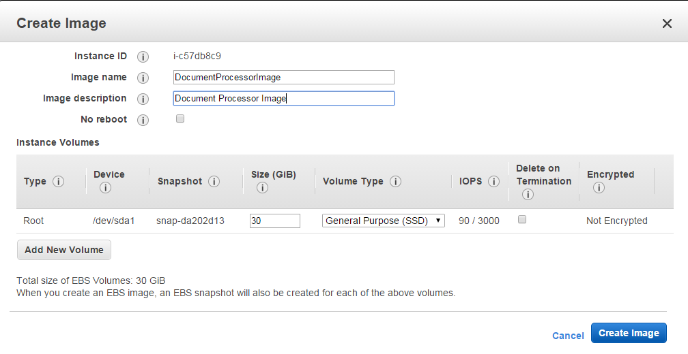
- Once its status changes from ‘pending’ to ‘available’, make a note of its AMI ID (e.g. ami-d3d991e3)
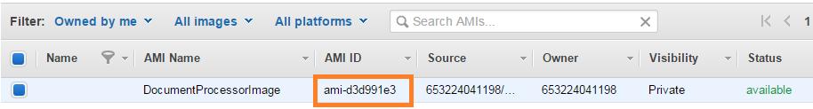
- Also make a note of the security group of the setup instance (e.g. launch-wizard-5)
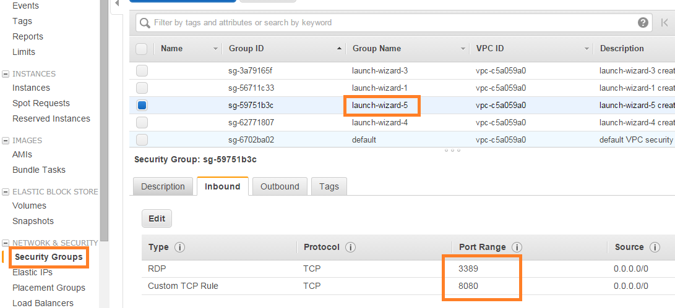
- Update the AMI ID and security group to the Document Manager/config.js file
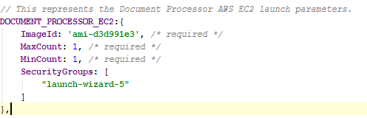

Node application
Run npm install command
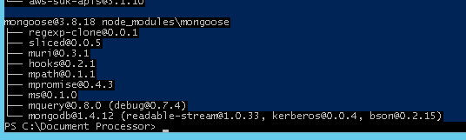

Run node server.js command
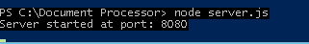

Verification

Process Document

Open POSTMAN and enter the value for url field as http://<your instance ip>:8080/processDocument and upload Testfile.pdf file from test_files folder

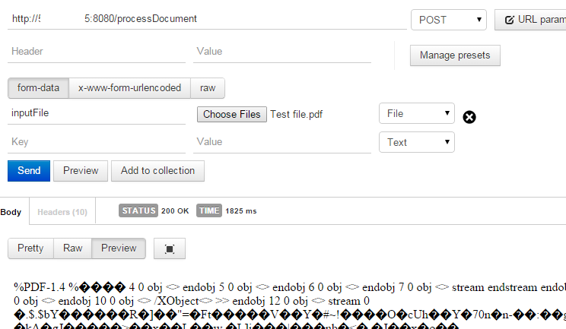

Response OK is received along with Pdf contents in body.

Get lic usage logs
Enter the url values as shown
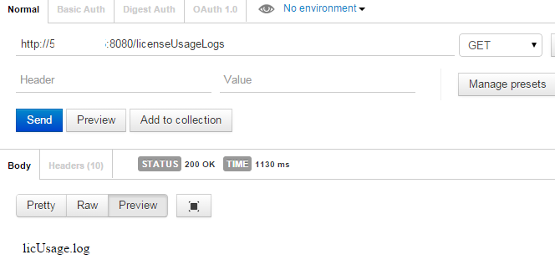
The file contents are returned in the body of the request (As of now this returns a dummy log file)

The server console will have the processing related log.

Resource Contact List

Name | Resource Email
arvind81983

