Engrafa Periodic Maintenance Challenge
v1.0 Deployment Guide

Revision History
Author | Revision Number | Date
TCASSEMBLER | 1.0 | 07.13.2015

Deployment Instructions 3
1. Organization of Submission 3
2. Application Setup 3
2.1. Configuration files 3
2.2. S3 configuration. 4
3. Database Setup 5
4. Deployment Instructions 6
5. Verification 6

Deployment Instructions

Organization of Submission

Path | Description
backup | The default backup directory.
config | Contains the configuration file.
docs | Contains this file.
Maintenance.js | The main script of this assembler
package.json | The dependency lib.
README.md | The git readme file

Application Setup

- Node.js 0.10.29 (http://nodejs.org/)
- MongoDB 2.6 (http://www.mongodb.org/)
- Box.com API (http://developer.box.com)
- CrowdFlower REST API (http://crowdflower.com)
- Git bash (http://git-scm.com/downloads)

This application also relies on Forever, you may install them globally using the Node Package Manager:

npm install -g forever

If you’re using Linux or Unix, please run it under root permission, for example, add sudo prefix before command.

Configuration files

config/config.js

Property | Description
CRON_PATTERN | The cron pattern.  Here is some sample.  '00 30 11 * * 1-5' - Runs every weekday (Monday through Friday) at 11:30:00 AM. It does not run on Saturday or Sunday  '* * * * * *' - runs every second  '*/5 * * * * *' - runs every 5 seconds  '10,20,30 * * * * *' - run at 10th, 20th and 30th second of every minute  '0 * * * * *' - runs every minute  '0 0 * * * *' - runs every hour (at 0 minutes and 0 seconds)
CRON_TIMEZONE | The cron time zone. The default value is ‘America/Los_Angeles’.
LOG_FILES_REMAINED_TIME | The log files modified time to remove. The default value is 7 days.
SHUTDOWN_JOB_INTERVAL | The waiting time before exit process. The default value is 10 seconds.  It also has SHUTDOWN_JOB_INTERVAL property in other modules, it’s better to use same value.
MONGO_DUMP_COMMAND | The mongodb dump command. Please refer to http://docs.mongodb.org/manual/reference/program/mongodump/ about how to run.
MONGO_DUMP_DIRECTORY | The mongodb dump output directory.
INTEGRATION_MANAGER_DB | The Integration Manager database.
WORKFLOW_MANAGER_DB | The WorkflowManager database.
S3_ACCESS_KEY_ID | The S3 access key id.
S3_SECRET_ACCESS_KEY | The S3 secret access key.
S3_BUCKET | The S3 bucket.

Bolded names represent environmental settings and you must update them before using the app. You can leave other fields with default value.

S3 configuration.

Open aws.amazon.com, login with your username and password.

In Services menu, select S3, create engrafatest Bucket.
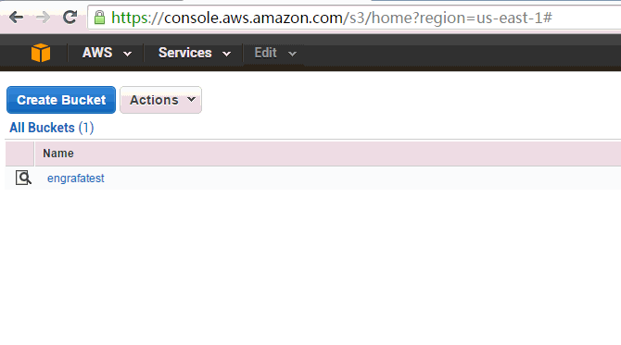

In menu of top right side, click the "Security Credential".
Click Users menu, add engrafa_test user. Get the access key id and access secret key in created page.
Click Groups menu, add S3_backup group with AmazonS3FullAccess permission.
Move the engrafa_test user to S3_backup group.
To see the access secret key again, select the just created IAM user, select User Actions -> Manage Access Keys to create new access key. Please refer to http://www.cloudberrylab.com/blog/how-to-find-your-aws-access-key-id-and-secret-access-key-and-register-with-cloudberry-s3-explorer/ for more detail.
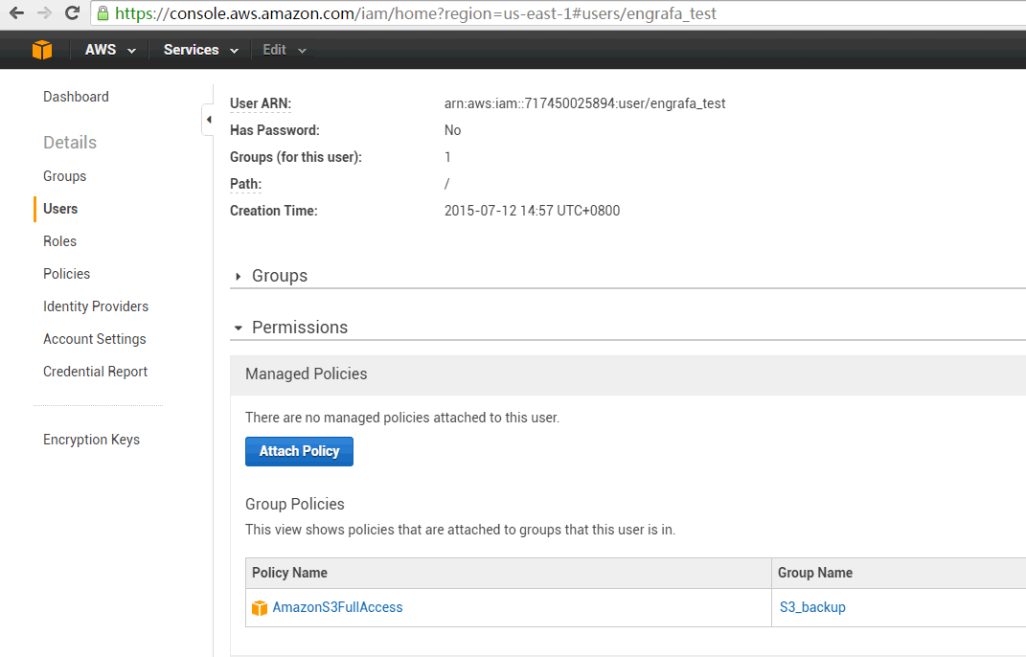

Database Setup
None.

Deployment Instructions
The assembly depends on other modules. Here is taking Windows for example, it’s similar to setup in other OS.
Modules | Reference document
WorkflowManager | WorkflowManager-SimplifiedDeployment.pdf in http://apps.topcoder.com/forums//?module=Thread&threadID=859413&start=0  Notes, in “node test_files/insert.js” script, update clientA to CLIENT_A.  In my test, I also need to run “npm config set msvs_version 2012” command to fix the build problem.  If failed to run “bower install” command, update following line in bower.json as discussed in http://apps.topcoder.com/forums//?module=Thread&threadID=860307&start=0  - "angular-ui-angular": "https://github.com/angular-ui/angular-ui-OLDREPO",
Integration Manager | 1. cd middleware_service  2. "D:/Program Files/MongoDB/Server/3.0/bin/mongorestore" ../resources/db-dumps/engrafa-test  3. npm install  4. node test_files/mock_api.js  5. node app.js  6. cd ../integration_manager  7. npm install  8. node test_files/populate.js  9. node apiServer.js  10. node worker.js  11. node webServer.js

In this assembly, it needs to run “npm install” command in code/maintenance directory to install.

The current Maintenance.js could run in following way:
Run in CORN type:
node Maintenance.js
Stop instance:
node Maintenance.js stopInstances
Delete logs:
node Maintenance.js deleteLogs
Start instances:
node Maintenance.js startInstances
Dump database:
node Maintenance.js dumpDatabases [prefix]
Upload files:
node Maintenance.js uploadFiles [prefix]

Please notes, in this module, it uses forever to control the node instances. If use directly use node command, for example, “node EngrafaServiceApp.js” to start instance, it’ll not stop by this module.

Verification

To test the remove log files logic, the LOG_FILES_REMAINED_TIME is set to 1 second.

Run in command line.

Start instances in forever:
node Maintenance.js startInstances
Use forever list command to check it.
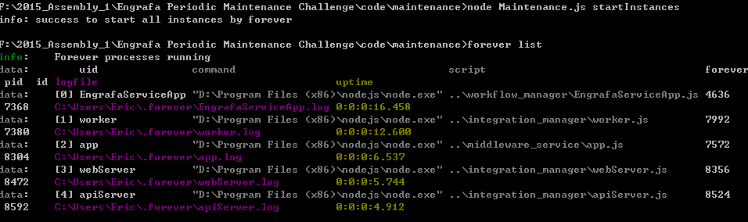

Stop instances in forever:
node Maintenance.js stopInstances
Use forever list command to check it.
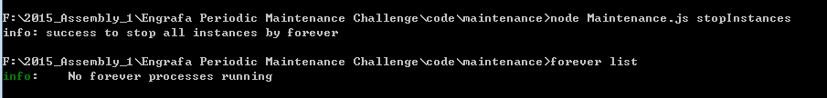

Delete log files:
node Maintenance.js deleteLogs
You can see the modules logs files are deleted based on modified time.
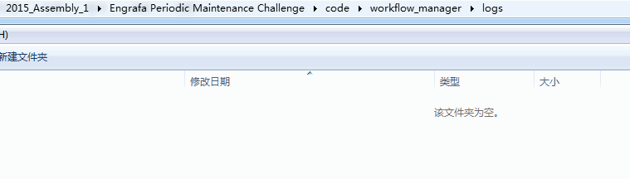

Dump the database:
node Maintenance.js dumpDatabases test
The database is exported in backup directory.
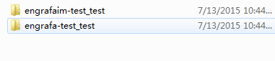

Upload to S3:
node Maintenance.js uploadFiles test
The files are uploaded to S3.
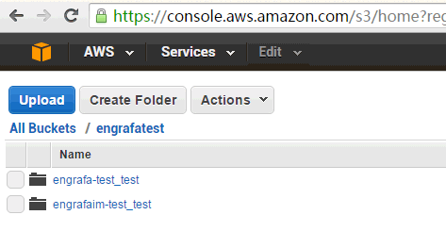

Run in CRON.
In current cron pattern, it's set to run every 3 minutes.

node Maintenance.js

After 3 minutes, you can see the command running.
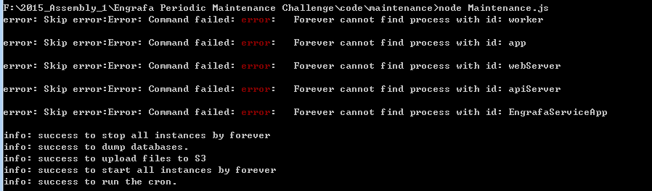

Uploaded files in S3.
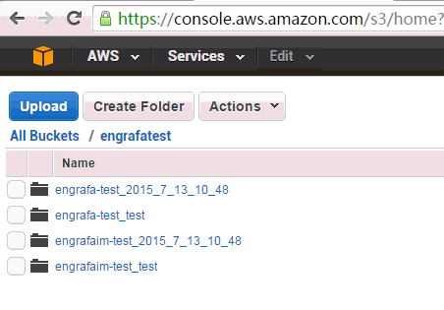
The instances are running in forever list command.
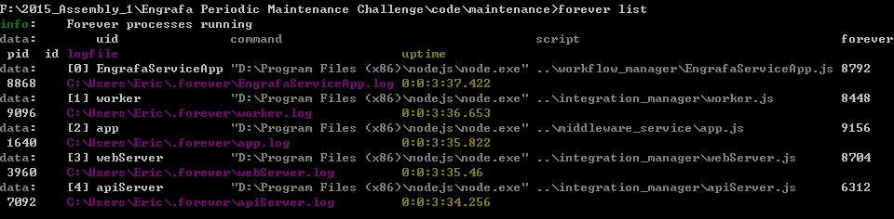

This module uses SIGINT signal to communicate between forever and node instances. To verify it, start EngrafaServiceApp.js in workflow_manager directly by “node EngrafaServiceApp.js”, then use Ctrl+C to quit the program, you can see it’ll wait about 10 seconds before exit the process.

