|  |  |  |
| --- | --- | --- |
|  | | |
|  | **Nitte Meenakshi Institute of Technology**  An Autonomous Institution under VTU, Belagavi  PB No. 6429, Yelahanka, Bangalore 560-064, Karnataka, India |  |
| **INTERNSHIP ON ARTIFICIAL INTELLIGENCE AND MACHINE LEARNING**  *An Internship Training Report Submitted in partial fulfillment of the requirements*  *for the award of degree of*  **MASTER OF COMPUTER APPLICATIONS**  **OF**  **Visvesvaraya Technological University (VTU)**  **VTU-logo**  **Submitted By**  **SANJAY M**  **1NT22MC091**  **Under the Guidance of**  **Dr. Dileep M R**  **Associate Professor**  **July 2024** | | |
|  | | |

|  |  |  |
| --- | --- | --- |
| **Nitte Meenakshi Institute of Technology**  **Yelahanka, Bengaluru- 560064**  **Department of Master of Computer Applications** | | |
| **CERTIFICATE**  *This is to certify that the Internship Training Report entitled* ***"INTERNSHIP ON ARTIFICIAL INTELLIGENCE AND MACHINE LEARNING",*** *in partial fulfillment of the requirements for the award of the Degree of Master of Computer Applications is a record of original training undergone by* ***SANJAY M*** *bearing USN* ***1NT22MC091*** *during the year* ***2023-24*** *of his study in the Department of Master of Computer Applications,* ***Nitte Meenakshi Institute of Technology*** *under my supervision and the report has not formed the basis for the award of any Degree/Fellowship or other similar title to any candidate of any University.* | | |
| **Signature of HOD**  Dr. Sreekanth R.  Prof & Head, Dept. of MCA  NMIT, Bengaluru | | **Signature of Guide**  Dr. Dileep M R  Associate Professor, Dept. of MCA  NMIT, Bengaluru |
| **Place:** Bengaluru  **Date:** | | |
|  |  | |

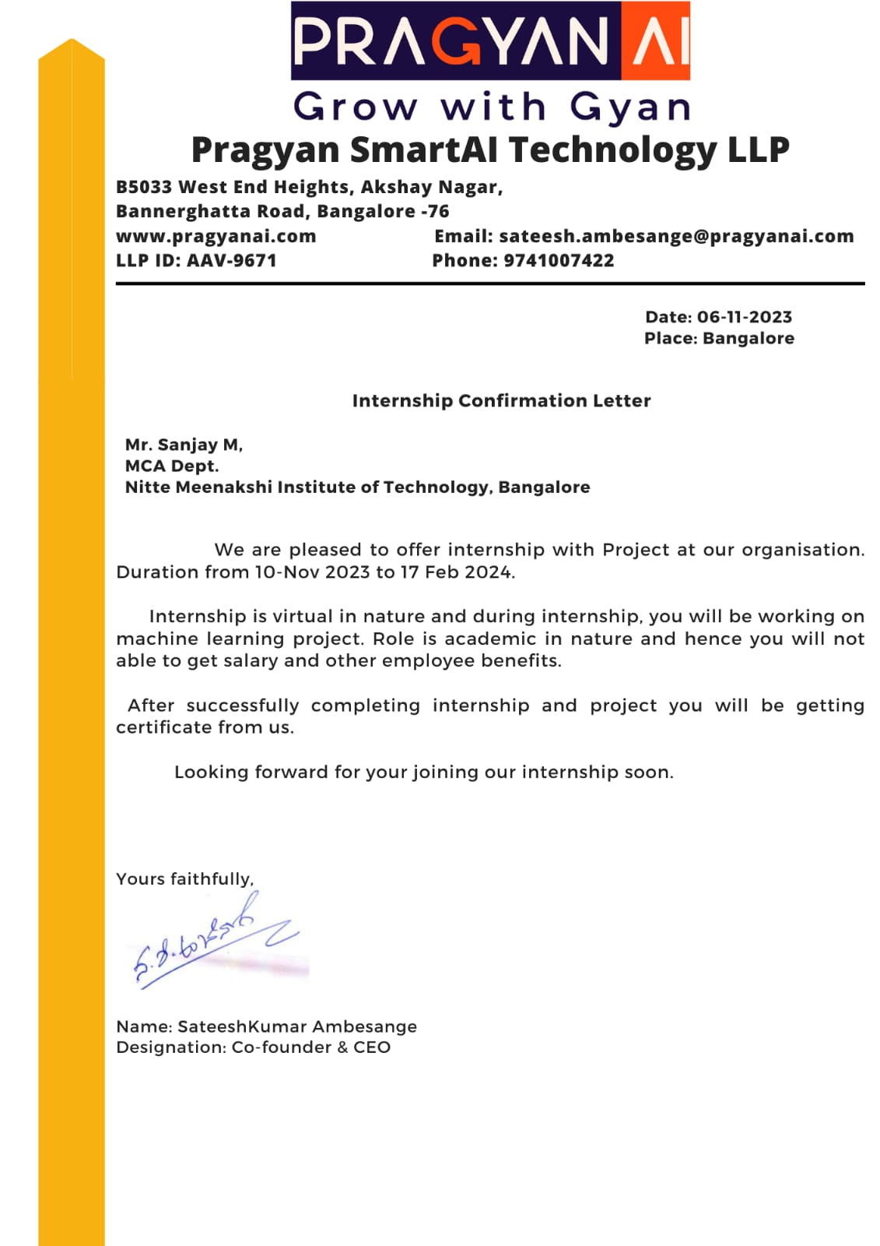

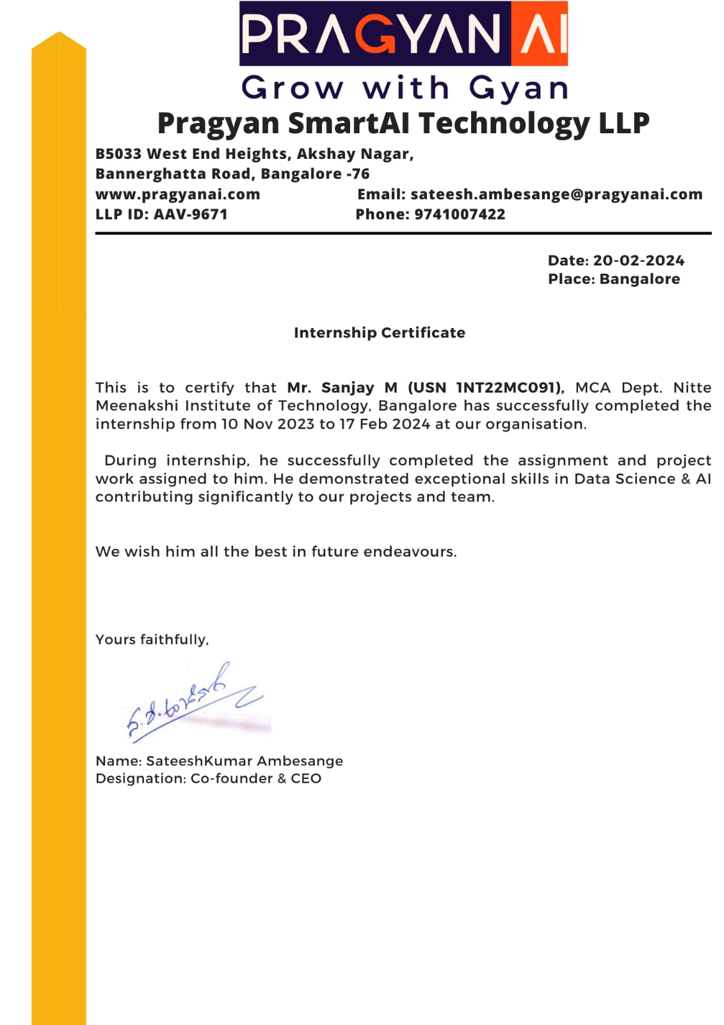

**DECLARATION**

I, **Sanjay M**, student of IV Semester of MCA, **Nitte Meenakshi Institute of Technology**, Bengaluru, bearing USN **1NT22MC091,** hereby declare that the that the Internship Training Report entitled “**INTERNSHIP ON ARTIFICIAL INTELLIGENCE AND MACHINE LEARNING”**  has been carried out by me under the guidance of **Dr. Sashikanth Reddy A, Associate Professor,** and submitted in partial fulfillment of the requirements for the award of the Degree of **Master of Computer Applications** by the **Visvesvaraya Technological University** during the academic year **2023 - 2024**. It has not formed the basis for the award of any Degree/Fellowship or other similar title to any candidate of any University.

Place: Bengaluru Signature of the Student

Date: Sanjay M

1NT22MC091

**ACKNOWLEDGEMENT**

The satisfaction that accompanies the successful completion of any task would be incomplete without mentioning the people who made it possible. With deep gratitude, I acknowledge all those whose guidance and encouragement served as a beacon of light and crowned my efforts with success. I thank each one of them for their valuable support.

I would like to thank **Pragyan SmartAI Technology LLP** for providing me an opportunity to work as an Intern and **Sateeshkumar Ambesange** for his timely support and guidance during my internship period.

I express my thanks to, **Dr. H. C. Nagaraj, Principal, NMIT**, Bengaluru, for all the support and encouragement during my Post Graduate Studies.

I express my sincere thanks to **Dr. Sreekanth R., Professor & HOD-MCA, NMIT,** Bengaluru, whose constant encouragement, guidance and support that has helped me complete the project work successfully on time.

I express my sincere thanks to my Internal Guide, **Dr. Dileep M R, Associate Professor, Department of MCA, NMIT**, Bengaluru, whose constant encouragement, guidance and support that has helped me complete the Internship and project work successfully on time.

My special thanks to all the teaching faculty members for providing me invaluable support and guidance.

Finally, I thank my Parents and Friends who have helped me in all possible ways for the success of this project work.

SANJAY M

1NT22MC091

**TABLE OF CONTENTS**

|  |  |  |
| --- | --- | --- |
| **CHAPTER** | **TITLE** | **PAGE NO** |
|  | **CERTIFICATE** | i. |
|  | **INTERNSHIP OFFERED CERTIFICATE** | ii. |
|  | **INTERSHIP COMPLETION CERTIFICATE** | iii. |
|  | **DECLARATION** | iv. |
|  | **ACKNOWLEDGEMENT** | v. |
|  | **TABLE OF CONTENTS** | vi |
| **1.** | **INTRODUCTION** |  |
|  | 1.1. Importance | 1 |
|  | 1.2. Objectives | 1 |
|  | 1.3. Scope | 2 |
|  | 1.4. Period of Training | 2 |
| **2.** | **COMPANY PROFILE** |  |
|  | 2.1. Vision and Mission | 3 |
| **3.** | **ACTIVITES OF VARIOUS DEPARTMENTS** | 4 |
| **4.** | **TECHNICAL SESSION** | 5 |
|  | 4.1. Output Image of Rain-fall Prediction | 9 |
|  | 4.2. Overview of Internship Work | 10 |
|  | 4.3. Techniques and Skills | 11 |
|  | 4.4. Contributions and Responsibilities | 12 |
|  | 4.5. Technical Tools | 14 |
|  | 4.6. Technical Illustrations and Diagrams | 14 |
| **5.** | **CONCLUSION** | 16 |
| **6.** | **BIBILOGRAPHY** | 16 |

**LIST OF FIGURES**

Fig no Description Page no

4.1. BITCOIN PREDICTION APP 8

4.6. ARCHITECTURE DIAGRAM 14

4.7. FLOW CHART 15

**1. INTRODUCTION**

During my internship at Pragyan SmartAI Technology LLP, I undertook an intensive training program focused on Artificial Intelligence (AI) and Machine Learning (ML). The duration of the internship spanned Nov 2023 to June 2024, encompassing rigorous theoretical learning and practical sessions.

Pragyan SmartAI Technology LLP is a leading training center specializing in AI and ML technologies. The internship provided a deep dive into fundamental AI algorithms, methodologies, and tools essential for modern data-driven applications. This training was designed to equip participants with practical insights and hands-on experience in leveraging AI to solve complex challenges across various domains.

The curriculum covered advanced topics such as deep learning, natural language processing (NLP), and machine learning algorithms. Practical applications included projects aimed at understanding and implementing these technologies in practical scenarios, fostering a solid foundation in AI application development.

**1.1. IMPORTANCE**

Artificial Intelligence (AI) and Machine Learning (ML) have revolutionized industries globally, offering unprecedented opportunities for automation, predictive analytics, and data-driven decision-making. In today's digital landscape, proficiency in AI and ML is not merely advantageous but essential for addressing complex challenges and driving innovation.

**1.2. OBJECTIVE**

My internship at Pragyan SmartAI Technology LLP aimed to immerse me in these transformative technologies, focusing particularly on machine learning algorithms and Python programming. The objectives were multifaceted: to gain proficiency in machine learning techniques such as supervised and unsupervised learning, reinforcement learning, and deep learning frameworks like TensorFlow and PyTorch. Additionally, I aimed to apply theoretical knowledge in real-world scenarios through hands-on projects, exploring the ethical and societal implications of AI technologies.

**1.3. SCOPE**

The internship spanned [duration], during which I delved into deep learning, natural language processing (NLP), computer vision, and various machine learning algorithms. Practical applications included projects in Big Data analytics and cloud computing, providing a comprehensive understanding of integrating AI with scalable data solutions.

**1.4. PERIOD OF TRAINING**

I undertook my internship at Pragyan SmartAI Technology LLP from Nov 2023 to July 2024. Throughout this period, I focused extensively on machine learning techniques and Python programming, engaging in structured learning sessions and practical applications under the guidance of experienced mentors. This report offers a comprehensive overview of my journey, highlighting key insights, technical proficiency gained, and reflections from this enriching experience.

**2. COMPANY PROFILE**

Pragyan SmartAI Technology LLP is a pioneering Data Science & AI EduTech Startup that has made significant strides in education and product development within the AI domain. Sateeshkumar Ambesange is the CEO And MD of this Institute. Since its inception, Pragyan SmartAI Technology LLP has conducted workshops, Faculty Development Programs (FDP), and training sessions, benefiting over 3000 students and faculty members. In addition to its educational initiatives, Pragyan SmartAI Technology LLP operates as a product company, developing AI solutions and providing resources to multiple multinational corporations.

**2.1. VISSION AND MISSION**

Pragyan SmartAI Technology LLP is dedicated to advancing the frontier of AI education and technology, empowering individuals and organizations to harness the power of data science for transformative impact. By bridging the gap between academia and industry, Pragyan SmartAI Technology LLP strives to create a future where AI-driven innovations drive sustainable growth and societal progress.

**3: ACTIVITIES OF VARIOUS DEPARTMENT**

During my internship at Pragyan SmartAI Technology LLP, a premier training center for Artificial Intelligence (AI) and Machine Learning (ML), I participated in an intensive program designed to enhance my understanding of AI technologies. The internship commenced with thorough workshops that covered essential AI concepts, including supervised and unsupervised learning, reinforcement learning, and a variety of machine learning algorithms such as linear regression, decision trees, and support vector machines. These sessions established a robust theoretical foundation that I immediately applied through practical exercises and coding projects.

A vital part of my training involved mastering data preprocessing techniques, including data cleaning, normalization, and feature engineering. I learned to manage missing data, outliers, and imbalanced datasets, which are critical steps to ensure high-quality inputs for ML models. Moreover, I gained proficiency in model evaluation methods, including cross-validation, precision, recall, F1 score, and ROC-AUC curve analysis, which enabled me to rigorously assess model performance. Working with experienced mentors, I developed hands-on experience in creating AI models using industry-standard tools like TensorFlow and PyTorch. This practical experience was further enhanced by opportunities to engage in industry-relevant projects. Collaborating with teams, I contributed to projects tackling complex challenges in areas such as computer vision, where I worked on image classification and object detection tasks, and natural language processing, where I focused on text classification, sentiment analysis, and language translation.

Beyond foundational skills, I delved into advanced ML techniques such as ensemble learning methods (bagging, boosting, and stacking), deep learning architectures (convolutional neural networks for image data and recurrent neural networks for sequential data), and model optimization strategies, including hyperparameter tuning and neural architecture search.

Pragyan SmartAI Technology LLP cultivated an environment of continuous learning, emphasizing the significance of ethical considerations and the societal impacts of AI. We explored topics like algorithmic fairness, transparency, and the broader implications of AI in various sectors, providing me with a comprehensive perspective on the responsible use of AI to drive positive change.

This holistic approach not only sharpened my technical skills but also enhanced my ability to collaborate effectively and innovate within multidisciplinary teams. Overall, the internship offered a comprehensive and enriching experience, preparing me for real-world applications and future challenges in the field of AI and ML.

**4: TECHNICAL SESSIONS**

During my internship at Pragyan SmartAI Technology LLP, I acquired a robust understanding of the basics of Python programming and essential machine learning (ML) concepts. These foundational skills were critical as I delved into more complex AI techniques and methodologies. The initial phase of my internship involved intensive training sessions where I learned about Python syntax, data structures, and libraries such as NumPy and pandas. These skills enabled me to manipulate and analyze data effectively, setting the stage for more advanced ML applications.

Machine learning concepts were introduced through theoretical lessons and practical case studies shared during classes. I gained insights into various ML algorithms, their applications, and their limitations. One of the key projects I worked on was a rainfall prediction system using the Random Forest algorithm. This project aimed to predict the amount of rainfall based on historical weather data. I started by preprocessing the dataset, which involved handling missing values, normalizing data, and selecting relevant features.

The Random Forest algorithm, an ensemble learning method, was used to build the predictive model. It operates by constructing multiple decision trees during training and outputting the mean prediction of the individual trees. This approach helps in improving the accuracy and

robustness of the model. The model's performance was evaluated using metrics such as Mean Squared Error (MSE) and R-squared (R²) values. The MSE is calculated as follows:

MSE = {"mathml":"<math style=\"font-family:stix;font-size:16px;\" xmlns=\"http://www.w3.org/1998/Math/MathML\"><mstyle mathsize=\"16px\"/></math>","origin":"MathType for Microsoft Add-in"}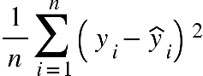

where {"mathml":"<math xmlns=\"http://www.w3.org/1998/Math/MathML\" style=\"font-family:stix;font-size:16px;\"><semantics><msub><mi>y</mi><mi>i</mi></msub><annotation encoding=\"application/json\">{\"x\":[[141,141,141,142,143,145,146,147,148,150,151,151,153,155,156,159,160,161,162,162,162,162,162,162,161,163,164,165,167,167,167,169,169,169,171,171,171,171,172,172,172,173,173,173,173,173,173,173,167,166,165,164,159,156,156],[187,187,187,187,188,189,189,189,189,191,192,193,194],[182,182,183,184,185,187,188,189,191,191,191,191,191,190,188,187,187,186,185,184]],\"y\":[[176,176,177,179,183,186,188,188,188,189,189,189,189,188,186,184,182,181,180,179,178,176,176,174,172,176,177,180,181,182,183,185,186,188,191,192,194,196,197,198,199,201,202,204,205,206,207,209,214,215,216,216,219,220,221],[194,195,198,200,204,207,208,208,210,212,216,217,217],[186,185,185,185,185,185,185,186,186,186,187,188,188,188,188,188,188,188,188,188]],\"t\":[[0,12,204,216,233,249,332,433,460,468,709,717,733,749,963,971,983,1000,1237,1260,1275,1283,1299,1316,1333,1933,1950,1967,1983,2000,2050,2067,2189,2200,2217,2233,2250,2266,2291,2301,2316,2333,2350,2483,2500,2517,2533,2701,2717,2734,2750,2766,2932,2950,2966],[4343,4573,4584,4600,4616,4633,4650,4666,4931,4939,4949,4966,5212],[6067,6492,6516,6534,6550,6666,6684,6701,6717,7036,7052,7300,7867,7900,7924,8308,8317,8332,8349,8366]],\"version\":\"2.0.0\"}</annotation></semantics></math>","origin":"MathType for Microsoft Add-in"} represents the actual values, {"mathml":"<math xmlns=\"http://www.w3.org/1998/Math/MathML\" style=\"font-family:stix;font-size:16px;\"><semantics><msub><mover><mi>y</mi><mo>^</mo></mover><mi>i</mi></msub><annotation encoding=\"application/json\">{\"x\":[[99,99,99,99,99,100,100,101,102,102,102,103,104,105,106,107,107,110,111,115,116,117,119,121,125,127,128,128,130,131,132,132,132,132,132,132,132,132,132,132,132,132,132,133,134,135,135,136,137,137,137,139,139,139,139,139,139,139,139,139,139,139,139,139,139,139,139,139,138,138,138,137,137,136,135,135,133,131,126,123,122,120,117,110,108,107],[151,151,151,151,152,152,152,153,153,153],[146,146,146,146,147,147,148,149,150,151,151,152,152,152,151,151,151,151,150,149,148,147,147],[77,77,78,80,83,87,90,92,93,94,95,96,97,99,100,101,103,104,105,106,107,108,115,119,119,122,127,129,130,131,133,137,140,143,144,145,147,150,151]],\"y\":[[143,144,145,146,148,152,153,156,159,160,162,164,164,165,168,168,168,169,169,169,169,169,169,169,169,169,169,168,166,163,160,159,156,154,152,151,150,149,148,147,145,144,144,144,145,149,151,155,157,159,160,164,166,168,171,172,173,176,178,180,181,182,183,185,188,191,193,196,197,199,200,201,202,204,207,208,209,210,212,212,213,213,213,214,214,214],[192,193,194,198,202,204,206,209,211,212],[177,178,179,180,180,182,182,183,183,183,183,183,182,180,178,177,176,176,176,176,175,175,174],[149,147,144,138,132,126,121,119,117,115,114,111,108,107,106,105,104,101,100,100,100,100,104,106,107,108,112,112,112,112,114,119,121,124,127,128,129,131,132]],\"t\":[[0,148,156,169,186,203,220,238,254,270,287,366,373,387,404,420,437,494,504,520,536,553,572,586,603,620,726,737,754,770,786,803,820,837,853,1038,1054,1071,1093,1104,1124,1169,1187,1558,1637,1654,1670,1686,1703,1720,1736,1753,1770,1786,1803,1820,1870,1887,1904,1920,1936,1998,2005,2019,2037,2053,2069,2136,2154,2170,2187,2204,2220,2236,2253,2269,2428,2437,2453,2469,2486,2670,2687,2703,2719,2736],[4455,4678,4687,4703,4719,4736,4753,4769,4786,4803],[5968,6137,6198,6213,6221,6253,6382,6388,6402,6554,6570,6790,6837,6887,6909,6920,6940,7055,7069,7092,7116,7132,7148],[8368,8590,8604,8620,8637,8653,8670,8686,8703,8720,8736,8753,8770,8786,8803,8820,8837,8853,8870,9236,9260,9269,9286,9303,9319,9336,9352,9369,9386,9403,9470,9487,9503,9520,9536,9586,9637,9654,9670]],\"version\":\"2.0.0\"}</annotation></semantics></math>","origin":"MathType for Microsoft Add-in"}represents the predicted values, and {"mathml":"<math xmlns=\"http://www.w3.org/1998/Math/MathML\" style=\"font-family:stix;font-size:16px;\"><semantics><mi>n</mi><annotation encoding=\"application/json\">{\"x\":[[69,70,71,71,73,75,76,76,78,78,78,79,79,80,80,81,81,81,81,82,83,83,83,83,84,86,87,87,87,87,87,87,87,88,89,90,90,90,91,91,92,92,93,95,97,100,102,104,105,105,105,105,105,106,106,106,107,107,107,107]],\"y\":[[118,117,117,117,120,122,126,128,131,132,132,134,136,139,140,143,144,144,145,148,148,149,148,147,141,137,134,133,132,132,131,130,129,128,125,124,123,121,121,120,119,117,116,117,120,125,132,138,140,141,144,145,146,148,148,149,151,152,152,153]],\"t\":[[0,76,117,141,151,168,185,201,217,234,251,277,293,309,318,334,351,367,434,451,468,484,694,703,716,733,750,766,821,834,851,877,900,918,934,950,967,984,1000,1070,1085,1102,1316,1367,1384,1401,1417,1434,1450,1467,1742,1757,1768,1784,1800,1828,1836,1852,1867,2054]],\"version\":\"2.0.0\"}</annotation></semantics></math>","origin":"MathType for Microsoft Add-in"} is the number of observations. The R-squared value, which indicates the proportion of variance in the dependent variable that is predictable from the independent variables, is calculated as:

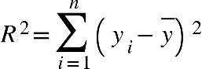

where {"mathml":"<math style=\"font-family:stix;font-size:16px;\" xmlns=\"http://www.w3.org/1998/Math/MathML\"><mstyle mathsize=\"16px\"><menclose notation=\"top\"><mi>y</mi></menclose></mstyle></math>","origin":"MathType for Microsoft Add-in"} is the mean of the actual values. The model's results showed a high R-squared value, indicating a good fit, and a low MSE, reflecting its accuracy in predicting rainfall.

In addition to my work on the Bitcoin price prediction project, I also delved into deep learning algorithms, focusing specifically on recurrent neural networks (RNNs) and long short-term memory (LSTM) networks for time series forecasting tasks. A significant project in this domain was the prediction of future Bitcoin prices using LSTM models, a powerful type of RNN well-suited for sequential data and time series analysis. LSTM networks are designed to capture long-term dependencies in data through a series of gates that control the flow of information.

For this project, I utilized a dataset of historical Bitcoin prices, including features such as the opening price, closing price, highest price, lowest price, and volume. The data was pre-processed by normalizing the values to ensure that the model could learn efficiently. I then used sliding windows to create sequences of data points to feed into the LSTM model, where each sequence represented a specific time frame of past prices used to predict the next price point.

The LSTM model was constructed with several layers, including multiple LSTM layers with ReLU activations, followed by dropout layers to prevent overfitting. The final dense layer produced the prediction for the next time step. The model's architecture is as follows:

**model = Sequential() model.add(Input(shape=(x.shape[1], 1))) model.add(LSTM(100, activation='relu', return_sequences=True)) model.add(Dropout(0.2)) model.add(LSTM(100, activation='relu', return_sequences=True)) model.add(Dropout(0.2)) model.add(LSTM(100, activation='relu', return_sequences=True)) model.add(Dropout(0.2)) model.add(LSTM(120, activation='relu')) model.add(Dense(units=1))**

The model was compiled with the Adam optimizer and mean squared error (MSE) as the loss function, and it was trained using the training data. Early stopping was implemented to halt training when the validation loss stopped improving, thus preventing overfitting.

The model's performance was evaluated using metrics such as MSE and mean absolute error (MAE). MSE is the average of the squares of the errors, while MAE is the average of the absolute errors. These metrics are defined as follows:

The trained model was then used to make predictions on a test set, and its predictions were compared to actual values to assess accuracy. This project enhanced my understanding of time series forecasting and the application of LSTM networks in predicting financial data, preparing me for more advanced and real-world applications in AI and machine learning.

Accuracy = 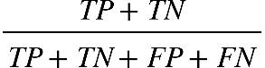

Precision = 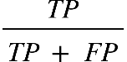

Recall = 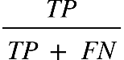

F1 score = {"mathml":"<math xmlns=\"http://www.w3.org/1998/Math/MathML\" style=\"font-family:stix;font-size:16px;\"><mn>2</mn><mo>&#xA0;</mo><msubsup><mo>&#xB7;</mo><mrow><mi>P</mi><mi>r</mi><mi>e</mi><mi>c</mi><mi>e</mi><mi>s</mi><mi>s</mi><mi>i</mi><mi>o</mi><mi>n</mi><mo>&#xA0;</mo><mo>+</mo><mo>&#xA0;</mo><mi>R</mi><mi>e</mi><mi>c</mi><mi>a</mi><mi>l</mi><mi>l</mi></mrow><mrow><mi>P</mi><mi>r</mi><mi>e</mi><mi>c</mi><mi>e</mi><mi>s</mi><mi>i</mi><mi>o</mi><mi>n</mi><mo>&#xA0;</mo><mo>&#xB7;</mo><mo>&#xA0;</mo><mi>R</mi><mi>e</mi><mi>c</mi><mi>a</mi><mi>l</mi><mi>l</mi></mrow></msubsup></math>","origin":"MathType for Microsoft Add-in"}

where TP is true positives, TN is true negatives, FP is false positives, and FN is false negatives. The VGG16 model achieved high accuracy and F1-score, demonstrating its effectiveness in predicting injuries based on image data.

In conclusion, my internship at Pragyan SmartAI Technology LLP provided a comprehensive and practical experience in AI and ML. The projects I worked on, from Bitcoin price prediction using LSTM models to house price prediction using deep learning algorithms, equipped me with valuable skills and insights. These experiences have significantly enhanced my understanding of AI technologies and prepared me for future challenges in this dynamic field. The hands-on experience with real-world datasets and advanced machine learning techniques, combined with the guidance of experienced mentors, has been instrumental in shaping my proficiency in AI. This internship has laid a strong foundation for my future endeavors in the rapidly evolving domain of artificial intelligence and machine learning.

**4.1. OUTPUT IMAGES OF BITCOIN PREDICTION**

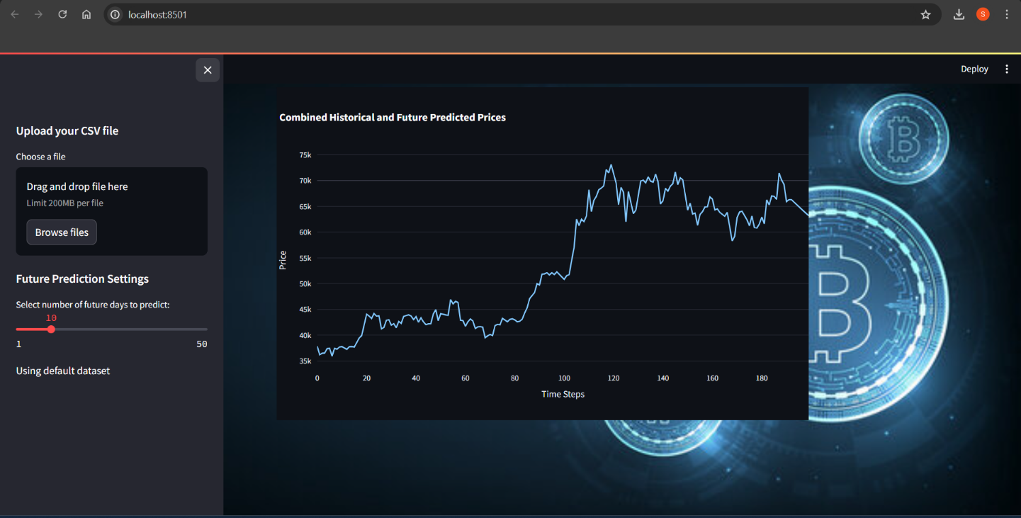

Figure 4.1: Bitcoin Prediction App

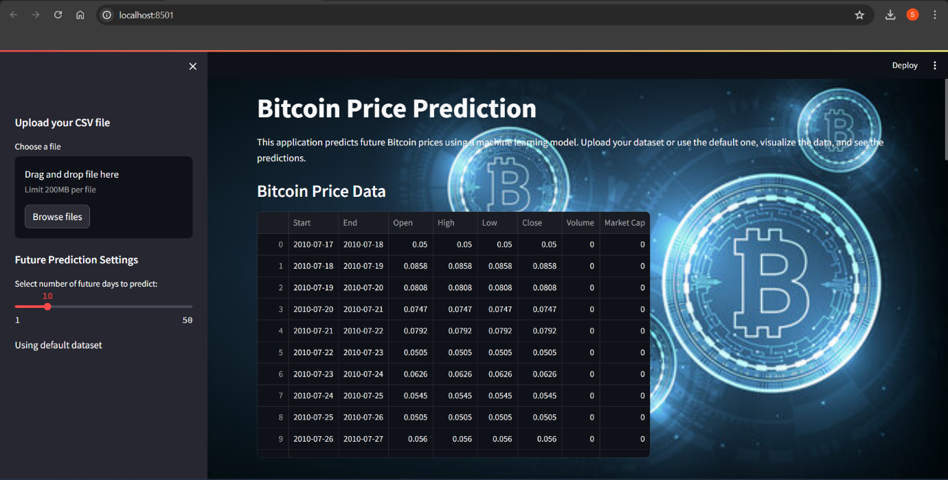

Figure: Bitcoin Prediction App

During my internship at Pragyan SmartAI Technology LLP, I delved into various aspects of AI and ML, significantly enhancing my skills and knowledge in these areas. One of the key projects I worked on was the Bitcoin price prediction using LSTM models. This involved understanding and implementing Long Short-Term Memory (LSTM) networks, which are a type of recurrent neural network (RNN) particularly suited for time series forecasting. By preprocessing historical Bitcoin price data and training the LSTM model, I was able to make accurate future price predictions, gaining valuable insights into time series analysis and neural network training.

Additionally, I worked on a house price prediction project using deep learning algorithms. This project involved gathering a comprehensive dataset of house prices and relevant features, followed by data cleaning, preprocessing, and feature engineering. By developing and training deep learning models, I was able to predict house prices with high accuracy, further honing my skills in handling complex datasets and building robust predictive models.

A significant aspect of my learning was the deployment of these models using Streamlit, an open-source app framework for machine learning and data science projects. Streamlit allowed

me to create interactive web applications, providing a user-friendly interface to showcase my models' predictions and insights. I learned how to integrate my trained models into Streamlit

applications, enabling real-time predictions and visualizations. This experience was crucial in understanding the end-to-end process of developing, training, and deploying machine learning models, preparing me for real-world applications and industry demands.

Overall, my internship provided a well-rounded experience in AI and ML, encompassing both the theoretical foundations and practical implementations. The opportunity to work on diverse projects, coupled with the guidance of experienced mentors, equipped me with the skills and confidence to tackle complex AI challenges and contribute effectively to future projects in this dynamic field.

**4.2. Overview of Internship Work**

1. Foundational Training in Python Programming:

* Gained knowledge of Python syntax, data structures, and essential libraries such as NumPy and pandas.
* Developed skills for efficient data manipulation and analysis, laying the groundwork for advanced ML applications.

1. In-depth Learning of Machine Learning Concepts:

* Explored various ML algorithms and their practical applications through theoretical lessons and case studies.
* Engaged in projects involving extensive data preprocessing, feature engineering, and model evaluation to solidify understanding and apply ML techniques to real-world problems.

1. Proficiency in AI Tools and Technologies:

* Worked with a variety of libraries and frameworks for building and training models, data visualization, and maintaining interactive coding environments.
* Participated in hands-on projects and collaborative efforts, gaining practical experience and insights into the ethical and societal implications of AI technologies.
* Enhanced technical abilities and prepared for future challenges in the AI and ML field, equipped with the skills and knowledge necessary to contribute effectively to the industry.

**4.3. Techniques and Skills**

1. Python Programming:

* Mastered syntax, data structures, and key libraries (NumPy, pandas) for efficient data manipulation and analysis.

2. Data Preprocessing:

* Learned techniques for handling missing values, data normalization, and feature selection to prepare datasets for machine learning models.

3. Machine Learning Algorithms:

* Gained proficiency in implementing various ML algorithms and understanding their applications and limitations through practical case studies.

4. Model Evaluation:

* Acquired skills in evaluating model performance using metrics such as Mean Squared Error (MSE), R-squared (R²), accuracy, precision, recall, and F1-score.

5. Deep Learning Techniques:

* Developed an understanding of deep learning concepts and architectures, particularly convolutional neural networks (CNNs) for image classification tasks.

6. Data Visualization:

* Utilized tools such as Matplotlib and Seaborn for creating informative visualizations to analyze and interpret data effectively.

7. AI Development Tools:

* Gained experience with TensorFlow and PyTorch for building and training deep learning models.
* Used Jupyter Notebooks, VS Code for interactive coding and efficient workflow management.

**4.4. Contributions and Responsibilities**

1. Project Contributions:

* **Developed and implemented a Bitcoin price prediction model using Long Short-Term Memory (LSTM) networks**: Engineered a time-series forecasting model to predict future Bitcoin prices based on historical data, managing all phases from data preprocessing and sequence generation to model training and performance evaluation.
* **Designed and deployed a Streamlit application for interactive visualization and analysis**: Created a user-friendly web interface to visualize Bitcoin price predictions, allowing users to upload data, interact with the model, and review prediction results in an accessible format.
* **Conducted Exploratory Data Analysis (EDA) to guide model development**: Performed comprehensive data analysis, including descriptive statistics, data visualization, and trend analysis, to understand data characteristics and inform model refinement.
* **Applied performance metrics to assess model accuracy**: Utilized evaluation metrics such as Mean Squared Error (MSE) and Mean Absolute Error (MAE) to measure and improve the accuracy of the prediction model, ensuring reliable and actionable insights.
* **Explored potential future enhancements for model improvement**: Identified and proposed strategies for future upgrades, such as incorporating additional features and optimizing prediction algorithms to enhance model accuracy and effectiveness.

2. Individual Responsibilities:

* Independently handled data preprocessing tasks, ensuring datasets were clean, normalized, and ready for analysis.
* Conducted model evaluations using various metrics, interpreting results to improve model accuracy and reliability.
* Maintained detailed documentation of all project processes, methodologies, and outcomes for future reference and knowledge sharing.

3. Adherence to Project Timelines:

* Demonstrated strong time management skills by meeting project deadlines and maintaining consistent progress.
* Prioritized tasks effectively, balancing individual work with collaborative efforts to ensure timely completion of all assigned responsibilities.
* Adapted to changing project requirements and timelines, showing flexibility and resilience in managing workload.

**4.5. Technical Tools**

1. Development Environment:

* Jupyter Notebooks: Used for interactive coding, documentation, and sharing of code and results.

2. Integrated Development Environment (IDE):

* Visual Studio Code (VS Code): Utilized for writing, debugging, and testing code efficiently.

**4.6. Technical Illustrations and Diagrams:**

1. Illustration and Diagrams related to Bitcoin Price Prediction Project:

**Architecture Diagram**

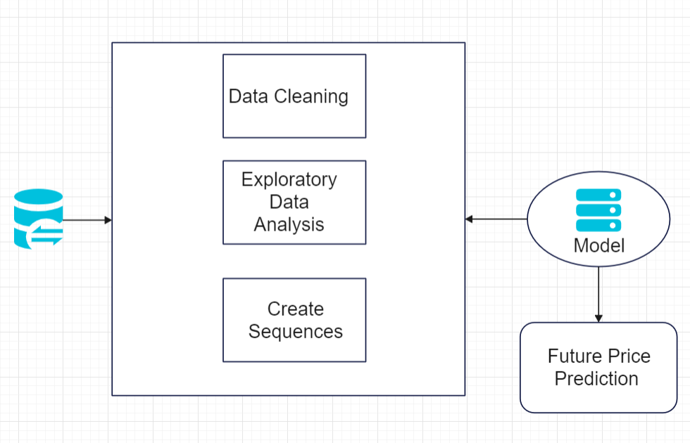

Figure 4.6: Architecture Diagram

**Flowchart Diagram**

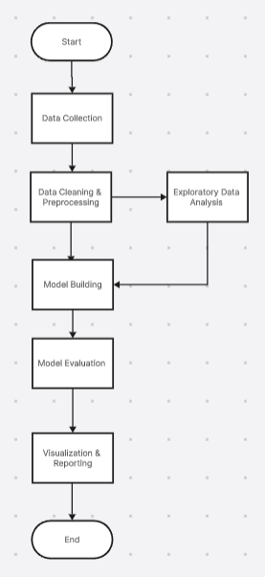

Figure 4.7: Flow Chart

**5: CONCLUSION**

This internship at Pragyan SmartAI Technology LLP has been profoundly impactful, offering me deep insights into both practical and theoretical aspects of Artificial Intelligence (AI) and Machine Learning (ML). Engaging in hands-on projects such as predicting Bitcoin prices with LSTM models. Working on these projects involved mastering advanced algorithms and model deployment techniques, including the use of Streamlit for creating interactive applications.

I have gained invaluable experience in model development, from data preprocessing to evaluation, and applied deep learning concepts in real-world scenarios. Collaborating with industry professionals has not only honed my technical skills but also improved my problem-solving abilities and teamwork. Utilizing tools like TensorFlow and Streamlit, I learned to bridge the gap between theoretical knowledge and practical application, ensuring that models are both effective and user-friendly.

Reflecting on this journey, I have developed a greater appreciation for the complexities of AI and ML. The experience underscored the importance of meticulous project management and the continuous pursuit of knowledge. This internship has equipped me with a robust foundation for pursuing future innovations in AI and ML, preparing me to tackle emerging challenges and contribute meaningfully to technological advancements.

**REFERENCES**

[1] http://www.pragyan-ai.com

[2] <https://www.wikipedia.org/>

[3] <https://towardsdatascience.com>

[4] <https://www.kaggle.com>

[5] https://arxiv.org/abs/1409.1556