1.On your Windows laptop or PC, open 'System Information' and take a screenshot showing your OS version, processor, and RAM details.

Ans.
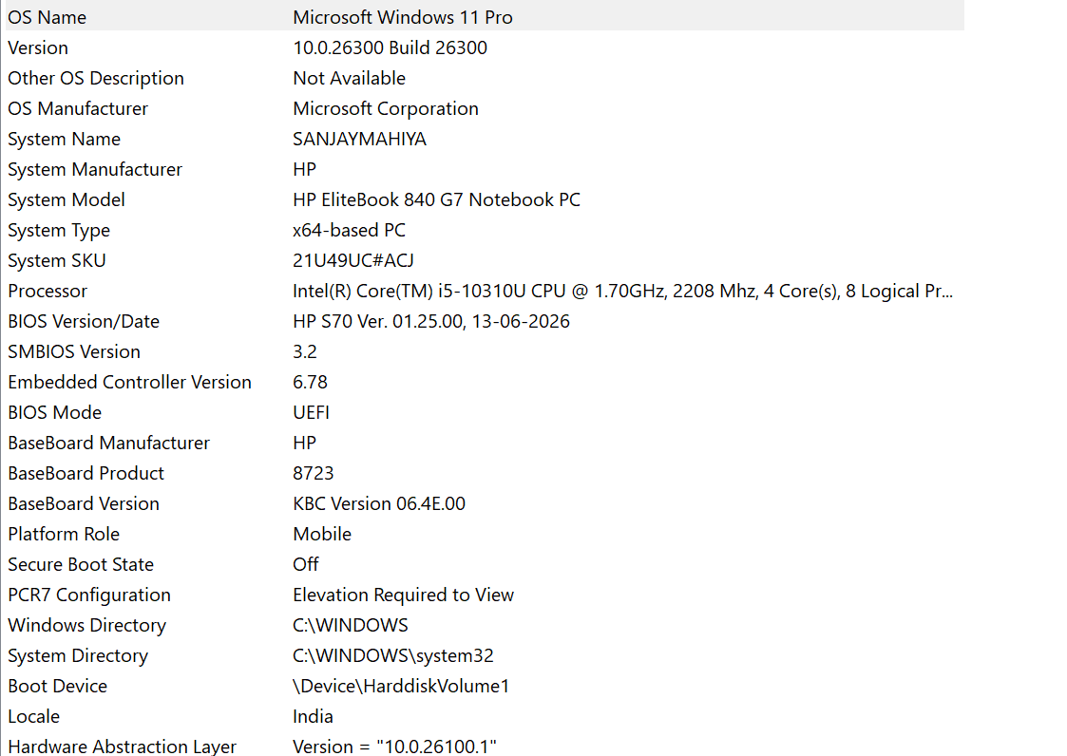
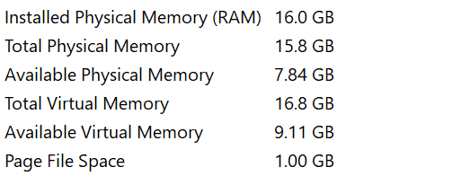

2.Download any official Linux distribution ISO (like Ubuntu or Fedora), and use Rufus or BalenaEtcher to create a bootable USB drive for
installation.<br><br><em><strong>Hint:</strong> If you don't have a spare USB, use a virtual machine tool like
VirtualBox to mount the ISO and start the installation process virtually.</em>

Ans.

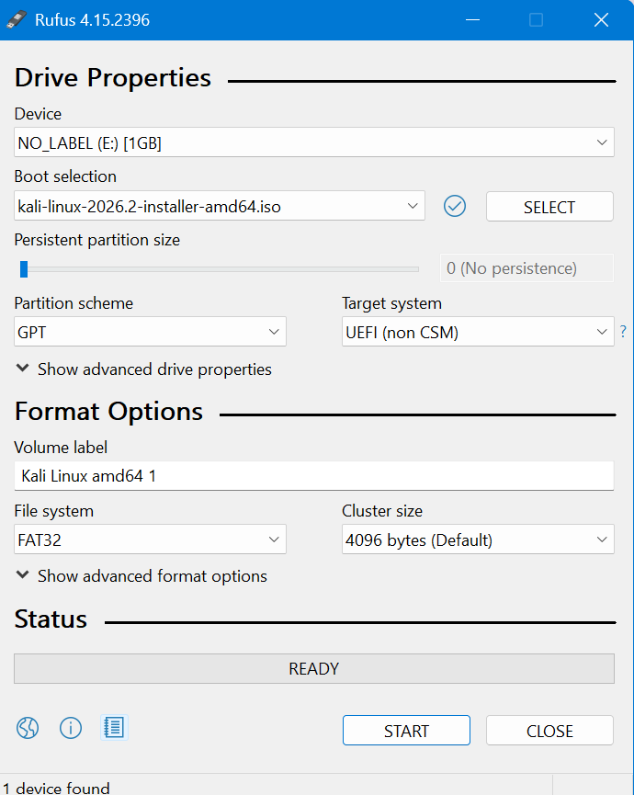

3.On a macOS device (or using a macOS virtual machine), open 'System Preferences' and change the desktop wallpaper, then adjust the system language to Hindi or Gujarati.

Ans.
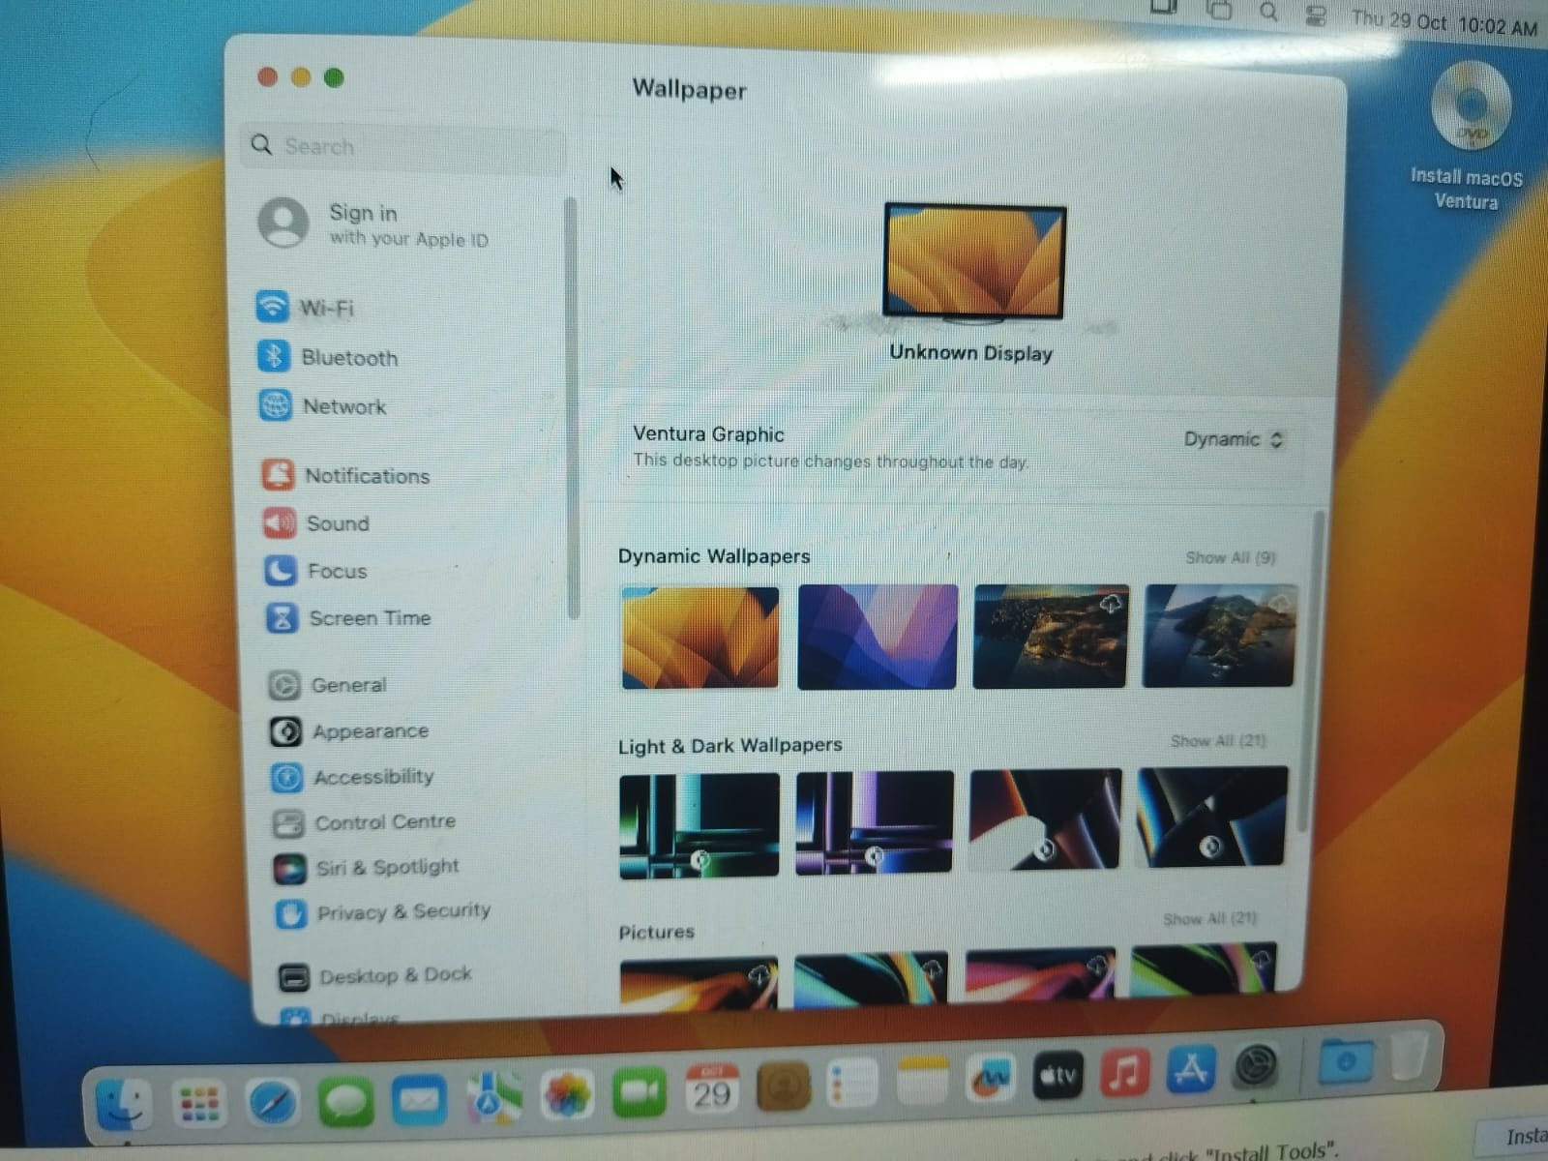

change the primary system language on your Mac:
- Click the Apple menu () in the top-left corner of your screen.
- Select System Settings.
- Click General in the sidebar on the left.
- Click Language & Region on the right side.
- Click the Add (+) button under the Preferred Languages section.
- Select your preferred language from the list and click Add.
- In the pop-up prompt, choose Use [hindi and gujarati] to set it as your primary language.
- Restart your Mac to apply the changes completely across all apps.
The system was lagging, so it didn't happen.

4.Install a fresh copy of Ubuntu Linux (real or virtual machine) and create a new user account named 'gamer'. After installation, enable automatic login for this user and take a screenshot of the login screen showing the username.

Ans.
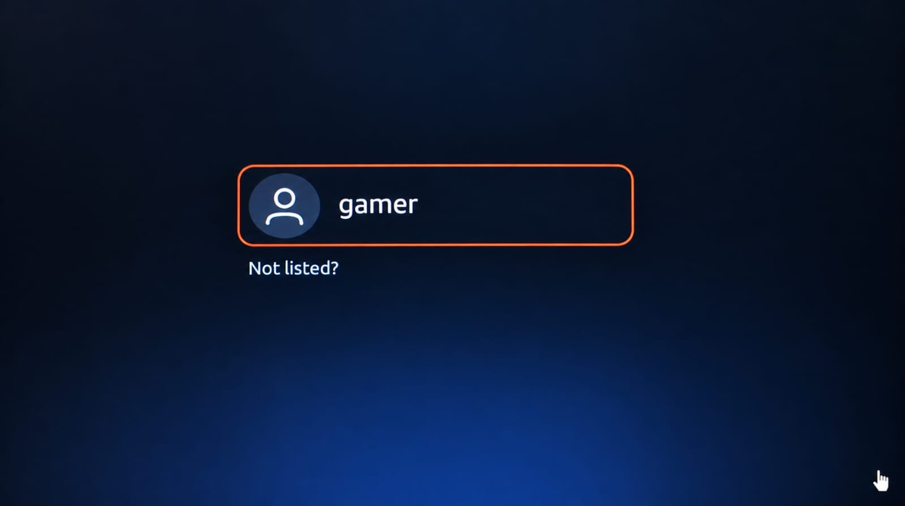

5.Use ChatGPT to generate a step-by-step guide for installing Windows 10 on a laptop, including partitioning tips and post-installation settings for privacy and updates. Follow the guide and note any steps that were unclear or missing.

Ans.

Practical Guide: Installing Windows 10 on a Laptop
Step-by-step practical assignment · Installation, partitioning, privacy and updates
1. Requirements before installation

Laptop and backup
- Laptop charger and stable power.
- Back up important files to an external drive or cloud storage.
- Keep a record of Wi-Fi details and any required software licences.

Bootable USB drive
- Use an 8 GB or larger USB drive; 16 GB is recommended.
- Download a legitimate Windows installation image from Microsoft.
- Create the bootable USB using Microsoft's Media Creation Tool, if available.
Important: Windows 10 reached the end of standard support on October 14, 2025. For normal internet use, consider Windows 11 if your laptop supports it, or check Microsoft's Extended Security Updates (ESU) eligibility before choosing Windows 10.
2. Step-by-step installation
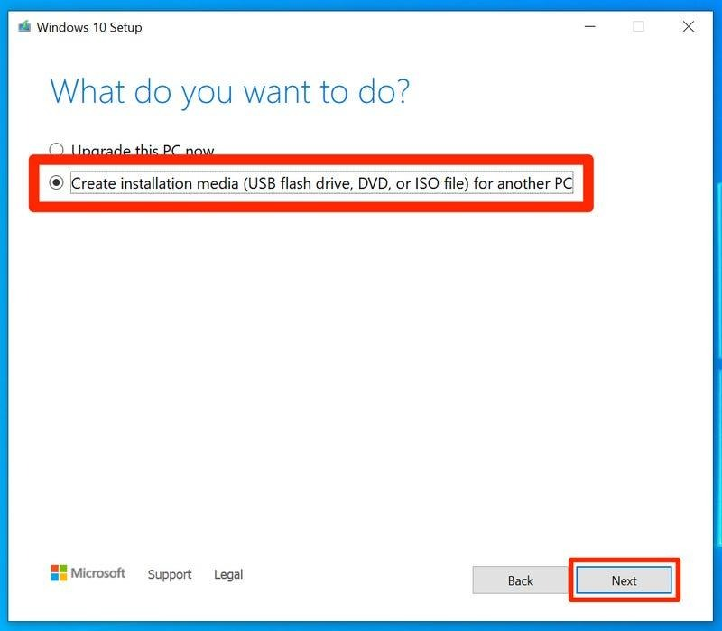
Step 1 — Create installation media
Download the Windows 10 installation tool from Microsoft's official Windows 10 download page. Follow its instructions to create a bootable USB.
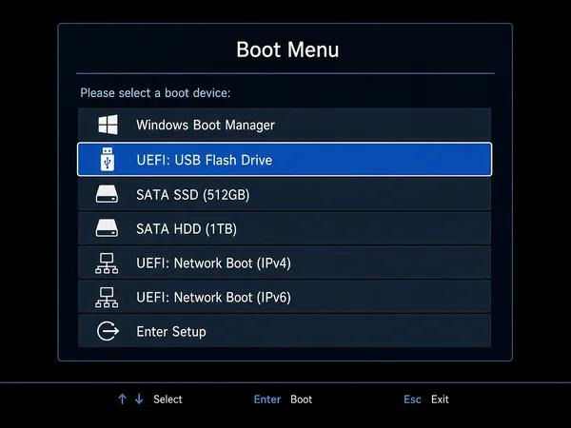
Step 2 — Boot from USB
Insert the USB and restart the laptop. Open the boot menu using the manufacturer's key, often F12, F9, Esc or F11. Select the USB's UEFI entry.
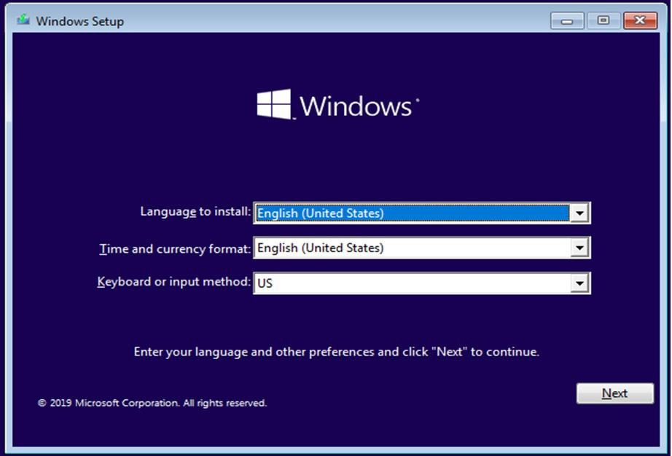
Step 3 — Start Windows Setup
Choose your language, time and keyboard layout, then select Install now. Enter your product key if requested, or choose the option to continue without one if available.
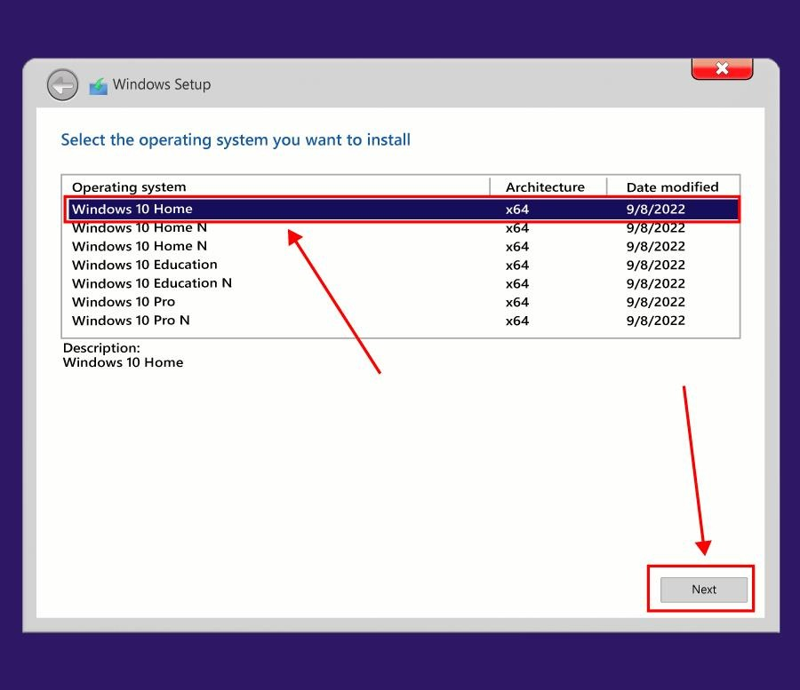
Step 4 — Choose the correct edition
Select the Windows edition matching your digital licence or product key, such as Home or Pro. Accept the licence terms and choose Custom: Install Windows only (advanced) for a clean installation.
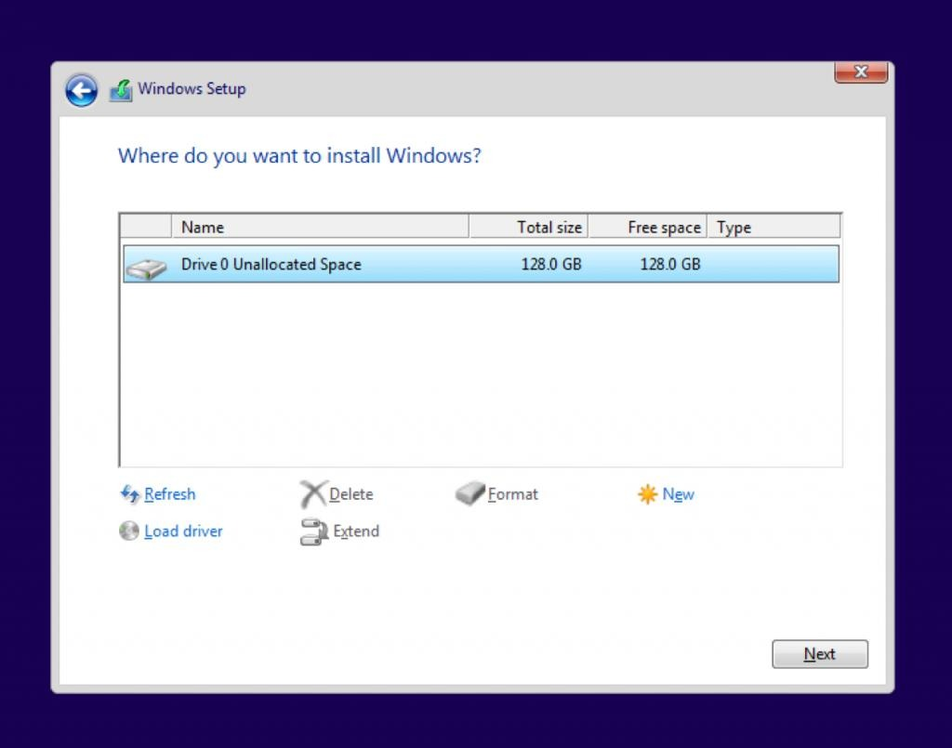
Step 5 — Select the installation partition
Review the disk and partition sizes carefully. Select the intended Windows partition or unallocated space. Only delete or format partitions when you have confirmed they contain no data you need.
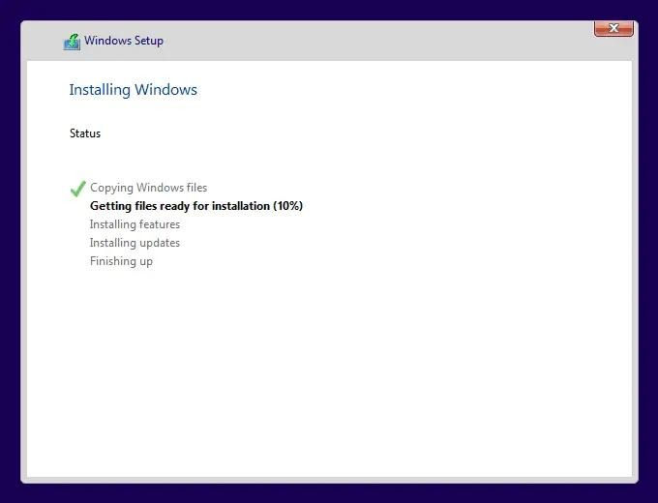
Step 6 — Install Windows
Select Next and wait while Setup copies files and restarts. Remove the USB when appropriate if the laptop keeps booting back into Setup.
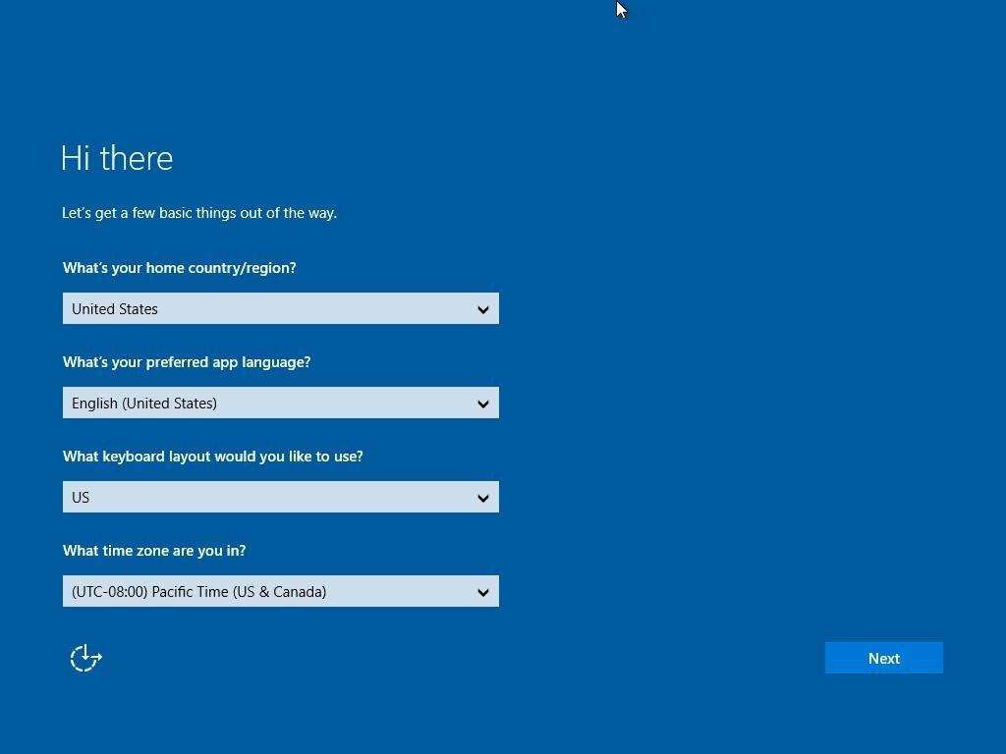
Step 7 — Complete initial setup
Choose your region and keyboard, connect to a network if needed, and configure your account and privacy options. The available choices depend on the Windows edition and setup version.
3. Partitioning tips
Partitioning divides your storage drive into separate logical sections. For example, you can keep Windows and applications on the C: drive and personal files on the D: drive.
Example for a 512 GB SSD:
C: Windows
180 GB
D: Personal files
Remaining space
Illustrative layout only. A 512 GB drive has approximately 477 GiB of usable capacity before formatting and system partitions.
- Keep sufficient space on C: for Windows updates and applications.
- Windows creates small system and recovery partitions automatically; do not delete them without a specific reason.
- If you want a separate D: drive, you can create it from the remaining unallocated space in Setup or later through Disk Management.
- Warning: Deleting or formatting a partition erases its data. Back up your files before proceeding.
- If the laptop has multiple drives, identify the correct drive by its capacity and model before making changes.
4. Post-installation settings
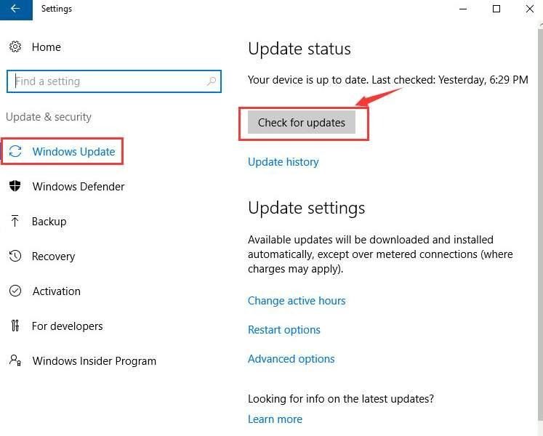
A. Updates and drivers
- Open Settings → Update & Security → Windows Update.
- Check for available updates and restart when required.
- Install drivers from the laptop manufacturer's official support page, especially Wi-Fi, graphics, chipset and audio drivers.
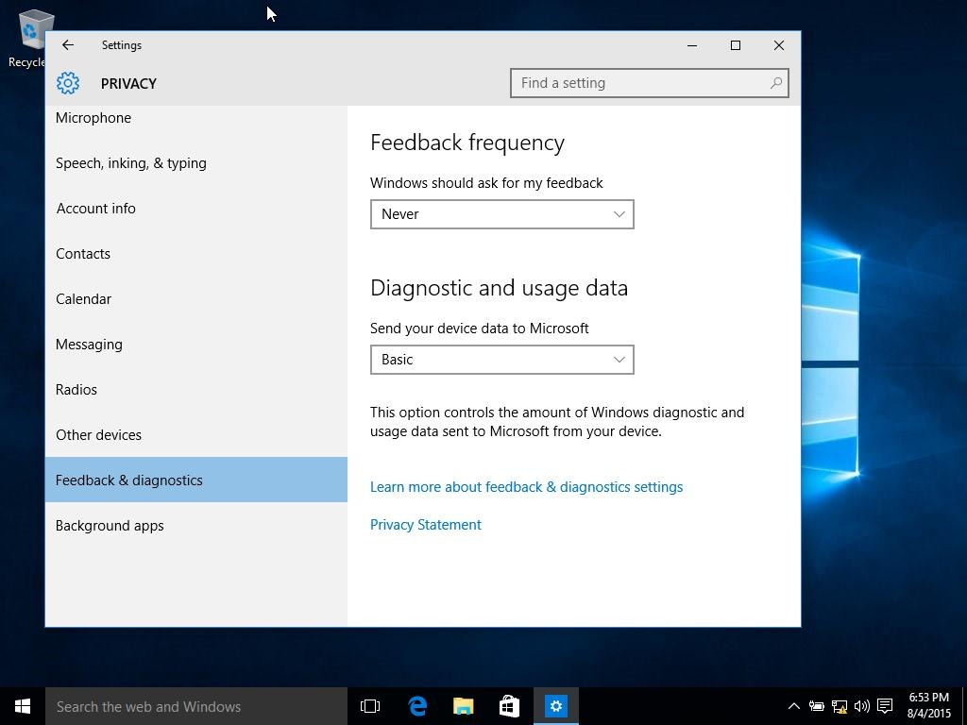
B. Privacy settings
Open Settings → Privacy and review:
- Location: disable if not needed.
- Camera and microphone: allow access only to apps that need it.
- Diagnostics and feedback: choose the most restrictive available diagnostic-data option.
- Activity history and advertising ID: disable options you do not need.
- Background apps: restrict unnecessary applications where the option is available.
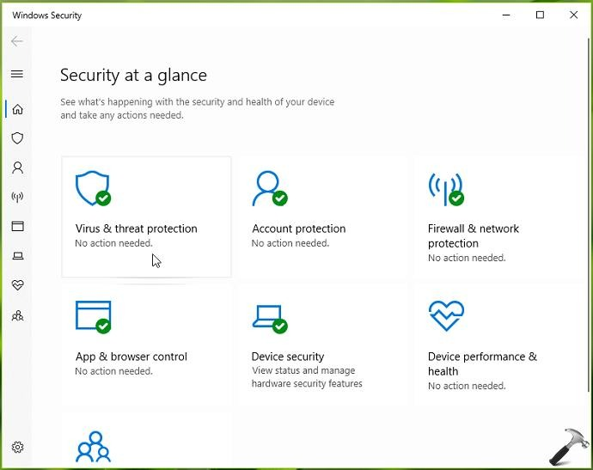
C. Security
- Check Windows Security → Virus & threat protection.
- Keep Microsoft Defender and the firewall enabled.
- Use a strong password and enable a PIN or Windows Hello if supported.
- Enable device encryption or BitLocker if supported, and securely back up the recovery key.
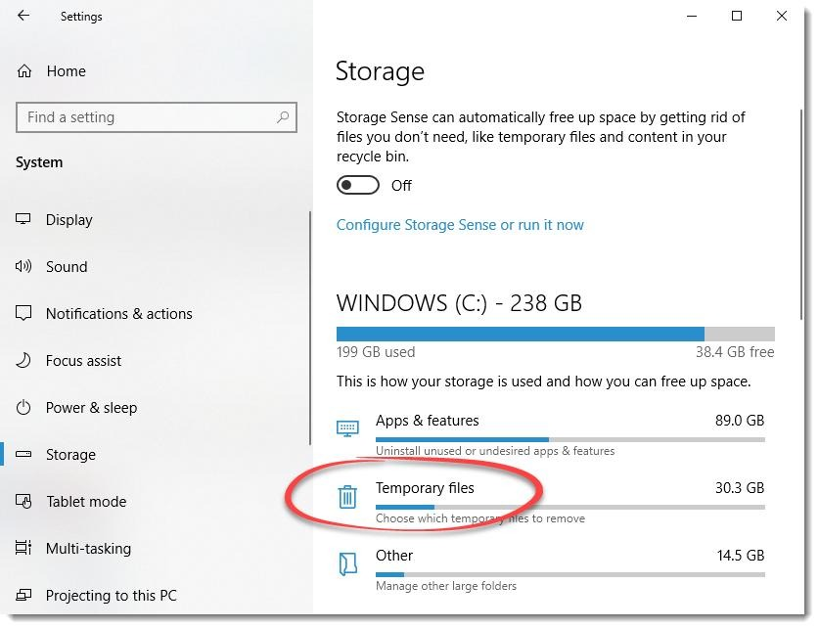
D. Final checks
- Confirm the correct time zone and keyboard layout.
- Check Device Manager for missing drivers or warning symbols.
- Test Wi-Fi, sound, webcam, touchpad and USB ports.
- Check Windows activation under Settings → Update & Security → Activation.
- Restore your backed-up files and install required applications.
Windows 10 security note: Because standard support has ended, ordinary Windows Update settings alone do not guarantee continued security updates. Check ESU coverage or use a supported operating system.
5. Practical observation sheet
After performing the installation on your laptop, complete this checklist.
Installation checklist
- 
0/10 complete
Backed up important files
Created bootable USB successfully
Opened boot menu and selected USB
Selected the correct Windows edition
Identified the correct disk and partitions
Completed Windows installation
Configured privacy and security settings
Checked updates and installed drivers
Tested Wi-Fi, audio and other hardware
Checked activation status
Steps that were unclear or missing
- Select the step that was difficult, then add your observations after trying the guide.
- Finding the correct boot-menu key
- Partition selection and disk formatting
- Product key and Windows activation
- Finding and installing drivers
- Understanding privacy settings
- No unclear steps encountered
- Additional observations
- Copy practical report
6. Common issues and missing instructions
Problem | What to check
USB does not appear | Try another USB port and verify that the USB was created correctly.
SSD is not detected | Check BIOS/UEFI storage settings and the manufacturer's storage-driver guidance. Do not change storage-controller modes without understanding the consequences.
Windows cannot install on the selected disk | Check the UEFI/GPT compatibility and the Setup error message before changing partition styles.
No Wi-Fi after installation | Download the correct network driver using another device if necessary.
Activation fails | Verify the licence, edition and digital activation status.
Laptop becomes stuck during setup | Check power, installation media and the displayed error; avoid repeatedly deleting partitions.

