1.Create a table listing 3 types of printers, 2 types of scanners, and 2 types of webcams, and for each, write one real-life use case (for example: 'Inkjet printer – printing college assignments').

Ans.

Device Type | Specific Type | Real-life Use Case
1.Printer | Inkjet Printer | Printing college assignments and color documents
2.Printer | Laser Printer | Printing a large number of documents in offices
3.Printer | Thermal Printer | Printing bills and receipts in shops
1.Scanner | Flatbed Scanner | Scanning documents and certificates
2.Scanner | Sheet-fed Scanner | Scanning multiple pages quickly
1.Webcam | USB Webcam | Using for online classes and video meetings
2.Webcam | Built-in Webcam | Making video calls on a laptop

2.Draw a labeled diagram showing how a typical home printer connects to a laptop or PC, including the connection interface used (USB, Wi-Fi, or Bluetooth).
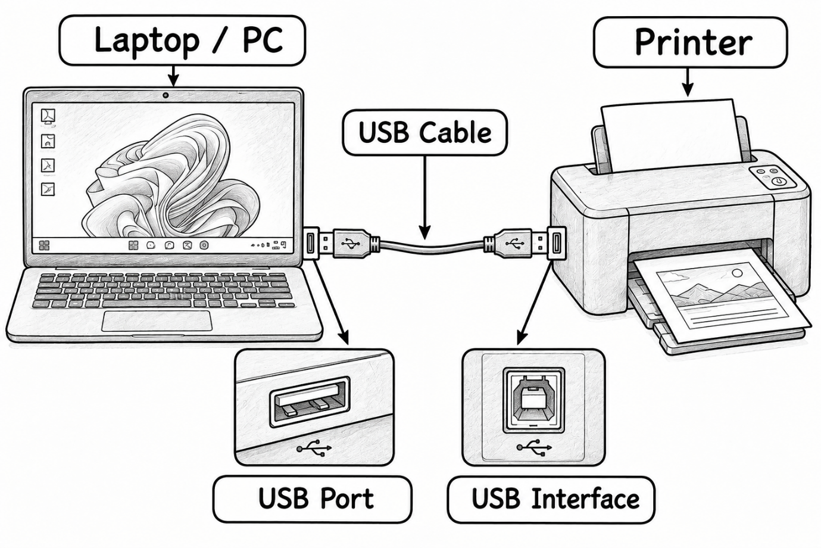Explanation:
A printer can be connected to a laptop or PC using a USB cable. One end of the cable is connected to the computer's USB port and the other end is connected to the printer's USB port. After connecting, the required printer driver is installed automatically or manually.
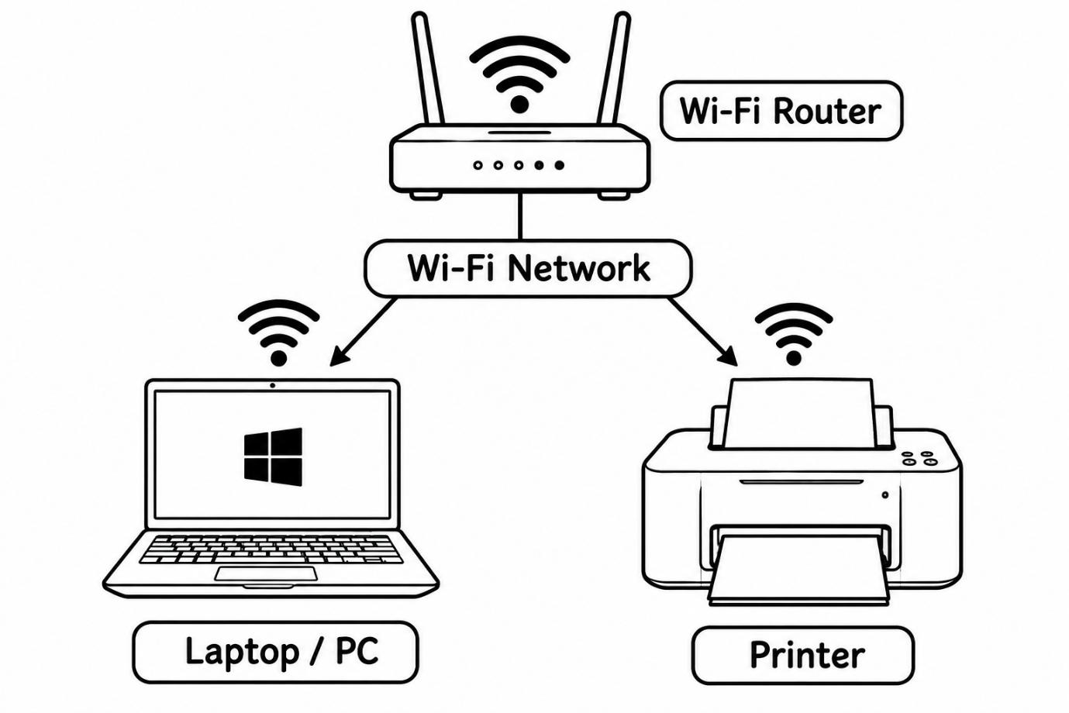
.3.List three different connection interfaces (such as USB, Wi-Fi, Bluetooth) used by peripherals like printers, scanners, and webcams, and for each, name one advantage and one disadvantage.

Ans.

Interface | Advantage | Disadvantage
USB | Fast and reliable connection | Requires a physical cable
Wi-Fi | Wireless and convenient; multiple devices can use the printer | Requires a Wi-Fi network and setup
Bluetooth | Wireless and easy for short-distance connections | Short range and generally slower than USB
4.Pick any one device you use at home or college (printer, scanner, or webcam). Write step-by-step instructions for how you would connect it to your computer, including what cable or wireless method you would use and any setup steps required.
Device selected: Printer
Step 1: Place the printer
I would place the printer near my computer and connect its power cable to a suitable power socket.
Step 2: Turn on the printer
I would press the power button and wait for the printer to start.
Step 3: Choose the connection method
I would use a USB cable to connect the printer to my computer.
Step 4: Connect the USB cable
I would connect one end of the USB cable to the printer and the other end to the computer's USB port.
Step 5: Install the printer driver
The computer may automatically detect the printer and install the required driver. If it does not, I would download and install the correct driver from the printer manufacturer's official website.
Step 6: Add the printer
In Windows, I would go to:
Settings → Bluetooth & devices → Printers & scanners → Add device
Then I would select my printer.
Step 7: Test the printer
I would print a test page or a simple document to check whether the printer is working correctly.
Step 8: Complete the setup
If the test page prints successfully, the printer is ready to use for printing assignments, documents, and other files.

