1.Connect a USB webcam to your computer, install any required drivers, and verify that the webcam works by opening the default camera app and capturing a photo.

Ans.
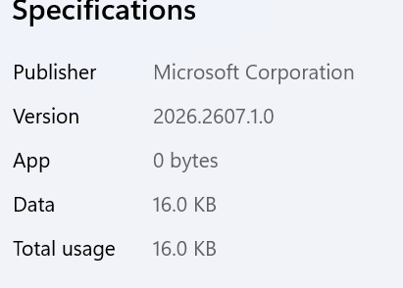
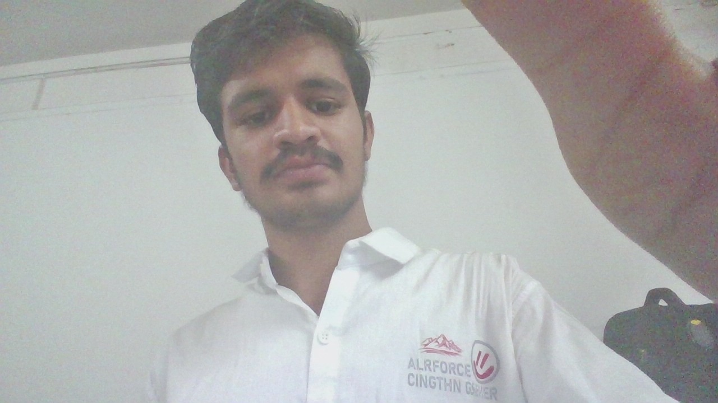

2.Set up a local printer (USB or network), install the correct driver, and print a test page to confirm successful installation.
Ans.

Step 1: Connect the Printer
- For a USB Printer:
  - Plug the printer into a power outlet and turn it on.
  - Connect the USB cable from the printer to an available USB port on your computer.
- For a Network Printer (Wi-Fi or Ethernet):
  - Ethernet: Plug an Ethernet cable from your router directly into the printer's LAN port.
  - Wi-Fi: Use the printer’s control panel screen to find your Wi-Fi network, enter your password, and connect. Ensure your computer is on the same Wi-Fi network.

Step 2: Install the Printer Driver
Most modern operating systems automatically detect connected printers and install generic drivers. If auto-detection doesn't start, follow these manual steps:
- On Windows (10/11):
  - Go to Settings and Bluetooth & devices and Printers & scanners.
  - Click Add device (or Add a printer or scanner).
  - Select your printer from the list once found.
  - (If Windows cannot find it, download the dedicated driver package from the manufacturer's official support page—e.g., HP, Canon, Epson, or Brother—and run the setup file).
- On macOS:
  - Go to System Settings and Printers & Scanners.
  - Click Add Printer, Scanner, or Fax
  - Select your printer from the list and click Add (macOS uses AirPrint/Bonjour for auto-driver setup).

Step 3: Print a Test Page
Once the printer status shows Ready or Connected, verify the installation by sending a test page:
Windows:
- Go back to Settings and Bluetooth & devices and Printers & scanners.
- Click on your newly installed printer.
- Select Print a test page (or go to Printer properties and Print Test Page).
macOS:
- Go to System Settings > Printers & Scanners and click your printer.
- Click Options & Supplies.
- Select the Utility tab and click Print Test Page (or open a document in TextEdit and press Cmd + P).
Verification Check: Look at your printed page. Ensure text alignment is straight, colors/black ink print clearly without streaks, and there are no print queue error notifications on your computer.

3.Simulate a connectivity issue by unplugging the printer's USB cable, then use Windows Device Manager to identify and resolve the 'printer not detected' problem.

Step-by-Step Practical Procedure

1.Simulate the Disconnection:Physical Action.
- Unplug the USB cable of your printer from your computer.
- Try sending a quick test document to print—it will fail or show as Offline / Not Detected.
2.Open Device Manager:Windows System Tool.
- Right-click the Start Menu button (or press Win + X).
- Select Device Manager from the list.
- Look under the Print queues or Printers category. You will notice your printer is either grayed out, missing, or under Other devices with a yellow error icon.
3.Reconnect & Scan for Hardware Changes:Troubleshooting Step.
- Plug the USB cable firmly back into your computer's USB port.
- In the Device Manager window, click on Action in the top menu bar.
- Click Scan for hardware changes (or click the computer icon with a magnifying glass on the toolbar).
4.Verify Resolution:Confirmation.
- Expand the Print queues section again.
- Confirm that your printer appears normally without any yellow warning triangles or error icons.
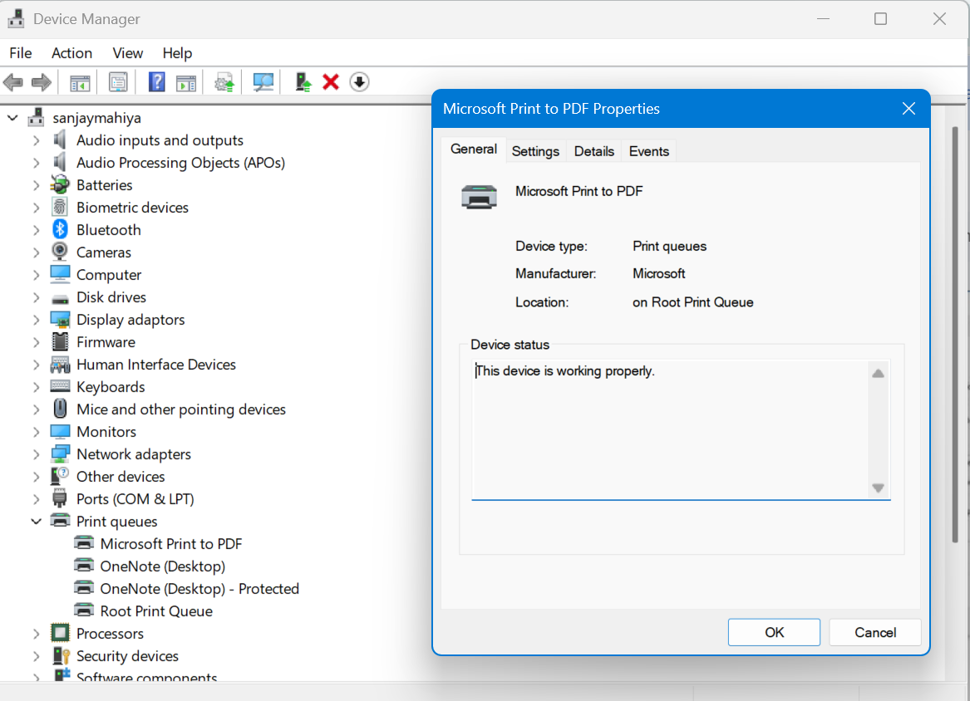

4.A user reports that their webcam video is not displaying in Zoom, but it works in the default camera app. Troubleshoot and resolve the issue so the webcam works in both applications.

Ans.
Step1: open settings(win+i) and cleck privacy and security and go to camera access allow.
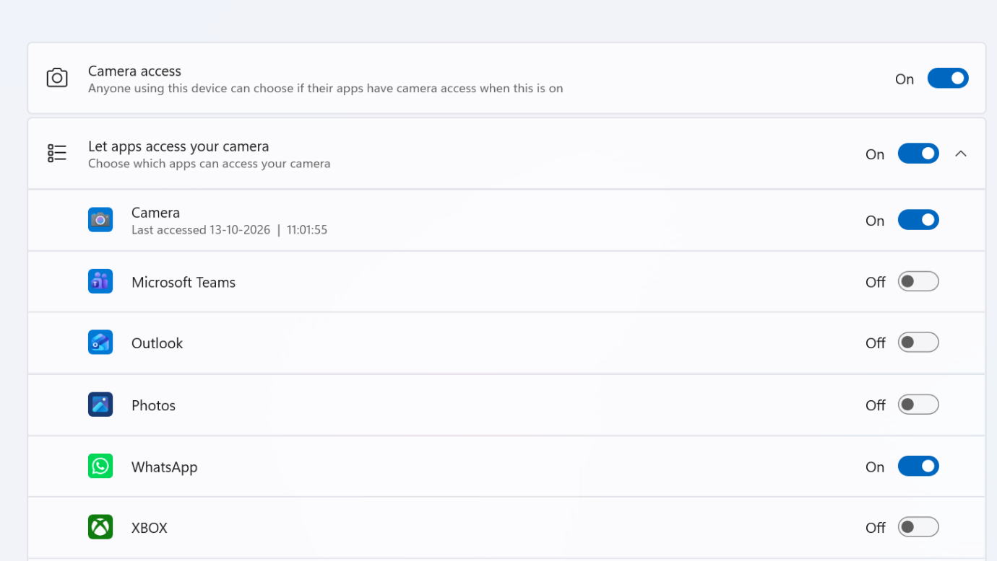

Setp:2
Zoom work
Open settings and cleck bluetooth and devices and go to cameras HP HD camera and zoom encourage

