1.Draw a labeled diagram of a desktop PC, clearly marking the motherboard, CPU, RAM, GPU, and both HDD and SSD storage components.

Ans.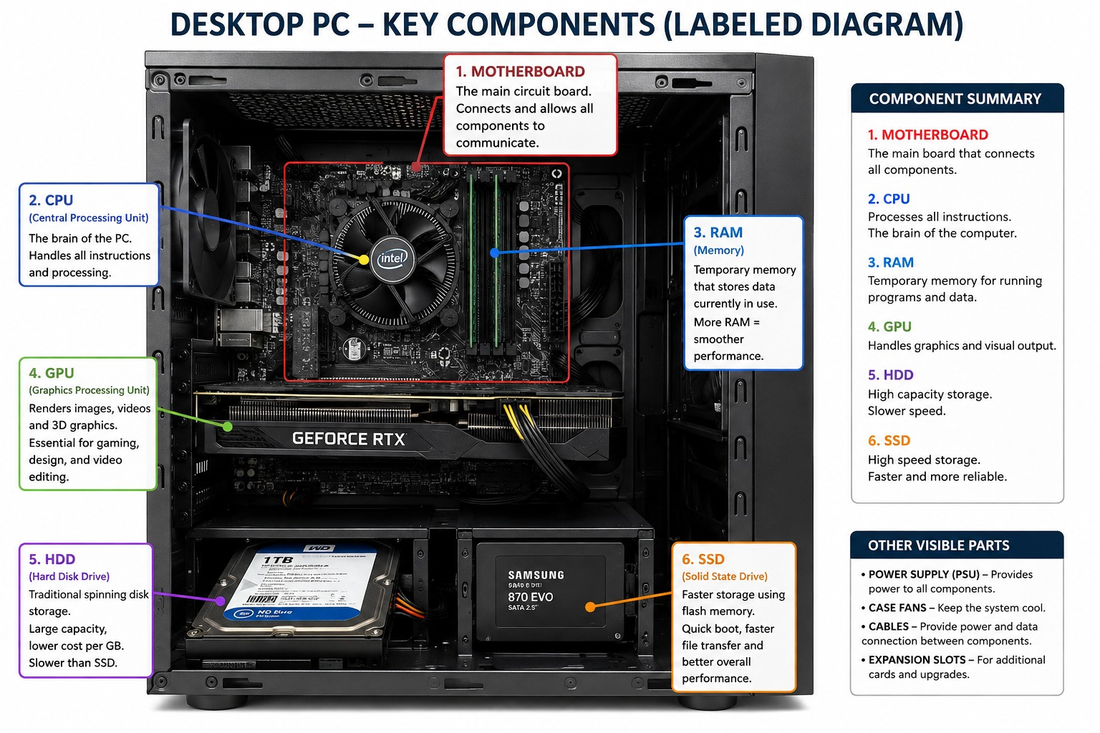

2.Create a comparison table showing the main differences between HDD and SSD storage in terms of speed, durability, and typical use cases.

Ans.
HDD (Hard Disk Drive)
- HDDs use spinning magnetic platters.
- Cheap and spacious, but slower than SSDs.
- HDDs have moving parts, such as spinning platters and a read/write head.
- Typical sequential read/write speeds are around 80–160 MB/s.
SSD (Solid State Drive)
- SSDs use flash memory chips — fast, silent, and shock-resistant.
- SSDs use NAND flash memory to store data.
- SSDs have no moving parts.
- Typical speeds range from around 500 MB/s (SATA SSD) to 7,000 MB/s or more (NVMe SSD).

3.Write a short explanation (2-3 sentences each) describing the role of the CPU, RAM, and GPU in running a game like PUBG or Free Fire on a PC.
Ans.
1.CPU (Central Processing Unit)
- The CPU handles the game's main calculations, game logic, physics, and controls. In PUBG or Free Fire, it processes player actions, AI, and communication between different game components.
2.RAM (Random Access Memory)
- RAM temporarily stores the game data and files that the CPU needs while the game is running. More RAM helps the game run smoothly and reduces slowdowns when other programs are open.
3.GPU (Graphics Processing Unit)
- The GPU renders the game's graphics, including characters, maps, textures, lighting, and effects. A powerful GPU helps provide higher FPS and smoother gameplay, especially at higher resolutions and graphics settings.
4.Imagine you want to upgrade your PC to run the latest version of FIFA smoothly. List which hardware components you would consider upgrading and explain why for each.
Ans.
1.GPU (Graphics Card)
- The most important upgrade for gaming. A better GPU provides higher FPS and smoother graphics at higher settings.
2.RAM
- Upgrading to 16 GB or more helps the game run smoothly, especially when other applications are open.
3.CPU (Processor)
- A faster CPU improves game calculations, player movements, physics, and overall performance.
4.SSD
- Installing FIFA on an SSD reduces loading times and makes the game and system feel more responsive.
5.Power Supply (PSU)
- If you install a more powerful GPU, you may need a PSU with sufficient wattage and the correct connectors.
6.Cooling System
- Better CPU/GPU cooling helps prevent overheating and maintains stable performance during long gaming sessions.

