1.Draw a labeled diagram of an ATX motherboard and mark at least 8 different slots and ports (such as RAM slots, PCIe slots, SATA ports, USB headers, CPU socket, power connector, etc.).

Ans.
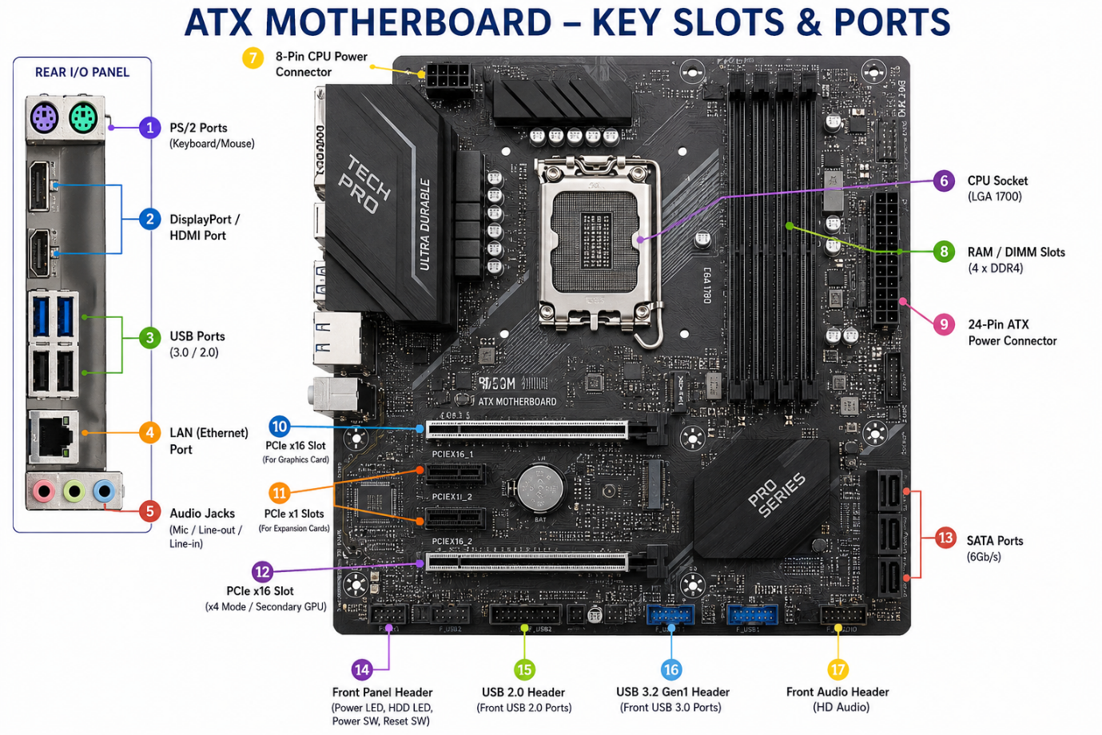

2.Research and list 3 popular CPU socket types (for example: LGA1151, AM4, LGA1200) and name one compatible CPU model for each.

Ans.

CPU Socket Type | Compatible CPU Model | Manufactrer
1. LGA 1151 | Intel Core i7-9700K | Intel
2. AM4 | AMD Ryzen 5 5600X | AMD
3. LGA 1200 | Intel Core i5-10600K | Intel

3.Explain in your own words the primary functions of the CPU and the chipset on a motherboard, and describe how they work together when you open a music app like Spotify.

Ans.
Functions of CPU and Chipset
1.CPU (Central Processing Unit):
The CPU is the main processor of a computer. It executes instructions, performs calculations, and processes data. It acts like the “brain” of the computer.
2.Chipset:
The chipset is a group of controllers on the motherboard that helps different hardware components communicate with the CPU. It manages communication between devices such as USB, storage drives, PCIe devices, and other motherboard components.

4.Find a clear photo of a real motherboard (from the internet or your own device), and identify at least 5 different ports or slots by circling them and labeling each one.
Ans.
