1.Create a comparison table listing the main differences between DDR3, DDR4, and DDR5 RAM, including speed, voltage, and typical use cases.

Ans.

Genertion | Typical Speed | Voltage |  | Use Case
1.DDR3 | 1066–2133 MHz | 1.5 V |  | Older desktop PCs and laptops, basic office work, older Windows systems, and legacy computers
2.DDR4 | 2133–4800 MHz | 1.2 V |  | Current mainstream — most office PCs in India
3.DDR5 | 4800–8400 MHz | 1.1 V |  | New builds 2023+ — Intel 12th Gen+, AMD Ryzen 7000

2.Open your laptop or desktop (with power disconnected), locate the RAM slots, and take a clear photo of the installed RAM module. Reinstall the RAM module and verify that your system boots up successfully.

Ans.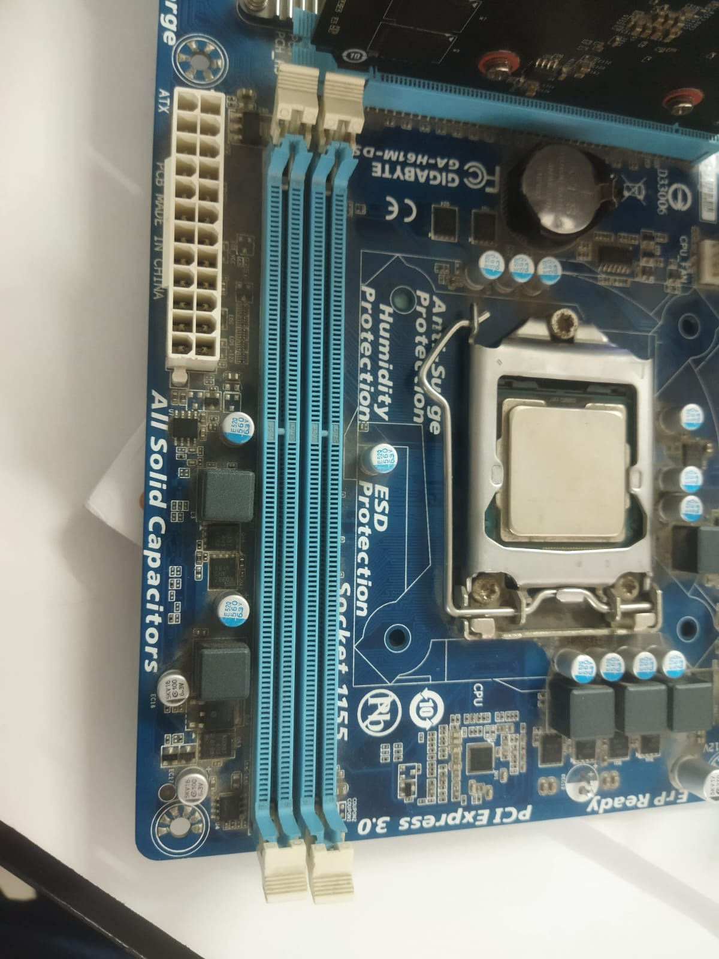

3.List three key differences between HDD, SSD, and NVMe storage types, and for each, name one app or use case (from apps you use daily) that would benefit most from that storage type.

Ans.

Storage Type | Speed | Key Difference | Best Daily Use Case / App
HDD | Slow | • Uses spinning magnetic disks  • Low cost  • High storage capacity  • More sensitive to physical damage | File Storage – Photos, videos, movies, and documents
SSD (SATA) | Fast | • Uses flash memory  • No moving parts  • Faster than HDD  • More durable and reliable | Windows / Microsoft Office – Faster booting and opening Word, Excel, etc.
NVMe SSD | Very Fast | • Uses PCIe interface  • Much faster than SATA SSD  • Lower latency  • Best for high-performance tasks | Gaming (e.g., GTA V) – Faster game and level loading
4.Remove the storage drive (HDD or SSD) from your system, take a photo of the connector type (SATA, M.2, or NVMe), and reinstall the drive. Confirm that your device recognizes the storage after reassembly.
Ans.
