GoKesari — Tile Board UI pass, performance and release
Final summary · 9–10 October 2026 · test.gokesari.com and gokesari.com
Prepared by Claude Code for the owner's review. Production deployment of anything not already released waits for the owner's written approval.

1. Status (three lines)
Done: every role's home is the Tile Board on one screen (60/60 local and 105/105 test-site checks, 3 languages); every function within 2 taps (236/236 links); released to gokesari.com on 9 Oct (PR #123, with the owner's approval).
Tested on test.gokesari.com with real test accounts: 48 of 57 end-to-end tests pass, 4 not run with a stated reason, 5 open; access 55/55, app view 4/4; PageSpeed (Lighthouse 13.5) mobile 93–100 on production after release.
Not done: signed-in pages are slow (3–5 s server time: database in Ohio, us-east-2) — needs the owner's hosting decision; second-level pages still median 2.2 phone screens; PR #124 (performance + second UI pass) waits on GitHub Actions billing for CI.

2. Assumptions and limits
- The earlier audit report, benchmark and usability proof were available as artifacts and were used (the faith-themed parts were excluded as the brief asks).
- All four roles were signed in on test.gokesari.com with the owner's test mailboxes (gk-cust, gk-shop, gk-admin, gk-ops) plus a new gk-uireg account for registration; codes came from the owner's Gmail.
- GitHub Actions stopped starting jobs at 18:04 UTC (billing). Consequences: no CI on staging after the merge, on release PR #123 or on PR #124; no Cashfree sandbox payment (the wallet and shop-wallet top-ups were not run). The owner approved releasing #123 without its own CI run.
- This environment cannot reach Cashfree or Google Maps; the Maps-based location page is the only navigation item not verified.
- Business rules on the test site were not changed (the cancellation rule allows cancelling only before the shop accepts; tested as such).
- Only Chromium is installed here: Firefox and Safari were not tested. Hindi and Marathi were tested for the boards, header, menu pages and states; second-level page bodies are still English.
- Lighthouse was run locally (13.5.0, the same engine as PageSpeed Insights) because the public PageSpeed API quota was exhausted; numbers match the owner's PDF reports within a few points.
- Production was checked read-only (public pages, smoke test, Lighthouse); no test data or test payments were used on gokesari.com.

3. Issue register (totals; full list in GoKesari_UI_Issue_Register_2026-10-09.xlsx)
Severity | Total | Fixed | Partly fixed | Not fixed
All | 71 | 39 | 16 | 16
Critical | 3 | 2 | 0 | 1
High | 31 | 20 | 9 | 2
Medium | 24 | 13 | 6 | 5
Low | 13 | 4 | 1 | 8

Issues not fully fixed:
ID | Problem | Status | Why / what is left
AUD-05b | Every shop card shows the same cart icon. | Not fixed | Reason: needs uploaded shop photos, not a UI change.
AUD-06 | One product per phone screen: search ‘milk’ 7.3 screens, Dairy 13 screens. | Partly fixed | Local: Dairy 13 → 5.0 screens, search 7.3 → 2.6. Still more than one screen when a category has many products (paging of product lists not added).
AUD-12 | Pages ran 4–14 screens on a phone. | Partly fixed | Second-level pages: median 2.1 phone screens (was 2.1–2.9); forms, policies and long data tables still scroll — see open items.
AUD-14 | 107 of 175 text items 12 px; buttons ~30 px; three action rows per card. | Partly fixed | Card still shows Add and Subscribe (two rows) when subscription is offered.
AUD-15 | English only; no Hindi/Marathi switch. | Partly fixed | Body text of second-level pages (forms, tables) is still English — open item.
AUD-19 | Kesari quality badge has the same pill style as type/closed/delivery pills. | Not fixed | Reason: low impact; needs a badge design decision (open item).
AUD-21 | Search ‘milk’ lists products but “0 shops” although shops sell milk. | Not fixed | Reason: business logic; recorded as open item.
BEN-01 | No reorder; no delivery promise on cards; search not scoped. | Not fixed | Reason: ETA and scoped search need new back-end data/logic.
BEN-04 | Savings not shown. | Not fixed | Reason: needs MRP/savings data on every line (back-end).
BEN-05 | Live order not surfaced on home; free-delivery progress not shown. | Partly fixed | Reason (progress bar): needs the shop's free-delivery rule in the cart bar data.
BEN-09 | Flat list, no saved views, no command search. | Partly fixed | Reason (command search): new feature, not UI regrouping.
BEN-10 | No voice search. | Not fixed | Reason: new feature (speech input), outside UI-only scope.
USA-01 | Smallest text on the approved mockups and build: 11–12 px (brief: body ≥14 px on mobile). | Partly fixed | Measured min 12 px (was 10–11). 14 px body met at 360×800 and taller; not on 360×728 / 320×640 boards.
USA-06 | Truncated labels (“Open n…”, “Fruits & …”, “Tomorrow's d…”) in the deployed boards. | Partly fixed | Zero cut-off labels at 360×800+ except place/shop names (data); 320×640: a few shop-owner/admin submenu labels hidden.
DT-12 | On the smallest phones (320×640) 1–3 submenu labels per board are hidden inside their tile. | Not fixed | Reason: physical limit of one screen with 48 px targets; see decision D-02.
DT-13 | Body content of forms, tables and policy pages not translated. | Not fixed | Reason: thousands of strings; needs native-speaker review. Open item O-02.
DT-14 | Inside older pages, some links and inputs remain under 44 px (inline text links, date inputs). | Partly fixed | All-pages scan: smallest target 13 px (native inputs) on some admin forms.
PERF-01 | Mobile Speed Index 8.6 s (score 92): the server took ~4 s to send the page when idle (Lighthouse: document latency 1,050–4,010 ms). The page itself scores 98–100 locally. | Not fixed | Owner/hosting setting; after release, home scored 99 when warm and 93–94 when cold.
PERF-02 | Signed-in pages take 3.4–5.1 s server time on test.gokesari.com (slow-4G check: 5 of 6 pages 3.6–5.0 s, target 3 s). Database is in Neon us-east-2 (Ohio): every query pays an India↔Ohio round trip. | Not fixed | Reproduced locally with a 200 ms database round trip: 2.1 s per signed-in page.
PERF-03 | 52 database queries per signed-in home page; the same user, wallet, addresses, unread count, roles and 8 business rules read several times. | Partly fixed | In PR #124 (tests 1,662 pass locally); waiting for GitHub CI (billing) before staging/production.
PERF-04 | Every query costs two database round trips (Drizzle sends unprepared queries; postgres-js describes, then executes). | Partly fixed | In PR #124; owner turns it on for test first (pooler must support prepared statements), then production.
PERF-05 | Lighthouse accessibility 99: heading order skipped a level; the phone language button's spoken name did not include its visible label. | Partly fixed | In PR #124.
PERF-06 | Render-blocking stylesheet (16 KB): 110–150 ms. | Not fixed | Decision D-23.
PERF-07 | Unused JavaScript 68 KiB, legacy JavaScript 17 KiB. | Not fixed | Framework-owned.
TST-01 | Resolving a dispute gave no visible confirmation within 5 s (the server took several seconds); a second click was refused (409). | Not fixed | Test A-06.
TST-02 | An approved return waiting for a rider cannot be completed by staff until a rider is on the way; with no rider online it waits. | Not fixed | Test S-11b not run.
TST-03 | The Returns tab links to /returns; /orders?tab=returns shows the Active tab. | Not fixed | Test C-10.
TST-04 | 126 products on one list (5 phone screens). | Partly fixed | In PR #124.
TST-05 | Category list 8.3 phone screens. | Partly fixed | In PR #124.
TST-06 | Business rules page 34.8 phone screens. | Partly fixed | In PR #124.
TST-07 | With two account alerts the shop owner's board is 2 px taller than a 320×640 screen; 1–6 submenu labels hidden on the smallest phones. | Not fixed | Decision D-02.
TST-08 | Long second-level pages (5–9 phone screens). | Partly fixed | In PR #124; second-level pages median 2.2 phone screens, 38 still over 3 (forms, legal texts, admin tools).

4. Design-thinking output

Personas
Persona | Context | Goals | Pain points (before)
Customer — Asha, 34, Pune | Orders milk and bread most mornings on a mid-range Android phone, often on 4G; reads Marathi first. | Re-order and track the daily order fast; see tomorrow's delivery; cancel or return without calling the shop. | Long pages, small buttons, English-only screens, not knowing whether an order is on its way.
Shop owner — Ramesh, 47, bakery | Runs the counter alone 6 am–10 pm; checks the phone between customers. | See new orders the moment they arrive, accept and pack them, keep prices and stock right, know if the account is blocked. | Morning rush buried 8 screens down; 21-link menus; missing that the wallet or a licence is blocking orders.
Admin — Platform owner | Desktop at the office, phone in the evening. | Approve shops, settle disputes and payments, change rules, watch reports. | A 17-section console of 28–71 screens; finding a function by scrolling; slow page (all data loaded at once).
Operator — Support desk | Laptop all day, handles tickets and onboarding queues. | Work the queues (late orders, applications, tickets) in order; find any order fast. | No work queue — 14 KPI tiles that could not be clicked; everything on one long page.

Top tasks — taps and scrolling, before → after
Role | Task | Taps before | Screens scrolled before | Taps after | Screens scrolled after | Path now
Customer | Track today's order | 3 | 1 | 1 | 0 | Do now › Track order
Customer | Order again from the usual shop | 4 | 2 | 2 | 0 | Shops tile › shop (products on the first screen)
Customer | Change tomorrow's milk | 3 | 1.5 | 1 | 0 | Do now › Tomorrow
Customer | Cancel an order before packing | 3 | 1 | 3 | 0 | Orders › Active › Cancel order › Yes (confirmation added)
Customer | Top up the wallet | 3 | 1 | 1 | 0 | Wallet tile › Add money
Shop owner | Accept a new order | 3 | 4 | 2 | 0 | Do now › New orders › Accept
Shop owner | Update a price | 3 | 6 | 2 | 0 | Price updates tile › Edit
Shop owner | See why the shop cannot take orders | 2 | 8 | 0 | 0 | Alert at the top of the board
Shop owner | Handle a return | 3 | 3 | 2 | 0 | Returns tile (Requests tab) › Approve
Admin | Approve a shop | 2 | 6 | 2 | 0 | Do now › Approvals
Admin | Change a business rule | 2 | 2 | 3 | 0 | Settings › Business rules › rule (one screen each)
Admin | Resolve a dispute | 3 | 2 | 2 | 0 | Disputes tile › Work case
Admin | Give a user a role | 3 | 14 | 3 | 0 | Users › Manage privileges › Save (confirmation)
Operator | Work the late-orders queue | 3 | 3 | 1 | 0 | Do now › Late orders
Operator | Close a ticket | 3 | 12 | 2 | 0 | Do now › Open tickets › View
Operator | Create/find a voucher | 2 | 16 | 1 | 0 | Vouchers tile

Taps and scrolling counted by walking each task on the old build (staging ff42729) and on the new one; scroll = phone screens (360×800) scrolled to reach the control.

What changed in the design
- One home per role: the Tile Board with a 'Do now' strip of live counts; every menu a tile; submenus as labelled counts on phones and 36 px chips on desktop.
- One path to each function: a tile opens its own page (tabs) or its menu page listing everything in that area; old dropdowns and the phone drawer removed; old links forward.
- Lists use tabs and paging (orders, returns, disputes, products, categories, search, profile, rules); long consoles split into their own pages; sections behind tabs on dashboards.
- Safety and feedback: confirmations before deleting or cancelling; error, not-found and offline screens; a progress bar from the tap.
- Accessibility: 44–48 px touch targets, 12 px minimum text (14 px tile labels), AA contrast, EN/हिं/मरा switch on every screen.

5. Usability scorecard per role, before → after
Expert review against Nielsen's ten heuristics, 1 (poor) – 5 (good), with the measured checks below.
Heuristic | Customer | Shop owner | Admin | Operator
Visibility of system status | 2 → 4 | 2 → 4 | 2 → 4 | 1 → 4
Match with the real world | 3 → 4 | 3 → 4 | 3 → 4 | 3 → 4
User control and freedom | 2 → 4 | 3 → 4 | 3 → 4 | 3 → 4
Consistency and standards | 2 → 4 | 2 → 4 | 2 → 4 | 2 → 4
Error prevention | 2 → 4 | 2 → 4 | 3 → 4 | 3 → 4
Recognition rather than recall | 2 → 4 | 1 → 4 | 1 → 4 | 1 → 4
Flexibility and efficiency | 2 → 4 | 2 → 4 | 2 → 3 | 2 → 4
Aesthetic and minimalist design | 2 → 4 | 1 → 4 | 1 → 4 | 1 → 4
Help users recover from errors | 2 → 4 | 2 → 3 | 2 → 3 | 2 → 3
Help and documentation | 3 → 3 | 3 → 3 | 2 → 3 | 2 → 3
Total (of 50) | 22 → 39 | 21 → 38 | 21 → 37 | 20 → 38

Measured check | Before | After | Target
Role homes on one screen (test site, real data, 7 sizes × 3 languages) | 0 of 105 (admin 70.9, operator 63.3, shop 24.0, customer 3.0 phone screens) | 104 of 105 (shop owner 320×640 is 2 px over) | 105
Role homes on one screen (local, 4 sizes × 3 languages, PR #124) | 0 | 60 of 60 | all
Every function within 2 taps (links clicked from the boards and menu pages) | not provable (dropdowns of 12–39 links) | 236 of 236 local (both sizes); 218 of 219 on test site (Maps blocked here) | all
Smallest touch target on role homes (phone) | 15–20 px | 44 px (48 px at ≥360 px wide) | 48 dp
Targets under 44 px on all pages (phone) | 4,056 | 347 (PR #124; mostly 20 px tick boxes inside 44 px labels, headings) | 0
Smallest text (phone) | 10–11 px | 12 px (labels 14 px; 13/12 px on short screens) | 14 px body
Lowest text contrast | 1.69:1 | 4.52:1 | 4.5:1
Second-level pages, median height (phone) | 2.2 screens (149 pages) | 2.2 screens (207 pages after splitting; 38 over 3) | 1
Access to another role's screens (direct links) | — | 55 of 55 refused (test site and local) | all
PageSpeed mobile, gokesari.com home | 92 (Speed Index 8.6 s) | 99 warm / 93 cold (Speed Index 3.3 s warm) | ≥90
Signed-in page, server time (test site) | 3.4–5.1 s | PR #124: 52→24 queries; with prepared statements ~2× faster (local, 200 ms DB); hosting fix pending | <1 s
Usable on slow 4G (test site, warm) | — | 1 of 6 pages under 3 s (2.8–5.0 s) | <3 s

6. Screens updated (before / after, phone and desktop)
Before = test.gokesari.com on 9 Oct before the change (staging ff42729); after = test.gokesari.com after #122 (staging 44ab921). Same test accounts and data. Full set in the screenshots folder.

Customer home
Before · Mobile | After · Mobile | Before · Desktop | After · Desktop
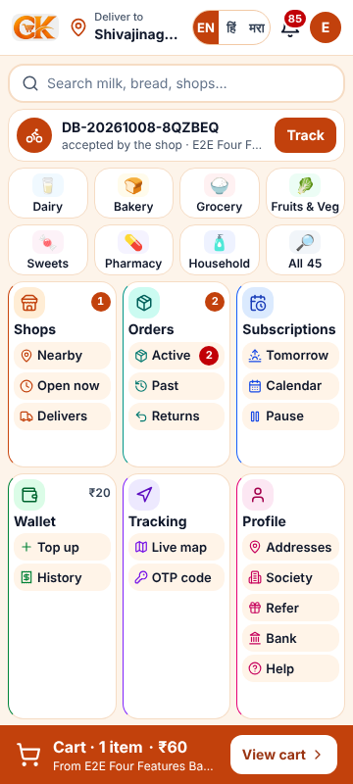 | 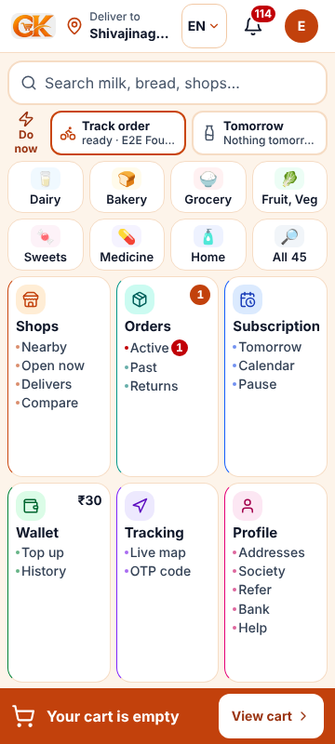 | 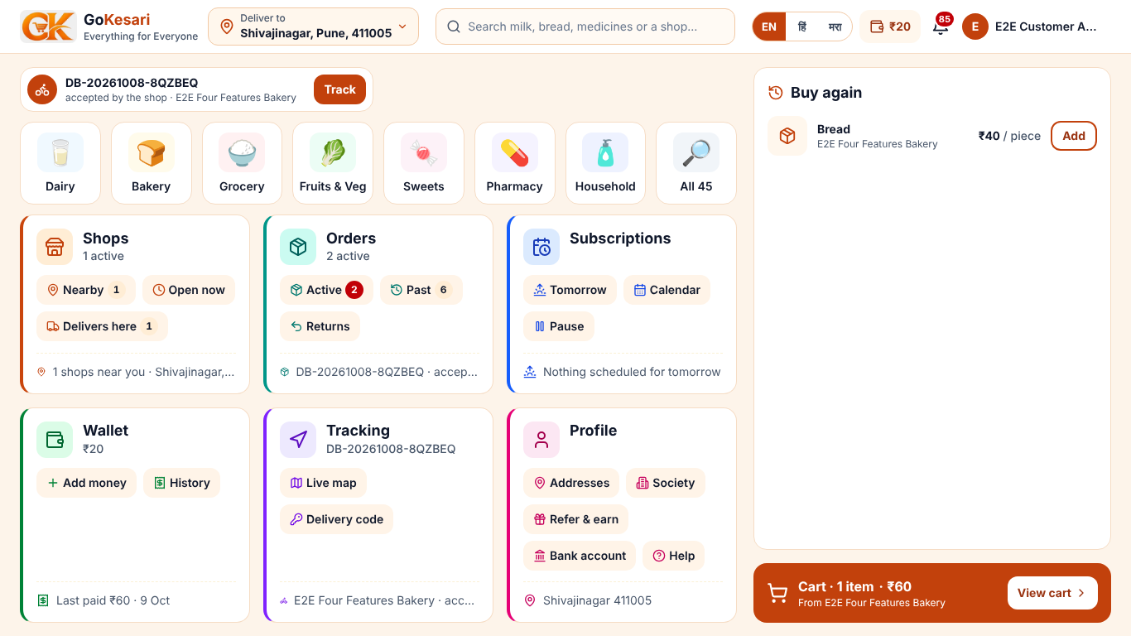 | 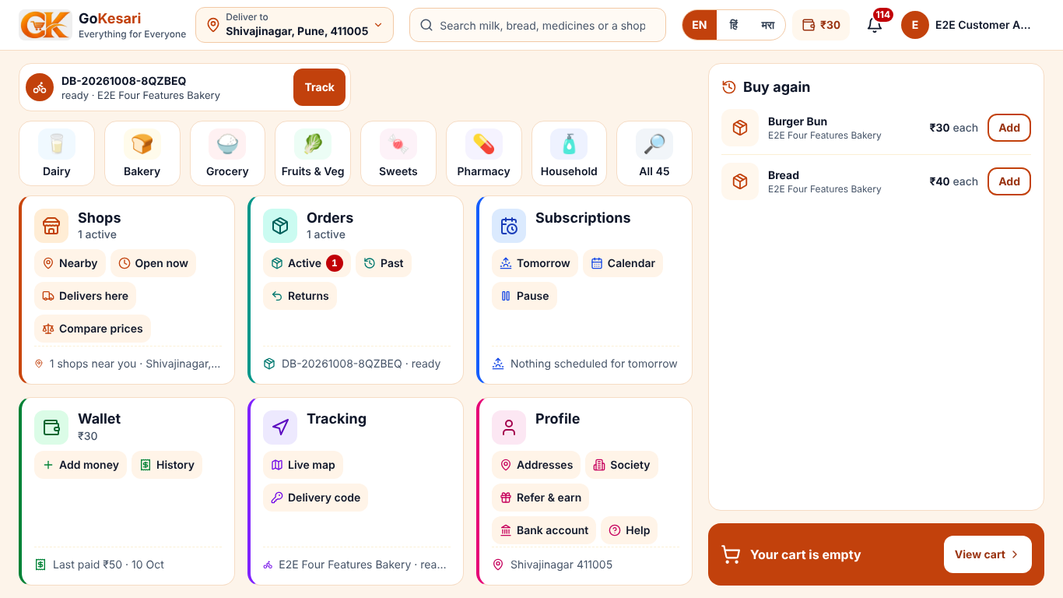

Shop owner home
Before · Mobile | After · Mobile | Before · Desktop | After · Desktop
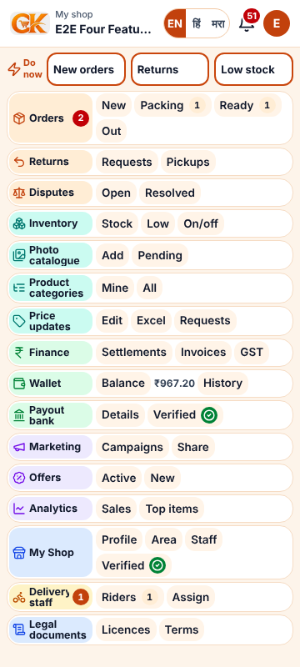 | 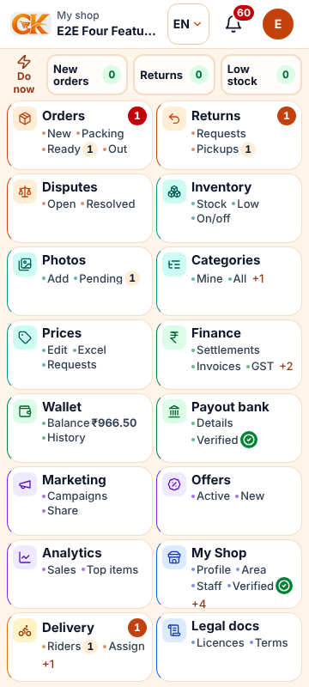 | 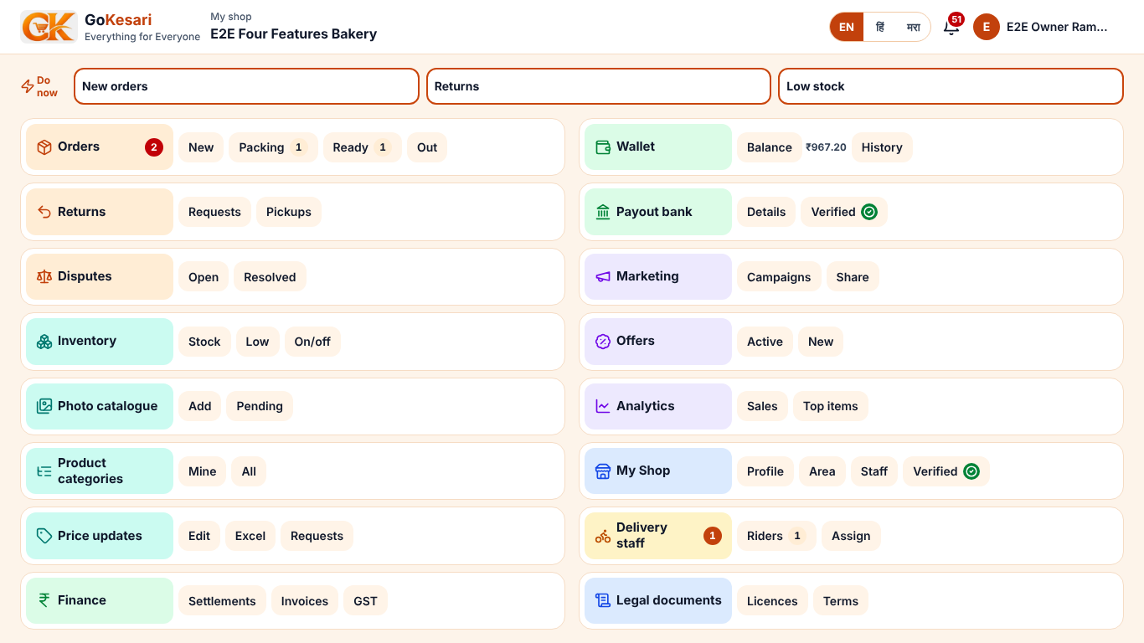 | 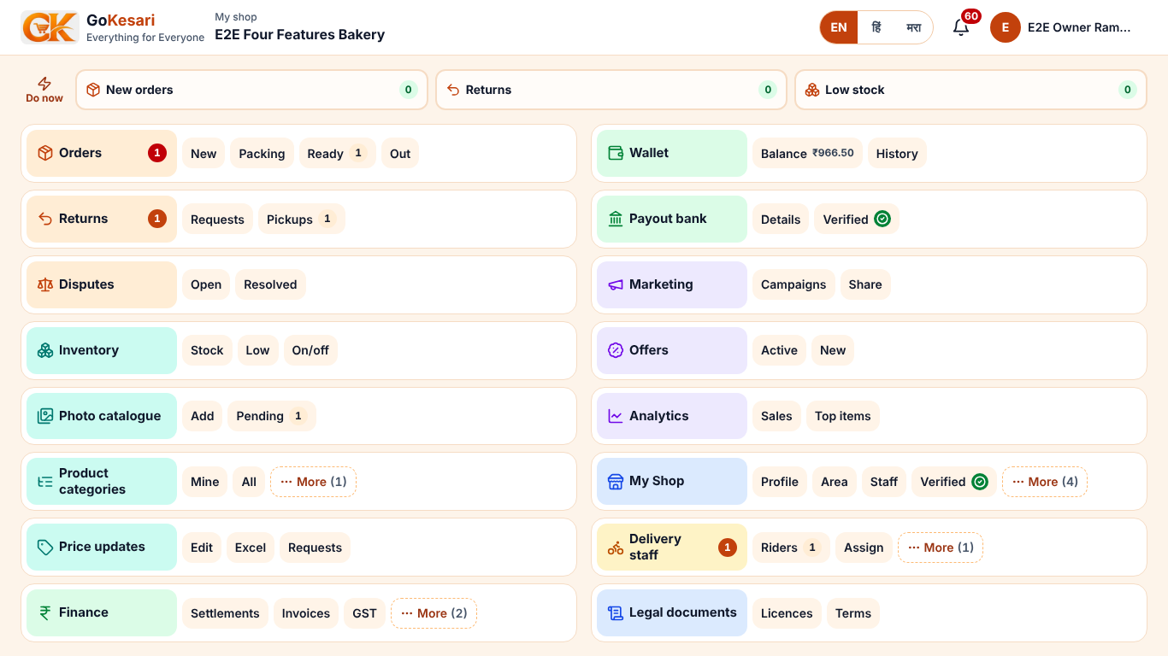

Admin home
Before · Mobile | After · Mobile | Before · Desktop | After · Desktop
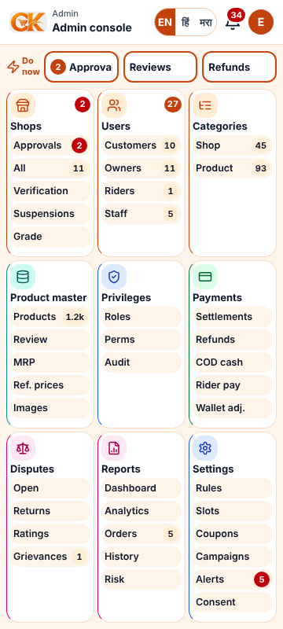 | 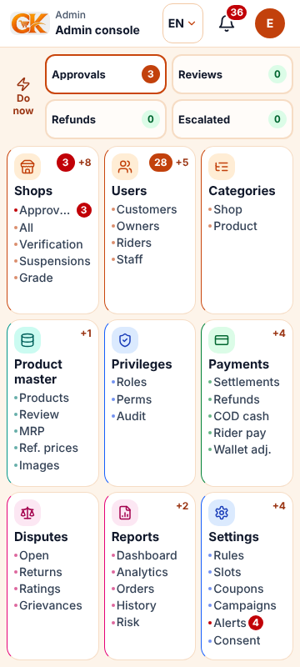 | 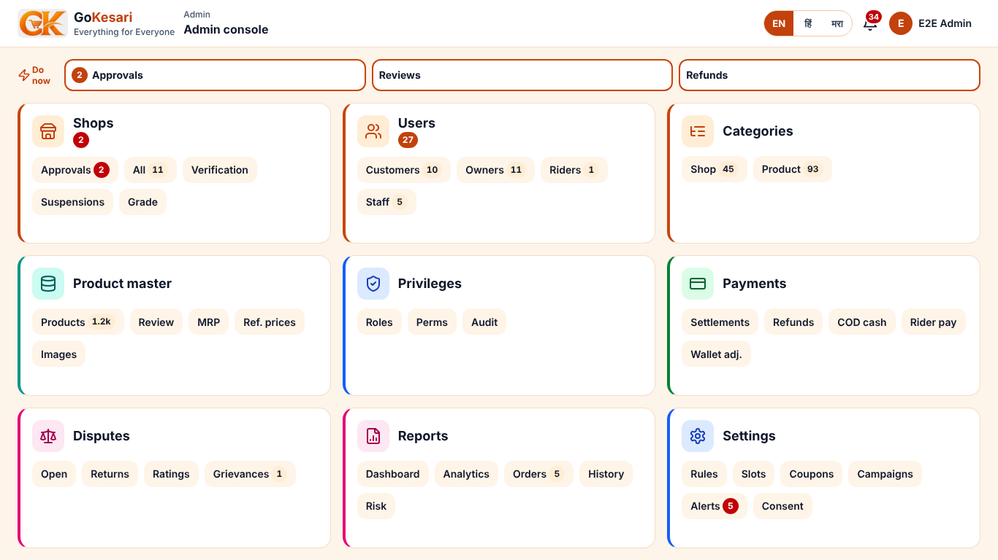 | 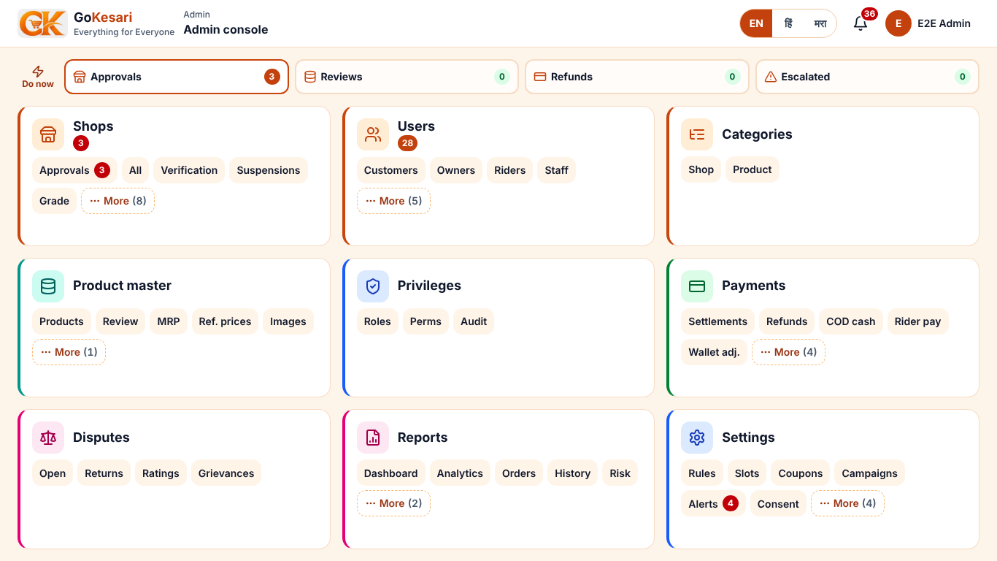

Operator home
Before · Mobile | After · Mobile | Before · Desktop | After · Desktop
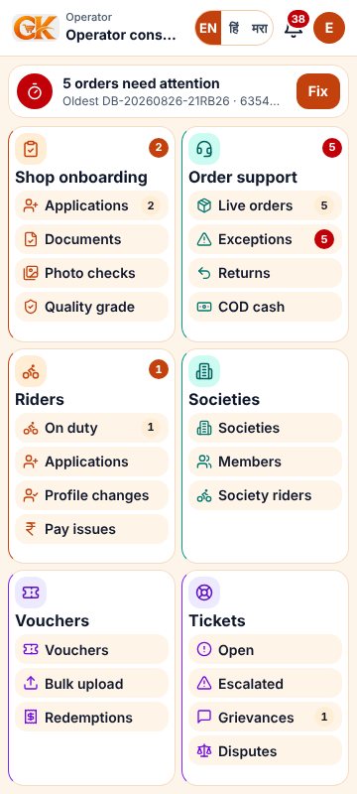 | 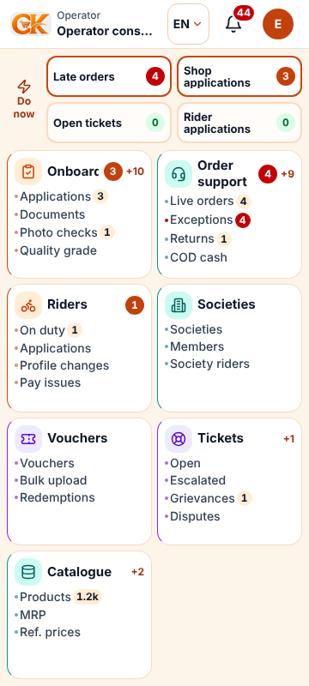 | 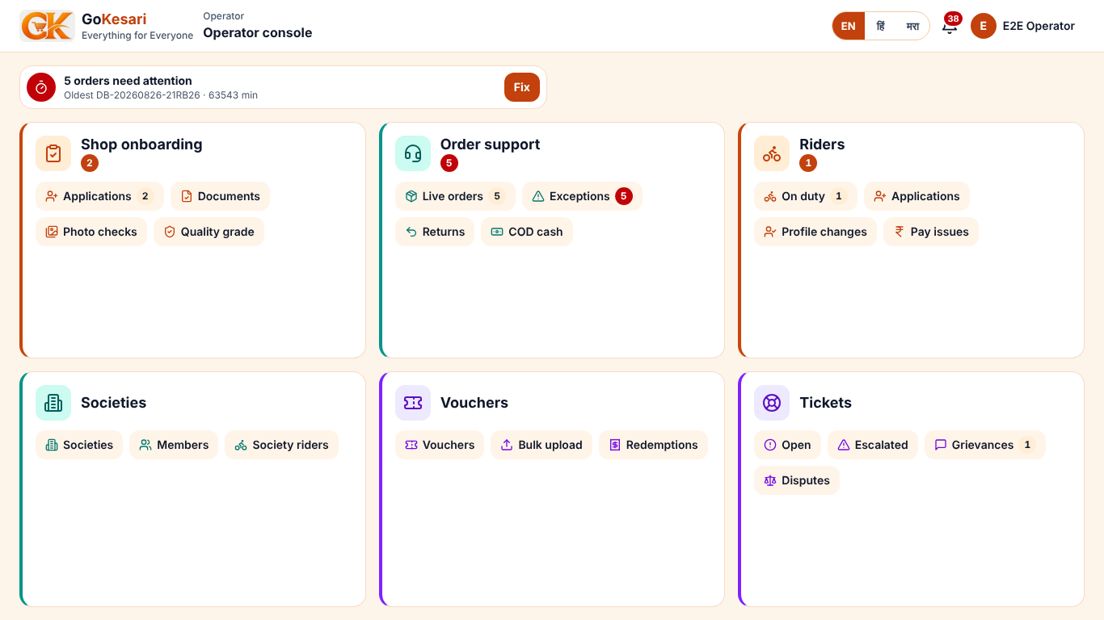 | 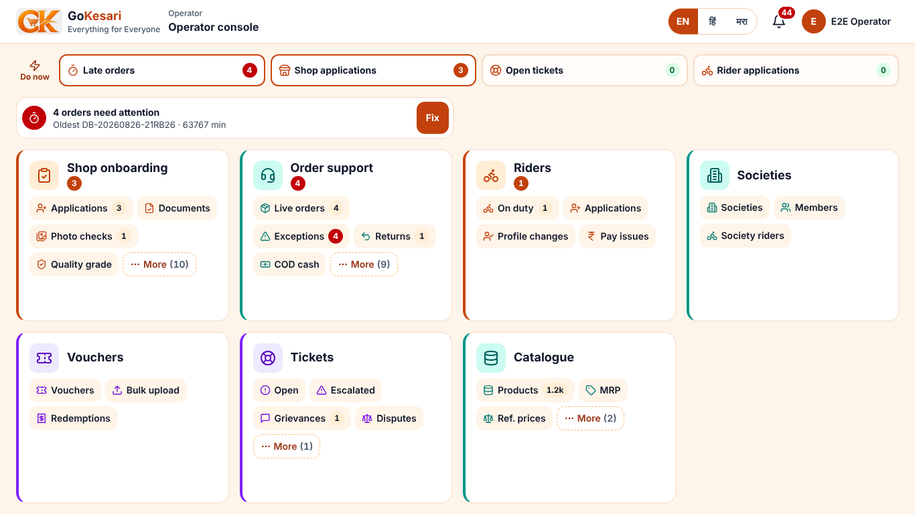

All screens changed: role homes (/, /shop, /admin for admin and operator); /admin/menu/* and /shop/menu/* (new); /admin/console/* and /shop/manage/* (split from the old long pages); site header on every page; orders, returns, disputes, inventory, prices, wallet, profile, subscriptions, categories, shop page, search, product cards, sign-in, error/not-found/offline; second pass: business rules, dashboard, finance, compliance, Today, product manager, shop categories.

7. Test report (counts per role; full table in GoKesari_UI_Test_Report_2026-10-09.xlsx)
Role / suite | Run | Pass | Fail | Not run
Customer · end-to-end (B, D) | 18 | 16 | 1 | 1
Shop owner · end-to-end (B, D) | 21 | 17 | 2 | 2
Operator · end-to-end (B, D) | 8 | 6 | 1 | 1
Admin · end-to-end (B, D) | 10 | 9 | 1 | 0
Customer · A Navigation | 93 | 93 | 0 | 0
ShopOwner · A Navigation | 168 | 167 | 1 | 0
Admin · A Navigation | 228 | 228 | 0 | 0
Operator · A Navigation | 168 | 168 | 0 | 0
Visitor · A Navigation | 34 | 34 | 0 | 0
Visitor · E Access | 30 | 30 | 0 | 0
Customer · E Access | 28 | 28 | 0 | 0
ShopOwner · E Access | 16 | 16 | 0 | 0
Operator · E Access | 24 | 24 | 0 | 0
Admin · E Access | 12 | 12 | 0 | 0
All · D Lighthouse | 15 | 14 | 1 | 0
Visitor · Fit role homes | 33 | 33 | 0 | 0
Customer · Fit role homes | 33 | 33 | 0 | 0
ShopOwner · Fit role homes | 33 | 32 | 1 | 0
Admin · Fit role homes | 33 | 33 | 0 | 0
Operator · Fit role homes | 33 | 33 | 0 | 0
Total | 1038 | 1026 | 8 | 4

Not run, and why:
- C-01 Top up the wallet (Cashfree sandbox, UPI testsuccess@gocash): Not completed: the wallet screen created the Cashfree sandbox session (session_iPGj…), but GitHub Actions did not start the Sandbox payment job (run 37973592123: “recent account payments have failed or your spending limit needs to be increased”). This session cannot reach Cashfree itself
- S-11b Return pickup, inspection and refund: Not tested: needs a delivery partner to accept and collect the pickup (manual completion is offered to staff only once a rider is on the way); no rider sign-in in this run
- O-02 Approve a shop application: Not completed: the shop is KYC pending (PAN, GSTIN, Shop Act certificate not yet verified), so Approve is disabled with the reason “Only a verified shop can be approved” (correct, gate rule statusModels). Queue, stage filters, next-step text and the verification link were checked
- S-13 Recharge the shop wallet (Cashfree sandbox): Not run: the pay step runs in the Sandbox payment GitHub workflow, which GitHub is not starting (billing). Shop wallet page, balance ₹967.20 and history were checked in the navigation test
- D-NET-Customer-_ / on slow 4G (150 ms, 1.6 Mbps down): usable after 3.8 s, fully loaded 3.9 s
- D-NET-Shopowner-_shop /shop on slow 4G (150 ms, 1.6 Mbps down): usable after 3.7 s, fully loaded 4.0 s
- D-NET-Shopowner-_shop_orders /shop/orders on slow 4G (150 ms, 1.6 Mbps down): usable after 5.0 s, fully loaded 5.1 s
- D-NET-Admin-_admin /admin on slow 4G (150 ms, 1.6 Mbps down): usable after 3.6 s, fully loaded 3.8 s
- D-NET-Operator-_admin /admin on slow 4G (150 ms, 1.6 Mbps down): usable after 3.6 s, fully loaded 4.0 s

8. Files changed, back-end changes, backup and rollback
- PR #122 (released): 90 files — boards, menus, header, list pages, shared UI; see docs/tile-board-2026-10/UI_PASS_2026-10-09.md.
- PR #124 (open, to staging): settings, profile, category, shop and search pages; dashboard, finance, compliance, Today; product manager and shop categories; globals.css (44 px rule); section-tabs component; services memoised per render; opt-in prepared statements.
Back-end changes (all additive; old behaviour kept):
- #122: board counts loaded for admin and operator alike (read-only).
- #124: React cache() on read-only lookups used by the layout, header and boards (session, addresses, wallet, unread count, roles, staff shops, cart count) — one database read per fact per page render; API routes and actions unchanged.
- #124: business rules requested at the same moment share one query (getRule).
- #124: DATABASE_PREPARED_STATEMENTS switch, default off (no change until the owner turns it on).
Backup and rollback:
- Code: branches backup/staging-before-ui-pass-2026-10-09 (ff42729) and backup/staging-before-ui-pass-2026-10-09-b (85de001); production before the release = main at add3a84.
- Database (test): 'Test database' workflow run 37953116925, artifact gokesari_test_2026-10-09_1537_run21.dump (kept to 23 Oct). Restore: pg_restore --clean --if-exists --no-owner -d "$TEST_DATABASE_URL" <file>. No schema or data change was made by this work.
- Rollback production: revert merge 37debcb on main (Hostinger redeploys). Rollback test: revert 44ab921 on staging. No migrations to undo.

9. Decisions taken
ID | Decision | Why
D-01 | Whole tile is the touch target on phones; submenus shown as labelled counts | 48 px rule and one screen cannot both hold for 3–6 chips per tile on a 360 px phone
D-02 | 320×640: labels may hide inside a tile (counts and menus stay) | Physical limit of one screen with 44 px targets
D-03 | Desktop chips 36 px | Mouse/keyboard; keeps every submenu one click away on 1366×768
D-04 | ≤7 entries per group; the rest on the tile's menu page | Hick's law
D-05 | Board instead of a bottom tab bar | Every menu visible at once; app and web the same
D-06 | Operator 'Catalogue' tile | Gives existing operator catalogue tools a home
D-07 | No faith-themed colours or symbols | Brief; saffron only as the brand colour
D-08 | Site footer kept below the board | Legal links required; not part of the board
D-09 | Kept the staging #121 sign-in (one consent box) | Another session's approved change
D-10 | Compare prices moved to /search/compare | Mobile app link rules forbid a new top-level path
D-11 | No route-level loading.tsx; a progress bar instead | loading.tsx turned 307 redirects into 200s (access checks)
D-12 | Tile labels 14 px, 13/12 px on screens under 760/660 px tall | Keeps one screen on short phones
D-13 | Only the chrome (boards, header, menus, states) translated | Page bodies need native-speaker review
D-14 | Page sizes: 5 orders, 6 products, 8 rules, 5 notifications | One phone screen per page
D-15 | Old #section links forward to the new pages | Bookmarks and emails keep working
D-16 | Same counts loaded for admin and operator | Menu pages show counts for both
D-17 | Customer cancellation follows the business rule (default: until the shop accepts) | Rule not changed on test; Cancel shown only when allowed
D-18 | Business rules shown as a searchable list; one editor at a time | 35 phone screens → 1
D-19 | Phone product card: one Add, then −/+ | One action row per card
D-20 | Test sign-in via the owner's test mailboxes | Real codes; no backdoor
D-21 | Released #123 without its own CI run | Owner's explicit choice; the same code passed CI on #122
D-22 | No test transactions on production; only read-only checks | Brief: test data on staging only
D-23 | Inline CSS not enabled | Saves only 10–50 ms on the local Lighthouse run; experimental flag
D-24 | Prepared statements behind a switch (default off) | Halves database round trips but depends on the pooler; owner verifies on test first
D-25 | Test vouchers paused, test shop reinstated, test roles restored after tests | Leave test data as found

10. Open items and risks
# | Item | Owner / next step
1 | GitHub Actions billing: no CI since 18:04 UTC; PR #124 (performance + second UI pass) cannot get CI. | Owner: GitHub Settings → Billing and plans (payment, Actions spending limit). Then: CI → staging → test → release PR → production.
2 | Signed-in pages 3–5 s: database in Neon us-east-2, far from the web server. | Owner: move the database (e.g. Neon ap-southeast-1) or the app so they share a region; set DATABASE_IDLE_TIMEOUT_SECONDS≈300; after #124, try DATABASE_PREPARED_STATEMENTS=on on test first.
3 | Wallet and shop-wallet top-ups (Cashfree sandbox) not tested in this run. | Run the Sandbox payment workflow once Actions works (UPI testsuccess@gocash).
4 | Shop approval not completed: test shops are KYC pending (documents unverified). | Verify a test shop's documents, then approve (operator).
5 | Return pickup and refund need a delivery partner. | Sign in a test rider and complete RT-30B14E73.
6 | Second-level page bodies still English; some admin forms and legal pages longer than one screen. | Native-speaker translation; split remaining admin forms (shop categories done; MRP, rider earnings, self-registration next).
7 | Firefox and Safari not tested (only Chromium here). | Run the navigation script with Playwright Firefox/WebKit on a machine that has them.
8 | Dispute queue gives no feedback while resolving (TST-01). | Small UI fix: busy state and success message.
9 | Test data created: orders LSIMHV, PKEFIF, 254Q4A; return RT-30B14E73; dispute DSP-000001; ticket GRV-000002; draft subscription; shop E2E UI Pass Stationery 504466; vouchers E2EUI5272/E2EUI5003 (paused). | Keep or clean up on the test database (test site only).

11. Production release checklist (awaiting approval)
✓ | Step
☑ | #122 Tile Board + #121 sign-in released to gokesari.com on 9 Oct 19:31 UTC (PR #123, owner approved); smoke test 200s; Lighthouse mobile 93–100.
☐ | Owner fixes GitHub Actions billing; CI green on PR #124.
☐ | Merge #124 into staging; test.gokesari.com rebuilt; re-run navigation (236), access (55), role homes fit, Lighthouse.
☐ | Optional, test first: DATABASE_PREPARED_STATEMENTS=on and DATABASE_IDLE_TIMEOUT_SECONDS=300 on test.gokesari.com; check sign-in, checkout, wallet pages; compare server time.
☐ | Release PR staging → main; its CI green; owner's written approval of this summary.
☐ | Merge; Hostinger redeploys gokesari.com; smoke: /, /shops, /categories, /signin, /search?q=milk 200; /admin and /shop redirect to sign-in.
☐ | PageSpeed (mobile and desktop) on gokesari.com; record in the tracker.
☐ | Rollback ready: revert the release merge on main (no migrations).

