System Requirements Statement (SRS) –

Online Hotel Booking

Doc. Ref. :

Version : 0.4

Status : Drafted

Created by :

Date : 1-March-2022

1. Introduction 3

2. Functional Requirements 4

2.1 Customer Module 5

2.2 Service Provider Module 10

2.3 admin Module 15

2.4 Use Case Diagram.............................................................................................................................18

THIS DOCUMENT CONTAINS 20 NUMBERED PAGES

# Introduction

This document explains the system requirements and scope for developing Online Hotel Booking System.

Online Hotel Booking System could divide the three main parts, Customer part, Service Provider part, Admin part.

This document describes the system requirement of the Account part.

# Functional Requirements

The Account part of Online Hotel Booking has three modules which are divided in processes described as below.

|  |  |  |
| --- | --- | --- |
| **No** | **BRS requirement ID** | **Description** |
| **2.1** | **Customer Module** | |
| **2.1.1** | **F1** | **Account Registration Process** |
| **2.1.2** | **F2** | **Login Process** |
| **2.1.3** | **F3** | **Forgot Password Process** |
| **2.1.4** | **F4** | **Change Password Process** |
| **2.1.5** | **F5** | **Update Account Process** |
| **2.1.6** | **F6** | **Search Hotel** |
| **2.1.7** | **F7** | **Browse Hotel Details** |
| **2.1.8** | **F8** | **Check Room Availability** |
| **2.1.9** | **F9** | **Book Room & Payment** |
| **2.1.10** | **F10** | **Cancel Booking** |
| **2.2** | **Service Provider Module** | |
| **2.2.1** | **F10** | **Account Creation Process** |
| **2.2.2** | **F11** | **Login Process** |
| **2.2.3** | **F12** | **Forgot Password Process** |
| **2.2.4** | **F13** | **Change Password Process** |
| **2.2.5** | **F14** | **Update Account Process** |
| **2.2.6** | **F15** | **Add Hotel** |
| **2.2.7** | **F16** | **Check hotel bookings** |
| **2.2.8** | **F17** | **Update Room Status** |
| **2.3 Admin Module** | | |
| **2.3.1** | **F18** | **Login Process** |
| **2.3.2** | **F19** | **Forgot Password Process** |
| **2.3.3** | **F20** | **Change Password Process** |
| **2.3.4** | **F21** | **Update Account Process** |
| **2.3.5** | **F22** | **Report Generation** |
| **2.3.6** | **F23** | **Account Management** |

## Customer Module

* Customer is the user of system who wants to book the hotel.

* He is also able to view multiple hotels according to city.

### Account Registration Process

* Online booking System compels to create the account before using it. So, Online booking System should provide the function which makes Customer creates new account.
* When customer creates new account, the function demands two information described as below.

1. Login information
2. Contact Details

* The Login information

The Login information consists of some items described as below.

1. CustomerID
2. Password
3. First Name
4. Last Name
5. E-mail address
6. User Type
   * All items are compulsory demanded.
   * CustomerID

* The CustomerID should be unique. If the CustomerID correspond with not case-sensitive to other which is previously registered, the CustomerID should not be registered as an account.
  + Password
* The Password has constraints which makes the Password consists of more than or equal 8 and less than or equal 16 characteristics including characters described as below.

1. Numeric figure (at least one)
2. Capital alphabet (A-Z)(at least one)
3. Small alphabet (a-z)(at least one)
4. Special character (#, $, %, &, etc.) (at least one)

* The Password is masked by dummy characters. The re-entering Password is demanded.
* The Password must be encrypted in Online Hotel Booking System.
  + User Type

The User Type falls into two categories described as below.

1. Customer
2. Service Provider

* The User Type defines also two types of user; "Customer user", "Service Provider user".
* In an Account Creation Process, the user can select Customer.
* Contact Details
* The Contact Detail consists of some items described as below.

1. Permanent Address
2. Contact Phone No
3. Aadhar no.
   * All items are compulsory demanded.
   * Permanent Address

* Permanent Address should be filled.
* But only the state should be selected from options.

### Login Process

* Online Hotel Booking System always compels user authentication before using itself except when a new account is successfully created.
* The user authentication demands CustomerID and Password. The CustomerID and the Password should be checked in three ways.
  + First, The CustomerID and the Password should be existed and correct.
* If The CustomerID and the Password are not equal to what the user has registered, the user authentication cannot be provided.
  + Second, the User Type linked to the CustomerID should be "customer".
* When the User Type is "Customer", then user can be placed on “Customer Home”.
  + Finally, CustomerID should be available.
* The Administrator can decide whether the CustomerID is available or suspended – Refer to the SRS of the Admin part.
* If customer is rejected, user authentication is not provided for system user.
* The customer account should alive for so long as the duration decided by Admin.
* Only when the three checks are successfully completed, customer can be placed on respected page.
* The “Customer Home” provides the some items described as below.

1. A trigger to logout
2. A trigger to update Account
3. A trigger to Change Password
4. A trigger to Search City
5. A trigger to View the Hotels Details
6. A trigger to Book Room
7. A trigger to Cancel Bookings

### Forgot Password Process

* When system user lost their Password, the recovery method should be provided by Online Booking System.

The recovery method is described as below.

* + First, system user enters their CustomerID for Online Booking System.
  + Next, Online Booking System demands the Email which has been registered since when the Account was created.
  + Only when the Email is correct, customer get the old password by E-mail which also has been registered since when the Account was created. After that customer can change password manually.
* If the Email is not correct, the correct Email is demanded for user again.
  + In that case, Of course, customer couldn’t get the old password.

### Change Password Process

* When customer wants to change their Password, the measure should be provided by Online Booking System.
* Therefore, Online Booking System should provide the function which is available after getting the customer authentication.
* The function demands the current password and the new password.
  + Of course, the new password should consist of more than or equal 8 and less than or equal 16 characteristics including at least a numeric figure, a capital alphabet, a small alphabet, and a special character.
  + The current password and the new password are masked by using dummy characters.
  + The new password is demanded to enter twice to avoid a typing error.
* Only when the current password is correct, customer could change their Password.
* When the current password is changed into new password, Online Booking System compels user authentication again.

### Update Account Process

* Online Booking System should provide the function which makes the account updated for customer.
* The information customer could update is described below.

1. Login information
2. Customer information

* The Login information

The updatable items as described below.

1. First Name
2. Last Name
3. E-mail address
   * All items are compulsory demanded, but updating is optional.

* The Customer information

The updatable items as described below.

1. Customer Name
2. Customer Phone No
3. E-mail address
4. Permanent address
   * All items are compulsory demanded, but updating is optional.

### Search Hotel By City

* Customer can search hotel according to city name and get hotel available in that city.

### 2.1.7 Browse Hotel Details

* Publish hotel requirements are described as below.

1. Hotel name
2. Price
3. Photos

* Customer can see various hotels before his booking.

### 2.1.8 Check Room Availability

* After browsing particular hotel customer can check room availability.
* According to

1. Room type
2. Room price
3. Date.

### 2.1.9 Book Room and Payment

• After checking room status customer can book the room.

• For booking customer has to pay advance payment accordingly.

### 2.1.10 Cancel Booking

• Customer can cancel his bookings.

#### 2.2Service Provider Module

### 2.2.1 Account Creation Process

* Online Hotel Booking System compels to create the account before using it. So, Online Hotel Booking System should provide the function which makes Service Provider creates new account.
* When Service Provider creates new account, the function demands two information described as below.

1. Login information

2.Contact Details

* The Login information

The Login information consists of some items described as below.

5.ServiceProviderID

6.Password

7.First Name

8.Last Name

9.E-mail address

10.User Type

* + All items are compulsory demanded.
  + ServiceProviderID
* The ServiceProviderID should be unique. If the ServiceProviderID correspond with not case-sensitive to other which is previously registered, the ServiceProviderID should not be registered as an account.
  + Password
* The Password has constrains which makes the Password consists of more than or equal 8 and less than or equal 16 characteristics including characters described as below.

1.Numeric figure (at least one)

2.Capital alphabet (A-Z)(at least one)

3.Small alphabet (a-z)(at least one)

4.Special character (#, $, %, &, etc.) (at least one)

* The Password is masked by dummy characters. The re-entering Password is demanded.
* The Password must be encrypted in Online Hotel Booking System.
  + User Type

The User Type falls into three categories described as below.

1.Customer

2.Service Provider

* The User Type defines also three types of user; " Customer user", "Service Provider user".
* In an Account Creation Process, the user can select Service Provider.
* Contact Details
* The Contact Detail consists of some items described as below.

1.Permanent Address

2.Contact Phone No

3.Aadhar No

* + All items are compulsory demanded.
  + Permanent Address
* Permanent Address should be filled.
* But only the state should be selected from options.

### 2.2.2 Login Process

* Online Hotel Booking System always compels Service Provider authentication before using itself except when a new account is successfully created.
* The user authentication demands ServiceProviderID and Password. The ServiceProviderID and the Password should be checked in three ways.
  + First, The ServiceProviderID and the Password should be existed and correct.
* If The ServiceProviderID and the Password are not equal to what the user has registered, the user authentication cannot be provided.
  + Second, the User Type linked to the ServiceProviderID should be "user".
* When the User Type is " Service Provider ", user can be placed on “Service Provider Home”.
  + Finally, ServiceProviderID should be available.
* The Administrator can decide whether the ServiceProviderID is available or suspended – Refer to the SRS of the Admin part.
* If customer is rejected, user authentication is not provided for Service Provider.
* The Service Provider account should alive for so long as the duration decided by Admin.
* Only when the three checks are successfully completed, Service Provider can be placed on respected page.
* The “Service Provider Home” provides the some items described as below.

1. A trigger to logout
2. A trigger to update Account
3. A trigger to Change Password
4. A trigger to Add hotel
5. A trigger to check hotel booking
6. A trigger to update room status

### 2.2.3 Forgot Password Process

* When Service Provider lost their Password, the recovery method should be provided by Online Hotel Booking System.

The recovery method is described as below.

* + First, Service Provider enters their ServiceProviderID for Online Hotel Booking System.
  + Next, Online Booking System demands the Email which has been registered since when the Account was created.
  + Only when the Email is correct, service provider get the old password by E-mail which also has been registered since when the Account was created. After that service provider can change password manually.
* If the Email is not correct, the correct Email is demanded for user again.
  + In that case, Of course, service provider couldn’t get the old password.

### 2.2.4 Change Password Process

* When Service Provider wants to change their Password, the measure should be provided by Online Hotel Booking System.
* Therefore, Online Hotel Booking System should provide the function which is available after getting the Service Provider authentication.
* The function demands the current password and the new password.
  + Of course, the new password should consist of more than or equal 8 and less than or equal 16 characteristics including at least a numeric figure, a capital alphabet, a small alphabet, and a special character.
  + The current password and the new password are masked by using dummy characters.
  + The new password is demanded to enter twice to avoid a typing error.
* Only when the current password is correct, Service Provider could change their Password.
* When the current password is changed into new password, Online Hotel Booking System compels Service Provider authentication again.

### 2.2.5 Update Account Process

* Online Hotel Booking System should provide the function which makes the account updated for Service Provider.
* The information Service Provider could update is described below.

1. Login information

2. User information

* The Login information

The updatable items as described below.

1. First Name
2. Last Name
3. E-mail address
   * All items are compulsory demanded, but updating is optional.

* The User information

The updatable items as described below.

1. User Name
2. User Phone No
3. E-mail address
4. Permanent address
   * All items are compulsory demanded, but updating is optional.

#### 2.2.6 Add hotel

• Service provider can add his hotel and its details.

1. Hotel Id

2. Hotel name

3. Price

4. Photos

5. Hotel City

6. Hotel Address

7. Hotel Email

8. Hotel contact no

9. Hotel Registration no

As the result of this, Service Provider could see the confirmation message.

#### 2.2.7 Check hotel bookings

* If customer books room service provider can see his hotel bookings.

**2.2.8 Update Room Status**

• Service Provider can update room status.

1. If all rooms are booked then update status as “Bookings not available”.

#### 2.3 Admin Module

**•** Administratorshould be responsible for following activities**,**

### 2.3.1 Login Process

* Online Hotel Booking System always compels user authentication before using itself except when a new account is successfully created.
* The user authentication demands AdminID and Password. The AdminID and the Password should be checked in three ways.
  + First, The AdminID and the Password should be existed and correct.
* If The AdminID and the Password are not equal to what the admin has registered, the admin authentication cannot be provided.
  + Second, the User Type linked to the AdminID should be "Admin".
* When the User Type is "Admin", user can be placed on “Admin Home”.
  + Finally, AdminID should be available.
* The Administrator can decide whether the AdminID is available or suspended.
* If user is rejected, user authentication is not provided for system user.
* The admin account should alive for so long as the duration decided by Admin.
* Only when the three checks are successfully completed, Admin can be placed on respected page.
* The “Admin Home” provides some items described as below.

1. A trigger to logout
2. A trigger to update Account
3. A trigger to Change Password
4. A trigger to Delete any User
5. A trigger to View Report of any User

### 2.3.2 Forgot Password Process

* When Admin lost their Password, the recovery method should be provided by Online Hotel Booking System.

The recovery method is described as below.

* + Online Booking System demands the Email which has been registered since when the Account was created.
  + Only when the Email is correct, admin get the old password by E-mail which also has been registered since when the Account was created. After that admin can change password manually.
* If the Email is not correct, the correct email is demanded for user again.
  + In that case, Of course, admin couldn’t get the old password.

### 2.3.2 Change Password Process

* When Admin wants to change his Password, the measure should be provided by Online Booking System.
* Therefore, Online Hotel Booking System should provide the function which is available after getting the admin authentication.
* The function demands the current password and the new password.
  + Of course, the new password should consist of more than or equal 8 and less than or equal 16 characteristics including at least a numeric figure, a capital alphabet, a small alphabet, and a special character.
  + The current password and the new password are masked by using dummy characters.
  + The new password is demanded to enter twice to avoid a typing error.
* Only when the current password is correct, Admin could change his Password.
* When the current password is changed into new password, Online Hotel Booking System compels user authentication again.

### 2.3.3 Update Account Process

* Online Hotel Booking System should provide the function which makes the account updated for Admin.
* The information Admin could update is described below.

1. Login information
2. User information

* The Login information

The updatable items as described below.

1. First Name
2. Last Name
3. E-mail address
   * All items are compulsory demanded, but updating is optional.

* The User information

The updatable items as described below.

1. User Name
2. User Phone No
3. E-mail address
4. Permanent address
   * All items are compulsory demanded, but updating is optional.

#### 2.3.4 Report Generation

• Admin should able to see all the records from any users.

• Daily report of enrolment to admin.

• Monthly report of enrolment to admin.

#### 2.3.5 Accounts Management

• Admin should able to manage all the accounts with following activities,

1. Enable accounts

2. Disable accounts

#### 2.4 Use Case Diagram

**Admin:**

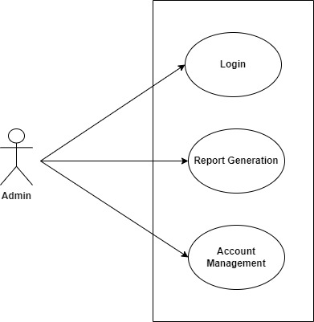

*Fig. Use case diagram for admin*

1. In Admin use case diagram Admin is the Actor.
2. Admin can handle following use cases:
3. Login
4. Report Generation
5. Controls account

**Customer:**

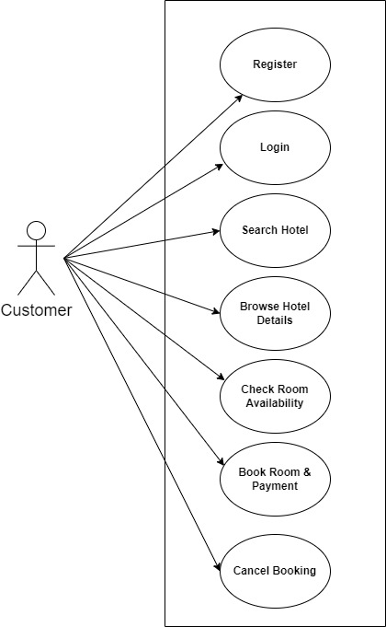

*Fig. Use case diagram for Customer*

1. In Customer use case diagram Customer is the Actor.
2. Customer can handle following use cases:
3. Register
4. Login
5. Search Hotel
6. Browse Hotel Details
7. Check Room availability
8. Book Room & Payment

**Service Provider:**

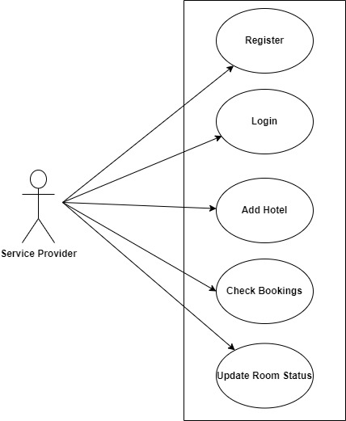

*Fig. Use case diagram for Service Provider*

1. In Service Provider use case diagram Service Provider is the Actor**.**
2. Service Provider can handle following use cases:
3. Register
4. Login
5. Add hotel
6. Check bookings
7. Update Room Status