Aedes aegypti COEAE3A (AAEL005112) and 6A (AAEL005123) vs albopictus – note in both species the genes ae neighbours

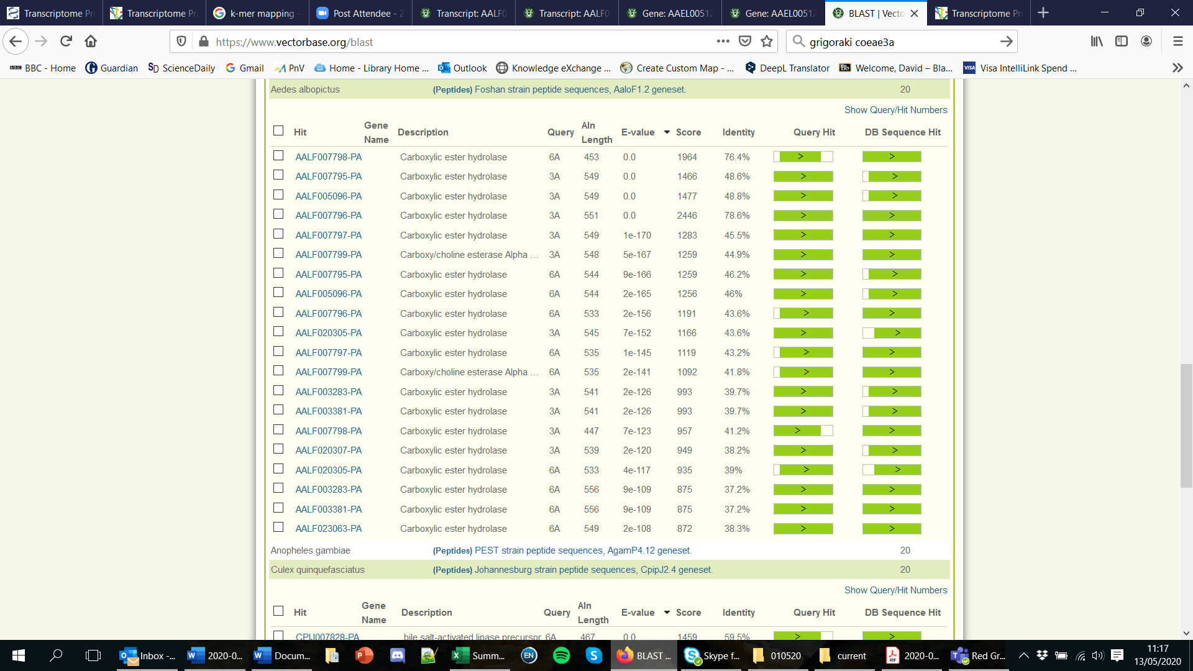

Aedes aegypti 3A and 6A vs culex



Aedes aegypti 3A and 6A vs PEST – COEAE1F, 2F are near bottom ☹



Ok so nothing there, next ….

Id’d the two OP-related worldwide sweep esterase gene sequences *EST2* and *EST3* From Buss and Callaghan Insect Biochemistry and Molecular Biology 34 (2004) 433–441

**CPIJ013918-RA**

>AY545983.1 Culex pipiens esterase A5 (Est-3) gene, complete cds

ATGGACGTCGAACATCCGGTAGTGCCGACCCAGTACGGTCCAGTTAGGGGGGTTCGTAAGTTGGCCGCAA

CGGGGGTCGATTACTACAGCTTTCAACGGATTCCGTACGTGCAGTCTCCCGTTGGAGAGCTTAGATTTAA

GGTAGGGGATTTGGGGTATTGATTGTGGGGTTTGAAATGATGGTGCTGAGTTTGACTCTGATTTTTAGGA

TGCTCAACCGCCGAAACCGTGGACGGAACCGTTGGACTGTACCGTCCAAGGGCCGGGTGGATATCAGTAC

AGCAAGTTGCTGAACAAAATCATTGGAAGTGAGGACAGCTTGCACATGAATGTGTTCACGAAGAACGTAA

GTTGAATGGACCATTGAACTGTTAGTGGTGCTGTTGTCGTGGTTATTGTATATATGATTAAAATTGTAGC

TCAATAGCAAGCAGTTACTGCCAGTGATGTTGTACATCCACGGAGGAGCCTTCATGAGAGGATCTAGTGG

AGTGGAGATGTACGGACCGGACTATCTCATACAGAAGGATGTCGTGTTCGTGTCGTTCAACTACAGAATC

GGTGCCCTTGGTATGATTTGTGATTCCTTGGTAGACAACCTTGAAGAATGCTCAACCTATCCTTCAGATT

CATCTCGTTCGATTCTCCCGAGCTGGGACTTCCGGGCAATGCCGGACTGAAGGACCAGAACCTCGCGCTT

CGCTGGGTGGTGGACAATATCGCCAACTTTGGGGGTGACCCGAAGAACATTACGCTGTTTGGAGAGAGTG

CCGGTGGTTGTTCCGTGCACTACCACATGGTGTCGGACCTGTCGCGGGGATTGTTTCAGCGCGCGATCGT

AATGTCCGGCTGCGTGCTGAACAATTGGTCCGTGATTCCACGAAGAAAGCGGAGCGAACGCCTGGCCAAA

GCTCTAGGCTGGAACGGGCAGGGTGGTGAGCGGACCGCTCTGGAGGTGCTCGTGAAGGCAGATCCGGAGA

GTATCGTTCGCGAGCAGGAGATTTTGCTGAACGAGAATGTAAGATTGATAGCTTGTTAGCTTAAATAGTT

GATATTCAGTTAATTTAATTTGTAGGAGATCGAAAATCGCATCCTATTCTCATTTGGACCAGTTATCGAG

CCATATGTTACGAAAAATTGCATGATTCCAAAGGATCCCCTGGAGATGTGTCGTGAAGCTTGGAGTAACG

AAATTGACATCTTGATCGGTGGAAACTCGGAAGAGGGTCTGTTCTGTCTCAACGGGATCAAGGAGAATCC

CTCGATCATGAGTAACTTGAAGGACTTTGAGTACCTGGTTCCGCTGGAGCTGGACTTGGTCAGGACTTCT

CAAAGATGCAAGCAGGTGGGCAAGCAGATGAAAAAGTTCTACTACGGTGAAACGGAACCGTCGTTTGAGA

ATCGAGAGGGTTACCTAACGGTAAGACGATCATTACGCATTTCAATATCTATTACAAGTATCGTTCCACA

CAGCTGATGACCGACAAGCTATTCCTGCACGGACTGCATCGTACGATCCTGTCAAGACTCAACTCGAAGA

AACCGTCGAAGACCTTCCTGTACCGCTTCTCCGTGGATTCGGACACCTACAACCACTACCGGATCGTGTT

CTGCGACAAGAACGTGCGCGGCACGGCCCATGCCGACGACCTGTCGTACATCTTCAAGAACGTGTTCAAC

GATCCGCCGGCGAAGGATACCTTCGAGCATCGCGCGATGATGAATATGGTGAGTTGGACTTTCTGATTTC

TATCCTTCATGTAGAGTAATTGAACGCTTACAGGTCGGCTTGTTCTCAACGTTCGCGAGTAACAATGGAA

ATCCCAACGGAGAGCAGACCAACGAATGGGAATCGATTGAGACGCCAACGGGACCGTTCAAGTGTCTCAA

CATCAACAACGACGGTTTGCAGTTTATTGAGTATCCGGAGCAGGAACGAATGCAGTTTTGGGATTCACTC

TACAGCAAAGATAAACTTTATTAG

**CPIJ013917-RA**

>AY545984.1 Culex pipiens esterase B5 (Est-2) gene, complete cds

ATGAGTTTGGAAAGCTTAACCGTTCAGACCAAATACGGCCCGGTCCGGGGCAAACGGAACGTATCGTTGC

TGGGACAGGAGTACGTCAGCTTTCAGGGAATTCCGTACGCTCGGGCACCGGAAGGGGAGCTGCGGTTTAA

GGTGAGAGTGGCAAAACTGTTTCGAGTGCTGTTCAAATTTTATGGATGTGCAAGTGCATTTTTGTGCAAA

TAAAGAGCAACGAGTGCTGCTGATTAGCGCTGTATCTAAGAGTGTGACCTCCGCGAGTTGATACTTCACC

ACAATGATGTGAAATATTTGTTTGAAAAAAAAACTGTAATAAATATTTTGTTCTTGGACACGTACAAACC

AGTCATGGGTCTAGGCTGGAAACAAATTGAAGAGTGACGCAGTCAAAAATAAATTTGGCAGTGACTTTCA

CATCCATTTTGATAAAAGATAAGACCATAAACTTAATCCAAAATTGTTTGTTGTACAATTGATAATGAAG

TCTGTGCAAGTATAGTTATTGAAACATTAAAGTGTTTAAAATTTAATTAATCTTAAATTAATCTTTATTT

TGTTTAATAATCTAAATTTTTATAAAACAAAAAACTCTTCAGAAAACCTATCAACTGCATGCAATAACAT

TTTCAAATGACTTCGAAATAACCCAGGGGAATGATGAAACGAGAGGAATCACATATCCGCATAAATAATT

CAAGATTGTTCAGGTGTAAACCGAAAATGTGATCAAAAATTAAAGTGGAGGAATAAGGCTTTCAACTGCT

TATTTAATTGTCGGTGTACAGGACGCCGCACTGTTTAATCATTTTCCAAAGTACATTTAATTTTGCAGCC

CAAAACCAGTTATTGAAATGGAAAAAAAAAAATCTTTTTCAAATTTTCTTTTCTTGATTTGTGTGCACCT

ACGTCGAAGACCAAGATTGTTTAGTTTTTGCTCTTTGGTCTGACAGTCTTGGTCCGACAGAATTGATCTG

ACAGCTTTATCATGGATTTTGGTCTGGTCTAGGCGAGGGATAGGACACAGCACCTTCCTGGAAATAACAT

TAAATTTGTCAGTAAAATTTAGTAGTTTTGACATTTTGAAAATGCTAAAAAAATGATCAAACTTGCAAAA

CCATTTTTTTTTTCATAAATCCTCAGCAATTTTGCGAAAAAAATATTAATAAAAAGAAACGTTCAAATAT

GTATTACACGTCCCTGTGTCAAATATTTTGTCCAGCACTGTATTTCCCGGAGACTTCAACGCAAAATAAG

TCACGAACCGAACTGAAAAATTCAAAAAAATAACTTTAAAACATTCAGGCACCAGTTCCACCGCAAAAGT

GGACCGAAACGTTGGACTGCACGCAGCAATGCGAGCCCTGCTATCACTTCGACCGGCGCCTCCAGAAGAT

CGTCGGCTGCGAGGACAGTCTGAAGATCAACGTGTTTGCGAAGGAGGTGAGTTGGATTTAAGAATTAAAA

AAATATCAAAAGTTATAATTTGGTAACTTCTCCAGATCAACCCTTCAACACCCCTCCCGGTGATGCTGTA

CATCTATGGCGGTGGCTTCACGGAAGGAACCAGCGGAACCGAACTGTACGGGCCGGATTTCCTGATTCAA

ACGGATATCGTGTTGGTGTCGTTCAACTACCGTATTGGGGCGTTGGGATTTCTGTGTTGTCAATCGGAGC

AGGATGGCGTACCCGGTAATGCCGGCCTTAAAGATCAGAACTTGGCCATTCGGTGGGTGTTGGAGAACAT

TTCAGCTTTTGGAGGAGACCCGAAGCGCGTGACCCTGGCCGGCCATAGCGCAGGTGCCGCTTCAGTTCAG

TATCATCTGATTTCGGATGCTTCCAAGGACTTGTTTCAGCGGGCTATCGTAATGTCTGGGAGTACGTATT

CCAGTTGGTCGTTGACCAGGCAACGCAACTGGGTTGAGAAATTGGCGAAAGCCATCGGTTGGGATGGACA

GGGTGGTGAGTCCGGTGCGTTGAGATTCTTGAGAGCTGCCAAACCGGAGGATATTGTTGCTCACCAGGAG

AAGCTTCTGACGGACCAGGACATGCAGGACGATATCTTTACTCCGTTTGGACCTACCGTTGAACCGTACC

TGACGGAACAGTGCATGATACCGAAGGAACCGTTCGAGATGGCTCGAACTGCTTGGGGTGACAAGATTGA

TATCATGATCGGAGGAACTTCTGAGGAAGGACTGCTGCTGCTGCAAAAGATCAAGTTGCAACCGGAACTA

CTGTCCCATCCACATCTATTCCTGGGAAATGTTCCTCCAAATTTGAAGATCAGCATGGAAAAACGAATCG

AGTTTGCTGCCAAGCTGAAACAACGTTACTACCCCGATAGCAATCCTTCAATGGAGAACAACCTGGGATA

CGTTCATGTAAGTCCCAATCAACCCTCGATCACCACATCAACTTATCAACCCCTCAAACCAATTCCAGAT

GATGTCCGACCGGGTCTTCTGGCACGGCCTGCACCGCACCATCCTTGCCCGAGCCGCCAGATCGCGCGCC

CGCACCTTCGTGTACCGGATCTGTCTGGATTCGGAGTTTTACAACCACTACCGCATCATGATGATCGACC

CGAAGCTGCGCGGCACCGCCCATGCCGACGAGCTGTCCTATCTGTTTTCCAACTTTACCCAGCAGGTCCC

CGGCAAGGAAACGTTCGAGTACCGCGGTCTGCAAACGCTGGTCGATGTGTTCAGCGCGTTCGTCATCAAC

GGGGATCCAAACTGTGGCATGACGGCGAAGAGTGGTGTGGTCTTTGAGCCGAACGCGCAGACGAAGCCCA

CGTTCAAGTGTCTGAACGTTGCCAACGACGGGGTGGCGTTCGTTGACTATCCGGATGCGGACCGGTTGGA

CATGTGGGACGCAATGTACGTGAATGATGAGCTGTTTTAA

BLAST clearly ID’s each – neighbouring genes in alt orientation about 1.5kb apart)



BLAST vs Anopheles gambiae (PEST) – bingo, kerching, etc!!!!!!!!!!!!!!!!!!!!!!!!!!!!!

COEAE1F=Est3; COEAE2F=Est2 (1-1 orthologues)



**In Aedes aegypti**

AAEL010389 = Est3; AAEL017071 = Est2 (both 1-1 orthos) neighbours <1kb apart



**In Aedes albopictus**

AALF012769 = Est3 (interestingly labelled as an aldehyde oxidase); AALF012768= Est2

(both 1-1 orthos) neighbours <1kb apart