<https://www.youtube.com/watch?v=xC1i0dLzzc0>

<https://www.youtube.com/watch?v=_mR85mg04qU>

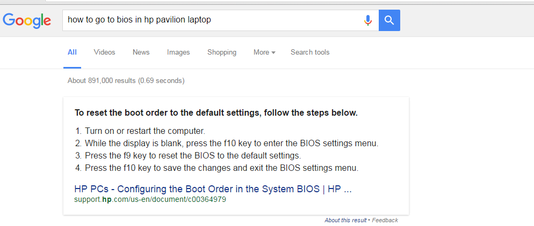

<https://www.microsoft.com/en-au/software-download/windows10> for windows iso download link

<https://www.youtube.com/watch?v=gDHDdt_C3sU> for windows iso download link on youtube

[**https://www.youtube.com/watch?v=Oy2R3Tl9rIE**](https://www.youtube.com/watch?v=Oy2R3Tl9rIE) **to change first boot device in bios**