**STUDENT ASSIGNMENT TRACKER SYSTEM**

**Python Project Title:** Student online assignment trackers system.

Github code Link:[sanjaypatil91/assignment-tracker (github.com)](https://github.com/sanjaypatil91/assignment-tracker)

**Project description:**

Students can upload/submit theirs different subject assignments online to the invigilator. Invigilator can review and check the assignments and put comment that assignments rejected or approved by email notification. Students can review and get feedback from invigilator by email and submit again on the system.

**Student waterfall steps:**

1. The student need to register first to create their own account.
2. By default the student need to login first to enable to access the system.
3. **Students can** update information details.
4. They will submit and upload their assignments on the system.
5. The student can view , examine and verify their assignment through the system.
6. After examine, student get notification/status about assignments his dashboard.

**Invigilator waterfall steps:**

1.The Invigilator need to register first to create their own account.

2. By default the teacher need to login first to enable to access the system.

**3.Teacher can** update information details.

4. Invigilator can check and review the assignments and submit feedback.(Rejected or else approved.)

5.  For the assignment, The teacher can create and update new assignment information.

6. Also teacher can track all the approved and rejected assignments.

**Proposed System:**

The system provides benefits to students and lecturers and it allows students to submit their assignment any time and from anywhere (home, cybercafé), hence the proposed system is to develop an automated online platform where the student assignment can be managed effectively and efficiently.

**Technique Description/Methodology**

The system application will consist of the following modules.

**1.User module**

**2.Student modules**

**3.Lecturer/Invigilator modules**

**User modules:** This system user is responsible for managing the users own account. (Student and Invigilator)

**Student Modules:**

1. Registration details
2. Login details
3. Download posted assignment
4. Submit assignments
5. View assignment

**Invigilator Modules:**

1. Registration details
2. Login details
3. Post assignment
4. View submitted assignment
5. Post assignment result
6. Track the assignments

**System Flow Chart:**

**Invigilator Flow Chart:**

**Home page SATS**

**Register as Teacher**

**Login as Teacher**

**Teacher Dashboard**

**View solution assignment**

**View solution of assignment**

**Post new assignment**

**Status of assignment**

**Track the assignments**

**Teacher profile update**

**List of rejected assignments**

**List of approved assignments**

**Return Login page**

**Return Login page**

**Return Login page**

**Student Flow Chart**

**Home page SATS**

**Register as Student**

**Login as Student**

**Student Dashboard**

**Student profile update**

**View result**

**View assignment**

**Upload assignment**

**Check status of assignment**

**Upload new assignment**

**Upload assignment with title**

**Resubmit the assignment**

**Return Login page**

**Return Login page**

**Return Login page**

**System Design and Implementation:**

**Database Table Structure:**

|  |  |  |  |
| --- | --- | --- | --- |
| **Sr.No.** | **Field** | **Datatype** | **Description** |
| 1 | User_id | Int | Primary key |
| 2 | Name | Varchar |  |
| 3 | Email | Vachar |  |
| 4 | Password | Vachar |  |
| 5 | Type of user | Varchar |  |

**Assignment Table (Teacher Table ):**

|  |  |  |  |
| --- | --- | --- | --- |
| **Sr.No.** | **Field** | **Datatype** | **Description** |
| 1 | Assignment_id | Int | Primary key |
| 2 | Assignment_title | varchar |  |
| 3 | Description | varchar |  |
| 4 | Submission Due Date | varchar |  |

**Submission Table (Student Table ):**

|  |  |  |  |
| --- | --- | --- | --- |
| **Sr.No.** | **Field** | **datatype** | **Description** |
| 1 | Submission Id | Int | Primary key |
| 2 | Assignment Id | varchar | Foreign Key |
| 3 | User Id | varchar | Foreign Key |
| 4 | Submission Date | varchar |  |
| 5 | Solution | varchar |  |
| 6 | Status of Assignment | varchar |  |

**Presentation of Results:**

The system interface basically showing the three module that the system consist of, which includes the User, Invigilator and the Students respectively.

**Home Page:**

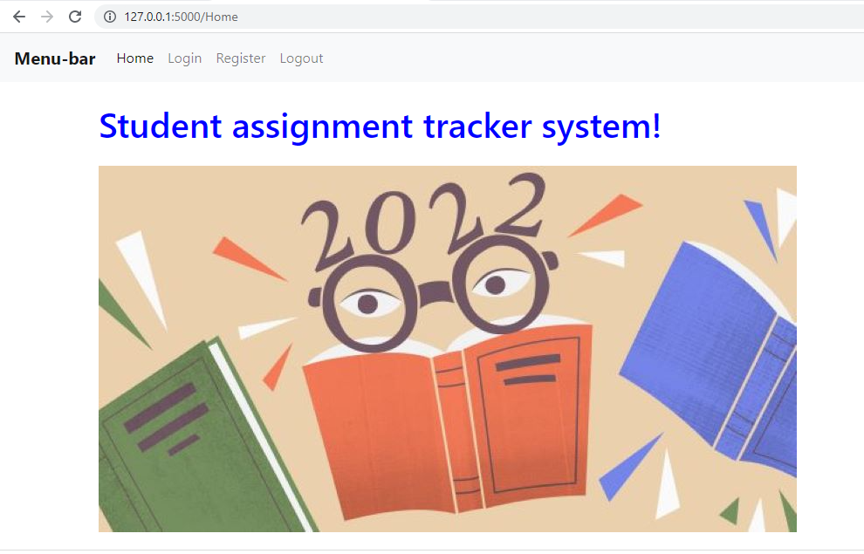

**The interface below shows the login page of the User:**

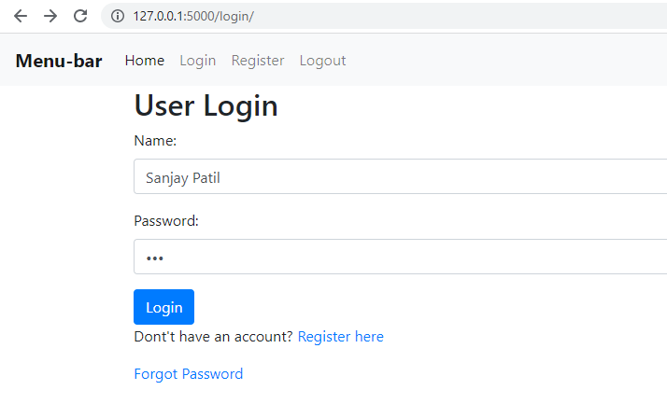

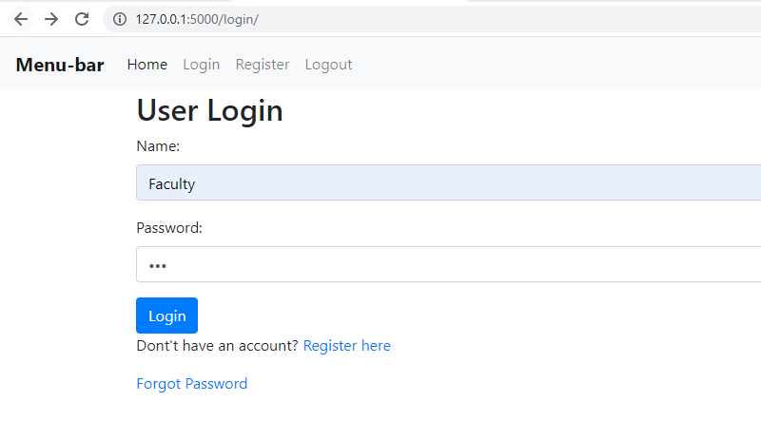

**New User Registration:**

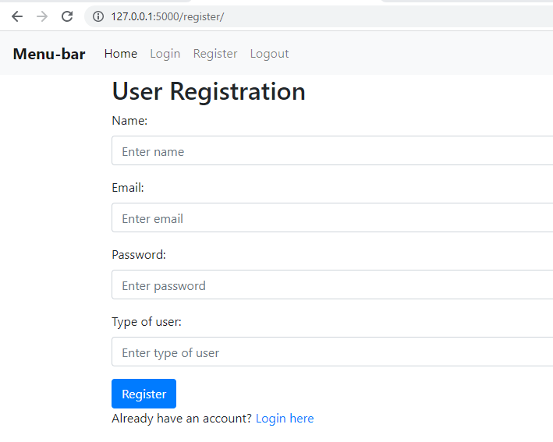

The user Teacher carries out the following functions as shown on the interface below:

Managing the students record.

**1.Teacher Dashboard:**

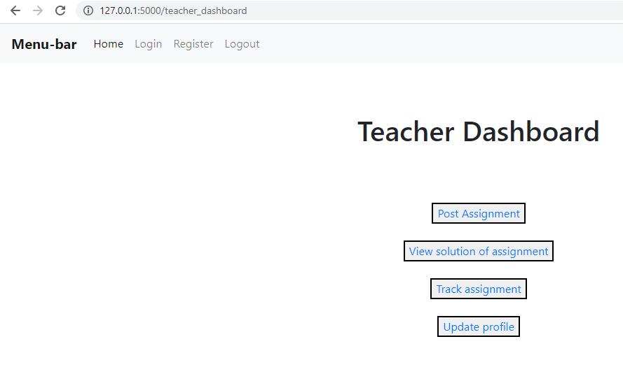

**The page shows that, Teacher can view their whole dashboard related assignment tracker. He can post the assignments, view solution, tracing the assignment and update his profile.**

* 1. **Post Assignment Window:**

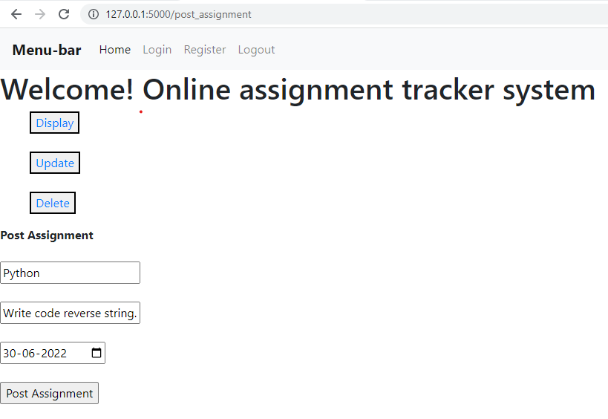

**1.2: Below page is for to check the solution of assignment uploaded by students and he can add the status of assignment or else he can put the result approved / reject.**

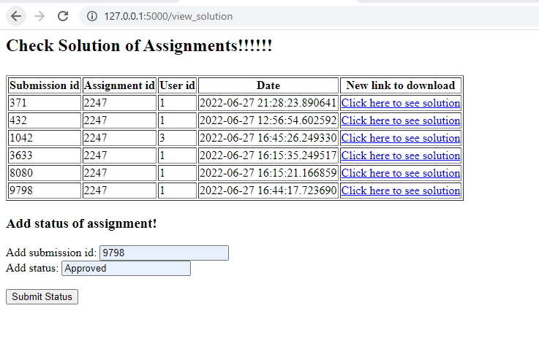

**1.3: This below window for tracking the assignment status list in one page and Teacher can also see approved and rejected assignments in separate page.**

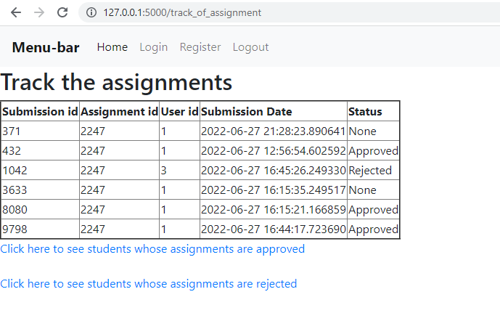

**1.4: Below page is,Students list whose assignments are approved.**

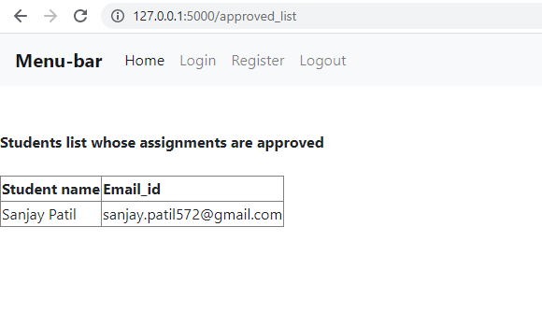

**1.4: Below page is,Students list whose assignments are rejected.**

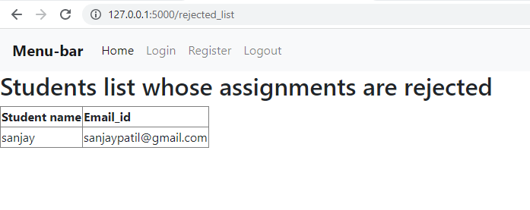

**1.5: The following window for update the profile details, display profile page and delete the his profile.**

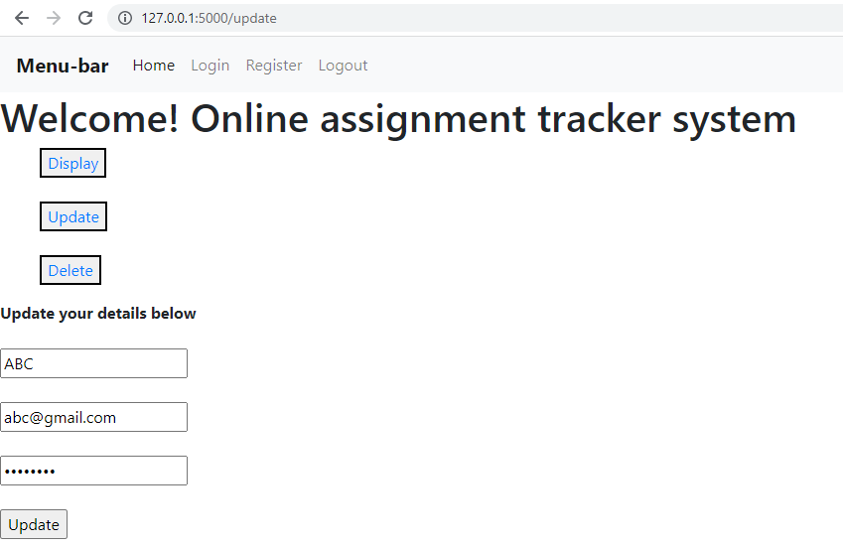

**1.6: Display the Teacher profile details:**

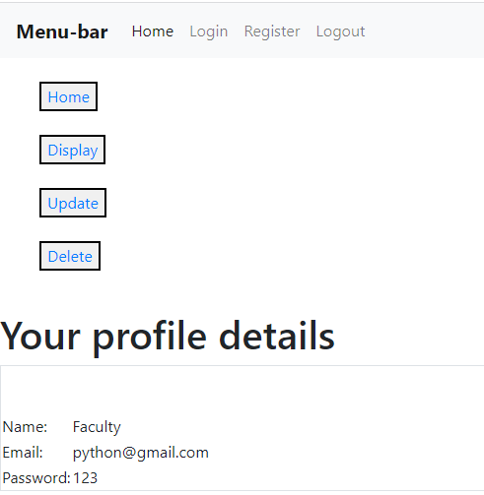

**1.6: Teacher can update their profile details and save into database.**

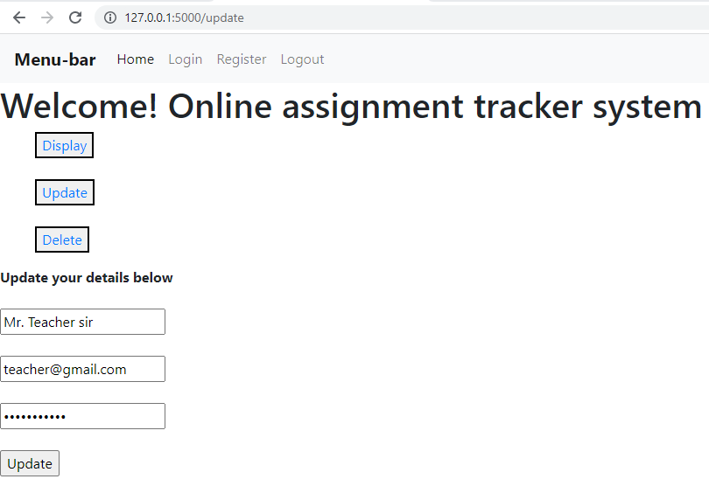

**2: Student Dashboard page:**

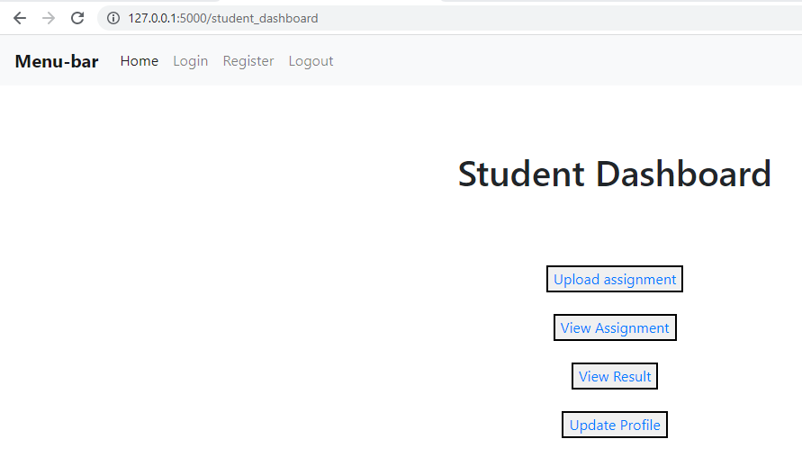

**The page below shows, upload the assignment of the students that uploaded file for submission.**

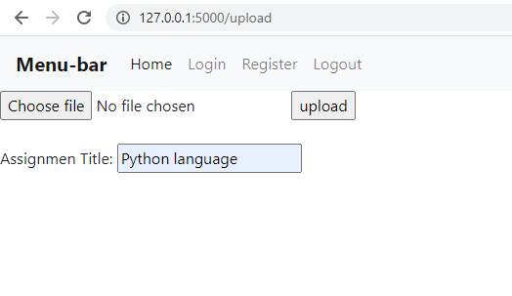

**The page below shows the submitted assignment by the Teacher to the students that uploaded file for submission**.

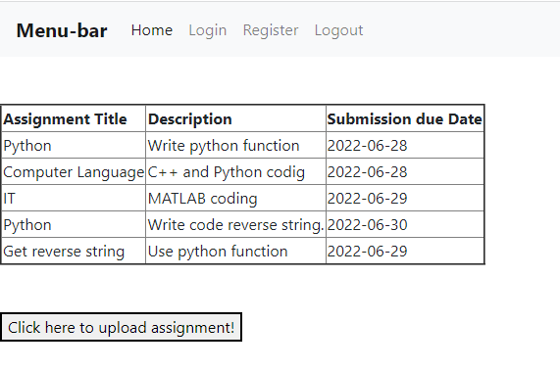

**Below page for to check the result of the assignment it is approved or rejected by the Teacher. If rejected, student can resubmit the assignment on same page.**

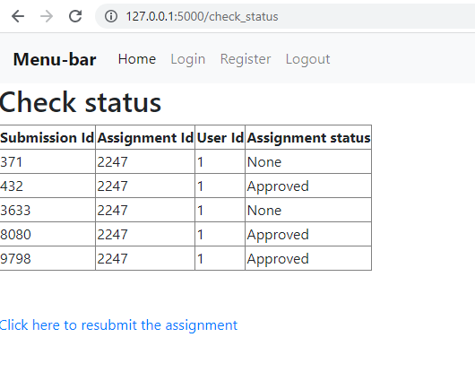

**Following page for to update the Students profile details. He can edit, delete and display the profile details.**

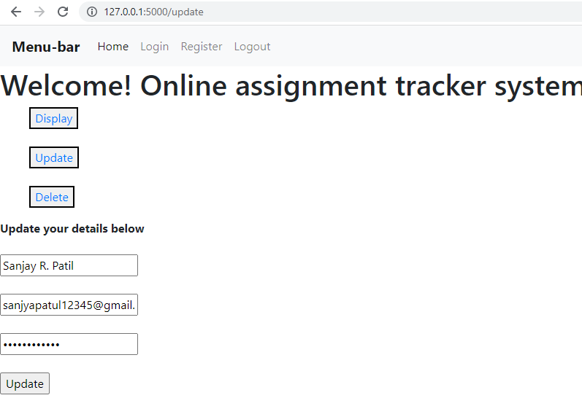

**Student can display his profile detail on below page.**

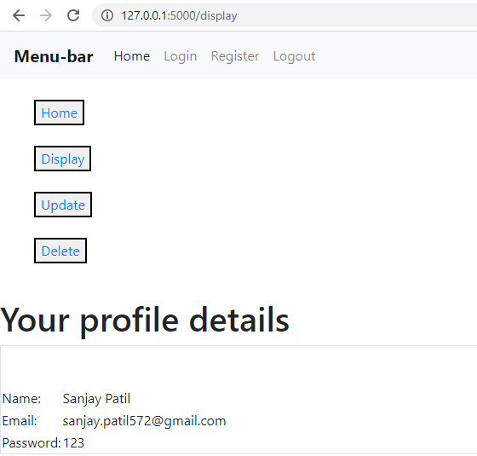

**Database Structure output window:**

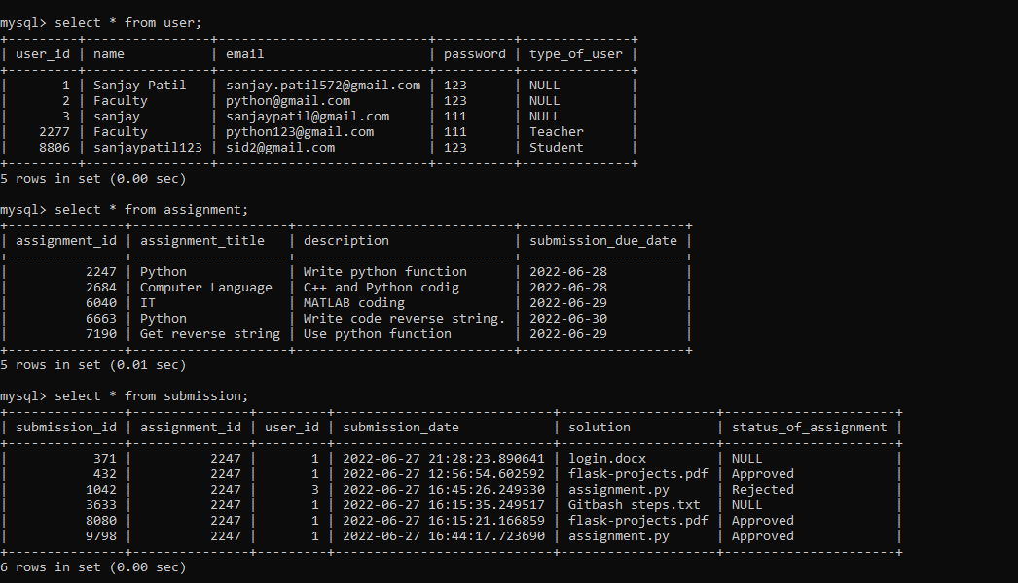

**5.1 CONCLUSION**

The purpose of this project was to explore the potential of the on-line submission and tracking of student assignments. The findings of the project have highlighted the potential benefits as well as a number of administrative and technical issues that need further examination. However, despite these issues it was an overall positive experience that will aid an effective and efficient system use for both invigilator and students.

**References:**

1.(https://itsourcecode.com/free-projects/python-projects/online-assignment-submission-system-in-django-with-source-code/)

2.https://sourcecodehero.com/online-assignment-submission-system-in-django-with-source-code/

3.https://github.com/Gadi-Rani/Feedback-system-project/tree/master/pyproject

4.https://github.com/Kunal1198/Student-Management-System-Django

5.https://github.com/blessedmadukoma/project_submission

6.https://www.educba.com/flask-upload-file/?source=leftnav

7.https://github.com/AnkushRathour/Online-Assignment-Submission-Portal