would like you to provide me info on

(1) Which functions of those modules we have not implemented and why?

(2) if you read literature online to perform this implementation , please provide me links

(3) What should I read ( What topics should I look it up) to understand better the implementation part ( everything is new to me so I would be happy to learn notetion, definitions and all orher info in regards to this implementation part)

Here’s the list of sub-modules/methods that wasn’t implemented,
For Content Features,

Explanation/Understanding,

Sub-module Name | Why it’s not implemented
FC4 | Understanding - From the given dataset, we were asked to define/build a 3D Vector.  Normally, sentiment analysis can be done via python libraries like tweepy/texblob, to do this so, its suggested to take new/old tweets from developer.twitter.com  Here’s the process,  - Expected to register developer account in twitter.  - Authentication required for your implemented code.  - To get tweet about a user/hashtag  tweets = api.get_tweets(query = 'Modi', count = 500)  Above would get response from twitter,  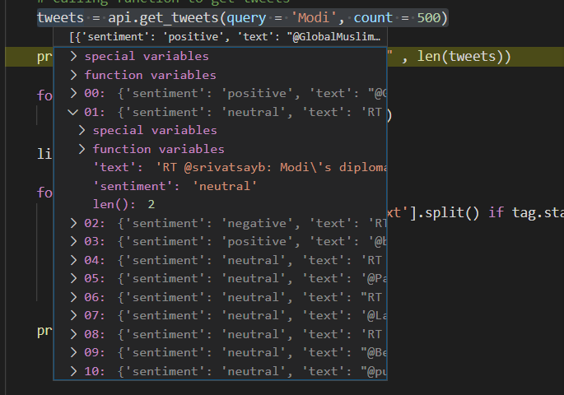  Why it’s not possible to implement?  - From the explanation and understanding, twitter itself does analysis and gives us the response  - Tweet about user/hashtag modi is analysed and decided whether its positive/negative/neutral  - Therefore, in our dataset, since tweet content doesn’t polarity value in it, we couldn’t able to proceed.  JFYI, here’s the implementation code, to decide whether tweet is positive/negative/neutral  if analysis.sentiment.polarity > 0:  return 'positive'  elif analysis.sentiment.polarity == 0:  return 'neutral'  else:  return 'negative'

For Contexual Features, here’s list,

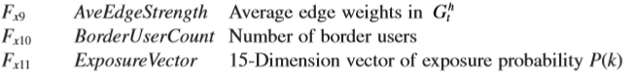

Sub-Module Method Name | Reason for not picking
FX9 | Understanding – Average edge strength (feature Fx8) measures the overall degree of userinteractionin The larger the edge weights,the more interactions among users.Let  denote the setofdiscon- nected components in  Feature Fx9 is computed by 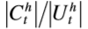  Why didn’t we implement?  From the above informtion, you can understanding that, larger edge weights are nothing but more intereation among users. Technically, we have deisgned our model in such way, based on hashtags, we can able to get nuber of users that are involved for a particular hashtags and also, can be to get each users total tweet count on a particular hashtag – (possible to get via userBasedHashTag.json). Finally, from Fx8, the component ratios are calculated based on the tweets and hashtag, therefore this implementation isn’t required.  .
Fx10 | Userstanding - Number of border users  Why it isn’t implemented?  Our task is to predict tomorrow’s trending hashtag, in that we cannot differenciate who would adopt the hashtag and users who has already exposed to the hashtag via social relatioship on Twitter Platform.  From the dataset we had, possibility of differenciating fx10 – border count users could not be possible.
Fx11 | 15 Dimension vector of Exposure Probablity Private Key.  Understanding - Border users are those have at least one edge from  users in but have not adopted hashtag h, that is, 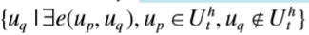  From the dataset we had, possibility of differenciating fx10 – border count users could not be possible.

Here’s the URL Reference – Content Feature,

- http://www.ijcaonline.org/research/volume125/number3/dandrea-2015-ijca-905866.pdf
- https://textblob.readthedocs.io/en/dev/quickstart.html#sentiment-analysis
- textblob.readthedocs.io/en/dev/_modules/textblob/en/sentiments.html

