Experiment 5: Filtering and Inspecting IP/ICMP Packets

Aim
To capture 100 packets from the LAN interface using Wireshark, apply a display filter to show only IP/ICMP packets, and inspect the packet details.

Procedure
- Open Wireshark and select the Local Area Connection interface.
- Go to Capture → Options.
- Tick “Stop capture automatically after 100 packets”.
- Click Start to begin the capture.
- Type ip || icmp in the display filter bar and press Enter.
- Select a packet and expand the Frame, Ethernet II, Internet Protocol and UDP/ICMP sections in the Packet Details pane to inspect it.
- Save the captured packets using File → Save.

Display Filter Used
Filter | ip || icmp
Protocols displayed | IPv4 traffic including ICMP (NBNS, SSDP, LLMNR, DHCP, etc.)

Output
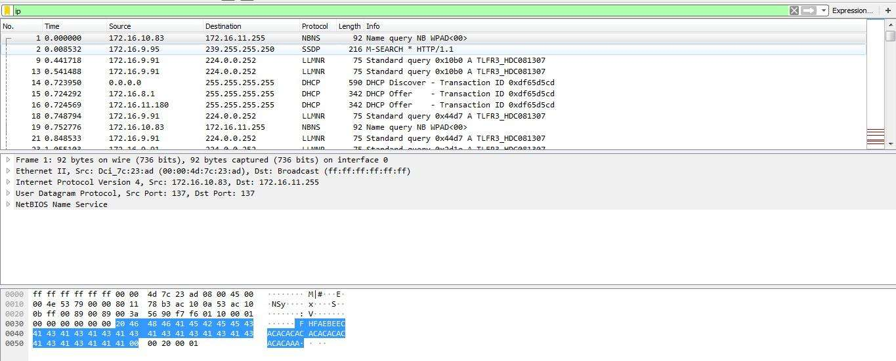
Figure 5.1: Wireshark output with the IP/ICMP display filter applied

Observation
- Every packet shown has an IPv4 header containing the source and destination IP addresses.
- Packet 1 is a NetBIOS name query from 172.16.10.83 sent to the broadcast address 172.16.11.255 over UDP port 137.
- LLMNR queries are sent to the multicast address 224.0.0.252, and SSDP uses 239.255.255.250.
- The Packet Bytes pane shows the raw hexadecimal data of the selected frame.

Result
The IP/ICMP packets were successfully filtered, captured and inspected using Wireshark.

