7. Project Documentation Phase
AnswerBot – AI-Powered FAQ and Customer Support Automation

7.1 Introduction to Project Documentation
The Project Documentation Phase records how AnswerBot was planned, designed, built, tested and configured, so that the work can be understood, reproduced and maintained by other people. AnswerBot is a backend system built with Node.js and Express.js. It stores users and Frequently Asked Questions (FAQs) in MongoDB through Mongoose, protects its routes with JSON Web Tokens (JWT) and bcrypt, and uses Google Gemini AI through the @google/genai package to generate answers and FAQ content. Because the system combines a REST API, a database, an authentication layer and an external AI service, its documentation must cover each of these parts clearly.
In AnswerBot, documentation is not a single task performed after coding is finished. It is maintained throughout the development lifecycle: requirements are written before design begins, architecture and database notes are recorded while the models and routes are created, API details are written as each endpoint is completed, and test results are recorded as each endpoint is tested in Thunder Client. The final project report is then assembled from these records rather than written from memory.
The way in which documentation supports the AnswerBot project is summarised below.
Table 7.1: Role of Documentation in the AnswerBot Project
Purpose | How Documentation Helps AnswerBot
Explain the project | States the problem of repetitive customer-support questions and how AnswerBot addresses it.
Record requirements | Lists the functional and non-functional needs, and the software and hardware required.
Describe architecture | Shows how a request moves from the API client through middleware, routes, controllers and services to MongoDB or Gemini.
Explain database design | Defines the User and FAQ models, their fields, data types and the one-to-many relationship.
Explain API endpoints | Records every endpoint with its method, URL, headers, body, response and error conditions.
Explain authentication | Describes registration, bcrypt hashing, JWT generation and Bearer-token verification.
Describe AI integration | Explains how the AI controller and Gemini service use @google/genai to produce answers and FAQs.
Record testing activities | Keeps test cases, expected results, actual results, defects and retest outcomes.
Help developers maintain the system | Explains folder structure, configuration and troubleshooting steps.
Help users understand the API | Provides request and response examples using safe sample data.
Support future development | Gives future developers a documented baseline for adding new features.
Provide evidence for evaluation | Supplies organised proof of the work carried out for the college project review.

Throughout this section, statements are labelled according to their status so that the report remains accurate. The conventions used are shown below.
Table 7.2: Status Conventions Used in This Section
Status | Meaning
Implemented | A feature that is part of the AnswerBot application, for example JWT authentication and FAQ CRUD.
Documented | A feature or procedure that is described in this report, whether or not it is automated.
Planned | An improvement that is proposed for future work and is not claimed as part of the current system.

7.2 Objectives of Documentation
The documentation of AnswerBot has the following objectives:
- Record the project requirements – capture what AnswerBot must do and the constraints under which it operates.
- Explain the system architecture – describe the layered structure from the API client to MongoDB and Google Gemini AI.
- Document software and hardware requirements – list the tools, versions and machine specifications needed to run the project.
- Describe the database structure – define the User and FAQ models and the relationship between them.
- Document REST API endpoints – record the authentication, FAQ and AI routes with request and response details.
- Explain authentication and authorization – describe how bcrypt, JWT and the middleware protect the API.
- Document FAQ management – explain how FAQs are created, read, updated and deleted.
- Explain FAQ search – describe the keyword-based search available at /api/faqs/search.
- Document Google Gemini AI integration – explain how AI answers and generated FAQs are produced.
- Record testing procedures and results – keep evidence of how each endpoint was tested in Thunder Client.
- Explain installation and configuration – provide repeatable steps to set up and run the server.
- Provide maintenance information – describe how dependencies, schemas, routes and integrations are kept up to date.
- Support future developers – enable new contributors to understand and extend the code with minimal guidance.
- Prepare the final academic project report – provide the material from which the complete report is compiled.

7.3 Types of Documentation
Six types of documentation are prepared for AnswerBot. Each has a different audience and a different purpose.

7.3.1 Project Documentation
Project documentation describes the complete project from idea to outcome. For AnswerBot it contains:
- Project introduction and problem statement
- Objectives and scope
- Requirements and design
- Development and testing
- Results and conclusion

7.3.2 Technical Documentation
Technical documentation explains how AnswerBot is implemented internally. It contains:
- System architecture and folder structure
- Database models and API routes
- Controllers, middleware and services
- Authentication mechanism
- Google Gemini AI integration

7.3.3 API Documentation
API documentation explains how a client uses the REST API. For every endpoint it records:
- Endpoint and HTTP method
- Request body and headers
- Authentication requirements
- Response format
- Error conditions

7.3.4 Database Documentation
Database documentation describes the MongoDB data that AnswerBot stores. It contains:
- User collection and FAQ collection
- Fields and data types
- Relationships between collections
- Validation rules

7.3.5 Testing Documentation
Testing documentation records how the system was verified. It contains:
- Test cases and expected results
- Actual results and pass/fail status
- Defects found
- Retesting after corrections

7.3.6 User/Developer Documentation
User and developer documentation helps people install and operate AnswerBot. It contains:
- Installation and configuration steps
- Instructions for running the server
- API usage guidance and environment variables
- Troubleshooting information
The purposes of the six documentation types are summarised below.
Table 7.3: Documentation Types Prepared for AnswerBot
Documentation Type | Purpose
Project Documentation | Describes the complete project
Technical Documentation | Explains internal system implementation
API Documentation | Explains REST API usage
Database Documentation | Describes database structure
Testing Documentation | Records testing activities
User/Developer Documentation | Helps users and developers operate and maintain the system

7.4 Project Report Documentation
The complete AnswerBot project report follows the structure shown below. The Project Documentation Phase (this section) is one part of that report, and it supplies material that several other sections reuse, such as requirements, architecture, testing evidence and conclusions.
Table 7.4: Structure of the AnswerBot Project Report
No. | Report Section | Purpose
1 | Title Page | Identifies the project title, the student and the academic details supplied by the institution.
2 | Certificate | Formal certification page, prepared in the format required by the institution.
3 | Declaration | Statement of originality, prepared in the format required by the institution.
4 | Acknowledgement | Thanks those who guided and supported the work.
5 | Abstract | Gives a brief summary of the problem, method and outcome of AnswerBot.
6 | Table of Contents | Helps readers locate sections, tables and figures.
7 | Introduction | Introduces AI-powered FAQ and customer-support automation and the purpose of AnswerBot.
8 | Problem Statement | Defines the difficulty of handling repeated customer questions manually.
9 | Objectives | States what AnswerBot is intended to achieve.
10 | Requirement Analysis | Documents functional, non-functional, software and hardware requirements.
11 | Project Design | Presents the architecture, database design and API design.
12 | Project Planning | Describes the schedule, tasks and development approach.
13 | Project Development | Explains how the backend, authentication, FAQ module and AI module were built.
14 | Project Testing | Records test cases, results and defects from Thunder Client testing.
15 | Project Documentation | Describes the documentation prepared for the project (this section).
16 | Project Demonstration | Shows the system running through API requests and responses.
17 | Results | Summarises what was achieved against the objectives.
18 | Conclusion | Gives the overall outcome and learning from the project.
19 | Future Enhancements | Lists planned improvements that are not part of the current system.
20 | References | Lists books, articles and official documentation used.
The Certificate and Declaration pages must follow the wording and layout prescribed by the institution. No institution-specific wording is included in this document; it should be inserted as supplied by the college.

7.5 System Requirement Documentation
The requirements below describe the environment needed to develop, run and test AnswerBot.

7.5.1 Software Requirements
Table 7.5: Software Requirements of AnswerBot
Software / Technology | Specification | Role in AnswerBot
Operating System | Windows 10/11 or compatible OS | Development and execution environment
Node.js | v18 or above | JavaScript runtime for the backend
npm | Bundled with Node.js | Installs dependencies and runs scripts
Express.js | Node.js framework | Builds the REST API, routing and middleware
MongoDB | Database server | Stores User and FAQ data
Mongoose | ODM library | Defines schemas and models, performs validation and queries
JavaScript | Programming language | Implementation language of the backend
JWT | Token standard / library | Issues and verifies authentication tokens
bcrypt | Hashing library | Hashes and verifies passwords
Google Gemini AI | External AI service | Generates AI-assisted answers and FAQs
@google/genai | Google GenAI package | Communicates with the Gemini API
Visual Studio Code | Code editor | Writing and editing the source code
Thunder Client | VS Code API client extension | Sends requests and records API test results

7.5.2 Hardware Requirements
Table 7.6: Hardware Requirements of AnswerBot
Component | Requirement | Remark
Processor | Intel Core i5 8th Generation or above / AMD Ryzen 5 or above | Minimum
Memory (RAM) | 8 GB | Minimum
Memory (RAM) | 16 GB | Recommended
Storage | At least 1 GB available space | Project files and dependencies
Network | Internet connection | Required for Gemini API access

7.6 System Architecture Documentation
AnswerBot follows a layered architecture. A request sent from Thunder Client (or any API client) first reaches the Express.js application, passes through the authentication and authorization middleware where required, is matched by a route, and is handled by a controller. The controller delegates business logic to a service or uses a Mongoose model to read and write MongoDB. Requests to the AI endpoints follow a second path in which the AI controller calls the Gemini service, which communicates with Google Gemini AI and returns the generated answer or FAQ in the API response.
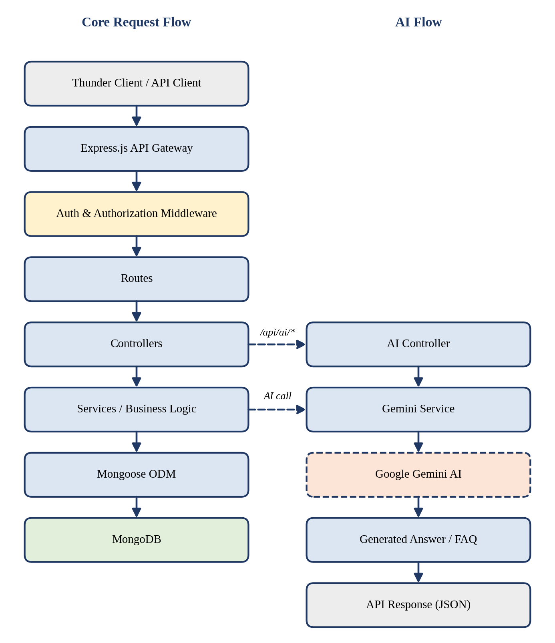
Figure 7.1: System Architecture Documentation of AnswerBot
Each layer of the architecture has a specific responsibility:
Table 7.7: Architecture Layers of AnswerBot
Layer | Responsibility
Thunder Client / API Client | Sends HTTP requests with headers and JSON bodies and displays the responses.
Express.js API Gateway | Receives all requests, parses JSON, and directs them to the correct route.
Authentication & Authorization Middleware | Reads the Bearer token, verifies the JWT and allows or rejects the request.
Routes | Map each URL and HTTP method to a controller function.
Controllers | Validate request data, call services or models and build the HTTP response.
Services / Business Logic | Contain reusable logic and external communication, such as the Gemini service.
Mongoose ODM | Provides schemas, models, validation and database queries.
MongoDB | Stores the User and FAQ collections.
AI Controller | Handles /api/ai/answer and /api/ai/generate-faq requests.
Gemini Service | Sends prompts to Google Gemini AI through @google/genai.
Google Gemini AI | External service that generates the answer or FAQ content.

7.7 Project Folder Structure Documentation
The AnswerBot source code is organised by responsibility so that each concern can be located quickly.
AnswerBot/
│
├── src/
│ ├── controllers/
│ ├── models/
│ ├── routes/
│ ├── middleware/
│ ├── services/
│ ├── config/
│ ├── app.js
│ └── server.js
│
├── .env
├── .gitignore
├── package.json
└── README.md

Table 7.8: Folder and File Purposes
Folder/File | Purpose
controllers | Handles API request logic
models | Contains Mongoose models
routes | Defines API routes
middleware | Authentication and error handling
services | External/business services such as Gemini
config | Database/configuration logic
app.js | Express application setup
server.js | Server startup
.env | Environment configuration
.gitignore | Prevents sensitive/unwanted files from being committed
package.json | Project dependencies and scripts
README.md | Project setup and usage information

7.8 Database Documentation
AnswerBot uses MongoDB with Mongoose. Two models are documented: User and FAQ. No other collections are part of the implemented project, and none are claimed in this report.

7.8.1 User Model
Table 7.9: User Model Fields
Field | Type | Description
_id | ObjectId | Unique user identifier
name | String | User name
email | String | User email
password | String | Hashed password (the plain password is never stored)
role | String | User role
createdAt | Date | Creation timestamp
updatedAt | Date | Last update timestamp

7.8.2 FAQ Model
Table 7.10: FAQ Model Fields
Field | Type | Description
_id | ObjectId | Unique FAQ identifier
question | String | FAQ question
answer | String | FAQ answer
category | String | FAQ category
createdBy | ObjectId | Reference to creator
createdAt | Date | Creation timestamp
updatedAt | Date | Last update timestamp

7.8.3 Relationship Between Models
The relationship between the two models is User 1 → Many FAQs. Each FAQ stores the _id of the user who created it in the createdBy field, while a single user may create any number of FAQs. This reference allows the application to identify the owner of an FAQ.
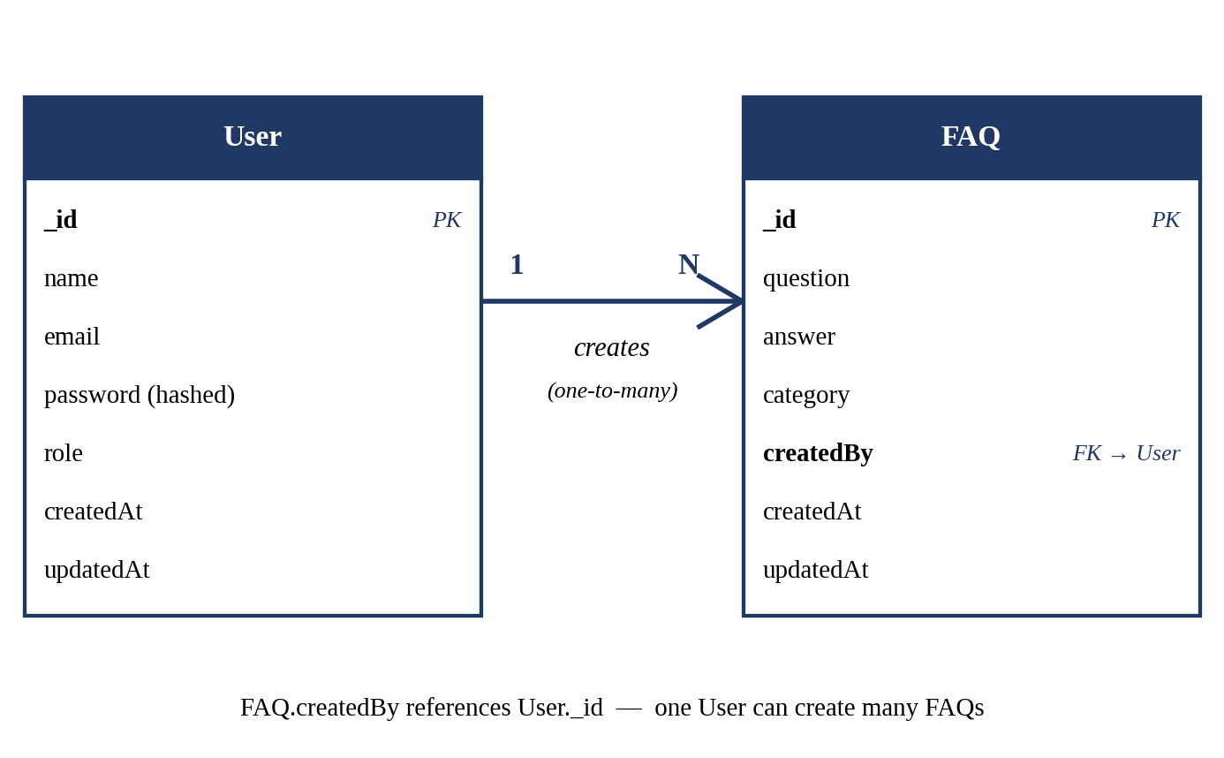
Figure 7.2: User–FAQ Database Relationship
The category field is stored as a text value inside each FAQ document. It is not a separate collection, and no separate category-management API is claimed. Validation is provided by the Mongoose schema definitions, for example required fields and data types, and by checks performed in the controllers.

7.9 API Documentation
AnswerBot exposes a REST API under three groups: authentication (/api/auth), FAQ management (/api/faqs) and AI services (/api/ai). The summary table lists every endpoint, and the subsections that follow document each one in detail.
Table 7.21: AnswerBot API Endpoint Summary
Method | Endpoint | Purpose | Authentication
POST | /api/auth/register | Register a new user | Public
POST | /api/auth/login | Authenticate a user and obtain a JWT | Public
GET | /api/faqs | Retrieve FAQs | Per route configuration*
GET | /api/faqs/:id | Retrieve a specific FAQ | Per route configuration*
POST | /api/faqs | Create an FAQ | Bearer JWT
PUT | /api/faqs/:id | Update an FAQ | Bearer JWT
DELETE | /api/faqs/:id | Delete an FAQ | Bearer JWT
GET | /api/faqs/search?q=keyword | Search FAQs by keyword | Per route configuration*
POST | /api/ai/answer | Generate an AI-powered answer | Per route configuration*
POST | /api/ai/generate-faq | Generate an AI-powered FAQ | Per route configuration*
* The exact access level of these routes must be confirmed against the route files in src/routes and the report updated accordingly. This document does not claim access restrictions that have not been verified. Registration and login are public by nature, because a user cannot hold a token before logging in.
Search is performed with keyword/regular-expression matching on FAQ records. It is not a semantic or vector search. The route /api/faqs/search must be defined before /api/faqs/:id in the routes file; otherwise Express would treat the word "search" as an FAQ identifier.

7.9.1 Register a New User
Table 7.11: POST /api/auth/register – Specification
Method | POST
Endpoint | /api/auth/register
Purpose | Register a new user.
Authentication | Public route; no token is required.
Headers | Content-Type: application/json
Request Body | { "name": "Sample User", "email": "user@example.com", "password": "sample_password" }
Success Response | Success status with a message and the created user details (the password is never returned).
Error Conditions | Missing or invalid fields (validation error); email already registered; server error.

7.9.2 Log In
Table 7.12: POST /api/auth/login – Specification
Method | POST
Endpoint | /api/auth/login
Purpose | Authenticate an existing user and obtain a JWT.
Authentication | Public route; no token is required.
Headers | Content-Type: application/json
Request Body | { "email": "user@example.com", "password": "sample_password" }
Success Response | Success status with a message and a JWT to be used as a Bearer token.
Error Conditions | Missing fields; incorrect email or password (authentication failure); server error.

7.9.3 Retrieve FAQs
Table 7.13: GET /api/faqs – Specification
Method | GET
Endpoint | /api/faqs
Purpose | Retrieve FAQs.
Authentication | Confirm against the route definition.*
Headers | Authorization: Bearer <your_jwt_token> (when the route is protected)
Request Body | None.
Success Response | Success status with a list of FAQ records.
Error Conditions | Missing or invalid token (if protected); server error.

7.9.4 Retrieve a Specific FAQ
Table 7.14: GET /api/faqs/:id – Specification
Method | GET
Endpoint | /api/faqs/:id
Purpose | Retrieve a specific FAQ.
Authentication | Confirm against the route definition.*
Headers | Authorization: Bearer <your_jwt_token> (when the route is protected)
Request Body | None. The FAQ identifier is supplied in the URL.
Success Response | Success status with the requested FAQ record.
Error Conditions | Invalid identifier; FAQ not found; missing or invalid token (if protected); server error.

7.9.5 Create an FAQ
Table 7.15: POST /api/faqs – Specification
Method | POST
Endpoint | /api/faqs
Purpose | Create an FAQ.
Authentication | Bearer JWT required (protected route).
Headers | Content-Type: application/json; Authorization: Bearer <your_jwt_token>
Request Body | { "question": "What is AnswerBot?", "answer": "AnswerBot is an FAQ and support automation API.", "category": "General" }
Success Response | Success status with the created FAQ; createdBy is set from the authenticated user.
Error Conditions | Missing required fields; missing or invalid token; server error.

7.9.6 Update an FAQ
Table 7.16: PUT /api/faqs/:id – Specification
Method | PUT
Endpoint | /api/faqs/:id
Purpose | Update an FAQ.
Authentication | Bearer JWT required (protected route).
Headers | Content-Type: application/json; Authorization: Bearer <your_jwt_token>
Request Body | { "question": "Updated question?", "answer": "Updated answer.", "category": "General" }
Success Response | Success status with the updated FAQ.
Error Conditions | Invalid data; FAQ not found; user is not the FAQ owner (ownership check); missing or invalid token; server error.

7.9.7 Delete an FAQ
Table 7.17: DELETE /api/faqs/:id – Specification
Method | DELETE
Endpoint | /api/faqs/:id
Purpose | Delete an FAQ.
Authentication | Bearer JWT required (protected route).
Headers | Authorization: Bearer <your_jwt_token>
Request Body | None. The FAQ identifier is supplied in the URL.
Success Response | Success status with a confirmation message.
Error Conditions | FAQ not found; user is not the FAQ owner (ownership check); missing or invalid token; server error.

7.9.8 Search FAQs
Table 7.18: GET /api/faqs/search?q=keyword – Specification
Method | GET
Endpoint | /api/faqs/search?q=keyword
Purpose | Search FAQ records using a keyword.
Authentication | Confirm against the route definition.*
Headers | Authorization: Bearer <your_jwt_token> (when the route is protected)
Request Body | None. The keyword is supplied in the query parameter q.
Success Response | Success status with the FAQs that match the keyword (the list may be empty).
Error Conditions | Missing keyword; missing or invalid token (if protected); server error.

7.9.9 Generate an AI Answer
Table 7.19: POST /api/ai/answer – Specification
Method | POST
Endpoint | /api/ai/answer
Purpose | Generate an AI-powered answer.
Authentication | Confirm against the route definition.*
Headers | Content-Type: application/json; Authorization: Bearer <your_jwt_token> (when the route is protected)
Request Body | { "question": "What is MongoDB?" }
Success Response | Success status with the answer generated by Google Gemini AI.
Error Conditions | Missing question; missing or invalid token (if protected); Gemini API error; server error.

7.9.10 Generate an AI FAQ
Table 7.20: POST /api/ai/generate-faq – Specification
Method | POST
Endpoint | /api/ai/generate-faq
Purpose | Generate an AI-powered FAQ.
Authentication | Confirm against the route definition.*
Headers | Content-Type: application/json; Authorization: Bearer <your_jwt_token> (when the route is protected)
Request Body | { "topic": "MongoDB" }
Success Response | Success status with an FAQ (question and answer) generated by Google Gemini AI.
Error Conditions | Missing topic; missing or invalid token (if protected); Gemini API error; server error.

7.10 API Request and Response Documentation
Every AnswerBot endpoint is documented with the same set of request and response components, so that the API can be used consistently from Thunder Client or any other client.
Table 7.22: Request Components Documented for Each Endpoint
Request Component | What Is Recorded
HTTP method | GET, POST, PUT or DELETE.
URL | The endpoint path, path parameters (such as :id) and query parameters (such as q).
Headers | For example Content-Type: application/json for JSON bodies.
Authorization | The Bearer token placed in the Authorization header for protected routes.
Request body | The JSON fields sent by the client, for example question or topic.

Table 7.23: Response Components Documented for Each Endpoint
Response Component | What Is Recorded
HTTP status code | For example 200 (OK), 201 (Created), 400 (Bad Request), 401 (Unauthorized), 403 (Forbidden), 404 (Not Found), 500 (Server Error).
JSON response | The body returned by the API.
Success/error indicator | A field or status that shows whether the request succeeded.
Message | A short human-readable description of the result.
Returned data | The user, token, FAQ list, FAQ record or AI-generated content.
The examples below use dummy data only. The field names of the response envelope are illustrative and must be checked against the running application. No real token, password, API key or database credential is shown.
Example 1 – Login request
POST http://localhost:5000/api/auth/login
Content-Type: application/json

{
"email": "user@example.com",
"password": "sample_password"
}

Example 2 – Successful login response (sample)
HTTP/1.1 200 OK
{
"success": true,
"message": "Login successful",
"token": "<sample_jwt_token>"
}

Example 3 – Create FAQ request
POST http://localhost:5000/api/faqs
Content-Type: application/json
Authorization: Bearer <your_jwt_token>

{
"question": "What is AnswerBot?",
"answer": "AnswerBot is an FAQ and support automation API.",
"category": "General"
}

Example 4 – AI answer response (sample)
HTTP/1.1 200 OK
{
"success": true,
"message": "Answer generated",
"data": { "answer": "<AI generated text about MongoDB>" }
}

Example 5 – Error response (sample)
HTTP/1.1 401 Unauthorized
{
"success": false,
"message": "Not authorized, token missing or invalid"
}

7.11 Authentication Documentation
AnswerBot authenticates users with bcrypt and JSON Web Tokens. The complete process, from registration to a protected API request, is shown in the figure and explained below.
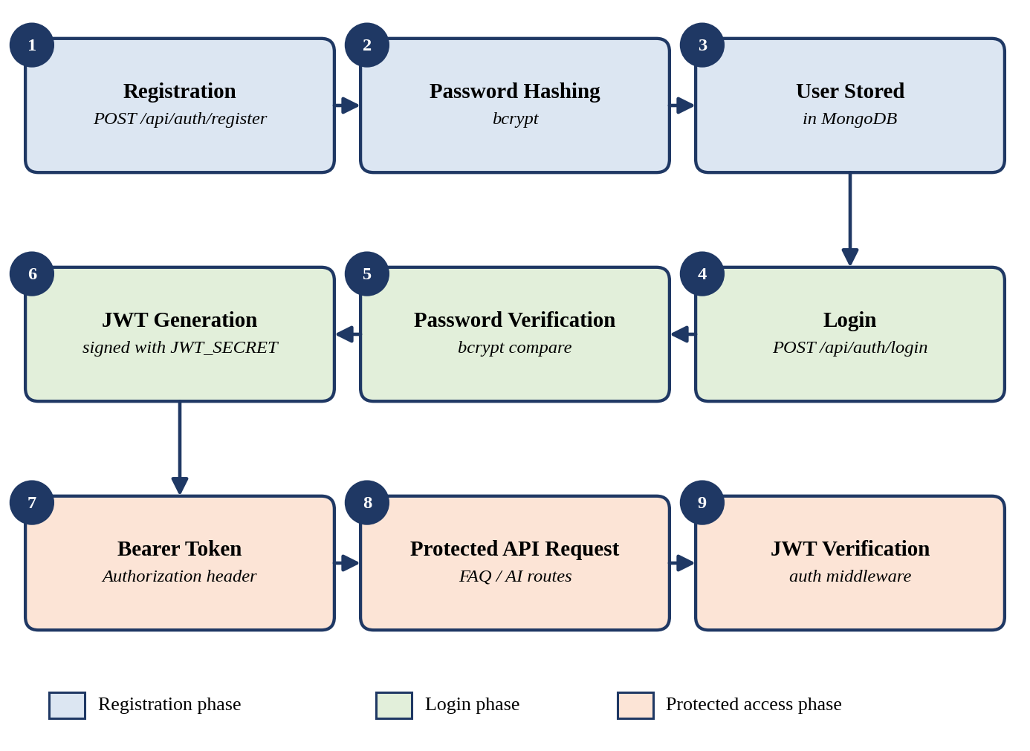
Figure 7.3: Authentication Documentation Flow
Table 7.24: Components of the Authentication Process
Component | Role in AnswerBot
bcrypt | Hashes the password during registration so that only the hash is stored in MongoDB. During login it compares the entered password with the stored hash.
JWT | A signed token generated after successful login. It identifies the user in later requests and is signed using the secret stored in JWT_SECRET.
Authorization header | The client sends the token in the header Authorization: Bearer <your_jwt_token>.
Authentication middleware | Reads the header, verifies the JWT and, when it is valid, allows the request to reach the controller. Otherwise the request is rejected.
The sequence is as follows. A new user registers, the password is hashed with bcrypt, and the user is stored in MongoDB. At login, the submitted password is verified against the stored hash and a JWT is generated. The client then sends the token as a Bearer token with each protected request, and the middleware verifies it before the controller runs.

7.12 AI Integration Documentation
Google Gemini AI provides the AI-assisted responses in AnswerBot. The @google/genai package is used for communication with the Gemini API. The integration is documented under the following points:
- AI answer generation is available through /api/ai/answer, which receives a question and returns a generated answer.
- AI FAQ generation is available through /api/ai/generate-faq, which receives a topic and returns generated FAQ content.
- The AI controller receives the request and calls the Gemini service, which sends the prompt to Google Gemini AI.
- Gemini configuration is stored using environment variables, and the API key is read from GEMINI_API_KEY.
- API keys must not be exposed in source code or public repositories.
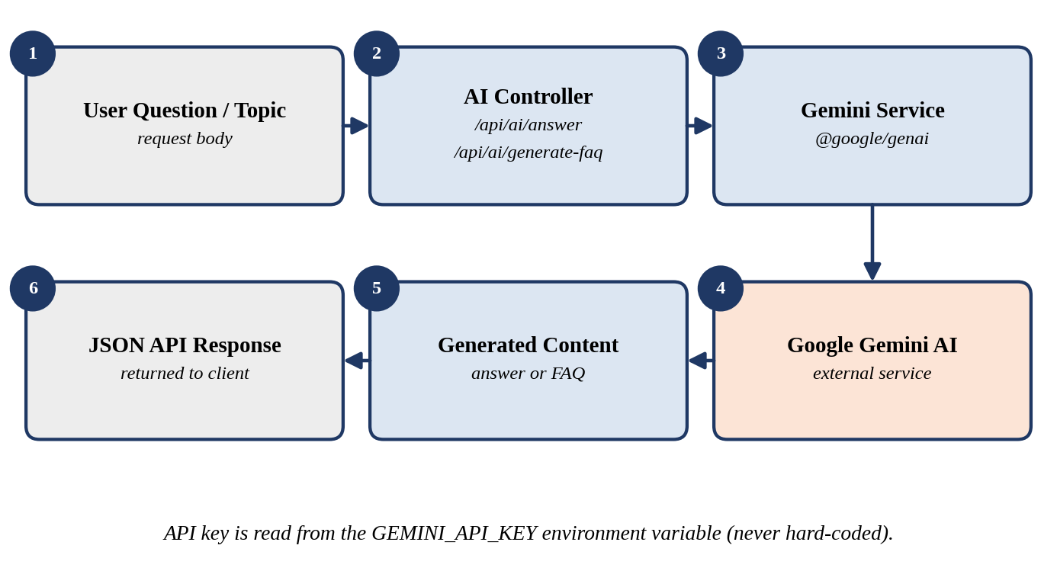
Figure 7.4: Google Gemini AI Documentation Flow
Table 7.25: AI Endpoints and Their Data
Endpoint | Input | Output
/api/ai/answer | question | AI-generated answer returned in the JSON response
/api/ai/generate-faq | topic | AI-generated FAQ content returned in the JSON response
Because the output is produced by an external model, the wording of a generated answer can vary between requests, and the service depends on network access and API availability. Generated content should therefore be reviewed before it is used as an official FAQ. The AI feature is documented as an assisting tool for the FAQ system, not as a replacement for it.

7.13 Security Documentation
The security mechanisms used by AnswerBot are documented below together with the reason each one matters.
Table 7.26: Security Mechanisms in AnswerBot
Mechanism | Why It Is Important
bcrypt password hashing | Stores passwords as hashes, so a leaked database does not reveal the original passwords.
JWT authentication | Lets the server recognise a logged-in user without storing the password in each request.
Bearer token validation | Ensures each protected request carries a token that is valid and correctly signed.
Protected routes | Prevent requests without a valid token from using restricted operations such as creating, updating and deleting FAQs.
FAQ ownership checks | Where enforced by the controllers, they prevent a user from changing or deleting an FAQ created by another user, using the createdBy field.
Environment variables | Keep configuration values outside the source code so they can differ between machines.
API key protection | Keeps the Gemini API key out of the source code and public repositories, preventing misuse and unexpected charges.
Input validation | Rejects missing or malformed request data before it is processed.
Mongoose validation | Enforces the schema rules, such as required fields and data types, before data is saved.
Sanitized error responses | Return simple messages to the client and avoid exposing stack traces, secrets or database details.
Only the mechanisms listed above are documented as security features. Additional measures, such as rate limiting or HTTPS deployment settings, are not claimed as part of the current system and may be considered as future enhancements.

7.14 Configuration Documentation
AnswerBot reads its configuration from environment variables stored in a .env file in the project root. The documentation shows a safe example that uses placeholders only. Real values must never be written in the report, the README or the repository.
PORT=5000
MONGO_URI=your_mongodb_connection_string
JWT_SECRET=your_secure_jwt_secret
GEMINI_API_KEY=your_gemini_api_key

Table 7.27: Environment Variables of AnswerBot
Variable | Explanation
PORT | The port on which the Express server listens. The sample value is 5000.
MONGO_URI | The connection string used by Mongoose to connect to MongoDB. It may contain server address and credentials.
JWT_SECRET | The secret key used to sign and verify JSON Web Tokens. It must be long, private and hard to guess.
GEMINI_API_KEY | The key that authorises requests to the Google Gemini API through @google/genai.
The .env file must be excluded from GitHub by listing it in .gitignore. If the file were uploaded, anyone able to view the repository could read the database connection details, forge tokens with the JWT secret, or use the Gemini API key. A separate .env.example file containing only placeholders can be committed to show other developers which variables are needed.

7.15 Installation and Setup Documentation
The following steps install and run AnswerBot on a development machine.

Step 1: Install Node.js
Download and install Node.js v18 or above. Verify the installation with node -v and npm -v.

Step 2: Open the Project in Visual Studio Code
Start Visual Studio Code and open the AnswerBot project folder.

Step 3: Open the Terminal
Open the integrated terminal in Visual Studio Code and make sure it points to the project root.

Step 4: Install Dependencies
Install the packages listed in package.json:
npm install

Step 5: Configure .env
Create the .env file in the project root and enter the values described in Section 7.14, replacing each placeholder with your own private value.

Step 6: Start MongoDB
Start the local MongoDB server, or make sure the MongoDB service referenced by MONGO_URI is reachable.

Step 7: Start the AnswerBot Server
npm run dev

Step 8: Verify the Server
Open the following address in a browser or in Thunder Client:
http://localhost:5000

The exact response should be verified against the current application, because the message returned by the root route depends on how the application is written. The console output should also confirm the database connection and the port number.

Step 9: Open Thunder Client
Open the Thunder Client extension in Visual Studio Code and create a new request or collection for AnswerBot.

Step 10: Test the API Endpoints
Send requests to the endpoints in Section 7.9 in the order given in Section 7.16 and record the results.

7.16 API Testing Documentation
API testing is documented using Thunder Client. The testing order below follows the natural flow of the application, because later tests need data or a token produced by earlier ones.
- Create/register a user with POST /api/auth/register.
- Log in with POST /api/auth/login.
- Copy the JWT token returned by the login response.
- Add Bearer authorization in Thunder Client (Auth tab, Bearer) using the copied token.
- Test the FAQ endpoints: create, retrieve all, retrieve one, update and delete.
- Test FAQ search with GET /api/faqs/search?q=keyword.
- Test AI answer generation with POST /api/ai/answer.
- Test AI FAQ generation with POST /api/ai/generate-faq.
- Record the expected result and the actual result for each test.
- Record any errors found and the corrections made, then retest.
The table below shows what is documented for each test area.
Table 7.28: API Testing Documentation Areas
Test Area | Endpoint/Feature | Documentation
Registration | /api/auth/register | Request and response
Login | /api/auth/login | Authentication result
FAQ | /api/faqs | CRUD results
Search | /api/faqs/search | Search result
AI Answer | /api/ai/answer | Generated answer
AI FAQ | /api/ai/generate-faq | Generated FAQ
A test record sheet such as the one below is used to store the evidence. The Actual Result and Status columns are completed while testing and are deliberately left blank in this document, so that no result is claimed before it has been observed.
Table 7.29: Test Record Template
ID | Test | Expected Result | Actual Result | Status | Retest
T1 | Register a new user | User created, password not returned
T2 | Login with valid credentials | JWT token returned
T3 | Create FAQ with token | FAQ created with createdBy
T4 | Create FAQ without token | Request rejected (unauthorized)
T5 | Search FAQ by keyword | Matching FAQs returned
T6 | AI answer for a question | Generated answer returned
T7 | AI FAQ for a topic | Generated FAQ returned

7.17 Error and Troubleshooting Documentation
Common problems that may occur while running or testing AnswerBot, with their causes and solutions, are documented below.
Table 7.30: Common Problems and Solutions
Problem | Possible Cause | Solution
MongoDB Connection Error | MongoDB server not running; incorrect connection string | Start MongoDB and verify MONGO_URI.
JWT Authentication Error | Missing or invalid token | Log in again and provide a valid Bearer token.
Gemini API Error | Invalid API key; API service/model issue; network/API availability problem | Verify the environment configuration and Gemini API setup.
Validation Error | Missing or invalid request data | Check the required fields and the request body.
Port Error | Port already in use | Stop the conflicting process or configure another available port.

7.18 Version Control Documentation
Git and GitHub can be used to manage the AnswerBot source code. Version control is documented under the following headings:
- Repository creation – initialise a Git repository in the project folder and create a matching repository on GitHub.
- Source-code commits – save small, meaningful changes with clear commit messages.
- Version history – allows the team to review earlier versions and undo mistakes.
- Collaboration – lets several developers work through branches and merge their changes.
- README – explains the purpose, setup and usage of the project on the repository home page.
- .gitignore – lists files and folders that Git must not track.
A typical first upload uses these commands:
git init
git add .
git commit -m "Initial commit"
git branch -M main
git remote add origin <your_repository_url>
git push -u origin main

Security note: the following must not be uploaded to GitHub:
.env
node_modules/

The .env file may contain MongoDB connection information, the JWT secret and the Gemini API key. node_modules/ is large and can be recreated with npm install. Both entries should appear in .gitignore before the first commit. If a secret is ever committed by mistake, it must be treated as exposed and replaced with a new one.

7.19 Maintenance Documentation
Future developers can maintain AnswerBot by following the activities below.
Table 7.31: Maintenance Activities for AnswerBot
Activity | Description
Updating dependencies | Review packages in package.json regularly, update them carefully and run the tests again.
Updating MongoDB schemas | Change the Mongoose models when fields are added or modified, and update Section 7.8.
Updating API routes | Record every new, changed or removed route in the API documentation.
Updating Gemini integration | Check the @google/genai package and model settings when Google changes the service.
Reviewing authentication | Review the JWT secret, token handling and middleware to keep access control correct.
Monitoring errors | Check server logs and error responses to find and correct recurring failures.
Adding new FAQ features | Design and document new capabilities before or while implementing them.
Updating documentation | Edit the report, README and API notes in the same change as the code.
Testing before deployment | Run the API test cases again and record the results before releasing any change.
Documentation must be kept synchronised with the source code. Outdated documentation is misleading: a wrong endpoint, field name or setup step can waste time and introduce errors. For this reason, every code change that affects behaviour should be accompanied by an update to the matching document.

7.20 Documentation Flow Diagram
The documentation of AnswerBot follows the development lifecycle. Each stage produces documents that feed the next stage, and the final report and maintenance updates complete the cycle.
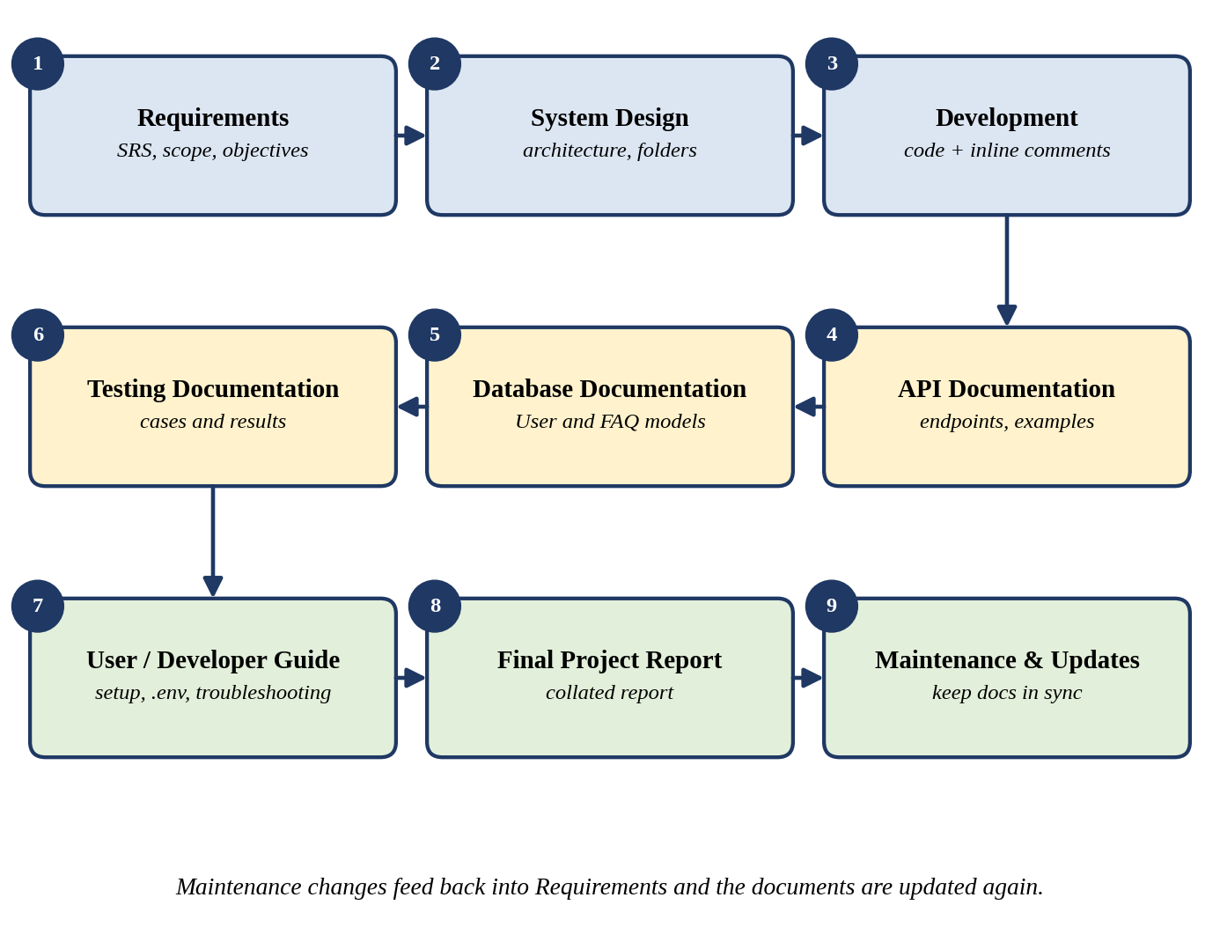
Figure 7.5: Documentation Lifecycle of AnswerBot

7.21 Documentation Checklist
The checklist below lists the documentation items required for AnswerBot. Because the completion of each item has not been independently verified in this document, the status column is labelled Required/Planned. Each item can be marked as completed after it is checked against the final project.
Table 7.32: Documentation Checklist
Documentation Item | Required/Planned | Section
Project Requirements | Required | 7.5
System Design | Required | 7.6, 7.7
Database Design | Required | 7.8
API Documentation | Required | 7.9, 7.10
Authentication Documentation | Required | 7.11
AI Integration Documentation | Required | 7.12
Testing Documentation | Required | 7.16
Installation Guide | Required | 7.15
Configuration Guide | Required | 7.14
Troubleshooting Guide | Required | 7.17
README | Required | 7.7, 7.18
Final Project Report | Required | 7.4

7.22 Project Documentation Summary
Documentation gives the AnswerBot project a structured and lasting record. It explains what the system must do, how it is built and how it is used, and it provides a single reference for developers, testers, users and evaluators. Through the requirements, architecture, database, API, authentication, AI integration, security, testing, installation and maintenance sections of this chapter, every major part of AnswerBot is described in a consistent way.
For developers, the documentation shows the folder structure, the User and FAQ models, the middleware and the Gemini service, so that changes can be made with confidence. For testers, it provides the endpoints, request examples and a record sheet for expected and actual results. For users of the API, it explains how to register, log in, send a Bearer token and call the FAQ and AI endpoints. For evaluators, it provides clear evidence of the work carried out and the way in which the system was verified.
The documentation also states the limits of the current system with care. FAQ search is keyword-based, categories are stored as a field of each FAQ, and only the features described in this chapter are claimed. Planned improvements are kept separate from implemented ones, which keeps the report honest and reliable.
Well-organised documentation improves maintainability, usability, knowledge transfer and the future enhancement of the system. When it is updated together with the source code, AnswerBot can be understood, operated and extended by new developers long after the original project has been completed.

