8. Project Demonstration Phase
AnswerBot – AI-Powered FAQ and Customer Support Automation

8.1 Introduction to Project Demonstration
The demonstration phase is the final stage of the AnswerBot – AI-Powered FAQ and Customer Support Automation project. Its purpose is to present the completed system in a practical way and to show that the implemented backend behaves according to the requirements planned in the earlier phases of the project.
AnswerBot is implemented as a backend REST API. It does not include a separate frontend application. Therefore, the demonstration focuses on the working API endpoints, which are tested and presented using Thunder Client inside Visual Studio Code. Each request and response shows how the different parts of the system work together.
The demonstration is used to show the following aspects of the system:
- Overall system functionality
- REST API operation
- User authentication
- JWT-based authorization
- FAQ management (create, retrieve, update and delete)
- FAQ search
- MongoDB database interaction
- Google Gemini AI integration
- Error handling
- Security mechanisms
- API testing using Thunder Client
The demonstration provides practical evidence that the developed system works according to the planned requirements and gives the evaluators a clear view of the architecture and implementation.

8.2 Objectives of Demonstration
The objectives of the AnswerBot demonstration are as follows:
- Demonstrate the working backend – show that the Express.js API runs correctly.
- Show successful server startup – confirm that the server starts on the configured port.
- Demonstrate database connectivity – confirm that the server connects to MongoDB.
- Demonstrate user registration – create a new user account through the API.
- Demonstrate user login – authenticate a registered user.
- Demonstrate JWT authentication – use the generated token for protected requests.
- Demonstrate FAQ creation – add a new FAQ record.
- Demonstrate FAQ retrieval – read all FAQs and a single FAQ.
- Demonstrate FAQ updating – modify an existing FAQ.
- Demonstrate FAQ deletion – remove an FAQ record.
- Demonstrate FAQ searching – find FAQs using a keyword.
- Demonstrate AI answer generation – generate an answer with Google Gemini AI.
- Demonstrate AI FAQ generation – generate a question and answer pair from a topic.
- Demonstrate authorization and ownership protection – show that users cannot modify FAQs created by others.
- Demonstrate error handling – show how the API responds to invalid or unauthorized requests.
- Present the final project workflow clearly – explain the complete working sequence of the system.

8.3 Demonstration Environment
Table 8.1 lists the environment used to demonstrate the AnswerBot API.
Table 8.1: Demonstration Environment
Component | Demonstration Environment
Operating System | Windows 10/11 or compatible OS
Runtime | Node.js v18+
Backend | Express.js
Database | MongoDB
ODM | Mongoose
Authentication | JWT
Password Security | bcrypt
AI Service | Google Gemini AI
API Testing | Thunder Client
IDE | Visual Studio Code
API Format | REST + JSON

The demonstration uses the development environment on a local machine. The API runs locally and is accessed through Thunder Client, which sends HTTP requests and displays the JSON responses.

8.4 Demonstration Preparation
The following steps must be completed before the demonstration begins.

Step 1 – Open the Project
Open the AnswerBot project folder in Visual Studio Code.

Step 2 – Open Terminal
Open the integrated terminal in Visual Studio Code from the Terminal menu.

Step 3 – Install Dependencies
If the dependencies are not already installed, run the following command in the project folder:
npm install

Step 4 – Configure Environment Variables
Create a .env file in the project root. Only safe example values are shown below; actual secrets must never be written in the report or shared publicly.
PORT=5000
MONGO_URI=your_mongodb_connection_string
JWT_SECRET=your_secure_jwt_secret
GEMINI_API_KEY=your_gemini_api_key

Table 8.2: Environment Variables Used in the Demonstration
Variable | Purpose
PORT | Port number on which the Express server listens
MONGO_URI | Connection string used by Mongoose to connect to MongoDB
JWT_SECRET | Secret key used to sign and verify JSON Web Tokens
GEMINI_API_KEY | API key used to access Google Gemini AI

Step 5 – Start MongoDB
MongoDB must be available before database operations are tested. This may be a local MongoDB service or a cloud-hosted database referenced by MONGO_URI.

Step 6 – Start the Server
Start the server in development mode using:
npm run dev

Step 7 – Verify Server
Open the following address in a browser or Thunder Client:
http://localhost:5000

The server should return its configured API status response, confirming that the API is running.

Step 8 – Open Thunder Client
Open Thunder Client inside Visual Studio Code and create a new request for each endpoint that is demonstrated. Thunder Client is used for all API demonstrations in this section.

8.5 Demonstration Flow
The demonstration follows a logical order. It begins with server startup and database connection, continues through authentication, FAQ management, search and AI features, and ends with security checks and the final result. Figure 8.1 shows the complete flow.
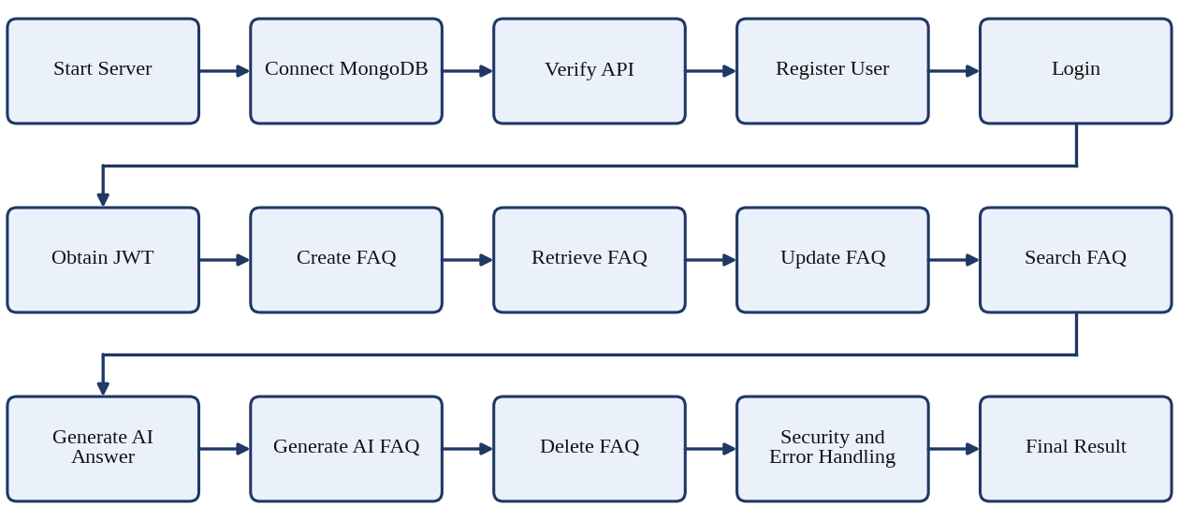
Figure 8.1: Complete Demonstration Flow of AnswerBot

8.6 Server Demonstration
The first demonstration step is to show that the server starts correctly. After running npm run dev, the terminal should display messages similar to the following:
MongoDB Connected
Server running in development mode on port 5000

The exact terminal message may vary depending on the implementation. The important point is that the terminal confirms both the database connection and the server startup.
Next, the root endpoint is tested in Thunder Client:
GET http://localhost:5000/

The API should return a successful JSON response confirming that the AnswerBot API is running. The exact content of the response depends on the implemented status message and is therefore not fixed in this report.

8.7 User Registration Demonstration
User registration is demonstrated using the following endpoint with sample data:
POST http://localhost:5000/api/auth/register
Content-Type: application/json

{
"name": "Priya Sharma",
"email": "priya@example.com",
"password": "securepassword123"
}

The registration process works as follows:
- The user sends a registration request to the API.
- The server validates the submitted data.
- The password is securely hashed using bcrypt.
- The user record is stored in MongoDB.
- The API returns a registration response.
The sample values are for demonstration only and do not represent real user credentials.
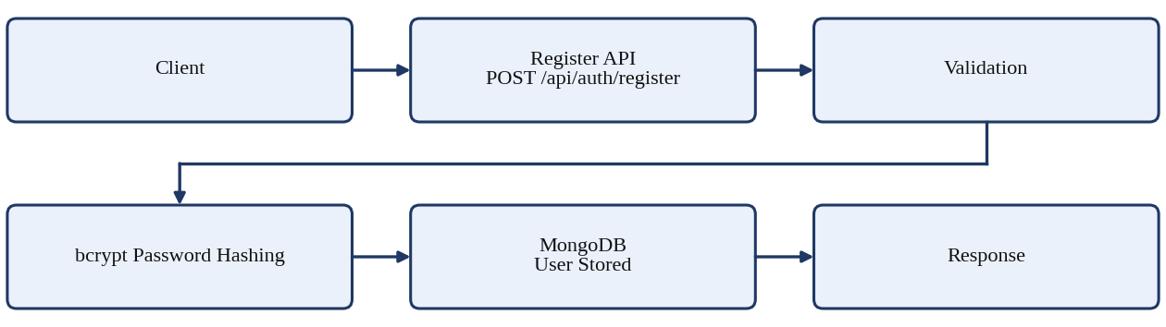
Figure 8.2: User Registration Demonstration

8.8 User Login Demonstration
Login is demonstrated using the following endpoint with sample credentials only:
POST http://localhost:5000/api/auth/login
Content-Type: application/json

{
"email": "priya@example.com",
"password": "securepassword123"
}

The login process works as follows:
- The user sends login credentials.
- The server finds the user in MongoDB.
- The submitted password is compared with the stored hash using bcrypt.
- A JWT is generated after successful authentication.
- The JWT is returned to the client.
- The token is used for protected API requests.
For security, no actual JWT token is shown in this report. In the live demonstration, the token returned by the server is copied into Thunder Client for the next requests.
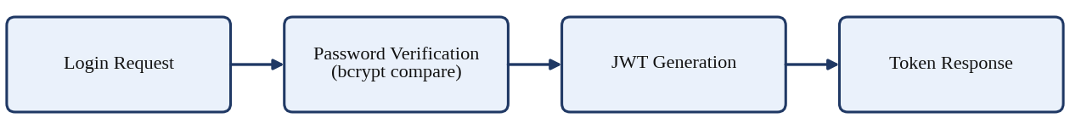
Figure 8.3: User Login and JWT Generation Demonstration

8.9 JWT Authentication Demonstration
After login, the client sends the JWT in the Authorization header of each protected request. In Thunder Client, this is added in the Headers tab or the Auth tab (Bearer token option).
Authorization: Bearer <JWT_TOKEN>

Here, <JWT_TOKEN> is a placeholder for the token received during login. The authentication process works as follows:
- The client sends the Bearer token with the request.
- The authentication middleware extracts the token from the header.
- The JWT is verified using the secret key configured on the server.
- The authenticated user information is attached to the request.
- The protected controller processes the request.
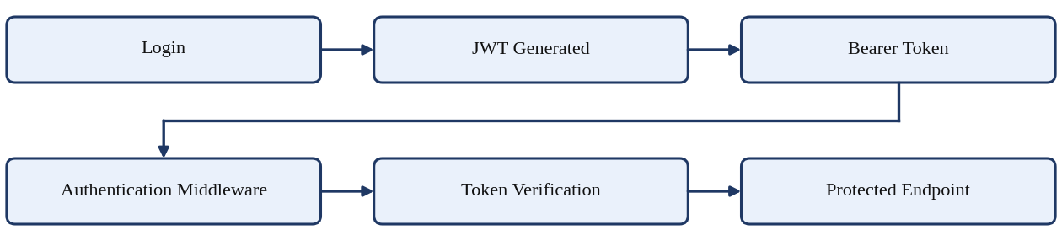
Figure 8.4: JWT Authentication Demonstration

8.10 FAQ Creation Demonstration
FAQ creation is demonstrated with the following request:
POST http://localhost:5000/api/faqs
Authorization: Bearer <JWT_TOKEN>
Content-Type: application/json

{
"question": "How do I configure custom category tags?",
"answer": "Open the settings panel, add the required keyword tags, and save the configuration.",
"category": "Technology"
}

During this demonstration, the following points are explained:
- Authentication is provided through the Bearer token.
- The request data is validated.
- The FAQ is created by the FAQ controller.
- The createdBy field identifies the user who created the FAQ.
- The FAQ is stored in MongoDB.
- A successful JSON response is returned.
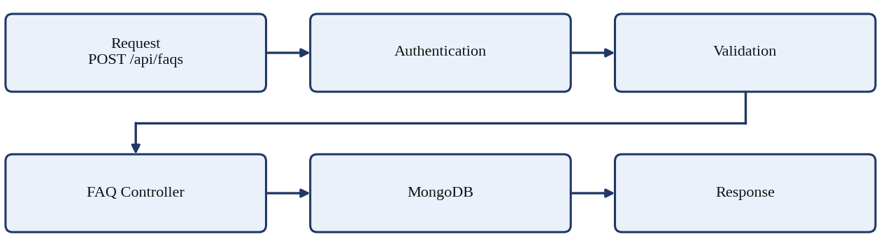
Figure 8.5: FAQ Creation Demonstration

8.11 FAQ Retrieval Demonstration
To retrieve FAQ records, the following request is sent:
GET http://localhost:5000/api/faqs

- The API retrieves the FAQ records.
- MongoDB provides the stored data.
- The response is returned as JSON.
An individual FAQ can be retrieved by using its identifier:
GET http://localhost:5000/api/faqs/:id

In Thunder Client, :id is replaced with the _id value of an FAQ that was created earlier. The API returns that single FAQ record as JSON.
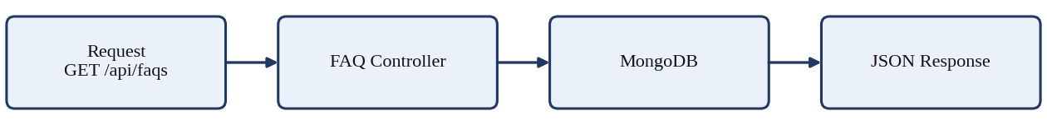
Figure 8.6: FAQ Retrieval Demonstration

8.12 FAQ Update Demonstration
An existing FAQ is updated with the following request:
PUT http://localhost:5000/api/faqs/:id
Authorization: Bearer <JWT_TOKEN>
Content-Type: application/json

{
"question": "How do I configure custom category tags in my application?",
"answer": "Open the settings panel, add the required keyword tags, and save the configuration.",
"category": "Technology"
}

The update process works as follows:
- The authenticated user sends the update request.
- The server identifies the FAQ using the given ID.
- Ownership is checked to confirm that the user created the FAQ.
- Valid data is applied to the FAQ.
- The updated FAQ is stored in MongoDB.
- The API returns the updated result.
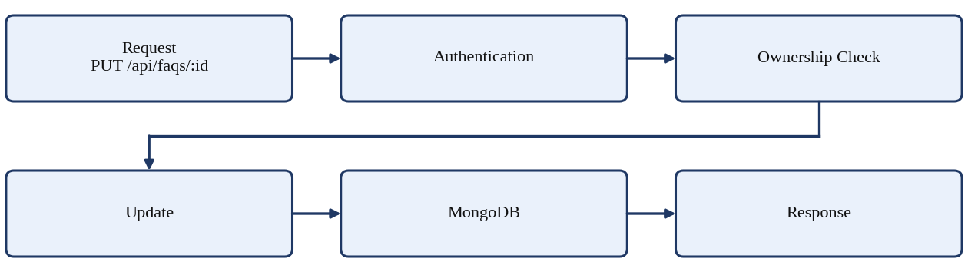
Figure 8.7: FAQ Update Demonstration

8.13 FAQ Search Demonstration
FAQ search is demonstrated using a query parameter:
GET http://localhost:5000/api/faqs/search?q=configure

- The search keyword is sent through the query parameter q.
- The backend searches the FAQ question, answer and category fields.
- Matching FAQ records are returned as JSON.
The current implementation uses keyword-based (regular expression) matching. It is not a semantic or vector search, and it does not understand the meaning of a query beyond the keyword entered.
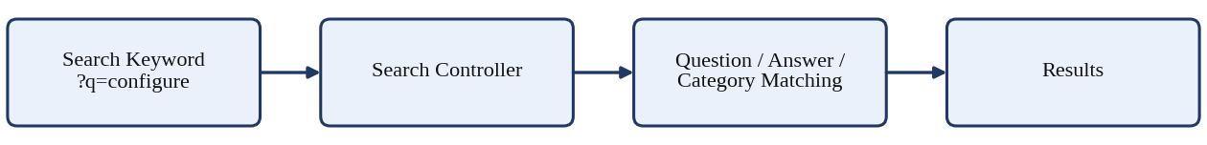
Figure 8.8: FAQ Search Demonstration

8.14 AI Answer Generation Demonstration
AI answer generation is demonstrated with the following request:
POST http://localhost:5000/api/ai/answer
Content-Type: application/json

{
"question": "What is MongoDB?"
}

If the route is protected in the implementation, the Bearer token is added to the request header as shown in Section 8.9. The AI answer process works as follows:
- The user sends a question.
- The AI controller receives the request.
- The Gemini service processes the question using the @google/genai library.
- Google Gemini AI generates the answer.
- The answer is returned through the REST API as JSON.
The generated text depends on the configured Gemini model and API, so the wording of the answer may differ each time the request is sent.
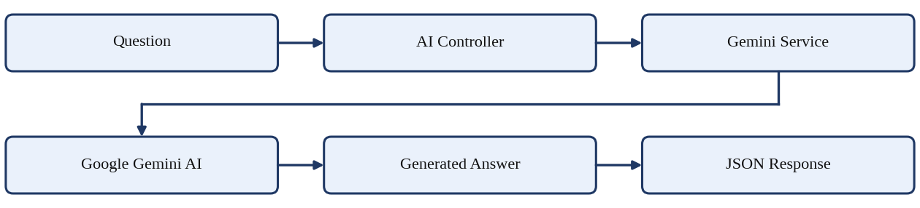
Figure 8.9: AI Answer Generation Demonstration

8.15 AI FAQ Generation Demonstration
AI FAQ generation is demonstrated with the following request:
POST http://localhost:5000/api/ai/generate-faq
Content-Type: application/json

{
"topic": "MongoDB"
}

- The user provides a topic.
- The AI controller receives the topic.
- The Gemini service sends the generation request.
- Google Gemini AI generates a question and an answer.
- The API returns the generated FAQ pair.
The expected response structure is shown below. The values are sample output only and are not an actual recorded response from the system.
{
"success": true,
"question": "Sample generated question",
"answer": "Sample generated answer"
}

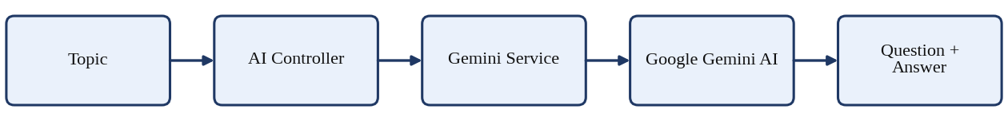
Figure 8.10: AI FAQ Generation Demonstration

8.16 FAQ Deletion Demonstration
FAQ deletion is demonstrated with the following request:
DELETE http://localhost:5000/api/faqs/:id
Authorization: Bearer <JWT_TOKEN>

- The authenticated user sends the delete request.
- The server finds the FAQ in MongoDB.
- Ownership is checked.
- The FAQ is deleted.
- A success response is returned.
After deletion, retrieving the same FAQ by its ID should no longer return the record.
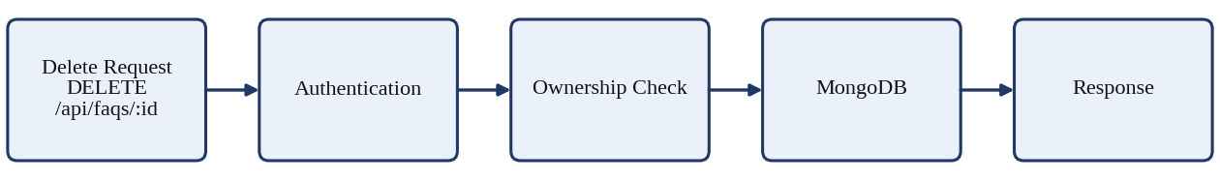
Figure 8.11: FAQ Deletion Demonstration

8.17 Authorization Demonstration
Authorization is demonstrated by showing that FAQ ownership is protected. Two scenarios are presented.

Scenario 1 – FAQ Owner
User A creates an FAQ and then attempts to update or delete it. Because User A is the creator, the ownership check succeeds. Expected result: request allowed.

Scenario 2 – Different User
User B logs in with a different account and attempts to update or delete the FAQ created by User A. The ownership check fails. Expected result: request rejected.
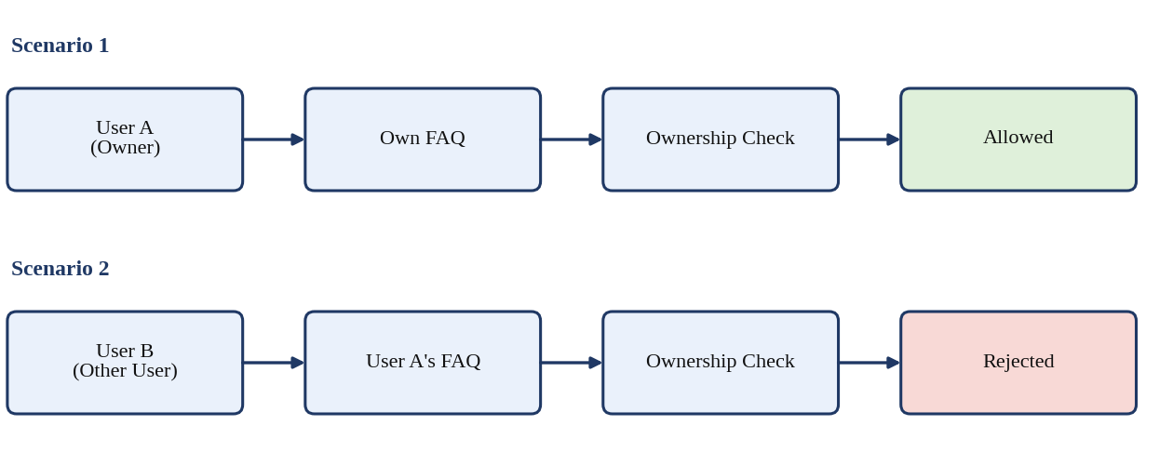
Figure 8.12: FAQ Ownership Authorization Demonstration
This demonstration covers ownership-based authorization only. Complete administrator functionality is not claimed as part of the current demonstration.

8.18 Error Handling Demonstration
The API should respond safely to incorrect or unauthorized requests. The following scenarios are demonstrated:
- Invalid Login – an incorrect password produces an authentication error.
- Missing JWT – calling a protected endpoint without a token produces an unauthorized response.
- Invalid FAQ ID – an invalid or non-existing ID produces an appropriate error response.
- Invalid FAQ Data – missing required fields produce a validation error.
- Unauthorized FAQ Modification – a different user modifying another user's FAQ produces a forbidden response.
- Gemini API Error – an invalid configuration or service failure produces an AI error response.
Table 8.3: Error Handling Scenarios
Scenario | How It Is Triggered | Expected Result
Invalid login | Send a correct email with a wrong password | Authentication failure (typically HTTP 401)
Missing JWT | Call a protected endpoint without the Authorization header | Unauthorized (typically HTTP 401)
Invalid FAQ ID | Use an invalid or non-existing ID in the URL | Error / not found (typically HTTP 400 or 404)
Missing FAQ fields | Send a create request without required fields | Validation error (typically HTTP 400)
Unauthorized update | User B updates User A's FAQ | Forbidden (typically HTTP 403)
AI service failure | Use an invalid Gemini configuration | AI error response (typically HTTP 500)

The status codes shown are typical for REST APIs. The exact codes and messages follow the implemented controllers and should be confirmed during the live demonstration.

8.19 Database Demonstration
MongoDB data can be verified during the demonstration by using a MongoDB viewer such as MongoDB Compass or Atlas, or by retrieving the data through the API. The data is stored using Mongoose models in two collections: users and FAQs.
Table 8.4: Data Stored in MongoDB
Collection | Field | Description
User | name | Name of the user
User | email | Email address used for login
User | password | Password stored only as a bcrypt hash
User | role | Role assigned to the user
User | timestamps | Creation and update times
FAQ | question | FAQ question text
FAQ | answer | FAQ answer text
FAQ | category | Category of the FAQ
FAQ | createdBy | Reference to the user who created the FAQ
FAQ | timestamps | Creation and update times

The relationship between the collections is User → Multiple FAQs: one user can create many FAQs, and each FAQ stores the identifier of its creator in createdBy. Real passwords and sensitive information must not be displayed during the demonstration; the stored password appears only as a hash.
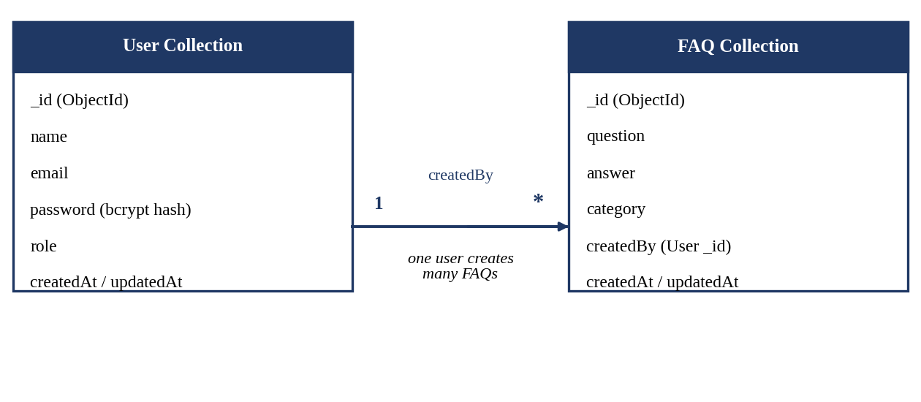
Figure 8.13: MongoDB Data Demonstration

8.20 Complete API Demonstration Table
Table 8.5 summarises the endpoints demonstrated, in the recommended order.
Table 8.5: Complete API Demonstration Sequence
Step | Module | Method | Endpoint | Demonstration Purpose
1 | Server | GET | / | Verify server
2 | Auth | POST | /api/auth/register | Register user
3 | Auth | POST | /api/auth/login | Login and obtain JWT
4 | FAQ | GET | /api/faqs | Retrieve FAQs
5 | FAQ | POST | /api/faqs | Create FAQ
6 | FAQ | GET | /api/faqs/:id | Retrieve one FAQ
7 | FAQ | PUT | /api/faqs/:id | Update FAQ
8 | FAQ | GET | /api/faqs/search | Search FAQ
9 | AI | POST | /api/ai/answer | Generate AI answer
10 | AI | POST | /api/ai/generate-faq | Generate AI FAQ
11 | FAQ | DELETE | /api/faqs/:id | Delete FAQ

Whether each endpoint is public or protected follows the route configuration of the implemented project. Where an endpoint is protected, the Bearer token from Section 8.9 is added to the request.

8.21 Demonstration Checklist
Table 8.6 is used to track each item during the demonstration. Because the completion status has not been recorded in this report, each item is marked as to be verified rather than completed. The presenter should mark each item after it has been demonstrated successfully.
Table 8.6: Demonstration Checklist
Demonstration Item | Status
Project opens successfully | To be demonstrated
Dependencies installed | To be demonstrated
Environment variables configured | To be demonstrated
MongoDB connected | To be demonstrated
Server started | To be demonstrated
Registration tested | To be demonstrated
Login tested | To be demonstrated
JWT authentication tested | To be demonstrated
FAQ creation tested | To be demonstrated
FAQ retrieval tested | To be demonstrated
FAQ update tested | To be demonstrated
FAQ search tested | To be demonstrated
AI answer tested | To be demonstrated
AI FAQ generation tested | To be demonstrated
FAQ deletion tested | To be demonstrated
Authorization tested | To be demonstrated
Error handling tested | To be demonstrated

8.22 Demonstration Presentation Sequence
For a college project viva or demonstration, the following sequence is recommended.
Table 8.7: Recommended Presentation Sequence
Part | Topic | What to Present
Part 1 | Introduction | Project title, problem, proposed solution and main objectives
Part 2 | Architecture | Express.js, MongoDB, Mongoose, JWT and Gemini AI
Part 3 | Live Backend | Project folder, server startup and MongoDB connection
Part 4 | Authentication | Registration, login and JWT
Part 5 | FAQ Module | Create, read, update, search and delete
Part 6 | AI Features | AI answer generation and AI FAQ generation
Part 7 | Security | JWT protection, ownership validation and invalid request handling
Part 8 | Testing | Thunder Client test results
Part 9 | Conclusion | Final outcome and possible future improvements

8.23 Demonstration Flow Diagram
Figure 8.14 presents the final demonstration flowchart, from the project introduction to the final outcome.
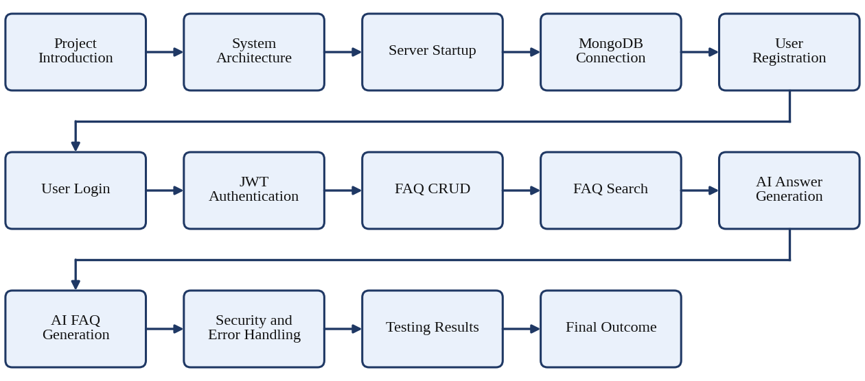
Figure 8.14: Complete AnswerBot Project Demonstration Sequence

8.24 Demonstration Results
This report distinguishes between two kinds of results. A verified result is one that has been observed during actual execution and recorded, for example through a Thunder Client response. An expected result is the outcome that the design of the system predicts and that should be confirmed during the live demonstration. The results in Table 8.8 are expected results. No screenshots, API responses or test results have been invented for this report; actual evidence should be attached separately after the demonstration.
Table 8.8: Expected Outcomes of the Demonstration
Capability | Expected Outcome | Status
RESTful API | Endpoints respond with JSON | Expected
User authentication | Registration and login work with hashed passwords | Expected
JWT protection | Protected operations require a valid token | Expected
FAQ management | Create, retrieve, update and delete FAQs | Expected
FAQ search | Keyword-based matching returns relevant FAQs | Expected
MongoDB storage | Users and FAQs are stored and retrieved | Expected
AI answers | Gemini generates an answer to a question | Expected
AI FAQ content | Gemini generates a question and answer for a topic | Expected
Authorization | Only the FAQ owner can update or delete it | Expected
Error handling | Invalid requests return appropriate error responses | Expected
Secure configuration | Secrets are stored in environment variables | Expected

8.25 Project Limitations
The following limitations describe the current scope of the implemented system. They are boundaries of the present project and are not defects.
- The project is a backend-focused implementation without a dedicated frontend.
- FAQ search is keyword/regex-based rather than full vector semantic search.
- The Gemini API depends on the availability of an external service.
- AI responses depend on the configured Gemini model and API.
- Advanced administrative functionality may require further development.

8.26 Future Enhancements
The following items are future enhancements. They are possible improvements and are not features of the current system.
- Dedicated web frontend
- Advanced semantic/vector search
- FAQ analytics dashboard
- More advanced role-based administration
- Category management interface
- AI response customization
- Conversation history
- Feedback/rating system
- Monitoring and analytics
- Cloud deployment
- Automated CI/CD
- Automated test suites

8.27 Project Demonstration Summary
The demonstration phase provides practical evidence of the AnswerBot – AI-Powered FAQ and Customer Support Automation system. It shows the integration of Node.js, Express.js, MongoDB, Mongoose, JWT, bcrypt and Google Gemini AI in one working backend application.
The demonstration begins with server startup and MongoDB connection, followed by user registration and login. The JWT obtained at login is used to access protected operations. The FAQ module is then demonstrated through creation, retrieval, update, keyword-based search and deletion. The AI module shows answer generation and FAQ generation using Google Gemini AI. Finally, ownership-based authorization and error handling show that the system protects user data and responds correctly to invalid requests, and Thunder Client testing brings the evidence together.
In conclusion, the demonstration gives a clear understanding of the functionality, architecture and practical implementation of AnswerBot, and confirms that the project meets its planned objectives as a secure and AI-assisted FAQ and customer support backend.

