6. Project Testing Phase

6.1 Introduction to Project Testing
The testing phase is the stage of the project in which the completed AnswerBot – AI-Powered FAQ and Customer Support Automation backend is checked against its requirements. AnswerBot is a REST API built with Node.js and Express.js. It stores users and Frequently Asked Questions (FAQs) in MongoDB through Mongoose, protects its routes with JSON Web Tokens (JWT), stores passwords in hashed form using bcrypt, and uses Google Gemini AI to answer customer questions and to generate new FAQ entries. Because the system has no graphical front end, every feature is reached through an HTTP request, and testing therefore focuses on sending requests to the API and examining the responses.
The purpose of the testing phase is to confirm that AnswerBot behaves correctly for valid requests and handles invalid, incomplete, or unauthorized requests safely. Testing is performed to verify the following aspects of the system:
- Correctness: each endpoint returns the expected data and HTTP status code.
- Reliability: the server continues to work correctly across repeated and varied requests.
- Security: passwords are protected, secrets are not exposed, and protected routes reject unauthorized access.
- API functionality: the authentication, FAQ, search, and AI endpoints perform their intended operations.
- Database operations: users and FAQs are created, read, updated, and deleted correctly in MongoDB.
- Authentication: only users with valid credentials receive a JWT, and only valid tokens are accepted.
- Authorization: a user can modify only the FAQs that the user created.
- AI integration: requests to Google Gemini AI return usable answers and failures are handled cleanly.
- Error handling: the API returns meaningful status codes and messages when something goes wrong.
- Input validation: missing or badly formatted input is rejected before it reaches the database or the AI service.
Thunder Client is used to test the AnswerBot REST API endpoints. Thunder Client is an extension for Visual Studio Code that allows a tester to build HTTP requests, add a JSON body and an Authorization header, send the request to the running server, and inspect the status code and JSON response without writing any additional test code.
Note on test status. In this section, the test cases are described as the planned test set for AnswerBot, together with the expected results. The Status and Result columns are to be filled in only after each request has actually been executed in Thunder Client against the running system. No result is recorded as “Passed” in this document unless the tester has verified it. Table columns that are still awaiting execution are marked “Pending”.

6.2 Objectives of Testing
The main objectives of testing the AnswerBot backend are listed below.
- Verify that all API endpoints (authentication, FAQ, search, and AI) work correctly.
- Verify user registration and login, including rejection of duplicate email addresses and wrong passwords.
- Verify JWT authentication, so that a token is issued only after a successful login.
- Verify protected routes, so that they cannot be reached without a valid Bearer token.
- Verify FAQ CRUD (Create, Read, Update, Delete) operations through the “/api/faqs” endpoints.
- Verify FAQ search through “/api/faqs/search”, which uses keyword-based (regular expression) matching.
- Verify MongoDB database operations performed through Mongoose models.
- Verify the Google Gemini AI integration for answer generation and FAQ generation.
- Verify input validation for user data, FAQ data, search queries, and AI requests.
- Verify unauthorized access handling for missing, invalid, or expired tokens and for FAQ ownership violations.
- Verify that error responses use suitable HTTP status codes and clear messages.
- Verify data integrity, so that stored records are complete, correctly linked, and unchanged by rejected requests.
- Verify security mechanisms such as password hashing, token validation, and protection of environment variables.
- Ensure that the system produces the expected API responses for both valid and invalid requests.

6.3 Testing Environment
The testing environment used for AnswerBot is summarised in Table 6.1. The same environment is used for development and for testing, so that the behaviour observed during testing matches the behaviour of the working application.
Table 6.1: Testing Environment for AnswerBot
Component | Testing Environment
Operating System | Windows 10/11 or compatible OS
Runtime | Node.js v18+
Backend | Express.js
Database | MongoDB
ODM | Mongoose
Authentication | JWT (JSON Web Token)
Password Security | bcrypt
AI Service | Google Gemini AI
API Testing Tool | Thunder Client
Development IDE | Visual Studio Code

During testing, the AnswerBot application server is started locally with Node.js. The Express.js server listens for HTTP requests sent from Thunder Client, which runs inside Visual Studio Code. When the server starts, it connects to the MongoDB database through Mongoose, and this connection must succeed before any database-related test is executed. User accounts and FAQ records created during testing are stored in this MongoDB database and are read back to confirm that the operations were carried out correctly. Configuration values such as the database connection string, the JWT secret, and the Google Gemini API key are kept in environment variables and are never written into the test requests or into this report.

6.4 Testing Strategy
The testing strategy for AnswerBot follows a bottom-up, layered approach. The individual components (password hashing, token verification, controllers, and services) are examined first, then the connected modules are tested together, and finally the complete API is tested from the client side using Thunder Client. Each category of testing has a specific purpose in the AnswerBot project, as shown in Table 6.2.
Table 6.2: Testing Categories Used for AnswerBot
Testing Category | Purpose in AnswerBot
Functional Testing | Checks that each feature, such as registration, login, FAQ management, search, and AI answers, produces the required output.
API Testing | Sends requests to each REST endpoint using the correct HTTP method and verifies the status code and JSON response.
Authentication Testing | Checks that valid credentials produce a JWT and that invalid credentials or tokens are refused.
Authorization Testing | Checks that a user can update or delete only the FAQs created by that user (ownership check).
Database Testing | Checks that MongoDB and Mongoose store, retrieve, update, and delete users and FAQs correctly and reject invalid data.
AI Integration Testing | Checks that the backend communicates correctly with Google Gemini AI and handles AI failures safely.
Input Validation Testing | Checks that empty, missing, or incorrectly formatted input is rejected with a clear error.
Error Handling Testing | Checks that the centralized error handler returns correct status codes (400, 401, 403, 404, 500).
Security Testing | Checks password hashing, JWT validation, protected routes, secret protection, and error message sanitization.
Integration Testing | Checks that connected parts, for example JWT middleware with the FAQ controller and MongoDB, work correctly together.

6.5 Unit Testing
Unit testing is the testing of the smallest parts of a program, such as a single function or module, independently of the rest of the system. In a backend application, this means that a piece of logic, for example a password check or a validation rule, is examined on its own so that a fault can be located quickly and does not have to be searched for across the whole application.
Important note: No automated unit-testing framework was used for AnswerBot. The activities described in this section therefore represent component-level testing activities, in which each backend component is exercised in isolation, or through the specific API request that reaches it, and its behaviour is checked manually. The components tested in this way are listed in Table 6.3.
Table 6.3: Component-Level Testing Activities for AnswerBot
Component | What Is Checked | How It Is Exercised
Authentication logic | A correct email and password lead to a successful login; a wrong password or unknown email is refused. | POST “/api/auth/login” with valid and invalid credentials
Password hashing (bcrypt) | The stored password is a hash, not the original text, and the login check compares the entered password against the hash. | Register a user, inspect the stored record, then log in
JWT verification | A valid token is accepted; a missing, malformed, or invalid token is rejected. | Call a protected route with different Authorization headers
FAQ controller logic | Create, read, update, and delete operations return the correct data and status codes. | Requests to “/api/faqs” and “/api/faqs/:id”
FAQ validation | Empty or missing question, answer, or unsupported category is rejected. | POST “/api/faqs” with incomplete data
Search logic | A keyword returns matching FAQs; a keyword with no match returns an empty or suitable response. | GET “/api/faqs/search?q=keyword”
AI service functions | The Gemini service returns generated text for a valid question or topic and reports failures. | POST “/api/ai/answer” and “/api/ai/generate-faq”
Error-handling functions | Errors thrown by controllers and middleware are converted into consistent JSON error responses. | Trigger 400, 401, 403, 404, and 500 conditions

6.6 Integration Testing
Integration testing checks that different components of AnswerBot work correctly when they are connected. A component may work correctly on its own but fail when it receives real data from another component, for example when a controller passes data to Mongoose or when a middleware passes a decoded user to a controller. The main integration paths tested for AnswerBot are shown in Table 6.4.
Table 6.4: Integration Testing Scenarios for AnswerBot
Integration | Component Flow | What Is Verified
Authentication + Database | Register → Password Hashing → MongoDB → User Record | A new user record is stored with a hashed password.
Login + JWT | Login → Password Verification → JWT Generation → Token Response | A JWT is returned only after the password is verified.
FAQ + Authentication | Bearer Token → JWT Middleware → FAQ Controller → MongoDB | Protected FAQ operations run only with a valid token.
AI + Backend | AI Request → AI Controller → Gemini Service → Google Gemini AI → API Response | The backend returns the AI-generated content in JSON.
FAQ + Search | FAQ Data → Search Query → Matching Records → JSON Response | Keyword search returns only the matching FAQs.

Integration testing is important for AnswerBot because most of its features depend on more than one component. For example, creating an FAQ requires the JWT middleware to identify the user, the controller to validate the data, and Mongoose to save the record with the correct “createdBy” value. The AI features depend on the controller, the Gemini service, the external Google Gemini AI, and the response formatting. Integration tests show whether these parts cooperate correctly and reveal problems, such as an incorrectly passed user identifier or an unhandled AI error, that component-level checks alone may not expose.

6.7 API Functional Testing
API functional testing verifies each REST endpoint of AnswerBot by sending requests through Thunder Client and comparing the actual response with the expected result. Table 6.5 lists the eighteen planned test cases, grouped by module: Authentication, FAQ, Search, and AI. The Status column is “Pending” until the test has been executed and the actual result has been checked. Where the exact status code or message depends on the implementation, the actual code returned by the AnswerBot API should be recorded.
Table 6.5: API Functional Test Cases for AnswerBot
Test ID | Module | HTTP Method | Endpoint | Test Description | Expected Result | Status
TC-01 | Authentication | POST | /api/auth/register | Register a new user. | User created successfully. | Pending
TC-02 | Authentication | POST | /api/auth/register | Attempt registration with a duplicate email. | Appropriate validation/error response. | Pending
TC-03 | Authentication | POST | /api/auth/login | Login using valid credentials. | Successful login and JWT token. | Pending
TC-04 | Authentication | POST | /api/auth/login | Login using an incorrect password. | Authentication failure. | Pending
TC-05 | FAQ | GET | /api/faqs | Retrieve FAQ records. | FAQ list returned. | Pending
TC-06 | FAQ | POST | /api/faqs | Create a valid FAQ with authentication. | FAQ created successfully. | Pending
TC-07 | FAQ | POST | /api/faqs | Submit invalid or missing FAQ data. | Validation error. | Pending
TC-08 | FAQ | GET | /api/faqs/:id | Retrieve a valid FAQ. | FAQ returned. | Pending
TC-09 | FAQ | GET | /api/faqs/:id | Request a non-existing FAQ. | Not-found response. | Pending
TC-10 | FAQ | PUT | /api/faqs/:id | Update an FAQ created by the authenticated user. | FAQ updated successfully. | Pending
TC-11 | FAQ | DELETE | /api/faqs/:id | Delete an FAQ created by the authenticated user. | FAQ deleted successfully. | Pending
TC-12 | FAQ | PUT / DELETE | /api/faqs/:id | Attempt to modify another user’s FAQ. | Forbidden/authorization response. | Pending
TC-13 | Search | GET | /api/faqs/search?q=keyword | Search using a valid keyword. | Matching FAQs returned. | Pending
TC-14 | Search | GET | /api/faqs/search?q=unknown | Search using a keyword with no matching result. | Empty result or appropriate response. | Pending
TC-15 | AI | POST | /api/ai/answer | Submit a valid question. | AI-generated answer returned. | Pending
TC-16 | AI | POST | /api/ai/answer | Submit an invalid or missing question. | Validation/error response. | Pending
TC-17 | AI | POST | /api/ai/generate-faq | Submit a valid topic. | AI-generated question and answer returned. | Pending
TC-18 | AI | POST | /api/ai/generate-faq | Submit an invalid or missing topic. | Validation/error response. | Pending

6.8 Authentication Testing
Authentication testing verifies that AnswerBot correctly identifies its users. After a successful login, the server issues a JWT. The client must send this token in the Authorization header using the Bearer format (Authorization: Bearer <token>) with every request to a protected route. The JWT middleware reads the header, verifies the token, and either allows the request to continue to the controller or stops it with an unauthorized response.
The following conditions are tested:
- A request sent without an Authorization header.
- A request sent with an invalid token.
- A request sent with an expired or otherwise invalid JWT.
- A request sent with a valid JWT.
- A request sent using the correct Bearer token format.
Table 6.6: JWT Authentication Test Cases
Test Case | Request Condition | Expected Result
A1 | No token (no Authorization header) | Unauthorized
A2 | Invalid token | Unauthorized
A3 | Malformed token (for example, missing the Bearer prefix or incorrect format) | Unauthorized
A4 | Valid token in the format Bearer <token> | Request allowed

These tests verify the protected API routes of AnswerBot. If the routes for creating, updating, and deleting FAQs respond correctly to test cases A1 to A3 by refusing access, and to test case A4 by allowing access, it is confirmed that only authenticated users can use the protected functions of the system. Real tokens are never printed in this report; only the placeholder <token> is used.

6.9 Authorization Testing
Authentication confirms who the user is, while authorization decides what that user is allowed to do. In AnswerBot, each FAQ stores the identity of the user who created it in the “createdBy” field. When a user tries to update or delete an FAQ, the controller compares the “createdBy” value with the identity taken from the JWT. Authorization testing checks that this ownership check works correctly.
Authorized User
User A logs in, creates an FAQ, and then updates and deletes the same FAQ. Expected result: Operation Allowed.
Unauthorized User
User B logs in with a different valid account and attempts to update or delete the FAQ created by User A. Expected result: Operation Rejected with a Forbidden response, and the FAQ remains unchanged in the database.
Table 6.7: Authorization Test Cases for FAQ Ownership
Test Case | Scenario | Expected Result | Related Test ID
Z1 | User A updates an FAQ created by User A | Operation allowed | TC-10
Z2 | User A deletes an FAQ created by User A | Operation allowed | TC-11
Z3 | User B updates an FAQ created by User A | Operation rejected (Forbidden) | TC-12
Z4 | User B deletes an FAQ created by User A | Operation rejected (Forbidden) | TC-12

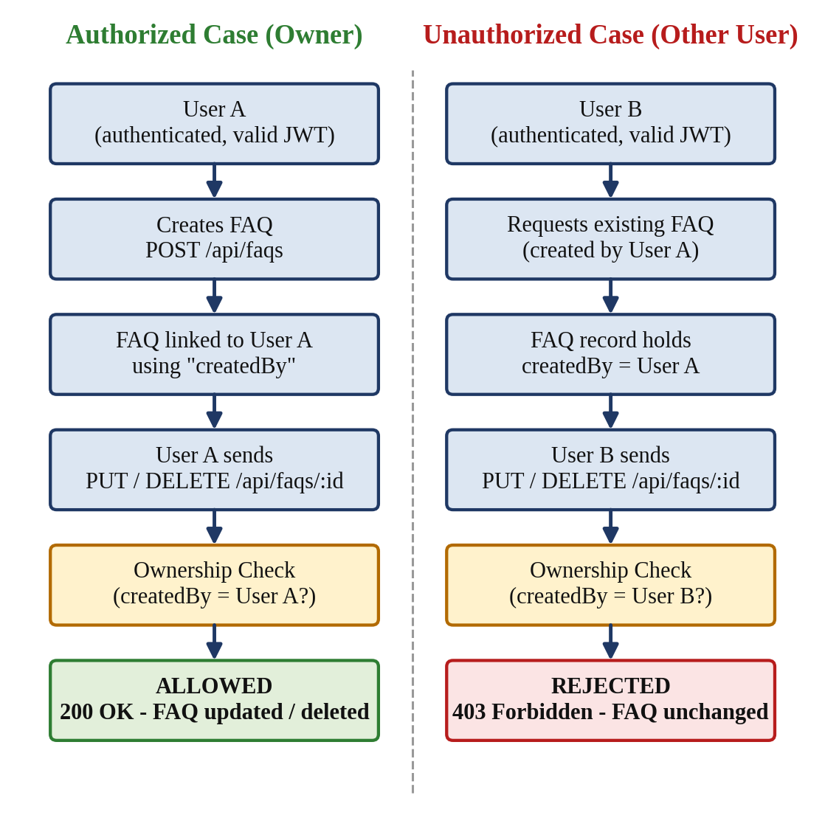
Figure 6.1: FAQ Authorization and Ownership Testing

6.10 Database Testing
Database testing verifies that AnswerBot stores and retrieves data correctly using MongoDB and Mongoose. The Mongoose models define the structure of the User and FAQ documents, including required fields, and Mongoose reports an error when the data does not follow this structure. Because the API is the only way to reach the database in normal use, most database tests are carried out through API requests, and the stored data is then checked by retrieving it again through the API or by viewing the collection in MongoDB.
The following database activities are tested:
- User creation and user retrieval.
- FAQ creation, retrieval, update, and deletion.
- Required field validation and handling of invalid data.
- The relationship between a user and the FAQs created by that user, using the “createdBy” reference.
- ObjectId handling, including the response to an incorrectly formatted ID.
- The database connection when the server starts.
Table 6.8: Database Test Cases
Database Test | Expected Result
Valid user insertion | User stored
Missing required field | Validation error
Valid FAQ insertion | FAQ stored
FAQ update | Updated data stored
FAQ deletion | FAQ removed
Invalid ID | Appropriate error
Database connection | Successful connection

6.11 AI Integration Testing
AnswerBot uses Google Gemini AI to produce answers to customer questions and to generate new FAQ entries. AI integration testing checks that the backend sends a correct request to the AI service, receives the response, and returns it to the client as a proper JSON response. Because the AI service is an external system, testing also checks how the backend behaves when the service is unavailable or returns an unexpected result. No real Gemini API key is shown in this report; the key is stored only in an environment variable.
AI Answer Generation
Endpoint: POST /api/ai/answer
Example request body:
{
"question": "What is MongoDB?"
}
Expected result: a successful API response, an AI-generated answer, and a properly formatted JSON response.
AI FAQ Generation
Endpoint: POST /api/ai/generate-faq
Example request body:
{
"topic": "MongoDB"
}
Expected result: a successful response containing a generated question and a generated answer.
AI Error Scenarios
The error scenarios in Table 6.9 are tested to confirm that a failure in the AI service does not crash the server and that the client receives a clear error response without any secret information.
Table 6.9: AI Integration Error Scenarios
Scenario | Condition | Expected Behaviour
Invalid API key | The configured Gemini API key is incorrect or missing | Error response; the key is not revealed
API service failure | The Gemini service returns a server-side failure | Error response (for example, 500); server keeps running
Unsupported or unavailable model | The configured model name is not available | Error response with a safe message
Empty AI response | The AI service returns no usable text | Error or fallback response; no empty success
Network/API errors | The connection to the AI service fails or times out | Error response; server keeps running

6.12 Input Validation Testing
Input validation testing checks that AnswerBot refuses data that is missing, empty, or in the wrong format. Validation protects the database from incomplete records and protects the AI service from meaningless requests. For AnswerBot, the following invalid inputs are tested: empty name, empty email, invalid email, empty password, empty FAQ question, empty FAQ answer, invalid category, empty search query, empty AI question, empty AI topic, and invalid FAQ ID.
Table 6.10: Input Validation Test Cases
Input | Invalid Condition | Expected Result
Name | Empty | Validation error
Email | Empty or invalid format | Validation error
Password | Missing | Validation error
FAQ question | Empty | Validation error
FAQ answer | Empty | Validation error
Category | Unsupported value | Validation error
Search query | Empty | Validation error or empty result, as implemented
FAQ ID | Invalid format | Error response
AI question | Empty | Validation/error response
AI topic | Empty | Validation/error response

6.13 Error Handling Testing
AnswerBot uses a centralized error-handling mechanism, so that errors raised in routes, middleware, controllers, and services are passed to one place and returned to the client in a consistent JSON format. Error handling testing is carried out by deliberately creating error conditions and checking that the correct HTTP status code and a clear message are returned. The status codes tested are shown in Table 6.11.
Table 6.11: HTTP Status Codes Tested for Error Handling
Status Code | Meaning | Example
400 | Bad Request | Invalid input
401 | Unauthorized | Missing/invalid JWT
403 | Forbidden | Unauthorized FAQ modification
404 | Not Found | FAQ does not exist
500 | Internal Server Error | Unexpected server/database/AI error

Error responses must not reveal internal details such as stack traces, database connection information, or API keys. This is checked together with the security tests in Section 6.14.

6.14 Security Testing
Security testing checks that AnswerBot protects user data and restricted operations. The security tests performed are listed in Table 6.12.
Table 6.12: Security Test Cases
Security Area | What Is Checked | Expected Result
Password hashing | The stored password in MongoDB is a bcrypt hash and not readable text. | Plain password not stored
JWT validation | Tokens that are invalid, malformed, or expired are refused. | Request rejected (401)
Protected routes | Protected FAQ endpoints cannot be used without authentication. | Request rejected (401)
Bearer token validation | The Authorization header must use the Bearer format. | Wrong format rejected
FAQ ownership | Only the creator of an FAQ can update or delete it. | Other user rejected (403)
Environment variable protection | The JWT secret, database string, and API key are read from environment variables and are not in responses or source files shared in the report. | No secrets exposed
API key protection | The Gemini API key does not appear in any response or error message. | Key not exposed
Input validation | Invalid input is rejected before it reaches the database or AI service. | Validation error
Error message sanitization | Error responses do not include stack traces or internal details. | Safe, generic messages

Important: No actual secret, token, password, or API key is included in this document. Placeholders such as <token> are used wherever a value would otherwise be shown.

6.15 Negative Testing
Negative testing means testing the system with invalid, unexpected, or unauthorized requests to confirm that it refuses them safely. While positive tests show that AnswerBot works when used correctly, negative tests show that it does not fail, leak data, or change stored data when used incorrectly. The negative conditions tested are shown in Table 6.13.
Table 6.13: Negative Test Cases
Negative Condition | Example Request | Expected Result
Invalid login | Login with an incorrect password or unknown email | Authentication failure
Duplicate registration | Register with an email that already exists | Error response
Missing token | Call a protected route without a token | 401 Unauthorized
Invalid token | Call a protected route with an incorrect token | 401 Unauthorized
Invalid FAQ ID | GET “/api/faqs/:id” with a badly formatted ID | Error response
Non-existent FAQ | GET “/api/faqs/:id” with a well-formed ID that is not stored | 404 Not Found
Invalid FAQ data | POST “/api/faqs” with empty question or answer | Validation error
Unauthorized FAQ update | PUT “/api/faqs/:id” by a user who is not the creator | 403 Forbidden
Unauthorized FAQ deletion | DELETE “/api/faqs/:id” by a user who is not the creator | 403 Forbidden
Invalid AI request | POST to “/api/ai/answer” or “/api/ai/generate-faq” with empty input | Validation/error response
Empty search request | GET “/api/faqs/search” with an empty query | Validation error or empty result
Database failure | Send a request while the database is unavailable | 500 Internal Server Error, safe message
Gemini API failure | Send an AI request when the AI service cannot respond | Error response, server keeps running

Negative testing ensures that incorrect requests are handled safely: the API returns a suitable status code and message, the server continues to run, no unauthorized change is made to the database, and no sensitive information is exposed.

6.16 API Testing Using Thunder Client
Thunder Client is used inside Visual Studio Code for testing the REST API endpoints of AnswerBot. Because it is part of the same editor used to write the backend code, the tester can start the server, send requests, and read responses in one place. The testing workflow followed for each test case is shown in Figure 6.2 (part a):
- Open Thunder Client in Visual Studio Code.
- Select the HTTP method (GET, POST, PUT, or DELETE).
- Enter the API endpoint, for example the local server address followed by “/api/faqs”.
- Add the request body (JSON) and, for protected routes, the Authorization header in the format Bearer <token>.
- Send the request.
- Receive the JSON response and read the status code.
- Compare the actual result with the expected result of the test case.
- Record the test status as Passed or Failed.
Part (b) of the figure shows the path taken by each request inside AnswerBot: Thunder Client sends the request to the Express API, the request passes through the routes and JWT middleware to the controller, the controller works with MongoDB or Google Gemini AI, and the JSON response returns to Thunder Client for result verification.
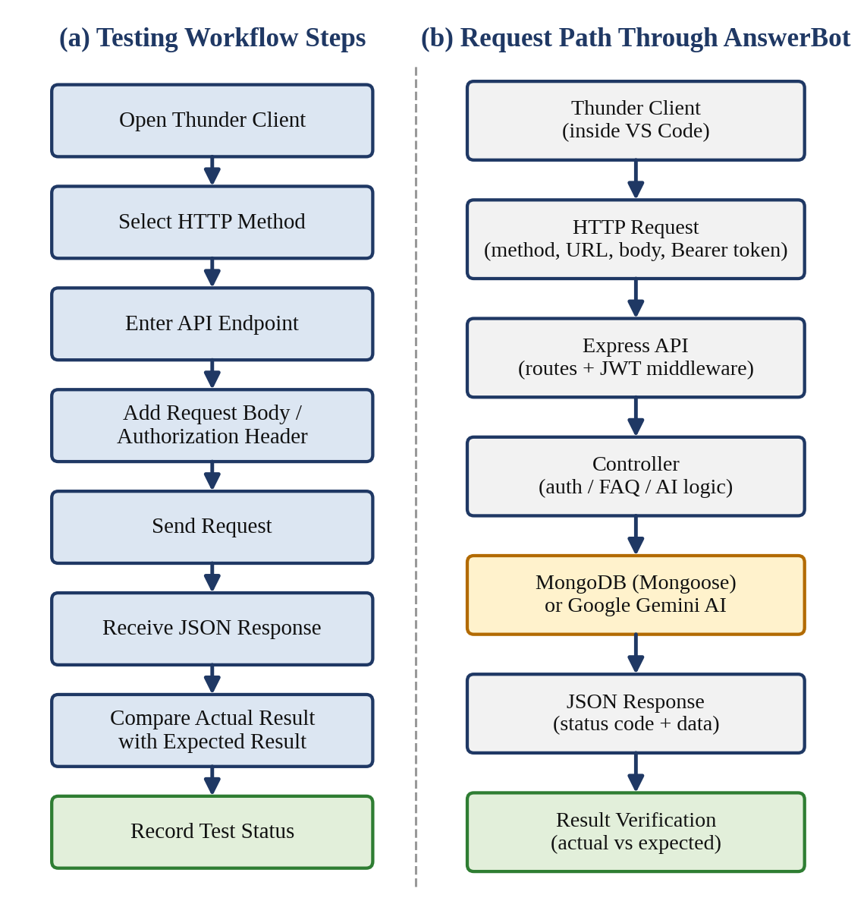
Figure 6.2: API Testing Workflow Using Thunder Client

6.17 Sample API Test Results
Table 6.14 lists a representative set of test cases together with the expected HTTP status codes. Only tests that have actually been executed in Thunder Client may be recorded as “Passed”. Because these results must come from real execution of the AnswerBot API, the Result column below is left as “To be recorded” and must be updated by the tester after running each test. If an actual status code differs from the expected code shown, the actual code returned by the implementation should be written in its place.
Table 6.14: Representative API Test Results (to be completed after execution)
Test ID | Endpoint | Expected Status | Result
TC-01 | POST “/api/auth/register” | 201/200 | To be recorded
TC-03 | POST “/api/auth/login” | 200 | To be recorded
TC-05 | GET “/api/faqs” | 200 | To be recorded
TC-06 | POST “/api/faqs” | 201/200 | To be recorded
TC-10 | PUT “/api/faqs/:id” | 200 | To be recorded
TC-11 | DELETE “/api/faqs/:id” | 200 | To be recorded
TC-13 | GET “/api/faqs/search” | 200 | To be recorded
TC-15 | POST “/api/ai/answer” | 200 | To be recorded
TC-17 | POST “/api/ai/generate-faq” | 200 | To be recorded

6.18 Testing Flow Diagram
The complete testing process for AnswerBot is shown in Figure 6.3. Testing begins with planning and preparation of the environment, continues with starting the server and connecting to MongoDB, and then moves through the authentication, FAQ, search, and AI tests, followed by validation, error, and security tests. The results are recorded, and any defects are fixed and retested before the final testing is completed.
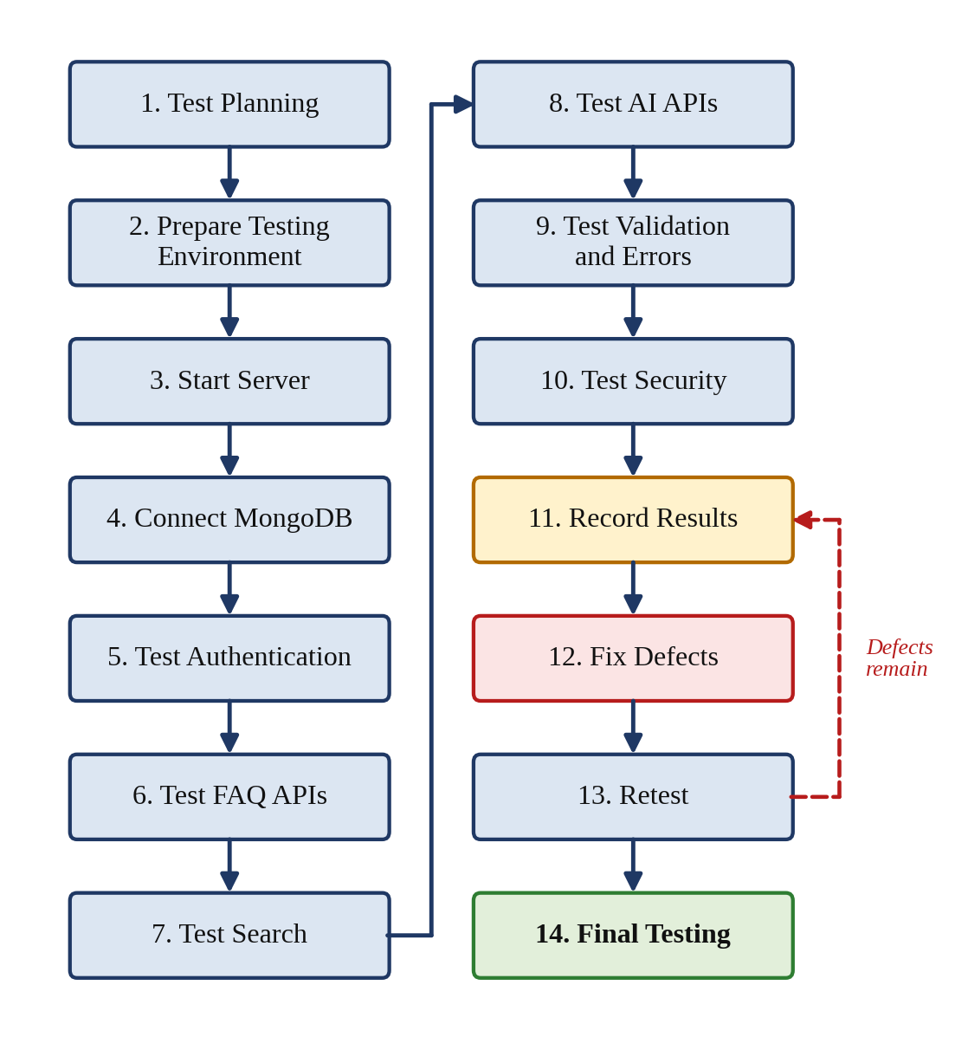
Figure 6.3: Testing Process of AnswerBot

6.19 Defect Identification and Retesting
When the actual result of a test differs from the expected result, a defect is identified. Defects in AnswerBot are handled through the following process:
- Identify the defect: notice that the actual response differs from the expected response.
- Record the problem: note the test ID, endpoint, request data, expected result, and actual result.
- Find the cause: examine the route, middleware, controller, model, or service involved, and check the server console output.
- Modify the code: correct the fault in the relevant part of the backend.
- Restart the server if required: restart the Node.js server so that the changes take effect.
- Repeat the test: send the same request again from Thunder Client.
- Verify the corrected result: confirm that the actual response now matches the expected result and that related tests are not affected.
- Mark the test as passed: update the status of the test case.
API testing is an iterative activity. A correction made for one defect can affect other parts of the system, so a defect may need to be tested several times, and related test cases may need to be repeated, before the API behaves as expected.

6.20 Testing Summary
The testing phase of AnswerBot provides a structured way of checking the backend from several points of view. The planned tests verify the following:
- Functional correctness: the register, login, FAQ, search, and AI endpoints return the expected results.
- API reliability: the API gives consistent responses to repeated and varied requests.
- Database operations: MongoDB and Mongoose store, retrieve, update, and delete users and FAQs correctly.
- Authentication: JWT tokens are issued after a valid login and validated on protected routes.
- Authorization: only the creator of an FAQ can update or delete it.
- AI integration: Google Gemini AI provides answers and generated FAQs, and its failures are handled safely.
- Input validation: incomplete or incorrectly formatted data is rejected.
- Error handling: the correct status codes (400, 401, 403, 404, and 500) and clear messages are returned.
- Security: passwords are hashed, secrets are protected, and protected routes are not accessible without a valid token.
In conclusion, systematic testing helps to ensure that AnswerBot – AI-Powered FAQ and Customer Support Automation behaves correctly for valid requests and handles invalid or unauthorized requests safely. The pass or fail status of each test should be recorded from the actual execution of the tests in Thunder Client, so that the results reported in this section are genuine and can be verified.

