4. Project Planning Phase
AnswerBot – AI-Powered FAQ and Customer Support Automation

4.1 Introduction to Project Planning
The planning phase is the stage in which the AnswerBot project is organised before the main development work begins. Its purpose is to decide what will be built, who will build it, which tools will be used, how long each activity will take, and how the final system will be tested and presented. For AnswerBot, a backend system that manages Frequently Asked Questions (FAQs) and uses Google Gemini AI to assist customer support, careful planning is important because the project combines several parts: a REST API, user authentication, a database, and an external AI service. If these parts are not planned properly, problems such as unclear requirements, missed deadlines, or insecure handling of data and API keys can arise.
In this project, planning was used to convert the initial idea of automating repetitive customer-support answers into a set of clear tasks and deliverables. The plan describes how the Node.js and Express.js backend will be developed, how FAQ data will be stored in MongoDB through Mongoose, how users will be protected with JWT and bcrypt, and how Gemini AI will be connected through the @google/genai package. The project is organised under the ten planning areas shown in Table 4.1.
Table 4.1: Planning Areas Applied to AnswerBot
Planning Area | Application in AnswerBot
Scope | Defines what AnswerBot will provide: FAQ management, user authentication, FAQ searching, and AI-powered answer and FAQ generation through a RESTful API.
Resources | Identifies the software tools, hardware requirements, and internet access needed, including access to the Google Gemini AI API.
Time | A 10-week schedule divided into phases, each with a defined deliverable (Sections 4.5 and 4.6).
Tasks | A Work Breakdown Structure of 14 major activities, from project identification to final demonstration (Section 4.4).
Technologies | Node.js, Express.js, MongoDB, Mongoose, JWT, bcrypt, Google Gemini AI, @google/genai, Thunder Client, and Visual Studio Code.
Team Responsibilities | Six project roles covering coordination, backend, database, AI integration, testing, and documentation.
Risk Management | Identifies development risks such as database connection failure, Gemini API errors, and invalid tokens, with planned mitigation.
Testing | API test cases prepared in Thunder Client for every major function, including invalid and unauthorised requests.
Documentation | Source code comments, README file, .env.example file, and the final project report.
Final Demonstration | A live demonstration of the complete API workflow: registration, login, FAQ management, search, and AI generation.

4.2 Project Scope
The scope of AnswerBot defines the boundary of the project. AnswerBot is planned as a backend REST API that allows FAQs to be created, stored, organised by category, searched, and maintained by authorised users. It also uses Google Gemini AI to help generate answers to customer questions and to generate new FAQ question-and-answer pairs. By providing quick and consistent answers, the system aims to reduce the repetitive work of customer-support staff.
Major functions in scope. The following functions are included in the planned scope of AnswerBot:
- User registration: new users can create an account through an API endpoint.
- User login: registered users can log in using their credentials.
- JWT-based authentication: a JSON Web Token is issued at login and used to access protected routes.
- Secure password storage using bcrypt: passwords are stored only as hashed values.
- FAQ creation: authenticated users can add new FAQ entries.
- FAQ viewing: stored FAQs can be retrieved individually or as a list.
- FAQ updating: existing FAQ entries can be edited by their owners.
- FAQ deletion: FAQ entries can be removed by their owners.
- FAQ searching: FAQs can be found using keywords.
- Category-based FAQ organisation: each FAQ belongs to a category so that related questions are grouped together.
- AI-powered answer generation: Google Gemini AI generates an answer for a given customer question.
- AI-powered FAQ generation: Google Gemini AI generates FAQ question-and-answer pairs for a given topic.
- MongoDB database storage: user and FAQ data are stored in MongoDB using Mongoose.
- RESTful API architecture: all functions are exposed as REST endpoints using standard HTTP methods.
- Error handling: the API returns clear, sanitised error messages with proper status codes.
- Authorization and ownership protection: only the owner of an FAQ may modify or delete it.
Out of scope. A graphical front-end interface, integration with live chat platforms, and analytics dashboards are not part of the planned scope of this project. They may be considered as future enhancements.
Planned and implemented functionality. This section describes the functionality that is planned for AnswerBot. It is a planning document, and the functions listed above should not be read as a statement that every function has already been completed. The actual implementation status of each function is reported in the implementation and testing chapters of this report.
Intended users. AnswerBot is planned for four types of users, as described in Table 4.2.
Table 4.2: Intended Users of AnswerBot
User Type | Description | Planned Access
Administrator | Supervises the system and the quality of FAQ content. | Oversight of FAQ content and system use. Role-level privileges beyond ownership checks are a planned extension.
Content Creator | Creates and maintains FAQ entries for customer support. | Create, update, and delete own FAQs; use AI-powered answer and FAQ generation.
Authenticated User | A registered user who has logged in and holds a valid JWT. | Access protected API routes, view and search FAQs, and use AI features.
Public User | A visitor who has not logged in. | Access only the endpoints intentionally left open, such as registration, login, and the server availability check.

4.3 Project Objectives
The planning objectives of AnswerBot describe what the project aims to achieve. Each objective is linked to a specific part of the system:
- Develop a secure REST API for FAQ management. The API is designed with Node.js and Express.js so that all FAQ operations are available through well-defined endpoints.
- Reduce repetitive customer-support work. By storing common questions and their answers, support staff do not need to answer the same question repeatedly.
- Provide AI-assisted answer generation. Users can submit a customer question and receive a suggested answer generated by AI.
- Generate FAQ question-and-answer pairs using Google Gemini AI. This reduces the manual effort needed to prepare a large FAQ collection.
- Store FAQ data using MongoDB and Mongoose. MongoDB provides flexible document storage, and Mongoose defines the data structure of users and FAQs.
- Protect authenticated API operations using JWT. Only requests carrying a valid token can access protected routes.
- Provide efficient FAQ searching. Users can quickly find relevant FAQs by keyword and category.
- Maintain structured and validated FAQ data. Schema rules and input checks keep FAQ records complete and consistent.
- Provide proper error handling and API responses. The API returns meaningful messages and correct HTTP status codes for both success and failure.
- Develop a maintainable and scalable backend structure. Code is organised into separate parts such as routes, models, and middleware so that new features can be added easily.

4.4 Work Breakdown Structure (WBS)
A Work Breakdown Structure divides the AnswerBot project into smaller, manageable activities. Each activity has a Task ID, a description, and an expected output so that progress can be tracked. Table 4.3 lists the 14 major activities of the project.
Table 4.3: Work Breakdown Structure of AnswerBot
Task ID | Task / Activity | Description | Expected Output
1 | Project Identification | Identify the problem of repetitive customer-support questions and decide to build AnswerBot. | Project title and problem statement
2 | Requirement Analysis | Collect functional and non-functional requirements for FAQ management, authentication, and AI features. | Requirement list
3 | System Design | Design the API structure, database schemas, and overall backend architecture. | Design of routes, models, and data flow
4 | Project Planning | Prepare the scope, WBS, schedule, resource plan, risk plan, and testing plan. | Project Planning Phase report section
5 | Environment Setup | Install Node.js, npm, MongoDB, Visual Studio Code, and Thunder Client; initialise the project. | Working development environment
6 | Backend Development | Create the Express.js server, routing structure, and middleware. | Running Node.js server
7 | Database Integration | Connect the backend to MongoDB using Mongoose and define user and FAQ schemas. | Database connection and schemas
8 | Authentication Development | Implement registration, login, bcrypt password hashing, and JWT token validation. | Secure authentication system
9 | FAQ Module Development | Implement FAQ create, view, update, delete, search, and category organisation with ownership checks. | Working FAQ management module
10 | AI/Gemini Integration | Connect to Google Gemini AI using @google/genai for answer generation and FAQ generation. | AI-powered answer and FAQ endpoints
11 | API Testing | Test all endpoints with Thunder Client, including valid and invalid requests. | API test results
12 | Error Handling and Security Testing | Verify error responses, token checks, ownership protection, and input validation. | Verified error handling and security behaviour
13 | Documentation | Prepare the README, .env.example, and the final project report. | Complete project documentation
14 | Final Demonstration | Present the working system and its main features. | Project demonstration

4.5 Project Schedule
The AnswerBot project is planned to be completed in 10 weeks, which is a realistic duration for an academic project. The schedule follows the natural order of development: requirements and design come first, followed by backend setup, database and authentication work, FAQ features, AI integration, testing, documentation, and finally the demonstration. Some phases overlap by one week where the work is closely related. Table 4.4 gives the phase-wise schedule, and the same timeline is shown visually in the Gantt chart in Section 4.6.
Table 4.4: Project Schedule of AnswerBot
Phase | Major Activities | Estimated Duration | Deliverable
Requirement Analysis | Identify users, functions, and constraints of AnswerBot | 1 week (Week 1) | Requirement list
Design | Design API endpoints, schemas, and architecture | 1 week (Week 2) | System design
Planning | Prepare scope, WBS, schedule, resources, risks, and test plan | 1 week (Week 2) | Project plan
Backend Setup | Set up Node.js, Express.js server, folder structure, and environment variables | 1 week (Week 3) | Running backend server
Database Development | Connect MongoDB with Mongoose; create user and FAQ schemas | 2 weeks (Weeks 3–4) | Database connection and models
Authentication | Registration, login, bcrypt hashing, JWT generation and verification | 2 weeks (Weeks 4–5) | Secure authentication module
FAQ CRUD | Create, view, update, and delete FAQs with categories and ownership checks | 2 weeks (Weeks 5–6) | FAQ management module
Search | FAQ keyword and category search | 2 weeks (Weeks 6–7) | FAQ search functionality
Gemini AI Integration | Connect Gemini AI; build answer-generation and FAQ-generation endpoints | 2 weeks (Weeks 7–8) | AI-powered features
Testing | Thunder Client testing, error handling and security checks, bug fixing | 2 weeks (Weeks 8–9) | Test results and fixed issues
Documentation | README, .env.example, and final project report | 2 weeks (Weeks 9–10) | Documentation and report
Demonstration | Prepare and present the final demonstration | 1 week (Week 10) | Project demonstration

4.6 Gantt Chart
The Gantt chart in Figure 4.1 shows the project phases along the vertical axis and the 10 project weeks along the horizontal axis. Each bar shows when a development activity starts and ends. The chart follows Table 4.4, where FAQ CRUD (Weeks 5–6) and Search (Weeks 6–7) are shown together as FAQ Management (Weeks 5–7).
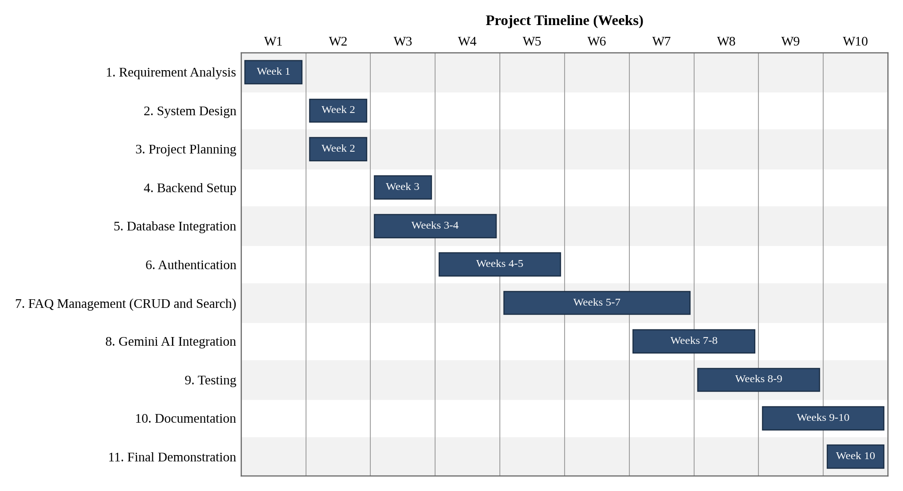
Figure 4.1: Gantt Chart for AnswerBot Project Development

4.7 Resource Planning
Resource planning identifies the software and hardware needed to develop and run AnswerBot. All software tools listed below are commonly available and suitable for a college project. Because AnswerBot depends on Google Gemini AI, a stable internet connection is also a required resource. The Gemini API key must be kept in an environment variable and must not be written directly in the source code. Table 4.5 summarises the resources.
Table 4.5: Software and Hardware Resources
Resource | Specification / Purpose
Software Resources
Operating System | Windows 10/11 or a compatible operating system
Node.js | Version 18 or above; JavaScript runtime for the backend
npm | Package manager for installing project dependencies
Express.js | Web framework for building the REST API
MongoDB | Database for storing user and FAQ data
Mongoose | Object Data Modelling (ODM) library for MongoDB
JavaScript | Programming language used for development
JSON | Data format for API requests and responses
JWT | Token-based authentication of users
bcrypt | Hashing of user passwords
Google Gemini AI | AI service for answer generation and FAQ generation
@google/genai | Package used to connect the backend to Gemini AI
Visual Studio Code | Code editor and development environment
Thunder Client | API testing extension used to send and check requests
Hardware Resources
Processor | Intel Core i5 8th Generation or above / AMD Ryzen 5 or above
RAM | Minimum 8 GB; 16 GB recommended
Storage | At least 1 GB of available storage
Network | Internet connection for Google Gemini AI API usage

4.8 Team and Responsibility Planning
A clear division of responsibilities helps the team avoid duplicated work and makes sure that every part of AnswerBot has an owner. Table 4.6 lists the project roles and their main responsibilities. These are project roles and can be assigned according to the actual team structure; in a small team, one member may take more than one role.
Table 4.6: Team Roles and Responsibilities
Team Role | Responsibility
Project Coordinator | Overall project coordination and planning
Backend Developer | Express.js API and backend development
Database Developer | MongoDB and Mongoose schema management
AI Integration Developer | Google Gemini API integration
Tester | API testing and validation
Documentation Team | Project report and documentation

4.9 Technology Planning
The technologies for AnswerBot were selected to keep the system simple, secure, and suitable for an academic project. Node.js allows the whole backend to be written in JavaScript, and Express.js provides a lightweight way to build REST routes and middleware. MongoDB stores FAQ data as flexible documents, while Mongoose adds schemas and validation so that the data stays structured. JWT allows the server to identify logged-in users without storing session data, and bcrypt protects passwords by storing only hashed values.
Google Gemini AI is selected as the AI component for generating answers and FAQ pairs, and the @google/genai package provides the connection between the Node.js backend and Gemini. Visual Studio Code is used as the development environment, and Thunder Client is used inside it to test the API without building a separate front-end. Table 4.7 summarises the purpose of each technology.
Table 4.7: Technologies and Their Purpose in AnswerBot
Technology | Purpose in AnswerBot
Node.js | Backend runtime
Express.js | REST API framework
MongoDB | Database
Mongoose | MongoDB ODM and schema validation
JWT | Authentication
bcrypt | Password hashing
Google Gemini AI | AI-powered answer and FAQ generation
@google/genai | Gemini API integration
Thunder Client | API testing
VS Code | Development environment

4.10 Risk Management
Risk management means identifying what could go wrong during the development and use of AnswerBot and deciding in advance how to reduce the effect of each problem. Because the project depends on a database, authentication, and an external AI service, several technical risks are possible. Table 4.8 lists the main risks, their possible impact, and the planned mitigation.
Table 4.8: Risk Analysis and Mitigation Plan
Risk | Possible Impact | Mitigation
MongoDB connection failure | API cannot read or save data; server may not start correctly | Check the connection string and MongoDB service; handle connection errors and log a clear message
Invalid JWT token | Protected routes are accessed incorrectly or requests fail | Verify the token on every protected route; return 401 Unauthorized for missing, invalid, or expired tokens
Gemini API failure | AI answer or FAQ generation is not available | Handle errors from the AI service; return a clear message while other FAQ functions continue to work
Invalid API key | Gemini requests are rejected | Store the key in an environment variable; check its value during setup; give a sanitised error message
API rate limits | AI requests may be blocked for a period | Limit unnecessary AI calls during testing and handle rate-limit errors gracefully
Incorrect user input | Bad or incomplete data enters the system | Validate request data before processing; return 400 Bad Request with a helpful message
Database validation errors | Records may be rejected or saved incorrectly | Define Mongoose schema rules such as required fields; handle validation errors in the API
Unauthorized FAQ modification | One user could change or delete another user's FAQ | Compare the FAQ owner with the logged-in user; return 403 Forbidden if they do not match
Server errors | Unexpected failures cause crashes or unclear responses | Use try-catch handling and a central error-handling approach; return 500 without internal details
Network problems | Gemini AI or database cannot be reached | Check connectivity before testing; handle timeouts and inform the user of the failure
Sensitive information exposure | Passwords, tokens, or API keys may be leaked | Use environment variables and .env.example; keep .env out of shared code; hash passwords; sanitise error messages

4.11 Security Planning
Security is planned from the beginning of the project because AnswerBot handles user accounts and an external API key. The following measures are planned for the system. As with the rest of this chapter, they describe the planned approach; the security mechanisms that are actually implemented and verified are reported in the implementation and testing chapters.
- Password hashing using bcrypt: user passwords will be stored only as bcrypt hashes, never as plain text.
- JWT authentication: a token will be issued after successful login and used to identify the user.
- Bearer token validation: protected requests will send the token in the Authorization header as a Bearer token, which the server will verify.
- Protected API routes: FAQ creation, update, deletion, and AI features are planned to require authentication.
- FAQ ownership checks: before an FAQ is updated or deleted, the server will confirm that it belongs to the logged-in user.
- Environment variables for secrets: the JWT secret, database connection string, and Gemini API key will be kept in a .env file.
- Input validation: request data will be checked before it is processed.
- Sanitized error responses: error messages will not reveal internal details such as stack traces or secrets.
- Database validation: Mongoose schema rules will enforce required fields and correct data types.
- Avoiding exposure of API keys: the Gemini API key will never be written in source code or returned in any response, and a .env.example file will show only placeholder values.
- Proper HTTP status codes: the API will use suitable codes such as 200, 201, 400, 401, 403, 404, and 500 so that clients can understand each result.

4.12 Testing Plan
AnswerBot has no graphical front-end, so its API endpoints will be tested using Thunder Client, an API testing extension for Visual Studio Code. For each test, a request will be sent to the server, and the response status and body will be compared with the expected result. Tests will cover both valid requests and invalid requests so that the error handling and security behaviour are also checked. Table 4.9 lists the planned test areas.
Table 4.9: API Testing Plan Using Thunder Client
Test Area | Test Method | Expected Result
Server availability | Send a GET request to the server's base or health route | Server responds successfully
User registration | Send a POST request with valid new user details | Account is created; password is not returned in plain text
User login | Send a POST request with correct credentials | Login succeeds and a JWT token is returned
JWT authentication | Call a protected route with a valid Bearer token | Request is accepted and processed
FAQ creation | Send a POST request with question, answer, and category using a valid token | FAQ is saved and a success response is returned
FAQ retrieval | Send GET requests for the FAQ list and a single FAQ | Correct FAQ data is returned
FAQ update | Send a PUT/PATCH request as the FAQ owner | FAQ is updated and the new data is returned
FAQ deletion | Send a DELETE request as the FAQ owner | FAQ is removed and a success response is returned
FAQ search | Send a GET request with a keyword or category | Only matching FAQs are returned
AI answer generation | Send a customer question to the answer-generation endpoint | A Gemini-generated answer is returned
AI FAQ generation | Send a topic to the FAQ-generation endpoint | Generated question-and-answer pairs are returned
Invalid requests | Send requests with missing or incorrect fields | 400 Bad Request with a clear message
Unauthorized requests | Call protected routes without a token, with an invalid token, or as a non-owner | 401 Unauthorized or 403 Forbidden; no data is changed
Database validation | Send data that breaks schema rules, such as a missing required field | Validation error is returned and the record is not saved
Error handling | Trigger error conditions such as unknown routes or an invalid ID | Suitable status code with a sanitised message

4.13 Project Deliverables
At the end of the project, the following deliverables are expected:
- Working Node.js backend
- RESTful API
- MongoDB database integration
- Authentication system (registration, login, JWT, and bcrypt)
- FAQ management module
- FAQ search functionality
- Google Gemini AI integration
- API testing results
- Source code
- .env.example file
- README and project documentation
- Final project report
- Project demonstration

4.14 Project Planning Flow Diagram
Figure 4.2 shows the order in which the planning activities of AnswerBot are carried out. The process starts with the project idea and ends with the final demonstration, and each step gives the input for the next one.
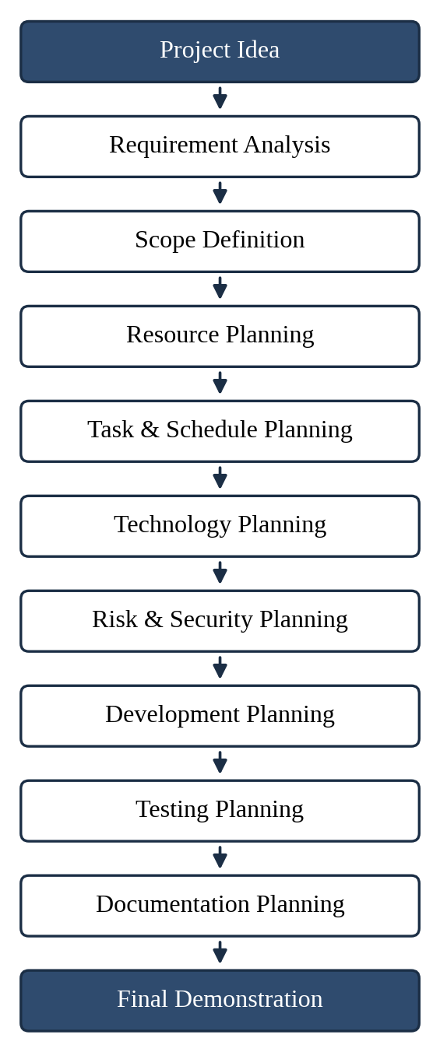
Figure 4.2: Project Planning Process of AnswerBot

4.15 Project Planning Summary
The planning phase gives AnswerBot a clear structure before development starts. The project scope defines which functions the system will offer, from user authentication and FAQ management to AI-powered answer and FAQ generation. The Work Breakdown Structure divides the work into 14 manageable tasks, and the 10-week schedule and Gantt chart place these tasks in a realistic order with a deliverable for each phase. Resource and technology planning confirm that Node.js, Express.js, MongoDB, Mongoose, JWT, bcrypt, Google Gemini AI, @google/genai, Visual Studio Code, and Thunder Client, together with suitable hardware and internet access, are enough to build the system.
Risk and security planning prepare the team for problems such as database failures, invalid tokens, Gemini API errors, and unauthorised FAQ changes, while the testing plan defines how each function will be checked using Thunder Client. Documentation and demonstration planning make sure that the source code, .env.example file, README, final report, and live demonstration are ready at the end of the project.
In this way, the planning phase acts as a structured roadmap for the AnswerBot system. It helps the team work in a clear sequence, use time and resources effectively, control risks and security concerns, and deliver a maintainable backend that reduces repetitive customer-support work.

