2. Requirement Analysis Phase
2.1 Purpose of Requirement Analysis
Requirement analysis was carried out before development to decide clearly what AnswerBot must do, how well it must do it, and which tools are needed to build it. The problems identified in the ideation phase, such as repetitive customer questions and slow, manual FAQ maintenance, were converted into specific requirements for the system. These requirements were then used to determine the following:
- Features: user registration, login, FAQ management, FAQ search, AI answer generation and AI FAQ generation.
- Technologies: Node.js, Express.js, MongoDB, Mongoose, JWT, bcrypt and Google Gemini AI.
- Security: protection of passwords, controlled access to FAQ operations and safe handling of API credentials.
- Database: the structure of the user and FAQ data stored in MongoDB.
- API functionality: the REST endpoints through which every feature is made available.
The overall flow of requirement gathering for AnswerBot is shown in Figure 2.
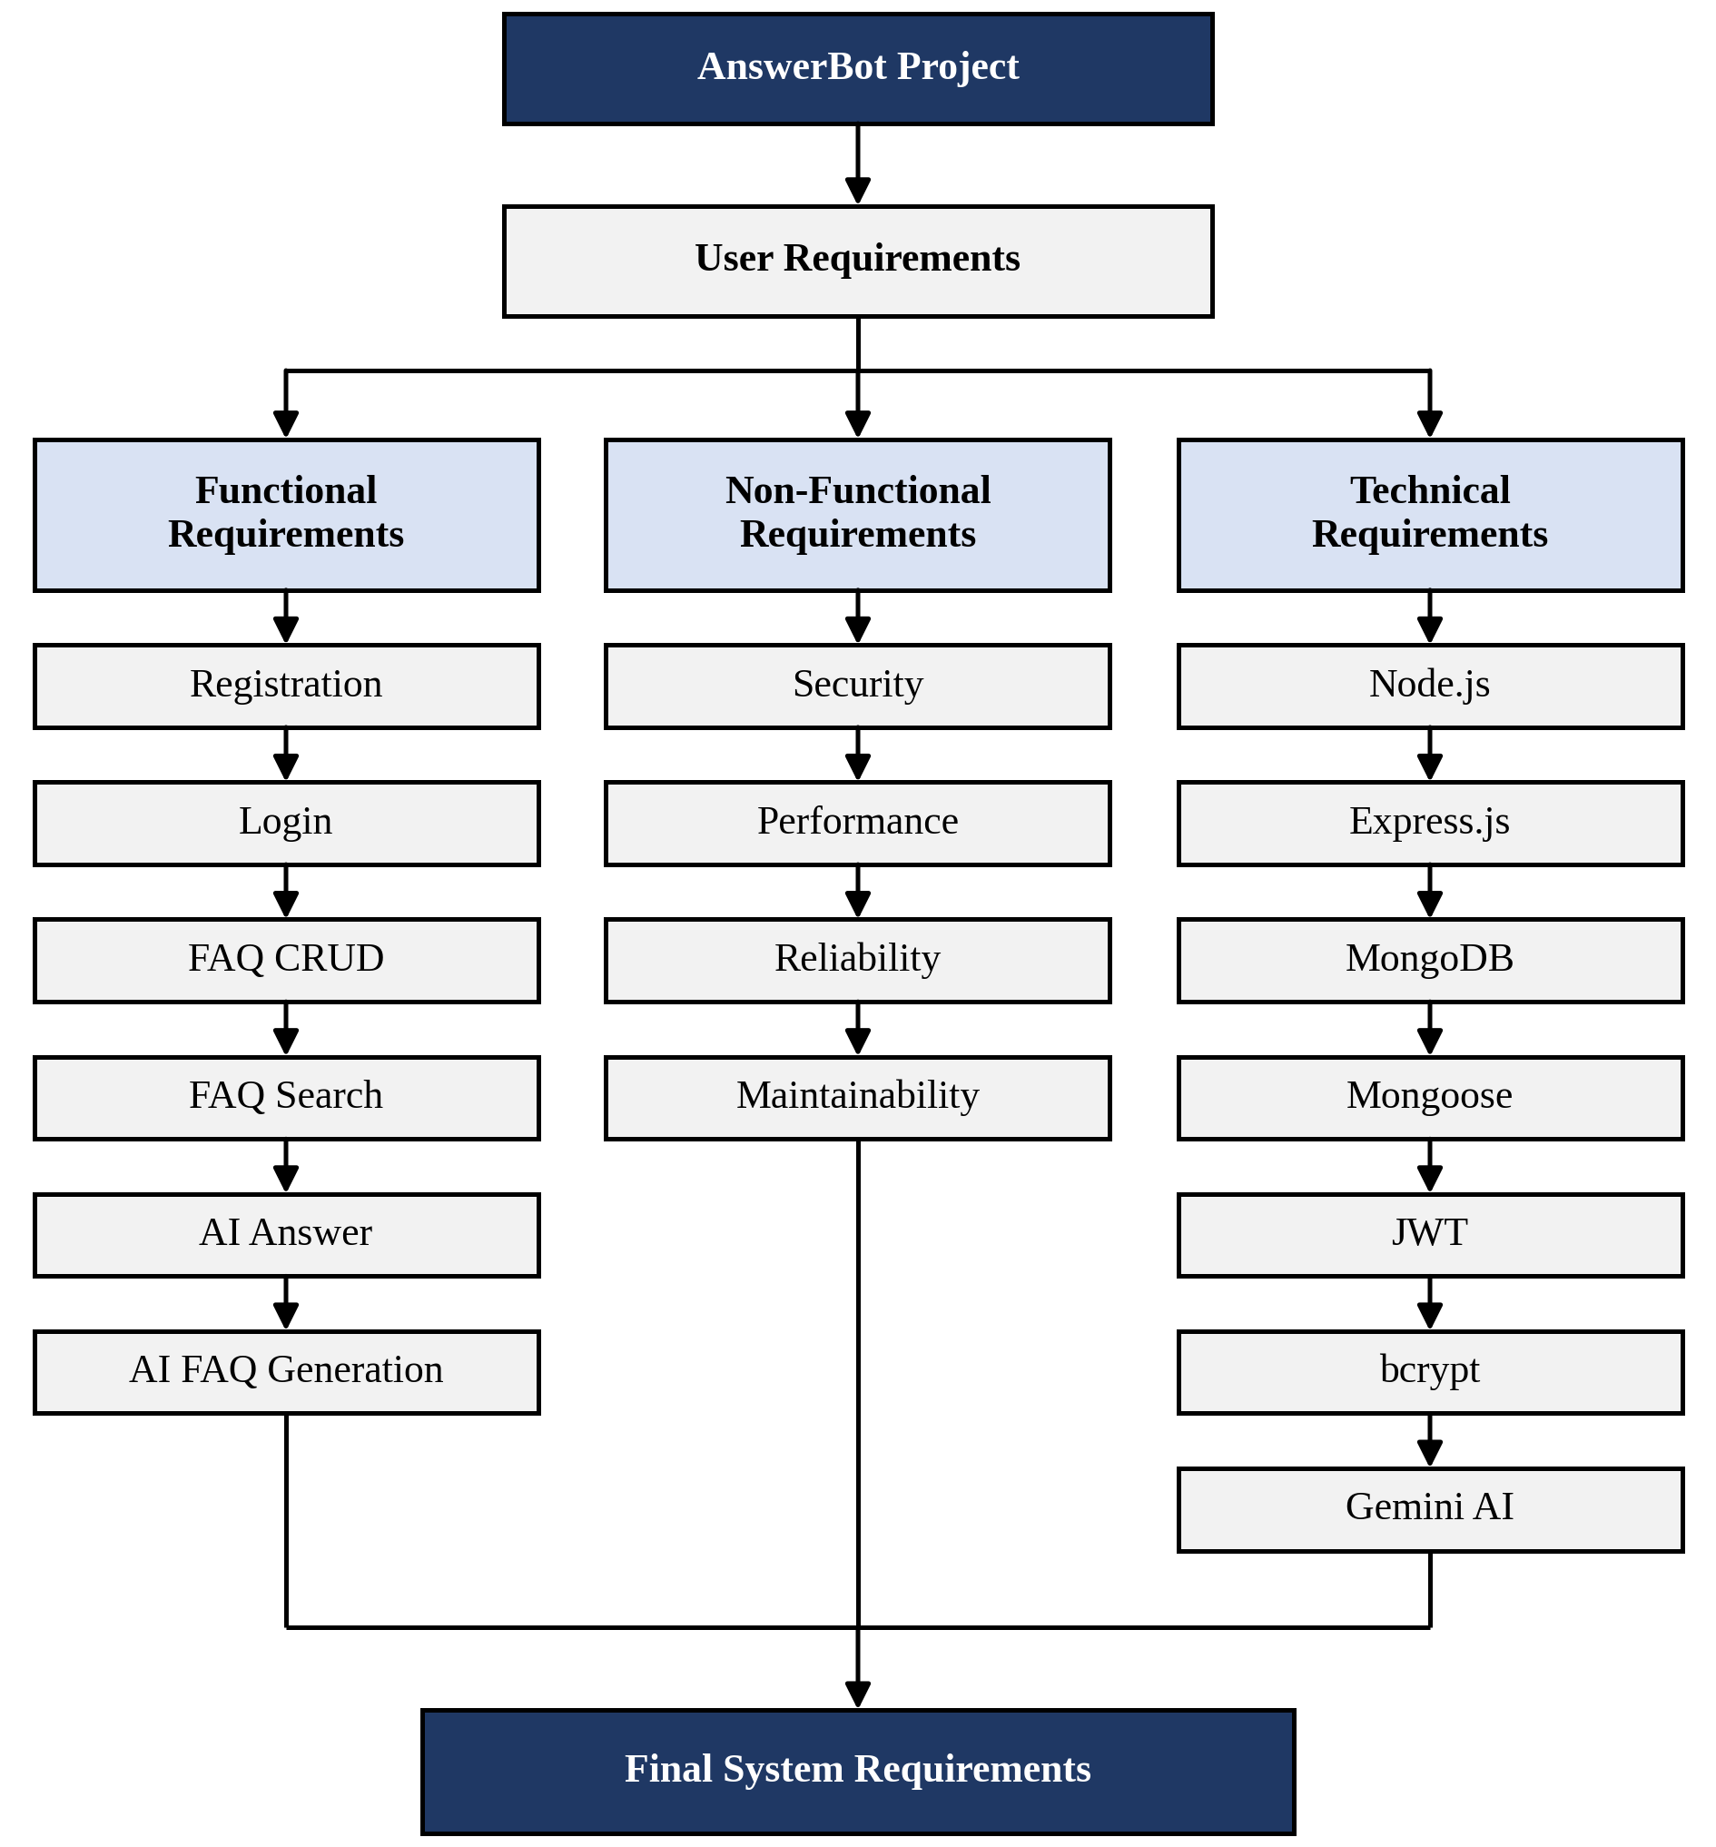
Figure 2: Requirement Analysis of AnswerBot
2.2 Functional Requirements
The functional requirements describe the operations that AnswerBot must provide.
- User Registration: users can create an account by providing their name, email and password.
- User Login: registered users can log in with their credentials. After successful authentication, the system generates a JWT token.
- Authentication and Authorization: protected endpoints require a valid JWT bearer token. Unauthorized users cannot access protected operations.
- FAQ Management: authenticated users can create FAQs. Users can view FAQs, and can update or delete the FAQs that they have created.
- FAQ Search: users can search FAQ content using keywords to find relevant answers quickly.
- AI Answer Generation: an authenticated user submits a question, and Google Gemini AI generates an answer.
- AI FAQ Generation: an authenticated user provides a topic, and Gemini AI generates an FAQ question and answer for it.
- Database Management: user and FAQ information is stored in MongoDB and handled through Mongoose.
2.3 Non-Functional Requirements
The non-functional requirements describe the quality expected from AnswerBot.
- Security: passwords must never be stored as plain text, and FAQ changes and AI features must be available only to authenticated users.
- Performance: FAQ retrieval, search and AI requests should return responses without noticeable delay. Since AI answers depend on the Gemini API, their response time also depends on the internet connection.
- Reliability: the API should return clear responses for both successful and failed requests, so that users know when an operation has not been completed.
- Maintainability: the code should be organized around clear responsibilities (authentication, FAQs and AI) so that each part can be modified independently.
- Scalability: the use of a REST API and MongoDB allows more users and FAQ records to be handled as the system grows.
- Usability: endpoints follow a consistent pattern and can be tested easily with Thunder Client, which makes the system simple to understand and use.
- Data integrity: user and FAQ data follows defined Mongoose structures, and each FAQ is linked to the user who created it, so that only the creator modifies or deletes it.
2.4 Software Requirements
The software required to develop and run AnswerBot is given in Table 1.
Requirement | Technology/Software
Programming Runtime | Node.js v18+
Backend Framework | Express.js
Database | MongoDB
ODM | Mongoose
Authentication | JWT
Password Security | bcrypt
AI Service | Google Gemini AI
API Testing | Thunder Client
Development Environment | Visual Studio Code
Package Manager | npm
Table 1: Software Requirements
2.5 Hardware Requirements
- Processor: Intel i5 8th Generation or equivalent AMD Ryzen 5 or above.
- RAM: minimum 8 GB, 16 GB recommended.
- Storage: minimum 1 GB of available space.
- Operating System: Windows 10/11, macOS or Linux.
- Network: internet connection for Gemini AI API communication.
2.6 Database Requirements
AnswerBot stores its data in MongoDB using two main entities, User and FAQ. Their fields are shown in Table 2 and Table 3.
User Field | Description
_id | Unique identifier generated by MongoDB
name | Name of the user
email | Email address used for registration and login
password | User password, stored in hashed form using bcrypt
role | Role of the user in the system
createdAt | Date and time the user record was created
updatedAt | Date and time the user record was last updated
Table 2: User Entity
FAQ Field | Description
_id | Unique identifier generated by MongoDB
question | The FAQ question
answer | The answer to the question
category | Category used to organize the FAQ
createdBy | Reference to the user who created the FAQ
createdAt | Date and time the FAQ was created
updatedAt | Date and time the FAQ was last updated
Table 3: FAQ Entity
The two entities are related through the createdBy field. One user can create many FAQs, while each FAQ belongs to exactly one user. This relationship allows the system to identify the owner of each FAQ and to allow only that user to update or delete it.
2.7 API Requirements
AnswerBot follows REST API principles. Each feature is exposed as an endpoint that uses standard HTTP methods, and data is exchanged in JSON format. The major API operations are listed in Table 4.
Method | Endpoint | Purpose
POST | /api/auth/register | Register a new user
POST | /api/auth/login | Log in and receive a JWT token
GET | /api/faqs | View FAQs
POST | /api/faqs | Create a new FAQ
PUT | /api/faqs/:id | Update an existing FAQ
DELETE | /api/faqs/:id | Delete an FAQ
GET | /api/faqs/search | Search FAQs using keywords
POST | /api/ai/answer | Generate an AI answer for a question
POST | /api/ai/generate-faq | Generate an FAQ from a topic
Table 4: API Endpoints
Registration and login are open to users who do not yet have a token. Protected endpoints use JWT Bearer authentication: the client sends the token received at login in the Authorization header, and the request is processed only if the token is valid.
2.8 Security Requirements
- Password hashing: passwords are hashed using bcrypt before being stored, so the original password is not saved in the database.
- JWT-based authentication: a signed token is issued after login and identifies the user in later requests.
- Protected API routes: FAQ creation, updating and deletion, and the AI endpoints, are accessible only with a valid token.
- Authorization checks: the system verifies that a user is allowed to perform an action, such as modifying only the FAQs they created.
- Environment variables: sensitive configuration, such as the database connection and JWT secret, is kept in environment variables instead of the source code.
- Gemini API credentials: the Gemini API key is stored as an environment variable and used only on the server, so it is not exposed to users.
2.9 Requirement Summary
The requirement analysis defines the foundation on which AnswerBot is designed and developed. The functional requirements set the features of the system, the non-functional requirements set the expected quality, and the software and hardware requirements define the environment needed to build and run it. The database, API and security requirements determine how data is stored, how features are accessed and how the system is protected. Together, these requirements guide the design and implementation of AnswerBot as a secure, AI-powered REST API for FAQ and customer support automation.

