1. Brainstorming & Ideation Phase
This section describes how the idea for AnswerBot – AI-Powered FAQ and Customer Support Automation was formed: the customer-support problems that motivated it, the solutions that were considered, and the reasoning behind the final project idea.
1.1 Problem Identification
Customer-support teams handle a steady stream of questions, and many of them are the same questions asked again and again. Studying this situation led to the identification of the following problems:
- Repetitive customer questions: the same queries about accounts, services and common issues reach the support team repeatedly, and each one is answered manually.
- Manual FAQ creation and maintenance: writing FAQ entries one by one is slow, and keeping them up to date depends entirely on human effort.
- Outdated FAQ information: when FAQs are not reviewed regularly, customers find answers that no longer match the current situation.
- Difficulty organizing FAQ content: without a central structure, questions and answers become scattered and hard to manage.
- Difficulty finding relevant answers quickly: customers and support staff struggle to locate the right answer when there is no effective search.
- Increased workload for support teams: all of the above consume time that could be spent on more complex customer issues.
1.2 Brainstorming Process
Once the problems were clear, different possible solutions were discussed, and each was considered for the specific problem it could address:
- Centralized FAQ management: storing all questions and answers in one place so they can be organized and maintained easily.
- FAQ search functionality: allowing relevant questions and answers to be found quickly by keyword.
- Secure user authentication: ensuring that only registered and logged-in users can change FAQ content.
- Automated FAQ generation: reducing the manual effort needed to write FAQ content.
- AI-powered answers: using an AI model to produce answers to customer questions.
- REST API-based customer-support system: exposing all of these features as API endpoints so that they can be tested and reused by different clients.
1.3 Project Idea
Each option solved only part of the problem when considered alone. A FAQ database without search is difficult to use, FAQ management without authentication is unsafe, and manual FAQ writing remains time-consuming even when the content is centralized. The ideas were therefore evaluated together, and it was decided to combine them into a single system. This resulted in AnswerBot, an AI-powered REST API platform that combines FAQ management, secure authentication, FAQ search and Google Gemini AI capabilities. The flow of ideas that led to this decision is shown in Figure 1.
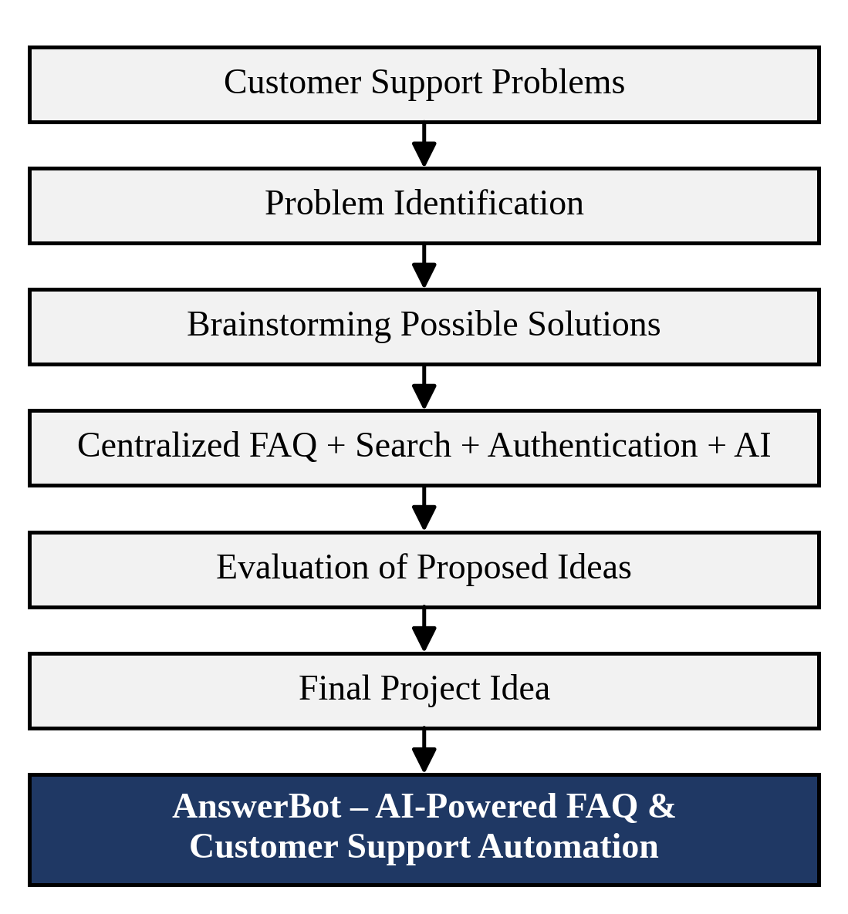
Figure 1: Brainstorming and Ideation Process of AnswerBot
1.4 Proposed Solution
AnswerBot is built as a backend REST API. It uses Node.js as the runtime and Express.js as the web framework. MongoDB is used as the database, accessed through Mongoose. User passwords are protected with bcrypt, and access to protected operations is controlled with JSON Web Tokens (JWT). Google Gemini AI provides the AI capabilities, and Thunder Client is used to test the API endpoints.
The system solves the identified problems through the following major functions:
- User registration and login: new users can create an account and registered users can log in to the system.
- JWT authentication: a token is issued on login and is required to access protected operations, so that FAQ management is restricted to authenticated users.
- FAQ creation, viewing, updating and deletion: FAQs are stored centrally in MongoDB and can be created, read, modified and removed, which keeps the information organized and easy to keep up to date.
- FAQ searching: stored FAQs can be searched so that relevant answers are found quickly.
- AI answer generation: Google Gemini AI generates an answer for a customer question, reducing repetitive manual replies.
- AI FAQ generation: Google Gemini AI generates FAQ content automatically, reducing the effort of manual FAQ writing.
1.5 Objectives
The objectives of the AnswerBot project are:
- Automate FAQ and customer-support content creation.
- Reduce repetitive manual support work.
- Provide secure authentication.
- Manage FAQ information efficiently.
- Generate AI-powered answers and FAQs.
- Provide a centralized searchable FAQ system.
- Protect authenticated API operations.
1.6 Expected Outcome
AnswerBot is expected to make FAQ management simpler by keeping all questions and answers in one central, organized system that can be updated whenever information changes. Automated FAQ generation and AI-generated answers should reduce the repetitive work of the support team, allowing them to focus on issues that need personal attention. The search function should make information easier and faster to access, and JWT-based authentication should keep FAQ operations protected. Overall, the project demonstrates how AI-assisted customer service can be delivered through a secure and well-structured REST API.

