5. Project Development Phase

5.1 Introduction to Project Development
The development phase is the stage in which the planned design of AnswerBot – AI-Powered FAQ and Customer Support Automation was converted into a working backend application. The architecture, database structure, API endpoints, and security mechanisms prepared during the design phase were implemented as real code and tested through API requests.
The backend of AnswerBot was developed in JavaScript using Node.js and the Express.js framework. MongoDB is used as the database and is accessed through Mongoose. User passwords are protected with bcrypt, and access to protected endpoints is controlled with JSON Web Tokens (JWT). AI functionality is provided by Google Gemini AI through the @google/genai package, and Thunder Client was used to send requests to the API and check the responses.
AnswerBot follows a RESTful API architecture, in which each resource is accessed through a URL and standard HTTP methods. It also uses a modular backend structure, in which routes, controllers, models, middleware, services, and configuration are kept in separate files so that each file has one clear responsibility.

5.2 Development Environment Setup
The following software was used to set up the development environment:
- Visual Studio Code: the code editor used to write the project.
- Node.js v18 or higher and npm: the JavaScript runtime and its package manager.
- MongoDB: the database, run as a MongoDB server / local database during development.
- Thunder Client: the extension used to test the API endpoints.
- Git and GitHub: used for version control and for storing the project source code.
Project Initialization
The project was initialized with a package.json file using the following command:
npm init -y
The required packages were then installed with a single command:
npm install express mongoose dotenv cors jsonwebtoken bcrypt @google/genai
Table 5.1 explains the purpose of each package and technology used in AnswerBot.
Table 5.1: Packages and Technologies Used in AnswerBot
Package / Technology | Purpose
Node.js | Backend runtime
Express.js | REST API framework
Mongoose | MongoDB ODM
MongoDB | Database
dotenv | Environment variable management
cors | Cross-Origin Resource Sharing
jsonwebtoken | JWT authentication
bcrypt | Password hashing
@google/genai | Google Gemini AI integration

5.3 Project Folder Structure
AnswerBot uses a modular folder structure so that the code for each responsibility is kept in its own place. The structure is shown below.
AnswerBot/
│
├── src/
│ ├── controllers/
│ │ ├── authController.js
│ │ ├── faqController.js
│ │ └── aiController.js
│ │
│ ├── models/
│ │ ├── User.js
│ │ └── FAQ.js
│ │
│ ├── routes/
│ │ ├── authRoutes.js
│ │ ├── faqRoutes.js
│ │ └── aiRoutes.js
│ │
│ ├── middleware/
│ │ ├── authMiddleware.js
│ │ └── errorMiddleware.js
│ │
│ ├── services/
│ │ └── geminiService.js
│ │
│ ├── config/
│ │ └── db.js
│ │
│ ├── app.js
│ └── server.js
│
├── .env
├── .gitignore
├── package.json
└── README.md
Table 5.2 describes the responsibility of each major folder and file.
Table 5.2: Responsibilities of Folders and Files
Folder / File | Responsibility
controllers/ | Contain the request-handling logic for authentication (authController.js), FAQ operations (faqController.js), and AI requests (aiController.js).
models/ | Contain the Mongoose schemas for users (User.js) and FAQs (FAQ.js).
routes/ | Define the API URLs and connect each URL to its controller function.
middleware/ | Contain the JWT authentication middleware (authMiddleware.js) and the centralized error handler (errorMiddleware.js).
services/ | Contains geminiService.js, which communicates with Google Gemini AI.
config/ | Contains db.js, which connects the application to MongoDB.
app.js / server.js | Configure the Express application (app.js) and start the server (server.js).
.env / .gitignore | Store secret configuration values (.env) and prevent them from being committed to Git (.gitignore).
package.json / README.md | Record project dependencies and scripts (package.json) and document the project (README.md).

5.4 Server and Express Application Development
The Express application is developed in three files, each with a separate role:
- app.js: creates the Express application, configures the middleware, registers the routes, and adds the error-handling middleware.
- server.js: is the entry point of the project. It loads the environment variables, connects to MongoDB, and starts the server on the configured port.
- db.js: contains the function that connects to MongoDB using Mongoose and the connection string stored in the environment variables.
The main development steps for the server were:
- Application initialization: the Express application is created in app.js.
- JSON request parsing: Express is configured to read JSON request bodies, which is required for registration, login, FAQ, and AI requests.
- CORS configuration: the cors package allows the API to be accessed from other origins.
- Environment variable loading: dotenv loads values such as the port and database connection string from the .env file.
- Route registration: the authentication, FAQ, and AI routes are registered under the /api paths.
- Error handling: the centralized error middleware is added after the routes.
- MongoDB connection and server startup: the server starts listening for requests once the application and database configuration are ready.
Every request passes through the same processing path, shown in Figure 5.1: Client Request → Express Server → Middleware → Route → Controller → Service/Model → Database/AI → Response.
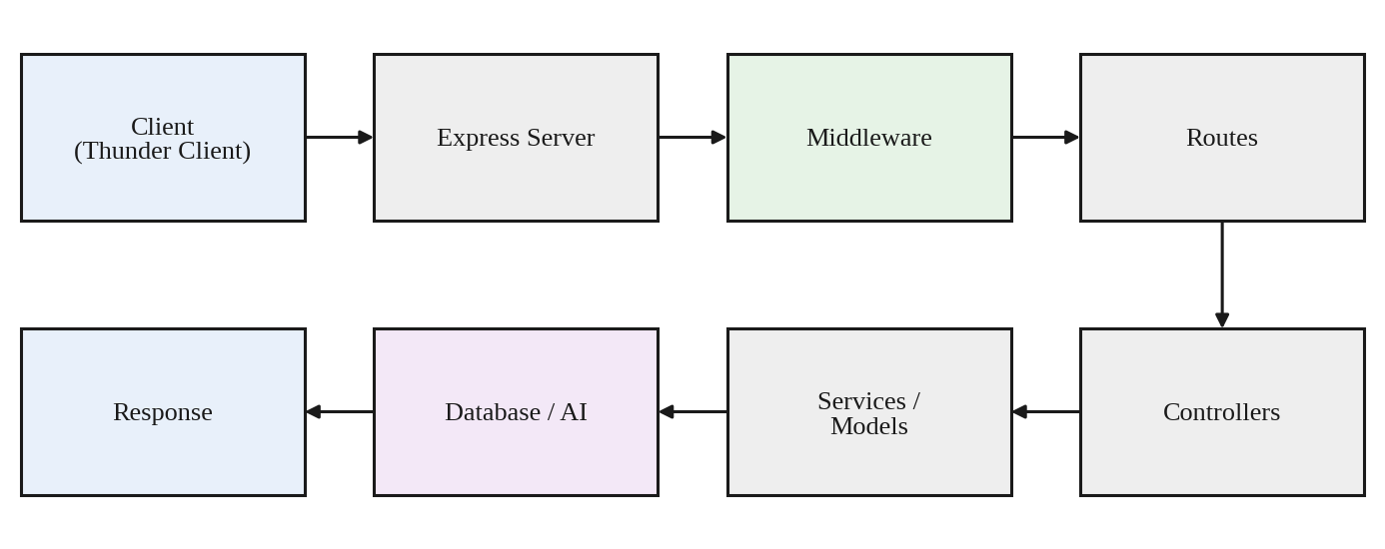
Figure 5.1: AnswerBot Backend Request Processing Flow

5.5 Database Development
The database layer was developed using Mongoose, which defines the structure of the data through schemas and models. Two models were created: User and FAQ.
User Model
The User model stores the fields _id, name, email, password, role, createdAt, and updatedAt. The _id field is the unique identifier created by MongoDB. The password field stores the bcrypt hash of the password and not the original password. The createdAt and updatedAt fields record when the user record was created and last modified.
FAQ Model
The FAQ model stores the fields _id, question, answer, category, createdBy, createdAt, and updatedAt. The createdBy field stores the _id of the user who created the FAQ.
User–FAQ Relationship
The createdBy field links each FAQ to its creator. One user can create multiple FAQ records, while each FAQ belongs to one user. This relationship is used to check ownership before an FAQ is updated or deleted.
Table 5.3: Database Models of AnswerBot
Model | Important Fields | Purpose
User | name, email, password, role | Stores user information
FAQ | question, answer, category, createdBy | Stores FAQ information

5.6 User Authentication Development
User Registration
Client → Register API → Validate Input → Hash Password → Save User → Return Response
A new user sends a registration request to POST /api/auth/register. The controller checks that the required fields are present, hashes the password using bcrypt, and saves the new user in MongoDB. The response confirms the registration and does not return the password. bcrypt was used because it converts the password into a hash before storage, so the original password is never saved in the database.
User Login
Client → Login API → Find User → Compare Password → Generate JWT → Return Token
A registered user sends the email and password to POST /api/auth/login. The controller finds the user by email and uses bcrypt to compare the entered password with the stored hash. If the credentials are correct, a JWT is generated and returned to the client. The client uses this token to access protected endpoints. No real password, token, or secret is included in this report.

5.7 JWT Authentication and Authorization
Protected routes in AnswerBot are guarded by authentication middleware built with the jsonwebtoken package. The development workflow was:
- The user logs in.
- The server generates a JWT.
- The client stores the token.
- The client sends the token using the Bearer authorization header.
- The authentication middleware extracts the token.
- The token is verified.
- User information is attached to the request.
- The protected controller processes the request.
Attaching the user information to the request allows later controllers to know which user is making the request, which is needed for FAQ ownership checks. If the token is missing or invalid, the middleware stops the request and returns an error. Figure 5.2 shows this flow.
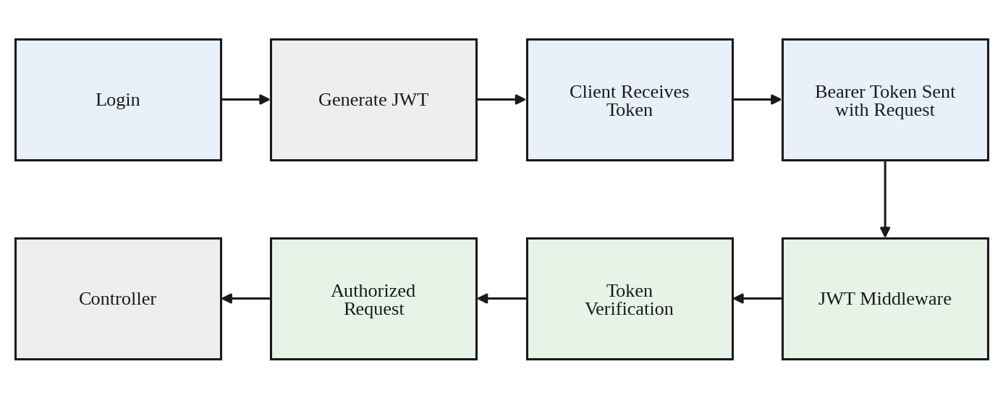
Figure 5.2: JWT Authentication Flow in AnswerBot

5.8 FAQ Management Development
The FAQ module was developed as a set of CRUD operations in faqController.js and exposed through faqRoutes.js.
- Create FAQ (POST /api/faqs): an authenticated user sends the question, answer, and category. The controller saves the FAQ and stores the logged-in user's id in the createdBy field.
- View FAQs (GET /api/faqs): retrieves the FAQ records from the database and returns them as JSON.
- View Individual FAQ (GET /api/faqs/:id): retrieves one FAQ using its id.
- Update FAQ (PUT /api/faqs/:id): the controller first finds the FAQ and compares its createdBy value with the logged-in user. The update is allowed only when the user is the creator.
- Delete FAQ (DELETE /api/faqs/:id): the same ownership validation is performed before the FAQ is removed.
If the ownership check fails, the request is rejected, so a user cannot modify another user's FAQ. Table 5.4 summarizes the operations.
Table 5.4: FAQ Management Operations
Operation | HTTP Method | Endpoint | Purpose
Create FAQ | POST | /api/faqs | Add a new FAQ
Get FAQs | GET | /api/faqs | Retrieve FAQs
Get FAQ | GET | /api/faqs/:id | Retrieve one FAQ
Update FAQ | PUT | /api/faqs/:id | Modify an FAQ
Delete FAQ | DELETE | /api/faqs/:id | Remove an FAQ

5.9 FAQ Search Development
FAQ search is provided through the endpoint GET /api/faqs/search?q=keyword. The value of the q parameter is the keyword entered by the user. The implementation performs keyword-based searching on fields such as the question, answer, and category of the FAQ records. FAQ records that match the keyword are returned through the API as JSON.
The current implementation is a keyword search. It does not use semantic or vector search.

5.10 Google Gemini AI Integration
The AI module was developed using Google Gemini AI through the @google/genai package. All communication with Gemini is placed in geminiService.js, while aiController.js receives the API requests. This keeps the AI logic separate from the rest of the application. The Gemini API key is read from the environment variables. The module provides two functions.
AI Answer Generation
The endpoint is POST /api/ai/answer. The client sends a question in the request body:
{
"question": "What is MongoDB?"
}
The flow is: Question → AI Controller → Gemini Service → Google Gemini AI → Generated Answer → API Response. The controller passes the question to the Gemini service, which sends it to Gemini and returns the generated answer to the client.
AI FAQ Generation
The endpoint is POST /api/ai/generate-faq. The client sends a topic:
{
"topic": "MongoDB"
}
Gemini generates an FAQ question and an FAQ answer for the topic. The API returns the generated question and answer as JSON. Figure 5.3 shows the integration flow.
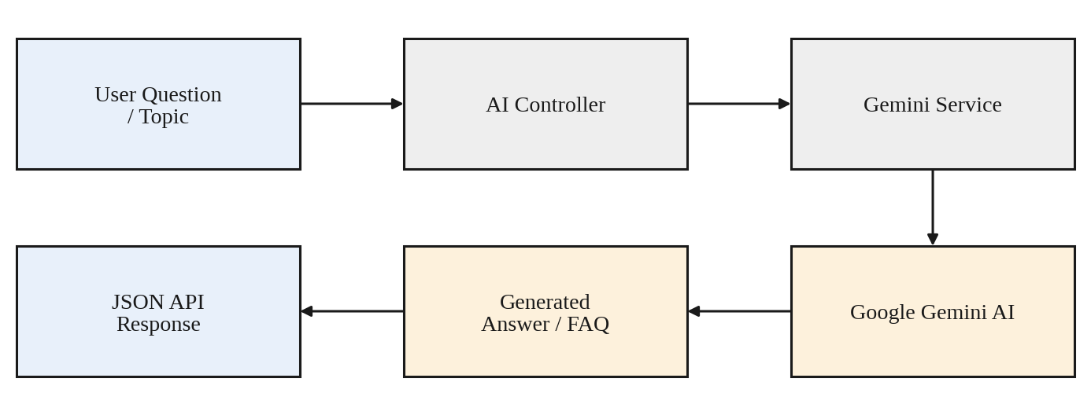
Figure 5.3: Google Gemini AI Integration Flow

5.11 Environment Variable Configuration
Sensitive values such as the database connection string, the JWT secret, and the Gemini API key must not be written directly in the source code. AnswerBot stores them in a .env file, which is loaded at startup using dotenv. The .env file contains the following variables, shown here with placeholder values only:
PORT=5000
MONGO_URI=your_mongodb_connection_string
JWT_SECRET=your_secure_jwt_secret
GEMINI_API_KEY=your_gemini_api_key
The .env file should never be committed to GitHub, because anyone who can see the repository would then see the secrets. For this reason, .env is listed in the .gitignore file so that Git ignores it. This report contains no real API key, JWT secret, or database password.

5.12 Error Handling Development
AnswerBot uses a centralized error-handling approach. Instead of handling every error separately in each controller, errors are passed to the error middleware (errorMiddleware.js), which returns a consistent JSON response. The errors handled include invalid requests, missing required fields, invalid login credentials, an invalid JWT, unauthorized access, FAQ not found, MongoDB errors, Gemini API errors, and unexpected server errors.
Suitable HTTP status codes tell the client what kind of problem occurred, and sanitized messages ensure that internal details, such as database errors or secret values, are not exposed. Table 5.5 lists the main error types.
Table 5.5: Error Types and HTTP Status Codes
Error Type | HTTP Status | Example
Bad Request | 400 | Invalid input
Unauthorized | 401 | Invalid/missing token
Forbidden | 403 | User not allowed to modify FAQ
Not Found | 404 | FAQ not found
Server Error | 500 | Unexpected server error

5.13 Input Validation and Data Integrity
Validation ensures that only correct and complete data is stored in the database. In AnswerBot, validation is handled in the controllers and in the Mongoose schemas:
- Required fields: requests with missing required fields are rejected.
- Email validation: the email is checked where applicable, during registration and login.
- Password validation: a password must be supplied before it is hashed or compared.
- FAQ question, answer, and category validation: these fields must be provided when an FAQ is created or updated.
- Mongoose schema validation: the schemas define required fields and data types.
- Invalid ObjectId handling: an id in the URL that is not a valid MongoDB ObjectId results in an error response and not a server failure.
- Request validation: incoming request data is checked before it is processed.
These checks keep the FAQ data complete and consistent, which is important because the FAQs are the content that users search and read.

5.14 Security Implementation
The following security mechanisms were used during the development of AnswerBot:
- bcrypt password hashing: passwords are stored as hashes.
- JWT authentication and Bearer token validation: the middleware verifies the token sent in the Authorization header.
- Protected routes: endpoints such as creating, updating, and deleting FAQs and the AI endpoints require authentication.
- FAQ ownership checks: the createdBy field is verified before an FAQ is updated or deleted.
- Environment variables and API key protection: the database string, JWT secret, and Gemini API key are kept in .env and excluded from Git.
- Input validation: request data is checked before use.
- Sanitized error responses and appropriate HTTP status codes: clients receive safe messages with correct status codes.

5.15 REST API Development Summary
Table 5.6 lists all the API endpoints of AnswerBot. Where the exact access behavior was not explicitly verified, the table shows “As implemented”.
Table 5.6: AnswerBot REST API Summary
Module | Method | Endpoint | Purpose | Authentication
Auth | POST | /api/auth/register | Register user | Public
Auth | POST | /api/auth/login | Login user | Public
FAQ | GET | /api/faqs | Get FAQs | As implemented
FAQ | POST | /api/faqs | Create FAQ | Protected
FAQ | GET | /api/faqs/:id | Get FAQ | As implemented
FAQ | PUT | /api/faqs/:id | Update FAQ | Protected
FAQ | DELETE | /api/faqs/:id | Delete FAQ | Protected
FAQ | GET | /api/faqs/search | Search FAQs | As implemented
AI | POST | /api/ai/answer | Generate AI answer | Protected
AI | POST | /api/ai/generate-faq | Generate FAQ using AI | Protected

5.16 Development Workflow
AnswerBot was developed in stages, with each stage building on the previous one. The project started with requirement analysis and system design, followed by the environment setup. The database, authentication, FAQ, and search modules were then developed, and the Gemini AI integration was added. Error handling and security were completed next, and the API was tested with Thunder Client. The project was documented at the end. Figure 5.4 shows the workflow.
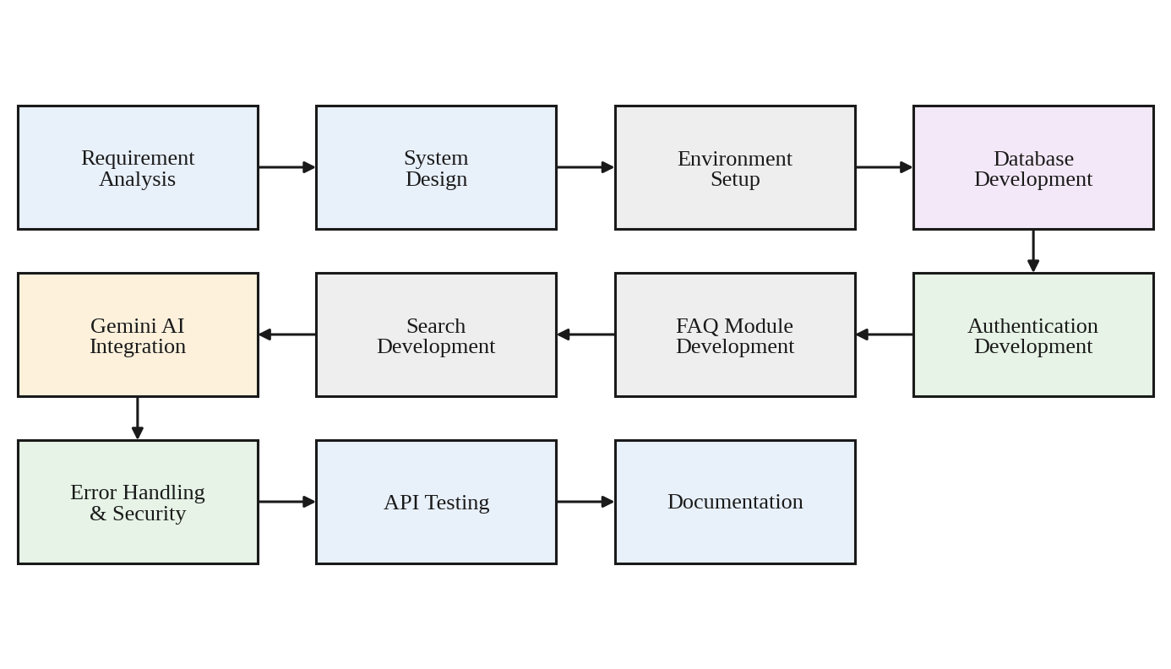
Figure 5.4: Development Workflow of AnswerBot

5.17 Development Challenges and Solutions
Table 5.7 lists the challenges that were relevant to the development of AnswerBot and the solutions used.
Table 5.7: Development Challenges and Solutions
No. | Challenge | Problem | Solution
1 | MongoDB Connection | Database connection configuration errors. | Correct the MongoDB connection string and verify that the MongoDB server is running.
2 | Gemini API Integration | Invalid API credentials or an unsupported model/API configuration. | Configure the Gemini API key correctly and use a supported Gemini model through the Google GenAI SDK.
3 | Authentication | Protecting API endpoints from unauthorized access. | JWT-based authentication middleware.
4 | FAQ Ownership | Preventing users from modifying another user's FAQ. | Verify the createdBy field before update and delete operations.
5 | Input Validation | Invalid or incomplete FAQ data. | Validate request data and use Mongoose schema validation.

5.18 Development Output
The development phase produced a working AnswerBot backend with the following implemented functionality:
- Running Express.js backend
- MongoDB database connectivity
- User registration and login
- JWT authentication
- FAQ CRUD operations and FAQ search
- AI answer generation and AI FAQ generation
- Error handling and security mechanisms
- RESTful API endpoints, with API testing support through Thunder Client
Table 5.8 separates the implemented functionality from features that are not part of the current implementation.
Table 5.8: Implemented and Not Implemented Functionality
Functionality | Status
Authentication, FAQ CRUD, FAQ keyword search, AI answer and FAQ generation, error handling, security mechanisms | Implemented
Semantic or vector search | Not implemented; keyword-based search is used
Separate category-management APIs | Not implemented; category is a field of the FAQ
Full admin-management system | Not implemented

5.19 Project Development Summary
The Project Development Phase converted the AnswerBot design into a functional backend system. Node.js and Express.js provide the server and the REST API. MongoDB with Mongoose stores the user and FAQ data and validates its structure. bcrypt protects the passwords, and JWT allows the server to identify authenticated users. Google Gemini AI, accessed through the @google/genai package, adds AI-based answer generation and FAQ generation.
The major modules work together as one system. The authentication module identifies the user, the middleware protects the routes, and the FAQ module manages and searches the FAQ records. The AI module generates answers and FAQ content, while error handling and environment variables keep the system reliable and its secrets safe. The modular structure and the testing done with Thunder Client make AnswerBot a working AI-powered FAQ and customer-support automation backend that can be maintained and extended in the future.

