Software Requirements Specification
for
TripWise – Smart Travel Companion
Prepared by Sanjay Raj K, Palvadi Adithya, Durgesh Kumar
Department of Computer Science & Engineering
Software Engineering Laboratory
Academic Year 2026–2027
Date Created: July 20, 2026
Revision History
Name | Date | Reason For Changes | Version
Sanjay Raj K | July 17, 2026 | Initial Draft (IEEE template structure) | 1.0
Sanjay Raj K | July 20, 2026 | Addressed review feedback: consistent 4.x.1/4.x.2/4.x.3 structure for all features, FR numbering fixed, improved NFRs, references, wording polish, and added architecture diagram | 1.1
Sanjay Raj K | July 22, 2026 | Addressed further review feedback: made NFR-019, NFR-020, NFR-023, and NFR-024 measurable; strengthened password policy (BR-002); clarified use-case reference in Section 4.12 | 1.2

Contents
1. Introduction 4
1.1 Purpose 4
1.2 Document Conventions 4
1.3 Intended Audience and Reading Suggestions 4
1.4 Product Scope 5
1.5 References 5
2. Overall Description 6
2.1 Product Perspective 6
2.2 Product Functions 7
2.3 User Classes and Characteristics 8
2.4 Operating Environment 9
2.5 Design and Implementation Constraints 9
2.6 User Documentation 9
2.7 Assumptions and Dependencies 10
3. External Interface Requirements 10
3.1 User Interfaces 10
3.2 Hardware Interfaces 11
3.3 Software Interfaces 11
3.4 Communications Interfaces 12
4. System Features 12
4.1 User Authentication (SF-001) 12
4.2 Traveler Dashboard (SF-002) 13
4.3 Trip Management (SF-003) 14
4.4 Destination Management (SF-004) 14
4.5 Itinerary Planner (SF-005) 15
4.6 Budget & Expense Management (SF-006) 16
4.7 Accommodation Management (SF-007) 16
4.8 Notes & Packing List Management (SF-008) 17
4.9 User Profile Management (SF-009) 18
4.10 Administration (SF-010) 18
4.11 Feature Prioritization (MoSCoW) 19
4.12 Chapter Summary 19
5. Other Nonfunctional Requirements 19
5.1 Performance Requirements 19
5.2 Safety Requirements 19
5.3 Security Requirements 20
5.4 Software Quality Attributes 20
5.5 Business Rules 20
5.6 Scalability & Maintainability 21
5.7 Availability & Reliability 21
6. Other Requirements 21
6.1 Future Enhancements 21
6.2 Out of Scope (Version 1) 22
6.3 Design Philosophy 22
6.4 Document Traceability Summary 22
Appendix A: Glossary 23
Appendix B: Analysis Models 23
Appendix C: To Be Determined List 24

1. Introduction

1.1 Purpose
The purpose of this Software Requirements Specification (SRS) is to define the functional and non-functional requirements for TripWise – Smart Travel Companion, a web-based travel planning and itinerary management application.
TripWise aims to simplify travel planning by providing users with a centralized platform to organize trips, manage destinations, create day-wise itineraries, track travel expenses, maintain accommodation details, and store essential travel notes. The system is intended to replace fragmented travel-planning methods such as spreadsheets, paper notes, and multiple messaging applications with a single, unified, user-friendly solution.
This document serves as the primary reference for stakeholders, developers, testers, project managers, and future maintainers. It clearly defines the system's scope, behavior, interfaces, and constraints, and establishes the foundation for system design, implementation, testing, and maintenance.

1.2 Document Conventions
This document follows the structure recommended by the IEEE Software Requirements Specification guidelines (ISO/IEC/IEEE 29148:2018), adapted for the Software Engineering Laboratory course.
The following conventions are used throughout the document:
- TripWise refers to the proposed software system.
- The term Traveler refers to any registered user of the application.
- The term Administrator refers to users responsible for managing the application and its data.
- Functional Requirements are identified using the prefix FR-XXX.
- Non-Functional Requirements are identified using the prefix NFR-XXX.
- Business Rules are identified using the prefix BR-XXX.
- High, Medium, and Low indicate feature priority wherever applicable.

1.3 Intended Audience and Reading Suggestions
This document is intended for the following stakeholders:
- Project Team – Developers responsible for designing, implementing, and maintaining TripWise should use this document as the primary source of system requirements.
- Faculty and Project Evaluators – Faculty members may use this document to understand project objectives, architecture, scope, and expected functionality.
- Testers – Quality assurance personnel may derive test cases directly from the functional requirements and acceptance criteria defined in this document.
- Future Developers – Future contributors can use this SRS to understand the architecture and functionality before extending the system.
- End Users – Travelers and administrators may refer to relevant sections to understand the intended capabilities of the application.
Reading Suggestions: Begin with Section 1 and Section 2 for context, then proceed to Section 4 for detailed functional requirements, followed by Section 5 for non-functional requirements. Developers and testers should focus on Sections 3, 4, and 5.

1.4 Product Scope
TripWise is a web-based Smart Travel Companion designed to assist users in planning and managing personal or group travel efficiently.
The application enables travelers to:
- Create and manage multiple trips.
- Organize destinations for each trip.
- Build detailed day-wise itineraries.
- Track travel expenses against a predefined budget.
- Maintain accommodation information.
- Store travel notes and packing lists.
- View all upcoming and completed trips through a personalized dashboard.
- Manage personal profile information.
The system also provides an administrative interface that allows authorized administrators to manage user accounts, monitor trips, and oversee overall system activity.
Future versions of TripWise may include advanced features such as Smart Carpool recommendations, integrated weather alerts, group communication, live location sharing, nearby-place recommendations, AI-assisted itinerary generation, and emergency assistance services.
The objective of TripWise is to provide an organized, intuitive, and centralized travel-planning experience while maintaining simplicity, scalability, and ease of use.

1.5 References
- IEEE Recommended Practice for Software Requirements Specifications (ISO/IEC/IEEE 29148:2018 (Systems and software engineering — Life cycle processes — Requirements engineering)).
- Sommerville, I. Software Engineering. 10th Edition. Pearson, 2015.
- Pressman, R. S. Software Engineering: A Practitioner’s Approach. 8th Edition. McGraw-Hill, 2014.
- React Documentation. https://react.dev (Accessed: July 2026).
- FastAPI Documentation. https://fastapi.tiangolo.com (Accessed: July 2026).
- PostgreSQL Documentation. https://www.postgresql.org/docs/ (Accessed: July 2026).
- JWT Introduction. https://jwt.io/introduction (Accessed: July 2026).

2. Overall Description

2.1 Product Perspective
TripWise is a standalone web-based Smart Travel Companion designed to simplify travel planning and organization. The system provides a centralized platform where travelers can create, organize, and manage every aspect of their trips, eliminating the need to rely on multiple applications, spreadsheets, or handwritten notes.
The application integrates trip planning, itinerary scheduling, budget tracking, accommodation management, travel notes, and packing lists into a single platform. By consolidating these functions, TripWise enhances travel organization, reduces planning complexity, and provides travelers with a structured and accessible travel-management experience.
The system follows a client–server architecture in which a web-based frontend communicates with a backend server through secure REST APIs. Data is stored in a centralized relational database, ensuring consistency, scalability, and reliability.
TripWise is designed with future scalability in mind. While Version 1 focuses on itinerary planning and trip management, the architecture allows future integration of advanced services such as Smart Carpool, AI-generated itineraries, real-time group communication, weather alerts, nearby-place recommendations, and live location sharing without requiring major architectural changes.
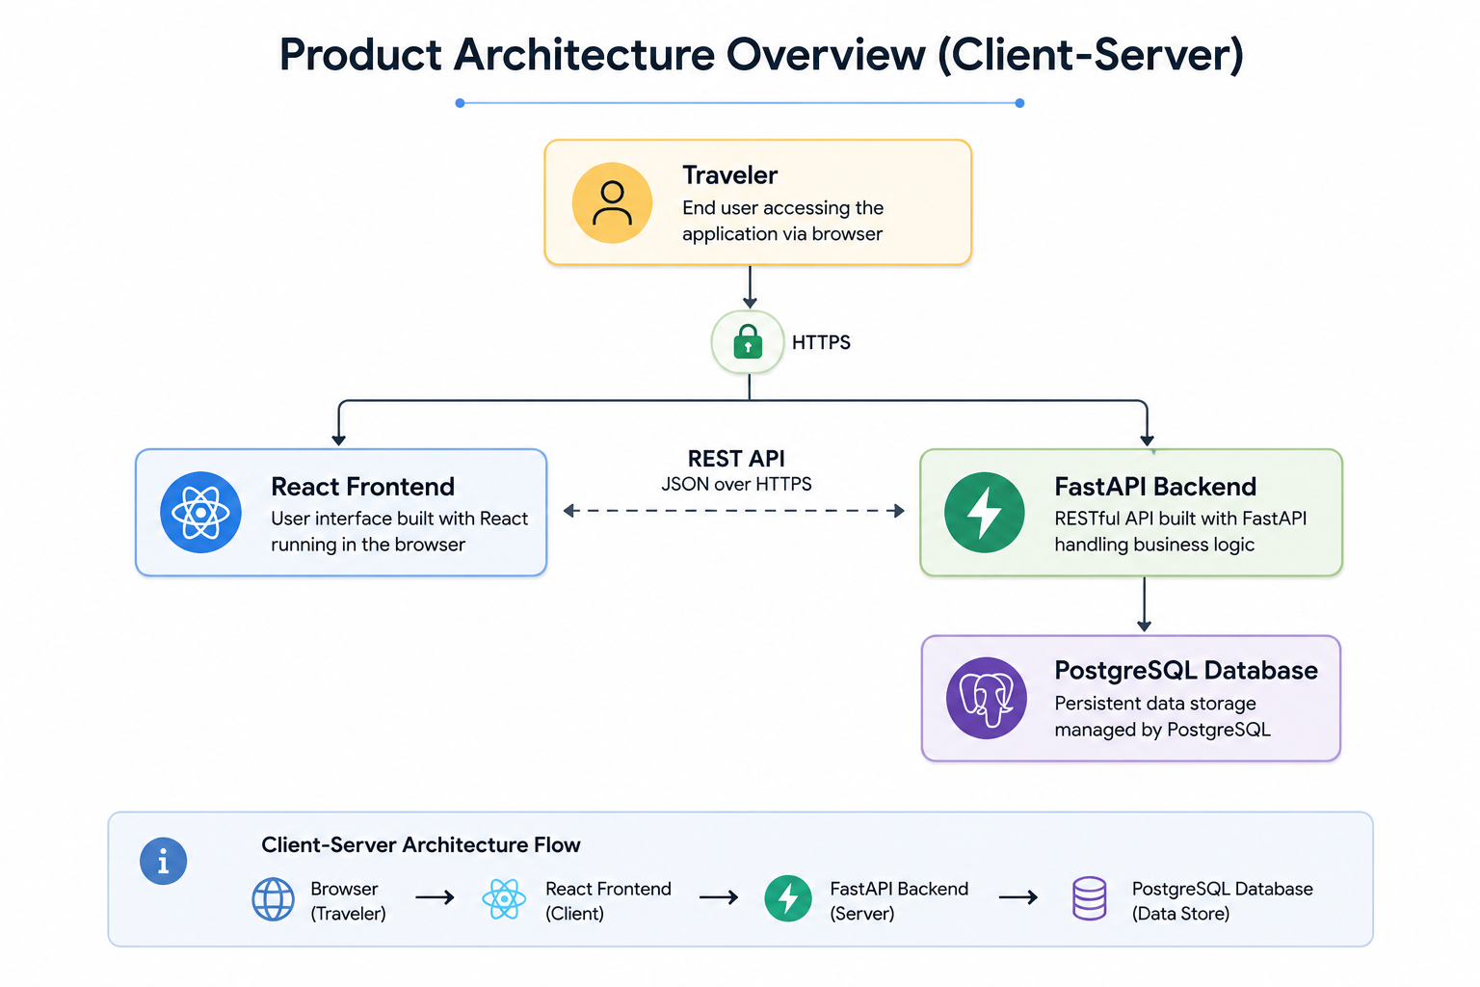

2.2 Product Functions
TripWise provides a comprehensive set of travel-planning functionalities through modular components. The major functions of the system include:
Authentication Module
- Traveler registration
- Secure login and logout
- Password management
- Profile management
Dashboard Module
- Display upcoming trips
- Display completed trips
- Budget summary
- Quick navigation to trip details
Trip Management Module
- Create a new trip
- Edit trip details
- Delete trips
- View trip information
- Organize multiple trips
Destination Management Module
- Add destinations to a trip
- Edit destination information
- Remove destinations
- View destination list
Itinerary Management Module
- Create day-wise itinerary
- Add scheduled activities
- Modify itinerary
- Remove activities
- Organize travel timeline
Budget & Expense Module
- Define trip budget
- Record expenses
- Categorize expenses
- Calculate remaining budget
- View spending summary
Accommodation Module
- Store accommodation details
- Edit accommodation information
- Delete accommodation records
Notes & Packing Module
- Create travel notes
- Maintain packing checklist
- Mark packed items
Administrative Module
- Manage traveler accounts
- Monitor system activity
- View travel statistics
- Remove inappropriate records

2.3 User Classes and Characteristics
TripWise consists of two primary user classes.
1. Traveler
The Traveler is the primary user of the application. Travelers use TripWise to plan, organize, and manage their trips.
Characteristics: Basic computer literacy, familiarity with web browsers, internet access, no technical expertise required.
Responsibilities: Register an account, plan trips, manage destinations, create itineraries, track expenses, maintain travel notes, update profile information.
2. Administrator
The Administrator is responsible for maintaining the platform and ensuring smooth operation.
Characteristics: Familiarity with system administration, authorized access privileges, basic understanding of application management.
Responsibilities: Manage traveler accounts, monitor trip records, view system statistics, maintain application integrity.
User Permissions Matrix:
Feature | Traveler | Administrator
Register / Login | Yes | Yes
Manage Profile | Yes | Yes
Create Trips | Yes | No
Manage Destinations | Yes | No
Manage Itinerary | Yes | No
Manage Budget | Yes | No
Manage Accommodation | Yes | No
Manage Packing List | Yes | No
View Personal Trips | Yes | No
View All Users | No | Yes
Manage Users / View Statistics | No | Yes

2.4 Operating Environment
Client Environment: Google Chrome, Microsoft Edge, Mozilla Firefox, Safari on Windows 10+, macOS, Linux, Android, and iOS.
Server Environment: Ubuntu Linux Server, FastAPI Application Server, PostgreSQL Database Server.
Network Requirements: Stable internet connection and HTTPS communication.

2.5 Design and Implementation Constraints
The development of TripWise is subject to the following constraints:
Technical Constraints: Frontend shall be developed using React; Backend shall be implemented using FastAPI (Python); PostgreSQL shall be used as the primary database; Communication shall use REST APIs with JSON; Authentication shall use JWT; Passwords shall be hashed with bcrypt.
Academic Constraints: The project shall be completed within the semester timeline; The implementation shall satisfy the Software Engineering Laboratory requirements; All documentation shall follow the prescribed SRS structure.
Security Constraints: Passwords shall never be stored in plain text; Only authenticated travelers shall access personal trip data; Administrative features shall be accessible only to authorized administrators.

2.6 User Documentation
The following documentation shall accompany TripWise:
- Installation Guide
- User Manual
- Administrator Guide
- API Documentation (optional)
- Project Report
- Software Requirements Specification (this document)
- UML Documentation

2.7 Assumptions and Dependencies
The following assumptions are considered during the development of TripWise:
- Travelers have access to a reliable internet connection.
- Users possess a valid email address for registration.
- Users provide accurate trip information.
- The backend server and database remain available during system operation.
- The application is primarily intended for individual travel planning in Version 1.
Advanced collaborative features such as Smart Carpool, Group Chat, Live Location Sharing, and AI-based itinerary recommendations are outside the scope of Version 1 and are planned for future releases.

3. External Interface Requirements

3.1 User Interfaces
TripWise provides a responsive web-based user interface designed to deliver a consistent experience across desktop and mobile browsers. The interface emphasizes simplicity, intuitive navigation, and quick access to frequently used travel-planning features.
Key user interfaces include:
- UI-001: Landing Page – Application overview and navigation to Register/Login.
- UI-002: Registration Page – Form for name, email, and password.
- UI-003: Login Page – Email and password authentication.
- UI-004: Traveler Dashboard – Upcoming/completed trips, budget summaries, and quick actions.
- UI-005: Trip Management – Create, edit, view, and delete trips.
- UI-006: Destination Management – Add, edit, and remove destinations (TripStops) for a trip.
- UI-007: Itinerary Planner – Day-wise activity planner with times and descriptions.
- UI-008: Budget Dashboard – Set budget, add expenses by category, view remaining budget and summaries.
- UI-009: Accommodation Management – Property details, dates, and booking reference per destination.
- UI-010: Notes & Packing List – Text notes and checklist with packed status.
- UI-011: Profile Management – View/edit information and change password.
- UI-012: Administrator Dashboard – User management and system statistics.
Design Principles: Consistency across modules, simplicity, responsiveness (desktop/tablet/mobile), accessibility, and immediate feedback through confirmation and error messages.

3.2 Hardware Interfaces
Since TripWise is a web application, hardware interfaces are minimal. It supports standard input devices (keyboard, mouse, touchscreen) on desktop computers, laptops, tablets, and smartphones. An active internet connection is required for full functionality.

3.3 Software Interfaces
The following software components form the implementation baseline for Version 1:
- Frontend: React
- Backend: FastAPI
- Database: PostgreSQL
- API Communication: REST API (JSON)
- Authentication: JWT
- Password Encryption: bcrypt
- Web Server: Uvicorn
- Version Control: Git & GitHub
The primary data entities shared across system components include User, Trip, Destination (TripStop), Itinerary Activity, Expense, Accommodation, Note, and PackingItem.

Figure 3.1 – TripWise Entity Relationship Diagram
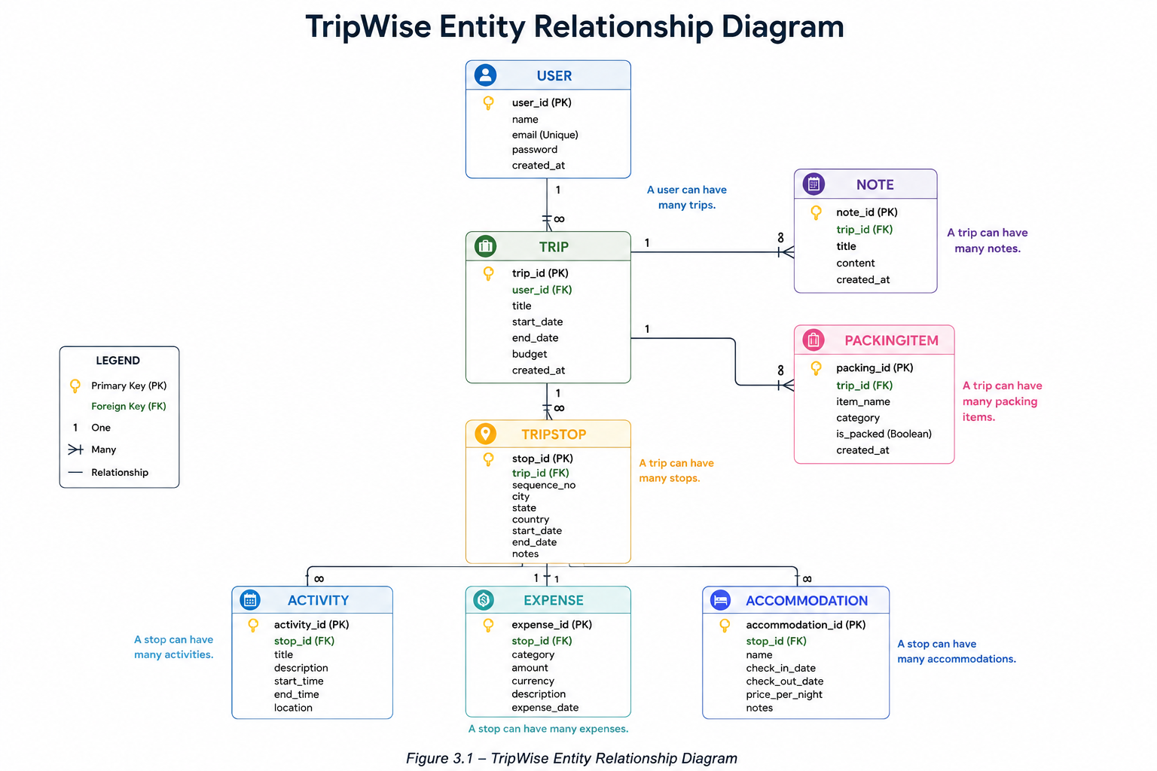

3.4 Communications Interfaces
The TripWise client and server communicate using secure RESTful APIs over HTTPS. Data is exchanged in JSON format.
- Protocol: HTTPS
- Data Format: JSON
- API Style: REST
- Authentication: JWT Bearer Token
- Character Encoding: UTF-8
Communication Flow: Traveler → React Frontend → HTTPS → FastAPI Backend → PostgreSQL Database.

4. System Features
This section organizes the functional requirements by major system features (the primary services provided by TripWise). Each feature follows a consistent structure: Description and Priority, Stimulus/Response Sequences, and Functional Requirements.

4.1 User Authentication (SF-001)
4.1.1 Description and Priority
Enables travelers to securely create an account, authenticate, and access TripWise using verified credentials. Protects traveler information and establishes user identity for all personalized services. Priority: High.
4.1.2 Stimulus/Response Sequences
- Traveler selects Register → Registration form is displayed.
- Traveler submits valid registration details → Account is created successfully and confirmation is shown.
- Traveler submits an existing email → Validation error message is displayed.
- Traveler selects Login → Login form is displayed.
- Traveler submits valid credentials → Authentication succeeds and the Dashboard is displayed.
- Traveler submits invalid credentials → Error message is displayed without revealing sensitive information.
- Traveler logs out → Session is terminated and the Login page is displayed.

Figure 4.1 – Traveler Login Sequence

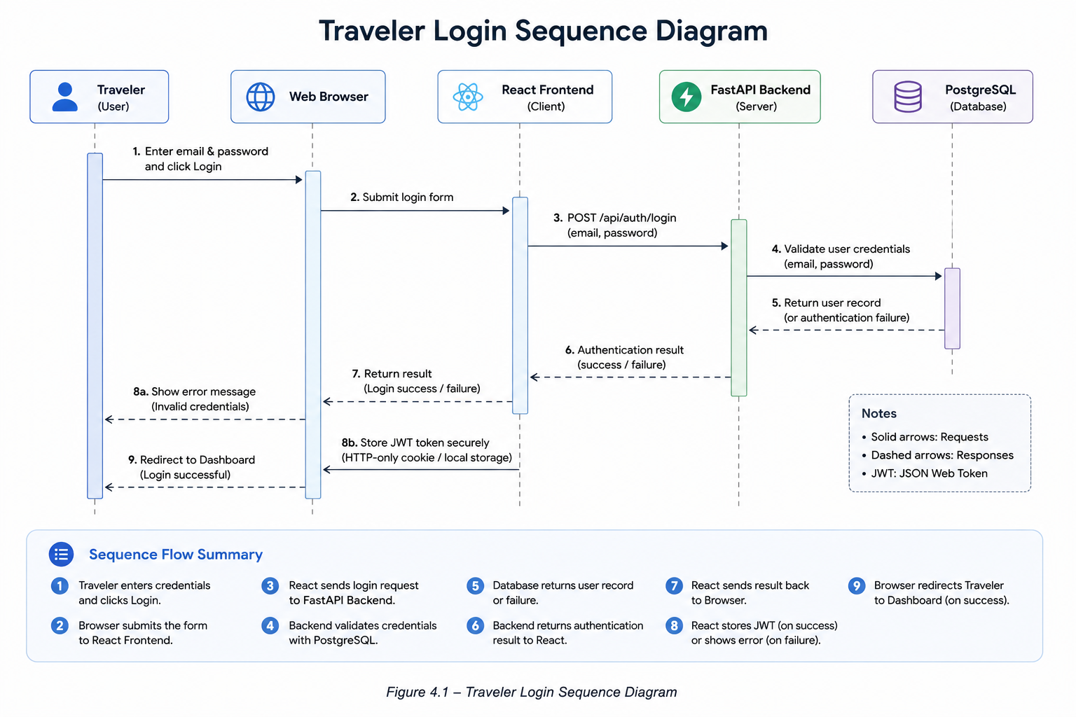
4.1.3 Functional Requirements
FR-001: The system shall allow a traveler to register using a unique email address, full name, and password. (High)
FR-002: The system shall validate that each registered email address is unique. (High)
FR-003: The system shall authenticate travelers using their registered email address and password. (High)
FR-004: The system shall securely terminate the traveler session upon logout. (Medium)
FR-005: The system shall allow travelers to change their password after successful authentication (accessible via Profile Management). (High)
FR-006: The system shall encrypt passwords before storing them in the database using bcrypt. (High)

4.2 Traveler Dashboard (SF-002)
4.2.1 Description and Priority
Provides travelers with a centralized overview of all trips, budgets, and quick navigation immediately after authentication. Enables quick access to ongoing and upcoming trips without navigating through multiple pages. Priority: High.
4.2.2 Stimulus/Response Sequences
- Traveler successfully logs in → Dashboard loads automatically with latest trip information.
- Traveler opens the Dashboard → Upcoming trips, completed trips, and budget summary are displayed.
- Traveler selects a trip card → Trip Details page opens.
4.2.3 Functional Requirements
FR-007: The system shall display all upcoming trips for the authenticated traveler. (High)
FR-008: The system shall display recently completed trips. (Medium)
FR-009: The system shall display a summary of the travel budget for active trips. (High)
FR-010: The system shall provide quick navigation to trip details. (High)

4.3 Trip Management (SF-003)
4.3.1 Description and Priority
Allows travelers to create, modify, organize, and manage personal travel plans. This is the core capability of TripWise and provides a structured environment for organizing all trip-related data. Priority: High.
4.3.2 Stimulus/Response Sequences
- Traveler selects Create Trip → Trip creation form is displayed.
- Traveler submits valid trip details (title, dates, budget) → Trip is created and saved.
- Traveler edits an existing trip → Updated information is stored after validation.
- Traveler selects Delete Trip → Confirmation dialog is shown; after confirmation the trip is permanently removed.
- Traveler views a trip → Complete trip details page is displayed.
4.3.3 Functional Requirements
FR-011: The system shall allow travelers to create a new trip by specifying a title, start date, end date, and estimated budget. (High)
FR-012: The system shall allow travelers to edit existing trip information. (High)
FR-013: The system shall allow travelers to delete trips after confirmation. (High)
FR-014: The system shall allow travelers to view complete trip details. (High)
FR-015: The system shall allow travelers to maintain multiple trips simultaneously. (Medium)

4.4 Destination Management (SF-004)
4.4.1 Description and Priority
Enables travelers to add, organize, update, and remove one or more destinations within a trip. Internally each destination is modeled as a TripStop; the user-facing term remains “Destination”. Priority: High.
4.4.2 Stimulus/Response Sequences
- Traveler selects Add Destination → Destination form is displayed.
- Traveler submits destination information → Destination is added to the selected trip.
- Traveler edits a destination → Updated information is saved.
- Traveler removes a destination → Confirmation is requested; after confirmation the destination is deleted.
- Traveler views trip destinations → Ordered destination list is displayed.
4.4.3 Functional Requirements
FR-016: The system shall allow travelers to add one or more destinations to an existing trip. (High)
FR-017: The system shall allow travelers to modify destination details including city, country, and travel dates. (High)
FR-018: The system shall allow travelers to remove destinations after confirmation. (Medium)
FR-019: The system shall display destinations in chronological order based on travel dates. (Medium)

4.5 Itinerary Planner (SF-005)
4.5.1 Description and Priority
Allows travelers to create, organize, and maintain a detailed day-wise itinerary by scheduling activities, assigning time slots, and recording important travel events. Priority: High.
4.5.2 Stimulus/Response Sequences
- Traveler selects Add Activity → Activity form is displayed.
- Traveler submits activity details (title, date, times, description) → Activity is added to the itinerary.
- Traveler edits an activity → Updated schedule is saved.
- Traveler removes an activity → Activity is deleted after confirmation.
- Traveler views itinerary → Day-wise itinerary is displayed in chronological order.
4.5.3 Functional Requirements
FR-020: The system shall allow travelers to create a day-wise itinerary for each trip. (High)
FR-021: The system shall allow travelers to add activities with a title, date, start time, end time, and description. (High)
FR-022: The system shall allow travelers to modify itinerary activities. (High)
FR-023: The system shall allow travelers to remove itinerary activities. (Medium)
FR-024: The system shall display activities in chronological order for each travel day. (High)

4.6 Budget & Expense Management (SF-006)
4.6.1 Description and Priority
Enables travelers to define a travel budget, record expenses, categorize spending, and monitor remaining funds throughout the trip. Priority: High.
4.6.2 Stimulus/Response Sequences
- Traveler sets trip budget → Budget is stored for the selected trip.
- Traveler records an expense → Expense is saved and categorized; remaining budget is recalculated.
- Traveler edits an expense → Updated expense information is stored and budget is recalculated.
- Traveler deletes an expense → Expense is removed and budget is recalculated.
- Traveler views budget summary → Spending analysis and remaining budget are displayed.
4.6.3 Functional Requirements
FR-025: The system shall allow travelers to define an estimated budget for each trip. (High)
FR-026: The system shall allow travelers to record expenses under predefined categories. (High)
FR-027: The system shall automatically calculate the remaining available budget. (High)
FR-028: The system shall allow travelers to edit recorded expenses. (Medium)
FR-029: The system shall allow travelers to delete recorded expenses. (Medium)
FR-030: The system shall display a categorized expense summary for each trip. (High)

4.7 Accommodation Management (SF-007)
4.7.1 Description and Priority
Enables travelers to record, organize, and manage accommodation details associated with each destination of a trip, including property information, check-in/check-out dates, booking references, and contact details. Priority: Medium.
4.7.2 Stimulus/Response Sequences
- Traveler selects Add Accommodation → Accommodation entry form is displayed.
- Traveler submits accommodation details → Accommodation information is saved for the selected destination.
- Traveler edits accommodation details → Updated information is stored successfully.
- Traveler deletes accommodation → Confirmation is requested; after confirmation the record is removed.
- Traveler views destination details → Associated accommodation information is displayed.
4.7.3 Functional Requirements
FR-031: The system shall allow travelers to record accommodation information for each destination within a trip. (High)
FR-032: The system shall allow travelers to store accommodation details including property name, address, check-in date, check-out date, booking reference, and contact information. (High)
FR-033: The system shall allow travelers to modify stored accommodation information. (Medium)
FR-034: The system shall allow travelers to remove accommodation records after confirmation. (Medium)
FR-035: The system shall associate each accommodation record with a specific destination within a trip. (High)

4.8 Notes & Packing List Management (SF-008)
4.8.1 Description and Priority
Enables travelers to maintain trip-specific notes and packing checklists to ensure important information and travel essentials are organized before and during the journey. Priority: Medium.
4.8.2 Stimulus/Response Sequences
- Traveler selects Add Note → Note editor is displayed.
- Traveler saves a note → Note is stored under the selected trip.
- Traveler adds a packing item → Packing item is added to the checklist.
- Traveler marks an item as packed → Item status is updated.
- Traveler deletes a note or packing item → Selected item is removed after confirmation.
4.8.3 Functional Requirements
FR-036: The system shall allow travelers to create, edit, and delete trip notes. (Medium)
FR-037: The system shall allow travelers to maintain a packing checklist for each trip. (High)
FR-038: The system shall allow travelers to mark packing items as packed or unpacked. (Medium)
FR-039: The system shall associate notes and packing lists with their respective trips. (High)

4.9 User Profile Management (SF-009)
4.9.1 Description and Priority
Enables travelers to manage their personal account information and account security settings. Priority: Medium.
4.9.2 Stimulus/Response Sequences
- Traveler opens Profile → Current profile information is displayed.
- Traveler edits profile details → Updated information is validated and saved.
- Traveler changes password → Password is securely updated after verification of the current password.
4.9.3 Functional Requirements
FR-040: The system shall allow travelers to view their profile information. (High)
FR-041: The system shall allow travelers to update their personal information. (High)
FR-042: The system shall allow travelers to change their account password after successful authentication. (High)
FR-043: The system shall maintain an updated profile for every registered traveler. (Medium)

4.10 Administration (SF-010)
4.10.1 Description and Priority
Provides administrators with the necessary tools to oversee the TripWise platform, manage traveler accounts, monitor system activity, and maintain operational integrity. Priority: High.
4.10.2 Stimulus/Response Sequences
- Administrator logs in → Admin Dashboard is displayed.
- Administrator views travelers → Traveler list is displayed.
- Administrator selects a traveler → Traveler information is displayed.
- Administrator deactivates an account → Account status is updated.
- Administrator views statistics → Dashboard displays system analytics.
4.10.3 Functional Requirements
FR-044: The system shall provide administrators with a dedicated administrative dashboard. (High)
FR-045: The system shall allow administrators to view registered traveler accounts. (High)
FR-046: The system shall allow administrators to activate or deactivate traveler accounts. (High)
FR-047: The system shall provide administrators with system usage statistics. (Medium)
FR-048: The system shall restrict administrative functionality to authenticated administrators only. (High)

4.11 Feature Prioritization (MoSCoW)
The following prioritization reflects release planning. Must Have features define the Minimum Viable Product (MVP).
Must Have: Authentication, Dashboard, Trip Management, Destination Management, Itinerary Planner, Administration
Should Have: Budget & Expense Management, Accommodation Management, User Profile
Could Have: Notes & Packing List Management

4.12 Chapter Summary
System Features: 10
Functional Requirements: 48 (FR-001 through FR-048)
Primary Use Cases: 12 (see Appendix B)
Note: Detailed Acceptance Criteria and additional Business Rules are maintained in the project repository and UML documentation.

5. Other Nonfunctional Requirements

5.1 Performance Requirements
NFR-001: 95% of Traveler Dashboard load requests shall complete within 3 seconds under normal network conditions. (High)
NFR-002: 95% of trip creation requests shall be processed within 2 seconds. (High)
NFR-003: 95% of search requests shall return results within 2 seconds. (Medium)
NFR-004: The system shall support at least 100 concurrent authenticated travelers without significant performance degradation. (Medium)
NFR-005: The system shall minimize unnecessary database queries through efficient API design. (Medium)

5.2 Safety Requirements
NFR-006: The system shall request confirmation before permanently deleting trips, destinations, accommodations, or expenses. (High)
NFR-007: The system shall validate all user input before processing requests. (High)
NFR-008: The system shall prevent invalid travel dates from being saved. (High)
NFR-009: The system shall prevent accidental modification of another traveler’s data. (High)

5.3 Security Requirements
NFR-010: Passwords shall be stored using a secure hashing algorithm (bcrypt). (High)
NFR-011: All authenticated requests shall require a valid JWT access token. (High)
NFR-012: Travelers shall access only their own trips and associated information. (High)
NFR-013: Administrative functions shall be restricted to authenticated administrators. (High)
NFR-014: Sensitive communication between client and server shall use HTTPS. (High)
NFR-015: User sessions shall expire automatically after a configurable period of inactivity. (Medium)
NFR-016: The system shall protect against SQL Injection by using parameterized queries / prepared statements for all database operations. (High)
NFR-017: The system shall validate and sanitize all user inputs on both client-side and server-side. (High)

5.4 Software Quality Attributes
The following quality attributes are expressed as measurable requirements:
NFR-018 (Usability): A new user shall be able to create a basic trip (title + dates) within 5 minutes without training.
NFR-019 (Maintainability): A single functional module shall be modifiable without requiring changes to more than one unrelated module; unit test coverage for core modules shall be ≥ 70%.
NFR-020 (Scalability): Future modules (e.g., Smart Carpool, AI Itinerary) shall be integratable by adding no more than 3 new classes and 2 new database tables without modifying existing core module interfaces. (High)
NFR-021 (Reliability): Data shall remain consistent during normal operation; database transactions shall maintain ACID properties.
NFR-022 (Portability): The application shall operate correctly on the latest versions of Chrome, Firefox, Edge, and Safari without platform-specific code changes.

5.5 Business Rules
Key domain-level rules that the system must enforce:
- BR-001: Every email address must be unique.
- BR-002: Passwords must be at least 8 characters long and contain at least one uppercase letter, one lowercase letter, one digit, and one special character.
- BR-003: Only authenticated travelers may access protected modules.
- BR-004: A traveler may create multiple trips.
- BR-005: Every TripStop (destination) shall belong to exactly one trip.
- BR-006: Every accommodation shall belong to exactly one TripStop.
- BR-007: Every itinerary activity shall belong to one TripStop.
- BR-008: Expenses shall be associated with a TripStop.
- BR-009: Packing items and notes shall belong to one trip.
- BR-010: Travelers shall access only resources that they own.
- BR-011: Administrators may view and manage all traveler accounts.

5.6 Scalability & Maintainability
NFR-023: Integration of external APIs (Google Maps, OpenWeather) shall require changes limited to a single adapter module and no more than 50 lines of new configuration code. (Medium)
NFR-024: The backend shall follow a modular architecture with clear separation of concerns (authentication, trip management, itinerary, administration); each module shall be independently testable and replaceable. (High)
NFR-025: The database shall follow normalization principles to reduce redundancy. (Medium)

5.7 Availability & Reliability
NFR-026: The system shall preserve traveler data during normal application failures. (High)
NFR-027: Database transactions shall maintain consistency when creating or updating trips. (High)
NFR-028: The system shall recover gracefully from unexpected application errors by displaying meaningful error messages instead of exposing internal exceptions. (Medium)

6. Other Requirements

6.1 Future Enhancements
Although TripWise Version 1 focuses on core travel planning, the system is designed for extensibility. Future versions may incorporate the following features:
Feature | Description | Planned Version
Smart Carpool | Match travelers with similar routes and travel dates for shared transportation. | Version 2
Group Chat | In-app messaging for travelers participating in the same trip. | Version 2
Live Location Sharing | Real-time location sharing among trip members. | Version 2
Nearby Places | Recommend nearby restaurants, hospitals, fuel stations, ATMs, and emergency services. | Version 2
Weather Alerts | Display weather forecasts and recommend itinerary adjustments. | Version 2
Split Expense Management | Automatically calculate and distribute shared expenses among travelers. | Version 2
AI Itinerary Generator | Generate optimized travel schedules based on destination, duration, and budget. | Version 3
Emergency SOS | Send emergency alerts with the traveler's current location to predefined contacts. | Version 3

6.2 Out of Scope (Version 1)
The following features are intentionally excluded from Version 1 to focus on a stable, maintainable MVP:
- Online Flight Booking (requires third-party airline reservation systems)
- Hotel Reservation Services (accommodation details are stored manually)
- Online Payment Gateway
- Live GPS Tracking
- Voice & Video Calling
- Offline Synchronization
- Multi-language Support
- AI-based Personalized Recommendations (planned after core modules)

6.3 Design Philosophy
TripWise has been designed according to the following software engineering principles:
- Modularity – Each functional module is independently developed and maintained.
- Scalability – The architecture supports future expansion with minimal structural changes.
- Usability – The interface prioritizes simplicity and intuitive navigation.
- Security by Design – Authentication and authorization are incorporated into every protected module.
- Maintainability – Components follow clear separation of concerns.
- Traceability – Every functional requirement is linked to system features, UML diagrams, and implementation.

6.4 Document Traceability Summary
ER Diagram ← Functional Requirements & Domain Model
Use Case Diagram ← System Features
Class Diagram ← Domain Model & ER Diagram
Activity Diagram ← Stimulus–Response Sequences
Sequence Diagram ← Functional Requirements
Database Schema ← ER Diagram
User Interface ← System Features
Implementation ← Software Requirements Specification

Appendix A: Glossary
Traveler: A registered user who creates and manages trips.
Administrator: A user responsible for managing the TripWise platform.
Trip: A travel plan created by a traveler.
TripStop (User-facing term: Destination): A planned stop within a trip, representing a city, landmark, attraction, or location.
Accommodation: Lodging information associated with a destination.
Itinerary Activity: A scheduled event or task within a destination.
Expense: A financial transaction recorded during a trip.
Packing Item: An item included in the travel checklist.
Dashboard: The main interface displaying trip summaries and quick actions.
JWT: JSON Web Token used for authentication.
REST: Representational State Transfer API architecture.
bcrypt: Secure password hashing algorithm.

Appendix B: Analysis Models
The following analysis models are developed from this Software Requirements Specification and are maintained in a separate UML documentation package:
- Entity Relationship (ER) Diagram – Refer to submitted UML Document
- Use Case Diagram – Refer to submitted UML Document
- Class Diagram – Refer to submitted UML Document
- Activity Diagram – Refer to submitted UML Document
- Sequence Diagram – Refer to submitted UML Document
- System Architecture Diagram – Additional detailed UML artifacts (Class Diagram and Activity Diagram) are maintained in the separate UML documentation package.

Figure B.1 – TripWise Use Case Diagram
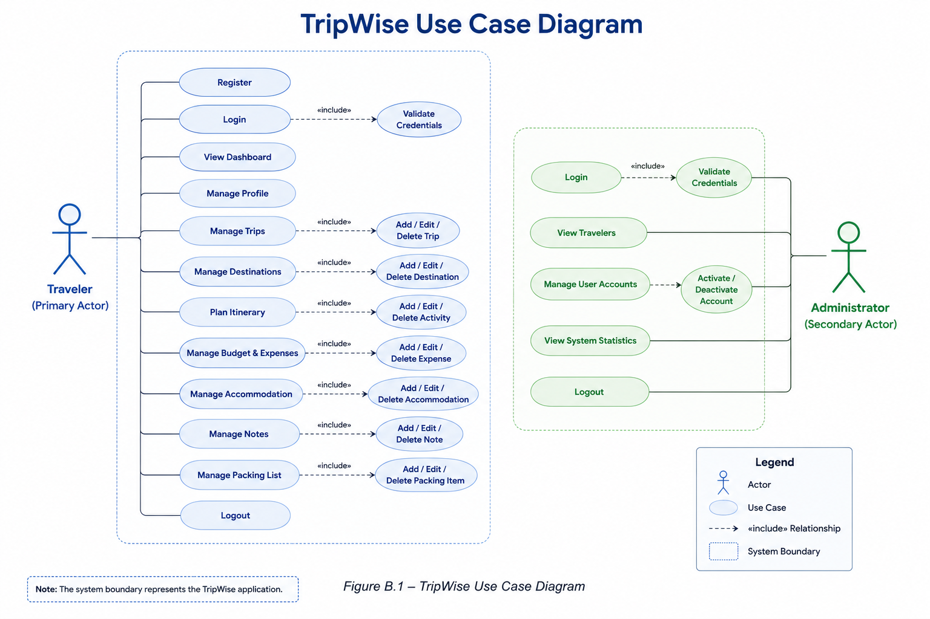

Appendix C: To Be Determined List
TBD-001: AI-generated itinerary optimization algorithm (requires further research and evaluation).
TBD-002: Carpool matching algorithm (depends on future collaboration features).
TBD-003: Integration with external booking platforms (pending API availability and licensing).
TBD-004: Offline synchronization strategy (requires conflict resolution design).
TBD-005: Push notification service technology selection.

— End of Document —

