PROJECT BASED LEARNING (PBL)

Report on

## UNIT CONVERTER

**Submitted for partial fulfillment of the requirements for the subject**

**17ITC01 & OOPS USING JAVA**

**lll SEMESTER / ll YEAR**

## BACHELOR OF ENGINEERING

**IN INFORMATION TECHNOLOGY**

***Submitted by***

### Register no: 21IT042

**Name of the student : SANJAY R**

Project coordinator Mrs.A BHARATHI

Assistant Professor of IT



## DEPARTMENT

**OF**

## INFORMATION TECHNOLOGY NANDHA ENGINEERING COLLEGE (Autonomous)

**ERODE – 638052**

## DECEMBER 2022

**NANDHA ENGINEERING COLLEGE**

(An Autonomous Institution, Aﬃliated to Anna University,Chennai)

## CERTIFICATE

This is to certify that the project work entitled “UNIT CONVERTER” is a bonaﬁde work carried out by

|  |  |
| --- | --- |
| Register No. | Name of the student |
| 21IT042 | SANJAY R |
|  |  |
|  |  |

#### in partial fulﬁllment of the requirements for the course 17ITC01& OOPS USING JAVA, lll sem / ll yr of BACHELOR OF ENGINEERING IN

INFORMATION TECHNOLOGY ENGINEERING during the academic year 2022-2023

**Mrs. A BHARATHI Dr.C SIVA**

**NAME OF THE GUIDE HEAD OF THE DEPARTMENT**

**PROJECT GUIDE: Mrs.A BHARATHI AP/IT**

## ACKNOWLEDGEMENT

#### The development of the project as part of Project based Learning in the course 17ITC01 & OOPS USING JAVA, lll-Sem/ ll-yr though it was an arduous task, it has been made by the help of many people. We are pleased to express our thanks to the people whose suggestions, comments, criticisms greatly encouraged us in betterment of the project. We would like to express our sincere gratitude and indebtedness to project Guide Mrs.A BHARATHI AP/IT, for his/her valuable suggestions and interest throughout the course of this project.

We wish to convey our gratefulness to our **Principal Dr. N.Rengarajan, B.Sc., B.Tech., M.E., Ph.D.,** for his strong support and motivation in completing this project.

We take this opportunity to express our thanks to Dr.C SIVAHead of the Department & Project Co-Ordinator for their continuous monitoring, motivation and priceless assistance during the course of our project work.

**TABLE OF CONTENTS**

**CHAPTER NO:**

1. ABSTRACT
2. INTRODUCTION
3. SYSTEM SPECIFICATION
4. SOFTWARE DESCRIPTION
5. PROJECT DESCRIPTION
6. FUTURE ENHANCEMENT
7. CONCLUSION
8. APPENDIX
   1. SOURCE CODE
   2. SCREEN SHOTS
9. REFERENCE

# ABSTRACT

Unit Converter is a quick, easy and powerful tool for converting various measurement units. Unit converter can convert different units of measure viz. Acceleration, Angle, Area, Current/Electric Current, Data or Bits & Bytes, Density, Energy, Force, Fuel consumption, Frequency. Length, Light-Illumination, Light-Luminance, Power, Pressure, Sound, Speed, Temperature, Time, Torque, Volume, Weight/Mass and etc.. As you might expect, the phone runs on the Android operating system and has specially designed applications and middleware. The applications are written in Java language and the system can also run applications that are written in other languages, like C language. But probably the biggest difference between Android phones and all the others is that Android has an advanced, complex operating system. By comparison, most other mobile phones, even the iPhone, run simple, real-time applications. When it comes to the internet, Android phones use WebKit to run Google's Chrome Lite web browser. Since Webkit is also used on the iPhone, Android phones are in direct competition with the iPhone when it comes to internet capabilities.

However, Android phones have several distinct advantages over the competition due in a large part to their more complex operating system. For instance, Android phone can run several applications simultaneously. which obviously makes it easier to multitask and improves the overall functionality of the phone. In fact, many Android phone users report that they are faster, more fluid, and casier to use that competing models. Another great thing about Android phones is that their platform is not tethered to a specific company, which means that any phone maker who wants to produce an Android phone can simply start making them. This will most likely lead to increased competition in the future and to lower mobile phone costs for consumers.

# INTRODUCTION

During the fall 2013 semester, our teacher told us to create a program in java Complier using java Language. We decide to create a Converter that can convert Temperature, Time and Length. Because in creating such a program we can learn many new techniques about how to make programAfter we complete the program, now we really know many things that we don't know previous.

# 3.SYSTEM SPECIFICATION

HARDWARE SPECIFICATIONS

* + Hard disk - 40 GB
  + Processor-. Pentium IV 2.4
  + GHZ Ram - 1 GB

OPERATING SYSTEMS

* + Windows XP (32-bit)
  + Vista (32- or 64-bit)
  + Windows 7 (32- or 64-bit)

# SOFTWARE SPECIFICATIONS

* + Eclipse IDE for Java Developers. Eclipse 3.6.2

**(**Helios) or greater:

* + Eclipse JDT plug-in (included in most Eclipse IDE packages)
  + JDK 6 (JRE alone is not sufficient)
  + Android Development Tools plug-in (recommended)

# PROJECT DESCRIPTION

Unit Converter is an android application developed for cell phones and android tablets. This app is for the conversion of one unit of physical quantity to anther equivalent unit; for example: conversion from degree Celsius to Kelvin or other equivalent units. Using this Unit Converter application, occurrence of error in unit conversion can be rooted out. The application establishes an easy and effective platform for unit conversion in Android devices.

Although SI unit is universally accepted, science and engineering works are not measured with the same units all over the world. Some nations’ code specifies meter as unit of length and some as feet. It means that measurement units are not same in all parts of the world.

In the manual system of unit conversion, there is high chance of occurrence of error, and it is not user-friendly. Further, it is tedious and time consuming. Only the experts or educated person is capable of unit conversion. But, it doesn’t need any skilled person to use this Unit Converter Android app. Anybody can convert any unit to desired equivalent unit easily and accurately.This project involves creating a unit converter in Java. The user will be able to select a unit of measurement and enter a value, and the program will convert the value to the desired unit of measurement. The program should include a GUI that allows users to select the unit of measurement and enter the value to be converted.

The programshould also have a back-end that implements the conversion algorithms. The algorithms should be able to handle a variety of units of measure, including length, area, volume, temperature, and weight. Additionally, the program should be able to handle both metric and imperial units of measure.

# STEPS INVOLVED

STEP 1: GETTING SET UP

STEP 2: CREATE A SKELETON FOR LENGTHCONVERTER STEP 3: CREATE ANY INSTANCE VARIABLES

STEP 4: IMPLEMENT CONSTRUCTOR STEP 5: IMPLEMENT TOMETERS() STEP 6: IMPLEMENT FROMMETERS() STEP 7: CREATE A MAIN() METHOD STEP 8: SCANNER AND USER INPUTS

STEP 9: CONSTRUCT TWO LENGTHCONVERTER OBJECTS

STEP 10: OBTAIN THE VALUE TO BE CONVERTED STEP 11: "FROM" TO METERS

STEP 12: METERS TO "TO"

# FUTURE ENHANCEMENTS

For future enhancements, the unit converter could be expanded to support additional types of measurements, such as time, energy, force, and power. Additionally, the unit converter could be updated to support additional metric and imperial units of measure. Finally, the user interface could be redesigned to provide a more intuitive user experience.

For future applications, the unit converter could be used to create a mobile app that can be used to convert units of measurement on the go. Additionally, the unit converter could be used as a component in other software applications that require unit conversions, such as engineering or construction software. Finally, the unit converter could be used to create an online platform that allows users to convert units of measurement from any location.

### MODULE DESCRIPTION

1. User Interface
2. Unit Conversion
3. Social Network Sharing
   * User Interface: The User Interface module is mainly depends on the user satisfaction and Interactions. The user interface is designed based on the user friendly UI designs. This Application is easy to use users. And it's designed to support Android versions 2.1 to 4.2.
   * Unit Conversion: The Unit conversion module is mainly contains the Unit Conversion operations. Unit Converter is a quick, easy and powerful tool for converting 75+ various categories and around 45,000 conversions.
   * Social Network Sharing: This module is mainly contains social network sharing options like Face book, email and SMS. The sharing is done by using the Broadcasting concepts in android.

# CONCLUSION

This project has successfully created a unit converter in Java that can convert a variety of units of measure. The unit converter is designed to be user-friendly, and it is capable of converting both metric and imperial units of measure. For future applications, the unit converter could be used in a variety of ways, such as in mobile apps, engineering software, and online platforms.

1. **APPENDIX**
   1. **SOURCE CODE**

import java.util.Scanner; public class Main

{

public static void main(String[] args)

{

Scanner in = new Scanner(System.in); System.out.println("Enter the Unit which want to Convert from:"); String fromUnit = in.nextLine();

System.out.println("Enter the Unit which want to Convert to: "); String toUnit = in.nextLine();

Uerter from = new Uerter(fromUnit); Uerter to = new Uerter(toUnit);

System.out.println("Enter the Value of Unit which want to Convert from:"); double val = in.nextDouble();

double meters = from.toMeters(val); double converted = to.fromMeters(meters);

System.out.println(val + " " + fromUnit + " = " + converted + " " + toUnit);

}

}

class Uerter

{

static double INCHES = 0.0254001; static double FEET = 0.3048;

static double MILES = 1609.35; static double MILLIMETERS = 0.001; static double CENTIMETERS = 0.01; static double METERS = 1;

static double KILOMETERS = 1000; private double val ,meters ,converted; String afromUnit;

public Uerter(String fromUnit)

{

afromUnit = fromUnit;

}

public double toMeters(double val)

{

if(afromUnit.equals("inch"))

{

meters = (val*INCHES);

}

else if(afromUnit.equals("ft"))

{

meters = (val*FEET);

}

else if(afromUnit.equals("mi"))

{

meters = (val*MILES);

}

else if(afromUnit.equals("mm"))

{

meters = (val*MILLIMETERS);

}

else if(afromUnit.equals("cm"))

{

meters = (val*CENTIMETERS);

}

else if(afromUnit.equals("m"))

{

meters = (val*METERS);

}

else if(afromUnit.equals("km"))

{

meters = (val*KILOMETERS);

}

return meters;

}

public double fromMeters(double meters)

{

if(afromUnit.equals("inch"))

{

converted = Math.round(meters*39.369923740457715);

}

else if(afromUnit.equals("ft"))

{

converted = Math.round(meters*3.280839895013123);

}

else if(afromUnit.equals("mi"))

{

converted = Math.round(meters*1609.34);

}

else if(afromUnit.equals("mm"))

{

converted = Math.round(meters*1000);

}

else if(afromUnit.equals("cm"))

{

converted = Math.round(meters*100);

}

else if(afromUnit.equals("m"))

{

converted = Math.round(meters*1);;

}

else if(afromUnit.equals("km"))

{

converted = Math.round(meters*0.001);

}

return converted;

}

}

# SCREENSHOTS

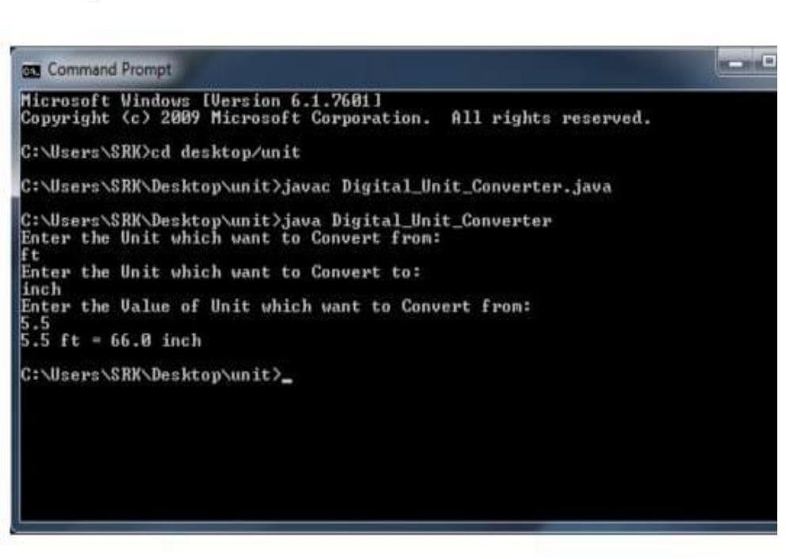

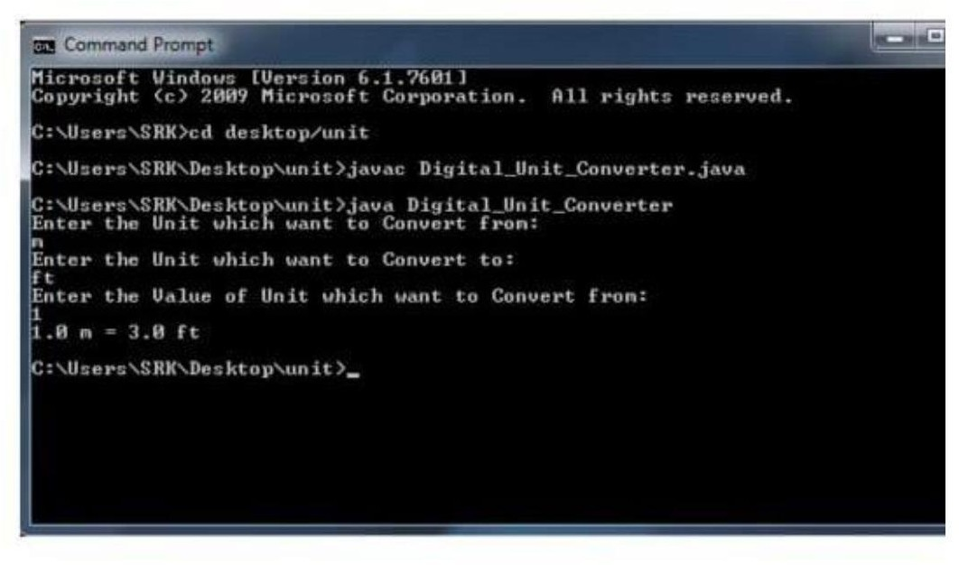

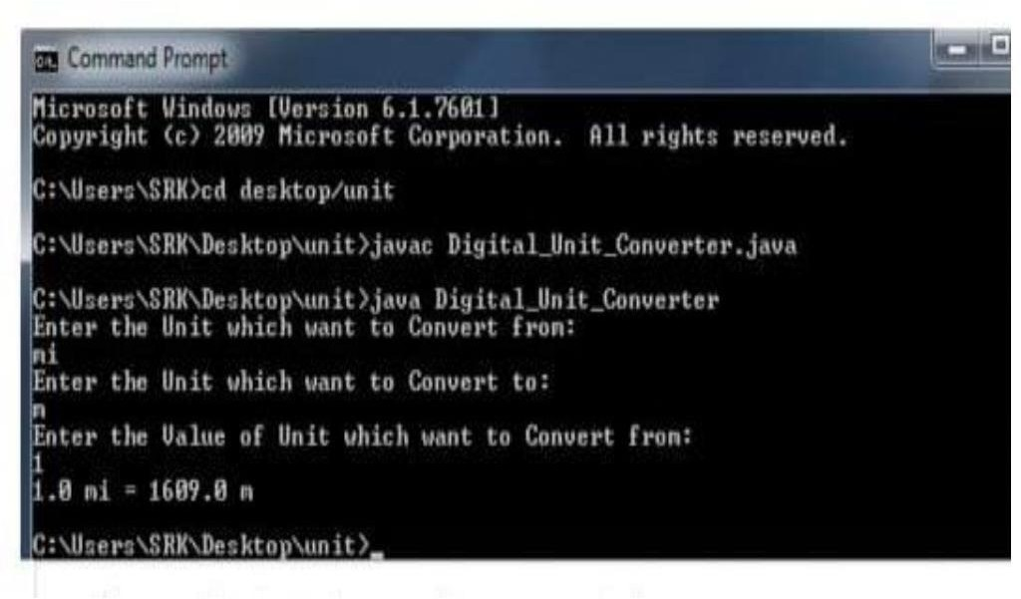

1. **REFERENCE**
   1. JAVA THE COMPLETE REFERENCE [https://w](http://www.udemy.com/course/java-for-beginners-in-2-h)ww.udemy[.com/course/java-for-beginners-in-2-h](http://www.udemy.com/course/java-for-beginners-in-2-h)

ours 2. EXPERT ORACLE JDBC PROGRAMING

-RM MENON

1. CORE JAVA - JAVA FUNDAMENTALS

#### [www.javapoint.com.](http://www.javapoint.com/)