EDUGENIE
Google Gemini Powered Learning Assistant
COMPLETE PROJECT DOCUMENTATION

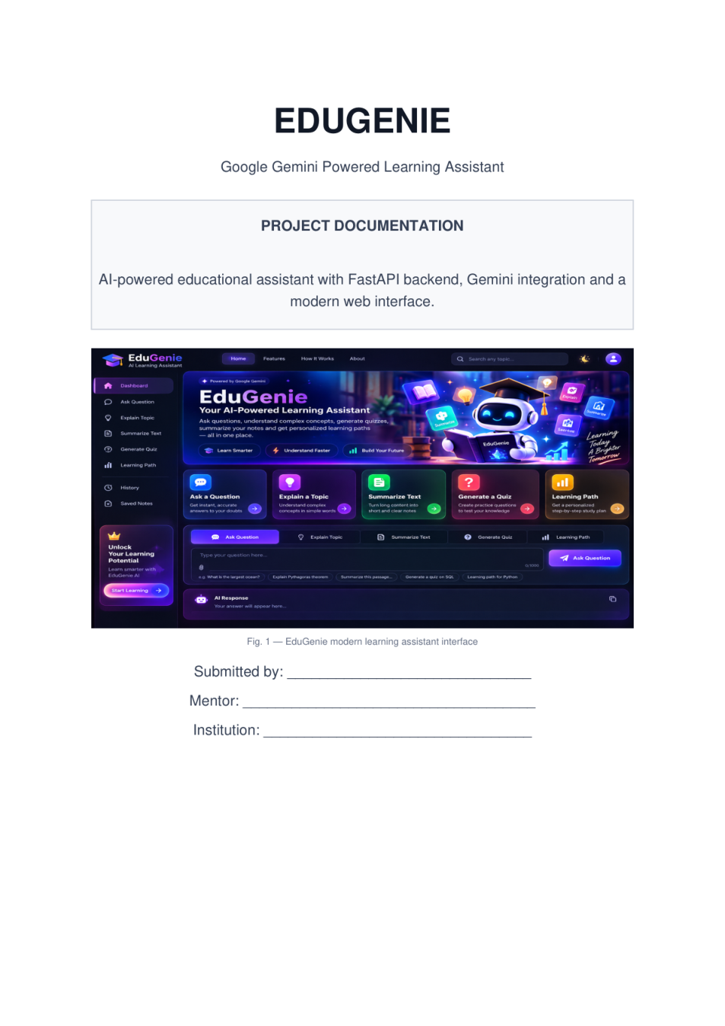
Figure 1. Supplied EduGenie project cover/interface evidence.
DOCUMENT BASIS This report was reconstructed from the current EduGenie source ZIP and the supplied screenshot-based project documentation. Source-code behavior is treated as authoritative where it differs from the reference screenshots.

Document detail | Value
Project | EduGenie
Application type | AI-powered educational web assistant
Backend | FastAPI + Uvicorn
AI provider | Google Gemini
Frontend | HTML + CSS + JavaScript
Validation / schemas | Pydantic
Documentation status | Complete source-based project report

Table of Contents
1. Executive Overview
2. Project Description
3. Problem Statement & Proposed Solution
4. Objectives & Scope
5. Key Features
6. System Architecture
7. Technology Stack
8. Project Structure
9. Backend API Design
10. AI / Gemini Integration
11. Feature Modules
12. Frontend Design & User Experience
13. End-to-End Workflow
14. Setup & Installation
15. Configuration & Security
16. Testing & Validation
17. Current Limitations & Implementation Status
18. Future Enhancements
19. Conclusion
Appendix A — API Reference
Appendix B — File-by-File Guide
QUICK VIEW EduGenie combines five learning workflows—Q&A, explanation, summarization, quiz generation and learning recommendations—behind a single browser interface.

1. Executive Overview
EduGenie is a lightweight, browser-based educational assistant that uses generative AI to help learners understand, revise and practice academic content. The current implementation uses FastAPI for request routing, modular Python feature services for learning tasks, Google Gemini for text generation, Pydantic for request/response validation, and a custom HTML/CSS/JavaScript interface.
The application is deliberately modular: the API layer receives validated input, delegates each learning task to a dedicated module, and the shared Gemini client handles model communication. Quiz generation is additionally schema-constrained so that the frontend receives predictable JSON.
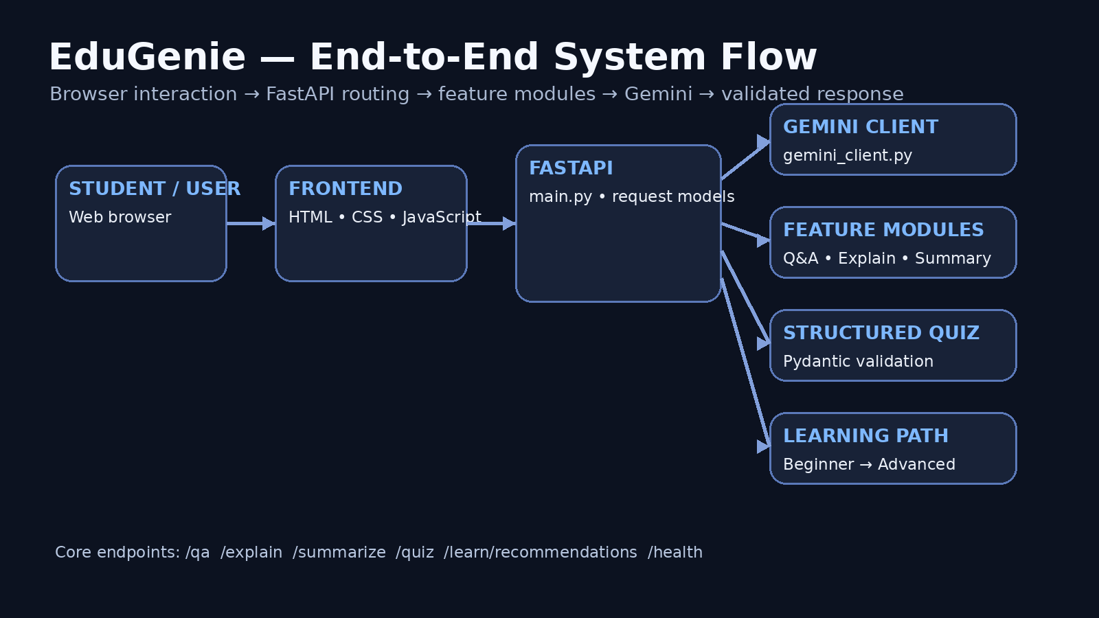
Figure 2. Source-based end-to-end architecture created for this documentation.

At-a-glance strengths
- Five clearly separated educational workflows with dedicated backend modules.
- Shared Gemini client with configurable model name and reusable generation helpers.
- Structured quiz output enforced with Pydantic validators: exactly 3 questions and 4 options per question.
- Input length validation at the FastAPI boundary: up to 5,000 characters for questions/topics and 30,000 for text-based tasks.
- Responsive single-page learning workspace with dark/light theme support, task tabs, loading states, error feedback and quiz scoring.
- Optional local explanation provider using a Transformers pipeline, while Gemini remains the default provider.

2. Project Description
The supplied reference documentation describes EduGenie as a Google Gemini powered learning assistant and organizes the work around architecture, module implementation, FastAPI integration, frontend development, deployment, configuration/security and functional testing. The current source implements that same broad structure with a cleaner shared Gemini service.
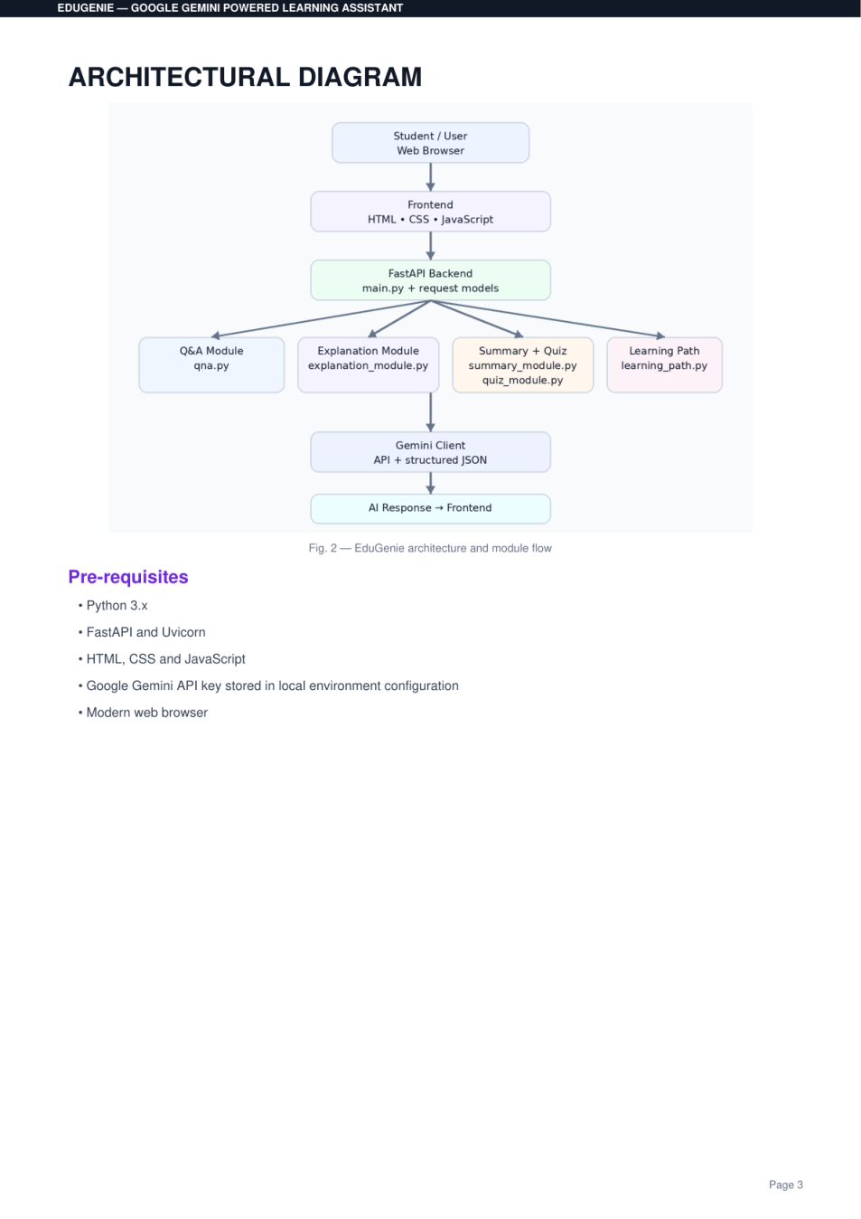
Figure 3. Supplied architecture evidence from the reference documentation.

Core learning scenarios
Scenario | User action | System result
Ask a question | Enter an academic question | Concise AI-generated educational answer
Explain a topic | Enter a difficult concept | Beginner-friendly explanation with definition, working, example and important points
Summarize text | Paste educational content | Concise revision-oriented summary
Generate a quiz | Enter a topic or passage | Three validated MCQs with four options and answer explanations
Learning path | Enter a topic | Beginner → Intermediate → Advanced study roadmap with practice and timeline guidance

Project value
The application reduces the friction between finding study material and turning that material into actionable learning activities. Instead of exposing the learner to a generic chatbot alone, the interface presents purpose-built tasks for understanding, revision, assessment and structured progression.

3. Problem Statement & Proposed Solution

Problem statement
- Students often need to switch between separate tools for doubt clearing, explanation, summarization and practice.
- Long study material can be difficult to revise quickly.
- A generic AI chat interface does not automatically enforce educational output structures such as a fixed quiz format.
- Learners may know the topic they want to study but not the sequence in which concepts should be learned.

Proposed solution
- Provide a single learning workspace containing five task-specific AI workflows.
- Use prompt instructions that target clarity, beginner-friendly language and educational usefulness.
- Use structured Pydantic validation for quiz responses to make the AI output predictable for the browser.
- Provide a learning-path generator that organizes progression from beginner to advanced levels.
- Keep the architecture modular so future features can be added without rewriting the entire application.
DESIGN PRINCIPLE EduGenie is not just a model call. The project combines UI design, API validation, prompt engineering, structured generation, configuration management and frontend rendering into one learning product.

4. Objectives & Scope

Primary objectives
- Create a modern web interface for AI-assisted learning.
- Implement reliable FastAPI endpoints for the five learning functions.
- Connect all AI workflows to a reusable Gemini service.
- Validate user inputs and AI-generated quiz structures.
- Provide an optional local explanation pathway.
- Support local development, testing and Git-based project management.

In scope
Area | Included in current source
AI learning | Q&A, explanation, summarization, quiz, learning path
Backend | FastAPI app, Pydantic models, endpoint validation, health check
Frontend | Dashboard, task tabs, workspace, response panel, quiz interaction
Configuration | .env-based Gemini settings and provider selection
Testing | FastAPI TestClient tests for home, health and empty-input validation
Developer experience | requirements files, VS Code settings and extension recommendations

Out of scope / not yet implemented
- Actual file upload processing is not implemented; the upload button currently displays a next-version message.
- History, Saved Notes and Settings appear in the navigation UI but do not have backend functionality in the current source.
- No user account, database, progress persistence or analytics layer is present.
- No dedicated image/PDF ingestion pipeline is present.

5. Key Features
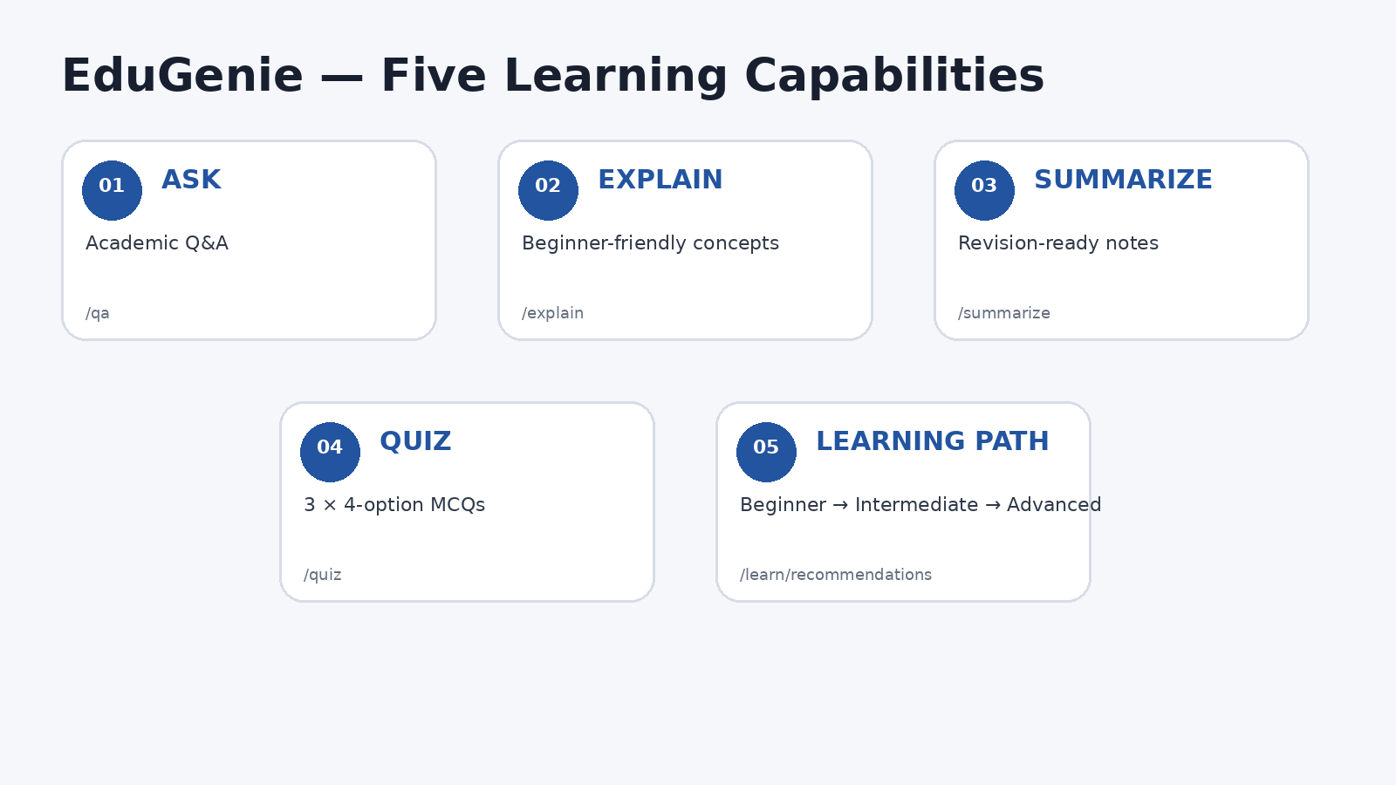
Figure 4. Feature map derived from the implemented API and frontend task configuration.
Feature | Implementation detail | Endpoint
Ask Question | Gemini text generation with educational system instruction | POST /qa
Explain Topic | Gemini by default; optional local Transformer pipeline | POST /explain
Summarize Text | Source-preserving educational summarization prompt | POST /summarize
Generate Quiz | Structured JSON + Pydantic validation | POST /quiz
Learning Path | Three-level progressive roadmap prompt | POST /learn/recommendations
Health Check | Reports app/version/provider and whether API key is configured | GET /health

Frontend experience highlights
- Task tabs dynamically change the input placeholder and action button.
- Loading state changes the action to “Thinking…” and shows a generation message.
- Responses are HTML-escaped before rendering to reduce injection risk from generated text.
- Quiz answers are checked in the browser and the user receives a score plus per-question feedback.
- Theme preference is stored in localStorage.
- Global Ctrl/Cmd + K focuses the search field.

6. System Architecture
Figure 5. EduGenie logical architecture and request flow.

Architecture layers
Layer | Responsibility | Key files
Presentation | Task selection, input, loading states, response rendering | templates/index.html, static/app.js, static/style.css
API | HTTP routes, validation, error translation | main.py
Feature services | Prompt construction and feature-specific logic | qna.py, explanation_module.py, summary_module.py, quiz_module.py, learning_path.py
AI service | Reusable Gemini client and generation configuration | gemini_client.py
Configuration | Environment-driven settings | config.py, .env
Validation | Request and structured-response schemas | main.py, quiz_module.py

Request lifecycle
- The learner selects a task and enters a question, topic or passage.
- JavaScript sends a POST request with JSON to the corresponding FastAPI endpoint.
- FastAPI validates the request model and rejects invalid/empty inputs.
- The endpoint delegates to the appropriate feature module.
- The feature module builds an educational prompt and calls the shared Gemini service.
- For quiz generation, Gemini is asked for application/json matching the Pydantic schema.
- The endpoint returns a JSON response to the browser.
- JavaScript renders the result or displays an error state.

7. Technology Stack
Technology | Role | Evidence in project
Python 3.10+ | Application language | README and requirements
FastAPI | REST API and application server | main.py
Uvicorn | ASGI development server | requirements.txt / reference run command
Google Gemini | Generative AI model service | gemini_client.py
google-genai | Gemini Python SDK | requirements.txt
Pydantic v2 | Input and structured-output validation | main.py, quiz_module.py
Jinja2 | HTML template rendering | main.py, templates/index.html
HTML/CSS/JavaScript | Browser UI | templates/index.html, static/
Transformers + PyTorch | Optional local explanation model | requirements-local.txt
pytest | Automated application tests | requirements.txt, tests/test_app.py

Dependency profiles
fastapi>=0.115,<1.0
uvicorn[standard]>=0.30,<1.0
jinja2>=3.1,<4.0
python-dotenv>=1.0,<2.0
google-genai>=1.0,<2.0
pydantic>=2.7,<3.0
httpx>=0.27,<1.0
pytest>=8.0,<9.0
The optional local-model profile extends the base dependencies with Transformers, PyTorch and SentencePiece.
-r requirements.txt
transformers>=4.45,<5.0
torch>=2.2,<3.0
sentencepiece>=0.2,<1.0

8. Project Structure
The source ZIP contains a small application core plus a bundled Python virtual-environment directory. For documentation and source control, the meaningful project files are the following:
EduGenie/
├── main.py
├── config.py
├── gemini_client.py
├── qna.py
├── explanation_module.py
├── summary_module.py
├── quiz_module.py
├── learning_path.py
├── requirements.txt
├── requirements-local.txt
├── .env.example
├── .gitignore
├── README.md
├── templates/
│ └── index.html
├── static/
│ ├── style.css
│ └── app.js
├── tests/
│ ├── __init__.py
│ └── test_app.py
└── .vscode/
├── settings.json
└── extensions.json

File responsibilities
File | Purpose
main.py | Creates FastAPI app, mounts static files, renders UI, defines endpoints and request/response models.
config.py | Loads environment variables into the Settings object.
gemini_client.py | Creates and caches the Gemini client; provides text and structured generation.
qna.py | Academic question answering prompt and service call.
explanation_module.py | Gemini explanation plus optional local Transformer explanation.
summary_module.py | Educational summarization.
quiz_module.py | Quiz prompt, Pydantic schema and validation.
learning_path.py | Beginner-to-advanced learning roadmap generation.
templates/index.html | Main dashboard markup and task workspace.
static/app.js | API calls, task state, quiz scoring, theme, search, errors and UI behavior.
static/style.css | Visual styling, responsive layout and task/response components.
tests/test_app.py | Seven TestClient tests covering home, health and invalid empty inputs.

9. Backend API Design

Endpoint reference
Method | Endpoint | Request body | Response
GET | / | None | HTML page
GET | /health | None | Status/configuration JSON
POST | /qa | { question: string } | { result: string }
POST | /explain | { topic: string } | { result: string }
POST | /summarize | { text: string } | { result: string }
POST | /quiz | { text: string } | QuizResponse JSON
POST | /learn/recommendations | { topic: string } | { result: string }

Validation rules
- Question and topic requests require at least 1 character and allow up to 5,000 characters.
- Text requests require at least 1 character and allow up to 30,000 characters.
- Empty input is rejected at the FastAPI/Pydantic boundary before the AI module is called.
- Feature modules also perform their own empty-string checks, providing defensive validation.
- Unexpected service failures are converted to HTTP 500 responses with feature-specific error messages.

Health endpoint
{
"status": "ok",
"app": "EduGenie",
"version": "1.0.0",
"gemini_configured": true,
"explanation_provider": "gemini"
}
The exact runtime values depend on the local .env configuration; the example above shows the response shape, not a claim about the supplied environment.

10. AI / Gemini Integration

Shared Gemini service
gemini_client.py centralizes model communication. The service reads the API key and model name from configuration, creates a google-genai client, and exposes two paths: normal text generation and schema-constrained structured generation.
from functools import lru_cache
from google import genai
from google.genai import types
from config import settings
class GeminiService:
"""Reusable Gemini API service."""
def __init__(self):
if not settings.GEMINI_API_KEY:
raise RuntimeError(
"GEMINI_API_KEY is missing. "
"Create a .env file and add your Gemini API key."
)
self.client = genai.Client(
api_key=settings.GEMINI_API_KEY
)
self.model = settings.GEMINI_MODEL
def generate_text(
self,
prompt: str,
*,
system_instruction: str | None = None,
temperature: float = 0.4,
max_output_tokens: int = 2048,
) -> str:
"""Generate normal text from Gemini."""
config = types.GenerateContentConfig(
temperature=temperature,
max_output_tokens=max_output_tokens,
system_instruction=system_instruction,
…

Why the shared client matters
- Avoids duplicating API-client setup across five feature modules.
- Keeps model selection in one environment-driven setting.
- Provides consistent generation parameters such as temperature and max output tokens.
- Supports structured JSON generation for the quiz workflow.
- Uses an LRU cache so the service object is reused within the application process.

Prompt-engineering pattern
Feature | Prompt focus
Q&A | Accuracy, concise educational explanation, examples when useful, uncertainty instead of invented facts
Explanation | Definition → how it works → simple example → important points
Summary | Preserve important information, remove repetition, support exam revision
Quiz | Exactly 3 questions, exactly 4 options, one correct answer, explanation
Learning path | Beginner → Intermediate → Advanced, practice, project ideas, prerequisites and timeline

11. Feature Modules

11.1 Question Answering
qna.py strips whitespace, rejects empty questions, constructs an educational prompt and calls the shared Gemini text generator. The system instruction explicitly asks for useful answers, simple language and uncertainty handling.
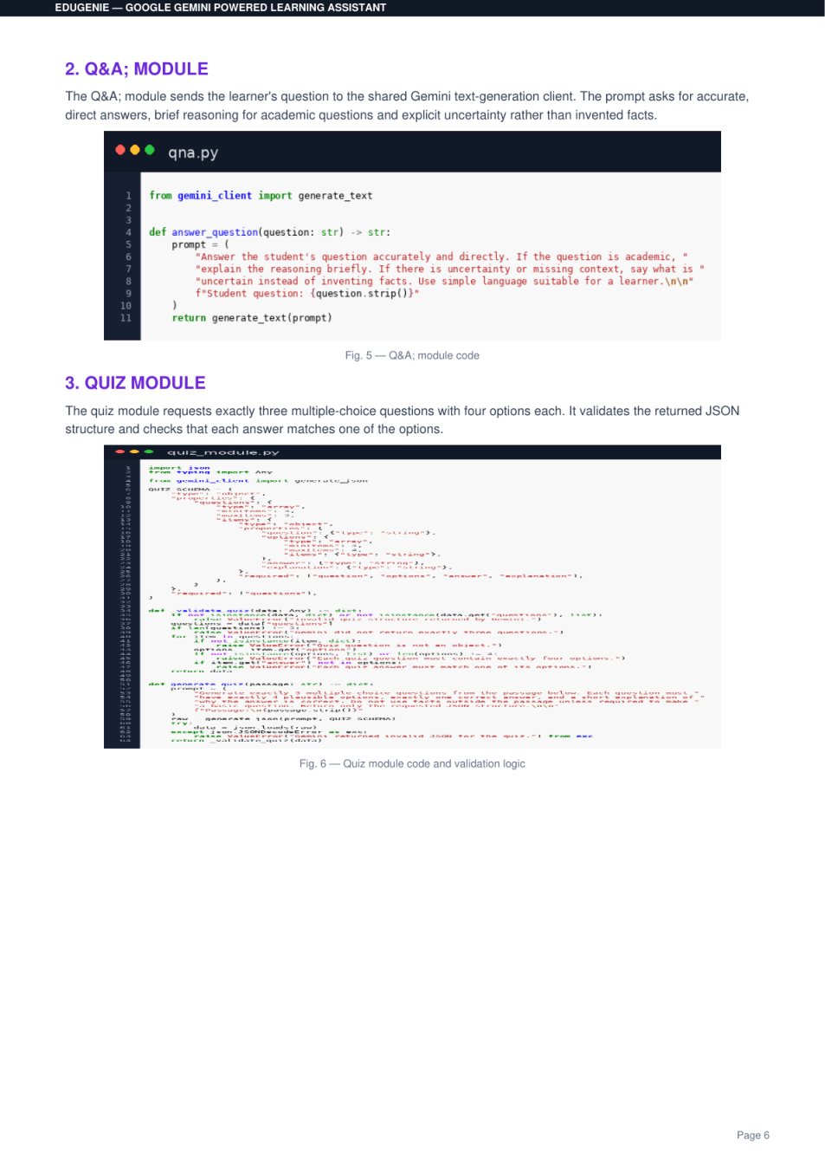
Figure 6. Supplied Q&A module evidence.

11.2 Explanation
explanation_module.py supports two providers. The default path uses Gemini. When EXPLANATION_PROVIDER is set to local, the module lazily creates a Transformers text2text-generation pipeline using the configured LaMini-Flan-T5 model.
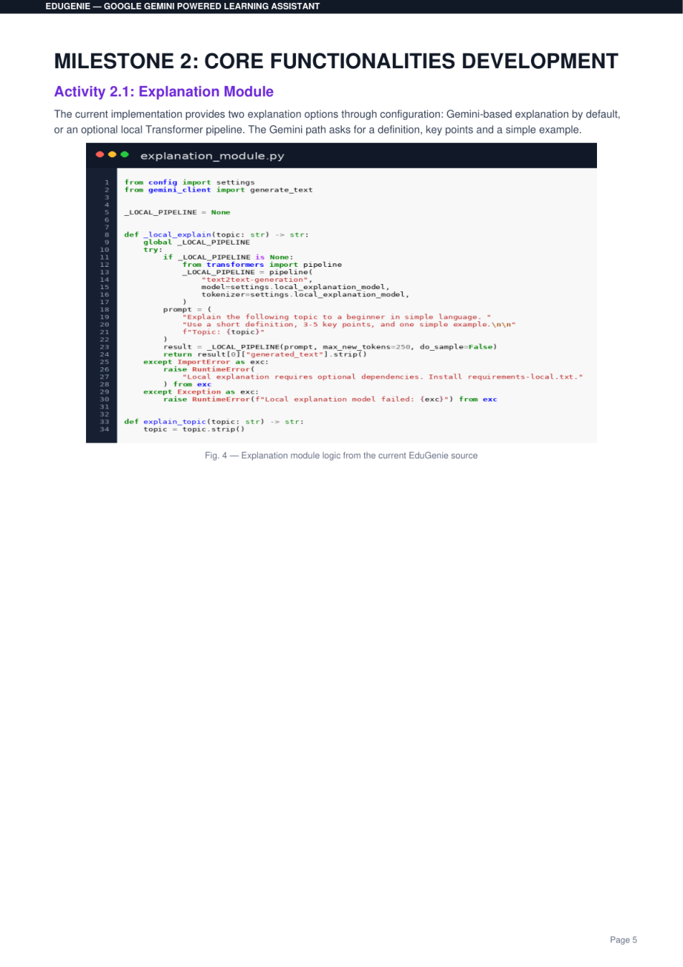
Figure 7. Supplied explanation-module evidence.

11.3 Summarization
summary_module.py is intentionally conservative: its prompt asks the model not to introduce facts that are not supported by the provided educational text.
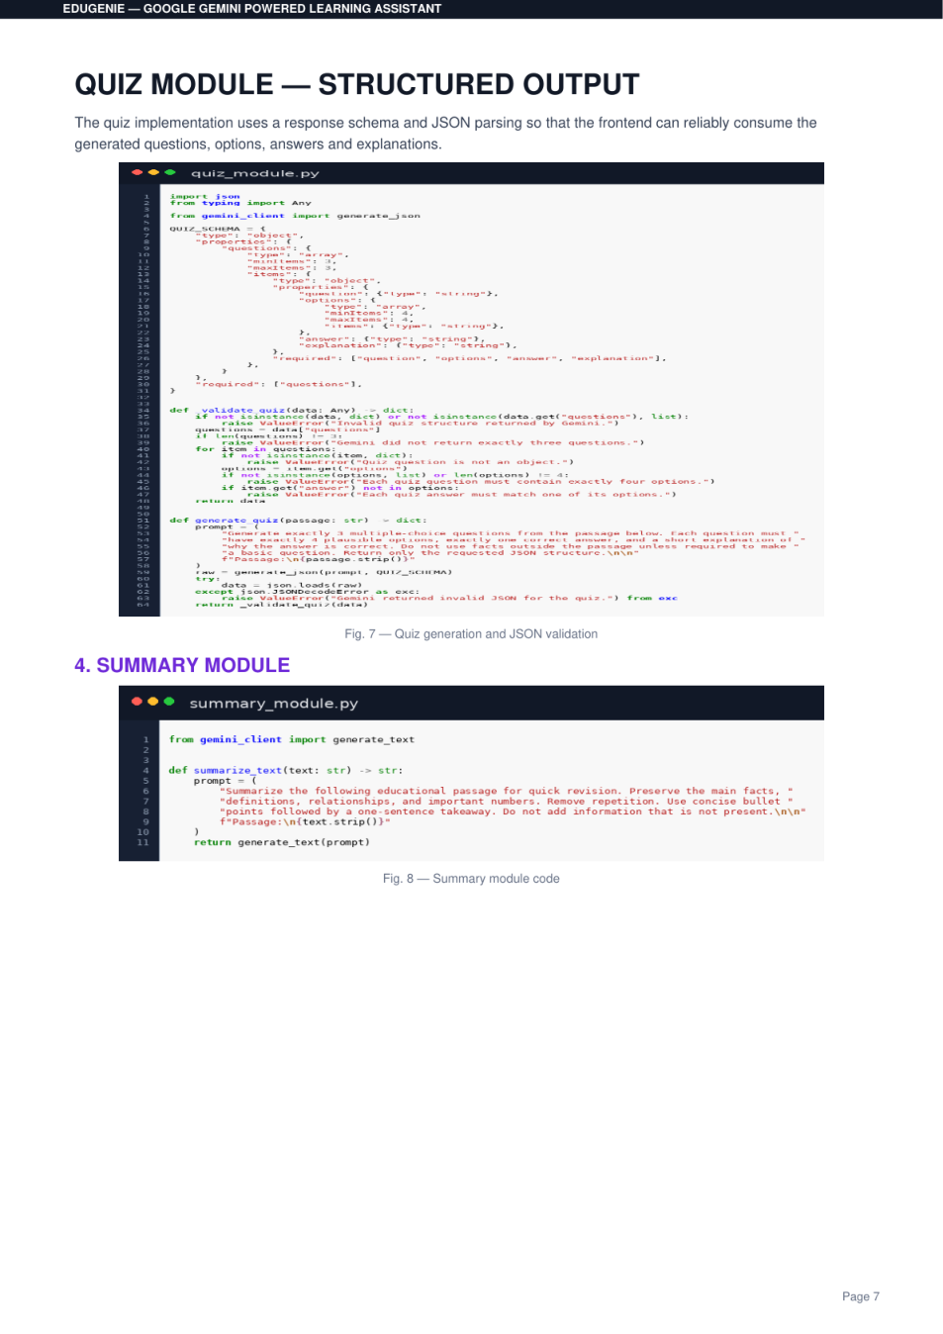
Figure 8. Supplied summary-module evidence.

12. Quiz & Learning Path Implementation

12.1 Structured quiz generation
The quiz module is the most strongly constrained AI workflow. QuizQuestion requires a question, four options, a correct answer that exactly matches one option, and a short explanation. QuizResponse requires exactly three questions.
Figure 9. Supplied structured-output quiz evidence.
STRUCTURED OUTPUT The backend requests JSON and then validates the returned JSON with QuizResponse.model_validate_json(). This creates a contract between the AI output and the frontend.

12.2 Learning path
learning_path.py asks Gemini to create a beginner-to-advanced progression and requests topics, understanding goals, practice, project ideas, resource types, learning order, approximate time, prerequisites and a final project.
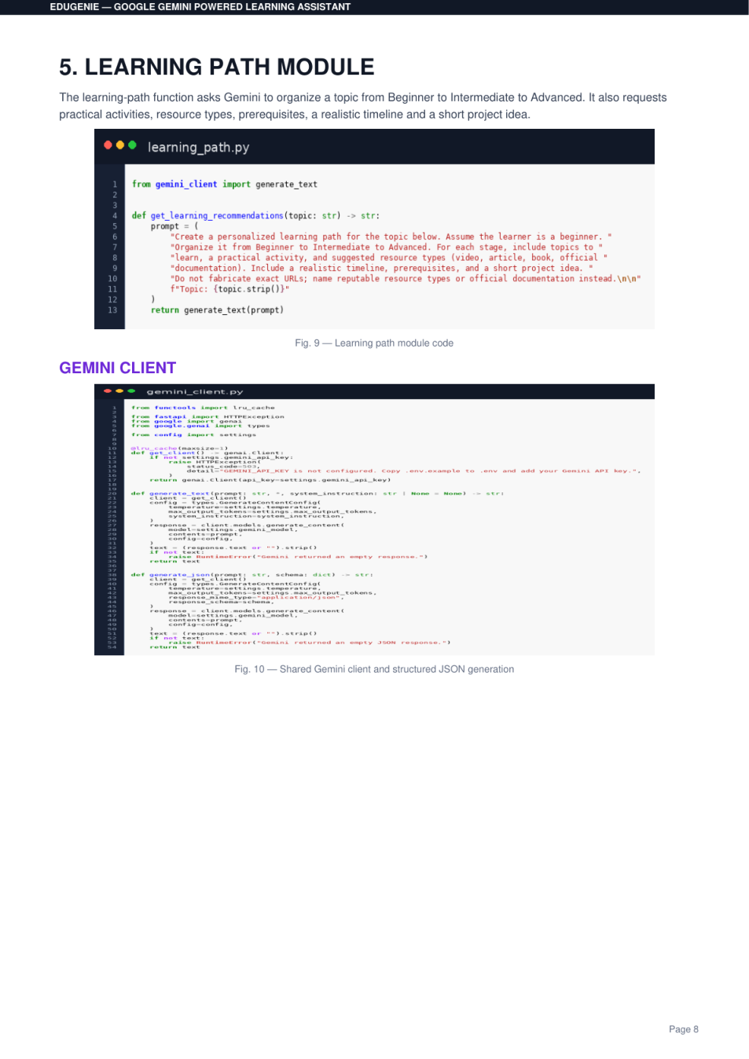
Figure 10. Supplied learning-path module evidence.

13. Frontend Design & User Experience
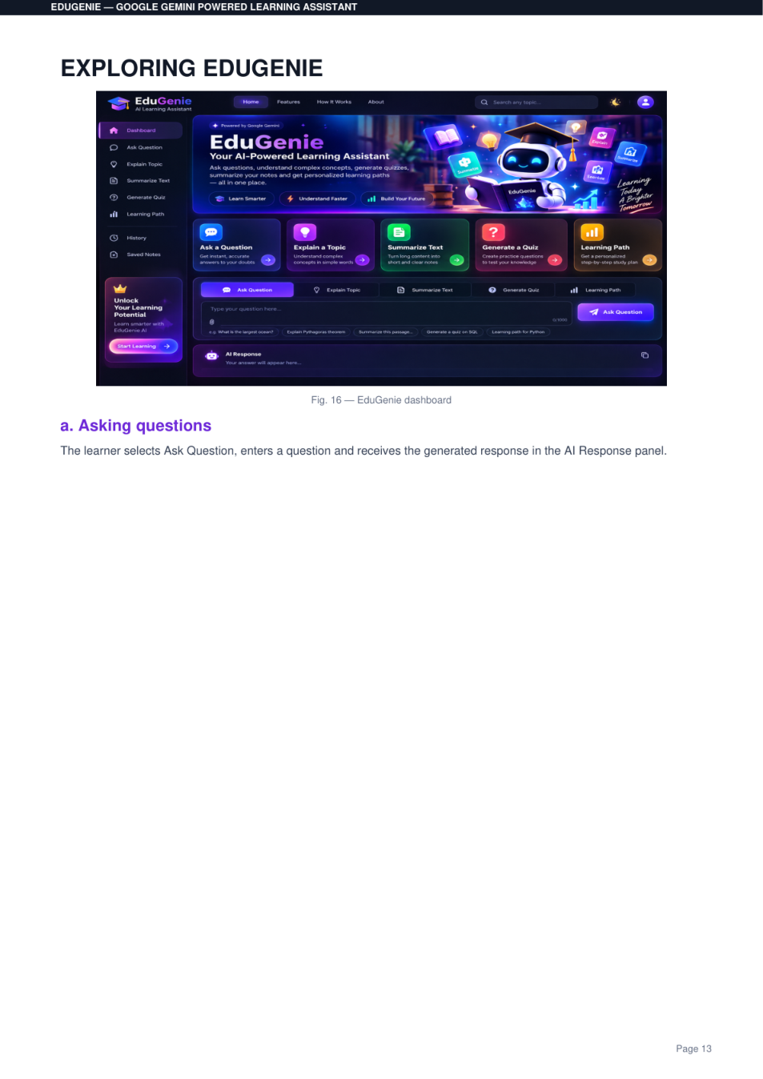
Figure 11. Supplied EduGenie dashboard evidence.
The frontend is a single dashboard-style experience. The sidebar exposes the five learning tasks, while the main workspace provides the task-specific input area and response panel. The visual system uses cards, rounded controls, gradients/glows and responsive layout rules.

Interactive behaviors implemented in app.js
- Task selection updates the placeholder, icon and action button.
- API requests use fetch() with JSON bodies and content-type application/json.
- Loading states disable the action button until the request completes.
- Normal responses are escaped and then line breaks are rendered for readability.
- Quiz responses become interactive radio-button questions with score calculation.
- Copy response uses the browser clipboard API.
- Theme switching persists the selected theme in localStorage.
- Mobile sidebar can be toggled.

Visual evidence
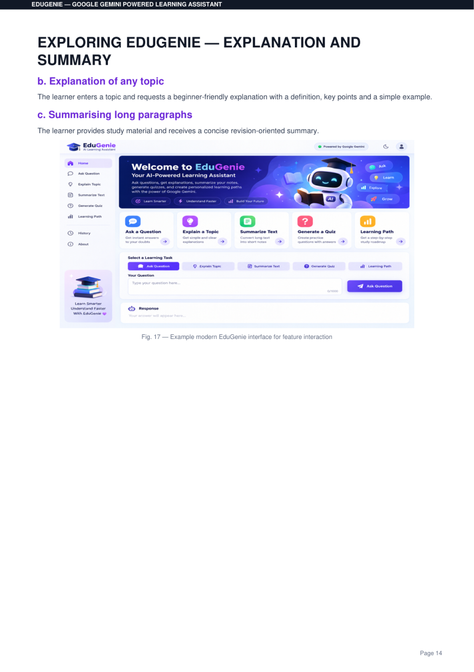
Figure 12. Supplied explanation/summary interface evidence.
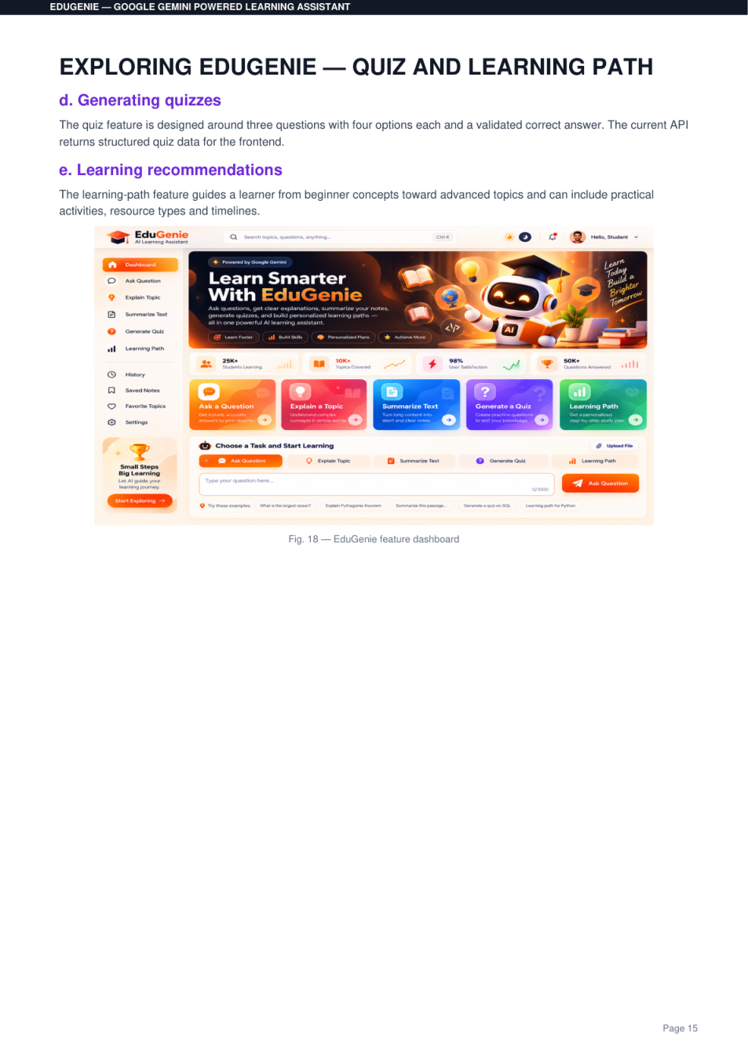
Figure 13. Supplied quiz/learning-path interface evidence.

14. End-to-End Workflow

Typical learner journey
- Open the EduGenie home page.
- Choose Ask Question, Explain Topic, Summarize Text, Generate Quiz or Learning Path.
- Enter the requested content into the main workspace.
- The browser sends a JSON POST request to the matching FastAPI endpoint.
- FastAPI validates the request and dispatches to the feature module.
- The feature module creates an educational prompt.
- Gemini generates the requested content; quiz output is additionally schema-validated.
- The API returns JSON to the browser.
- The browser renders the response, feedback or quiz interaction.

Frontend ↔ backend mapping
UI action | JavaScript function | Endpoint
Ask Question | askQuestion() | /qa
Explain Topic | explainTopic() | /explain
Summarize Text | summarizeText() | /summarize
Generate Quiz | generateQuiz() | /quiz
Learning Path | generateLearningPath() | /learn/recommendations

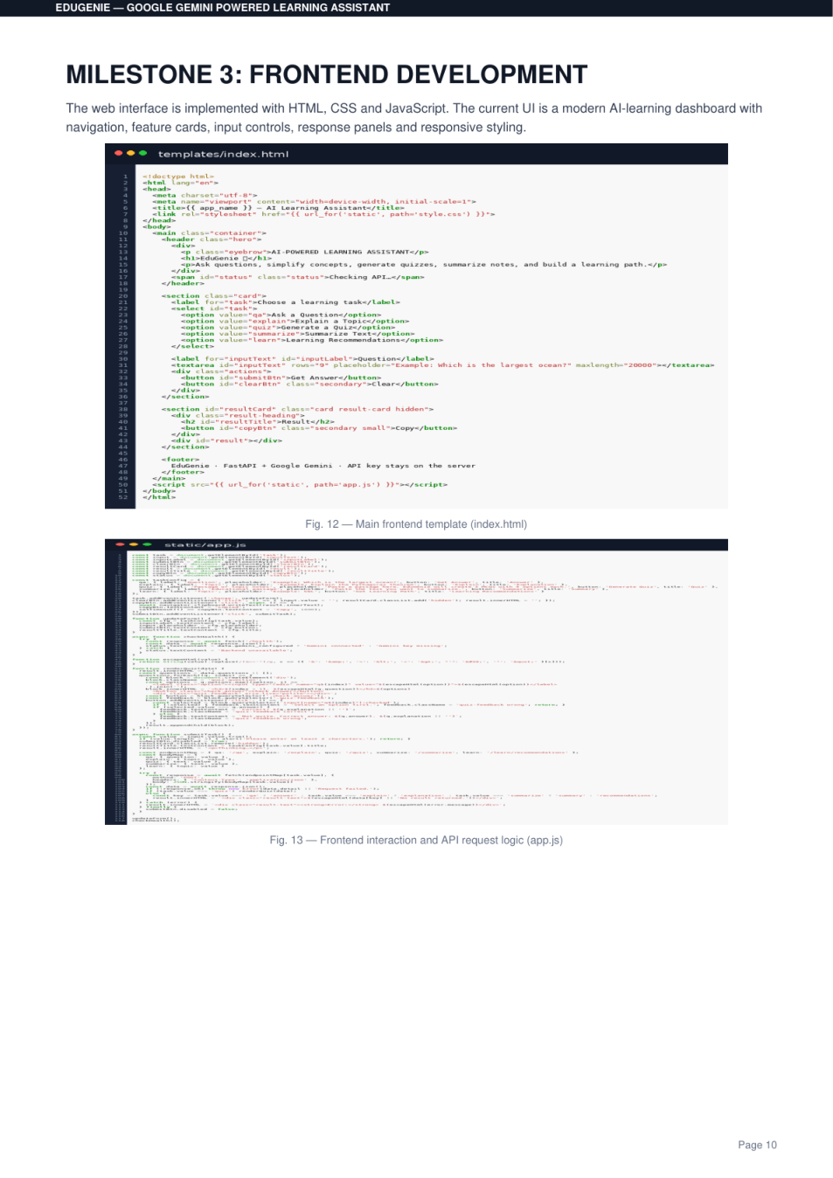
Figure 14. Supplied frontend/API integration evidence.

15. Setup & Installation

Prerequisites
- Python 3.10 or newer.
- A modern web browser.
- A Google Gemini API key for the default Gemini provider.
- VS Code is recommended; the project includes Python/Pylance/Ruff extension recommendations.

Recommended clean setup
# 1. Create a virtual environment
py -3.10 -m venv .venv
# 2. Activate on Windows PowerShell
.venv\Scripts\Activate.ps1
# 3. Install base dependencies
pip install -r requirements.txt
# 4. Create .env from .env.example and add your Gemini API key
# 5. Start the application
python -m uvicorn main:app --reload
# 6. Open
http://127.0.0.1:8000

Optional local explanation setup
pip install -r requirements-local.txt
# Then set in .env:
EXPLANATION_PROVIDER=local
LOCAL_EXPLANATION_MODEL=MBZUAI/LaMini-Flan-T5-783M
The supplied reference documentation shows a successful local Uvicorn run and HTTP 200 responses for the major endpoints. Those screenshots are retained as project evidence, while this report does not claim a fresh end-to-end Gemini call was executed during documentation generation.

16. Configuration & Security
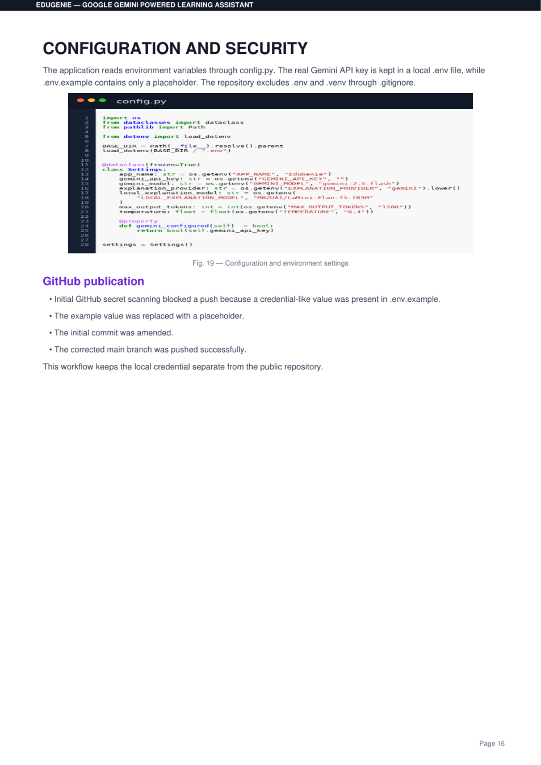
Figure 15. Supplied configuration/security evidence.

Environment configuration
# ==========================================
# EduGenie Environment Configuration
# ==========================================
# Get your Gemini API key from Google AI Studio
GEMINI_API_KEY=your_gemini_api_key_here
GEMINI_MODEL=gemini-2.5-flash
# Explanation provider:
# gemini = recommended/easiest
# local = LaMini-Flan-T5-783M
EXPLANATION_PROVIDER=gemini
# Local model name
LOCAL_EXPLANATION_MODEL=MBZUAI/LaMini-Flan-T5-783M
# Application settings
APP_NAME=EduGenie
APP_VERSION=1.0.0
DEBUG=true

Security observations from the supplied ZIP
IMPORTANT BEFORE SHARING The supplied ZIP currently contains a .env file. Although .gitignore excludes .env, the archive itself includes it. Do not redistribute a real API key. Remove .env from any public/shareable ZIP and provide only .env.example.

- Use .env for local secrets and .env.example for placeholders.
- Never paste a real Gemini API key into source files, screenshots or documentation.
- Set DEBUG=false for production-style deployment.
- Keep the API key server-side; browser JavaScript should call the backend rather than exposing the Gemini key.
- Consider rate limiting, authentication and request logging controls before public deployment.

Repository hygiene
The .gitignore correctly excludes .env, virtual environments, Python caches and local model/cache directories. The source ZIP, however, also includes the .venv directory; this should normally be excluded from a source distribution because dependencies can be recreated from requirements files.

17. Testing & Validation

Automated tests present in source
tests/test_app.py contains seven TestClient tests covering the home page, health endpoint and empty-input validation for all five learning endpoints.
Test area | Expected behavior
Home page | GET / returns HTTP 200 and contains “EduGenie”
Health | GET /health returns HTTP 200 and status “ok”
Empty Q&A | POST /qa with empty question returns HTTP 422
Empty explanation | POST /explain with empty topic returns HTTP 422
Empty summary | POST /summarize with empty text returns HTTP 422
Empty quiz | POST /quiz with empty text returns HTTP 422
Empty learning path | POST /learn/recommendations with empty topic returns HTTP 422

Static source verification performed for this report
PYTHON SYNTAX All core Python modules and tests were successfully syntax-compiled with Python 3.13 during documentation preparation.

A fresh API test run was not claimed because the documentation environment did not have the google-genai package installed. The project’s requirements.txt specifies the required dependency, so the intended validation path is to install the project requirements and then run pytest.
pytest -q

Reference functional testing
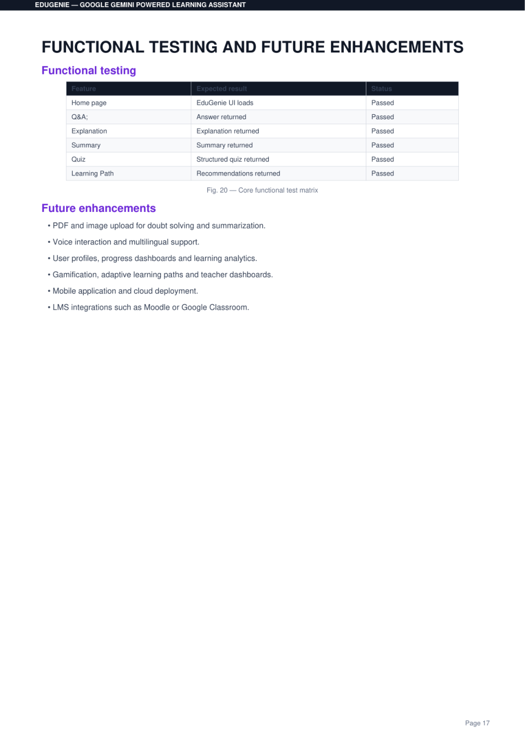
Figure 16. Supplied functional-testing evidence from the reference documentation.

18. Current Limitations & Implementation Status
Capability | Current status | Documentation note
Q&A | Implemented | Backend + frontend integration present.
Explanation | Implemented | Gemini default; local model option available.
Summary | Implemented | Backend + frontend integration present.
Quiz | Implemented | Structured JSON and Pydantic validation present.
Learning Path | Implemented | Backend + frontend integration present.
Dark/light theme | Implemented | Frontend localStorage persistence.
Copy response | Implemented | Browser clipboard API.
File upload | UI placeholder | Button shows a next-version message; no upload endpoint.
History | UI only | No persistence/backend workflow found.
Saved Notes | UI only | No persistence/backend workflow found.
Settings | UI only | No settings workflow found.
User accounts | Not present | No authentication/database layer found.
Analytics/progress | Not present | No learner profile or dashboard persistence found.

Important distinction
The reference screenshots describe future enhancements such as PDF/image upload, voice interaction, multilingual support, user profiles, analytics, gamification, teacher dashboards, mobile apps and LMS integrations. These should be treated as roadmap items, not current capabilities.

19. Future Enhancements
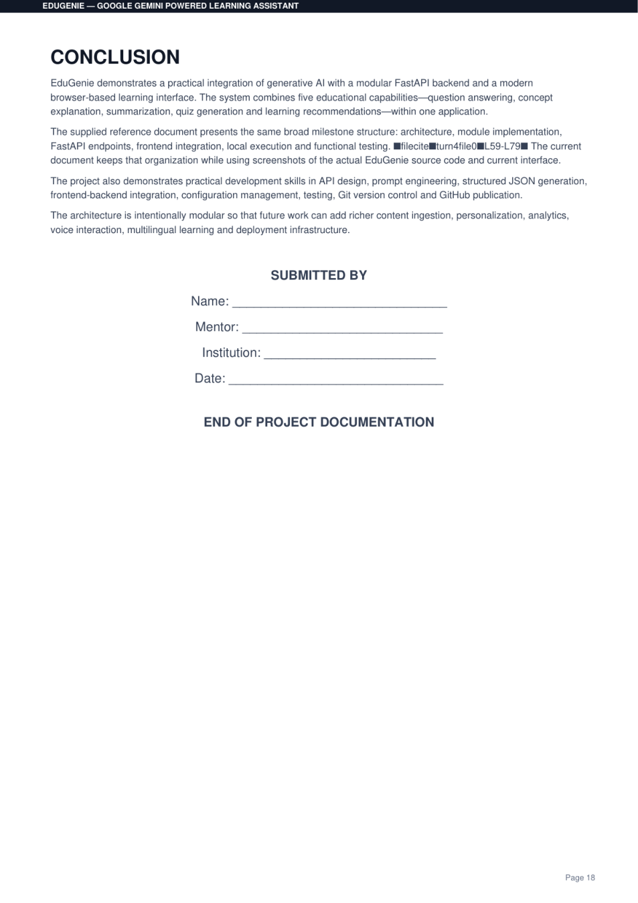
Figure 17. Supplied conclusion/roadmap evidence.
Priority area | Potential enhancement | Technical direction
Content ingestion | PDF/image upload for doubt solving and summarization | Add upload endpoint, extraction/OCR pipeline and safe file handling.
Personalization | Profiles, saved notes and learning history | Add authentication plus database models.
Analytics | Progress dashboards and learning analytics | Persist quiz attempts, topics and activity metrics.
Adaptive learning | Difficulty-aware and progress-aware paths | Use learner state to influence prompts and recommendations.
Accessibility | Voice and multilingual interaction | Speech-to-text, text-to-speech and language-aware prompts.
Education integrations | Moodle / Google Classroom | OAuth/API integrations and assignment workflows.
Deployment | Cloud-hosted production service | Containerization, secrets manager, HTTPS, rate limiting and observability.
Mobile | Dedicated Android/iOS experience | Reuse REST API with a mobile client.

Suggested next engineering milestone
- Remove .env and .venv from distributable source archives.
- Add real file ingestion with size/type validation.
- Add persistent user profiles and saved learning history.
- Expand automated tests to mock Gemini responses and test all success paths.
- Add authentication, rate limiting and production logging before public deployment.

20. Conclusion
EduGenie demonstrates a practical generative-AI application architecture for education. Its strongest implementation characteristic is separation of concerns: FastAPI handles HTTP and validation, feature modules own prompt logic, the Gemini client centralizes model communication, and the browser interface focuses on interaction and presentation.
The project currently delivers five core learning workflows—question answering, concept explanation, summarization, quiz generation and learning recommendations. The quiz pipeline goes beyond free-form generation by requesting structured JSON and validating the result with Pydantic, creating a more reliable frontend contract.
The project is also well positioned for extension. The current modular structure can accommodate content ingestion, personalization, analytics, voice, multilingual learning and external education-platform integrations without changing the basic architecture.
FINAL NOTE For academic submission, this documentation can be used as the main technical report. For public distribution, remove the supplied .env and bundled .venv first, then recreate the environment from requirements.txt.

Appendix A — API Reference

POST /qa
Request
{
"question": "What is photosynthesis?"
}
Response
{
"result": "..."
}

POST /explain
Request
{
"topic": "Binary search"
}
Response
{
"result": "..."
}

POST /summarize
Request
{
"text": "Long educational passage..."
}
Response
{
"result": "..."
}

POST /quiz
Request
{
"text": "Python functions"
}
Response shape
{
"title": "...",
"questions": [
{
"question": "...",
"options": ["...", "...", "...", "..."],
"correct_answer": "...",
"explanation": "..."
}
]
}

POST /learn/recommendations
Request
{
"topic": "Machine Learning"
}
Response
{
"result": "..."
}

Appendix B — File-by-File Technical Guide
File | Key responsibilities | Important implementation points
main.py | FastAPI application and REST endpoints | Request models, HTTP errors, static/template mounting, /health.
config.py | Environment settings | Gemini key/model, provider, app metadata.
gemini_client.py | AI gateway | Text generation, JSON schema generation, cached service.
qna.py | Question answering | Educational system instruction and concise answer prompt.
explanation_module.py | Concept explanations | Gemini or local LaMini-Flan-T5 provider.
summary_module.py | Summarization | Revision-oriented source-preserving prompt.
quiz_module.py | Quiz generation | 3-question/4-option schema validation.
learning_path.py | Study roadmap | Beginner/intermediate/advanced progression.
templates/index.html | UI markup | Dashboard, sidebar, hero, task tabs, workspace and response area.
static/app.js | UI behavior | API calls, task state, quiz scoring, theme, clipboard, errors.
static/style.css | UI styling | Responsive dashboard, cards, forms, quiz and theme rules.
tests/test_app.py | Automated tests | Seven basic TestClient validation tests.

Recommended submission package
- EduGenie source folder without .venv/.
- .env.example with placeholder values only.
- requirements.txt and, if needed, requirements-local.txt.
- This complete project documentation PDF/DOCX.
- Optional screenshots showing the application running locally.
- A separate private copy of .env only for the developer—not for submission or public repositories.

— END OF EDUGENIE PROJECT DOCUMENTATION —

