**Issue Title** - **Referrals - Search bar functionality is not working**

**Environment – Test**

**Role – Admin, HR**

**Expected**: Matching results of referrals should display for searched referral.

**Actual:** Matching results of referrals is not displayed for searched referral.

**Steps to reproduce:**

1. Login to the Recru test environment
2. Click on Referrals
3. Enter the referral name in search bar.

**Issue screenshot:**

1.

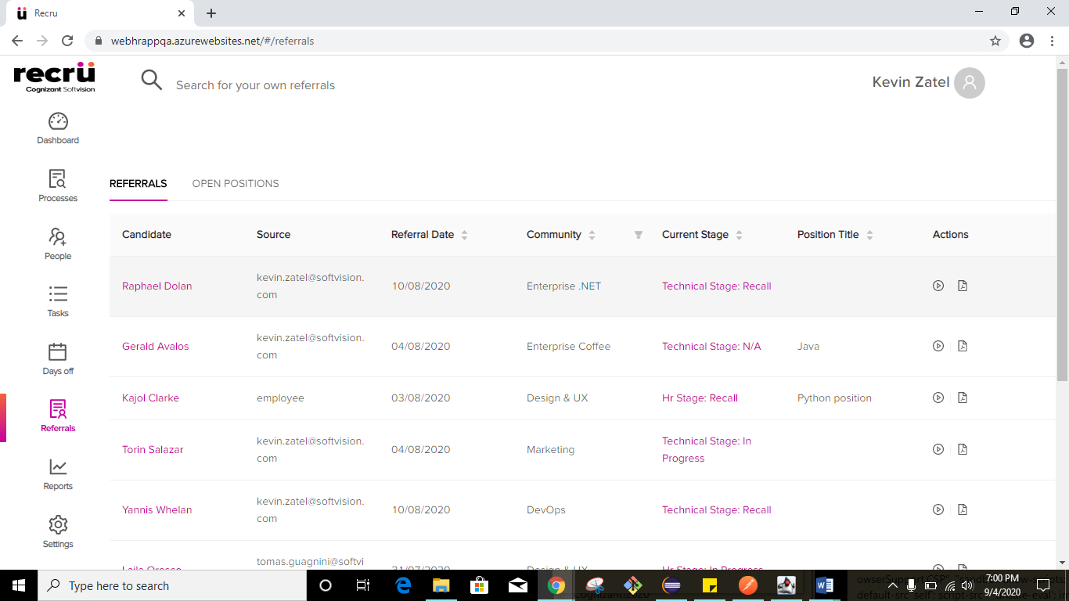

2.

