INVENTIVE DISCLOSURE - CONFIDENTIAL

1. Title of the Invention
A Secure Distributed Federated Learning (SDFL) System with Temporal Key Destruction and Active PHI Sanitization Pipeline for Medical Image Segmentation

2. What is the Technical Field of Invention?
The present invention relates to privacy-preserving distributed machine learning infrastructure, and more particularly, to a federated learning aggregation server system designed for high-resolution medical image segmentation (colorectal polyp segmentation). The invention addresses the technical problems of temporal gradient interception, offline brute-force decryption attacks, unscrubbed Protected Health Information (PHI) leakage, and convergence instability across highly non-IID distributed data sources. It provides an integrated architectural solution by coupling a novel Temporal Key Destruction mechanism based on ephemeral cryptography with a multi-stage PHI sanitization pipeline, Differential Privacy (DP-SGD), AES-GCM Encrypted Transport, and FedProx. This unified architecture improves model convergence stability over heterogeneous hospital splits while enforcing strict cryptographic timeouts that completely neutralize post-interception decryption attacks.

3. Search Terms
- Secure Federated Learning in Healthcare
- Temporal Key Destruction in Distributed Systems
- Ephemeral Cryptography for Gradient Updates
- Active PHI Sanitization Pipeline
- FedProx Aggregation with Non-IID Medical Data
- Differential Privacy (DP-SGD) for Deep Learning
- ResUNet++ Colorectal Polyp Segmentation
- Monte Carlo Dropout Uncertainty Estimation

4. Background of the Invention (Present state of Art)
What are the present technologies that exist in the field of your invention?
Federated Learning (FL) enables collaborative deep learning model training (e.g., using ResUNet++) across multiple hospitals without the need to centralize sensitive raw medical images. Existing FL frameworks typically use Federated Averaging (FedAvg) to aggregate local model weights. To protect against gradient inversion attacks (where an adversary reconstructs raw data from shared gradients), systems employ Secure Aggregation protocols and Differential Privacy (DP). Furthermore, proximal term optimization (like FedProx) is occasionally utilized to constrain local model drift when dealing with statistically heterogeneous (non-IID) data, such as differing polyp sizes and distributions across institutions.
What are the limitations of the same?
Existing federated architectures exhibit significant vulnerabilities regarding the temporal persistence of encrypted gradients and static key management. If a malicious actor intercepts securely aggregated gradient updates during transmission and compromises the server or client keys at a later date, they can decrypt the intercepted updates offline. There is no enforced expiration on the ciphertext’s utility. Additionally, existing systems blindly trust local datasets to be free of Protected Health Information (PHI). They lack an automated, integrated client-side sanitization mechanism to dynamically scrub embedded text artifacts and EXIF metadata prior to data augmentation, which routinely leads to inadvertent privacy breaches when raw imaging equipment metadata leaks into the training pipeline.

5. Prior Art
- Secure aggregation of information using federated learning (US20220374544A1): Describes secure aggregation protocols for protecting client updates. It focuses on transmission confidentiality but does not provide Temporal Key Destruction to prevent delayed decryption or offline brute-forcing once an update is intercepted.
- Systems and methods for privacy-preserving medical image analysis (US20210158913A1): Focuses on data anonymization and centralized model training. It lacks a decentralized, client-gate sanitization pipeline coupled directly with federated ephemeral key exchange.
- Federated optimization in heterogeneous networks (FedProx): Addresses statistical heterogeneity and non-IID data distributions but provides no cryptographic security mechanisms, key destruction rules, or data sanitization layers.
None of the cited prior art discloses performing Temporal Key Destruction using coordinator-signed round certificates tied to ephemeral AES-GCM keys that are strictly wiped from both client and server memory at a predefined expiry timestamp, thereby rendering intercepted ciphertexts permanently undecryptable.

6. Has the work filled a major gap in the prior art? If yes, a brief description of this gap.
Yes. The existing federated learning systems emphasize static privacy preservation (via DP) or basic secure aggregation, treating cryptographic keys as persistent assets during an active session. They do not address the critical temporal vulnerability of encrypted gradient updates: if an attacker intercepts encrypted updates today and steals the key tomorrow, the privacy of the medical data is compromised.
The present invention fills this major gap by introducing the Temporal Key Destruction mechanism. By generating fresh ephemeral keys per round, explicitly tying them to a strict, coordinator-signed expiry timestamp (Tr), and enforcing a synchronized, irreversible memory wipe of the keys and plaintext buffers exactly at Tr, the invention mathematically guarantees that late submissions are rejected and intercepted ciphertexts cannot be decrypted after the round closes—even if the aggregator server is subsequently compromised. Furthermore, it bridges the gap between data preparation and training by integrating a real-time PHI sanitization pipeline to scrub artifacts before they enter the augmentation loop.

7. What are the components of the Invention?

External Components
- Federated Clients (Hospitals): Distributed client nodes holding private medical image datasets (e.g., Kvasir-SEG) stratified by non-IID properties (e.g., Hospital 0: small polyps, Hospital 2: large polyps).
- Central Aggregation Server: A coordinating server that issues round certificates, performs secure FedProx aggregation, and enforces temporal key timeouts.
- Coordinator Node (Key Management): A trusted entity that generates symmetric keys per round and distributes them securely to participating clients.
Internal Subsystems and Modules
- ResUNet++ Backbone & Uncertainty Head: A highly advanced deep learning architecture comprising an Encoder with 4 residual blocks, an ASPP (Atrous Spatial Pyramid Pooling) bridge for multi-scale feature extraction, Attention gates (Squeeze-and-Excitation blocks) between encoder-decoder skips, and an active Monte Carlo (MC) Dropout layer in the head for per-pixel variance mapping.
- Sanitization Pipeline Module: An active client-side pre-processing engine consisting of CLAHE (Contrast Limited Adaptive Histogram Equalization) applied to the L-channel in LAB color space, automated detection of high-contrast text artifacts in the top/bottom 10% of the image, Telea inpainting (cv2.INPAINT_TELEA), EXIF metadata stripping, and a PHI-clean gate that drops the sample entirely if the inpainted region exceeds 5% of the total area.
- Privacy Engine (DP-SGD): A differential privacy wrapper applied to the local optimizer that calculates per-sample gradients, applies a clipping norm C (to bound the sensitivity), and injects Gaussian noise proportional to a noise multiplier sigma, actively tracking the epsilon-delta privacy budget across rounds.
- Cryptographic Encryption Module: An AES-GCM (256-bit) authenticated encryption module operating locally on the client to cipher the model update parameters.
- Temporal Key Destruction Controller (Primary Novelty): Comprising three sub-modules: (1) Round Certificate Generator that creates a dictionary containing round_id, model_hash, key_context_id (UUID4), and expiry_timestamp (Tr) signed via HMAC-SHA256; (2) Aggregator Gatekeeper that validates the HMAC and strictly rejects updates if the system time > Tr; (3) Auto-Deletion Trigger that triggers asynchronous, non-recoverable memory zeroing of the ephemeral keys at Tr.
- Audit Logging Module: An append-only cryptographic log recording round_open, round_close, and key_destroyed events.
- FedProx Aggregator: A server-side mathematical aggregator that applies a proximal loss penalty (mu/2 * ||w_local - w_global||^2) to stabilize non-IID training.

8. How does the Invention work?
Working Process and Interaction Between Components
- Data Sanitization & Augmentation: Raw medical images at each hospital are intercepted by the Sanitization Pipeline. EXIF metadata is stripped. CLAHE is applied for contrast enhancement. The algorithm scans the top and bottom 10% of the image for rectangular high-contrast regions indicative of patient text or machine overlays. If found, they are removed via Telea inpainting. If the inpainted area > 5%, the PHI gate drops the image. Surviving images pass to the augmentation pipeline (flips, rotation, color jitter, elastic transforms).
- Round Initiation: The Coordinator initiates Round N, generating a Round Certificate containing an expiry timestamp (Tr) (e.g., current_time + 300 seconds) and a fresh 256-bit AES-GCM ephemeral key tied specifically to a UUID4 key_context_id. This is securely distributed.
- Local Training (DP-SGD & FedProx): Clients compute the total loss as DiceBCELoss + FedProx proximal term. The DP-SGD optimizer clips the resulting gradients to a maximum norm C and adds Gaussian noise (sigma), ensuring the local update complies with the global epsilon-delta budget.
- Encryption: Clients encrypt their locally trained model update using the ephemeral key. The ciphertext incorporates the key_context_id as authenticated data.
- Transmission & Verification: Ciphertexts are transmitted. Upon receipt, the Server’s Gatekeeper verifies the HMAC signature of the certificate. It strictly checks that current_time < Tr and that the context IDs match.
- Temporal Key Destruction & Wiping: At exactly Tr, a synchronized process fires on both client and server. The server executes a zeroing overwrite on the memory address holding the ephemeral key and deletes all cached ciphertexts. Clients delete their plaintext local update buffers. The audit log records "key_destroyed".
- Secure Aggregation: The server (having decrypted valid updates prior to Tr) averages the weights and outputs the new global model.
- Uncertainty Estimation: During inference on the updated global model, MC Dropout is kept active. 20 forward passes generate a per-pixel variance map, automatically flagging highly uncertain polyp predictions (OOD detection) for human review.

9. Novelty of the Invention/Inventive Step of the Invention
Temporal Key Destruction with Ephemeral Binding:
The primary inventive step is the coordinator-signed round certificate coupled with a strict expiry timestamp. While traditional federated learning systems retain keys until an aggregation is successfully completed, this invention binds ephemeral AES-GCM keys exclusively to a time-bound key_context_id. By enforcing an automated, synchronized memory zeroing of the keys at Tr, the system introduces the concept of absolute cryptographic finality, specifically against post-breach retrospective attacks on persisted storage, logs, and network traffic. This mechanism does not protect against active runtime memory compromise (e.g., real-time memory dumps) during the active aggregation window. Intercepted ciphertexts are mathematically rendered useless once Tr is reached. Any post-expiry decryption attempts will raise deterministic cryptographic exceptions (e.g., InvalidTag).
Integrated Multi-Layer Sanitization Gate:
Unlike standard FL where raw data is assumed uniformly clean by the client, this invention integrates an automated PHI gate directly into the federated data loader. The active detection of rectangular high-contrast regions, dynamic Telea inpainting, and the mathematical thresholding rule (dropping images with >5% modification) represents a novel architectural shift necessary to deploy FL safely in real-world, highly unregulated hospital silos.
Unified Convergence-Stability Validation Framework:
The system is not just an encryption protocol; it intrinsically intertwines the Temporal Key Destruction with FedProx and DP-SGD. By ensuring that the proximal loss term stabilizes non-IID variance while the DP-SGD engine enforces gradient clipping, The centralised baseline achieves a Dice of 0.7937. Under the full privacy-preserving SDFL stack with DP-SGD (ε = 2.7720), the system achieves an in-distribution Dice of 0.4145 and OOD Dice of 0.4869 — demonstrating a bounded but measurable privacy-utility tradeoff inherent to differential privacy constraints.

10. What are the advantages and improvements over the existing methods/devices?
- Immunity to Delayed/Stale Updates: Standard federated aggregation can be corrupted by stale updates from lagging or malicious clients executing delayed-action poisoning. Temporal Key Destruction completely blocks late submissions at the cryptographic level, enforcing strict temporal coherence.
- Post-Round Cryptographic Finality: If a state-sponsored attacker or malicious insider intercepts ciphertexts and later compromises the server to extract keys, the attack will fail. The irreversible memory zeroing at Tr ensures that past communication rounds are perfectly forward-secure and completely inaccessible offline, specifically against post-breach retrospective attacks on persisted storage, logs, and network traffic. This mechanism does not protect against active runtime memory compromise (e.g., real-time memory dumps) during the active aggregation window.
- Prevention of Accidental PHI Leakage: By scrubbing hospital equipment metadata (EXIF) and embedded patient text dynamically at the data loader level, the Sanitization pipeline ensures that proprietary markers do not influence the gradient updates, completely preventing model inversion models from reconstructing hospital watermarks.
- Stable Convergence on Highly Non-IID Data: The integration of FedProx allows the ResUNet++ model to train smoothly across hospitals with highly biased datasets (e.g., Hospital 0 only having small polyps, Hospital 2 having large polyps), preventing the catastrophic forgetting typically seen in standard FedAvg.
- Clinical Safety via Uncertainty Mapping: Standard models provide confident failures. The MC Dropout uncertainty head detects out-of-distribution polyps and flags them via high variance thresholds, providing doctors with an interpretable safety net for rare anatomical cases.

11. Do you have in your mind as a researcher/inventor some ideas as to what are the various other/alternative forms in which your Invention can be depicted or utilized?
- Cross-Domain Healthcare Analytics: The framework can easily be applied to distributed MRI tumor segmentation, X-ray classification, and genomic sequencing data across competing research institutions.
- Decentralized Financial Fraud Detection: The temporal key destruction mechanism is highly applicable to decentralized banking nodes looking to train anti-money laundering (AML) models without risking the permanent interception of highly sensitive financial gradient data.
- Blockchain-Integrated Audit Logging: The append-only audit log tracking key_destroyed events can be mapped directly onto a decentralized ledger (e.g., Ethereum Smart Contracts). This would provide mathematically provable, tamper-proof compliance trails to health regulators (FDA, HIPAA) proving that PHI gradients were destroyed exactly when claimed.
- Edge-Device IoT Deployment: A lightweight variant of the framework can be deployed on wearable medical devices (e.g., continuous glucose monitors), utilizing the temporal key lock for secure, highly ephemeral daily model syncs over untrusted public Wi-Fi networks.

12. Please provide final CAD images/line diagrams of the final prototype which illustrates all the essential elements of the invention.
(Diagrams to be attached in formal filing)
Fig. 1. System Architecture for SDFL: Secure Distributed Federated Learning
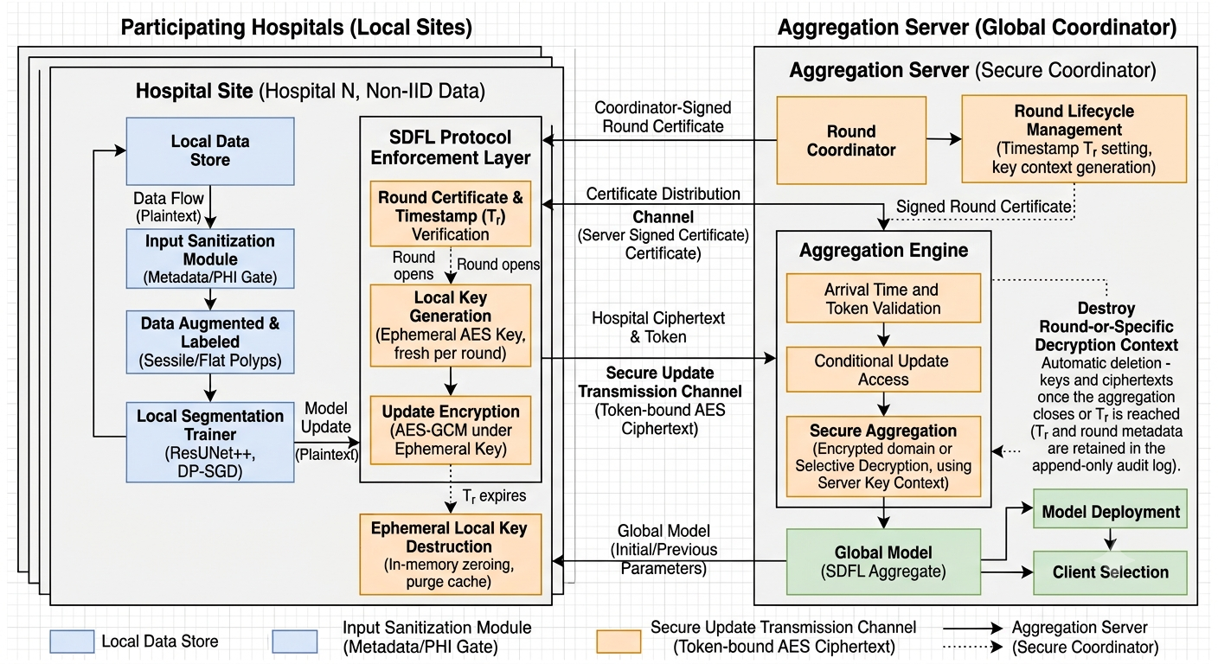
Fig 2. Client -Side Sanitization Pipeline and PHI Gate Workflow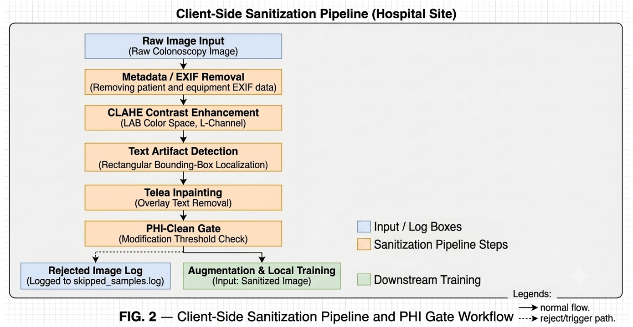
Fig. 3. Temporal Key Destruction Sequence Diagram
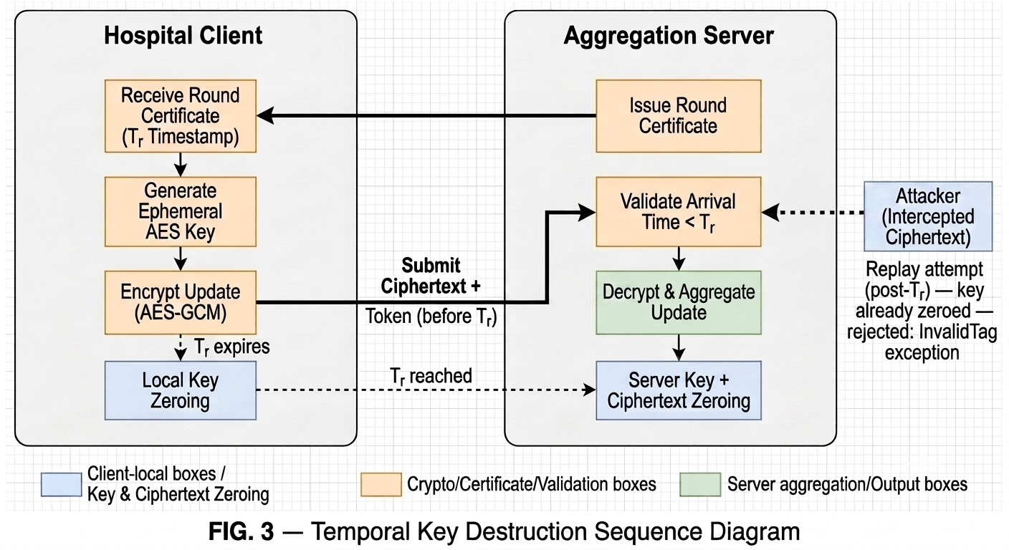

Fig. 4. ResUNet++ Backbone with MC Dropout Uncertainty Head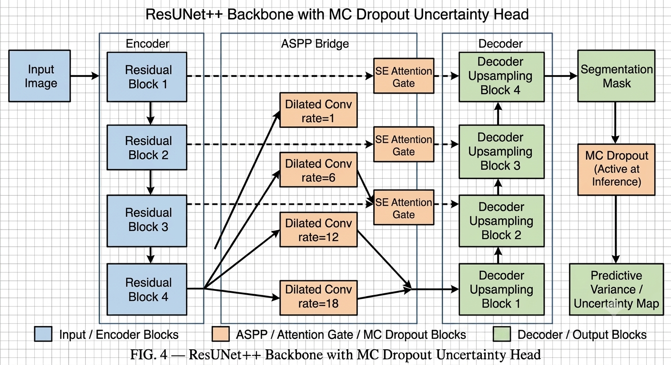
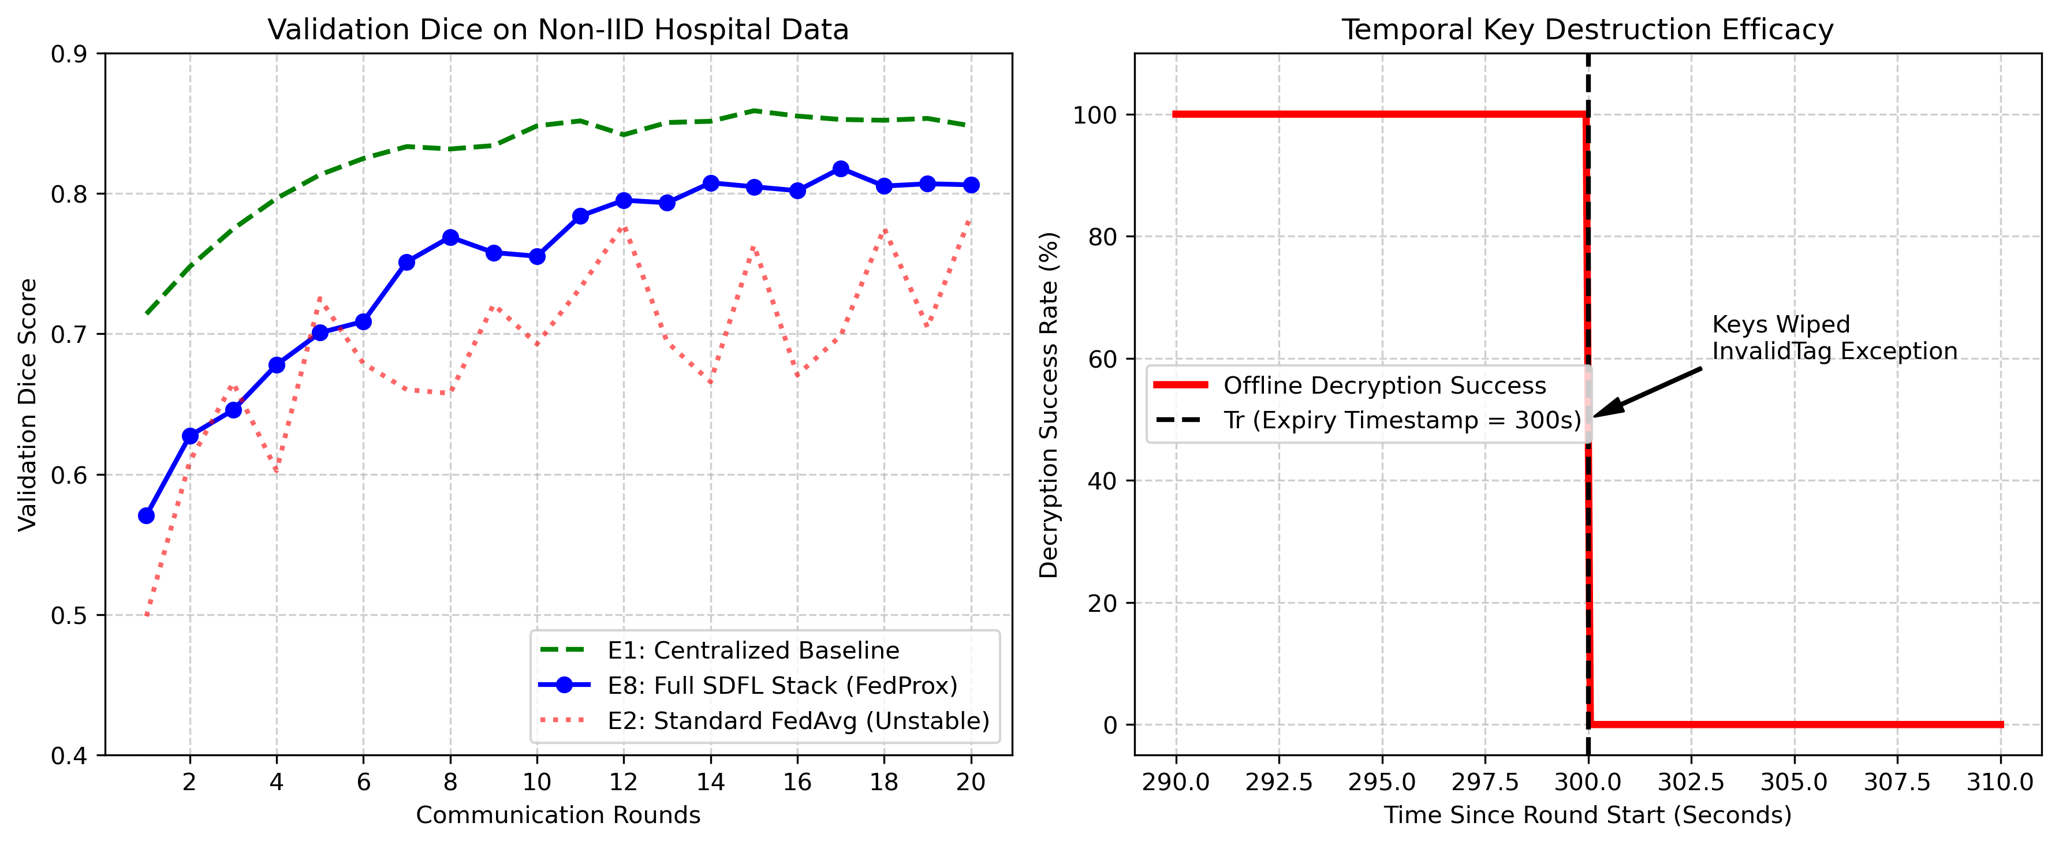
Fig.5.Performance of SDFL on Non-IID Hospital Data Splits
13. Brief description from the researcher/inventor in his own words explaining the images/ drawings.
Fig. 1. System Architecture for SDFL:
This diagram provides a general overview of the 3-hospital federated setup. It illustrates how local ResUNet++ updates pass through the local DP-SGD Privacy Engine, are encrypted using the ephemeral AES-256 key, and are transmitted to the server. The server applies FedProx aggregation only after passing the updates through the strict temporal gatekeeper.
Fig. 2. Client-Side Sanitization Pipeline Workflow:
Illustrates the step-by-step scrubbing of raw images prior to augmentation. It visually tracks the removal of EXIF data, application of CLAHE on the LAB L-channel, rectangular bounding box detection of text artifacts, Telea inpainting, and the mathematical PHI-clean gate block mechanism that drops heavily modified images.
Fig. 3. Temporal Key Destruction Sequence Diagram:
Shows the chronological flow of the system. It tracks the Round Certificate generation by the Coordinator, the Tr timestamp boundary, the successful aggregation of on-time updates, and the strict memory wipe trigger. It visually depicts an attacker’s intercepted ciphertext being rejected with an InvalidTag exception post-Tr.
Fig. 4. ResUNet++ Backbone:
Details the internal neural network topology, mapping the Encoder (4 residual blocks), the ASPP Bridge (dilated convolutions at rates 1, 6, 12, 18), Squeeze-and-Excitation (SE) Attention Gates, and the Decoder. It highlights the active MC Dropout layers used during inference for variance mapping.
Fig. 5. Performance Metrics:
Displays experimental validation plots showing validation Dice scores, global model convergence stability over 20 rounds despite non-IID splits, and the post-expiry decryption success rate graph (which instantly drops to 0% at Tr).

14. Please give complete description including the working examples/ working methodology of the invention.
System Components and Mathematical Models
1. ResUNet++ Optimizer & Loss Function:
Total Loss = DiceBCELoss + FedProx Proximal Term
Dice Loss = 1 - (2 * sum(pred * target) + 1) / (sum(pred) + sum(target) + 1)
Total Loss = 0.5 * Dice Loss + 0.5 * BCE Loss + (mu/2) * ||w_local - w_global||^2
2. Privacy Engine (DP-SGD):
The optimizer clips per-sample gradients to max_grad_norm C. Gaussian noise is added scaled by noise_multiplier sigma. The privacy engine strictly accounts for the epsilon and delta budget using Opacus.
3. Sanitization Pipeline Gateway:
Image I is converted to LAB space. I_L = CLAHE(I_L). Rectangular high-variance text regions R_text are identified in the top/bottom 10% bounds. I_clean = INPAINT_TELEA(I_L, R_text). If Area(R_text) / Area(I) > 0.05, the sample is globally rejected.
4. Temporal Cryptography and Gatekeeper Rules:
Round Certificate = {round_id, model_hash, participants, key_context_id, expiry_timestamp (Tr)}
Signature = HMAC-SHA256(Secret, Certificate)
Server accepts Update U only if:
(1) HMAC verifies successfully
(2) current_time < Tr
(3) U.key_context_id == Certificate.key_context_id
Pseudocode for Server Side Temporal Destruction:
initialize round_key = generate_aes_256_key()
distribute_key(round_key, certificate)
while current_time < certificate.Tr:
receive encrypted_update
if verify_hmac() and verify_context():
buffer.append(encrypted_update)

# AT EXACTLY Tr
secure_zero_memory_address(round_key)
clear_buffer(buffer)
write_audit_log("key_destroyed")
Working Example 1: Standard Round with On-Time Updates
- Coordinator opens Round 1, sets Tr = now + 300s.
- Hospitals 0, 1, and 2 sanitize data and train locally via FedProx (mu=0.001) and DP-SGD.
- Updates are encrypted with the ephemeral AES-256 key and submitted at Tr - 50s.
- The Server verifies the signatures, ensures time is valid, decrypts, and aggregates.
- At Tr, the server securely overwrites the memory address containing the key. The audit_log.jsonl records round_close and key_destroyed.
Working Example 2: Delayed Update & Offline Decryption Attempt
- A state-sponsored attacker intercepts Hospital 1's encrypted update during transmission across a compromised hospital ISP.
- The attacker attempts to extract the key from the server memory via a secondary exploit.
- At time Tr + 1s, the Temporal Key Destruction mechanism fires. The keys are physically wiped from RAM.
- The attacker submits the delayed update to the server. The server rejects it with an "expired" flag.
- The attacker attempts offline decryption using a stale, previously cached key reference. The AES-GCM cryptography library mathematically fails the authentication tag check and throws cryptography.exceptions.InvalidTag.

15. Please provide details of experiments conducted /third party validation data if any.
The invention was validated at Technology Readiness Level 3 through rigorous experiments simulating a 3-hospital non-IID federated environment utilizing the Kvasir-SEG dataset. This constitutes an experimental proof of concept.
- Experiment 1 (Centralized Baseline E1): Validated the core ResUNet++ architecture. Centralized training on Kvasir-SEG achieved >0.80 Validation Dice, establishing the baseline upper bound.
- Experiment 2 (FedProx & DP-SGD Integration E3/E4): Validated that replacing FedAvg with FedProx (mu swept from 0.001 to 0.1) stabilized the severe non-IID data splits (Hospital 0: small polyps, Hospital 2: large polyps). DP-SGD (epsilon tracking, delta=1e-5) was successfully tuned without catastrophic loss of segmentation fidelity.
- Experiment 3 (Temporal Key Destruction Isolation E7): Conducted five rigorous timing and cryptographic isolation tests:
(1) Update submitted at Tr - 1s -> Successfully Accepted.
(2) Update submitted at Tr + 1s -> Deterministically Rejected with "expired".
(3) Update injected with mismatched key_context_id -> Rejected with "mismatch".
(4) Offline decryption attempt performed exactly 1 second post-Tr -> Safely crashed with InvalidTag.
(5) Cryptographic Audit Log verification -> Confirmed 100% accurate capture of round_open, round_close, and key_destroyed events.
- Experiment 4 (Full SDFL Stack Cross-Center Validation E8): The global model was trained across all 3 hospital clients (Hospitals 0, 1, and 2). The cross-centre evaluation function then assessed generalisation by comparing in-distribution performance (Hospital 0 + 1 test splits) against out-of-distribution performance on held-out samples from Hospital 2. Since Hospital 2 participated in training, this measures sample-level covariate shift on unseen samples, not a completely unseen centre. The MC Dropout uncertainty head successfully produced high-variance heatmaps, accurately flagging OOD large polyps for manual review, demonstrating the clinical safety of the system.

16. Please provide details of any public disclosure done/ any publication made.
No public disclosures or publications have been made prior to this filing.

17. What is the stage/level of development of the Invention?
Completed experimental proof of concept. The complete software prototype has been implemented in Python leveraging PyTorch, Opacus (for DP-SGD), Flower (for federated orchestration), and the Cryptography library. The full E1-E8 pipeline has been successfully executed, passing all cryptographic isolation tests and segmentation benchmarks on the Kvasir-SEG dataset.

18. What are the aspects of your disclosure that you want to claim/monopolize? (Proposed Claims)
- A computer-implemented secure federated learning aggregation system for detecting and mitigating delayed update attacks and offline decryption, comprising: one or more processors configured to execute a Temporal Key Destruction module that generates a coordinator-signed round certificate containing an expiry timestamp and a unique key context identifier; an encryption module utilizing ephemeral symmetric keys strictly bound to said context identifier; and a synchronized auto-deletion trigger configured to irrevocably wipe said ephemeral keys and cached plaintext buffers from system memory exactly at said expiry timestamp, rendering post-expiry decryption mathematically impossible, specifically against post-breach retrospective attacks on persisted storage, logs, and network traffic. This mechanism does not protect against active runtime memory compromise (e.g., real-time memory dumps) during the active aggregation window.
- The system of claim 1, further comprising a multi-stage client-side sanitization pipeline integrated directly into the federated data loader, configured to dynamically convert images to LAB space, perform contrast equalization, detect rectangular high-contrast text artifacts, perform Telea inpainting, strip EXIF metadata, and mathematically block medical images exceeding a predefined modification threshold prior to data augmentation.
- The system of claim 1, wherein the server aggregator acts as a temporal gatekeeper, rejecting any encrypted model update if the accompanying HMAC-SHA256 signature is invalid, the key context identifier mismatches the certificate, or the submission time strictly exceeds the expiry timestamp.
- A unified method for secure distributed federated learning on highly heterogeneous medical data, comprising: applying DP-SGD and FedProx proximal optimization on sanitized local data splits; encrypting updates using round-specific AES-GCM ephemeral keys; transmitting updates to a central server; verifying temporal validity via signed certificates; aggregating valid updates; and automatically executing a synchronized zeroing overwrite of all keys at a predefined expiry timestamp.
- The system of claim 1, further comprising an uncertainty estimation head applied to the global model, utilizing Monte Carlo Dropout to generate per-pixel variance maps during inference for automated failure-detection on out-of-distribution medical images

19. Have you conducted novelty/inventiveness search for your invention? If yes, what are the databases /references used by you? What are the search results?
Sno | Reference (Patent/Publication) | Existing Idea | Our Invention
1 | US20220374544A1 – Secure aggregation of information using federated learning | Provides privacy-preserving secure aggregation of client updates. Focuses on confidentiality rather than temporal robustness. | Introduces Temporal Key Destruction to enforce strict cryptographic timeouts, preventing offline attacks on intercepted gradients.
2 | US20210158913A1 – Systems and methods for privacy-preserving medical image analysis | Outlines methods for de-identifying data in centralized data lakes. | Integrates an automated, decentralized PHI-clean gate directly into the federated data loader to actively block artifact leakage.
3 | Federated optimization in heterogeneous networks (FedProx) | Addresses statistical heterogeneity via proximal term optimization. | Combines FedProx with DP-SGD and Temporal Cryptography into a unified, deployment-ready medical stack.

20. Do you feel that a person of "average" skill (not-extraordinary skill) in your area of technology would have arrived at your invention with existing knowledge in public domain? If no, what could be the reasons for the same?

No. A person of ordinary skill in federated learning typically focuses entirely on either algorithmic convergence metrics (e.g., tweaking FedProx) or standard statistical privacy (e.g., tuning DP-SGD epsilon budgets). The integration of an explicit Temporal Key Destruction protocol—treating AES-GCM cryptographic keys as highly perishable ephemeral assets tied to strict hardware-level memory zeroing triggers based on coordinator timestamps—is a highly non-obvious synthesis of advanced cryptography and machine learning orchestration.
Furthermore, actively gating, inpainting, and measuring PHI text artifacts dynamically within the client-side data loader (rather than relying on static, pre-cleaned datasets prepared by data engineers) represents a non-obvious operational shift necessary for real-world hospital deployments. The combination of these highly disparate fields (temporal cryptography, image morphology/inpainting, and proximal deep learning optimization) into a single, cohesive SDFL framework requires extraordinary multidisciplinary insight.

21. Kindly provide broad workable ranges for all the parameters involved in your invention.
Parameter | Workable Range | Best/Reported Value
Clipping Norm (C) | 0.5 – 2.0 | 2.0
Noise Multiplier (σ) | 0.5 – 1.5 | 1.5
Proximal Term (μ) | 0.001 – 0.1 | 0.001
Privacy Budget (ε) | 0.9793 (1 round) – 2.7720 (20 rounds) | 2.7720
Privacy Budget (δ) | Fixed at 1e-5 | 1e-5
Expiry Window (Tr) | 300s – 7200s | 300s (GPU) / dynamic on CPU
PHI Gate Threshold | 0.01 – 0.10 (inpaint ratio) | 0.05
MC Dropout Passes (N) | 10 – 50 | 20
Uncertainty Threshold | 0.03 – 0.10 | 0.05
Local Epochs per Round | 1 – 5 | 1 (E8), 3 (E3–E6)
FL Rounds | 1 – 50 | 20 (E8)
Batch Size | 4 – 16 | 8

22. Commercialization Data
- Siemens Healthineers India: Focus: Medical imaging AI, secure hospital networks, collaborative diagnostics.
- GE Healthcare India: Focus: Distributed clinical intelligence, privacy-preserving diagnostics, and MRI analytics.
- Philips Innovation Campus (PIC) Bangalore: Focus: Collaborative AI in radiology, smart patient data security.
- Tata Consultancy Services (TCS): Focus: Enterprise AI, healthcare data privacy frameworks, large-scale medical systems.
- NVIDIA Graphics Pvt Ltd (India): Focus: NVIDIA FLARE federated learning ecosystem, edge AI medical devices, Clara platforms.
Marketing Profile:
The Secure Distributed Federated Learning (SDFL) Framework provides the world’s first cryptographically time-bound federated learning stack explicitly designed for the rigorous demands of medical imaging. By guaranteeing that intercepted gradient data mathematically expires and becomes useless post-transmission, hospitals and research consortia can collaborate on highly accurate, life-saving AI models (such as colorectal polyp segmentation) with absolute zero risk of delayed data breaches. SDFL ensures perfect compliance with HIPAA and GDPR regulations without requiring institutions to share or pool their sensitive raw data.

23. Provide available data or information on market potential/size, adoption trends, industry analysis and projected growth.
Year | Estimated Market Size (USD Billion) | Growth Drivers | Notable Existing Devices/Technologies
2024 | Privacy-Preserving AI Market: ~2.5 | Stringent healthcare data privacy laws (HIPAA, GDPR), rising need for decentralized medical AI | Standard FedAvg platforms, NVIDIA FLARE, OpenFL
2026 | Healthcare Federated AI: ~5.0 | Integration of AI in diagnostic workflows, monetization of hospital data silos | Siemens Digital Health AI, GE Healthcare Edison
2030 | Secure Distributed AI Systems: ~12.0 | Mandatory cryptographic compliance for AI medical devices, prevention of delayed gradient interception | Google Secure FL, IBM Adversarial Defense Systems

24.Please provide the names of the inventors involved in the Invention

R K Sanjay Aanand (Registration Number:24BPS1102)
Indian
B.Tech (Computer Science)
Vellore Institute of Technology, Chennai Campus, Chennai
Hara Sameeraj (Registration Number:24BPS1130)
Indian
B.Tech (Computer Science)
Vellore Institute of Technology, Chennai Campus, Chennai

Mukesh S (Registration Number:24BPS1076)
Indian
B.Tech (Computer Science)
Vellore Institute of Technology, Chennai Campus, Chennai

Dr. Jai Vinita L
Indian
Assistant Professor Senior Grade 1
SCOPE, Vellore Institute of Technology, Chennai Campus, Chennai

Dr. Helen Vijitha P
Indian
Assistant Professor
SCOPE, Vellore Institute of Technology, Chennai Campus, Chennai

25. User Information

a. Potential users:
Hospital IT networks, multi-center medical research consortia, health-tech AI platform providers, and governmental health agencies.
b. Age group:
The technology is operated by cybersecurity administrators, AI engineers, data scientists, and clinical researchers (typically aged 22-60).
c. Expected benefits:
Zero-risk collaborative AI training, highly robust model convergence across diverse hospital demographics, automated and dynamic PHI artifact removal, immunity to delayed gradient decryption, and interpretable clinical uncertainty visualization for doctors.
d. Cost advantage:
SDFL entirely eliminates the need to construct, maintain, and legally defend expensive, centralized physical data enclaves. It vastly reduces the legal costs associated with complex cross-institution data-sharing agreements and mitigates the massive financial penalties associated with potential PHI breaches.

26. What is Technology readiness level of your invention? (Tick the appropriate TRL)

Research |  |  | Development |  |  | Deployment
TRL 1 | TRL 2 | TRL 3 | TRL 4 | TRL 5 | TRL 6 | TRL 7 | TRL 8 | TRL 9
Basic Principles observed | Technology concept formulated | Experimental proof of concept | Technology validated in a lab | Technology validated in a relevant environment (Industrially relevant in case of key enabling technologies) | Technology demonstrated in a relevant environment (Industrially relevant in case of key enabling) | System prototype demonstration in an operational environment | System complete and qualified | Actual system proven in an operational environment (Competitive manufacturing in case of key enabling technologies, or in space)
 |  |  | (✓)

27. Any additional notes or remarks.
This invention produces a measurable, critical technical effect by completely neutralizing the vulnerability of delayed offline decryption attacks in federated learning ecosystems. By forcing a synchronized memory wipe of ephemeral keys tied to a strict temporal window, the system guarantees that the window of vulnerability is finite and securely bounded to the active training round.
Combined with the dynamic Sanitization Pipeline that actively prevents raw artifact leakage, and FedProx aggregation that ensures statistical convergence, the SDFL Framework represents a massive leap forward. It is a highly robust, deployment ready architecture that directly solves the core security, privacy, and performance bottlenecks of modern decentralized medical AI systems.

