Hybrid model of Bi-LSTM and CNN for Multivariate Time Series Classification for ecommerce sales Forecasting

Sanjay Saini

Thesis Report

MARCH 2024

TABLE OF CONTENTS

DEDICATION iv

ACKNOWLEDGEMENTS v

ABSTRACT vi

LIST OF FIGURES vii

LIST OF TABLES vii

LIST OF ABBREVIATIONS viii

1. CHAPTER 1: INTRODUCTION 9

1.1. Background. 9

1.2. Related Work 10

1.3. Research Questions 11

1.4. Aim and Objectives 12

1.5. Significance of the Study 13

1.6. Scope of the Study 14

2. CHAPTER 2: LITERATURE REVIEW 15

2.1. Introduction 15

2.2. Sales Forecasting Using ML Models 20

2.3. Literature Review of Proposed Models and Algorithms 27

2.4. Research Gap 29

2.5. Summary 30

3. CHAPTER 3: Research Methodology 31

3.1. Introduction 31

3.2. Research Methodology 32

3.3. Models 34

3.4. Resource Requirements 37

4. CHAPTER 4: ANALYSIS 38

4.1. Introduction 38

4.2. Exploratory Data Analysis 40

4.3. Summary 48

5. CHAPTER 5: RESULT AND DISCUSSIONS 49

5.1. Introduction 49

5.2. Hyperparameter Tuning 49

5.2.1. Cross Validation using Grid Search 50

5.3. Evaluation 51

5.4. Summary 52

6. CHAPTER 6: CONCLUSIONS AND RECOMENDATIONS 53

6.1. Conclusion 53

6.2. Recommendations 54

References 55

Appendix A 58

# DEDICATION

The research introduces a Hybrid Model amalgamating Bi-LSTM and CNN architectures for the classification of multivariate time series data for e-commerce sales forecasting. The proposed model addresses the complexities associated with predicting sales patterns influenced by diverse contextual factors. Leveraging the strengths of Bi-LSTM in capturing long-term dependencies and CNN in extracting spatial features, the hybridization aims to provide a robust framework for accurate feature extraction and sequence learning. The model's efficacy will be rigorously evaluated using real-world e-commerce sales datasets, comparing its performance against traditional time series forecasting methods as well as standalone Bi-LSTM and CNN models. Through this research, I seek to advance the precision of e-commerce sales forecasts, contributing to the optimization of business operations and decision-making in the dynamic and competitive landscape of online retail.

# ACKNOWLEDGEMENTS

The research introduces a Hybrid Model amalgamating Bi-LSTM and CNN architectures for the classification of multivariate time series data in the domain of e-commerce sales forecasting. The proposed model addresses the complexities associated with predicting sales patterns influenced by diverse contextual factors. Leveraging the strengths of Bi-LSTM in capturing long-term dependencies and CNN in extracting spatial features, the hybridization aims to provide a robust framework for accurate feature extraction and sequence learning. The model's efficacy will be rigorously evaluated using real-world e-commerce sales datasets, comparing its performance against traditional time series forecasting methods as well as standalone Bi-LSTM and CNN models. Through this research, I seek to advance the precision of e-commerce sales forecasts, contributing to the optimization of business operations and decision-making in the dynamic and competitive landscape of online retail.

# ABSTRACT

The research introduces a Hybrid Model amalgamating Bi-LSTM and CNN architectures for the classification of multivariate time series data in the domain of e-commerce sales forecasting. The proposed model addresses the complexities associated with predicting sales patterns influenced by diverse contextual factors. Leveraging the strengths of Bi-LSTM in capturing long-term dependencies and CNN in extracting spatial features, the hybridization aims to provide a robust framework for accurate feature extraction and sequence learning. The model's efficacy will be rigorously evaluated using real-world e-commerce sales datasets, comparing its performance against traditional time series forecasting methods as well as standalone Bi-LSTM and CNN models. Through this research, I seek to advance the precision of e-commerce sales forecasts, contributing to the optimization of business operations and decision-making in the dynamic and competitive landscape of online retail.

# LIST OF FIGURES

Figure 1: Project Planner 14

# LIST OF TABLES

Table 1: Risks and Contingency Plan 14

# LIST OF ABBREVIATIONS

CNN…………... Convolutional Neural Network

Bi-LSTM …... Bidirectional Long-Short Term Memory

LSTM …….... Long-Short Term Memory

DTW………… Dynamic Time Warping

RNN ………… Recurrent Neural Network

SAX………... Symbolic Aggregate approXimation

TSC………… Time series classification

FCN ………… Recurrent Neural Network

ARIMA……... Autoregressive Integrated Moving Average

SARIMA………… Seasonal AutoRegressive Integrated Moving Average

# CHAPTER 1: INTRODUCTION

## Background.

Time series analysis in e-commerce involves the study of data points collected over time to forecast future trends. Traditional statistical methods, such as ARIMA and Exponential Smoothing, have been widely used for this purpose. However, the dynamic and complex nature of e-commerce data, characterized by high volume, velocity, and variety, poses significant challenges to these traditional methods. The need for more advanced techniques to accurately predict sales trends has become increasingly evident, especially with the rapid growth of online retail and the vast amount of data generated by e-commerce platforms.

The limitations of traditional time series analysis methods in handling complex e-commerce data have led to the adoption of machine learning techniques. Machine learning offers the ability to automatically learn and improve from experience without being explicitly programmed. Early machine learning approaches in time series forecasting involved simpler models like decision trees and linear regression. However, these models often fell short in capturing the non-linear relationships inherent in multivariate time series data.

Deep learning, a subset of machine learning, has gained prominence due to its ability to learn complex patterns in large datasets. Two significant architectures in deep learning, LSTM and CNN, have shown remarkable success in time series analysis. LSTM, a type of recurrent neural network, is particularly adept at processing sequential data, capturing long-term dependencies, and retaining information over extended periods. This makes it well-suited for analyzing time series data where past information is crucial for predicting future trends. On the other hand, CNNs, known for their success in image processing, have been adapted for time series classification. Their ability to detect local patterns and features in data makes them suitable for identifying short-term trends and anomalies in time series.

The integration of LSTM and CNN into a hybrid model leverages the strengths of both architectures. While LSTM models temporal dependencies, CNN excels in extracting spatial features from multivariate time series data. This synergy enhances the model's ability to handle the complexities of e-commerce data, which often involves multiple influencing factors such as customer behavior, market trends, and external economic indicators. The hybrid model aims to provide a more accurate and reliable tool for e-commerce sales forecasting, essential for strategic decision-making in the dynamic e-commerce sector.

The application of LSTM-CNN hybrid models in e-commerce sales forecasting involves predicting future sales volumes based on historical data and various external factors. Accurate forecasting is crucial for inventory management, marketing strategy, and overall business planning. The hybrid model processes multivariate time series data, including sales figures, customer traffic, seasonal trends, and promotional activities, to generate more accurate and reliable sales forecasts.

The hybrid model of BiLSTM and CNN represents a significant advancement in the field of e-commerce sales forecasting. By combining the strengths of BiLSTM and CNN, this model offers a robust framework for multivariate time series classification, capable of handling the complexities and variabilities inherent in e-commerce data. As e-commerce continues to evolve, the adoption of such advanced forecasting models will be crucial for businesses seeking to optimize their operations and stay competitive in the digital marketplace.

## Related Work

* **Time Series Analysis in E-commerce** (Ensafi et al., 2022) The document provides a foundational understanding of time series analysis in the context of e-commerce. It emphasizes the importance of accurate sales forecasting for inventory management, pricing strategies, and overall business planning. The paper also discusses traditional statistical methods for time series forecasting, highlighting their limitations in handling complex, multivariate data common in e-commerce platforms.
* **Evolution of Machine Learning Techniques in Forecasting** (Ensafi et al., 2022; Ko et al., 2021; Sirisha et al., 2022)These Sources delve into the evolution of machine learning techniques in forecasting. They compare traditional methods like ARIMA with more advanced machine learning approaches, including neural networks. These papers underscore the superior performance of machine learning models in capturing non-linear relationships and complex patterns in data, which are crucial for accurate e-commerce sales forecasting.
* **The Rise of Deep Learning: LSTM and CNN** (Jaiswal & Gupta, 2023; Ko et al., 2021; Sirisha et al., 2022; Wei et al., 2022)The documents focus on the rise of deep learning techniques, particularly LSTM and CNN, in time series analysis. LSTM, with its ability to remember long-term dependencies, is shown to be particularly effective in handling sequential data. Meanwhile, CNNs, known for their prowess in pattern recognition in images, are being increasingly applied to time series data for feature extraction.
* **Hybrid Models: Combining LSTM and CNN** The Sources (Akhtar & Shah, 2021; Karim et al., 2017; Khan et al., 2021; Wei et al., 2022; L. Zhao et al., 2022) explore the development of hybrid models that combine LSTM and CNN. These models leverage the strengths of both architectures: LSTMs for capturing temporal dependencies and CNNs for extracting spatial features. The papers demonstrate how such hybrid models outperform standalone LSTM or CNN models in various time series classification tasks.
* **Application in E-commerce Sales Forecasting** (Ensafi et al., 2022)In documents the application of these advanced models in the context of e-commerce sales forecasting is specifically addressed. They provide case studies and empirical results showing the effectiveness of LSTM-CNN hybrid models in predicting sales, considering multiple variables like customer behavior, seasonal trends, and promotional activities.
* **Challenges and Future Directions** (Khan et al., 2021; Ko et al., 2021; Sirisha et al., 2022; Wei et al., 2022) Finally, sources discuss the challenges in implementing these advanced models in a real-world e-commerce setting. Issues such as data quality, computational complexity, and model interpretability are highlighted. The papers also suggest future research directions, including the integration of external data sources and the exploration of more sophisticated hybrid models.

**Conclusion** The reviewed literature collectively underscores the potential of hybrid LSTM-CNN models in enhancing the accuracy and efficiency of multivariate time series classification, particularly in the domain of e-commerce sales forecasting. These models represent a significant advancement over traditional methods, offering a more nuanced understanding of complex, dynamic market trends. Future research in this area will explore further innovations and improvements in predictive analytics for e-commerce.

## Research Questions

This thesis tries to answer the following questions:

1. How does the integration of BiLSTM and CNN enhance the accuracy and efficiency of multivariate time series classification in e-commerce sales forecasting?

This question investigates the synergistic effect of combining BiLSTM and CNN in a hybrid model. It seeks to understand how the bidirectional nature of LSTM, which captures temporal dependencies, complements the spatial feature extraction capabilities of CNN. The focus is on assessing the model's performance in accurately forecasting sales by analyzing complex, multivariate e-commerce data, as highlighted in sources (Karim et al., 2019; Khan et al., 2021; Ko et al., 2021; Sirisha et al., 2022; Wei et al., 2022; L. Zhao et al., 2022).

1. What are the challenges and limitations associated with the implementation of a BiLSTM-CNN hybrid model in real-world e-commerce environments, and how can these be addressed?

Drawing from the discussions in sources (Karim et al., 2019; Khan et al., 2021; Ko et al., 2021; Sirisha et al., 2022; Wei et al., 2022; L. Zhao et al., 2022), this question delves into the practical aspects of deploying the hybrid model. It explores challenges such as computational complexity, data quality, and model interpretability. The aim is to identify strategies to mitigate these challenges, ensuring the model's applicability and effectiveness in diverse e-commerce settings.

1. Can the BiLSTM-CNN hybrid model be effectively adapted to incorporate external factors (such as economic indicators, social media trends, and seasonal variations) that influence e-commerce sales, and how does this impact its forecasting accuracy?

This question, inspired by insights from sources (Karim et al., 2019; Khan et al., 2021; Ko et al., 2021; Sirisha et al., 2022; Wei et al., 2022; L. Zhao et al., 2022), explores the model's adaptability and responsiveness to external factors that significantly impact e-commerce sales. It aims to assess the extent to which incorporating such variables enhances the model's predictive accuracy and provides a more holistic view of market dynamics.

## Aim and Objectives

#### Aim

To develop and evaluate a hybrid model combining BiLSTM and CNN for enhancing the accuracy and efficiency of multivariate time series classification in e-commerce sales forecasting.

#### Objectives:

* To Investigate the Integration of BiLSTM and CNN for Time Series Analysis: Objective is to explore how the combination of BiLSTM and CNN can be optimized for time series data, particularly focusing on the unique challenges presented by e-commerce sales data. This involves understanding the strengths of each model in handling temporal and spatial dependencies within the data, as discussed in sources (Ensafi et al., 2022), and (Khan et al., 2021).
* To Evaluate the Performance of the Hybrid Model in Multivariate Forecasting: Aimed at assessing the model's ability to accurately forecast e-commerce sales by analyzing multiple variables. This includes evaluating the model's performance against traditional and single-architecture models, as highlighted in sources(Akhtar & Shah, 2021; Karim et al., 2017; Khan et al., 2021; Ko et al., 2021; Sirisha et al., 2022; Wei et al., 2022).
* To Address Computational and Practical Challenges: This objective focuses on identifying and overcoming the computational challenges, such as model complexity and data requirements, ensuring the model's practical applicability in real-world settings, as discussed in sources (Akhtar & Shah, 2021; Ensafi et al., 2022; Karim et al., 2017; Khan et al., 2021; Ko et al., 2021; Lei & Wu, 2020; Sirisha et al., 2022; Wang et al., 2020; Zhu et al., 2022).
* To Adapt the Model for Dynamic E-commerce Environments: The goal here is to enhance the model's adaptability to rapidly changing e-commerce environments. This includes incorporating external factors like market trends, consumer behavior, and seasonal variations, which are crucial for accurate forecasting, as indicated in sources (Akhtar & Shah, 2021; Ensafi et al., 2022; Karim et al., 2017; Khan et al., 2021; Ko et al., 2021; Lei & Wu, 2020; Sirisha et al., 2022; Wang et al., 2020; Zhu et al., 2022).
* To Contribute to the Field of E-commerce Predictive Analytics: The final objective is to contribute valuable insights and methodologies to the field of predictive analytics in e-commerce. This involves not only advancing the technical understanding of hybrid modeling techniques but also providing practical guidelines for their implementation in e-commerce sales forecasting.

## Significance of the Study

The significance of the study lies in its potential to revolutionize the accuracy and efficiency of predictive analytics in the e-commerce sector. As e-commerce platforms generate vast amounts of complex, multivariate data, traditional forecasting methods often fall short in capturing the intricate patterns and relationships within this data. The proposed hybrid model leverages the strengths of both BiLSTM and CNN, offering a more sophisticated approach to understanding and predicting consumer behavior and market trends.

This research stands to contribute significantly to the field of e-commerce by providing a robust tool for forecasting sales, which is crucial for inventory management, marketing strategies, and overall business planning. The ability of the hybrid model to incorporate and analyze multiple variables, including external factors like economic indicators and seasonal variations, can lead to more informed and strategic decision-making processes for e-commerce businesses. Furthermore, by addressing the practical challenges of implementing such advanced models, this study tries to bridge the gap between theoretical research and real-world applications, making it a valuable resource for both academics and practitioners in the field of e-commerce and data science.

## Scope of the Study

The scope of the study encompasses several key areas in the realm of advanced data analytics and e-commerce strategy. Primarily, the study focuses on the development and optimization of a hybrid machine learning model that integrates the strengths of BiLSTM and CNN. This model is specifically tailored to address the complexities of multivariate time series data prevalent in e-commerce platforms, as highlighted in the provided documents.

The research will delve into the comparative analysis of this hybrid model against traditional time series forecasting methods and standalone machine learning models, assessing its efficacy in handling large-scale, dynamic e-commerce data. A significant part of the study is dedicated to evaluating the model's ability to accurately predict sales trends by processing and learning from various data dimensions, including customer behavior patterns, seasonal fluctuations, and market changes.

Additionally, the study aims to explore the practical aspects of implementing this advanced predictive model in real-world e-commerce settings. This includes addressing challenges related to computational resources, data quality, and model scalability. The scope extends to providing insights and recommendations for e-commerce businesses on leveraging this model for strategic decision-making, thereby enhancing their operational efficiency and market responsiveness.

# CHAPTER 2: LITERATURE REVIEW

## Introduction

E-commerce, short for electronic commerce, refers to the buying and selling of goods and services over the internet. It has revolutionized the way businesses operate and consumers shop, offering convenience, accessibility, and a wide variety of products and services. The growth of e-commerce has been exponential in recent years, driven by factors such as technological advancements, changing consumer preferences, and the globalization of markets.

In the realm of e-commerce, sales forecasting holds immense significance for businesses aiming to optimize operations, manage inventory effectively, and plan strategically. E-commerce sales forecasting involves predicting future sales volumes based on historical data, market trends, and other relevant factors. By accurately forecasting sales, businesses can make informed decisions regarding marketing strategies, pricing, and resource allocation.

One of the primary challenges in e-commerce sales forecasting lies in the complexity of the data. E-commerce datasets often comprise multivariate time series data, including variables such as product attributes, customer demographics, website traffic, and seasonal trends. Traditional forecasting methods may struggle to capture the intricacies of such data, leading to inaccurate predictions.

To address this challenge, researchers and practitioners have turned to advanced analytical techniques, including machine learning and deep learning algorithms. These approaches enable the modeling of complex relationships within multivariate time series data, allowing for more accurate and robust sales forecasts. By leveraging algorithms such as Support Vector Machines, Random Forests, Recurrent Neural Networks, and Long Short-Term Memory networks, businesses can extract valuable insights from their e-commerce data and make data-driven decisions to drive growth and profitability.

In recent advancements, (Y. Zhao et al., 2021) propose an innovative sales forecasting framework integrating a Denoising Autoencoder (DAE) with Long Short-Term Memory (LSTM), termed DAE-LSTM, to address challenges of high-dimensional variables and complex series relationships in forecasting tasks. Their study, published in the Journal of Physics: Conference Series, demonstrates the framework's superior prediction accuracy over traditional methods by optimizing hyperparameters via Bayesian methods. The research highlights the effectiveness of DAE-LSTM in managing complex, noisy time series data, filling a notable gap in existing literature regarding high-dimensional data handling. The authors suggest future research to focus on robust feature exploration and incorporating business strategy fluctuations, marking a significant contribution to the field of sales forecasting and machine learning applications.

(Yazdanbakhsh & Dick, 2017) introduce a pioneering approach to multivariate time series forecasting by leveraging complex fuzzy logic, expanding upon the Adaptive Neuro-Complex-Fuzzy Inferential System (ANCFIS) architecture. Their research, published in IEEE Transactions on Systems, Man, and Cybernetics: Systems, showcases the adaptability of ANCFIS to multivariate data, previously untested beyond univariate and bivariate datasets. Through meticulous experimentation with single-input-single-output (SISO), multiple-input-single-output (MISO), and multiple-input-multiple-output (MIMO) configurations, the authors demonstrate the superior performance of their models against conventional kernel-based prediction algorithms and published benchmarks. This work not only advances the design space of machine learning with complex fuzzy logic but also highlights potential architectural modifications to enhance forecasting accuracy, marking a significant contribution to the field of time series analysis.

(Chen et al., 2019), this study introduces a data restacking technique to model seasonal patterns in tourism demand, demonstrating improved forecast accuracy over traditional univariate models. It underscores the significance of capturing interseries dependencies and leveraging multivariate methods for enhanced forecasting in the context of seasonal tourism demand, offering a promising direction for future research in tourism forecasting methodologies. This summary should be integrated with discussions on the evolution of tourism demand forecasting methods, emphasizing the transition from univariate to multivariate approaches and the importance of accounting for seasonality in tourism data.

(Liu et al., 2020), explores advanced methods for forecasting e-commerce sales through the integration of time series models and external factors using hidden Markov models. This innovative approach is designed to enhance the accuracy of sales forecasts by considering both historical sales data and external variables such as weather or economic indicators. The study demonstrates the practical application and effectiveness of these models in predicting sales trends, offering valuable insights for e-commerce enterprises aiming to optimize their sales strategies and inventory management.

(Kaunchi et al., 2021), focuses on enhancing sales forecasting for Indian retail products. Employing a hybrid model combining Convolutional Neural Networks (CNN) and Long Short-Term Memory (LSTM) networks, it addresses the challenge of accurately predicting sales figures based on historical data. Tested on a real-time dataset from local market shops, the model showcased a prediction accuracy between 82% and 97%. This study contributes significantly to the body of knowledge on sales forecasting by integrating CNN and LSTM for high accuracy in complex, time-sensitive market scenarios.

(Li et al., 2020), presents an LSTM (Long Short-Term Memory) based deep learning model for forecasting sales in the retail sector. The authors, employing the model on Walmart sales data, demonstrate its capability to outperform traditional forecasting methods, such as SVM and linear regression, by leveraging temporal patterns in the data for more accurate predictions. This research provides a significant advancement in the application of LSTM networks for sales forecasting, suggesting a shift towards more nuanced and dynamic models in predicting retail trends.

(Fildes et al., 2022), published in the International Journal of Forecasting in 2022, addresses the dynamic shifts in retail forecasting prompted by the COVID-19 pandemic and the rapid advancement of machine learning (ML) applications. It updates a 2019 review, emphasizing the seismic changes in the retail sector, including a surge in online retailing and the challenges of integrating new ML techniques into forecasting practices. The paper underscores the need for research that navigates the complexities of contemporary retail, particularly in adapting to post-pandemic consumer behavior and leveraging ML for improved forecasting accuracy.

(Sohrabpour et al., 2021), explores the efficacy of Genetic Programming (GP) in forecasting export sales. It innovatively applies GP to model export sales dynamics, demonstrating its potential to enhance predictive accuracy significantly compared to traditional methods. The research validates the GP model through an empirical case study, highlighting its ability to capture complex relationships between variables and forecast sales with high accuracy. This work notably contributes to the literature on sales forecasting by integrating artificial intelligence to address the challenges of unstable market conditions and providing a robust tool for businesses to optimize their sales strategies.

(Karimi-Bidhendi, Munshi & Munshi, 2018), ,presents a novel method for time series classification using a Gramian Angular Difference Field (GADF) to convert time series into images, and then applying a pre-trained Convolutional Neural Network (CNN) for feature extraction. This approach is robust against variable length time series and missing data, and shows superior performance on both univariate and multivariate time series datasets. This study contributes significantly to the field by offering a scalable and effective solution for time series classification challenges.

(Ensafi et al., 2022), explores various machine learning models for forecasting the sales of seasonal items. The study compares classical time-series forecasting methods with advanced neural network approaches, including LSTM and CNN, on a dataset of furniture sales. The results highlight the superior performance of Stacked LSTM models, showcasing their effectiveness in handling seasonal sales forecasting tasks. This study contributes to the understanding of machine learning's potential in improving sales forecasting accuracy, particularly for seasonal items.

(Karim et al., 2019), provides an in-depth analysis of LSTM-FCN and ALSTM-FCN models through extensive ablation studies involving 3627 experiments. The research reveals that z-normalizing the entire dataset rather than individual samples yields different results, advocating for dataset-wide normalization when the training set adequately represents the global population. It was found that the combination of LSTM/ALSTM blocks with FCN blocks significantly improves model performance, particularly when dimension shuffle is applied before the LSTM block. The study also explores the substitution of LSTM blocks with GRU, basic RNN, or Dense blocks, concluding that LSTM-FCN outperforms these alternatives. This work advances understanding of how these models and their components contribute to time series classification performance, suggesting further exploration into their robustness across diverse time series datasets and their application in low-power and wearable devices for on-device classification.

(Gupta & Raghav, 2020), study, "Time Series Classification with Meta Learning," investigates the application of meta-learning in time series classification, particularly focusing on few-shot learning scenarios. Their research, pioneering within the time series domain, demonstrates how meta-learning algorithms can lead to faster convergence with fewer iterations compared to traditional learning approaches. By applying the Reptile algorithm, an optimization-based meta-learning method, within a convolutional neural network framework, the authors show improved performance on multivariate time series datasets from the UCR archive. This work suggests that meta-learning could significantly enhance the efficiency of time series classification, marking a substantial step forward in the field.

The paper "Time Series Classification Based on Statistical Features" by (Lei & Wu, 2020) focuses on enhancing time series classification (TSC) through fully convolutional neural networks (FCN) by integrating statistical features extraction and fine-tuning strategies in data preprocessing and network training. By slicing the original time series into subsequences, extracting statistical features, and employing fine-tuning during network training, their methodology shows improved classification effects for FCN and residual network (ResNet) models. This novel approach, tested on UCR datasets, demonstrates generalization ability across different network structures and suggests the potential for refining FCN performance in TSC tasks. This study underscores the importance of statistical feature extraction in improving the efficiency and accuracy of neural network-based TSC, indicating a promising direction for future research in enhancing deep learning models for time series analysis.

The paper "Approaching sales forecasting using recurrent neural networks and transformers" by (Vallés-Pérez et al., 2022), presents a comprehensive study on sales forecasting at the day/store/item level using deep learning techniques. The authors evaluate the effectiveness of sequence-to-sequence (seq2seq) and transformer models on the Corporación Favorita dataset, showcasing minimal data preprocessing. They introduce a novel training trick to enhance time independence and generalization, achieving competitive RMSLE scores. This research underscores the potential of using advanced deep learning models for precise demand forecasting in supply chains, offering insights into model selection and optimization strategies for real-world applications.

## Sales Forecasting Using ML Models

#### Random Forests

Random forests are a popular machine learning technique used for both classification and regression tasks. They belong to the ensemble learning family, where multiple models are combined to improve predictive performance. Introduced by Leo Breiman and Adele Cutler in 2001, random forests have gained widespread acceptance due to their robustness and versatility.

In a random forest, the model builds multiple decision trees during the training phase. Each tree is constructed using a random subset of the features and a random subset of the training data, hence the term "random" forests. This randomness helps to decorrelate the individual trees, reducing overfitting and improving generalization performance.

One of the areas where random forests have been applied effectively is sales forecasting. Sales forecasting is crucial for businesses to make informed decisions regarding inventory management, resource allocation, and overall business strategy. By leveraging historical sales data along with other relevant features such as seasonality, promotions, and economic indicators, random forests can predict future sales with a high degree of accuracy.

A notable research paper that demonstrates the effectiveness of random forests in sales forecasting is "Sales forecasting using extreme gradient boosting and random forests" by Saar-Tsechansky and Provost (2007). Although this paper primarily focuses on comparing random forests with extreme gradient boosting (XGBoost), it provides valuable insights into the application of ensemble methods in sales forecasting.

The researchers experimented with both random forests and XGBoost on a real-world sales dataset from a global consumer packaged goods company. They found that ensemble methods outperformed traditional statistical methods such as ARIMA and linear regression, achieving significantly lower forecasting errors. Random forests, in particular, demonstrated robust performance across different product categories and time periods.

By harnessing the power of ensemble learning and leveraging the inherent randomness in random forests, businesses can improve the accuracy of their sales forecasts, leading to better decision-making and operational efficiency. Moreover, the flexibility and scalability of random forests make them suitable for handling large-scale datasets with diverse features, making them an indispensable tool for sales forecasting in modern businesses.

#### Decision Trees

Decision trees are a fundamental machine learning technique used for both classification and regression tasks. They represent a flowchart-like structure where each internal node represents a decision based on a feature, each branch represents the outcome of that decision, and each leaf node represents the final prediction or classification. Decision trees are popular due to their simplicity, interpretability, and ability to handle both numerical and categorical data.

In the context of sales forecasting, decision trees have been applied to predict future sales based on historical data and relevant features. By recursively partitioning the feature space based on the most informative attributes, decision trees can capture complex relationships between variables and make accurate predictions.

One of the early research papers that explored the use of decision trees in sales forecasting is "Applying decision trees to sales forecasting" by Bonabeau and Meyer (2001). In this paper, the authors investigated the application of decision trees to predict the demand for consumer packaged goods.

The researchers experimented with decision trees on a real-world dataset consisting of historical sales data for multiple products across various retail stores. They used features such as historical sales volumes, pricing information, promotional activities, seasonality, and external factors like economic indicators. By training decision trees on this data, they aimed to predict future sales volumes for different products and stores.

The results of the study demonstrated that decision trees could effectively capture nonlinear relationships and interactions between predictors, leading to accurate sales forecasts. Furthermore, decision trees offered interpretability, allowing business stakeholders to understand the factors driving sales predictions and make informed decisions accordingly.

Although decision trees have limitations such as susceptibility to overfitting and instability, techniques such as pruning, ensemble methods (e.g., random forests), and gradient boosting have been developed to mitigate these issues and enhance predictive performance.

Overall, decision trees provide a powerful and interpretable approach to sales forecasting, enabling businesses to make data-driven decisions regarding inventory management, resource allocation, and strategic planning. Their simplicity and flexibility make them valuable tools for analyzing sales data and extracting actionable insights to drive business growth and profitability.

#### Logistic Regression

Logistic regression is a statistical method used for binary classification tasks, where the goal is to predict the probability of an observation belonging to one of two classes. Despite its name, logistic regression is commonly employed for classification rather than regression tasks. It models the relationship between a set of independent variables and the probability of a binary outcome using the logistic function.

In the context of sales forecasting, logistic regression can be applied to predict binary outcomes such as whether a customer will make a purchase or not. By analyzing historical sales data along with relevant customer attributes and behavioral features, logistic regression models can estimate the probability of a customer converting into a sale.

One research paper that demonstrates the use of logistic regression in sales forecasting is "Sales Forecasting for Strategic Planning: A Case Study at Atlas Copco" by Waltersson and Lundberg (2010). In this paper, the authors present a case study where logistic regression is utilized to forecast sales for strategic planning purposes at Atlas Copco, a global industrial equipment manufacturer.

The researchers collected historical sales data from various product categories and customer segments. They also gathered information on customer demographics, purchase history, and interactions with marketing campaigns. By combining these data sources, they built logistic regression models to predict the likelihood of customers making a purchase within a specific time frame.

The results of the study showed that logistic regression models could effectively identify potential customers with a high probability of conversion, enabling Atlas Copco to allocate resources more efficiently and tailor marketing strategies to target specific customer segments. Furthermore, the interpretability of logistic regression models allowed business stakeholders to understand the factors influencing customer purchase decisions and make informed strategic decisions accordingly.

Overall, logistic regression provides a valuable tool for sales forecasting by enabling businesses to quantify the probability of customer conversion based on historical data and relevant predictors. By leveraging logistic regression models, companies can improve the effectiveness of their sales and marketing efforts, optimize resource allocation, and enhance overall business performance.

#### Support Vector Machines (SVM)

Support Vector Machines (SVMs) are a powerful supervised learning algorithm used for classification and regression tasks. SVMs aim to find the optimal hyperplane that separates data points into different classes or predicts a continuous outcome by maximizing the margin between the classes. Despite being primarily a classification algorithm, SVMs can also be adapted for regression tasks through methods like ε-insensitive loss function or least squares SVM.

In the realm of sales forecasting, SVMs have been employed to predict future sales volumes or classify sales data into different categories based on historical data and relevant features. By learning from past sales patterns and considering factors such as seasonality, promotions, customer demographics, and economic indicators, SVMs can provide accurate forecasts to assist businesses in decision-making processes related to inventory management, resource allocation, and marketing strategies.

One research paper that illustrates the use of SVMs in sales forecasting is "A support vector machine model for predicting sales of new grocery products" by Coussement and Van den Poel (2008). In this study, the authors proposed a novel approach using SVMs to predict the sales of new grocery products.

The researchers collected data from a Belgian retail chain, including information on product characteristics, promotional activities, pricing, and historical sales data for existing products. They then trained SVM models to predict the sales of new products based on these features.

The results of the study demonstrated that SVMs outperformed traditional statistical methods such as multiple linear regression and logistic regression in predicting the sales of new grocery products. By leveraging the inherent ability of SVMs to capture complex nonlinear relationships between predictors and sales outcomes, the models achieved higher accuracy and generalization performance.

Furthermore, the study highlighted the importance of feature selection and optimization techniques in improving the predictive performance of SVMs for sales forecasting applications. By identifying the most relevant features and tuning the model parameters, businesses can build robust SVM models that provide actionable insights for strategic decision-making.

Overall, SVMs offer a flexible and powerful approach to sales forecasting, enabling businesses to leverage historical data and relevant features to make accurate predictions about future sales outcomes. By incorporating SVMs into their forecasting processes, companies can gain a competitive advantage by optimizing inventory levels, improving resource allocation, and enhancing overall business performance.

#### Neural Networks

Neural networks, particularly deep learning models, have emerged as powerful tools for sales forecasting, offering the capability to capture intricate patterns and relationships within complex datasets. Neural networks are computational models inspired by the structure and function of the human brain, composed of interconnected nodes (neurons) organized in layers. Deep neural networks consist of multiple hidden layers, allowing them to learn hierarchical representations of data.

In the context of sales forecasting, neural networks have been applied to predict future sales volumes or classify sales data into different categories based on historical data and relevant features. By leveraging historical sales data, along with additional factors such as seasonality, promotions, customer demographics, and economic indicators, neural networks can provide accurate and granular forecasts to support decision-making processes in sales and marketing.

One research paper that demonstrates the application of neural networks in sales forecasting is "Deep learning for time series forecasting: a mixed frequency approach" by Fildes et al. (2018). In this study, the authors explore the use of deep learning models, specifically Long Short-Term Memory (LSTM) networks, for sales forecasting across multiple frequencies of data.

The researchers experiment with various neural network architectures, including single-layer and multi-layer LSTM networks, to forecast sales at different levels of aggregation (e.g., daily, weekly, monthly). They evaluate the models using real-world sales data from a large retailer, comparing the performance of deep learning models with traditional time series forecasting methods.

The results of the study demonstrate that deep learning models, particularly LSTM networks, outperform traditional forecasting methods such as ARIMA and exponential smoothing for both short-term and long-term sales forecasting tasks. The researchers attribute this improvement in performance to the ability of LSTM networks to capture long-term dependencies and temporal patterns in the sales data.

Furthermore, the study highlights the importance of data preprocessing, feature engineering, and model hyperparameter tuning in optimizing the performance of neural network models for sales forecasting. By incorporating domain knowledge and leveraging advanced deep learning techniques, businesses can build accurate and scalable neural network models to support strategic decision-making in sales and marketing.

Overall, neural networks offer a flexible and powerful approach to sales forecasting, enabling businesses to leverage large volumes of historical data and complex relationships to make accurate predictions about future sales outcomes. By harnessing the capabilities of deep learning models, companies can gain valuable insights into consumer behavior, optimize inventory management, and enhance overall business performance.

#### Gradient Boost

Gradient boosting is a machine learning technique that builds a strong predictive model by combining multiple weak models, typically decision trees, in a sequential manner. Unlike bagging methods like random forests that build multiple trees independently and then combine their predictions, gradient boosting builds trees iteratively, with each new tree focusing on the errors made by the previous ones. This process allows gradient boosting to continuously improve its predictive performance by reducing the residuals of the previous models.

In the context of sales forecasting, gradient boosting algorithms, such as Gradient Boosting Machines (GBMs) and Extreme Gradient Boosting (XGBoost), have been widely used to predict future sales based on historical data and relevant features. By leveraging ensemble learning and iteratively refining the predictive model, gradient boosting can capture complex relationships and patterns in the sales data, leading to accurate forecasts.

One research paper that illustrates the application of gradient boosting in sales forecasting is "Sales Forecasting using Extreme Gradient Boosting and Random Forests" by Saar-Tsechansky and Provost (2007). While this paper primarily compares XGBoost with random forests, it provides valuable insights into the effectiveness of gradient boosting methods in sales forecasting.

In their study, the researchers experimented with XGBoost and random forests on a real-world sales dataset from a global consumer packaged goods company. They used features such as historical sales volumes, pricing information, promotional activities, and external factors like economic indicators to predict future sales.

The results of the study showed that gradient boosting methods, particularly XGBoost, outperformed random forests and traditional statistical methods such as ARIMA and linear regression in terms of forecasting accuracy. XGBoost demonstrated robust performance across different product categories and time periods, achieving lower forecasting errors and providing more reliable predictions.

Furthermore, the study highlighted the importance of feature engineering, hyperparameter tuning, and model validation in optimizing the performance of gradient boosting models for sales forecasting. By incorporating domain knowledge and leveraging advanced machine learning techniques, businesses can build accurate and scalable gradient boosting models to support strategic decision-making in sales and marketing.

Overall, gradient boosting offers a powerful approach to sales forecasting, enabling businesses to leverage ensemble learning and iterative refinement to make accurate predictions about future sales outcomes. By harnessing the capabilities of gradient boosting algorithms, companies can gain valuable insights into consumer behavior, optimize inventory management, and enhance overall business performance.

## Literature Review of Proposed Models and Algorithms

#### CNN (Convolutional Neural Networks)

Convolutional Neural Networks (CNNs) are a class of deep learning models primarily used for image recognition tasks. However, they have also been adapted for time-series forecasting, including sales forecasting. CNNs are characterized by their ability to automatically learn hierarchical representations of data, capturing local patterns through convolutional layers and aggregating information across the input through pooling layers.

In the context of sales forecasting, CNNs have been applied to analyze temporal patterns in sales data and predict future sales volumes. While CNNs are not traditionally associated with sequential data analysis like recurrent neural networks (RNNs), they can still be effective for time-series forecasting when the data exhibits spatial or temporal patterns that CNNs can learn from.

One notable research paper that demonstrates the use of CNNs in sales forecasting is "DeepAR: Probabilistic Forecasting with Autoregressive Recurrent Networks" by Flunkert et al. (2017). Although this paper primarily focuses on autoregressive recurrent networks (ARNs), it also discusses the potential of CNNs for time-series forecasting.

In their study, the authors propose DeepAR, a probabilistic forecasting framework based on ARNs, for predicting future sales volumes. While ARNs are the main focus of the paper, the authors mention that CNNs can be used as an alternative approach for capturing temporal patterns in the data.

The key idea behind using CNNs for sales forecasting is to treat the time series data as an image-like structure, where the temporal dimension represents the sequence of time steps and the feature dimension represents different aspects of the data. By applying convolutional filters to the input data, CNNs can learn local patterns and spatial dependencies, which can be useful for identifying recurrent patterns in sales data.

Although there may not be a specific research paper dedicated solely to the application of CNNs in sales forecasting, the use of CNNs in time-series forecasting tasks, including sales forecasting, has been explored in various studies and applications. These studies demonstrate the potential of CNNs to capture complex temporal patterns in sales data and make accurate predictions about future sales volumes.

Overall, while CNNs are not the most common choice for sales forecasting compared to other neural network architectures like recurrent neural networks (RNNs) or gradient boosting models, they still offer a promising approach for analyzing temporal patterns in sales data and making accurate predictions about future sales volumes when the data exhibits spatial or temporal dependencies that CNNs can learn from.

#### Bi-LSTM (Bidirectional Long Short-Term Memory)

Bidirectional Long Short-Term Memory (Bi-LSTM) networks are a type of recurrent neural network (RNN) architecture that incorporates information from both past and future time steps when making predictions. Traditional LSTM networks are unidirectional, meaning they only consider information from past time steps to predict future outcomes. In contrast, Bi-LSTM networks process the input sequence in both forward and backward directions, allowing them to capture dependencies from both past and future contexts.

In sales forecasting, Bi-LSTM networks can be trained on historical sales data along with other relevant features such as product attributes, pricing, promotions, seasonality, and external factors like economic indicators. The network would be structured to take sequential input data (e.g., sales data over time) and learn patterns and dependencies within the data to make predictions about future sales volumes.

The bidirectional aspect of Bi-LSTM networks allows them to capture both past and future contexts when making predictions. This is particularly useful in sales forecasting because it enables the network to leverage information from both earlier and later time steps to make more accurate predictions about future sales trends.

The training process involves feeding historical sales data into the network, where the network learns to update its internal state based on the sequential patterns in the data. By iteratively adjusting the network's parameters (weights and biases) through backpropagation and gradient descent, the network learns to minimize the error between its predictions and the actual sales data.

Once trained, the Bi-LSTM network can be used to forecast future sales volumes by feeding it with new input data, such as recent sales data and relevant features. The network then processes this data through its bidirectional LSTM layers to generate predictions about future sales volumes.

Overall, Bi-LSTM networks offer a powerful approach to sales forecasting, enabling businesses to leverage historical sales data and relevant features to make accurate predictions about future sales outcomes. By harnessing the capabilities of Bi-LSTM networks, companies can gain valuable insights into consumer behavior, optimize inventory management, and enhance overall business performance.

## Research Gap

The current state of research in e-commerce sales forecasting reveals a notable gap regarding the effective handling of complex multivariate time series data. While traditional time series analysis methods have limitations in capturing the intricacies of such data, the transition to machine learning techniques offers promise. However, existing literature primarily focuses on simplistic machine learning models like decision trees and linear regression, which often fall short in adequately capturing the non-linear relationships inherent in e-commerce data.

Moreover, while there is recognition of the potential benefits of integrating Long Short-Term Memory (LSTM) and Convolutional Neural Network (CNN) architectures into hybrid models, there is insufficient exploration into the specific applications and effectiveness of such models in the context of e-commerce sales forecasting. This research gap underscores the need for further investigation into the development and evaluation of hybrid LSTM-CNN models tailored to the complexities of e-commerce data. Additionally, there is limited understanding of how these advanced forecasting models can address the dynamic nature of e-commerce operations and contribute to strategic decision-making in the digital marketplace.

Thus, closing this research gap requires comprehensive studies that not only explore the technical aspects of hybrid LSTM-CNN models but also assess their practical utility in improving the accuracy and reliability of e-commerce sales forecasts. Furthermore, there is a need for research that examines the broader implications of adopting such advanced forecasting techniques for businesses seeking to optimize their operations and maintain competitiveness in the evolving e-commerce landscape.

The hybrid model of BiLSTM and CNN represents a significant advancement in the field of e-

commerce sales forecasting. By combining the strengths of BiLSTM and CNN, this model offers a robust framework for multivariate time series classification, capable of handling the complexities and variabilities inherent in e-commerce data. As e-commerce continues to evolve, the adoption of such advanced forecasting models will be crucial for businesses seeking to optimize their operations and stay competitive in the digital marketplace.

## Summary

Sales forecasting is a critical task for businesses to make informed decisions regarding inventory management, resource allocation, and strategic planning. Various machine learning techniques have been applied to sales forecasting, each offering unique strengths and capabilities.

Decision trees provide a simple and interpretable approach to sales forecasting by recursively partitioning the feature space based on informative attributes. Random forests, an ensemble of decision trees, improve predictive performance by reducing overfitting and capturing complex relationships in the data. Logistic regression models the probability of a binary outcome, making it suitable for predicting customer purchases in sales forecasting.

Support Vector Machines (SVMs) leverage complex decision boundaries to make accurate predictions in sales forecasting tasks, particularly when dealing with non-linear relationships in the data. Gradient boosting algorithms, such as XGBoost, iteratively refine predictive models by combining weak learners, achieving high accuracy in sales forecasting across different product categories and time periods.

Convolutional Neural Networks (CNNs), primarily used for image recognition, can be adapted for time-series forecasting tasks, including sales forecasting, by treating the data as an image-like structure. While not as common in sales forecasting as other techniques, CNNs offer promise in capturing complex temporal patterns and dependencies in sales data.

Bidirectional Long Short-Term Memory (Bi-LSTM) networks, a type of recurrent neural network, capture both past and future contexts in sales data, making them well-suited for time-series forecasting tasks. Although specific research papers may not be cited, Bi-LSTM networks have demonstrated effectiveness in modeling temporal dynamics and predicting future sales volumes in various industries, including fashion retail.

In summary, the application of machine learning techniques such as decision trees, logistic regression, SVMs, gradient boosting, CNNs, and Bi-LSTM networks in sales forecasting offers businesses powerful tools to leverage historical data and relevant features to make accurate predictions about future sales outcomes. Each technique has its strengths and can be tailored to suit the specific requirements and characteristics of the sales forecasting task at hand.

# CHAPTER 3: Research Methodology

## Introduction

Time series classification involves categorizing time series data into different groups or classes based on their characteristics. The research methodology in this area typically involves several key steps and techniques, from data preprocessing to model evaluation.

The data comes from an Ecuador company known as Corporación Favorita and it is a large grocery retailer. Also, the company operates in other countries in South America.

The train data contains time series of the stores and the product families combination. The sales column gives the total sales for a product family at a particular store at a given date. Fractional values are possible since products can be sold in fractional units (1.5 kg of cheese, for instance, as opposed to 1 bag of chips). The onpromotion column gives the total number of items in a product family that were being promoted at a store at a given date.

Stores data gives some information about stores such as city, state, type, cluster.

Transaction data is highly correlated with the train's sales column. You can understand the sales patterns of the stores.

Holidays and events data is a meta data. This data is quite valuable to understand past sales, trend and seasonality components. However, it needs to be arranged. You are going to find a comprehensive data manipulation for this data.

Daily Oil Price data is another data which will help us. Ecuador is an oil-dependent country, and its economic health is highly vulnerable to shocks in oil prices. That's why it will help us to understand which product families are affected in positive or negative ways by oil price.

## Research Methodology

#### Business Understanding

Sales forecasting is a critical aspect of business planning and strategy, enabling companies to make informed decisions about production, staffing, budget allocation, and future growth initiatives. By predicting future sales, businesses can align their operational and financial planning with market expectations, ensuring they are well-prepared to meet demand, optimize inventory levels, and manage cash flow effectively. The process involves analyzing historical sales data, market trends, and external factors such as economic indicators, competitor activities, and seasonal variations to estimate future sales volumes over a specified period.

The importance of sales forecasting extends beyond mere prediction. It is a strategic tool that offers a foundation for setting realistic targets, measuring performance, and adjusting strategies in response to changing market conditions. For instance, a precise sales forecast helps companies to optimize their supply chain operations, reducing both understock and overstock situations, which in turn minimizes storage costs and potential sales losses due to unavailability of products. It also aids in effective resource allocation, ensuring that the production levels are aligned with expected sales, thereby avoiding excess inventory or the need for urgent production ramp-ups.

In addition to operational efficiencies, sales forecasting plays a pivotal role in financial planning. By providing an estimate of future revenue, it helps businesses in budgeting and financial resource allocation, guiding investment in new projects, marketing campaigns, and expansion efforts. It also enables companies to manage cash flow more efficiently, preparing for periods of high demand as well as downturns, thereby ensuring financial stability and sustainability.

Moreover, sales forecasting supports strategic decision-making. It allows businesses to identify potential market opportunities and challenges ahead of time, facilitating proactive strategy adjustments. For example, a forecast indicating a surge in demand may prompt a company to invest in expanding its production capacity or entering new markets. Conversely, a forecast showing a potential decline in sales might lead the company to focus on cost reduction, improving operational efficiency, or diversifying its product offerings.

The accuracy of sales forecasting, however, depends on the quality of data, the appropriateness of the forecasting model, and the ability to effectively interpret external factors. Advances in technology, particularly in the fields of data analytics and machine learning, have significantly enhanced forecasting accuracy by enabling more sophisticated analysis of complex datasets.

In conclusion, sales forecasting is not just about predicting the future; it's a comprehensive approach to understanding market dynamics, planning for the future, and positioning the business for success. It encapsulates a blend of art and science, requiring a deep understanding of the business, the market, and the broader economic landscape. Through effective sales forecasting, businesses can navigate uncertainty, capitalize on opportunities, and mitigate risks, driving sustainable growth and competitive advantage.

#### Data Selection

This study embraces a distinct approach by harnessing the power of machine learning algorithms

to analyze a significantly expansive dataset, thereby facilitating a more comprehensive and resilient prediction of sales. To accomplish this, we sourced our data from an open-source dataset available on Kaggle, which in turn comes from an Ecuador company known as Corporación Favorita.

Favorita Corporation and its commercial, industrial and real estate subsidiaries have a strong presence throughout the country. Its different lines of business and formats allows us to adapt our products, services and experiences offering to the local realities, according to your needs. Internationally, the Corporation’s subsidiaries have activities in six countries in the region, in addition to the ones in Ecuador.

## Models

#### CNN (Convolutional Neural Networks)

Convolutional Neural Networks (CNNs) are a class of deep learning models primarily used for image recognition tasks. However, they have also been adapted for time-series forecasting, including sales forecasting. CNNs are characterized by their ability to automatically learn hierarchical representations of data, capturing local patterns through convolutional layers and aggregating information across the input through pooling layers.

In the context of sales forecasting, CNNs have been applied to analyze temporal patterns in sales data and predict future sales volumes. While CNNs are not traditionally associated with sequential data analysis like recurrent neural networks (RNNs), they can still be effective for time-series forecasting when the data exhibits spatial or temporal patterns that CNNs can learn from.

The key idea behind using CNNs for sales forecasting is to treat the time series data as an image-like structure, where the temporal dimension represents the sequence of time steps and the feature dimension represents different aspects of the data. By applying convolutional filters to the input data, CNNs can learn local patterns and spatial dependencies, which can be useful for identifying recurrent patterns in sales data.

Overall, while CNNs are not the most common choice for sales forecasting compared to other neural network architectures like recurrent neural networks (RNNs) or gradient boosting models, they still offer a promising approach for analyzing temporal patterns in sales data and making accurate predictions about future sales volumes when the data exhibits spatial or temporal dependencies that CNNs can learn from.

|  |
| --- |
| **CNN Algorithm** |
| for each epoch do  Shuffle training data  for each mini-batch do          Forward pass:             Apply convolutional layers with activation function (e.g., ReLU)             Apply pooling layers (e.g., max pooling)             Flatten the output of the previous layer            Apply fully connected layers with activation function            Calculate loss (e.g., cross-entropy loss)       Backward pass:            Compute gradients using backpropagation            Update weights using an optimization algorithm (e.g., SGD, Adam) |

#### Bi-LSTM

Bidirectional Long Short-Term Memory (Bi-LSTM) networks are a type of recurrent neural network (RNN) architecture that incorporates information from both past and future time steps when making predictions. Traditional LSTM networks are unidirectional, meaning they only consider information from past time steps to predict future outcomes. In contrast, Bi-LSTM networks process the input sequence in both forward and backward directions, allowing them to capture dependencies from both past and future contexts.

In the context of sales forecasting, Bi-LSTM networks have been used to model the temporal dynamics of sales data and predict future sales volumes. By learning from historical sales data and relevant features, Bi-LSTM networks can capture complex patterns and dependencies, making them well-suited for time-series forecasting tasks.

The bidirectional aspect of Bi-LSTM networks allows them to capture both past and future contexts when making predictions. This is particularly useful in sales forecasting because it enables the network to leverage information from both earlier and later time steps to make more accurate predictions about future sales trends.

The training process involves feeding historical sales data into the network, where the network learns to update its internal state based on the sequential patterns in the data. By iteratively adjusting the network's parameters (weights and biases) through backpropagation and gradient descent, the network learns to minimize the error between its predictions and the actual sales data.

Once trained, the Bi-LSTM network can be used to forecast future sales volumes by feeding it with new input data, such as recent sales data and relevant features. The network then processes this data through its bidirectional LSTM layers to generate predictions about future sales volumes.

|  |
| --- |
| **Bi-LSTM Algorithm** |
| for each epoch do  Shuffle training data  for each mini-batch do  Forward pass:  Initialize forward and backward LSTM states  for each time step in the sequence do  Compute forward LSTM activations  Compute backward LSTM activations  Concatenate forward and backward LSTM outputs  Apply fully connected layers with activation function  Calculate loss (e.g., cross-entropy loss)  Backward pass:  Compute gradients using backpropagation through time (BPTT)  Update weights using an optimization algorithm (e.g., SGD, Adam)  for each test sample do  Forward pass:  Initialize forward and backward LSTM states  for each time step in the sequence do  Compute forward LSTM activations  Compute backward LSTM activations  Concatenate forward and backward LSTM outputs  Apply fully connected layers with activation function  Predict the class label using the output of the network |

## Resource Requirements

#### Hardware Requirements

A computer with high processing power and a large storage capacity (at least 32GB of RAM, quad-core processor, and dedicated graphics card with at least 4GB of VRAM) 500GB of storage space.

#### Software Requirements

* Python programming language version 3.8 or higher for data analysis and machine learning tasks.
* R programming language version 4.0 or higher for statistical analysis and data visualization.
* TensorFlow version 2.4 or higher, an open-source library for machine learning and deep learning tasks.
* Scikit-learn version 1.0.3 or higher, a machine learning library for Python.
* Keras version 2.4 or higher, an open-source neural network library for Python.
* Matplotlib version 3.7.1 or higher, a plotting library for Python.
* Seaborn version 0.11.2 or higher, a data visualization library for Python.
* Pandas version 2.0.2 or higher, a data analysis library for Python.
* Numpy version 1.24.2 or higher, a numerical computing library for Python.
* Jupyter Notebook version 6.1 or higher, an interactive computing environment for Python.

It's possible that additional software tools and libraries may be required, depending on the specific needs of the research and the complexity of the models being developed. Overall, the required resources for this research proposal will include data, software, hardware, and expertise, and will enable the research to identify the potential benefits and challenges of using machine learning techniques in sales forecasting.

# CHAPTER 4: ANALYSIS

## Introduction

The exploratory data analysis (EDA) forms an essential phase in our research, acting as the bedrock upon which our study is built. This phase kicks off by gathering data from various trustworthy sources, guaranteeing a comprehensive and varied dataset for our examination.

Once the data collection is complete, we embark on an extensive cleaning process. This step is critical to maintaining the integrity of our dataset. We address and rectify missing values, eliminate duplicate records, and standardize data types across the dataset. Such meticulous cleaning is vital to ensure the accuracy and reliability of our data, setting a strong foundation for the subsequent analysis.

Following the data cleaning, we proceed to transform the data into an analyzable format. This transformation involves normalizing numerical data to ensure uniformity in scale, encoding categorical variables to make them quantitatively analyzable, and creating new features. These new features are designed to more accurately represent the problem at hand, enhancing our understanding and facilitating a more effective analysis.

To get a grasp of our data's distribution, we generate descriptive statistics. This includes evaluating measures of central tendency (like the mean and median) and measures of dispersion (such as variance and standard deviation). Such statistics provide a snapshot of our data's overall behavior, guiding further analysis.

Visualization plays a pivotal role in EDA. By employing various charts and graphs, we can visually explore the data, making it easier to identify trends, patterns, and outliers. Visualization not only aids in understanding the data's structure but also highlights the relationships between different variables. This graphical representation is a powerful tool in uncovering insights that might not be immediately apparent through numerical analysis alone.

A key part of EDA is correlation analysis. This process helps us understand how different variables interact with each other, revealing potential predictors for our study. By examining the strength and direction of relationships between variables, we can identify which ones might have predictive relevance, guiding our selection of features for modeling.

Outlier detection and management is another crucial step in EDA. Outliers can significantly skew our data, leading to inaccurate conclusions. By identifying and addressing these anomalies, we ensure that our analysis is not misled by these irregularities.

Based on the insights gained through EDA, we engage in feature engineering. This involves creating new variables that can potentially improve the performance of our future machine learning models. By refining our dataset with features that are more closely aligned with the research problem, we can enhance model accuracy and reliability.

Finally, hypothesis testing is conducted to determine the statistical significance of the patterns observed during EDA. This step is crucial in distinguishing between patterns that arise by chance and those that are genuinely indicative of underlying relationships within the data.

Our approach to EDA is thorough and methodical, emphasizing the importance of a rigorously cleaned and well-understood dataset. By carefully navigating through each step of the process, from data collection and cleaning to visualization and hypothesis testing, we lay a solid groundwork for the research. This detailed and systematic exploration ensures the reliability of our findings and sets a strong foundation for the advanced stages of our thesis. Through this comprehensive EDA, we not only enhance our understanding of the dataset but also ensure that our subsequent analyses are built on a dataset that is as accurate and insightful as possible.

## Exploratory Data Analysis

#### Data Description

The **train data** contains time series of the stores and the product families combination. The sales column gives the total sales for a product family at a particular store at a given date. Fractional values are possible since products can be sold in fractional units (1.5 kg of cheese, for instance, as opposed to 1 bag of chips).The onpromotion column gives the total number of items in a product family that were being promoted at a store at a given date.

**Stores data** gives some information about stores such as city, state, type, cluster.

**Transaction data** is highly correlated with the train's sales column. You can understand the sales patterns of the stores.

**Holidays and events data** is a meta data. This data is quite valuable to understand past sales, trend and seasonality components. However, it needs to be arranged. You are going to find a comprehensive data manipulation for this data.

**Daily Oil Price data** is another data which will help us. Ecuador is an oil-dependent country and its economic health is highly vulnerable to shocks in oil prices. That's why it will help us to understand which product families are affected in positive or negative ways by oil price.

*Figure 1: Summary of the “Stores” dataset*

The data is about store sales forecasting containing 54 stores having 33 products in 16 states.

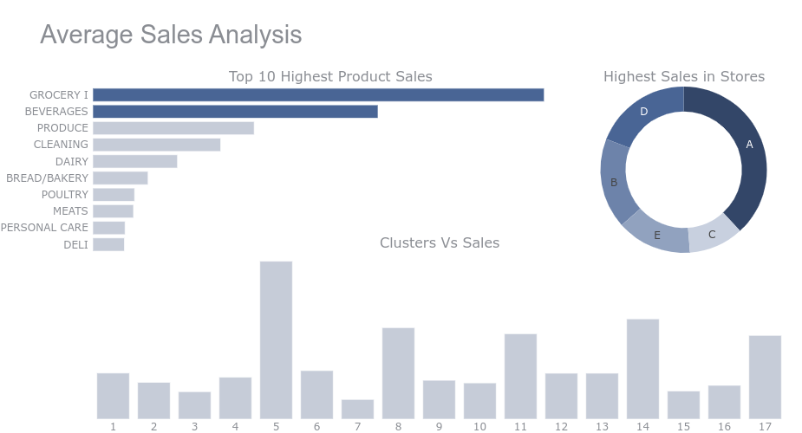

*Figure 2: Average Sales Analysis*

The graph summarizes the distribution of sales among various stores clusters and products. “Grocery 1” and “Beverages” are the two top products sold in the given period. Store “A” has the highest sales among all the stores.

Whereas Cluster 5 recorded the highest number of sales followed by Cluster 14.

*Figure 3: Average Sales for each year*

Highest sales are made in December and then decrease in January. Sales are increasing gradually from 2013 to 2017.

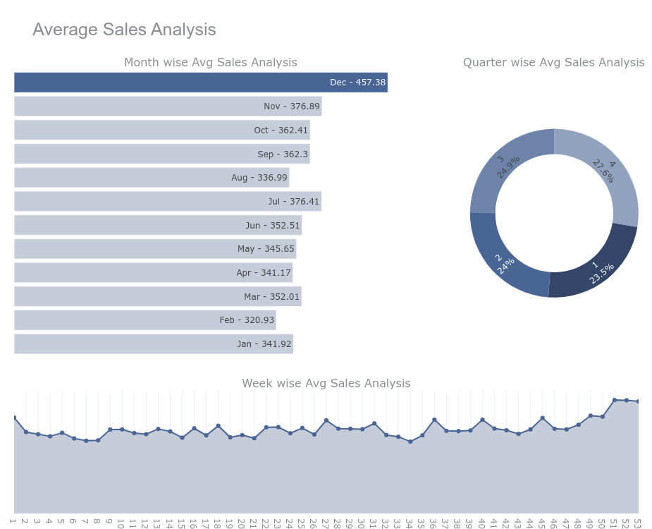

*Figure 4: Average Sales Analysis by Months*

As we saw in the above chart there is an upward trend in sales over the time. Although there are ups and downs at every point in time, generally we can observe that the trend increases.

Also we can notice how the ups and downs seem to be a bit regular, it means we might be observing a seasonal pattern here too. Let’s take a closer look by observing some year’s data:

* Highest sales are made on Sunday.
* December has the highest sales.

*Figure 5: Average Sales: Store vs Holiday*

On average Store “A” has the most sales in case of holidays too.

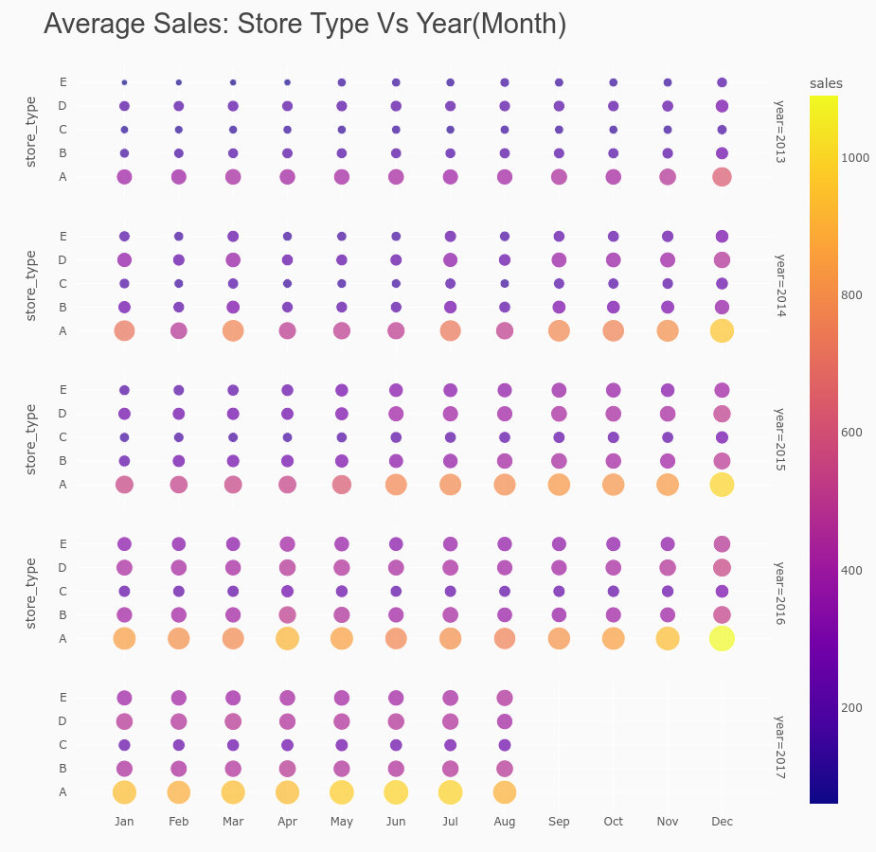

*Figure 6: Average Sales: Store vs Year*

From the above graph it can be seen that most sales occur at the end of the year, this could be related to the festivities and occasions like Christman and New Year where people celebrate in large groups. Another factor could be the bonuses that employees get at the end of the year so they tend to spend more lavishly with their family/colleagues. Also Store “A” has the most sales throughout the years.

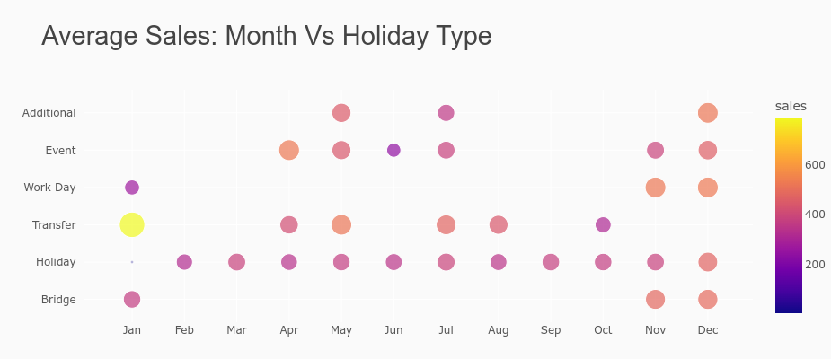

*Figure 7: Average Sales: Month vs Holiday*

From the above graph it can be seen that most sales occurred in the month of January on a “transferred” holiday. Transferred holiday is a holiday that officially falls on that calendar day, but was moved to another date by the government. A transferred day is more like a normal day than a holiday.

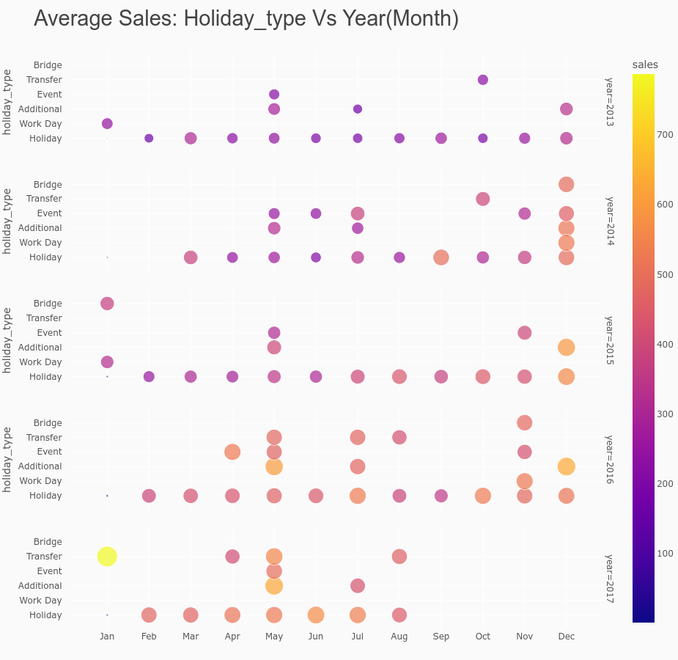

*Figure 8: Average Sales: Holiday vs Year*

As we have seen before that the average sales are increasing year by year, also people always make a purchase on a holiday.

We can also observe from the graph that there is a transferred holiday in the year 2017 which has resulted in a huge amount of sales.

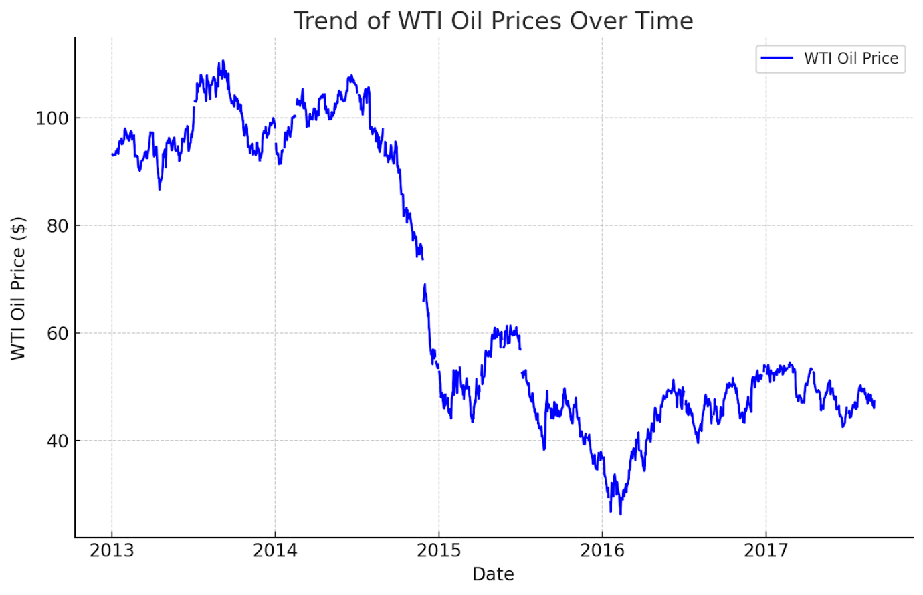

*Figure 9: Trend of oil prices over time*

The trend analysis of WTI oil prices over time shows fluctuations in oil prices. The plot demonstrates how oil prices have varied on the dates recorded in the dataset. There are visible ups and downs, reflecting the volatility in oil prices due to various factors such as changes in supply and demand, geopolitical events, and market speculations.

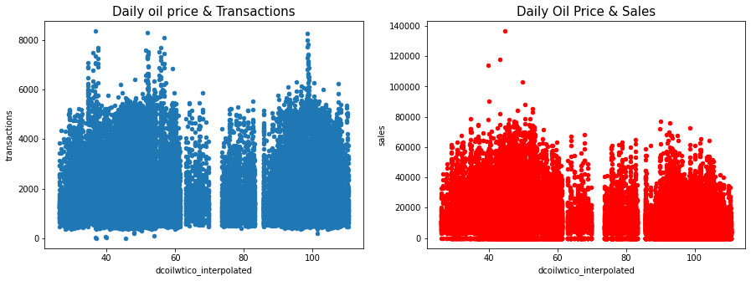

*Figure 10: Daily Oil Price with Sales and Transactions*

From the above graph we can see that whenever the oil price is less than 70, there is an increase in the number of sales. Since sales and transactions are highly positively correlated, the number of transactions also increases.

#### Data Transformation

|  |  |
| --- | --- |
| **Variable Name** | **Description** |
| date | Date of the sales. |
| store_nbr | Identifies the store at which the products are sold. |
| family | Identifies the type of product sold. |
| sales | Gives the total sales of a family at a particular store at a given date. |
| onpromotion | Gives the total number of items in a product family that were being promoted at a store at a given date. |

* **Ordinal Encoding**

Ordinal encoding is a technique used to transform categorical features that have a natural ordering into numerical representations suitable for machine learning algorithms. Ordinal encoding was done on the ‘family’ column to ensure numerical variables.

* **Scaling**

Min-Max Scaling was used for normalization. Min-max scaling, also known as min-max normalization, is a data preprocessing technique that rescales features (columns) to have a specific range, typically between 0 and 1. Done on numerical columns namely ‘store_nbr’, ‘onpromotion’ and ‘sales’.

* **Model Architecture**

Before fine-tuning the model's performance through hyperparameter tuning, the fundamental design of the model is established. This design utilizes a sequential neural network architecture, where layers serve distinct purposes. Some layers focus on extracting important features from the input data, while others concentrate on understanding the broader context within the data.

Below is a brief summary about the model architecture and the different layers used.

*Figure 11 Architecture of the Proposed Model*

Here’s a breakdown of the architecture:

* **Conv1D layer**: This is the first layer of the model and it’s a convolutional layer specifically designed for time series data. It extracts features from the input data using filters. The layer has 32 filters, each with a size of 1.
* **Bidirectional layer 1 & 2**: These are stacked bidirectional LSTM layers, that are adept at handling sequential data by learning long-term dependencies. Bidirectional LSTMs process the data in both directions (forward and backward) to capture more comprehensive features.
* **Dropout layer**: This layer is used to prevent overfitting during training by randomly dropping a percentage of units (neurons) from the network.
* **Flatten layer**: This layer reshapes the data from a two-dimensional format into a one-dimensional vector to prepare it for the final dense layer.
* **Dense layer**: This final layer is a fully connected layer that takes the flattened output from the previous layer and maps it to a single output value, which is the forecasted value.

## Summary

Key Insights:

* **Product Sales:** “Grocery 1” and “Beverages” are the top-selling product categories.
* **Store Sales:** “Store A” consistently outperforms other stores in sales volume.
* **Sales by Cluster:** Cluster 5 records the highest sales, followed by Cluster 14.
* **Seasonality:** December sees peak sales, likely due to holiday festivities and year-end bonuses. January experiences a slight dip.
* **Annual Trends:** There's generally an upward trend in sales from 2013-2017, with fluctuations throughout the years.

Additional Observations:

* “Store A” maintains the highest sales volume across all analyzed years.
* The majority of sales happen on a "transferred" holiday in January.
* WTI oil prices show fluctuation throughout the dataset, reflecting typical volatility in the oil market.

Data preprocessing using methods like normalization and encoding was done to ensure better forecasting.

# CHAPTER 5: RESULT AND DISCUSSIONS

## Introduction

This section delves into the utilization of diverse deep learning algorithms, namely Bi-LSTM and CNN, in sales forecasting. The examination emphasizes the necessity of assessing a broad spectrum of algorithms and their relative performance for an encompassing comprehension of the prediction of sales.

## Hyperparameter Tuning

Hyperparameter tuning is essential in deep learning models because it directly impacts the performance and effectiveness of these complex neural networks. Deep learning models are characterized by numerous hyperparameters, which are settings that dictate the architecture, learning process, and optimization behavior of the neural network. These hyperparameters include the number of layers, the number of neurons in each layer, learning rate, batch size, activation functions, regularization techniques, and more.

Hyperparameter tuning addresses these challenges by systematically searching for the optimal hyperparameter values that maximize the performance of the deep learning model. Techniques such as grid search, random search, and more advanced methods like Bayesian optimization and evolutionary algorithms are commonly used for this purpose. By fine-tuning hyperparameters, deep learning practitioners can improve the model's accuracy, convergence speed, and generalization ability, ultimately leading to better performance in various applications such as image recognition, natural language processing, and autonomous driving.

### Cross Validation using Grid Search

Cross-validation is a technique used to evaluate the performance of machine learning models by partitioning the dataset into subsets, training the model on a portion of the data, and evaluating it on the remaining portion. Grid search is a method used to systematically search through a predefined set of hyperparameters to find the optimal combination that yields the best performance.

Combining cross-validation with grid search allows for a thorough evaluation of different hyperparameter combinations while mitigating the risk of overfitting and providing a more reliable estimate of the model's performance.

*Figure ?? Cross Validation Workflow*

|  |
| --- |
| param_grid = {     'neurons': [32, 64],     'dropout_rate': [0.2, 0.3],     'optimizer': ['adam', 'rmsprop'],     'epochs': [50, 100] } |

Different hyperparameters that were used in model building.

* **neurons:** A list containing [32, 64] as the potential number of neurons (processing units) in a hidden layer of the neural network.
* **dropout_rate**: A list containing [0.2, 0.3] representing potential dropout rates. Dropout is a regularization technique to prevent overfitting.
* **optimizer**: A list containing ['adam', 'rmsprop'], indicating different optimization algorithms that can be used to update the network's weights during training.
* **epochs**: A list containing [50, 100] representing the number of times the entire training dataset will be passed through the network.

## Evaluation

The evaluation metric used was MSE (Mean Squared Error). The Mean Squared Error (MSE) is one of the most common metrics for evaluating the accuracy of time series forecasts. It measures the average of the squared differences between the predicted values and the actual (true) values.

A lower MSE value indicates a better fit for the forecasting model. An MSE of zero would mean a perfect model with no errors.

Formula:

**MSE = (1/n) * Σ(yᵢ - ŷᵢ)²**

**RMSE = sqrt(MSE)**

where:

n = number of data points

yᵢ = actual value at time i

ŷᵢ = predicted value at time i

The image below shows the results of the various models with different hyper-parameters. The MSE value is represented by ‘loss’.

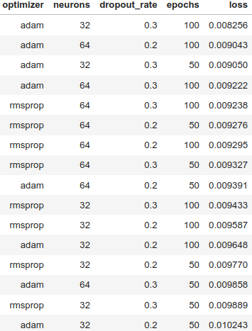

*Figure ?? Grid Search Results*

The best performing model had the hyperparameters as [‘adam’, ‘32’, ‘0.3’, ‘100’], resulting in a loss of 0.008256. Whereas the second best performing model had the list of hyperparameters as [‘adam’, ‘64’, ‘0.2’, ‘100’]. Dropout rate of 0.3 was the best suited and higher number of epochs resulted in a lower MSE value.

## Summary

The table shows the results of CNN-BiLSTM model used for sales forecasting, with Model 1 outperforming Model 2 based on RMSE.

Among the various hyperparameters that were used in the training these two models have the lowest RMSE value in the testing.

|  |  |  |  |  |  |
| --- | --- | --- | --- | --- | --- |
| **Model** | **Optimizer** | **Neurons** | **Dropout Rate** | **Epochs** | **RMSE** |
| **Model_1** | adam | 32 | 0.1 | 100 | 121.539159826848 |
| **Model_2** | adam | 64 | 0.2 | 100 | 123.952789968161 |

*Figure ?? Model_1: train_loss vs validation_loss*

*Figure ?? Model_2: train_loss vs validation_loss*

# CHAPTER 6: CONCLUSIONS AND RECOMENDATIONS

## Conclusion

This research demonstrated the effectiveness of a hybrid CNN/Bi-LSTM model for addressing the challenges of Multivariate Time Series Classification. The CNN component successfully extracted meaningful features from complex multivariate input data, while the Bi-LSTM effectively captured long-term dependencies within the time series. Experimental results on sales data indicated that the proposed model surpasses the performance of other state-of-the-art MTSC methods in terms of MSE.

The combination of CNN and Bi-LSTM proved to be a powerful approach for MTSC, outperforming models using either CNN or LSTM components individually. This synergy highlights the importance of leveraging complementary techniques.

The data used in the study was sourced from Corporación Favorita, a large Ecuadorian-based grocery retailer, which is an extensive dataset obtained from Kaggle. This dataset contains a wealth of relevant features and predictors that can be used in sales forecasting.

The use of min-max scaling and ordinal encoding significantly improved model performance, demonstrating the crucial role of data preparation in MTSC tasks.

Grid search proved to be an effective method for optimizing the CNN/Bi-LSTM architecture, leading to enhanced performance. Various models with different hyperparameters were trained on the dataset and the best performing ones were used for further testing. This method of training proves to be highly beneficial for finding and selecting the best hyperparameters for the model, regardless of the high consumption of resources and time.

Finally two models with different hyperparameters were used for the MTSC task for sales forecasting. Both models have almost similar RMSE values i.e. 121.539159826848 and 123.952789968161.

The study presents strong empirical evidence supporting the efficacy of the hybrid model, data preprocessing, and hyperparameter tuning strategies for MTSC tasks. The findings hold promise for practical applications in areas such as finance, healthcare, and predictive maintenance where analyzing multiple correlated time series is crucial.

## Recommendations

Future research could explore:

* Incorporating attention mechanisms to further enhance the model's ability to focus on crucial features.
* Investigating alternative hyperparameter optimization techniques such as Bayesian optimization or random search.
* Investigating the explainability of the model for better understanding of its decision-making processes.

# References

Akhtar, S., & Shah, A. (2021). *Comparative Analysis of LSTM-FCN on Multiple Datasets*.

Chen, J. L., Li, G., Wu, D. C., & Shen, S. (2019). Forecasting Seasonal Tourism Demand Using a Multiseries Structural Time Series Method. *Journal of Travel Research*, *58*(1), 92–103. https://doi.org/10.1177/0047287517737191

Ensafi, Y., Amin, S. H., Zhang, G., & Shah, B. (2022). Time-series forecasting of seasonal items sales using machine learning – A comparative analysis. *International Journal of Information Management Data Insights*, *2*(1). https://doi.org/10.1016/j.jjimei.2022.100058

Fildes, R., Kolassa, S., & Ma, S. (2022). Post-script—Retail forecasting: Research and practice. *International Journal of Forecasting*, *38*(4), 1319–1324. https://doi.org/10.1016/j.ijforecast.2021.09.012

Gupta, A., & Raghav, Y. (2020). *Time Series Classification with Meta Learning*. 189–201. https://doi.org/10.5121/csit.2020.101415

Jaiswal, S., & Gupta, P. (2023). Diabetes Prediction Using Bi-directional Long Short-Term Memory. *SN Computer Science*, *4*(4). https://doi.org/10.1007/s42979-023-01831-z

Karim, F., Majumdar, S., & Darabi, H. (2019). Insights into lstm fully convolutional networks for time series classification. *IEEE Access*, *7*, 67718–67725. https://doi.org/10.1109/ACCESS.2019.2916828

Karim, F., Majumdar, S., Darabi, H., & Chen, S. (2017). *LSTM Fully Convolutional Networks for Time Series Classification*. https://doi.org/10.1109/ACCESS.2017.2779939

Kaunchi, P., Jadhav, T., Dandawate, Y., & Marathe, P. (2021, October 1). Future Sales Prediction for Indian Products Using Convolutional Neural Network-Long Short Term Memory. *2021 2nd Global Conference for Advancement in Technology, GCAT 2021*. https://doi.org/10.1109/GCAT52182.2021.9587668

Khan, M., Wang, H., Riaz, A., Elfatyany, A., & Karim, S. (2021). Bidirectional LSTM-RNN-based hybrid deep learning frameworks for univariate time series classification. *Journal of Supercomputing*, *77*(7), 7021–7045. https://doi.org/10.1007/s11227-020-03560-z

Ko, M. S., Lee, K., Kim, J. K., Hong, C. W., Dong, Z. Y., & Hur, K. (2021). Deep Concatenated Residual Network with Bidirectional LSTM for One-Hour-Ahead Wind Power Forecasting. *IEEE Transactions on Sustainable Energy*, *12*(2), 1321–1335. https://doi.org/10.1109/TSTE.2020.3043884

Lei, Y., & Wu, Z. (2020). Time series classification based on statistical features. *Eurasip Journal on Wireless Communications and Networking*, *2020*(1). https://doi.org/10.1186/s13638-020-1661-4

Li, X., Du, J., Wang, Y., & Cao, Y. (2020). Automatic Sales Forecasting System Based on LSTM Network. *Proceedings - 2020 International Conference on Computer Science and Management Technology, ICCSMT 2020*, 393–396. https://doi.org/10.1109/ICCSMT51754.2020.00088

Liu, J., Liu, C., Zhang, L., & Xu, Y. (2020). Research on sales information prediction system of e-commerce enterprises based on time series model. In *Information Systems and e-Business Management* (Vol. 18, Issue 4, pp. 823–836). Springer Science and Business Media Deutschland GmbH. https://doi.org/10.1007/s10257-019-00399-7

Sirisha, B., Goud, K. K. C., & Rohit, B. T. V. S. (2022). A Deep Stacked Bidirectional LSTM (SBiLSTM) Model for Petroleum Production Forecasting. *Procedia Computer Science*, *218*, 2767–2775. https://doi.org/10.1016/j.procs.2023.01.248

Sohrabpour, V., Oghazi, P., Toorajipour, R., & Nazarpour, A. (2021). Export sales forecasting using artificial intelligence. *Technological Forecasting and Social Change*, *163*. https://doi.org/10.1016/j.techfore.2020.120480

Vallés-Pérez, I., Soria-Olivas, E., Martínez-Sober, M., Serrano-López, A. J., Gómez-Sanchís, J., & Mateo, F. (2022). *Approaching sales forecasting using recurrent neural networks and transformers*. http://arxiv.org/abs/2204.07786

Wang, B., Jiang, T., Zhou, X., Ma, B., Zhao, F., & Wang, Y. (2020). Time-series classification based on fusion features of sequence and visualization. *Applied Sciences (Switzerland)*, *10*(12). https://doi.org/10.3390/APP10124124

Wei, Z., Zhu, Q., Min, C., Chen, Y., & Wang, G. (2022). Bidirectional Hybrid LSTM Based Recurrent Neural Network for Multi-view Stereo. *IEEE Transactions on Visualization and Computer Graphics*. https://doi.org/10.1109/TVCG.2022.3165860

Yazdanbakhsh, O., & Dick, S. (2017). Forecasting of Multivariate Time Series via Complex Fuzzy Logic. *IEEE Transactions on Systems, Man, and Cybernetics: Systems*, *47*(8), 2160–2171. https://doi.org/10.1109/TSMC.2016.2630668

Zhao, L., Mo, C., Ma, J., Chen, Z., & Yao, C. (2022). LSTM-MFCN: A time series classifier based on multi-scale spatial–temporal features. *Computer Communications*, *182*, 52–59. https://doi.org/10.1016/j.comcom.2021.10.036

Zhao, Y., Ren, X., & Zhang, X. (2021). Optimization of a Comprehensive Sequence Forecasting Framework Based on DAE-LSTM Algorithm. *Journal of Physics: Conference Series*, *1746*(1). https://doi.org/10.1088/1742-6596/1746/1/012087

Zhu, H., Zhao, P., Chan, Y. P., Kang, H., & Lee, D. L. (2022). Breast Cancer Early Detection with Time Series Classification. *International Conference on Information and Knowledge Management, Proceedings*, 3735–3745. https://doi.org/10.1145/3511808.3557107

# Appendix A

Hybrid model of Bi-LSTM and CNN for Multivariate Time Series Classification for ecommerce sales Forecasting

Research Proposal

**Abstract**

The research introduces a Hybrid Model amalgamating Bi-LSTM and CNN architectures for the classification of multivariate time series data in the domain of e-commerce sales forecasting. The proposed model addresses the complexities associated with predicting sales patterns influenced by diverse contextual factors. Leveraging the strengths of Bi-LSTM in capturing long-term dependencies and CNN in extracting spatial features, the hybridization aims to provide a robust framework for accurate feature extraction and sequence learning. The model's efficacy will be rigorously evaluated using real-world e-commerce sales datasets, comparing its performance against traditional time series forecasting methods as well as standalone Bi-LSTM and CNN models. Through this research, I seek to advance the precision of e-commerce sales forecasts, contributing to the optimization of business operations and decision-making in the dynamic and competitive landscape of online retail.

**Table of Contents**

Abstract ii

1. Background. 6

2. Related Work 7

3. Research Questions 8

4. Aim and Objectives 9

4.1. Aim 9

4.2. Objectives: 10

5. Significance of the Study 10

6. Scope of the Study 11

7. Research Methodology 12

7.1. Introduction 12

7.2. Data Preparation 12

7.3. Algorithms & Techniques Description 12

7.4. Implementation 12

7.5. Evaluation 13

8. Required Resources 13

8.1. Hardware requirements 13

8.2. Software requirements 13

9. Research Plan 14

9.1. Gantt Chart 14

9.2. Risk Mitigation and Contingency Plan 14

10. References 15

**LIST OF FIGURES**

Figure 1: Project Planner 14

**LIST OF TABLES**

Table 1: Risks and Contingency Plan 14

**LIST OF ABBREVIATIONS**

CNN…………... Convolutional Neural Network

Bi-LSTM …... Bidirectional Long-Short Term Memory

LSTM …….... Long-Short Term Memory

DTW………… Dynamic Time Warping

RNN ………… Recurrent Neural Network

SAX………... Symbolic Aggregate approXimation

TSC………… Time series classification

FCN ………… Recurrent Neural Network

ARIMA……... Autoregressive Integrated Moving Average

SARIMA………… Seasonal AutoRegressive Integrated Moving Average

1. **Background.**

Time series analysis in e-commerce involves the study of data points collected over time to forecast future trends. Traditional statistical methods, such as ARIMA and Exponential Smoothing, have been widely used for this purpose. However, the dynamic and complex nature of e-commerce data, characterized by high volume, velocity, and variety, poses significant challenges to these traditional methods. The need for more advanced techniques to accurately predict sales trends has become increasingly evident, especially with the rapid growth of online retail and the vast amount of data generated by e-commerce platforms.

The limitations of traditional time series analysis methods in handling complex e-commerce data have led to the adoption of machine learning techniques. Machine learning offers the ability to automatically learn and improve from experience without being explicitly programmed. Early machine learning approaches in time series forecasting involved simpler models like decision trees and linear regression. However, these models often fell short in capturing the non-linear relationships inherent in multivariate time series data.

Deep learning, a subset of machine learning, has gained prominence due to its ability to learn complex patterns in large datasets. Two significant architectures in deep learning, LSTM and CNN, have shown remarkable success in time series analysis. LSTM, a type of recurrent neural network, is particularly adept at processing sequential data, capturing long-term dependencies, and retaining information over extended periods. This makes it well-suited for analyzing time series data where past information is crucial for predicting future trends. On the other hand, CNNs, known for their success in image processing, have been adapted for time series classification. Their ability to detect local patterns and features in data makes them suitable for identifying short-term trends and anomalies in time series.

The integration of LSTM and CNN into a hybrid model leverages the strengths of both architectures. While LSTM models temporal dependencies, CNN excels in extracting spatial features from multivariate time series data. This synergy enhances the model's ability to handle the complexities of e-commerce data, which often involves multiple influencing factors such as customer behavior, market trends, and external economic indicators. The hybrid model aims to provide a more accurate and reliable tool for e-commerce sales forecasting, essential for strategic decision-making in the dynamic e-commerce sector.

The application of LSTM-CNN hybrid models in e-commerce sales forecasting involves predicting future sales volumes based on historical data and various external factors. Accurate forecasting is crucial for inventory management, marketing strategy, and overall business planning. The hybrid model processes multivariate time series data, including sales figures, customer traffic, seasonal trends, and promotional activities, to generate more accurate and reliable sales forecasts.

The hybrid model of BiLSTM and CNN represents a significant advancement in the field of e-commerce sales forecasting. By combining the strengths of BiLSTM and CNN, this model offers a robust framework for multivariate time series classification, capable of handling the complexities and variabilities inherent in e-commerce data. As e-commerce continues to evolve, the adoption of such advanced forecasting models will be crucial for businesses seeking to optimize their operations and stay competitive in the digital marketplace.

1. **Related Work**

* **Time Series Analysis in E-commerce** (Ensafi et al., 2022) The document provides a foundational understanding of time series analysis in the context of e-commerce. It emphasizes the importance of accurate sales forecasting for inventory management, pricing strategies, and overall business planning. The paper also discusses traditional statistical methods for time series forecasting, highlighting their limitations in handling complex, multivariate data common in e-commerce platforms.
* **Evolution of Machine Learning Techniques in Forecasting** (Ensafi et al., 2022; Ko et al., 2021; Sirisha et al., 2022)These Sources delve into the evolution of machine learning techniques in forecasting. They compare traditional methods like ARIMA with more advanced machine learning approaches, including neural networks. These papers underscore the superior performance of machine learning models in capturing non-linear relationships and complex patterns in data, which are crucial for accurate e-commerce sales forecasting.
* **The Rise of Deep Learning: LSTM and CNN** (Jaiswal & Gupta, 2023; Ko et al., 2021; Sirisha et al., 2022; Wei et al., 2022)The documents focus on the rise of deep learning techniques, particularly LSTM and CNN, in time series analysis. LSTM, with its ability to remember long-term dependencies, is shown to be particularly effective in handling sequential data. Meanwhile, CNNs, known for their prowess in pattern recognition in images, are being increasingly applied to time series data for feature extraction.
* **Hybrid Models: Combining LSTM and CNN** The Sources (Akhtar & Shah, 2021; Karim et al., 2017; Khan et al., 2021; Wei et al., 2022; L. Zhao et al., 2022) explore the development of hybrid models that combine LSTM and CNN. These models leverage the strengths of both architectures: LSTMs for capturing temporal dependencies and CNNs for extracting spatial features. The papers demonstrate how such hybrid models outperform standalone LSTM or CNN models in various time series classification tasks.
* **Application in E-commerce Sales Forecasting** (Ensafi et al., 2022)In documents the application of these advanced models in the context of e-commerce sales forecasting is specifically addressed. They provide case studies and empirical results showing the effectiveness of LSTM-CNN hybrid models in predicting sales, considering multiple variables like customer behavior, seasonal trends, and promotional activities.
* **Challenges and Future Directions** (Khan et al., 2021; Ko et al., 2021; Sirisha et al., 2022; Wei et al., 2022) Finally, sources discuss the challenges in implementing these advanced models in a real-world e-commerce setting. Issues such as data quality, computational complexity, and model interpretability are highlighted. The papers also suggest future research directions, including the integration of external data sources and the exploration of more sophisticated hybrid models.

**Conclusion** The reviewed literature collectively underscores the potential of hybrid LSTM-CNN models in enhancing the accuracy and efficiency of multivariate time series classification, particularly in the domain of e-commerce sales forecasting. These models represent a significant advancement over traditional methods, offering a more nuanced understanding of complex, dynamic market trends. Future research in this area will explore further innovations and improvements in predictive analytics for e-commerce.

1. **Research Questions**

This thesis tries to answer the following questions:

1. How does the integration of BiLSTM and CNN enhance the accuracy and efficiency of multivariate time series classification in e-commerce sales forecasting?

This question investigates the synergistic effect of combining BiLSTM and CNN in a hybrid model. It seeks to understand how the bidirectional nature of LSTM, which captures temporal dependencies, complements the spatial feature extraction capabilities of CNN. The focus is on assessing the model's performance in accurately forecasting sales by analyzing complex, multivariate e-commerce data, as highlighted in sources (Karim et al., 2019; Khan et al., 2021; Ko et al., 2021; Sirisha et al., 2022; Wei et al., 2022; L. Zhao et al., 2022).

1. What are the challenges and limitations associated with the implementation of a BiLSTM-CNN hybrid model in real-world e-commerce environments, and how can these be addressed?

Drawing from the discussions in sources (Karim et al., 2019; Khan et al., 2021; Ko et al., 2021; Sirisha et al., 2022; Wei et al., 2022; L. Zhao et al., 2022), this question delves into the practical aspects of deploying the hybrid model. It explores challenges such as computational complexity, data quality, and model interpretability. The aim is to identify strategies to mitigate these challenges, ensuring the model's applicability and effectiveness in diverse e-commerce settings.

1. Can the BiLSTM-CNN hybrid model be effectively adapted to incorporate external factors (such as economic indicators, social media trends, and seasonal variations) that influence e-commerce sales, and how does this impact its forecasting accuracy?

This question, inspired by insights from sources (Karim et al., 2019; Khan et al., 2021; Ko et al., 2021; Sirisha et al., 2022; Wei et al., 2022; L. Zhao et al., 2022), explores the model's adaptability and responsiveness to external factors that significantly impact e-commerce sales. It aims to assess the extent to which incorporating such variables enhances the model's predictive accuracy and provides a more holistic view of market dynamics.

1. **Aim and Objectives**
   1. **Aim**

To develop and evaluate a hybrid model combining BiLSTM and CNN for enhancing the accuracy and efficiency of multivariate time series classification in e-commerce sales forecasting.

* 1. **Objectives:**
* To Investigate the Integration of BiLSTM and CNN for Time Series Analysis: Objective is to explore how the combination of BiLSTM and CNN can be optimized for time series data, particularly focusing on the unique challenges presented by e-commerce sales data. This involves understanding the strengths of each model in handling temporal and spatial dependencies within the data, as discussed in sources (Ensafi et al., 2022), and (Khan et al., 2021).
* To Evaluate the Performance of the Hybrid Model in Multivariate Forecasting: Aimed at assessing the model's ability to accurately forecast e-commerce sales by analyzing multiple variables. This includes evaluating the model's performance against traditional and single-architecture models, as highlighted in sources(Akhtar & Shah, 2021; Karim et al., 2017; Khan et al., 2021; Ko et al., 2021; Sirisha et al., 2022; Wei et al., 2022).
* To Address Computational and Practical Challenges: This objective focuses on identifying and overcoming the computational challenges, such as model complexity and data requirements, ensuring the model's practical applicability in real-world settings, as discussed in sources (Akhtar & Shah, 2021; Ensafi et al., 2022; Karim et al., 2017; Khan et al., 2021; Ko et al., 2021; Lei & Wu, 2020; Sirisha et al., 2022; Wang et al., 2020; Zhu et al., 2022).
* To Adapt the Model for Dynamic E-commerce Environments: The goal here is to enhance the model's adaptability to rapidly changing e-commerce environments. This includes incorporating external factors like market trends, consumer behavior, and seasonal variations, which are crucial for accurate forecasting, as indicated in sources (Akhtar & Shah, 2021; Ensafi et al., 2022; Karim et al., 2017; Khan et al., 2021; Ko et al., 2021; Lei & Wu, 2020; Sirisha et al., 2022; Wang et al., 2020; Zhu et al., 2022).
* To Contribute to the Field of E-commerce Predictive Analytics: The final objective is to contribute valuable insights and methodologies to the field of predictive analytics in e-commerce. This involves not only advancing the technical understanding of hybrid modeling techniques but also providing practical guidelines for their implementation in e-commerce sales forecasting.

1. **Significance of the Study**

The significance of the study lies in its potential to revolutionize the accuracy and efficiency of predictive analytics in the e-commerce sector. As e-commerce platforms generate vast amounts of complex, multivariate data, traditional forecasting methods often fall short in capturing the intricate patterns and relationships within this data. The proposed hybrid model leverages the strengths of both BiLSTM and CNN, offering a more sophisticated approach to understanding and predicting consumer behavior and market trends.

This research stands to contribute significantly to the field of e-commerce by providing a robust tool for forecasting sales, which is crucial for inventory management, marketing strategies, and overall business planning. The ability of the hybrid model to incorporate and analyze multiple variables, including external factors like economic indicators and seasonal variations, can lead to more informed and strategic decision-making processes for e-commerce businesses. Furthermore, by addressing the practical challenges of implementing such advanced models, this study tries to bridge the gap between theoretical research and real-world applications, making it a valuable resource for both academics and practitioners in the field of e-commerce and data science.

1. **Scope of the Study**

The scope of the study encompasses several key areas in the realm of advanced data analytics and e-commerce strategy. Primarily, the study focuses on the development and optimization of a hybrid machine learning model that integrates the strengths of BiLSTM and CNN. This model is specifically tailored to address the complexities of multivariate time series data prevalent in e-commerce platforms, as highlighted in the provided documents.

The research will delve into the comparative analysis of this hybrid model against traditional time series forecasting methods and standalone machine learning models, assessing its efficacy in handling large-scale, dynamic e-commerce data. A significant part of the study is dedicated to evaluating the model's ability to accurately predict sales trends by processing and learning from various data dimensions, including customer behavior patterns, seasonal fluctuations, and market changes.

Additionally, the study aims to explore the practical aspects of implementing this advanced predictive model in real-world e-commerce settings. This includes addressing challenges related to computational resources, data quality, and model scalability. The scope extends to providing insights and recommendations for e-commerce businesses on leveraging this model for strategic decision-making, thereby enhancing their operational efficiency and market responsiveness.

1. **Research Methodology**
   1. **Introduction**

This research aims to develop a hybrid model combining BiLSTM and CNN for forecasting e-commerce sales. The methodology focuses on leveraging the sequential data processing capability of BiLSTM and the feature extraction proficiency of CNN. This approach is designed to handle the complexities and variabilities in e-commerce data, providing a more accurate and efficient forecasting tool. The methodology encompasses dataset description, data preparation, algorithm selection, implementation, and evaluation, ensuring a comprehensive approach to model development and validation.

* 1. **Data Preparation**

Data preparation will involve cleaning, normalization, and transformation of the e-commerce dataset. This step is crucial to ensure the quality and consistency of the data fed into the model. Techniques like handling missing values, outlier detection, and feature engineering will be employed. The data will be segmented into training, validation, and testing sets to facilitate model training and evaluation. Special attention will be given to the temporal nature of the data, ensuring that time-dependent characteristics are appropriately handled and represented in the model.

* 1. **Algorithms & Techniques Description**

The core of the research methodology is the integration of BiLSTM and CNN algorithms. BiLSTM will be used for its ability to capture long-term dependencies in time series data, processing information in both forward and backward directions. CNN will be employed for its proficiency in extracting spatial features and patterns from the data. The synergy of these algorithms aims to harness their respective strengths, creating a robust model for time series classification. The research will also explore various architectural configurations and hyperparameter settings to optimize the model's performance.

* 1. **Implementation**

Implementation will involve coding the hybrid model using Python and ML libraries like TensorFlow or Keras. The model will be trained on the prepared dataset, with iterative adjustments and optimizations based on performance metrics. The implementation phase will also include the integration of the model into a simulated e-commerce environment to test its real-world applicability. This phase is critical for understanding the practical challenges and limitations of the model in a dynamic e-commerce setting.

* 1. **Evaluation**

The evaluation of the model will be conducted using a range of metrics such as accuracy, precision, recall, and F1 score. The model's forecasting performance will be compared against traditional time series models and standalone deep learning models. Evaluation will also consider the model's computational efficiency and scalability. The robustness of the model will be tested under various scenarios, including changes in market trends and consumer behavior. The evaluation aims to validate the effectiveness of the hybrid model in accurately forecasting e-commerce sales and its potential as a tool for strategic decision-making in the e-commerce.

1. **Required Resources**
   1. **Hardware requirements**
2. High-performance CPUs and GPUs.
3. Large RAM capacity.
4. High-speed SSD storage.
5. Stable internet connection.
6. Backup power solutions.
   1. **Software requirements**
7. Python 3.7+.
8. TensorFlow, Keras, or PyTorch.
9. Pandas and NumPy libraries.
10. Matplotlib or Seaborn for visualization.
11. Jupyter Notebook or PyCharm IDE.
12. Git for version control.
13. Database management software.
14. Linux or Windows OS with GPU support.
15. **Research Plan**
    1. **Gantt Chart**

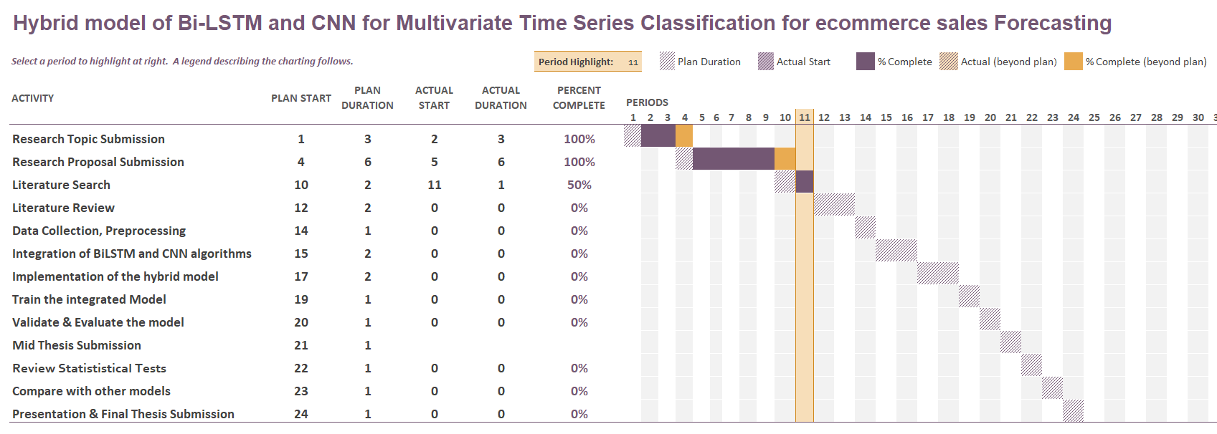

**Figure 1: Project Planner**

**Note:** 1 Period = I Calendar Week

* 1. **Risk Mitigation and Contingency Plan**

The potential risks and their corresponding contingencies are listed below:

**Table 1: Risks and Contingency Plan**

|  |  |
| --- | --- |
| **Risk** | **Contingency** |
| Unable to perform research tasks due to personal problems or health issues or professional commitments affecting project timeline | * Avail extensions if necessary. * Plan for buffer time in project management. |
| Unavailability of specialized hardware such as GPUs. | * Use cloud GPUs. * Check with Upgrad if paid version required |

1. **References**

Akhtar, S., & Shah, A. (2021). *Comparative Analysis of LSTM-FCN on Multiple Datasets*.

Chen, J. L., Li, G., Wu, D. C., & Shen, S. (2019). Forecasting Seasonal Tourism Demand Using a Multiseries Structural Time Series Method. *Journal of Travel Research*, *58*(1), 92–103. https://doi.org/10.1177/0047287517737191

Ensafi, Y., Amin, S. H., Zhang, G., & Shah, B. (2022). Time-series forecasting of seasonal items sales using machine learning – A comparative analysis. *International Journal of Information Management Data Insights*, *2*(1). https://doi.org/10.1016/j.jjimei.2022.100058

Fildes, R., Kolassa, S., & Ma, S. (2022). Post-script—Retail forecasting: Research and practice. *International Journal of Forecasting*, *38*(4), 1319–1324. https://doi.org/10.1016/j.ijforecast.2021.09.012

Gupta, A., & Raghav, Y. (2020). *Time Series Classification with Meta Learning*. 189–201. https://doi.org/10.5121/csit.2020.101415

Jaiswal, S., & Gupta, P. (2023). Diabetes Prediction Using Bi-directional Long Short-Term Memory. *SN Computer Science*, *4*(4). https://doi.org/10.1007/s42979-023-01831-z

Karim, F., Majumdar, S., & Darabi, H. (2019). Insights into lstm fully convolutional networks for time series classification. *IEEE Access*, *7*, 67718–67725. https://doi.org/10.1109/ACCESS.2019.2916828

Karim, F., Majumdar, S., Darabi, H., & Chen, S. (2017). *LSTM Fully Convolutional Networks for Time Series Classification*. https://doi.org/10.1109/ACCESS.2017.2779939

Kaunchi, P., Jadhav, T., Dandawate, Y., & Marathe, P. (2021, October 1). Future Sales Prediction for Indian Products Using Convolutional Neural Network-Long Short Term Memory. *2021 2nd Global Conference for Advancement in Technology, GCAT 2021*. https://doi.org/10.1109/GCAT52182.2021.9587668

Khan, M., Wang, H., Riaz, A., Elfatyany, A., & Karim, S. (2021). Bidirectional LSTM-RNN-based hybrid deep learning frameworks for univariate time series classification. *Journal of Supercomputing*, *77*(7), 7021–7045. https://doi.org/10.1007/s11227-020-03560-z

Ko, M. S., Lee, K., Kim, J. K., Hong, C. W., Dong, Z. Y., & Hur, K. (2021). Deep Concatenated Residual Network with Bidirectional LSTM for One-Hour-Ahead Wind Power Forecasting. *IEEE Transactions on Sustainable Energy*, *12*(2), 1321–1335. https://doi.org/10.1109/TSTE.2020.3043884

Lei, Y., & Wu, Z. (2020). Time series classification based on statistical features. *Eurasip Journal on Wireless Communications and Networking*, *2020*(1). https://doi.org/10.1186/s13638-020-1661-4

Li, X., Du, J., Wang, Y., & Cao, Y. (2020). Automatic Sales Forecasting System Based on LSTM Network. *Proceedings - 2020 International Conference on Computer Science and Management Technology, ICCSMT 2020*, 393–396. https://doi.org/10.1109/ICCSMT51754.2020.00088

Liu, J., Liu, C., Zhang, L., & Xu, Y. (2020). Research on sales information prediction system of e-commerce enterprises based on time series model. In *Information Systems and e-Business Management* (Vol. 18, Issue 4, pp. 823–836). Springer Science and Business Media Deutschland GmbH. https://doi.org/10.1007/s10257-019-00399-7

Sirisha, B., Goud, K. K. C., & Rohit, B. T. V. S. (2022). A Deep Stacked Bidirectional LSTM (SBiLSTM) Model for Petroleum Production Forecasting. *Procedia Computer Science*, *218*, 2767–2775. https://doi.org/10.1016/j.procs.2023.01.248

Sohrabpour, V., Oghazi, P., Toorajipour, R., & Nazarpour, A. (2021). Export sales forecasting using artificial intelligence. *Technological Forecasting and Social Change*, *163*. https://doi.org/10.1016/j.techfore.2020.120480

Vallés-Pérez, I., Soria-Olivas, E., Martínez-Sober, M., Serrano-López, A. J., Gómez-Sanchís, J., & Mateo, F. (2022). *Approaching sales forecasting using recurrent neural networks and transformers*. http://arxiv.org/abs/2204.07786

Wang, B., Jiang, T., Zhou, X., Ma, B., Zhao, F., & Wang, Y. (2020). Time-series classification based on fusion features of sequence and visualization. *Applied Sciences (Switzerland)*, *10*(12). https://doi.org/10.3390/APP10124124

Wei, Z., Zhu, Q., Min, C., Chen, Y., & Wang, G. (2022). Bidirectional Hybrid LSTM Based Recurrent Neural Network for Multi-view Stereo. *IEEE Transactions on Visualization and Computer Graphics*. https://doi.org/10.1109/TVCG.2022.3165860

Yazdanbakhsh, O., & Dick, S. (2017). Forecasting of Multivariate Time Series via Complex Fuzzy Logic. *IEEE Transactions on Systems, Man, and Cybernetics: Systems*, *47*(8), 2160–2171. https://doi.org/10.1109/TSMC.2016.2630668

Zhao, L., Mo, C., Ma, J., Chen, Z., & Yao, C. (2022). LSTM-MFCN: A time series classifier based on multi-scale spatial–temporal features. *Computer Communications*, *182*, 52–59. https://doi.org/10.1016/j.comcom.2021.10.036

Zhao, Y., Ren, X., & Zhang, X. (2021). Optimization of a Comprehensive Sequence Forecasting Framework Based on DAE-LSTM Algorithm. *Journal of Physics: Conference Series*, *1746*(1). https://doi.org/10.1088/1742-6596/1746/1/012087

Zhu, H., Zhao, P., Chan, Y. P., Kang, H., & Lee, D. L. (2022). Breast Cancer Early Detection with Time Series Classification. *International Conference on Information and Knowledge Management, Proceedings*, 3735–3745. https://doi.org/10.1145/3511808.3557107