# Final Checkpoints



Agenda

Q&A

Rubric

Submissions

References

Formatting

Abstract

Chapter

Revisit

## sis Structure

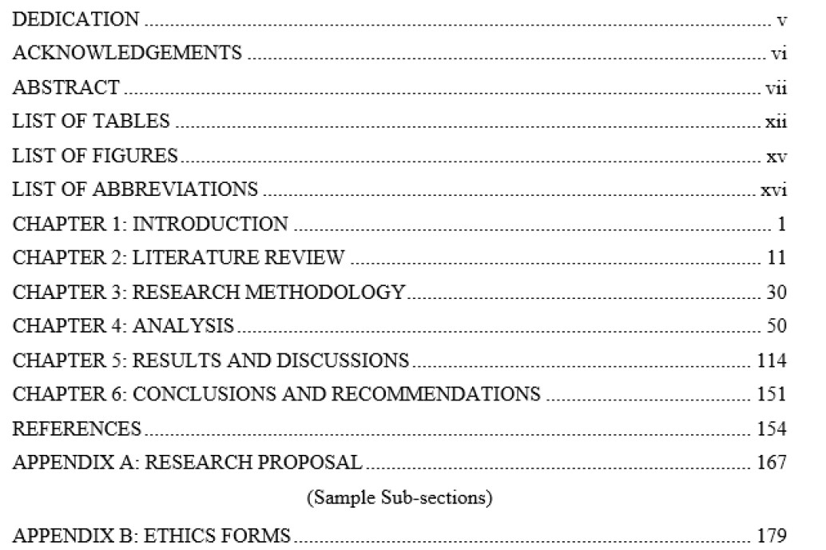

## Chapter Revisit

Generic

•

Chapter 2 to 5 has

Introduction and Summary

•

Figure Caption at bottom

•

Table Caption at top

•

Text Justified

•

Section should have

content

•

First occurrence of

acronyms should be

expanded

•

Reference/Citation and

Figure, Equation, Algorithm,

Table Caption

Chapter 4

•

Experiments explained

well?

•

Analysis if applicable

•

Hyperparameter tuning

Chapter5

•

Final Results

included?

•

Result Analysis

•

Error Analysis

•

Justification and Discussion

Chapter 6

•

Concluded according to

aims & objectives

•

Contribution Highlighted

•

Recommendation?

## Chapter Revisit

Chapter 1

•

Update & Refine

•

Revisit all sections

•

Update Structure of the study

Chapter

2

•

Overall story is getting reflected

via sections?

•

Have you included recent

papers?

•

Summarized well?

•

Compared with existing

techniques/gaps?

Chapter 3

•

Workflow updated?

•

Methods cited?

•

Justified methods?

•

Each objective has some

method?

## Abstract

Should include

•

Introduction

•

Objective

•

Methodology

•

Results

•

Conclusion

Abbreviation should be

avoided.

Do not use

reference/citations or any

graphic element in

abstract

Be short, Concise and

deep



Formatting

Cover Page

List of Tables

List of Figures

List of Abbreviations

Body

Harvard Referencing

Guide

MSc Project

Guidelines

Submission Files

|  |  |  |
| --- | --- | --- |
| Final Thesis Submission |  | Final Video Presentation |
| * Thesis * Turnitin Report * Code(Optional)link * Dataset(Optional)link * Feedback Response Sheet | * PPT * Video recording(presentation with audio & Video)link |

Rubrics