Ex. No. : 5

Date:

**SELECT with various clause – BETWEEN, IN, Aggregate function**

**AIM:**

To view the records from the tables using SELECT commands with BETWEEN, IN, Aggregate functions.

**DESCRIPTION**:

The BETWEEN operator allows you to specify a range to test. We often use the BETWEEN operator in the WHERE clause of the SELECT, INSERT, UPDATE, and DELETE statements.

The IN operator allows you to determine if a specified value matches any one of a list or a sub query.

MySQL provides many aggregate functions that include AVG, COUNT, SUM, MIN, MAX, etc. An aggregate function ignores NULL values when it performs calculation except for the COUNT function.

**BETWEEN operator**:

SELECT

column1,column2,...

FROM

table_name

WHERE expr [NOT] BETWEEN begin_expr AND end_expr;

The *expr* is the expression to test in the range that is defined by *begin_expr* and *end_expr*.

**IN operator:**

SELECT

column1,column2,...

FROM

table_name

WHERE (expr|column_1) IN ('value1','value2',...);

**Questions:**

**IN & BETWEEN**

1. List the type of the courses “Statistics” and “Programming”
2. The instructor wants to know the CourseNos whose scores are in the range 50

to 80

**AGGREGATE**

1. Find the average mark of “C002”.
2. List the maximum, minimum mark for “C021”
3. List the maximum, minimum, average mark for each subject in 5th semester
4. List the name of the courses and average mark of each courses.
5. Calculate the sum of all the scores.
6. How many students are registered for each course? Display the

course description and the number of students registered in each course.

1. How many courses did each student register for? Use Assessment table.

**OUTPUTS:**

1)

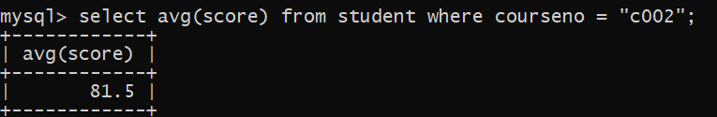

2)

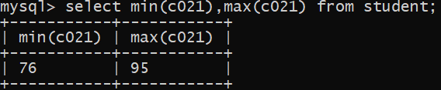

3)

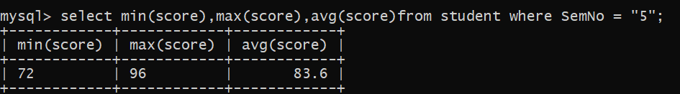

4)

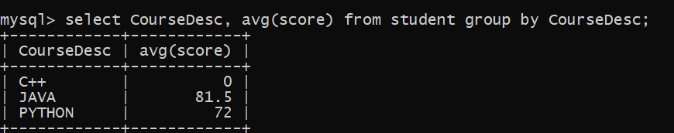

5)

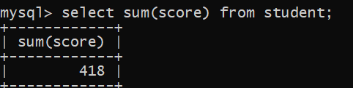

6)

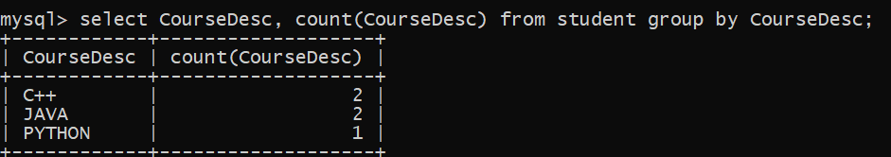

7)

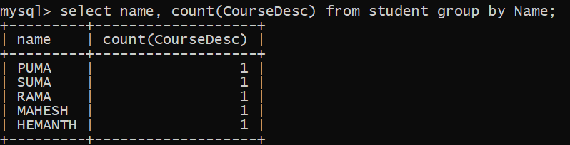

**RESULT**:

The records from the tables are displayed using SELECT commands with WHERE Clause and Pattern matching.