Ex. No.: 6

Date:

**SELECT with various clause – GROUP BY, HAVING, ORDER BY**

**AIM:**

To view the records from the tables using SELECT commands with Group By, Having, Order By

**DESCRIPTION**:

**GROUP BY – HAVING:**

The GROUP BY clause groups a set of rows into a set of summary rows by values of columns or expressions. The GROUP BY clause returns one row for each group. In other words, it reduces the number of rows in the result set.

The GROUP BY clause is used with aggregate functions such as SUM, AVG, MAX, MIN, and COUNT. The aggregate function that appears in the SELECT clause provides the information about each group.

The GROUP BY clause is an optional clause of the SELECT statement.

To filter the groups returned by GROUP BY clause, you use a HAVING clause.

**ORDER BY:**

When you use the SELECT statement to query data from a table, the result set is not sorted in any orders. To sort the result set, you use the ORDER BY clause. The ORDER BY clause allows you to:

* Sort a result set by a single column or multiple columns. 
* Sort a result set by different columns in ascending or descending order. 

**SYNTAX**:

**GROUP BY – HAVING:**

SELECT

c1, c2,...,cn, aggregate_function(ci)

FROM

table

WHERE

where_conditions

GROUP BY c1 , c2,...,cn

HAVING conditionS

**Questions**:

**GROUP BY - HAVING**

1. How many students are registered for each course? Display the course description and the number of students registered in each course.
2. How many courses did each student register for? Use Assessment table.

**ORDER BY**

1. Retrieve Name, Gender, MobileNo of all the students in ascending order of RegNo.
2. List the faculty members in the order of older faculty first.

**OUTPUTS:**

**1)**

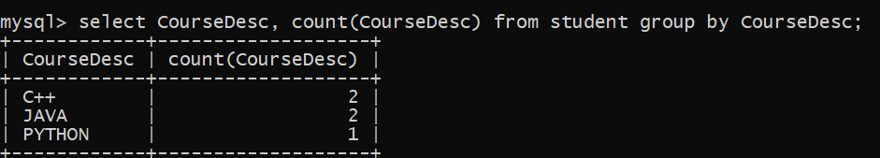

2)

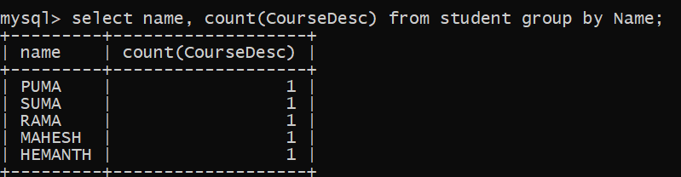

3)

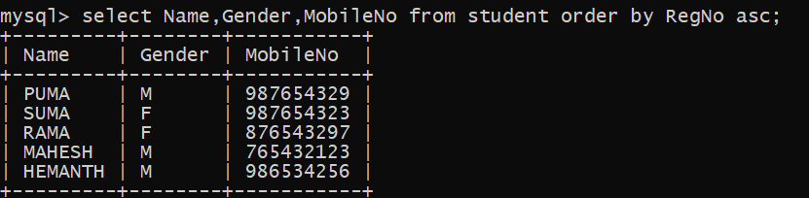

4)

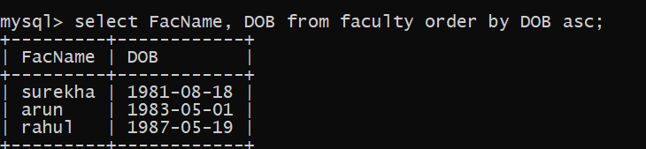

**ORDER BY:**

SELECT column1, column2,...

FROM tbl

ORDER BY column1 [ASC|DESC], column2 [ASC|DESC],...

ASC stands for ascending and the DESC stands for descending. By default, the ORDER BY clause sorts the result set in ascending order if you don’t specify ASC or DESC explicitly.

**RESULT**:

The records from the tables are displayed using SELECT commands with GROUP BY, HAVING and ORDER BY.