JENKINS

* Installed jenkins locally and set up an account with the github plugin.
* Using ngrok, exposed a public url that forwards requests to localhost:8080 where jenkins server runs.
* Added a webhook to the github repository settings that will send payload on every push to the repository.

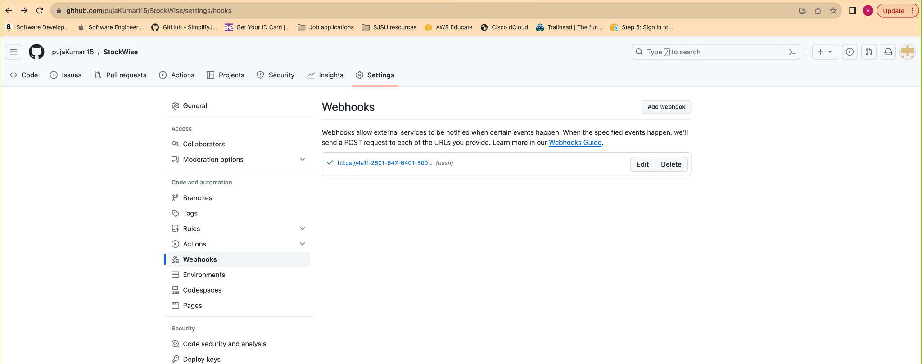

* Created a new job in the jenkins that receives payload from a github repository and executes a shell script

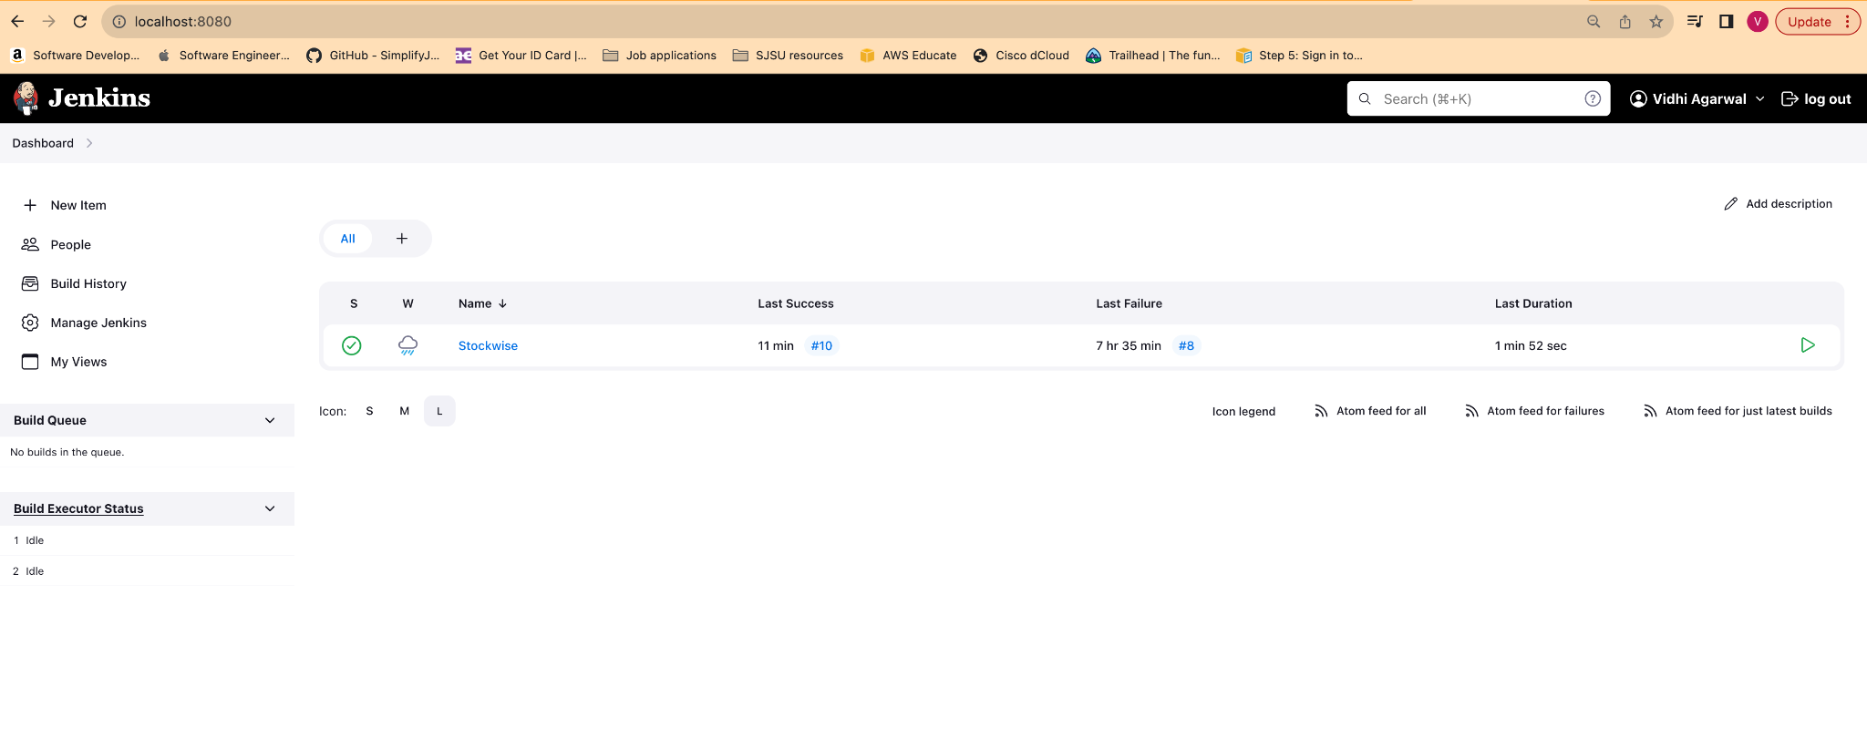

* When a new commit is made to the repository build is triggered.

