
THIAGARAJAR COLLEGE OF ENGINEERING
(A (Govt. Aided Autonomous Institution Affiliated to Anna University)
Madurai 625 015
Assignment-II (2025-2026)
PROBABILITY DISTRIBUTION AND RANDOM PROCESS
1. | 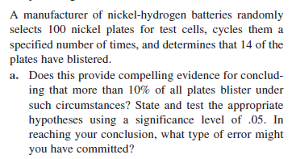
2. | 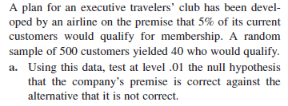
3. | 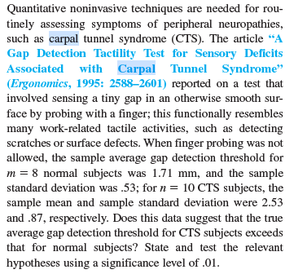
4. | 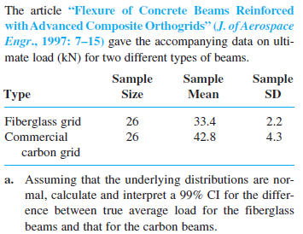
5. | 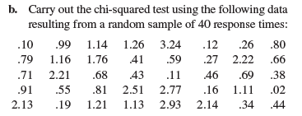
6. | 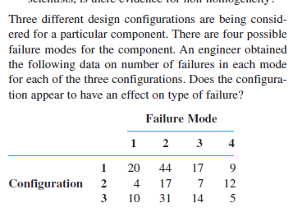
7. | 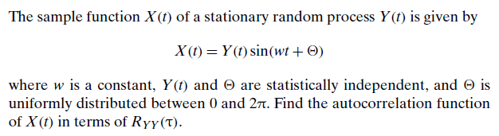
8. | 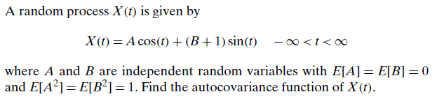
9. | 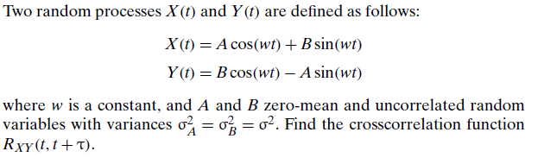
10. | 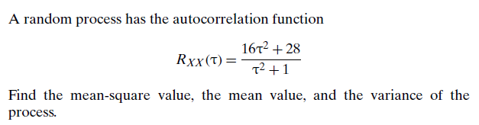
11. | 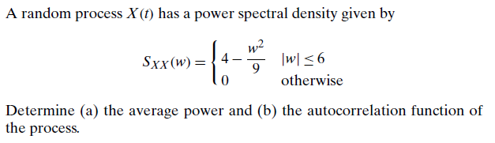
12. | 