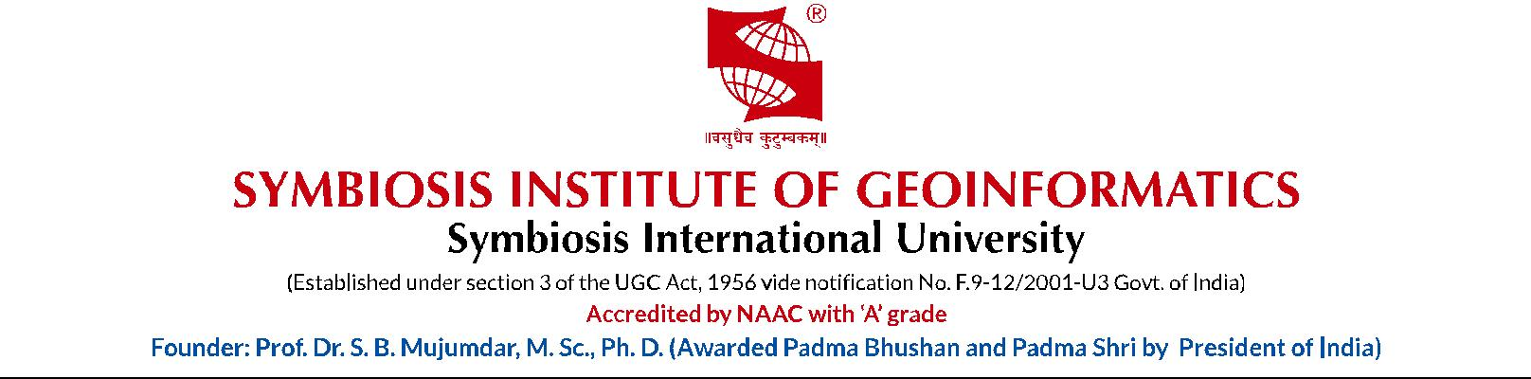

**Faculty of Engineering**

**Specialization: Geoinformatics**

**Course Name:** Software Testing Methodologies

**(UG/PG):** PG

**Number of Credits:** 2

**Level:** 4

**Learning Objectives**

**The student will be able to:**

Understand importance of software testing

Detect software defects and process to rectify

Software verification and validation

Various testing processes and tools

**Pedagogy**

Classroom sessions

**Pre-requisites**

Programming Concepts

|  |  |  |
| --- | --- | --- |
| **S. No.** | **Topic** | **Hours** |
| 1 | Software Testing: Role of software testing in ensuring software quality, Fundamentals and Essentials of software testing, static and dynamic testing, Black box testing and white box testing | 3 |
| 2 | The ‘V’ test model: Life Cycle testing, testing during each phase of SDLC: requirements, design, coding, installation, maintenance | 3 |
| 3 | Test Planning: Why test plans? Building the test plan, Test administration, Post Planning activities, change control and management | 4 |
| 4 | Software defects and quality, defects vs bugs, defect types, finding defects, step in finding and fixing defects, Cost of finding and fixing defects, projecting defects, defect rates, using defect data, defect density, defect estimation, defect injection and removal, reducing defect injection, improving defect removal, nature of design defects, identifying design defects, causes & impact of design defects | 6 |
| 5 | Software verification and validation: Walk through, inspection reviews, methodologies, dos & don’ts , benefits, localization issues, defect classification | 4 |
| 6 | Testing processes: Building test data and scripts: Test file design, entering test data, analyzing results, creating test scripts, executing scripts Test data and test results, Acceptance testing, alpha tests and beta tests | 5 |
| 7 | Software Testing tools: Manual Testing vs automated testing, static testing tools, Tools for test planning and design, coverage analysis: cause effect graphs, statement coverage, condition coverage, decision coverage | 5 |

**Course Outline**

**Books Recommended**

### The art of software Testing by G.J. Myers

Software Testing in the real world by Edward Kit

Introduction to Personal Software Process by Watts Humphrey

Effective methods for software testing by William Perry

**Suggested Evaluation Methods**

1. **Continuous Assessment**
2. **Essential**
3. Written Exams
4. Lab Assignment
5. **Optional**

a) Quizzes

**End Semester Examination**

1. Written Exam

**Parallel/Similar courses in the existing curriculum**

|  |  |  |
| --- | --- | --- |
| S.No. | Name of the course | Institute where it is offered |
|  |  |  |
|  |  |  |
|  |  |  |
|  |  |  |

**Sub-specialization committee**

|  |  |  |  |  |
| --- | --- | --- | --- | --- |
| Name of Member | Ashwini Mohgaonkar | Dr. T.P. Singh |  |  |
| Designation | Visiting Faculty | Director |  |  |
| Org. / Inst. | SIG | SIG |  |  |
| Signature |  |  |  |  |

Name of the Expert:

Signature:

Date: